Project-3
1. Create two virtual machines in east us (web servers)
2. Configure load balancer for above servers.
Steps:
1. Install awscli and Terraform in the gitbash
2. Create one directory and create different blocks.
2.Creating three blocks
- Terraform block
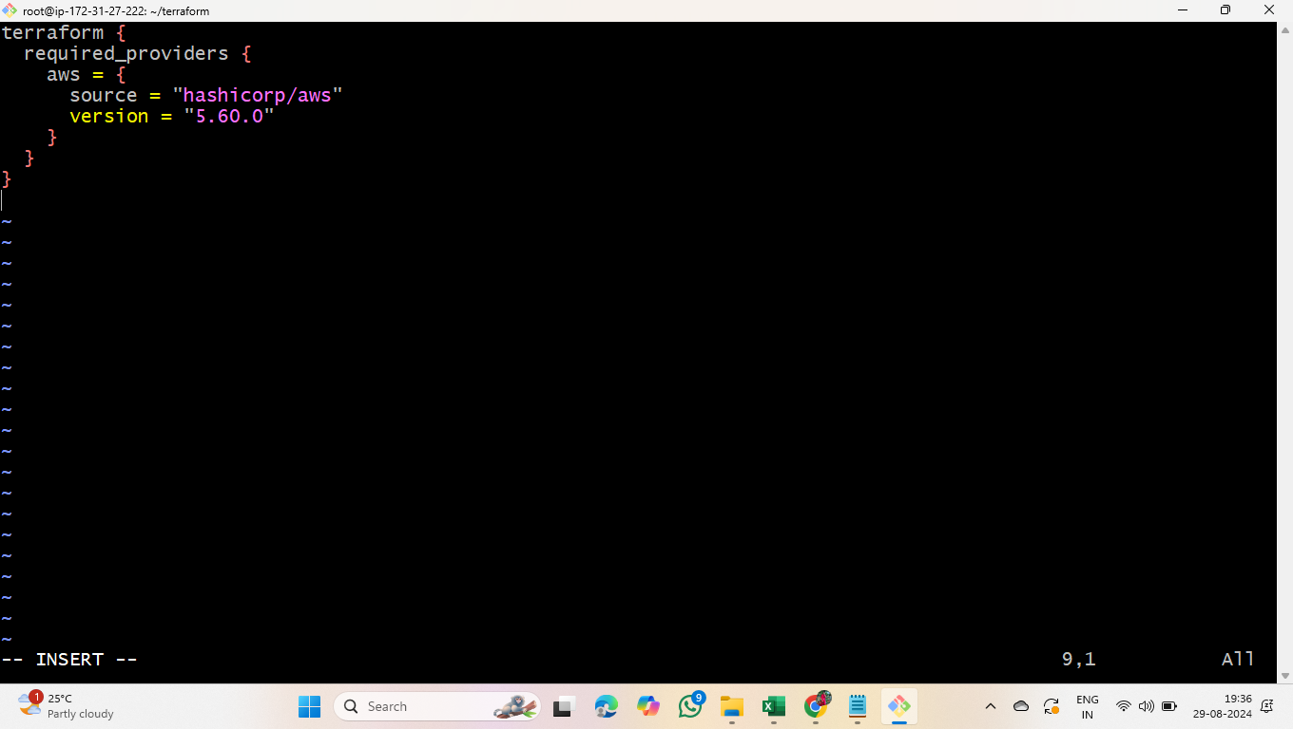
- Provider block
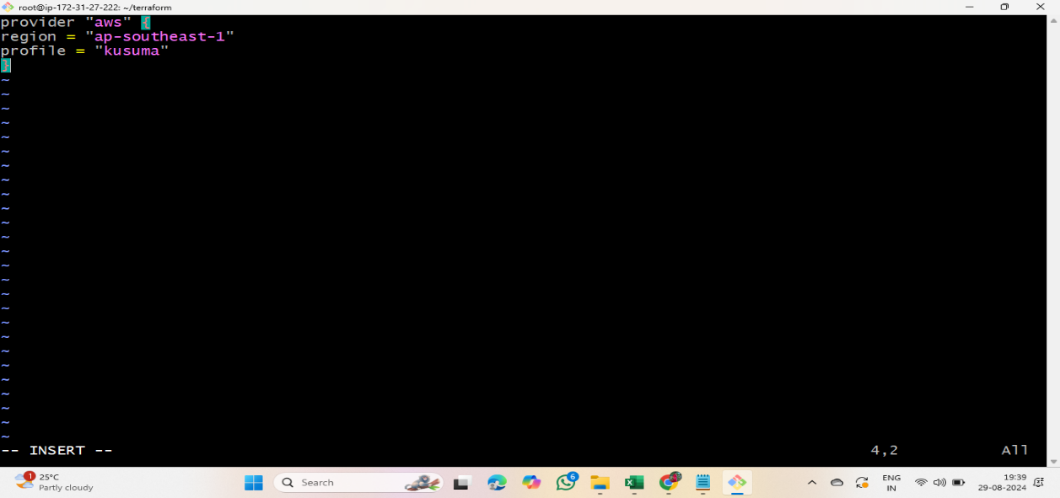

- Resource block
As we have to create loadbalancer using terraform, give the below script in resource block

# Define VPC
resource "aws_vpc" "main" {
cidr_block = "10.0.0.0/16"
}

# Define subnets
resource "aws_subnet" "subnet1" {
vpc_id = aws_vpc.main.id
cidr_block = "10.0.1.0/24"
availability_zone = "ap-southeast-1a" # Update to your desired AZ
}

resource "aws_subnet" "subnet2" {
vpc_id = aws_vpc.main.id
cidr_block = "10.0.2.0/24"
availability_zone = "ap-southeast-1b" # Update to your desired AZ
}

# Define Internet Gateway
resource "aws_internet_gateway" "main" {
vpc_id = aws_vpc.main.id
}

# Define a route table
resource "aws_route_table" "main" {
vpc_id = aws_vpc.main.id

route {
cidr_block = "0.0.0.0/0"
gateway_id = aws_internet_gateway.main.id
}
}

# Associate route table with subnets
resource "aws_route_table_association" "a" {
subnet_id = aws_subnet.subnet1.id
route_table_id = aws_route_table.main.id
}

resource "aws_route_table_association" "b" {
subnet_id = aws_subnet.subnet2.id
route_table_id = aws_route_table.main.id
}

# Define security group
resource "aws_security_group" "allow_http" {
vpc_id = aws_vpc.main.id

egress {
from_port = 0
to_port = 0
protocol = "-1"
cidr_blocks = ["0.0.0.0/0"]
}

ingress {
from_port = 80
to_port = 80
protocol = "tcp"
cidr_blocks = ["0.0.0.0/0"]
}
}

# Define EC2 instances
resource "aws_instance" "web1" {
ami = "ami-01811d4912b4ccb26" # Update with your desired AMI ID
instance_type = "t2.micro"
subnet_id = aws_subnet.subnet1.id
}

resource "aws_instance" "web2" {
ami = "ami-01811d4912b4ccb26" # Update with your desired AMI ID
instance_type = "t2.micro"
subnet_id = aws_subnet.subnet2.id
}

# Define Application Load Balancer
resource "aws_lb" "web_alb" {
name = "web-load-balancer"
internal = false
load_balancer_type = "application"
security_groups = [aws_security_group.allow_http.id]
subnets = [aws_subnet.subnet1.id, aws_subnet.subnet2.id]

enable_deletion_protection = false
idle_timeout = 60
drop_invalid_header_fields = true

enable_http2 = true
}

# Define Target Group
resource "aws_lb_target_group" "web_target_group" {
name = "web-target-group"
port = 80
protocol = "HTTP"
vpc_id = aws_vpc.main.id

health_check {
path = "/"
interval = 30
timeout = 5
healthy_threshold = 2
unhealthy_threshold = 2
}
}

# Define Listener for ALB
resource "aws_lb_listener" "web_listener" {
load_balancer_arn = aws_lb.web_alb.arn
port = 80
protocol = "HTTP"

default_action {
type = "forward"
target_group_arn = aws_lb_target_group.web_target_group.arn
}
}

# Register Targets
resource "aws_lb_target_group_attachment" "web_instance_1" {
target_group_arn = aws_lb_target_group.web_target_group.arn
target_id = aws_instance.web1.id
port = 80
}

resource "aws_lb_target_group_attachment" "web_instance_2" {
target_group_arn = aws_lb_target_group.web_target_group.arn
target_id = aws_instance.web2.id
port = 80
}

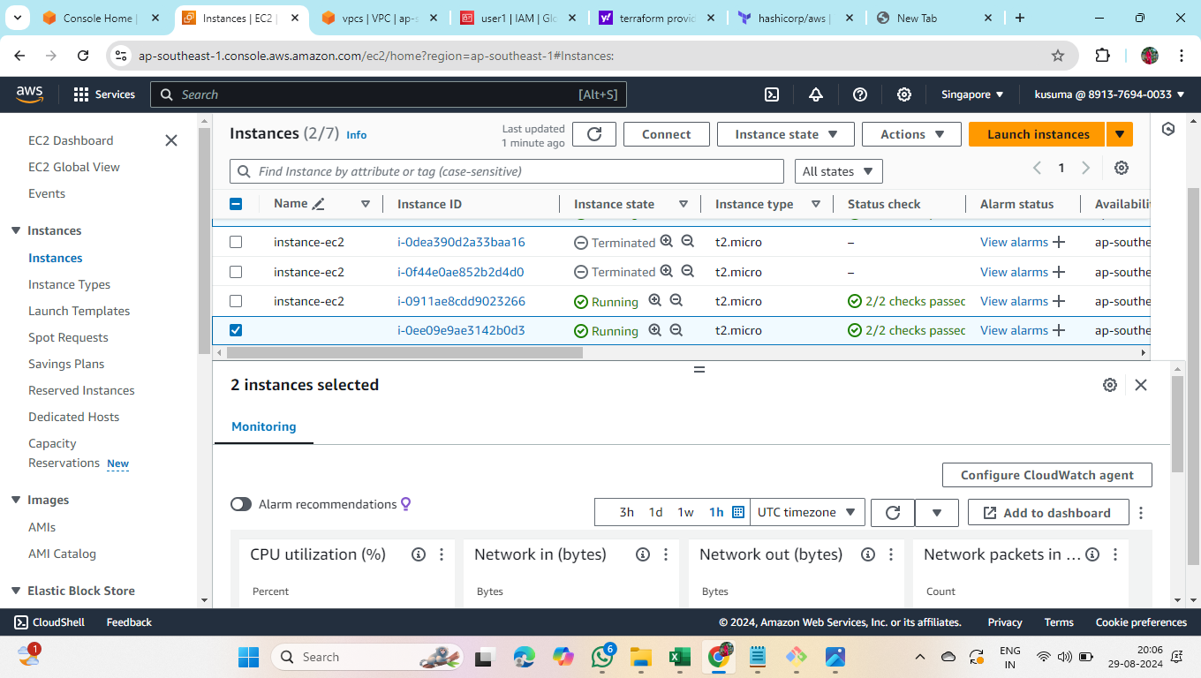

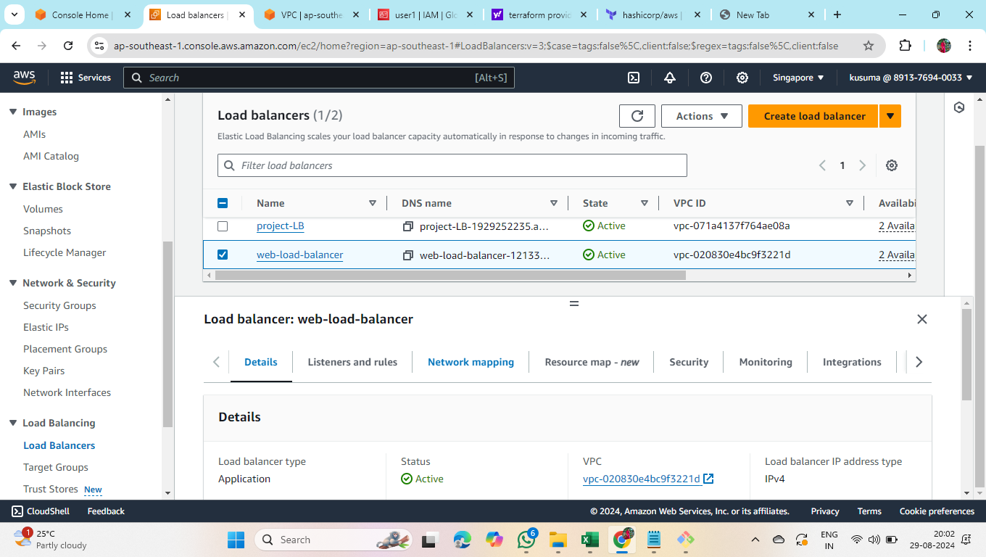
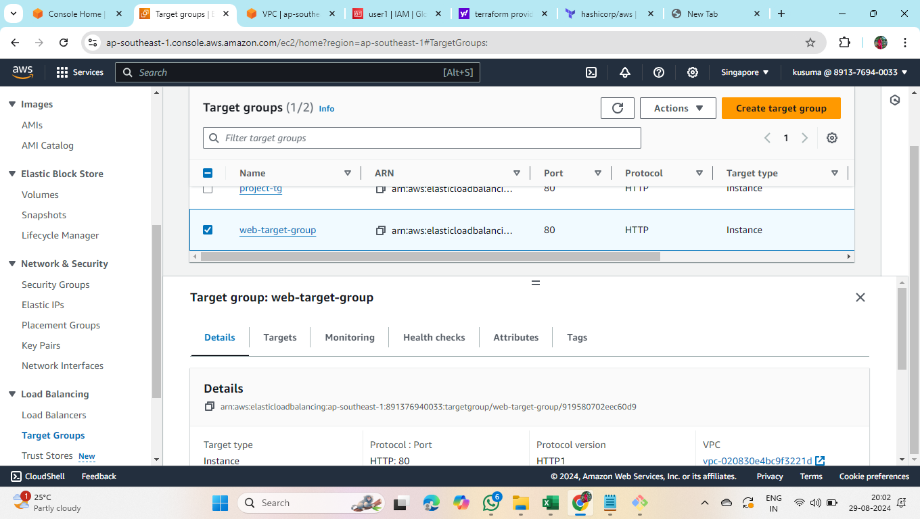

The above screenshots show the laodbalancer created using terraform script.

