SOFTWARE REQUIREMENTS SPECIFICATION
Vehicle Service & Maintenance Management System

Member 2 – Requirements & Analysis
Sections 3, 4 and 5

Name | Date | Reason For Changes | Version
Priya K L | 11 September 2026 | Prepared Sections 3–5: interfaces, analysis models and functional requirements | 1.0

Section-3 External Interface Requirements

3.1 User Interfaces
The system shall provide a user interface for customers, service staff, service technicians and administrators. The interface shall provide access to functions according to the user's role and authorization level.
The main interfaces shall include user authentication, customer and vehicle information management, service request management, service activity tracking, maintenance history, service-status information and search and retrieval of service records.
The interface shall provide clearly labelled fields, forms, buttons, tables and status information. Appropriate validation and error messages shall be displayed when invalid or incomplete information is entered.
User Interface | Purpose
Login / Authentication | Authenticate users
Customer Management | Manage customer information
Vehicle Management | Manage vehicle information
Service Request | Create and manage service requests
Service Activity | Record and track service work
Maintenance History | View previous maintenance records
Service Status | Track service progress
Search | Retrieve customer, vehicle and service information

3.2 Software Interfaces
The system shall provide interfaces between the user interface, application services and persistent data storage. The user interface shall communicate with the application layer to submit requests, retrieve information and update records.
The application shall communicate with a database or other suitable persistent storage mechanism for storing customer, vehicle, service request, service activity, maintenance and service-status information.
If external services are introduced during implementation, they shall communicate with the system through suitable documented interfaces or APIs.
Software Interface | Purpose
User Interface | Interaction between users and the system
Application Layer | Processes requests and applies system rules
Database / Persistent Storage | Stores system records
External APIs, if applicable | Communication with external services

3.3 Communications Interfaces
The system shall support communication between the client interface and application services through the network environment used by the final implementation.
Where a client-server architecture is used, requests and responses shall be exchanged between the user interface and application server. Communication involving sensitive user or service information should use secure communication mechanisms.
Any external service interfaces introduced during implementation shall use appropriate communication protocols and shall be documented as part of the final implementation.

3.4 Hardware Interfaces
No specialized hardware interface is required for the proposed system based on the current project scope. The system is expected to operate using standard computing devices capable of running the selected user interface and application environment.
If specialized hardware is introduced in the final implementation, its interface and communication requirements shall be documented accordingly.

Section-4 Analysis Models

The following analysis models describe the major users, information entities and service workflow of the proposed Vehicle Service & Maintenance Management System.

4.1 Use Case Diagram
The Use Case Diagram should include the following actors and major interactions:
- Customer / Vehicle Owner – Login, view customer and vehicle information, submit service requests, view service status and view service history.
- Service Advisor / Service Staff – Login, register and manage customers and vehicles, create and manage service requests, assign service work, update service status and search records.
- Service Technician – Login, view assigned work and service details, record service activities and maintenance details, and update completion information.
- Administrator – Login, manage users, manage access and manage system information.

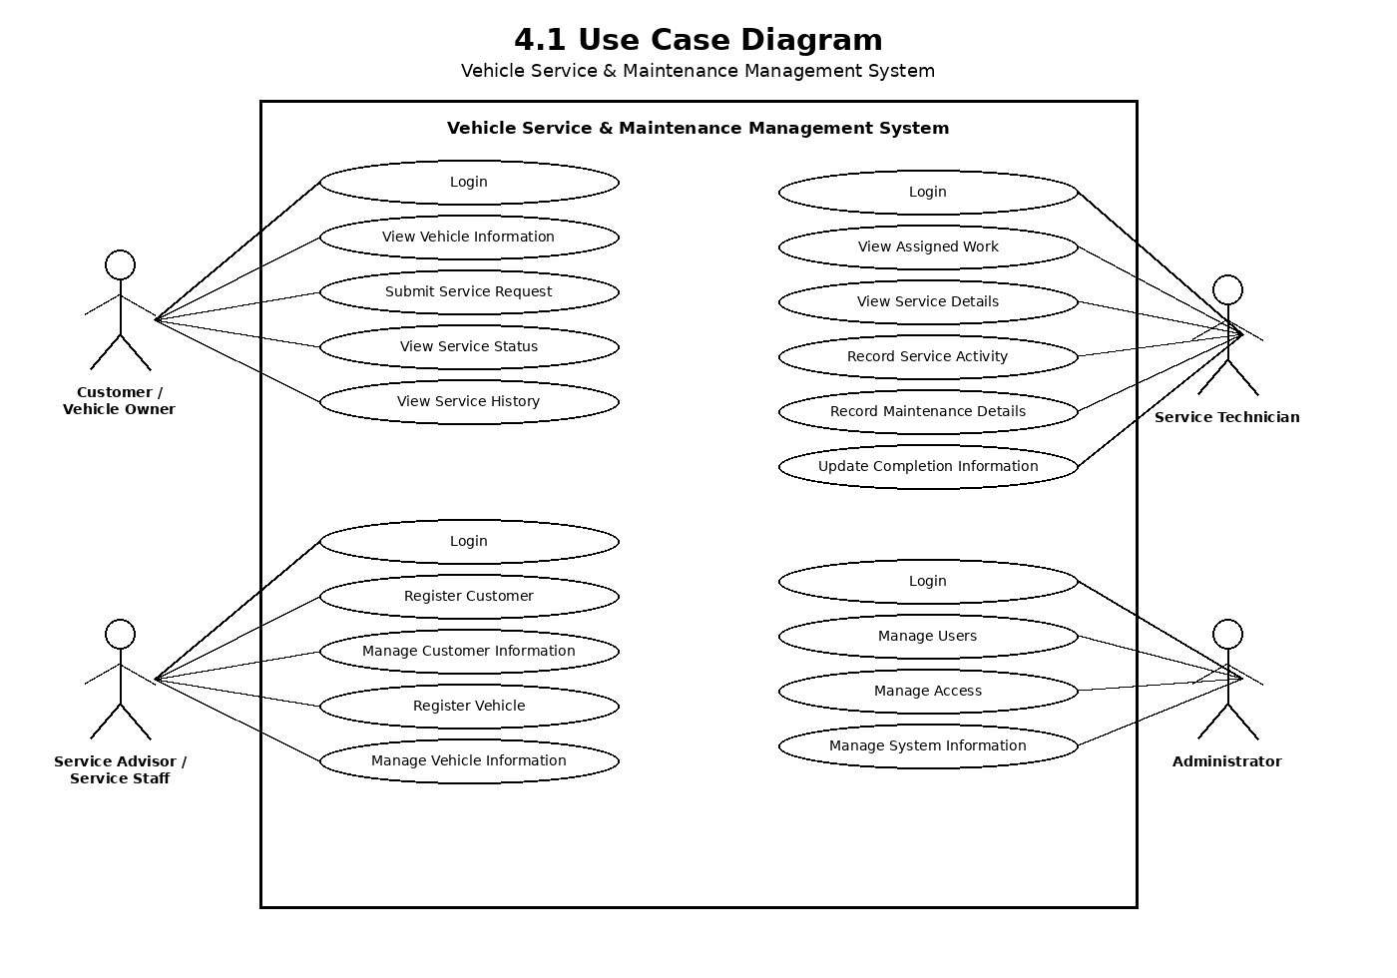

4.2 Entity Relationship Diagram
The following is an analysis-level proposed ER model. The final database structure is to be confirmed during implementation.
Entity | Key Attributes
CUSTOMER | Customer_ID (PK), Name, Phone, Email, Address
VEHICLE | Vehicle_ID (PK), Customer_ID (FK), Registration_No, Make, Model, Year
SERVICE_REQUEST | Service_Request_ID (PK), Vehicle_ID (FK), Request_Date, Service_Type, Description, Status
SERVICE_ACTIVITY | Activity_ID (PK), Service_Request_ID (FK), Technician_ID (FK), Activity_Date, Description, Completion_Details
MAINTENANCE_RECORD | Maintenance_ID (PK), Vehicle_ID (FK), Activity_ID (FK), Maintenance_Date, Details
USER | User_ID (PK), Name, Username, Password, Role
Relationships:
- CUSTOMER 1–M VEHICLE
- VEHICLE 1–M SERVICE_REQUEST
- SERVICE_REQUEST 1–M SERVICE_ACTIVITY
- VEHICLE 1–M MAINTENANCE_RECORD
- USER 1–M SERVICE_ACTIVITY
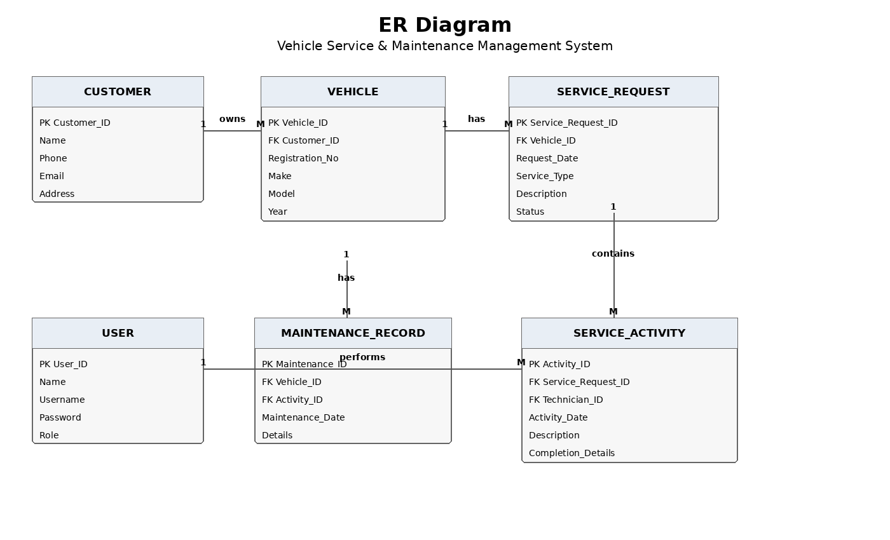

4.3 Activity Diagram
The main vehicle service workflow can be represented as follows:
START → Provide Customer/Vehicle Information → Register/Retrieve Customer & Vehicle → Create Service Request → Review Request → Assign Service Work → Technician Performs Service → Record Service Activity → Update Service Status → Record Completion/Maintenance Details → Update Service History → Provide Service Information/Status → END
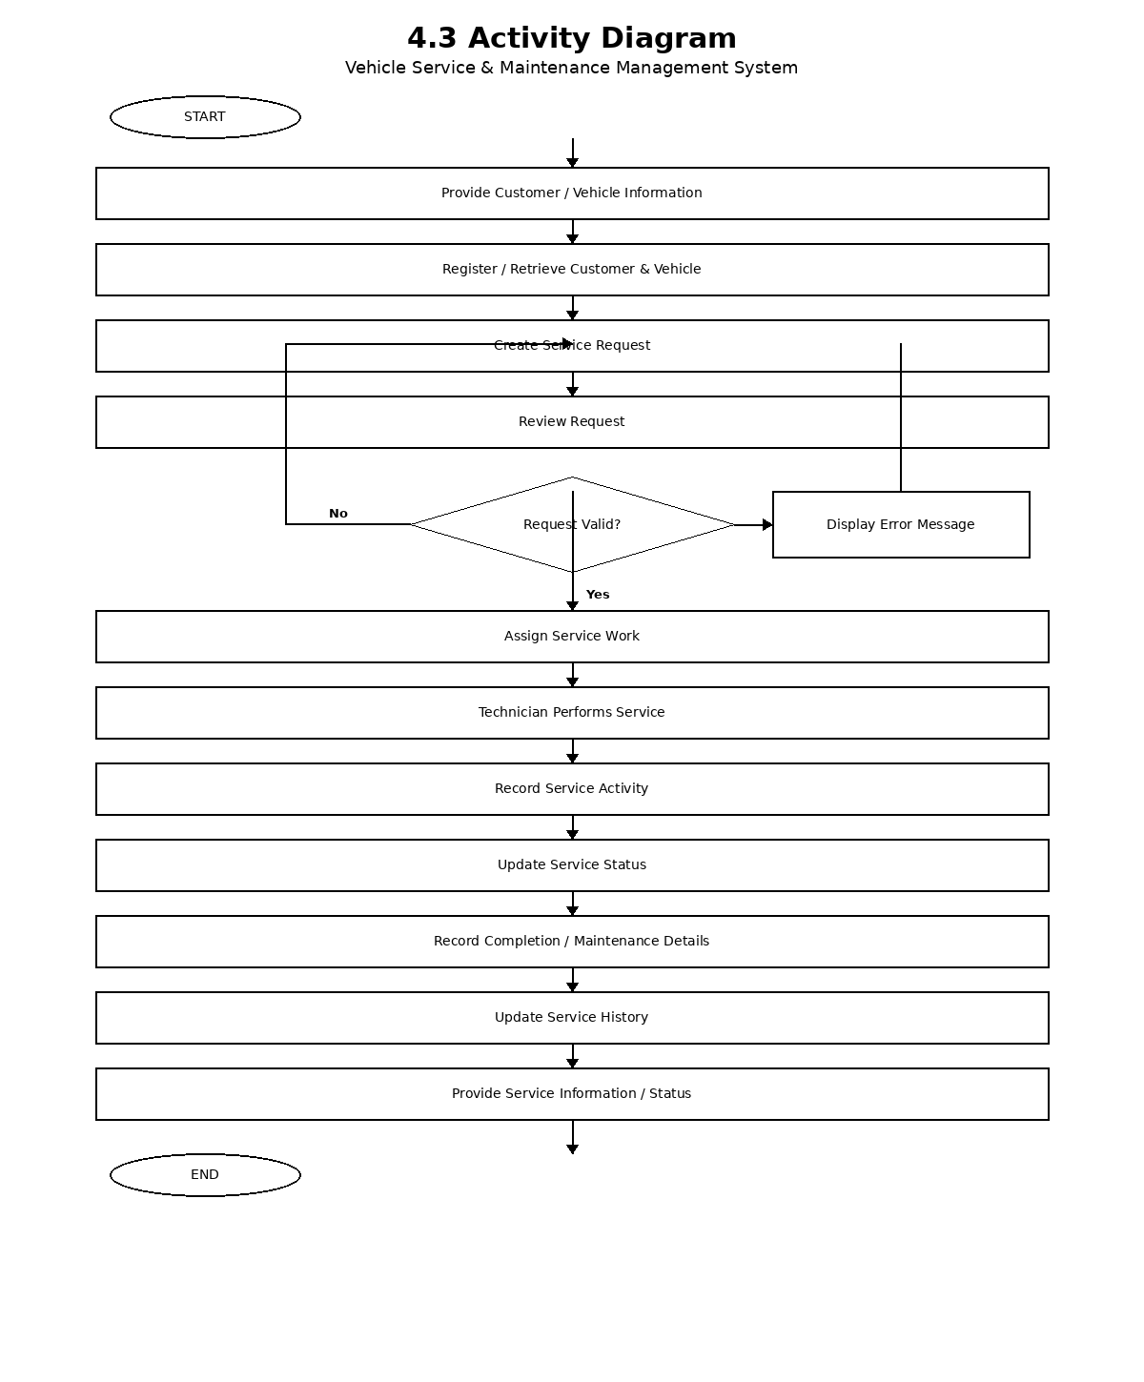

Section-5 System Features

The following system features are derived from the project scope. Each feature includes its description, priority, stimulus/response sequence and functional requirements.

5.1 User Authentication and Access Control

→Description
This feature provides authentication and role-based access to protect system functions and information.
→Priority
High
→Stimulus / Response Sequence
Step | Stimulus | System Response
1 | User opens login page | System displays login interface
2 | User enters credentials | System validates authentication information
3 | Valid credentials are provided | System authenticates the user
4 | User is authenticated | System identifies the user's role
5 | User accesses a protected function | System checks authorization
6 | Unauthorized access is attempted | System denies access

→Functional Requirements
Requirement ID | Functional Requirement
REQ-AUTH-01 | The system shall allow registered users to authenticate before accessing protected functions.
REQ-AUTH-02 | The system shall validate authentication information provided by the user.
REQ-AUTH-03 | The system shall provide access according to the user's assigned role.
REQ-AUTH-04 | The system shall restrict unauthorized users from protected functions.
REQ-AUTH-05 | The system shall display an appropriate message when authentication fails.
REQ-AUTH-06 | The system shall support the user roles defined for the system.
REQ-AUTH-07 | The system shall protect system functions according to user authorization.
REQ-AUTH-08 | The system shall restrict access when an authenticated session is no longer valid.

5.2 Customer and Vehicle Management

→Description
This feature supports the creation, viewing and updating of customer and vehicle records.
→Priority
High
→Stimulus / Response Sequence
Step | Stimulus | System Response
1 | Service staff selects customer management | System displays customer information and available actions
2 | New customer information is entered | System validates and records customer information
3 | Vehicle information is entered | System associates the vehicle with the appropriate customer
4 | Existing information is selected | System displays the relevant customer or vehicle record
5 | Updated information is submitted | System validates and updates the record
6 | Search information is provided | System retrieves matching records

→Functional Requirements
Requirement ID | Functional Requirement
REQ-CV-01 | The system shall allow authorized service staff to register customer information.
REQ-CV-02 | The system shall allow authorized users to view customer information according to their permissions.
REQ-CV-03 | The system shall allow authorized service staff to update customer information.
REQ-CV-04 | The system shall allow authorized service staff to register vehicle information.
REQ-CV-05 | The system shall associate each vehicle record with the appropriate customer record.
REQ-CV-06 | The system shall allow authorized users to view vehicle information.
REQ-CV-07 | The system shall allow authorized service staff to update vehicle information.
REQ-CV-08 | The system shall validate required customer and vehicle information before saving records.

5.3 Service Request and Service Activity Management

→Description
This feature supports service requests, assignment of service work and recording of service activities.
→Priority
High
→Stimulus / Response Sequence
Step | Stimulus | System Response
1 | A service request is initiated | System displays the service request interface
2 | Service request information is entered | System validates and records the request
3 | Request is reviewed | System makes the request available for service processing
4 | Service work is assigned | System records the assignment
5 | Technician performs service | System allows service activity information to be recorded
6 | Service activity is updated | System updates the related service record

→Functional Requirements
Requirement ID | Functional Requirement
REQ-SR-01 | The system shall allow authorized users to create service requests.
REQ-SR-02 | The system shall record the vehicle associated with each service request.
REQ-SR-03 | The system shall record the date and relevant service information for a service request.
REQ-SR-04 | The system shall allow authorized service staff to manage service requests.
REQ-SR-05 | The system shall allow authorized service staff to assign service work to service personnel.
REQ-SR-06 | The system shall allow service technicians to view their assigned service work.
REQ-SR-07 | The system shall allow service technicians to record service activities performed.
REQ-SR-08 | The system shall maintain service activity information associated with the relevant service request.

5.4 Maintenance History and Service Status

→Description
This feature supports maintenance records, service progress and retrieval of service history.
→Priority
High
→Stimulus / Response Sequence
Step | Stimulus | System Response
1 | User selects a vehicle | System retrieves related service and maintenance records
2 | Service activity is completed or updated | System updates the service status
3 | Maintenance details are recorded | System stores the maintenance record
4 | User requests service status | System displays the current status to authorized users
5 | User requests service history | System displays relevant historical information

→Functional Requirements
Requirement ID | Functional Requirement
REQ-MH-01 | The system shall maintain maintenance records for vehicles.
REQ-MH-02 | The system shall associate maintenance records with the relevant vehicle.
REQ-MH-03 | The system shall allow authorized users to record maintenance details.
REQ-MH-04 | The system shall update service status based on recorded service progress.
REQ-MH-05 | The system shall allow authorized users to view service status.
REQ-MH-06 | The system shall maintain service history for vehicles.
REQ-MH-07 | The system shall allow authorized users to retrieve relevant service history.
REQ-MH-08 | The system shall present service and maintenance information consistently to authorized users.

5.5 Search and Service Information Management

→Description
This feature allows authorized users to retrieve relevant customer, vehicle and service information.
→Priority
Medium
→Stimulus / Response Sequence
Step | Stimulus | System Response
1 | User opens search | System displays search options
2 | Search criteria are entered | System validates the criteria
3 | Search is submitted | System retrieves matching records
4 | Matching records exist | System displays the relevant information
5 | No records match | System displays an appropriate message

→Functional Requirements
Requirement ID | Functional Requirement
REQ-INFO-01 | The system shall provide search functionality for authorized users.
REQ-INFO-02 | The system shall allow users to search relevant customer records according to their permissions.
REQ-INFO-03 | The system shall allow users to search relevant vehicle records according to their permissions.
REQ-INFO-04 | The system shall allow users to search relevant service request records according to their permissions.
REQ-INFO-05 | The system shall allow users to retrieve relevant service activity information.
REQ-INFO-06 | The system shall display matching records based on the supplied search criteria.
REQ-INFO-07 | The system shall display an appropriate message when no matching records are found.
REQ-INFO-08 | The system shall restrict search results to information the user is authorized to access.

Revision History
Name | Date | Reason For Changes | Version
Priya K L | 11 September 2026 | Prepared Sections 3–5: interfaces, analysis models and functional requirements | 1.0

