
PES UNIVERSITY, BANGALORE
Department of Computer Science and Engineering

Software Requirements Specification
for
Vehicle Service & Maintenance Management System
Version 1.0 approved.

Prepared by:
Priya K L - PES1UG24CS600
Prajwal S J - PES1UG24CS594
Harshith S - PES1UG24CS574
Basavaraj Mruthyunjaya Mudakammanavar - PES1UG24CS561

PES University,

01/10/2026

PES UNIVERSITY, BANGALORE
Department of Computer Science and Engineering

Table of Contents
Table of Contents ii
Revision History iii

1. Introduction 1
1.1 Purpose 1
1.2 Intended Audience and Reading Suggestions 1
1.3 Product Scope 1
1.4 References 2

2. Overall Description 2
2.1 Product Perspective 2
2.2 Product Functions 3
2.3 User Classes and Characteristics 3
2.4 Operating Environment 4
2.5 Design and Implementation Constraints 4
2.6 Assumptions and Dependencies 4

3. External Interface Requirements 5
3.1 User Interfaces 5
3.2 Software Interfaces 5
3.3 Communications Interfaces 6
3.4 Hardware Interfaces 6

4. Analysis Models 6 5. System Features 12
5.1 Customer and Vehicle Registration 12
5.2 Service Request Intake, Review and Validation 13
5.3 Service Work Assignment 13
5.4 Service Execution and Recording 14
5.5 Service Status Tracking, History and Search 15
5.6 User and Access Administration 16

6. Other Nonfunctional Requirements 16
6.1 Performance Requirements 16
6.2 Safety Requirements 17
6.3 Security Requirements 17
6.4 Software Quality Attributes 17
6.5 Business Rules 18

7. Other Requirements 18 Appendix A: Glossary 19 Appendix B: Field Layouts 20 Appendix C: Requirement Traceability Matrix 23
PES UNIVERSITY, BANGALORE
Department of Computer Science and Engineering

Revision History
Name | Date | Reason For Changes | Version
Priya K L | 01-Oct-2026 | Initial version of the SRS for the Vehicle  Service & Maintenance Management System | 1.0
Prajwal | 28-Oct-2026 | Final version of the SRS for the Vehicle  Service & Maintenance Management System | 1.1

- Introduction:

  - Purpose:

This Software Requirements Specification (SRS) defines the requirements for release 1.0 of the Vehicle Service & Maintenance Management System . VSMMS is a web-based application used by a vehicle service centre to register customers and their vehicles, capture and triage service requests, assign work to technicians, record the service and maintenance activity actually performed, and keep customers informed of status and history.
This SRS covers the complete release 1.0 product: customer and vehicle registration, service-request intake and validation, work assignment, service execution and recording, status tracking and search, and user/access administration. It has been written for the Requirements Engineering & UML Use-Case Modelling .

  - Intended Audience and Reading Suggestions:

This document is intended for the following readers:
    - Developers and architects: to design and implement the features in Sections 3, 5 and 6; read Sections 2, 3, 5, 6 and Appendix B first.
    - Project managers: to plan scope and priorities; read Sections 1, 2 and the priority ratings in Section 5.
    - Testers / QA engineers: to derive test cases from the Pass/Fail acceptance criteria; read Sections 5 and 6 and Appendix C.
    - UI/UX designers: to design screens and flows; read Sections 2.3, 3.1, 4 and 5.
    - Service centre staff (service advisors, technicians) and administrators: to understand what the system will do for their role; read Sections 1, 2 and 5.
    - Course evaluators: to assess the requirements and models; read the whole document, especially Section 4 (Analysis Models) and Section 5.
→Organisation of this SRS: Section 1 introduces the document. Section 2 gives an overall description of the product, its users and its constraints. Section 3 lists the external interface requirements. Section 4 contains the analysis models: the UML use-case diagram, the use-case flow specification, the activity diagram and the entity-relationship diagram. Section 5 organises the functional requirements (FR-001 to FR-006) by system feature. Section 6 states the non-functional requirements (NFR-001 and NFR-002), quality attributes and business rules. Section 7 lists other requirements. The appendices provide a glossary, field layouts and a requirement traceability matrix.

  - Product Scope:

The Vehicle Service & Maintenance Management System digitises the front-of-house and workshop workflow of a vehicle service centre. A service advisor registers walk-in or returning customers and their vehicles; a customer or advisor raises a service request describing the work needed; the advisor reviews and validates the request; once valid, the work is assigned to a service technician, who performs and records the service, logs maintenance details and marks the work complete. The system keeps the service status and a full service history visible to the customer and searchable by staff.
Objectives and goals:
    - Replace paper job cards and spreadsheets with a single, auditable digital record per vehicle and per service request.
    - Reduce turnaround time by routing requests to the right technician quickly and by validating requests before work starts.
    - Give customers self-service visibility into the status and history of their vehicle’s servicing.
    - Maintain accurate maintenance records that support warranty, resale and regulatory needs.

  - References:

The following documents and web resources are referred to in this SRS.
Ref | Title | Author / Publisher | Version / Date | Source / Location
[1] | Software Requirements  Specification (SRS) Template | Adapted from K. Wiegers; supplied by PES University | As supplied, 2026 | Course material (SRS-Template.docx  )
[2] | Project diagrams: UML Use-Case  Diagram, ER Diagram, Activity  Diagram for the Vehicle Service &  Maintenance Management System | Project team | 2026 | Supplied diagram images (Sections 4.1-4.4 of this SRS)
[3] | ISO/IEC/IEEE 29148:2018, Systems and software engineering:  Life cycle processes:  Requirements engineering | ISO / IEC / IEEE | 2018 | https://www.iso.org/ standard/72089.html
[4] | IEEE Std 830-1998,  Recommended Practice for  Software Requirements  Specifications | IEEE | 1998 | IEEE Xplore
[5] | Software Requirements, 3rd Edition | K. Wiegers and J. Beatty, Microsoft Press | 2013 | Book
[6] | OMG Unified Modeling Language (UML) Specification | Object Management Group | Version 2.5.1,  December 2017 | https://www.omg.or g/spec/UML/2.5.1
[7] | OWASP Application Security  Verification Standard (ASVS) | OWASP Foundation | Version 4.0.3, 2021 | https://owasp.org/w ww-project-applicati on-security-verificat ion-standard/
[8] | The Digital Personal Data Protection Act, 2023 (Act No. 22 of 2023) | Government of India | 2023 | https://www.meity.g ov.in

- Overall Description:

  - Product Perspective:

The Vehicle Service & Maintenance Management System is a new, self-contained product; it does not replace an existing system and is not a member of an existing product family. It is conceived as a browser-based application used inside a single service centre (or a small chain) and does not depend on external financial or inventory systems in release 1.0.
The major logical components of the system and their responsibilities are:
Component | Responsibility
Web Client (responsive UI) | Browser-based interface used by Customers, Service Advisors, Technicians and Administrators.
Customer & Vehicle Registry | Registration and maintenance of customer and vehicle records (FR-001).
Service Request Service | Intake, review and validation of service requests (FR-002).
Work Assignment Service | Assigns validated requests to technicians and tracks assigned work (FR-003).
Service Execution & Recording Service | Records service activity, maintenance details and completion information (FR-004).
Status & History Service | Tracks status transitions, service history and search across records (FR-005).
User & Access  Administration Service | User accounts, roles and system configuration (FR-006).
Relational Database | Persistent store for customers, vehicles, service requests, activities and maintenance records.

  - Product Functions:
At a high level the product shall allow users to perform the following major functions (details are given in Section 5):
    - Customer and vehicle registration: register and maintain customer and vehicle records (FR-001).
    - Service request intake and validation: submit, review and validate service requests, rejecting invalid ones with a clear error message (FR-002).
    - Work assignment: assign a validated request to a technician, who can view assigned work (FR-003).
    - Service execution and recording: perform the service, record service activity, maintenance details and completion information (FR-004).
    - Status tracking, history and search: update and view service status, view service history and search records (FR-005).
    - User and access administration: manage user accounts, roles/access and system configuration (FR-006).

  - User Classes and Characteristics:

User class | Description and characteristics | Frequency of use | Technical expertise | Privilege level | Importance
Customer / Vehicle Owner | Submits service requests for an owned vehicle and checks status and service history. Occasional use, around each service visit. | A few times a year | Basic web skills | Standard (own records only) | Most important (primary)
Service Advisor / Service Staff | Registers customers and vehicles, creates and manages service requests, reviews and validates them, assigns work and updates status. Front-of-house staff. | Many times a day | Moderate | Standard staff | Most important (primary)
Service Technician | Views assigned work, performs the service, records service activity, maintenance details and completion information. | Many times a day | Moderate; high mechanical/do main expertise | Standard staff | Most important (primary)
Administrator | Manages user accounts, access/roles and system configuration. | Occasional | Moderate to high | Elevated (admin) | Important (secondary)

  - Operating Environment:

    - Client: any device with a current web browser: Google Chrome, Microsoft Edge, Mozilla Firefox and Apple Safari (latest two major versions); responsive layout for screen widths from 360 px (phones) upwards, since advisors and technicians may use tablets in the workshop.
    - Server: Linux-based server or container platform (for example Ubuntu Server 22.04 LTS or later) behind an HTTPS reverse proxy.
    - Database: a relational database that supports ACID transactions
    - Network: the workshop network and the public Internet; no special hardware is required beyond standard computers, tablets or phones.

  - Design and Implementation Constraints:

    - Role-based workflow: the design must enforce that only a Service Advisor can validate/assign a request and only the assigned Technician can record completion for that request.
    - Standards: all external communication shall use HTTPS with TLS 1.2 or higher.
    - Technology: open-source frameworks and libraries only, because of the academic project budget; a modular design with separately testable registration, request, assignment and recording modules.
    - Language: the user interface is English-only in release 1.0, but text must be externalised to allow later translation.
    - Schedule and team: the project is developed by a small student team within one academic term; design conventions follow the team’s coding standard and version control on GitHub.
  - Assumptions and Dependencies:

Assumptions (the project may be affected if any of these is wrong):
    - Every registered customer and staff member has a valid e-mail address or phone number for contact.
    - One service request concerns one vehicle; a vehicle may have many service requests over time.
    - A service request is validated by a Service Advisor before it is assigned to a Technician.
    - The service centre starts with a modest volume: a few hundred vehicles and at most 50 concurrent staff/customer users.
Dependencies:
    - A hosting environment that offers TLS certificates and automated database backups.
    - Third-party open-source libraries for the web framework, database access and password hashing.

- External Interface Requirements:

  - User Interfaces:

The system provides a responsive web interface. The logical characteristics of the user interface are as follows; the detailed screen design is documented in a separate user-interface specification.
Screen / component | Used by | Purpose
Sign-up / Log-in | All users | Register or authenticate.
Customer & Vehicle Registration | Service Advisor | Register a customer and their vehicle(s); edit customer/vehicle details.
My Vehicles | Customer | View registered vehicles and their information.
Submit / Create Service Request | Customer, Service Advisor | Describe the work needed for a vehicle and submit the request.
Review Requests | Service Advisor | Review pending requests; validate or reject with a reason.
Assign Work | Service Advisor | Assign a validated request to an available technician.
My Assigned Work | Service Technician | List of requests assigned to the logged-in technician.
Service Execution / Recording | Service Technician | Record service activity, maintenance details and mark completion.
Service Status & History | Customer, Service Advisor | Track current status and the full history of a vehicle’s services.
Search Records | Service Advisor, Administrator | Search customers, vehicles and service requests by various criteria.
User & Access Management | Administrator | Create/edit users, assign roles and configure system settings.

GUI standards and constraints:
    - A common header on every screen shows the logo, the logged-in user’s name/role and a Help link; a common footer links to Terms of Use.
    - The interface shall follow WCAG 2.1 Level AA guidelines (keyboard navigation, sufficient colour contrast, text alternatives).
    - Standard buttons: Save, Cancel, Back and Help are placed consistently across screens.
    - Error messages are shown inline next to the field concerned, in plain language, without technical details (for example “Request rejected: vehicle registration number not found”).
    - Screen layouts must work without horizontal scrolling on screens 360 px wide and above.

  - Software Interfaces:

Interface (name / version) | Direction | Data items or messages | Purpose and nature of communication
Relational database | In / Out | Customer, vehicle, service-request, service-activity and maintenance-record records | Persistent storage using parameterised SQL over a  TLS-protected connection.
Operating system and web server | n/a | HTTP requests and responses | Linux server running the application behind an HTTPS reverse proxy.
Libraries | n/a | Password hashing (bcrypt or Argon2), input validation | Open-source libraries; exact versions are recorded in the design document.

  - Communications Interfaces:

    - Web communication: HTTPS (HTTP over TLS 1.2 or higher) between browser and server; plain HTTP requests are redirected to HTTPS.
    - Application programming interface: internal REST-style API exchanging JSON encoded in UTF-8; timestamps are exchanged in ISO 8601 format.
    - Security and rate control: authenticated sessions use secure, HTTP-only cookies; API requests are rate-limited to protect availability.

  - Hardware Interfaces:
The system has no dedicated hardware interfaces. It is used only through the standard input and output devices (keyboard, pointing device or touch screen, display) of the users’ own computers, tablets or phones.

- Analysis Models:
This section contains the analysis models of the system: the UML use-case diagram, a use-case flow specification for one core use case, the activity diagram and the entity-relationship (data) model.

  - UML Use-Case Diagram:
Actors: Customer / Vehicle Owner (primary), Service Advisor / Service Staff (primary), Service Technician (primary) and Administrator (secondary). The diagram below is a revision of the project’s original use-case diagram: it adds four Service Advisor interactions that were present in the workflow but missing from the first draft — Create/Manage Service Requests, Assign Service Work, Update Service Status and Search Records — shown outlined in red. These four use cases correspond directly to FR-002, FR-003 and FR-005 below; without them the Service Advisor actor had no way to move a request from "submitted" to "assigned" to "tracked", which is the core workflow of the system.
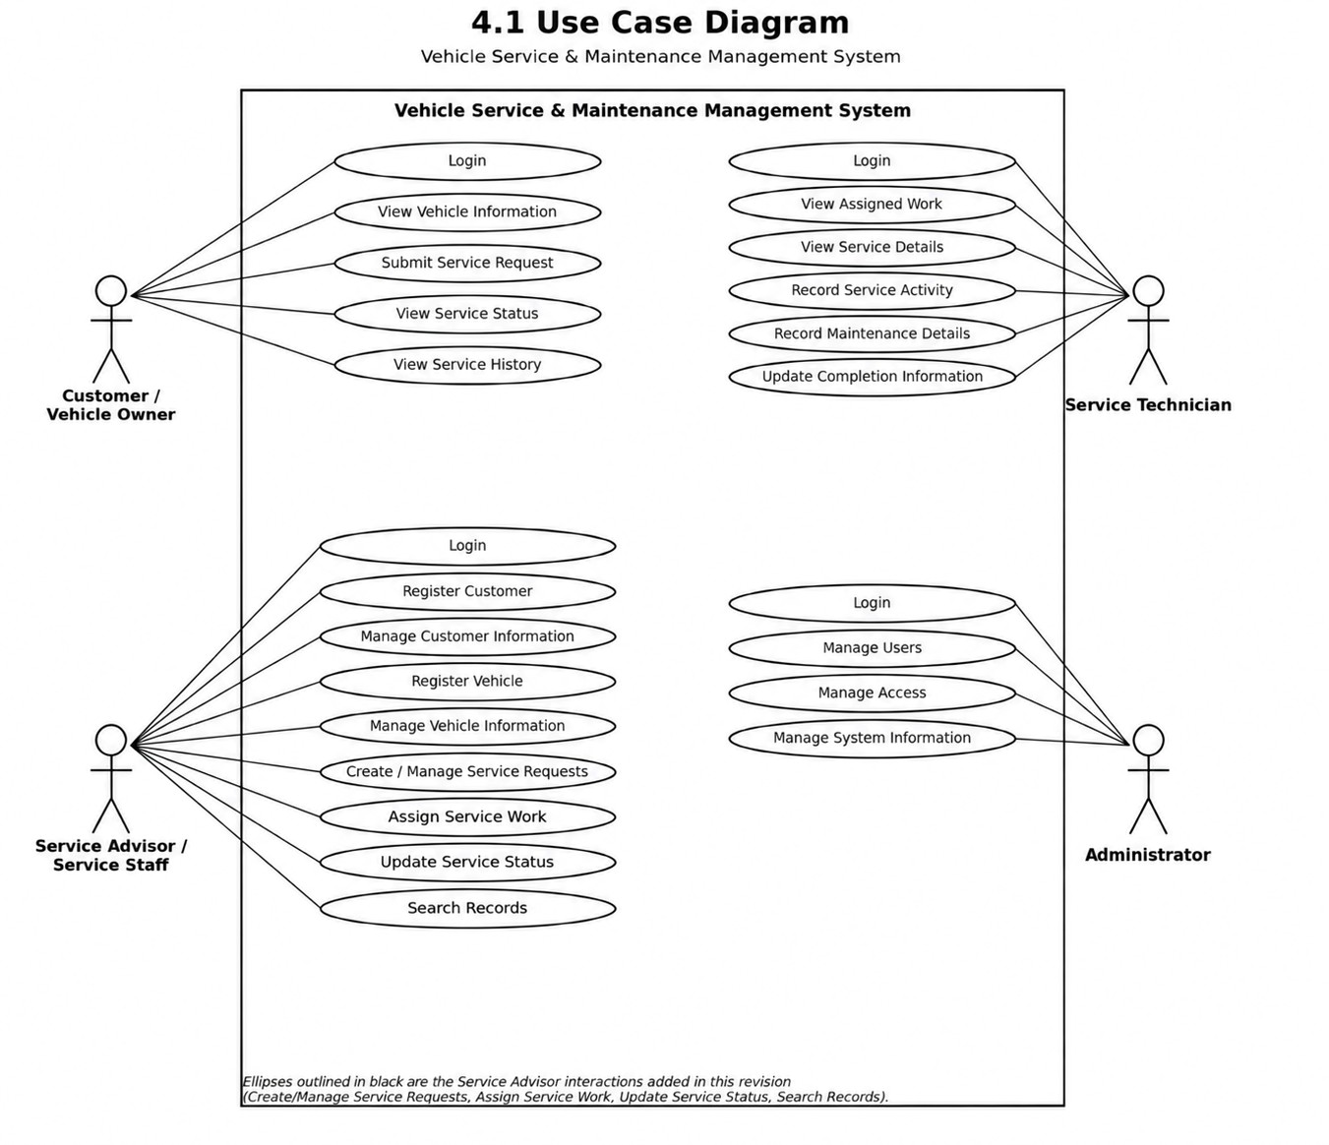

→Use-case catalogue:
ID | Use case | Primary actor | Brief description | Related  requiremen  t
UC-01 | Login | All actors | Authenticate to access role-specific functions. | FR-006
UC-02 | Register Customer | Service Advisor | Create a new customer record. | FR-001
UC-03 | Manage Customer Information | Service Advisor | Edit or deactivate a customer record. | FR-001
UC-04 | Register Vehicle | Service Advisor | Associate a vehicle with a customer. | FR-001
UC-05 | Manage Vehicle Information | Service Advisor | Edit a vehicle’s details. | FR-001
UC-06 | View Vehicle Information | Customer | View details of an owned vehicle. | FR-001
UC-07 | Submit Service Request | Customer | Describe the work needed and submit a request. | FR-002
UC-08 | Create / Manage Service Requests | Service Advisor | Create a request on a customer’s behalf, or edit/withdraw one. | FR-002
UC-09 | Review Request | (part of UC-08) | Review a submitted request for completeness and validity. | FR-002
UC-10 | Assign Service Work | Service Advisor | Assign a validated request to a technician. | FR-003
UC-11 | View Assigned Work | Service Technician | View the list of requests assigned to the technician. | FR-003
UC-12 | View Service Details | Service Technician | View the full detail of an assigned request. | FR-003
UC-13 | Record Service Activity | Service Technician | Log the work carried out during the service. | FR-004
UC-14 | Record Maintenance Details | Service Technician | Log parts, consumables and maintenance notes. | FR-004
UC-15 | Update Completion Information | Service Technician | Mark the service complete with closing notes. | FR-004
UC-16 | Update Service Status | Service Advisor | Change the status of a request as it progresses. | FR-005
UC-17 | View Service Status | Customer | Check the current status of a request. | FR-005
UC-18 | View Service History | Customer | View the full service history of a vehicle. | FR-005
UC-19 | Search Records | Service Advisor, Administrator | Search customers, vehicles and requests by criteria. | FR-005
UC-20 | Manage Users | Administrator | Create, edit or deactivate user accounts. | FR-006
UC-21 | Manage Access | Administrator | Assign or change roles and permissions. | FR-006
UC-22 | Manage System Information | Administrator | Configure system-wide settings. | FR-006

  - Use-Case Flow Specification: UC-08 Create / Manage Service Requests (Review and Validation):
Use-case ID / name | UC-08 Create / Manage Service Requests (Review and Validate)
Primary actor | Service Advisor / Service Staff
Secondary actors | Customer; Service Technician (receives the assignment once validated)
Description | A service advisor reviews a submitted service request, checks that the customer and vehicle details are complete and the vehicle is registered, and either validates it (so it can be assigned, UC-10) or rejects it with a reason.
Preconditions | - The advisor is logged in.  - A service request exists with status Submitted/Pending.  - The request references a registered customer and vehicle.
Postconditions  (success) | - The request status becomes Validated and is visible on the "Ready to assign" list.  - The customer is notified that the request has been accepted.
Postconditions (failure) | The request status becomes Rejected, no work is assigned, and the customer is notified with the rejection reason.
Main success scenario | - The advisor opens the list of Submitted service requests.  - The advisor selects a request and opens "Review Request".  - The system displays the request details together with the referenced customer and vehicle records.  - The advisor checks that the request is complete (service type, description, vehicle reference) and that the vehicle is registered.  - The system evaluates "Request Valid?": the request has all mandatory fields and a registered vehicle, so the check passes.  - The advisor confirms validation; the system sets the request status to Validated.  - The system makes the request available on the "Assign Service Work" screen (UC-10) and notifies the customer. The use case ends.
Alternate flow A1:  request invalid (at step  5) | 5a. The check fails -- for example a mandatory field is missing or the vehicle is not registered.  5b. The system displays an error message explaining why the request is invalid ("Display Error Message", matching the "No" branch of the Request Valid? decision in the activity diagram, Section 4.3).  5c. The advisor either corrects the request and resubmits it for review (returns to step 2, matching the activity diagram’s loop back to "Create Service Request"), or rejects it outright with a reason, which ends the use case.
Related requirements | FR-001, FR-002, FR-003

  - Activity Diagram:
The activity diagram traces the end-to-end workflow from vehicle intake to closing out a service, including the validation decision described in Section 4.2.
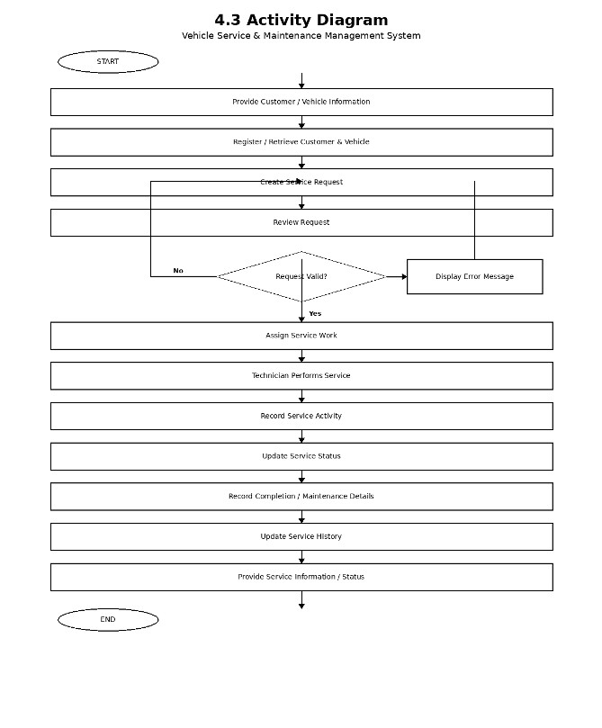
Workflow (matching the decision shown in the diagram):
1.Start.
2.Provide Customer / Vehicle Information.
3.Register / Retrieve Customer & Vehicle.
4.Create Service Request.
5.Review Request.
6.Decision -- "Request Valid?"
7.If No: Display Error Message, then loop back to Create Service Request so the request can be corrected and resubmitted.
8.If Yes: continue to Assign Service Work.
9.Technician Performs Service.
10.Record Service Activity.
11.Update Service Status.
12.Record Completion / Maintenance Details.
13.Update Service History.
14.Provide Service Information / Status.
15.End.

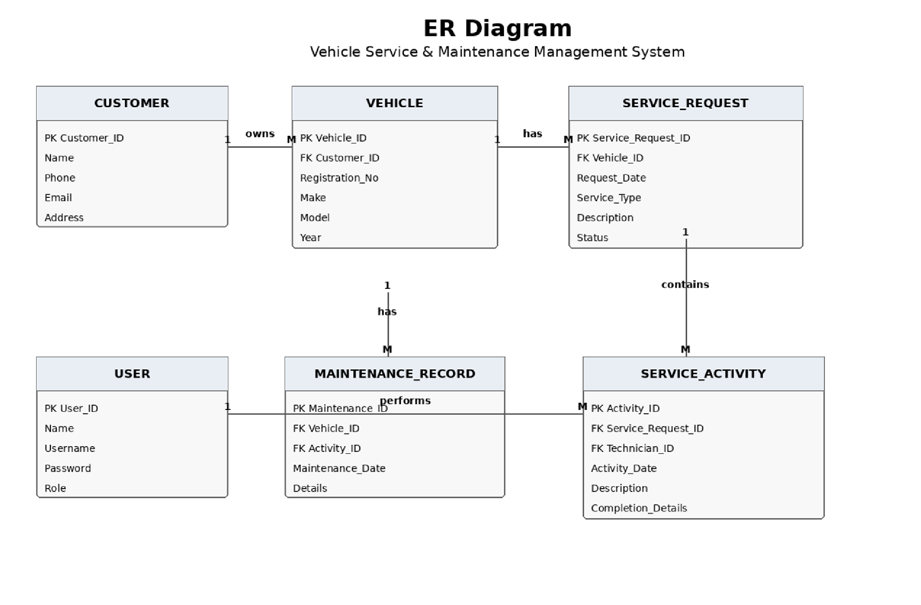
4.4 Entity-Relationship (ER) Diagram:

→Entities and relationships:
Entity | Key attributes | Relationship
Customer | Customer_ID (PK), Name, Phone, Email, Address | One Customer owns many Vehicles (1:M "owns").
Vehicle | Vehicle_ID (PK), Customer_ID (FK), Registration_No, Make, Model, Year | One Vehicle has many Service_Requests and many Maintenance_Records (1:M "has", both relationships).
Service_Request | Service_Request_ID (PK), Vehicle_ID (FK),  Request_Date, Service_Type, Description, Status | One Service_Request contains many Service_Activity entries (1:M "contains").
Service_Activity | Activity_ID (PK), Service_Request_ID (FK),  Technician_ID (FK), Activity_Date, Description, Completion_Details | One User (Technician) performs many Service_Activity entries (1:M "performs").
Maintenance_Reco  rd | Maintenance_ID (PK), Vehicle_ID (FK), Activity_ID (FK), Maintenance_Date, Details | Links a Vehicle to the Service_Activity that produced the maintenance entry.
User | User_ID (PK), Name, Username, Password, Role | Represents staff (Service Advisor,  Technician, Administrator) who perform or record activities.

- System Features:

The functional requirements are organised by system feature, that is, by the major services that the product provides. The product has six functional requirements, FR-001 to FR-006, one for each feature below. Each requirement carries a unique identifier, its type, priority, description, Pass/Fail acceptance criteria and rationale. Priorities are High, Medium or Low; the optional component ratings (Benefit, Penalty, Cost, Risk) use a relative scale from 1 (low) to 9 (high).

5.1 Customer and Vehicle Registration:

5.1.1Description and Priority
The Service Advisor registers customers and their vehicles and keeps these records up to date; the Customer can view their own vehicle information. This is the foundation that every service request, assignment and history record builds on.
Priority: High (Benefit 8, Penalty 7, Cost 4, Risk 3)

5.1.2Stimulus/Response Sequences
Stimulus (user action or system event) | System response
Advisor submits a new customer record (name, phone, e-mail, address). | The system validates the mandatory fields and saves the record.
Advisor registers a vehicle against an existing customer (registration number, make, model, year). | The system checks the registration number is unique and saves the vehicle, linked to the customer.
Advisor edits customer or vehicle information. | The system updates the record and keeps a change timestamp.
Customer opens "My Vehicles". | The system shows the vehicles registered to that customer.

- 1.3Functional Requirements:
Requirement ID | FR-001
Type | Functional
Priority | High
Description | The system shall allow a Service Advisor to register and maintain customer records and to register and maintain vehicle records linked to a customer by a unique registration number, and shall allow a Customer to view the vehicles registered to them.
Acceptance Criteria | Pass: A new vehicle with a registration number that already exists is rejected with "Vehicle already registered"; a valid registration creates the vehicle linked to the correct customer, and the customer can see it under "My Vehicles".  Fail: Two vehicles are saved with the same registration number, or a vehicle is created without a linked customer.
Rationale | Every later feature (requests, assignment, history) depends on a correct customer-vehicle record; duplicate or orphaned records would corrupt the whole service history.

5.2 Service Request Intake, Review and Validation:

5.2.1Description and Priority
A Customer or Service Advisor creates a service request for a registered vehicle; the Advisor reviews it for completeness and validity before it can be assigned to a technician. An invalid request is rejected with a clear error message rather than silently dropped. Priority: High (Benefit 9, Penalty 8, Cost 5, Risk 5)

5.2.2Stimulus/Response Sequences
Stimulus (user action or system event) | System response
Customer or Advisor submits a service request (vehicle, service type, description). | The system saves the request with status Submitted and adds it to the advisor’s review list.
Advisor opens "Review Request". | The system shows the request together with the linked customer and vehicle details.
Advisor reviews a complete request for a registered vehicle (the Request Valid? check passes). | The system sets the status to Validated and makes it available for assignment (UC-10).
Advisor reviews a request missing a mandatory field or referencing an unregistered vehicle (the Request Valid? check fails). | The system displays an error message and keeps the request open for correction and resubmission.

5.2.3Functional Requirements
Requirement ID | FR-002
Type | Functional
Priority | High
Description | The system shall allow a Customer or Service Advisor to submit a service request for a registered vehicle, and shall allow a Service Advisor to review each submitted request against a "Request Valid?" check (mandatory fields present and the vehicle is registered). A request that fails the check shall be rejected with a displayed error message and shall remain available to correct and resubmit; a request that passes shall be marked Validated and made available for assignment.
Acceptance Criteria | Pass: A request missing the service type is kept at Submitted status and shows "Display Error Message" with the missing field named; a complete request for a registered vehicle becomes Validated and appears on the "Assign Service Work" list.  Fail: An incomplete request becomes Validated, or a valid request cannot be found on the assignment list.
Rationale | Validating requests before assignment prevents technicians from starting work on incomplete or unregistered-vehicle requests, which was the gap in the original use-case diagram that this revision closes.

5.3 Service Work Assignment:

5.3.1Description and Priority
The Service Advisor assigns a Validated service request to an available Service Technician, who can then see it on their assigned-work list. Priority: High (Benefit 8, Penalty 7, Cost 4, Risk 4)

5.3.2Stimulus/Response Sequences
Stimulus (user action or system event) | System response
Advisor opens "Assign Service Work" and selects a Validated request and a technician. | The system sets the request status to Assigned, links the technician and notifies them.
Technician opens "My Assigned Work". | The system lists all requests currently assigned to that technician, most recent first.
Technician opens a specific assigned request. | The system shows the full service details (UC-12).

5.3.3Functional Requirements
Requirement ID | FR-003
Type | Functional
Priority | High
Description | The system shall allow a Service Advisor to assign a Validated service request to a Service Technician, and shall allow that Technician to view the request on an "assigned work" list and open its full details.
Acceptance Criteria | Pass: After assignment, the request appears on the named technician’s assigned-work list with status Assigned and does not appear on any other technician’s list.  Fail: A request not yet Validated can be assigned, or an assigned request is visible to a technician it was not assigned to.
Rationale | Clear ownership of each job prevents duplicated or missed work and gives the technician exactly the information needed to start.

5.4 Service Execution and Recording:

5.4.1Description and Priority
The assigned Service Technician performs the service and records what was done: the service activity, maintenance details (parts/consumables and notes) and finally the completion information that closes out the job.
Priority: High (Benefit 9, Penalty 7, Cost 5, Risk 4)

5.4.2Stimulus/Response Sequences
Stimulus (user action or system event) | System response
Technician records service activity performed against an assigned request. | The system saves the activity entry with a timestamp and technician reference.
Technician records maintenance details (parts used, notes) for the vehicle. | The system saves a maintenance record linked to the vehicle and the activity.
Technician marks the request complete with completion details. | The system sets the request status to Completed and locks further edits to the activity/maintenance entries.

5.4.3Functional Requirements
Requirement ID | FR-004
Type | Functional
Priority | High
Description | The system shall allow the assigned Service Technician to record one or more service-activity entries and maintenance-record entries against an Assigned request, and to mark the request Completed with completion information. Entries shall be attributable to the recording technician and shall not be editable after the request is marked Completed.
Acceptance Criteria | Pass: A completed request shows its service activity, maintenance details and completion notes, each timestamped and attributed to the technician; attempting to edit an entry after completion is rejected.  Fail: An activity or maintenance entry is saved without a technician reference, or can still be edited after the request is Completed.
Rationale | An accurate, tamper-evident service record is the core value of the system for warranty, resale and dispute-resolution purposes.

5.5 Service Status Tracking, History and Search:

5.5.1Description and Priority
As a request moves through Submitted, Validated, Assigned and Completed, the Service Advisor updates its status; the Customer can check current status and the full service history of a vehicle; staff can search across customers, vehicles and requests.
Priority: High (Benefit 8, Penalty 6, Cost 4, Risk 3)
5.5.2Stimulus/Response Sequences:
Stimulus (user action or system event) | System response
Request status changes (validated, assigned, completed, etc.). | The system updates the status and timestamps the transition.
Customer opens "View Service Status" for a request. | The system shows the current status and the date of the last update.
Customer opens "View Service History" for a vehicle. | The system lists all past service requests for that vehicle with their outcomes.
Advisor or Administrator searches by customer name, registration number or request status. | The system returns matching customers, vehicles or requests.

5.5.3Functional Requirements
Requirement ID | FR-005
Type | Functional
Priority | High
Description | The system shall track and display the status of every service request through its lifecycle (Submitted, Validated, Assigned, Completed, Rejected), shall let a Customer view the current status and the full service history of their vehicle, and shall let a Service Advisor or Administrator search customers, vehicles and service requests by name, registration number or status.
Acceptance Criteria | Pass: A status change is reflected immediately in "View Service Status"; "View Service History" lists every past request for a vehicle in date order; a search by registration number returns the correct vehicle and its requests.  Fail: A status update is not reflected, a completed request is missing from the vehicle’s history, or a search misses a matching record.
Rationale | Visibility of status and history is the main customer-facing value of the system, and search is what lets staff manage daily workload across many vehicles.

5.6 User and Access Administration:

5.6.1Description and Priority
An Administrator manages user accounts, roles/access and system-wide configuration, so that only the right people can perform the right actions. Priority: Medium (Benefit 6, Penalty 6, Cost 3, Risk 4)

5.6.2Stimulus/Response Sequences
Stimulus (user action or system event) | System response
Administrator creates a user account and assigns a role (Customer, Service Advisor, Technician,  Administrator). | The system creates the account and restricts the user’s functions to that role.
Administrator deactivates a user. | The system blocks that user’s login while keeping their historical records intact.
Administrator changes a system configuration setting. | The system applies and logs the change.

5.6.3Functional Requirements
Requirement ID | FR-006
Type | Functional
Priority | Medium
Description | The system shall allow an Administrator to create, edit and deactivate user accounts, assign roles that determine which functions a user can access, and configure system-wide settings. Role changes shall take effect on the user’s next action.
Acceptance Criteria | Pass: A user assigned the Technician role cannot access "Assign Service Work" (an Advisor-only function); a deactivated user cannot log in but their past records remain visible to staff.  Fail: A user can perform an action outside their assigned role, or deactivating a user deletes their historical records.
Rationale | Role-based access keeps the validation -> assignment -> recording workflow trustworthy by ensuring each step can only be performed by the actor responsible for it.

- Other Nonfunctional Requirements:
The product has two formally numbered non-functional requirements, NFR-001 (Section 6.1) and NFR-002 (Section 6.3). Sections 6.2, 6.4 and 6.5 give supporting explanations, design goals and business rules that elaborate these two requirements; they are not additional numbered requirements.

  - Performance Requirements:
Requirement ID | NFR-001
Type | Performance
Priority | High
Description | Under a load of 50 concurrent users, at least 95% of search, status-lookup and request-review requests shall be answered within 2 seconds, and 99% within 5 seconds.
Acceptance Criteria | Pass: A 15-minute load test with 50 virtual users shows a 95th-percentile response time of 2 seconds or less and an error rate below 1%.  Fail: The 95th-percentile response time exceeds 2 seconds, or the error rate is 1% or higher.
Rationale | Advisors and technicians use search and status screens continuously through the working day; slow responses directly slow down the workshop.

  - Safety Requirements:
The product does not control physical equipment, so there is no risk of physical injury from its operation. The safety concerns relate to data integrity and to protecting the service record from being altered after the fact.
    - Service activity, maintenance and completion entries shall not be editable once a request is marked Completed (see FR-004).
    - Every status change and record edit shall be timestamped and attributed to the user who made it.
    - No external safety certification is required for release 1.0.

  - Security Requirements:
Requirement ID | NFR-002
Type | Security
Priority | High
Description | The system shall protect user and customer data: all communication shall use TLS 1.2 or higher; passwords shall be stored only as salted hashes using an adaptive algorithm (bcrypt or Argon2); role-based access control shall ensure a user can only perform the functions permitted for their role (Customer, Service Advisor, Technician,  Administrator); and every status change or record edit shall be written to an audit log.
Acceptance Criteria | Pass: A TLS scan shows that no protocol below TLS 1.2 is accepted; no password is stored in readable form; a Customer account attempting to open "Assign Service Work" receives an "access denied" (HTTP 403) response.  Fail: Any plaintext password, or any user performing an action outside their assigned role.
Rationale | The service record is the product’s core asset; a single integrity or access-control failure would undermine trust in the whole system.

  - Software Quality Attributes:
The table lists the additional quality attributes and their targets, in order of relative preference.
# | Attribute | Target (specific and verifiable) | Priority
1 | Correctness / Reliability | Status and history always reflect the latest recorded activity; no completed entry can be silently changed. | Highest
2 | Security | As specified in NFR-002 and Section 6.3. | Highest
3 | Usability | A first-time advisor can register a customer and vehicle and create a request in under 3 minutes without help. | High
4 | Performance | 95% of key requests within 2 seconds at 50 concurrent users (NFR-001). | High
5 | Maintainability and testability | Modular services; every requirement traceable to a test case (Appendix C). | Medium
6 | Portability | Runs on any Linux host and works in the four supported browsers. | Medium
7 | Recoverability | Daily backups; target recovery point of 24 hours. | Medium

  - Business Rules:
The following operating principles govern who may do what and under which conditions. They are not functional requirements in themselves but imply functions that enforce them.
ID | Business rule | Enforced by
BR-1 | A vehicle must be registered to a customer before a service request can reference it. | FR-001, FR-002
BR-2 | A service request must be Validated by a Service Advisor before it can be assigned to a technician. | FR-002, FR-003
BR-3 | An invalid request is never silently dropped: it is either corrected and resubmitted, or explicitly rejected with a reason. | FR-002
ID | Business rule | Enforced by
BR-4 | Only the technician a request is assigned to may record activity, maintenance details or completion for it. | FR-003, FR-004
BR-5 | Once a request is Completed, its activity and maintenance entries are read-only. | FR-004
BR-6 | Only Administrators can create accounts, assign roles or change system configuration. | FR-006

- Other Requirements:

    - Database requirements: relational schema normalised to at least third normal form; foreign keys between customers, vehicles, service requests, service activity and maintenance records; automated daily backups.
    - Internationalisation: English user interface in release 1.0; all texts stored in resource files; UTF-8 everywhere.
    - Legal requirements: compliance with the Digital Personal Data Protection Act, 2023 [8] for customer personal data (consent, access, correction).
    - Accessibility: WCAG 2.1 Level AA.
    - Documentation: a quick-start guide for advisors and technicians and an administrator guide shall be delivered with the release.

Appendix A: Glossary
The following terms, acronyms and abbreviations are used in this SRS.
Term | Definition
Customer / Vehicle Owner | A registered person who owns one or more vehicles serviced by the centre.
Service Advisor / Service Staff | Front-of-house staff who register customers and vehicles, and review, validate, assign and track service requests.
Service Technician | Workshop staff who perform the service and record activity, maintenance details and completion information.
Administrator | A privileged user who manages user accounts, roles and system configuration.
Service request | A record describing work a customer wants done on a vehicle. Statuses: Submitted, Validated, Assigned, Completed, Rejected.
Request Valid? | The validation check performed during review: the request has all mandatory fields and references a registered vehicle.
Service activity | A logged entry describing work actually carried out during a service, attributed to the technician and timestamped.
Maintenance record | A logged entry of parts, consumables and maintenance notes linked to a vehicle and a service activity.
Completion information | The closing notes a technician enters when a service request is marked Completed.
Role-based access control  (RBAC) | Restricting which functions a user can perform based on their assigned role.
ACID | Atomicity, Consistency, Isolation, Durability: the properties of a reliable database transaction.
API | Application Programming Interface.
DPDP Act | The Digital Personal Data Protection Act, 2023 of India.
FR / NFR | Functional Requirement / Non-Functional Requirement.
HTTP / HTTPS | Hypertext Transfer Protocol / its secure variant over TLS.
JSON | JavaScript Object Notation, a text format for data exchange.
REST | Representational State Transfer, an architectural style for web APIs.
SRS | Software Requirements Specification.
TLS | Transport Layer Security, the protocol that encrypts web traffic.
UC | Use Case.
UI / UX | User Interface / User Experience.
UML | Unified Modeling Language.
VSMMS | Vehicle Service & Maintenance Management System (this product).
WCAG | Web Content Accessibility Guidelines.
TBD | To Be Determined.

Appendix B: Field Layouts
An Excel sheet containing field layouts and properties/attributes and report requirements. The sheets below list the fields of the main data records, matching the entities in the ER diagram (Section 4.4). Length is the maximum number of characters (or digits); data types are String, Alphanumeric, Numeric, Date and DateTime.
Sheet 1: Customer
Field | Length | Data Type | Description | Is Mandatory
Customer_ID | 10 | Alphanumeric | System-generated unique customer identifier | Y
Name | 60 | String | Customer full name | Y
Phone | 15 | Alphanumeric | Contact phone number | Y
Email | 100 | String | Contact e-mail address | N
Address | 200 | String | Postal address | N

Sheet 2: Vehicle
Field | Length | Data Type | Description | Is Mandatory
Vehicle_ID | 10 | Alphanumeric | System-generated unique vehicle identifier | Y
Customer_ID | 10 | Alphanumeric | Owning customer (foreign key) | Y
Registration_No | 15 | Alphanumeric | Vehicle registration / licence-plate number; must be unique | Y
Make | 40 | String | Vehicle manufacturer | Y
Model | 40 | String | Vehicle model | Y
Year | 4 | Numeric | Manufacturing year | Y

Sheet 3: Service_Request
Field | Length | Data Type | Description | Is Mandatory
Service_Request_ID | 10 | Alphanumeric | System-generated unique request identifier | Y
Vehicle_ID | 10 | Alphanumeric | Vehicle the request concerns (foreign key) | Y
Request_Date | 8 | Date | Date the request was submitted | Y
Service_Type | 40 | String | Type of service requested, e.g. Oil Change, Brake Repair | Y
Description | 500 | String | Description of the problem or work requested | Y
Status | 15 | Alphanumeric | Submitted / Validated / Assigned / Completed / Rejected | Y

Sheet 4: Service_Activity
Field | Length | Data Type | Description | Is Mandatory
Activity_ID | 10 | Alphanumeric | System-generated unique activity identifier | Y
Service_Request_ID | 10 | Alphanumeric | Request this activity belongs to (foreign key) | Y
Technician_ID | 10 | Alphanumeric | Technician who performed the activity (foreign key to User) | Y
Activity_Date | 8 | Date | Date the activity was performed | Y
Description | 500 | String | Description of the work carried out | Y
Field | Length | Data Type | Description | Is Mandatory
Completion_Details | 500 | String | Closing notes recorded when the request is marked Completed | N

Sheet 5: Maintenance_Record
Field | Length | Data Type | Description | Is Mandatory
Maintenance_ID | 10 | Alphanumeric | System-generated unique maintenance-record identifier | Y
Vehicle_ID | 10 | Alphanumeric | Vehicle the maintenance was performed on (foreign key) | Y
Activity_ID | 10 | Alphanumeric | Service activity that produced this record (foreign key) | Y
Maintenance_Date | 8 | Date | Date of the maintenance entry | Y
Details | 500 | String | Parts used, consumables and maintenance notes | Y

Sheet 6: User
Field | Length | Data Type | Description | Is Mandatory
User_ID | 10 | Alphanumeric | System-generated unique user identifier | Y
Name | 60 | String | User full name | Y
Username | 40 | Alphanumeric | Login username | Y
Password | 60 | Alphanumeric | Salted hash of the password; never stored in readable form | Y
Role | 20 | Alphanumeric | Customer / Service Advisor / Service Technician / Administrator | Y

Report Requirements: fields to be included in each report
Service Request Report | Technician Activity Report
Service_Request_ID  Vehicle Registration_No  Customer Name Service_Type  Request_Date  Status  Assigned Technician  Completion Date  Remarks | Technician Name  Service_Request_ID  Vehicle Registration_No  Activity_Date  Description  Maintenance Details  Completion_Details  Status

Appendix C: Requirement Traceability Matrix
Sl. No | Requirement ID | Brief Description of Requirement | Architecture Reference | Design  Reference | Code  File Referenc e | Test Case ID | System Test Case  ID
1 | FR-001 | Register and maintain customer and vehicle records | Customer &  Vehicle  Registry | Class:  Customer, Vehicle; Seq:  Register Vehicle | TBD | TC-FR001-0  1 to 03 | ST-001
2 | FR-002 | Submit, review and validate service requests (Request Valid? decision) | Service Request Service | Class:  Service_Reques t; Seq: Review  Request; Activity diagram Fig. 4.2 | TBD | TC-FR002-0  1 to 04 | ST-002
3 | FR-003 | Assign validated requests to technicians; view assigned work | Work Assignment  Service | Class:  Service_Reques t, User; Seq:  Assign Service  Work | TBD | TC-FR003-0  1 to 03 | ST-003
4 | FR-004 | Record service activity, maintenance details and completion | Service  Execution &  Recording Service | Class:  Service_Activit  y,  Maintenance_R ecord; Seq:  Record Service  Activity | TBD | TC-FR004-0  1 to 03 | ST-004
5 | FR-005 | Track status, view history, search records | Status &  History Service | Class:  Service_Reques t; Seq: Update Service Status,  Search Records | TBD | TC-FR005-0  1 to 03 | ST-005
6 | FR-006 | Manage users, roles/access and system configuration | User & Access  Administration  Service | Class: User;  Component:  Auth, RBAC | TBD | TC-FR006-0  1 to 02 | ST-006
7 | NFR-001 | 95% of key requests within 2 s at 50 concurrent users | Web Client; all services | Performance test plan | TBD | TC-NFR001 -01 | ST-007
8 | NFR-002 | TLS 1.2+, hashed passwords, RBAC, audit log | Security layer; Database | Component:  Auth, AuditLog | TBD | TC-NFR002  -01 to 03 | ST-008

