Vehicle Servicing Application

Technical Documentation

1. Login Activity Diagram of Vehicle Service Management System

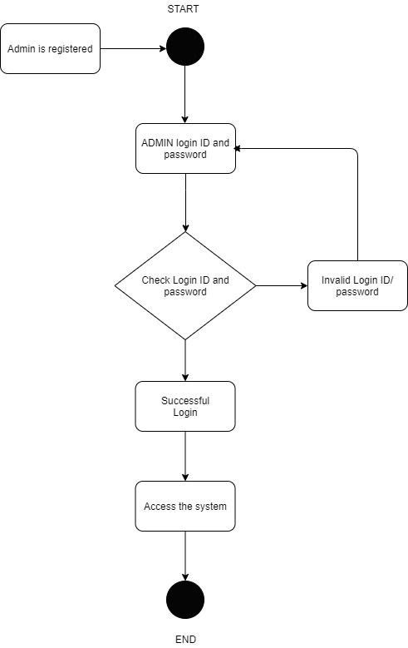

2. Login Sequence Diagram of Vehicle Service Center Management System

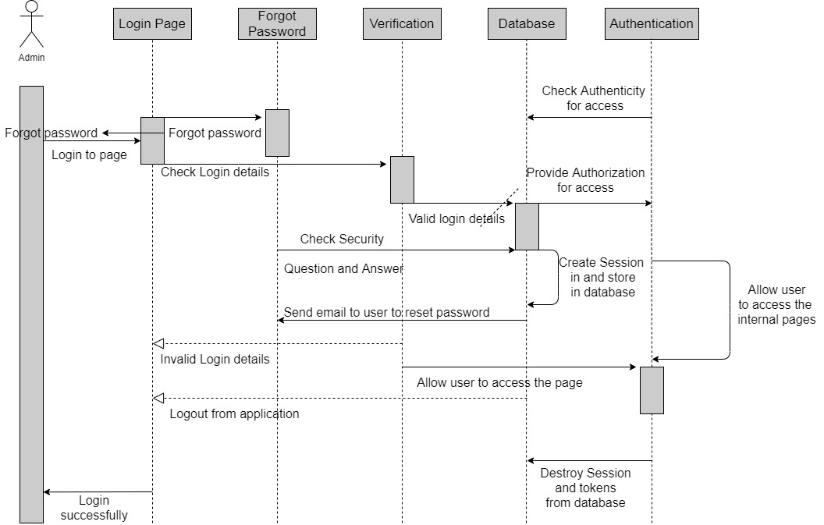

3. Zero Level DFD

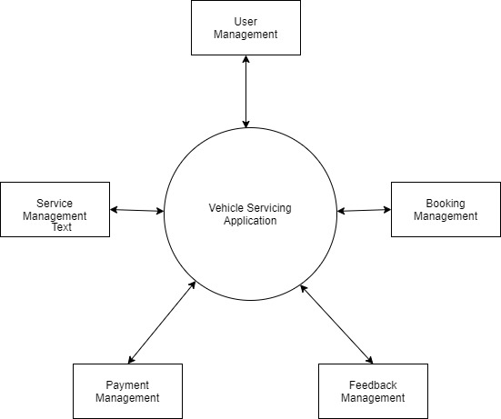

4. First Level DFD:

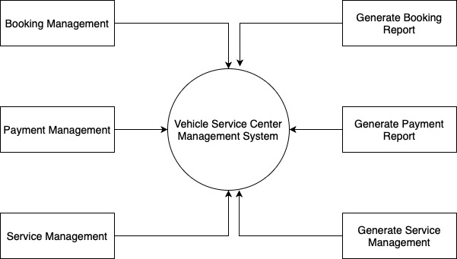

5. Second Level DFD:

