https://github.com/Vehnem/dbpedia-release-notes

Release date (15 July)

Channels:
Release notes in collection??
Spread HTML via:
- List of mailing lists
- Newsletter
- Website
Teaser:
- Twitter
- Forum
- Blog
- LinkedIn

Producing:
- Export to odt, then export to html (to get clean HTML)
- Insert layout, images and dynamic part programmatically

Overview EN DBpedia (Brand name tiny diamond)

The DBpedia latest core is the refurbished equivalent of the "core" folder used for previous releases before 2020 (e.g. http://downloads.dbpedia.org/2016-10/core/). It contains a small but useful subset of datasets from the DBpedia Extractions. Moreover this subset is loaded to the DBpedia Main SPARQL endpoint. With the help of Databus Latest-Core Collection it is quite easy to fetch a fresh custom-tailored selection of DBpedia files for a specific use case (e.g. a custom list of languages).

https://databus.dbpedia.org/dbpedia/collections/tiny-diamond-2021-06

consisting of ###CLASS_Person### persons, ###CLASS_Place### places (including ###CLASS_PopulatedPlace### populated places), ###CLASS_Work### works (including ###CLASS_Album### music albums, ###CLASS_Movie### films and TODO video games), ###CLASS_Organisation### organizations (including ###CLASS_Company### companies and TODO educational institutions), ###CLASS_Species### species, ###CLASS_Plant### plants and ###CLASS_Disease### diseases.

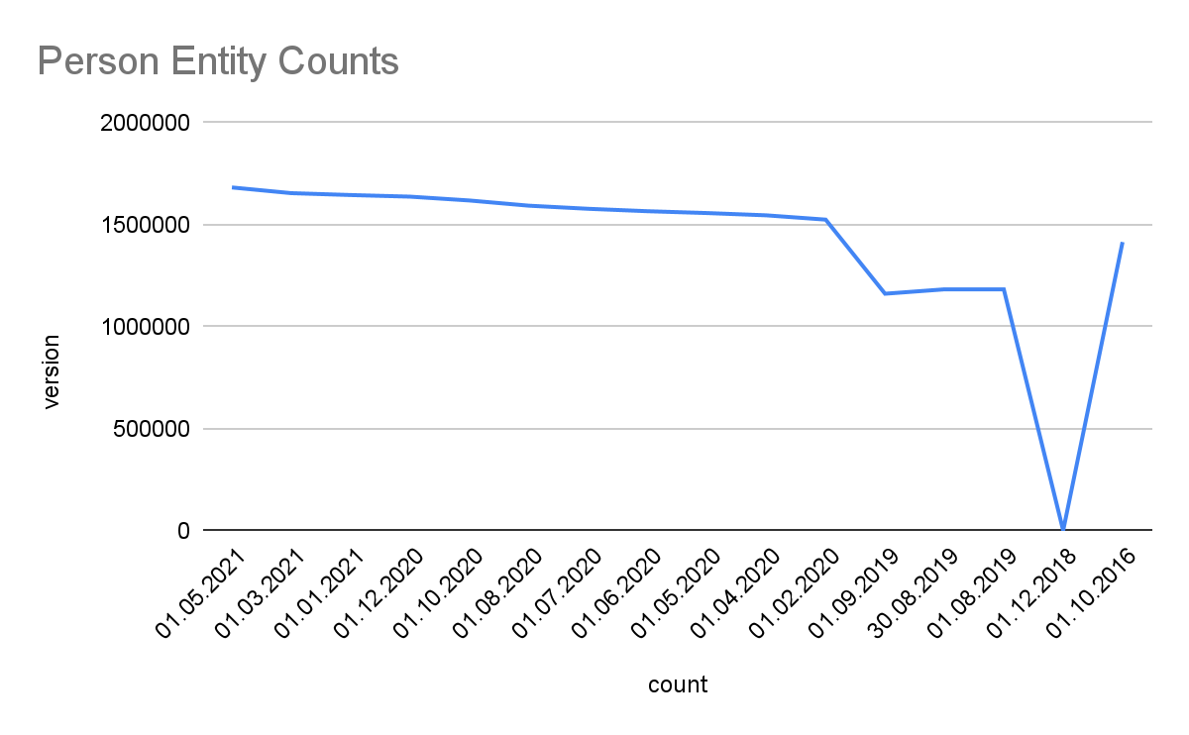
###CLASS

----------------------
?TODO? Property stats (how many props/dbo), total triple count

Look at the complete history since 2016 per class:
TODO Dropdown menu

Download via Collection

Multilingual

Wikidata

DBpedia Global

Archivo
- New ontologies w.r.t last release

Global.dbpedia.org

