24CYS401 – SECURE SOFTWARE ENGINEERING
END SEMESTER LABORATORY EXAMINATION

Phase 1 – Agile Process and Development Approach

Selection of Agile Approach
Chosen Approach: Scrum with XP (Extreme Programming) Engineering Practices
Why Scrum?
- Security requirements evolve rapidly (new CVEs, new attack vectors, new ecosystems) → Scrum's iterative, backlog-driven model adapts well.
- Security-critical systems benefit from short feedback loops (2-week sprints) so threats are detected and fixed early.
- Enables incremental delivery: Sprint 1 ships project registry + dependency recorder; Sprint 2 ships scanning + risk reports; etc.
Why XP practices layered on Scrum?
XP contributes the engineering discipline that Scrum alone lacks — critical for security:
XP Practice | Security Benefit for SSCSP
Test-Driven Development (TDD) | Vulnerability-matching logic is verified before code is written
Pair Programming | Two sets of eyes on cryptographic/signing code
Continuous Integration | Every commit scanned by SAST + dependency scanner
Refactoring | Keeps security logic clean, auditable, maintainable
Simple Design | Reduces attack surface — no speculative features
Collective Code Ownership | No single point of failure in security knowledge
Coding Standards | Consistent secure-coding patterns (no hard-coded secrets)

Justification Summary: SSCSP is both security-critical and evolution-driven (CVE feeds update daily). Scrum provides the adaptive planning cadence; XP provides the engineering rigor. Together they satisfy the exam's requirement for a "complete secure software model and development workflow."

Mapping of Agile Manifesto Principles to SSCSP
# | Agile Manifesto Principle | Application to SSCSP
1 | Working software over comprehensive documentation | Ship a functional scanner for one ecosystem (npm) in Sprint 1 before writing detailed specs for all 5 ecosystems. Documentation (SBOM schema, API contracts) is kept lightweight and auto-generated where possible.
2 | Welcome changing requirements, even late in development | New CVE feeds (e.g., a newly published GitHub Advisory) and new package ecosystems (e.g., adding Cargo support) are added to the backlog at any sprint boundary without disrupting the release plan.
3 | Deliver working software frequently | Bi-weekly releases: each sprint produces a deployable increment — Sprint 1: registry + dependency graph; Sprint 2: scanner + risk report; Sprint 3: artifact signing + remediation tracker.
4 | Business people and developers must work together daily | Security analysts sit in on daily scrums and refinement sessions to prioritize high-CVSS findings and validate exploitability. Stakeholders triage findings jointly with developers.
5 | Continuous attention to technical excellence enhances agility | Every sprint includes a refactoring task (e.g., deduplicating scanner logic) and enforces SAST/DAST gates in CI. Technical debt is tracked as backlog items, not ignored.

Refactoring Opportunities (Before / After)
Refactoring 1: Duplicate Vulnerability-Matching Logic
Problem: Scanner logic is duplicated per ecosystem, violating DRY and increasing the risk that a fix in one ecosystem is missed in another.
Before:
def check_npm(dep, cves):
for cve in cves:
if cve.package == dep.name and cve.version == dep.version:
return cve
return None

def check_pypi(dep, cves):
for cve in cves:
if cve.package == dep.name and cve.version == dep.version:
return cve
return None

def check_maven(dep, cves):
for cve in cves:
if cve.package == dep.name and cve.version == dep.version:
return cve
return None

After (Unified + version-range aware):
from packaging.specifiers import SpecifierSet

def check_dependency(dep, cves):
"""Single source of truth for CVE matching across all ecosystems."""
for cve in cves:
if cve.package != dep.name:
continue
if dep.version in SpecifierSet(cve.version_range):
return cve
return None

Improvement:
- Maintainability: One function to fix/extend instead of N.
- Security: Adding a new ecosystem (Go, Cargo) now only requires registering its PURL parser — no duplication of matching logic.
- Correctness: Adds version-range matching (semver), catching transitive-version vulnerabilities missed by the naive equality check.

Refactoring 2: Hard-Coded Severity Thresholds
Problem: The CVSS threshold that blocks a build is hard-coded, meaning any change requires a code edit + redeploy — error-prone and unauditable.
Before:
def evaluate_build(findings):
for f in findings:
if f.cvss > 7.0: # magic number, hard-coded
return "BLOCK"
return "ALLOW"

After (Configuration-driven + policy-as-code):
import os

BLOCK_THRESHOLD = float(os.getenv("BLOCK_CVSS", "7.0"))

def evaluate_build(findings, policy=None):
policy = policy or {"block_cvss": BLOCK_THRESHOLD}
for f in findings:
if f.cvss > policy["block_cvss"]:
return {"decision": "BLOCK", "reason": f"CVSS {f.cvss} > {policy['block_cvss']}"}
return {"decision": "ALLOW"}

Improvement:
- Security: Threshold changes are now auditable (env var / config map / OPA policy) and can be reviewed through the change-management process.
- Testability: Policy can be injected in unit tests (evaluate_build(findings, {"block_cvss": 5.0})).
- Operability: Different environments (dev/staging/prod) can use different thresholds without code changes.

Limitations / Risks of Agile for This Security-Critical System + Mitigations
# | Limitation / Risk | Why It Matters for SSCSP
1 | Security work deprioritized under feature pressure — Sprints reward shippable features; security hardening is often deferred to "next sprint." | For a supply-chain security platform, deferring a signature-verification fix means vulnerable artifacts could ship.
2 | Fast iterations may skip threat modeling — Rapid sprint cycles can encourage "code now, threat-model later," leaving architectural risks undiscovered until late. | Threat modeling is most effective before code is written; skipping it means rework and possible latent vulnerabilities in the build/scan pipeline itself.

Phase 2 - Stakeholders and User Types

Stakeholders and User Types
Stakeholder | Type | Interest / Concern | Influence
Developer | Primary user | Register projects, fix vulnerable dependencies, keep builds green | High
Security Analyst | Primary user | Triage findings, assign remediation, sign off on risk | High
Administrator | Primary user | Manage users, RBAC, policy configuration, audit review | High
CI/CD System | Automated actor | Push builds, trigger scans, request artifact signing | High
Auditor / Compliance Officer | Secondary user (justified) | Read-only access to reports, SBOMs, and audit logs | Medium
CISO / Security Manager | Sponsor | Overall supply-chain risk posture | High
Upstream Maintainers / Vendors | External | Fix upstream CVEs, publish advisories | Low
End Customer / Regulator | External | Assurance that shipped software is not compromised | Medium

User Types (Role Summary)
Role | Permissions
Developer | Register project, submit manifest, view own findings, open remediation tickets
Security Analyst | View all findings, triage severity, assign remediation, generate reports
Administrator | Manage users, configure policy, view audit logs, manage integrations
CI/CD System | Push artifact, trigger scan, request signing (service account)
Auditor | Read-only: SBOMs, risk reports, audit logs

Requirements

Functional Requirements (FR)
ID | Requirement | Priority
FR-01 | System shall allow a Developer to register a project with metadata (name, owner, repo URL, criticality). | High
FR-02 | System shall parse dependency manifests (pom.xml, package.json, requirements.txt, go.mod, Cargo.toml) and record direct dependencies. | High
FR-03 | System shall resolve and record transitive dependencies to a configurable depth (default ≥ 2). | High
FR-04 | System shall query vulnerability feeds (OSV, NVD, GitHub Advisory) and match each dependency version against known CVEs. | Critical
FR-05 | System shall detect suspicious packages (typosquatting, dependency confusion, malicious install scripts). | Critical
FR-06 | System shall detect secret leakage (API keys, tokens) in source, manifests, and build logs. | High
FR-07 | System shall generate a risk report with CVSS, EPSS, severity, and remediation suggestion per finding. | High
FR-08 | System shall export an SBOM in CycloneDX and SPDX formats. | High
FR-09 | System shall create and track remediation tickets with status (Open → In Progress → Fixed → Verified → Closed). | High
FR-10 | System shall sign build artifacts and verify signatures before deployment. | Critical
FR-11 | System shall maintain an immutable audit log of all actions. | Critical
FR-12 | Administrator shall configure policy (block thresholds, allowlists, SLA by severity). | High
FR-13 | System shall notify users (email/webhook) when new critical findings appear. | Medium

Non-Functional Requirements (NFR)
ID | Requirement | Category | Priority
NFR-01 | Scan of 1,000 dependencies shall complete in ≤ 30 seconds. | Performance | High
NFR-02 | System availability shall be ≥ 99.9% monthly. | Reliability | Medium
NFR-03 | System shall support at least 5 ecosystems (npm, PyPI, Maven, Go, Cargo). | Scalability | High
NFR-04 | System shall scale horizontally to 10,000 concurrent scans/day. | Scalability | Medium
NFR-05 | API response time (P95) shall be ≤ 300 ms for read endpoints. | Performance | Medium
NFR-06 | System shall use TLS 1.3 for all external communications. | Security-related NFR | Critical
NFR-07 | System shall be containerized and deployable on Kubernetes. | Portability | High
NFR-08 | All data at rest shall be encrypted with AES-256. | Security-related NFR | Critical
NFR-09 | System shall be observable via logs, metrics, and traces (OpenTelemetry). | Operability | High
NFR-10 | Recovery Time Objective (RTO) ≤ 1 hour; RPO ≤ 15 minutes. | Disaster Recovery | High

Security Requirements
ID | Requirement | Category | Priority
SR-01 | All human users shall authenticate via SSO + MFA. | Authentication | Critical
SR-02 | CI/CD service accounts shall authenticate using short-lived OIDC tokens (no static keys). | Authentication | Critical
SR-03 | System shall enforce Role-Based Access Control (RBAC) on every API endpoint. | Authorization | Critical
SR-04 | Findings and SBOMs shall be visible only to authorized roles (project-scoped). | Authorization | High
SR-05 | Signing keys shall be stored in an HSM / KMS and never leave the boundary. | Confidentiality | Critical
SR-06 | Artifact signatures shall be verified before any deployment approval. | Integrity | Critical
SR-07 | All actions on projects, findings, and artifacts shall be logged to an append-only, hash-chained audit log. | Audit | Critical
SR-08 | Secrets (API keys, DB passwords) shall never be hard-coded; they shall be fetched from Vault at runtime. | Confidentiality | Critical
SR-09 | All API inputs shall be schema-validated; output shall be encoded to prevent injection. | Integrity | High
SR-10 | Session tokens shall expire within 30 minutes of inactivity; refresh tokens within 8 hours. | Authentication | High
SR-11 | System shall detect and rate-limit brute-force login attempts (> 5/min per user → lockout). | Authentication | High
SR-12 | Deployment gate shall enforce policy-as-code (no unsigned artifact, no critical CVE). | Integrity / Authorization | Critical

CIA / AuthN / AuthZ / Audit Classification

Requirement | C | I | A | AuthN | AuthZ | Audit
FR-01 Project registration | ✓ | ✓ | — | ✓ | ✓ | ✓
FR-02–03 Dependency recording | — | ✓ | — | — | ✓ | ✓
FR-04 CVE matching | — | ✓ | — | — | ✓ | —
FR-05 Malicious package detection | — | ✓ | — | — | ✓ | ✓
FR-06 Secret leakage detection | ✓ | ✓ | — | — | ✓ | ✓
FR-07–08 Risk report / SBOM | ✓ | ✓ | — | — | ✓ | ✓
FR-09 Remediation tracking | — | ✓ | — | — | ✓ | ✓
FR-10 Artifact signing / verification | — | ✓ | ✓ | ✓ | ✓ | ✓
FR-11 Audit log | ✓ | ✓ | ✓ | — | ✓ | ✓
FR-12 Policy configuration | — | ✓ | — | ✓ | ✓ | ✓
SR-01 MFA | ✓ | — | — | ✓ | — | ✓
SR-03 RBAC | — | ✓ | — | — | ✓ | ✓
SR-05 Key protection | ✓ | ✓ | ✓ | — | ✓ | ✓
SR-06 Signature verification | — | ✓ | — | — | ✓ | ✓
SR-07 Audit trail | ✓ | ✓ | ✓ | — | ✓ | ✓
SR-08 Secrets from Vault | ✓ | — | — | — | — | ✓
Requirement | C | I | A | AuthN | AuthZ | Audit
FR-01 Project registration | ✓ | ✓ | — | ✓ | ✓ | ✓
FR-02–03 Dependency recording | — | ✓ | — | — | ✓ | ✓
FR-04 CVE matching | — | ✓ | — | — | ✓ | —
FR-05 Malicious package detection | — | ✓ | — | — | ✓ | ✓
FR-06 Secret leakage detection | ✓ | ✓ | — | — | ✓ | ✓
FR-07–08 Risk report / SBOM | ✓ | ✓ | — | — | ✓ | ✓
FR-09 Remediation tracking | — | ✓ | — | — | ✓ | ✓
FR-10 Artifact signing / verification | — | ✓ | ✓ | ✓ | ✓ | ✓
FR-11 Audit log | ✓ | ✓ | ✓ | — | ✓ | ✓
FR-12 Policy configuration | — | ✓ | — | ✓ | ✓ | ✓
SR-01 MFA | ✓ | — | — | ✓ | — | ✓
SR-03 RBAC | — | ✓ | — | — | ✓ | ✓
SR-05 Key protection | ✓ | ✓ | ✓ | — | ✓ | ✓
SR-06 Signature verification | — | ✓ | — | — | ✓ | ✓
SR-07 Audit trail | ✓ | ✓ | ✓ | — | ✓ | ✓
SR-08 Secrets from Vault | ✓ | — | — | — | — | ✓

Prioritization
Priority | Requirements
Must Have | FR-01, FR-04, FR-05, FR-07, FR-09, FR-10, FR-11; SR-01, SR-03, SR-05, SR-06, SR-07, SR-08, SR-12
Should Have | FR-02, FR-03, FR-06, FR-08, FR-12; NFR-01, NFR-03, NFR-06, NFR-08; SR-02, SR-04, SR-09
Could Have | FR-13; NFR-02, NFR-05, NFR-10; SR-10, SR-11
Won't Have (v1) | Multi-tenant isolation, AI-based zero-day prediction

SRS / Requirements Table (Concise Consolidated Form)
Req ID | Type | Description | Actor / Component | Priority | CIA + A&A | Verification Method
FR-01 | Functional | Register project | Developer | High | AuthN, AuthZ, Audit | Unit + E2E test
FR-02 | Functional | Parse manifests | Dependency Service | High | Integrity | Unit test on 5 formats
FR-03 | Functional | Resolve transitive deps | Dependency Service | High | Integrity | Integration test
FR-04 | Functional | CVE matching | Scanner Service | Critical | Integrity | Test vs OSV sample
FR-05 | Functional | Malicious package detection | Scanner Service | Critical | Integrity, Audit | Seeded typosquat test
FR-06 | Functional | Secret leakage detection | Scanner Service | High | Confidentiality | Gitleaks integration
FR-07 | Functional | Risk report generation | Risk Engine | High | Confidentiality, Integrity | Snapshot test
FR-08 | Functional | SBOM export | Risk Engine | High | Integrity | CycloneDX schema validation
FR-09 | Functional | Remediation ticketing | Remediation Service | High | Integrity, Audit | State-machine test
FR-10 | Functional | Artifact signing | Artifact Service | Critical | Integrity, AuthN | cosign verify test
FR-11 | Functional | Immutable audit log | Audit Service | Critical | C, I, A | Hash-chain verification
FR-12 | Functional | Policy configuration | Administrator | High | AuthZ, Audit | Config unit test
FR-13 | Functional | Notifications | Notification Service | Medium | — | Webhook test
NFR-01 | Performance | 1,000 deps ≤ 30 s | Scanner | High | — | Load test
NFR-03 | Scalability | 5 ecosystems | Dependency Service | High | — | E2E per ecosystem
NFR-06 | Security-NFR | TLS 1.3 | All services | Critical | Confidentiality | TLS scan (testssl.sh)
NFR-08 | Security-NFR | AES-256 at rest | DB / Artifact store | Critical | Confidentiality | Config audit
NFR-09 | Operability | OpenTelemetry | All services | High | — | Instrumentation check
SR-01 | Security | SSO + MFA | API Gateway | Critical | AuthN | Login flow test
SR-02 | Security | OIDC service tokens | API Gateway | Critical | AuthN | Token expiry test
SR-03 | Security | RBAC on all endpoints | API Gateway | Critical | AuthZ | Negative authZ test
SR-05 | Security | HSM-backed keys | Artifact Service | Critical | C, I, A | Key-ceremony audit
SR-06 | Security | Signature verification | Deployment Gate | Critical | Integrity | Negative verify test
SR-07 | Security | Append-only audit log | Audit Service | Critical | C, I, A | Tamper-detection test
SR-08 | Security | Vault-managed secrets | All services | Critical | Confidentiality | Secret-scan test
SR-12 | Security | Policy-as-code gate | Admission Controller | Critical | AuthZ, Integrity | OPA policy test

Phase 3 – Requirements Analysis and UML

UML Use Case Diagram

Actors and Use Case

Actor | Type | Use Cases
Developer | Primary (human) | Register Project, Submit Manifest, View Findings, Fix Dependency, Open Remediation Ticket
Security Analyst | Primary (human) | Triage Vulnerability, Generate Risk Report, Assign Remediation, Close Remediation
Administrator | Primary (human) | Manage Users, Configure Policy, View Audit Log
CI/CD System | Primary (system) | Submit Build, Trigger Scan, Push Artifact, Request Signature
Auditor | Secondary (human) | View SBOM, View Risk Report, Export Audit Log
External Advisory Feed (OSV/NVD) | Supporting system | Provide CVE Data

Relationships
Relationship | From | To | Type | Reason
R1 | Submit Build | Scan Dependencies | «include» | Every build must be scanned
R2 | Push Artifact | Verify Signature | «include» | No artifact is stored unverified
R3 | Generate Risk Report | Export SBOM | «include» | Report always contains SBOM
R4 | Fix Dependency | Re-scan | «extend» | Re-scan is optional after fix
R5 | Triage Vulnerability | Assign Remediation | «extend» | Triage may or may not lead to a ticket
R6 | Register Project | Configure Policy | «extend» | Admin may apply custom policy per project

Use Case Diagram
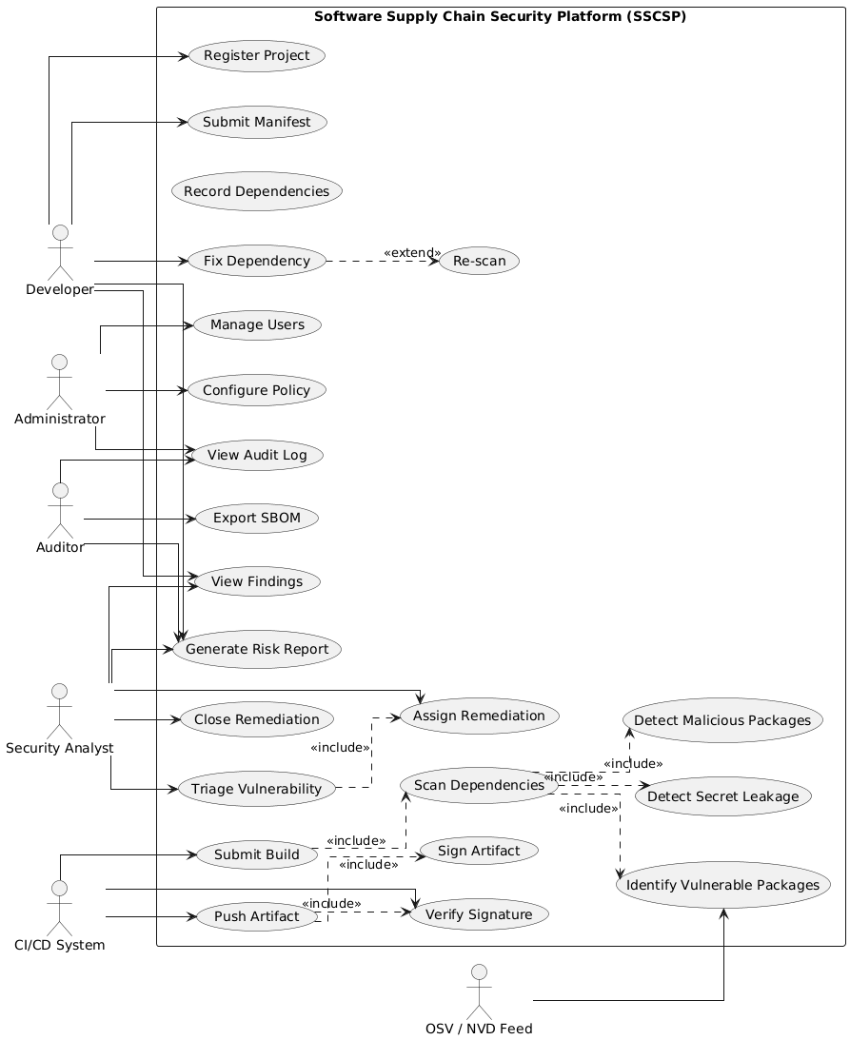

Two Critical Use Case Specifications
- UC-01: Scan Dependencies
Field | Detail
Use Case ID | UC-01
Name | Scan Dependencies
Actor(s) | CI/CD System (primary), Developer (secondary)
Goal | Detect vulnerable or malicious dependencies in a build so the artifact is not published with known risk
Preconditions | 1. Project is registered (FR-01).  2. A valid manifest (or lock file) is available.  3. OSV/NVD feed is reachable or cached.
Trigger | CI/CD system calls POST /scan after a successful build step.
Main Flow | 1. System receives manifest + project ID.  2. System parses manifest and builds a dependency graph (FR-02, FR-03).  3. System normalizes each dependency to a PURL.  4. System queries OSV/NVD for matching advisories (FR-04).  5. System applies version-range matching (semver).  6. System runs typosquatting + dependency-confusion heuristics (FR-05).  7. System runs secret scanner on manifests and build logs (FR-06).  8. System stores findings and computes a risk score (FR-07).  9. System returns a scan result: {risk_score, findings[], decision}.
Alternative Flow A1 | Feed unavailable → system uses cached advisory DB; result is marked STALE and a warning is returned.
Alternative Flow A2 | No advisories found → result is CLEAN with risk score 0.
Exception E1 | Manifest malformed → system rejects with 400 INVALID_MANIFEST; no scan recorded.
Exception E2 | Dependency graph too deep (> configured depth) → truncate + flag INCOMPLETE_GRAPH.
Postconditions | 1. Findings are persisted (FR-09, FR-11 audited).  2. Risk score is available for the deployment gate (SR-12).  3. If any finding exceeds the block threshold, decision = BLOCK.
Related Requirements | FR-02, FR-03, FR-04, FR-05, FR-06, FR-07; SR-12
Related Threats (Phase 7) | V1 Dependency confusion, V2 Typosquatting, V3 Secret leakage

- UC-02: Verify Artifact Signature
Field | Detail
Use Case ID | UC-02
Name | Verify Artifact Signature
Actor(s) | CI/CD System (primary), Deployment Gate (secondary)
Goal | Ensure the artifact has not been tampered with and originates from a trusted build
Preconditions | 1. Artifact is published to the Artifact Repository.  2. A signature and public key / certificate exist.  3. Trust store is reachable.
Trigger | Deployment request or POST /verify from CI/CD.
Main Flow | 1. System fetches the artifact and its signature (FR-10).  2. System recomputes the artifact hash.  3. System verifies the signature against the trusted public key (SR-06).  4. System checks the attached SBOM matches the artifact (FR-08).  5. System checks that no critical CVE exists for this build (SR-12).  6. System returns VERIFIED and permits deployment.
Alternative Flow A1 | Key rotation in progress → system fetches new key from trust store; retries once.
Alternative Flow A2 | Artifact has no SBOM → system marks UNVERIFIED_NO_SBOM and blocks deploy.
Exception E1 | Signature mismatch → system blocks deploy and raises a CRITICAL alert; audit entry created.
Exception E2 | Trust store unreachable → fail closed; block deploy.
Postconditions | 1. Artifact marked VERIFIED or REJECTED.  2. Decision recorded in the audit log (SR-07).  3. Deployment gate enforces the decision (SR-12).
Related Requirements | FR-08, FR-10; SR-06, SR-07, SR-12
Related Threats (Phase 7) | Artifact tampering (STRIDE-T), key theft, unsigned artifact
Field | Detail
Use Case ID | UC-02
Name | Verify Artifact Signature

Scenario-Based Analysis Model: "Submit Build → Scan → Sign & Store"

Scenario Overview
Element | Description
Scenario Name | Submit Build → Scan Dependencies → Sign Artifact
Primary Actor | CI/CD System
Supporting Actors | Developer, OSV/NVD Feed, Artifact Repository, HSM/KMS
Trigger | A developer pushes a commit; CI runs build; build succeeds
Goal | A signed, SBOM-attached artifact is published only if no blocking vulnerabilities exist
Precondition | Project registered; manifest valid; scanner and HSM available
Postcondition | Artifact is either (a) signed & stored with SBOM, or (b) blocked with findings attached

Scenario Sequence
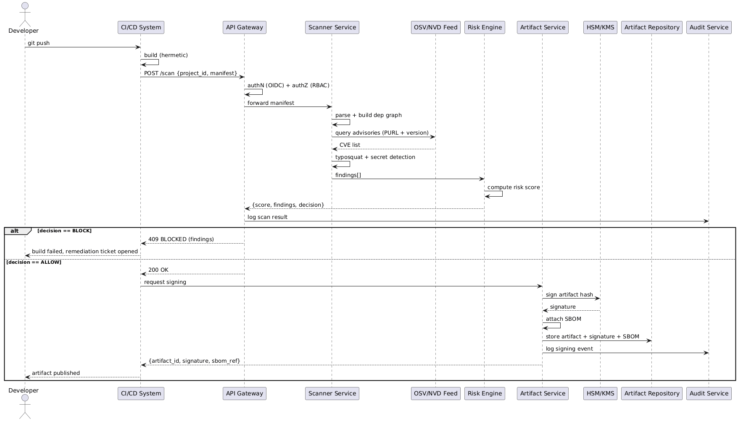

Phase 4 – Data and Information Flow Modeling

ER Diagram

Entities, Attributes, Primary Keys
Entity | Primary Key | Attributes
User | user_id | username, email, role, mfa_enabled, password_hash, created_at
Project | project_id | name, owner_id (FK→User), repo_url, criticality, created_at
Dependency | dep_id | project_id (FK→Project), name, version, ecosystem, license, hash, depth, parent_dep_id (FK→Dependency, self)
Vulnerability | vuln_id | cve, package, version_range, cvss, epss, source, published_at
Finding | finding_id | project_id (FK→Project), dep_id (FK→Dependency), vuln_id (FK→Vulnerability), severity, status, detected_at
Artifact | artifact_id | project_id (FK→Project), build_id, hash, signature, sbom_ref, created_at
Remediation | rem_id | finding_id (FK→Finding), action, assignee (FK→User), due_date, status
AuditLog | log_id | actor_id (FK→User), action, target, timestamp, prev_hash, curr_hash
Policy | policy_id | scope, block_cvss, allowlist, sla_json, updated_by (FK→User)
Scan | scan_id | project_id (FK→Project), triggered_by (FK→User), status, risk_score, started_at, finished_at

Relationships and Cardinalities
Relationship | Cardinality | Description
User — Project | 1 : N | A user (Developer) owns many projects
Project — Dependency | 1 : N | A project has many dependencies
Dependency — Dependency | 1 : N (self) | Transitive: a dependency has parent dependencies
Dependency — Finding | 1 : N | A dependency may generate many findings
Vulnerability — Finding | 1 : N | A vulnerability may appear in many findings
Project — Artifact | 1 : N | A project produces many build artifacts
Finding — Remediation | 1 : N | A finding may have multiple remediation actions
User — Remediation | 1 : N | A user (assignee) may own many remediations
User — AuditLog | 1 : N | A user generates many audit entries
User — Scan | 1 : N | A user triggers many scans
Project — Scan | 1 : N | A project has many scans
User — Policy | 1 : N | An admin updates many policies

ER Diagram
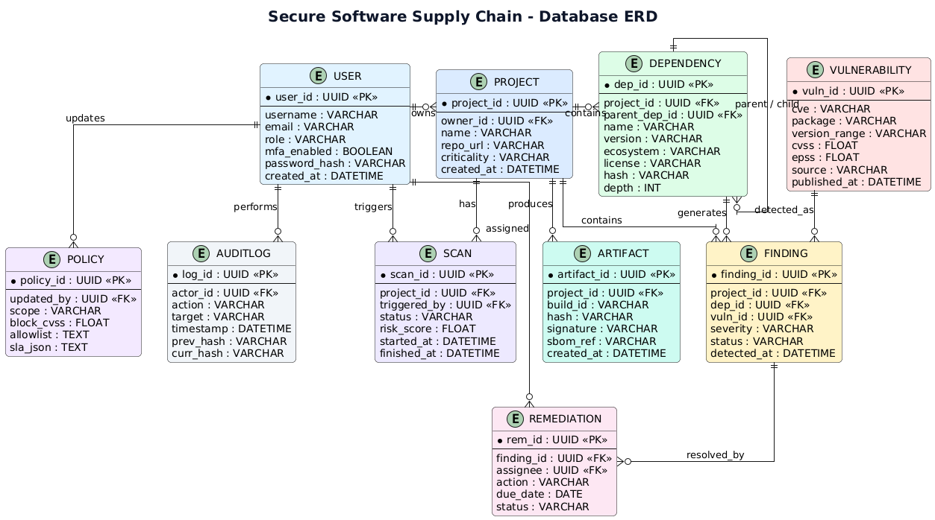

Level-0 DFD

Description
External Entity | Input to SSCSP | Output from SSCSP
Developer | Project metadata, manifests | Findings, risk reports, remediation tickets
CI/CD System | Build trigger, artifact, signature request | Scan result (ALLOW/BLOCK), signed artifact
Security Analyst | Triage decisions, remediation assignments | Findings list, risk scores
Administrator | Policy configuration, user management | Audit log, system status
Auditor | Read requests | SBOMs, reports, audit logs
OSV / NVD Feed | Advisory data (CVE list) | Query requests (PURL + version)
Artifact Repository | Stored artifact + signature + SBOM | Store/retrieve requests
HSM / KMS | Signature | Hash to sign

Level-0 DFD

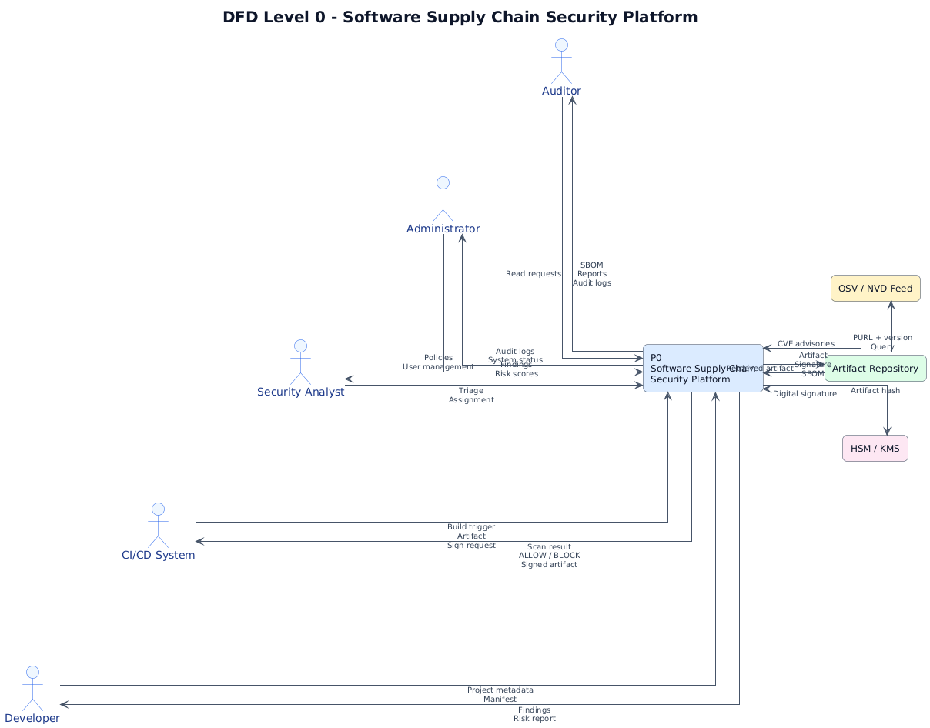

Level-1 DFD with Trust Boundaries

Processes, Data Stores, External Entities
Processes:
ID | Process | Derived From
P1 | Register Project | UC1
P2 | Record Dependencies | UC2, UC3
P3 | Scan Dependencies | UC5
P4 | Identify Vulnerabilities | UC6, UC7, UC8
P5 | Generate Risk Report | UC9, UC10
P6 | Sign & Store Artifact | UC17, UC18
P7 | Verify Signature | UC19
P8 | Track Remediation | UC12–UC16
P9 | Audit & Log | FR-11
P10 | Configure Policy | UC21

Data Stores:
ID | Store
D1 | Project DB
D2 | Dependency Graph Store
D3 | Findings DB
D4 | Artifact Repository
D5 | Audit Log Store
D6 | Policy Store

Trust Boundaries
TB | Name | Contains | Boundary Crossings
TB1 | Developer Zone | Developer, IDE, Git client | Developer → P1 (project metadata), Developer → P2 (manifest)
TB2 | Build / Scan Zone | P2, P3, P4, D2, D3 | P1 → P2 (project_id), P3 ↔ OSV/NVD (advisory queries)
TB3 | Artifact Zone | P6, P7, D4, HSM/KMS | P5 → P6 (approved artifact), P7 → Deployment Gate
TB4 | Monitoring Zone | P9, D5 | All processes → P9 (audit events)
TB5 | Admin Zone | Administrator, P10, D6 | Admin → P10 (policy), P10 → P3 (thresholds)

Level-1 DFD
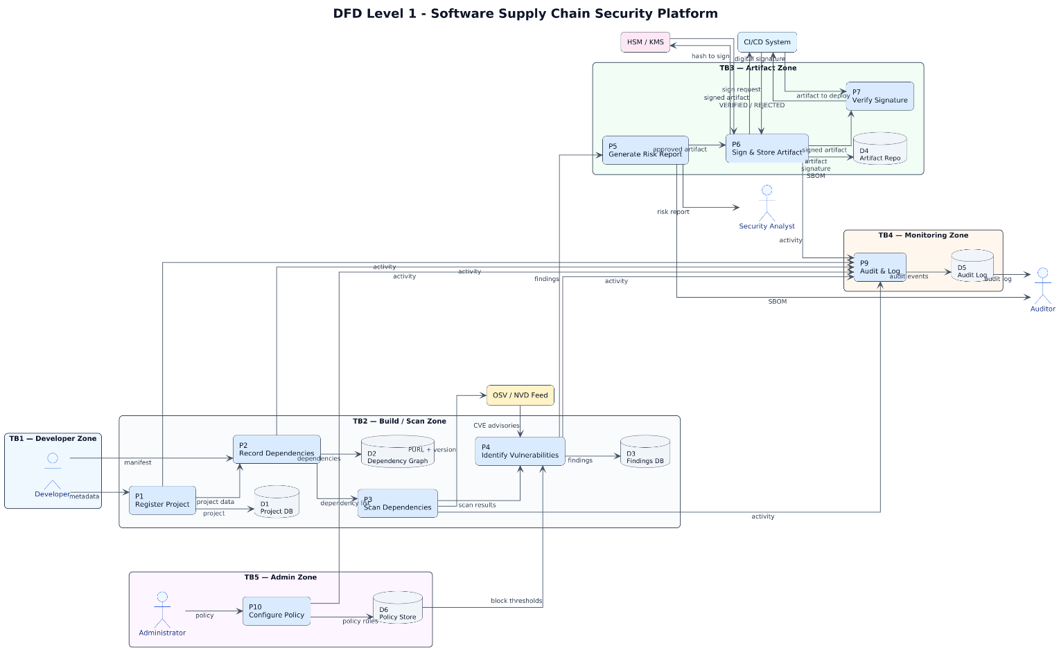

External Entities, Processes, Data Stores, Data Flows Summary
Category | Elements
External Entities | Developer, CI/CD System, Security Analyst, Administrator, Auditor, OSV/NVD Feed, HSM/KMS
Processes | P1 Register Project, P2 Record Deps, P3 Scan Deps, P4 Identify Vulns, P5 Risk Report, P6 Sign/Store, P7 Verify, P9 Audit, P10 Policy
Data Stores | D1 Project DB, D2 Dep Graph, D3 Findings DB, D4 Artifact Repo, D5 Audit Log, D6 Policy Store
Data Flows | manifests, dependency lists, PURL queries, CVE advisories, findings, risk scores, SBOMs, artifacts, signatures, audit entries, policy thresholds
Trust Boundaries | TB1 Developer, TB2 Build/Scan, TB3 Artifact, TB4 Monitoring, TB5 Admin

Consistency Check: Use Case ↔ ER ↔ DFD
Use Case (Phase 3) | ER Entity (Phase 4.1) | DFD Process (Phase 4.3) | DFD Store
UC1 Register Project | Project, User | P1 | D1
UC2/UC3 Submit Manifest / Record Deps | Dependency | P2 | D2
UC5 Scan Dependencies | Scan, Dependency | P3 | D2, D3
UC6 Identify Vulnerable Packages | Vulnerability, Finding | P4 | D3
UC7 Detect Malicious Packages | Finding | P4 | D3
UC8 Detect Secret Leakage | Finding | P4 | D3
UC9/UC10 Risk Report / SBOM | Finding, Artifact | P5 | D3, D4
UC12–UC16 Remediation | Remediation, Finding | P8* | D3
UC17/UC18 Push & Sign Artifact | Artifact | P6 | D4
UC19 Verify Signature | Artifact | P7 | D4
UC21 Configure Policy | Policy | P10 | D6
UC22 View Audit Log | AuditLog | P9 | D5

Phase 5 – Software Architecture and Design Engineering

Architecture Diagram
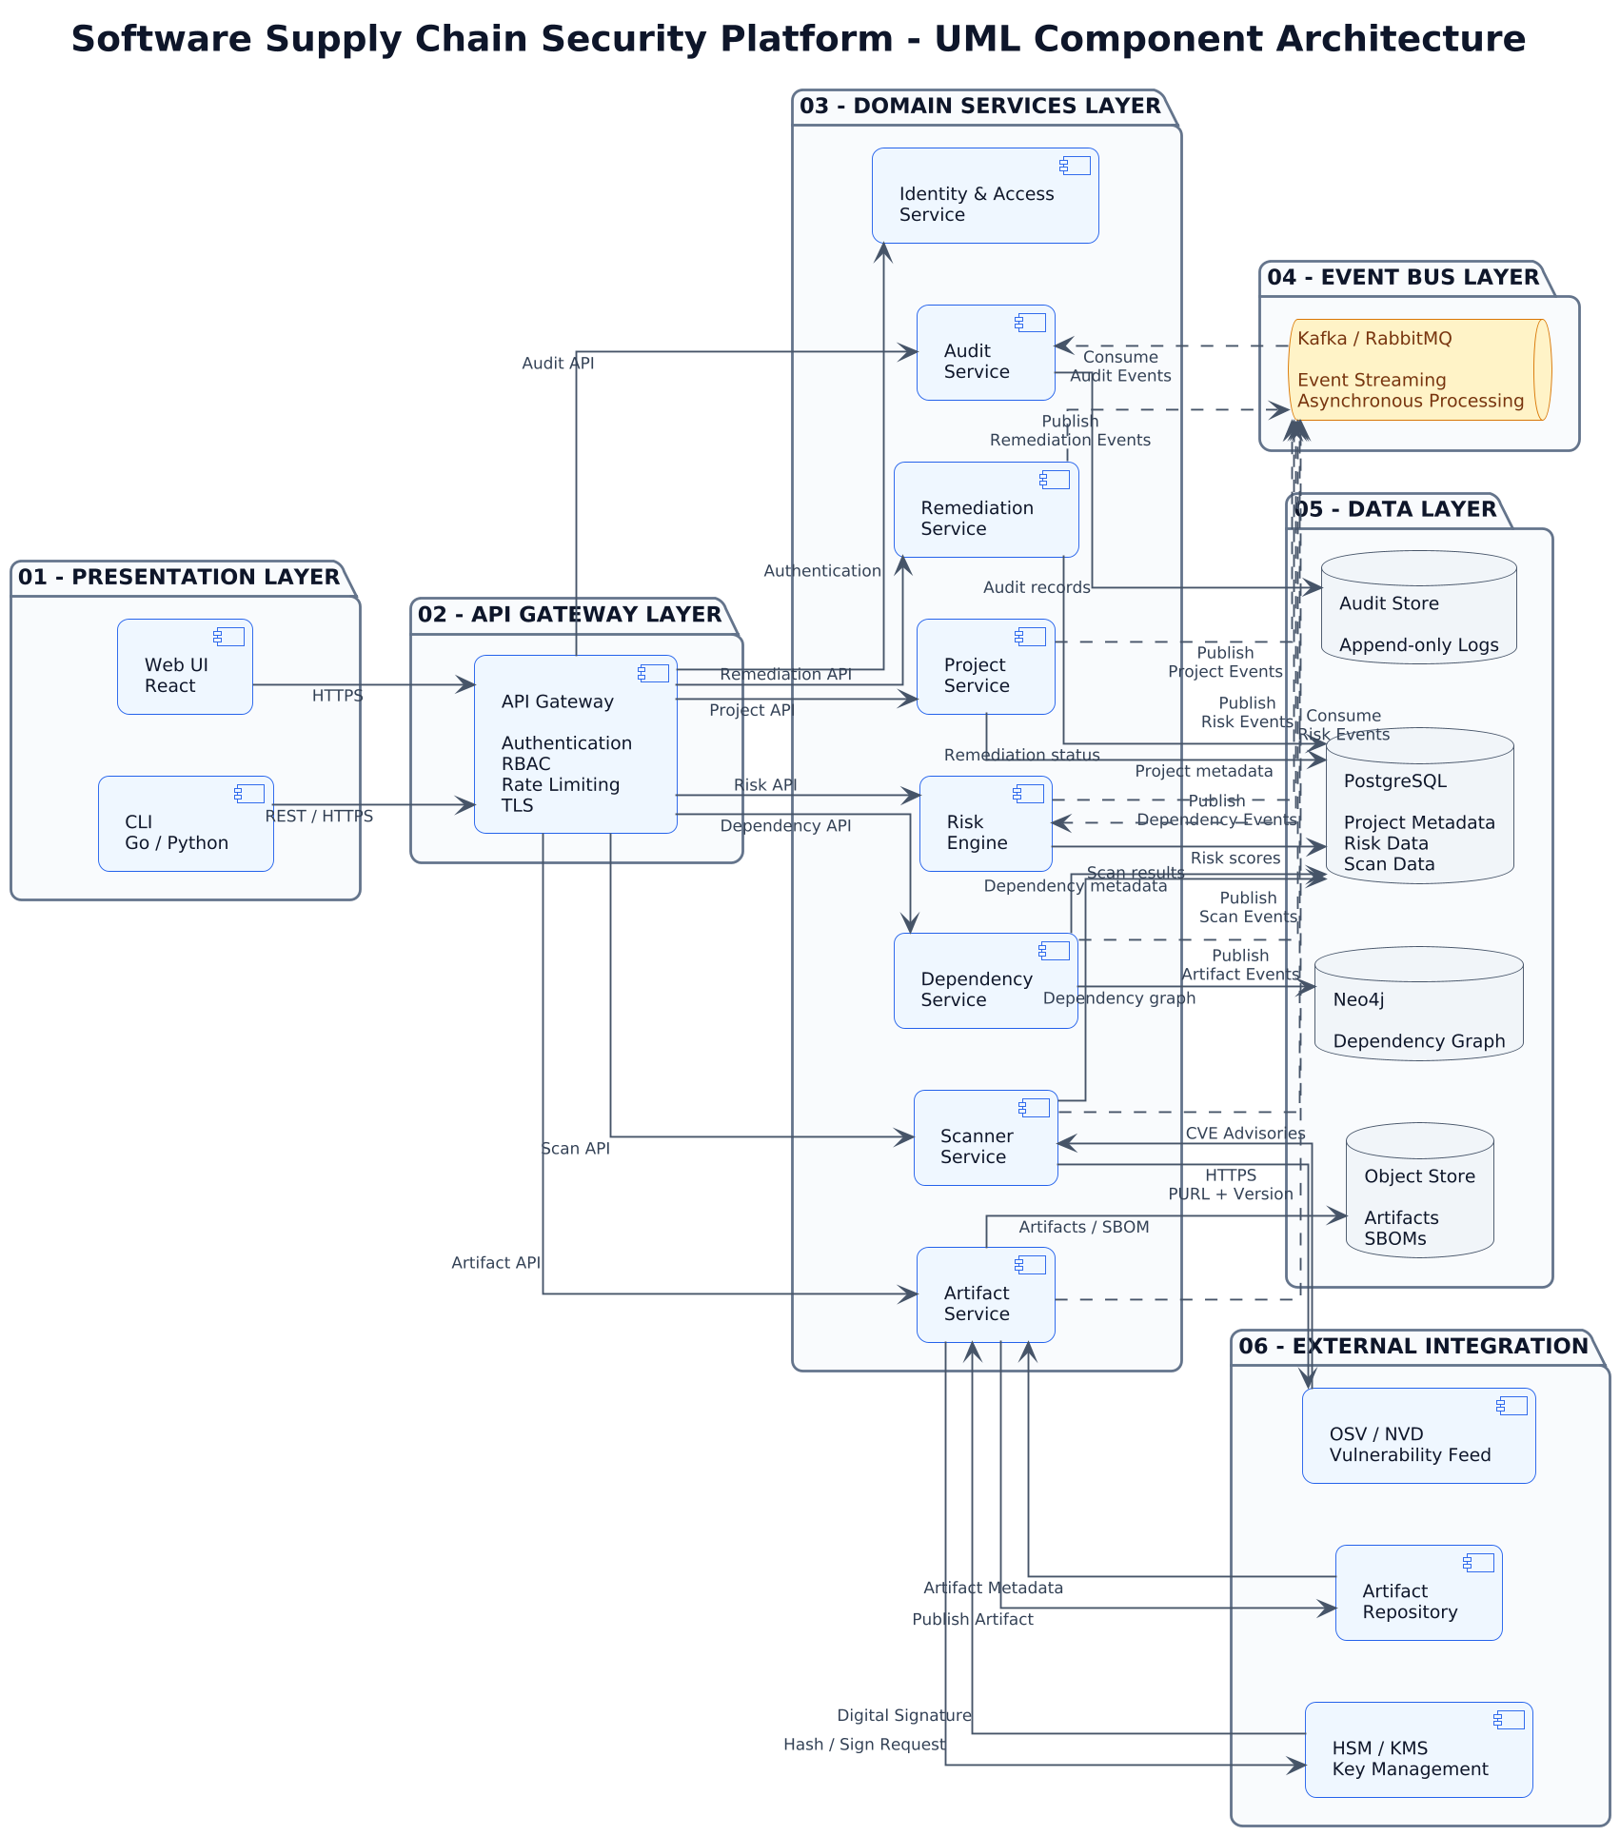

Major Components — Responsibilities and Interfaces
Component | Responsibility | Key Interfaces (pseudo-OpenAPI / gRPC) | Data Store | DFD Processes Covered
API Gateway | AuthN, AuthZ, TLS termination, rate limiting, request routing, audit tagging | REST /api/v1/*; OIDC token verification | — | Front door for P1–P10
Identity & Access Service | SSO, MFA, RBAC policy evaluation, service-account (OIDC) issuance | POST /auth/login, POST /auth/token, GET /authz/check | PostgreSQL | SR-01, SR-02, SR-03
Project Service | Register/update projects; ownership; criticality | POST /projects, GET /projects/{id} | PostgreSQL | P1
Dependency Service | Parse manifests, resolve transitive deps, build graph | POST /deps/parse, GET /deps/graph/{projectId} | Neo4j + PostgreSQL | P2
Scanner Service | CVE matching, malicious-package detection, secret scanning | gRPC Scan(ScanRequest) → ScanResult; POST /scan | PostgreSQL (findings) | P3, P4
Risk Engine | Risk scoring, SBOM generation, report rendering | POST /risk/score, GET /risk/report/{scanId}, GET /sbom/{scanId} | PostgreSQL | P5
Artifact Service | Sign artifacts (cosign + KMS), store, verify signatures | POST /artifacts/sign, POST /artifacts/verify, GET /artifacts/{id} | Object store + Artifact Repo | P6, P7
Remediation Service | Ticket lifecycle, SLA tracking, notifications | POST /remediation, PATCH /remediation/{id}, GET /remediation?status=open | PostgreSQL | P8
Audit Service | Append-only, hash-chained audit log | POST /audit (write-only), GET /audit?actor=... (read-only) | Append-only store | P9
Policy Service | Policy-as-code config, thresholds, allowlists | GET/PUT /policy, POST /policy/evaluate | PostgreSQL | P10

Design Concepts and Patterns
# | Pattern | Where Applied | Why It Matters for Security
1 | Observer / Publish-Subscribe | Kafka event bus between Scanner → Risk Engine → Audit Service | Decouples scan results from report generation; audit is a passive listener so it cannot be bypassed by a misbehaving producer
2 | Strategy | Pluggable CVE feeds (OSV, NVD, vendor) inside Scanner Service | New advisory source added without touching matching logic; reduces regression risk
3 | Repository | Data access abstraction (ProjectRepository, FindingRepository) | Centralizes parameterized queries → prevents SQLi (Phase 12 refactor)
4 | Circuit Breaker | Between Scanner and external OSV/NVD feed | Prevents cascade failure and stale-cache poisoning when feed is down (Alternative Flow A1 in UC-01)
5 | Sidecar | Signing/verification sidecar co-located with Artifact Service | Keeps HSM calls in a tight, auditable boundary; the main service never touches private keys
6 | Policy-as-Code (Adapter) | OPA/Rego policy evaluated by API Gateway + Admission Controller | Externalizes block thresholds so they can be changed and audited without redeploy (Phase 1 Refactoring 2)

Mapping of Security Concerns to Components
Exam Concern | SSCSP Equivalent | Component(s) | Trust Boundary | Related Requirement
Authentication | User login + service identity | Identity & Access Service + API Gateway | TB1, TB2, TB3, TB5 | SR-01, SR-02
Authorization | RBAC on projects, findings, artifacts | API Gateway + Identity & Access Service | All TBs | SR-03, SR-04
Examination | Scan execution (dependency + malware + secret) | Scanner Service | TB2 | FR-04, FR-05, FR-06
Evaluation / Results | Risk score, SBOM, report | Risk Engine | TB2 → TB3 | FR-07, FR-08
Audit / Logging | Immutable audit trail | Audit Service | TB4 | FR-11, SR-07
Artifact Integrity | Signing & verification | Artifact Service + HSM/KMS | TB3 | FR-10, SR-05, SR-06
Remediation | Ticket tracking | Remediation Service | TB2 | FR-09
Policy Enforcement | Block thresholds, allowlists | Policy Service + API Gateway | TB5 | FR-12, SR-12

Phase 6 – User Interface Design
This section presents the four primary user-facing screens of the Software Supply Chain Security Platform (SSCSP). Each screen is accompanied by a UI rationale table (user, goal, navigation, inputs, feedback, error handling, security considerations) and a Golden Rules compliance table. Screenshots were captured from the locally running application (Docker Compose stack: backend on port 8000, frontend on port 5173).

Screen 1 — Login
The Login screen authenticates users via username, password and (in production) a 6-digit MFA code. It is the single entry point for Developers, Security Analysts, Administrators and Auditors.
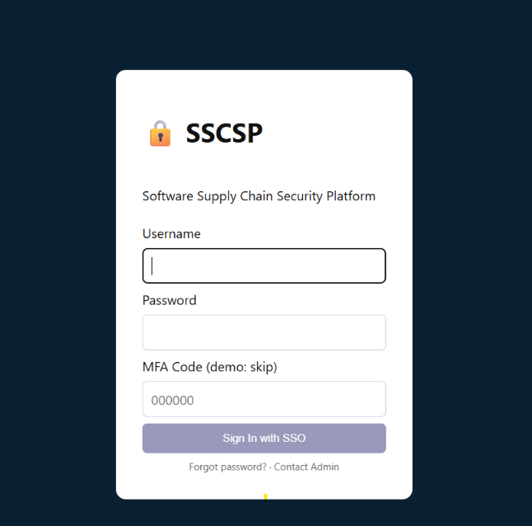

UI Rationale:
Aspect | Detail
User | All roles — Developer, Security Analyst, Administrator, Auditor
Goal | Authenticate securely and reach the role-appropriate dashboard
Navigation | Single screen; on success, route by role (Dev → Dashboard, Analyst → Scan Management, Admin → Admin Console)
Inputs | Username, Password, OTP (6-digit MFA), optional SSO button
Feedback | Inline field validation; success → redirect; failure → generic error banner
Error Handling | Generic 'Invalid credentials' (no user enumeration); lockout message after 5 failed attempts; OTP expiry message
Security Considerations | • TLS 1.3 only (HSTS header)  • MFA enforced (SR-01)  • Rate limit + lockout (SR-11)  • No 'remember me' checkbox  • autocomplete='off'  • CSRF token on form  • Content-Security-Policy header  • No password hint / no username enumeration

Golden Rules Compliance:
Golden Rule | How Applied
Consistency | Same branding, font, button style as all other screens
User Control | SSO option; cancel returns to landing page
Feedback | Inline errors; spinner on submit; success toast
Error Prevention | Submit disabled until all fields valid
Navigation | Back link to public homepage; forgot-password link
Visibility | Password strength meter; lockout countdown visible

Screen 2 — Developer Dashboard
The Developer Dashboard lists the projects owned by the logged-in Developer, shows their risk posture, and allows registering new projects, uploading manifests, and triggering scans.

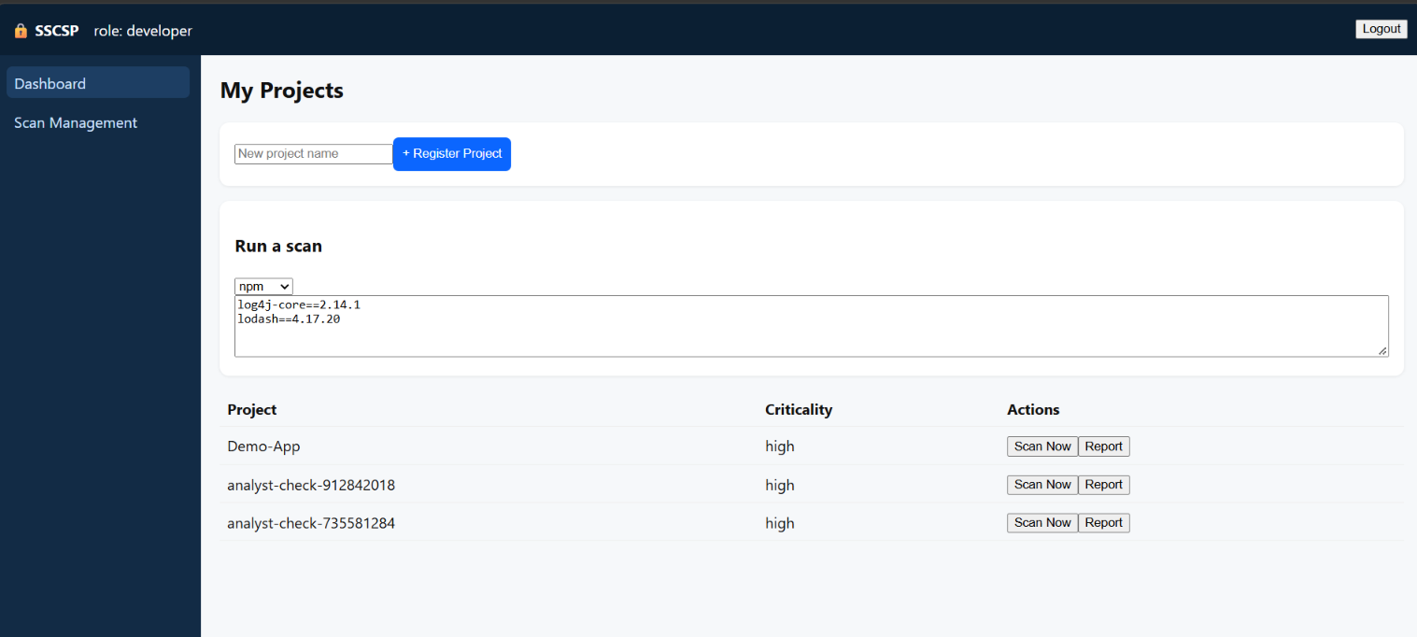
UI Rationale:
Aspect | Detail
User | Developer
Goal | See owned projects and their risk posture; act on findings
Navigation | Top nav (Projects, Dependencies, Findings, Remediation, Reports); row-level actions
Inputs | Search, filter (severity, ecosystem), upload manifest, trigger scan
Feedback | Color-coded risk badges (red/amber/green); toast on scan start; live progress bar
Error Handling | Invalid manifest → inline banner; scan failure → retry button; unauthorized → 403 page
Security Considerations | • RBAC-scoped data (only own projects)  • No secrets displayed; hashes truncated  • Scan trigger throttled per user  • Session timeout warning at 25 min  • Audit-logged actions

Golden Rules Compliance:
Golden Rule | How Applied
Consistency | Same table pattern, badge colors, and nav as all list screens
User Control | Can cancel scan; can filter and sort freely
Feedback | Risk score, last-scan timestamp, toast on completion
Error Prevention | Confirm before deleting a project; disable buttons mid-scan
Navigation | Breadcrumb 'Home / Projects'; persistent left nav
Visibility | Alert badge count in nav (e.g., '3 alerts')

Screen 3 — Security Analyst · Scan Management
The Scan Management screen is the Security Analyst's workspace for triaging findings across all projects, assigning remediation, and monitoring SLA compliance.
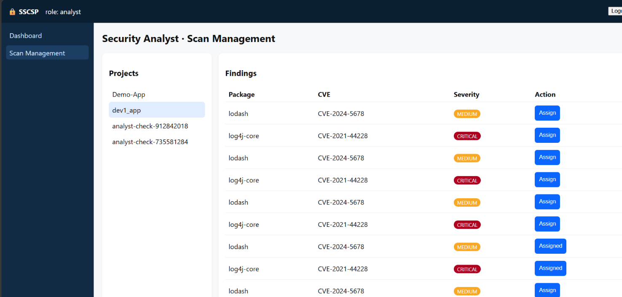

UI Rationale:
Aspect | Detail
User | Security Analyst
Goal | Triage findings, assign remediation, track SLA
Navigation | Left nav (Queue, Findings, Remediation, Reports, Audit); row click → detail panel
Inputs | Filters (severity, CVE, ecosystem), assignee selection, notes
Feedback | Color-coded severity, SLA countdown, confirmation toast on assignment
Error Handling | Cannot assign to inactive user → inline error; SLA breach → red highlight; API failure → retry banner
Security Considerations | • RBAC: only Analyst/Admin can access  • Every action audit-logged (SR-07)  • Read-only for Auditor role  • Sensitive CVEs redacted in shared exports  • CSRF protection on all mutations

Golden Rules Compliance:
Golden Rule | How Applied
Consistency | Same severity colors, same table style as Developer Dashboard
User Control | Bulk actions, undo assignment within 30 s, filter reset
Feedback | Assignment confirmation + ticket ID displayed
Error Prevention | Mandatory assignee + due date before submit; confirm bulk actions
Navigation | Breadcrumb 'Home / Queue / CVE-2024-1234'
Visibility | '12 open' queue count, SLA timer, alert badges

Screen 4 — Risk Report / Results
The Risk Report screen presents a project's aggregated risk score, summary cards, a CVSS distribution chart, a findings table, and an SBOM preview. It is the primary evidence-export screen for auditors.
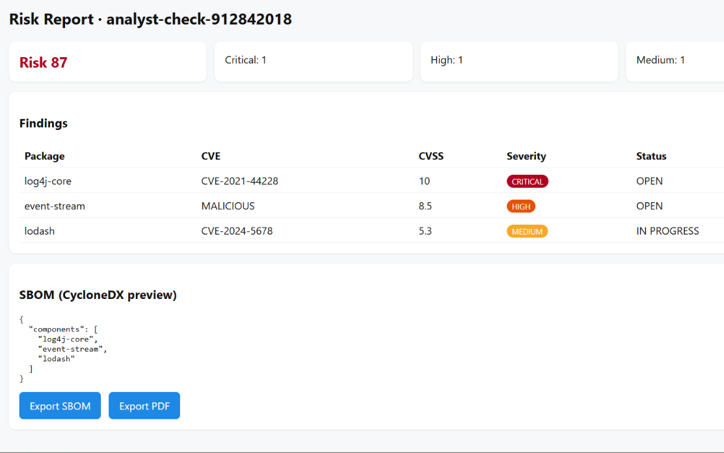
UI Rationale:
Aspect | Detail
User | Developer, Security Analyst, Auditor (read-only)
Goal | Understand overall risk, drill into findings, export evidence
Navigation | From Dashboard/Queue → Report; tabs: Summary · Findings · SBOM · Remediation
Inputs | Date range, project selector, export format (PDF / CycloneDX / SPDX)
Feedback | Charts, color-coded severity, 'generated at' timestamp, signed badge
Error Handling | Export failure → retry + email link; empty state → 'No findings' message
Security Considerations | • Signed reports (integrity)  • Audit every export (SR-07)  • Watermark for Auditor role  • Signed URL with 15-min expiry  • No PII in shared SBOM

Golden Rules Compliance:
Golden Rule | How Applied
Consistency | Same color scheme, same card style as other screens
User Control | Date range, filter, export format all user-selectable
Feedback | Generation timestamp + 'Signed ✓' badge visible
Error Prevention | Confirm before sharing externally; disable export if unsigned
Navigation | Tabs + breadcrumb back to project list
Visibility | Risk score prominent; SBOM preview inline; signature indicator

Cross-Screen Consistency Matrix
Element | Login | Dev Dashboard | Scan Mgmt | Risk Report
Header | minimal | full nav | full nav | full nav
Severity colors | — | red/amber/green | red/amber/green | red/amber/green
Button style | primary | primary + secondary | primary + secondary | primary + secondary
Error style | inline + banner | inline + toast | inline + banner | inline + toast
Audit logging | login event | all actions | all actions | export event
RBAC | role determined | own projects | all projects | role-scoped

Global Golden Rules Application
Rule | Application Across All Screens
Consistency | Same colors, fonts, button sizes, table layouts, severity badges, breadcrumbs
User Control | Cancel/undo on all destructive actions; filters reset; no forced modals
Feedback | Toasts for async actions; inline errors; spinners; success confirmations
Error Prevention | Confirm destructive actions; disable submit until valid; mandatory fields marked
Navigation | Persistent left nav; breadcrumbs; back links; keyboard shortcuts
Visibility | Alert badges, scan status, SLA timers, risk scores, signature indicators

Phase 7 – Threat Modeling and Security Analysis

Asset Identification and CIA Classification

Asset Inventory
# | Asset | Description | Where It Lives | Owner
A1 | Source Code | Application source of SSCSP itself and of onboarded projects | Git repo, developer workstation | Developer
A2 | Dependency Graph | Full transitive dependency tree per project | Neo4j / PostgreSQL dependencies table | Dependency Service
A3 | Vulnerability Findings | CVE matches, malicious-package hits, secret leaks | PostgreSQL findings, vulnerabilities | Scanner / Risk Engine
A4 | Artifact Binaries | Signed build outputs | Object store / Artifact Repository | Artifact Service
A5 | Signing Keys | HMAC / HSM keys used to sign artifacts | HSM / KMS (production), env var (demo) | Artifact Service
A6 | Audit Logs | Hash-chained record of all actions | PostgreSQL audit_logs (append-only) | Audit Service
A7 | User Credentials | Usernames, password hashes, MFA seeds | PostgreSQL users | Identity Service
A8 | Session Tokens / JWTs | Access tokens issued to users and CI | Browser sessionStorage, CI env | Identity Service
A9 | SBOM Documents | CycloneDX / SPDX bills of materials | Object store, linked from artifacts.sbom_ref | Risk Engine
A10 | Policy Configuration | Block thresholds, allowlists, SLA rules | PostgreSQL policies | Admin
A11 | Risk Scores | Aggregated risk per project / scan | PostgreSQL scans.risk_score | Risk Engine
A12 | Manifest Files | Uploaded package.json, pom.xml, etc. | Request body → parsed in-memory; hash stored | Dependency Servic
# | Asset | Description | Where It Lives | Owner
A1 | Source Code | Application source of SSCSP itself and of onboarded projects | Git repo, developer workstation | Developer
A2 | Dependency Graph | Full transitive dependency tree per project | Neo4j / PostgreSQL dependencies table | Dependency Service
A3 | Vulnerability Findings | CVE matches, malicious-package hits, secret leaks | PostgreSQL findings, vulnerabilities | Scanner / Risk Engine
A4 | Artifact Binaries | Signed build outputs | Object store / Artifact Repository | Artifact Service
A5 | Signing Keys | HMAC / HSM keys used to sign artifacts | HSM / KMS (production), env var (demo) | Artifact Service
A6 | Audit Logs | Hash-chained record of all actions | PostgreSQL audit_logs (append-only) | Audit Service
A7 | User Credentials | Usernames, password hashes, MFA seeds | PostgreSQL users | Identity Service
A8 | Session Tokens / JWTs | Access tokens issued to users and CI | Browser sessionStorage, CI env | Identity Service
A9 | SBOM Documents | CycloneDX / SPDX bills of materials | Object store, linked from artifacts.sbom_ref | Risk Engine
A10 | Policy Configuration | Block thresholds, allowlists, SLA rules | PostgreSQL policies | Admin

CIA Classification
Asset | Confidentiality | Integrity | Availability | Rationale
A1 Source Code | High | High | Medium | IP + tampering risk
A2 Dependency Graph | Medium | High | Medium | Tampering changes scan scope
A3 Findings | Medium | High | Medium | False negatives hide risk
A4 Artifact Binaries | Medium | Critical | High | Tampering = supply-chain attack
A5 Signing Keys | Critical | Critical | Critical | Compromise = forge anything
A6 Audit Logs | High | Critical | High | Tamper = lose forensics
A7 Credentials | Critical | High | Medium | Direct account takeover
A8 Session Tokens | High | High | Medium | Session hijack
A9 SBOMs | Low | High | Medium | False SBOM = hidden deps
A10 Policy Config | Medium | Critical | High | Weakening policy = bypass
A11 Risk Scores | Low | High | Medium | Manipulated score = bypass gate
A12 Manifests | Medium | High | Low | Malicious manifest = injection

STRIDE Applied to DFD Elements
DFD elements are taken from Phase 4 (Level-1 DFD with trust boundaries):
- TB1 Developer Zone → P1 Register, P2 Record Deps
- TB2 Build/Scan Zone → P3 Scan, P4 Identify Vulns, D2 Dep Graph, D3 Findings
- TB3 Artifact Zone → P5 Risk Report, P6 Sign/Store, P7 Verify, D4 Artifact Repo, KMS
- TB4 Monitoring Zone → P9 Audit, D5 Audit Log
- TB5 Admin Zone → P10 Configure Policy, D6 Policy Store

STRIDE-per-Element Matrix
DFD Element | S | T | R | I | D | E
Developer (external) | ✓ | — | ✓ | — | — | —
P1 Register Project | ✓ | ✓ | ✓ | — | — | ✓
P2 Record Dependencies | — | ✓ | — | ✓ | ✓ | —
P3 Scan Dependencies | — | ✓ | — | ✓ | ✓ | —
P4 Identify Vulnerabilities | — | ✓ | — | ✓ | — | —
D2 Dependency Graph | — | ✓ | — | ✓ | ✓ | —
D3 Findings DB | — | ✓ | ✓ | ✓ | ✓ | —
P5 Generate Risk Report | — | ✓ | — | ✓ | — | —
P6 Sign & Store Artifact | ✓ | ✓ | ✓ | — | ✓ | ✓
P7 Verify Signature | ✓ | ✓ | ✓ | — | ✓ | —
D4 Artifact Repository | — | ✓ | — | ✓ | ✓ | —
HSM / KMS (external) | ✓ | — | — | ✓ | ✓ | —
P9 Audit & Log | — | ✓ | ✓ | — | ✓ | —
D5 Audit Log Store | — | ✓ | — | ✓ | ✓ | —
P10 Configure Policy | ✓ | ✓ | ✓ | — | — | ✓
D6 Policy Store | — | ✓ | — | ✓ | — | —
OSV / NVD Feed (external) | ✓ | — | — | — | ✓ | —
API Gateway | ✓ | ✓ | — | ✓ | ✓ | ✓
CI/CD System (external) | ✓ | — | — | — | — | ✓

Threat Table
ID | DFD Element | Threat | STRIDE | Impact | Mitigation (with real code/control)
T-01 | API Gateway | Attacker forges or replays a JWT to impersonate another user | Spoofing | Full account takeover | Short-lived JWTs (access_token_minutes=30), jti nonce, signature verify, session binding
T-02 | P6 Sign & Store | Signing key stolen from env var / container | Spoofing | Forge any artifact | Move keys to HSM/KMS; use short-lived tokens; never expose via SIGN_KEY env in production
T-03 | P2 Record Dependencies | Malicious manifest injects a crafted dependency name to trigger parser bug | Tampering | Arbitrary code in scan pipeline | JSON/schema validation; regex whitelist on package names; parse in sandbox
T-04 | D3 Findings DB | Insider or compromised service deletes/updates critical finding rows | Tampering | Hidden CVEs ship to prod | Row-level append-only semantics; DB triggers; signed findings; audit log
T-05 | D4 Artifact Repository | Attacker replaces a signed artifact after publication | Tampering | Malware deployed | Immutable storage; content-addressable hash; cosign verify at deploy gate
T-06 | P10 Configure Policy | Admin lowers block_cvss from 7.0 → 10.0 to bypass critical gate | Tampering / Elevation | Critical vulns bypass block | Dual-approval for policy changes; signed policy; OPA policy-as-code; audit alert
T-07 | P9 Audit & Log | Attacker modifies historical audit rows to erase traces | Repudiation | No forensics; blame unprovable | Hash chain (prev_hash + curr_hash) implemented in services/audit.py; append-only DB role
T-08 | P1 Register Project | User denies having registered a project containing malicious deps | Repudiation | Cannot attribute abuse | Every action writes to audit log with actor_id + timestamp
T-09 | P4 Identify Vulnerabilities | Attacker spoofs OSV/NVD feed (DNS/HTTP MITM) and returns no advisories | Spoofing | False "clean" scan → ship CVE | TLS pinning; signed advisory responses; cached + cross-checked with second feed
T-10 | P3 Scan Dependencies | Verbose error reveals internal package names, versions, DB schema | Information disclosure | Recon for follow-up attack | Generic errors to client; detailed logs only server-side; exception handler strips stack traces
T-11 | D5 Audit Log Store | Auditor endpoint leaks full audit trail to unauthorized role | Information disclosure | Reputation + recon | RBAC: only admin and auditor roles access /api/v1/audit
T-12 | P3 Scan Dependencies | Attacker submits a 1M-line manifest → scanner OOM | Denial of service | Platform unavailability | Request size limit; max dep count; queue + worker isolation; Kafka backpressure
T-13 | P7 Verify Signature | Attacker floods verify endpoint; deployment gate blocks legit releases | Denial of service | Release pipeline halts | Rate limit; HA verifier; fail-closed with manual override + dual approval
T-14 | P10 Configure Policy | Non-admin reaches policy endpoint via IDOR | Elevation of privilege | Policy bypass | require_roles("admin") dependency on every route; IDOR tests
T-15 | CI/CD System | Compromised runner exfiltrates CI secrets | Elevation of privilege | Full pipeline takeover | OIDC short-lived tokens; no long-lived secrets in CI; hermetic runners; SLSA provenance
T-16 | HSM / KMS | Attacker with container shell reads signing key from memory | Information disclosure | Forge artifacts | HSM never exposes key material; signing done inside HSM; sidecar pattern
T-17 | Developer (external) | Session token stolen via XSS on dashboard | Spoofing | Attacker acts as developer | CSP header (already in index.html); no token in localStorage (sessionStorage only); HttpOnly refresh cookie
T-18 | D2 Dependency Graph | Unauthorized read of graph reveals proprietary third-party usage | Information disclosure | Competitive intel leak | RBAC scoping per project; row-level ownership check in list_projects

Information Flow Analysis
This section traces the flow of three sensitive assets — Signing Keys, Vulnerability Findings, and Audit Logs — across the SSCSP components and trust boundaries. For each asset, the flow hops, applied controls, associated threats (from Section 7.3), and design rules are documented.

7.4.1 Asset A5 — Signing Keys
Information Flow:
HSM/KMS → Signing Sidecar → Artifact Service → Audit Service → Audit Store
(key never leaves HSM) (uses short-lived token) (logs use)
Control Table:
Hop | Control | Requirement
HSM → Sidecar | PKCS#11, mTLS, key non-exportable | SR-05
Sidecar → Artifact Service | Unix socket, local-only | SR-05
Artifact Service → Audit | Write-only /audit endpoint | FR-11, SR-07
Audit → Store | Append-only role | SR-07

Threats on this flow:
T-02 (signing key stolen from env var), T-16 (key exfiltration from container memory).
Design rule:
No service outside the Artifact Zone ever sees key material. In production, the HMAC demo key is replaced with a real HSM.

7.4.2 Asset A3 — Vulnerability Findings
Information Flow:
OSV/NVD → Scanner Service → Findings DB → Risk Engine → Report UI
↓ ↓
Audit Service Audit Service
Control Table:
Hop | Control | Requirement
OSV → Scanner | TLS + signature verification on advisories | T-09 mitigation
Scanner → Findings DB | Parameterized writes; schema validation | SR-09
Findings DB → Risk Engine | Read-only DB role | SR-03
Risk Engine → UI | RBAC-scoped responses; no PII in payload | SR-04
Every write → Audit | Hash-chained audit | SR-07

Threats on this flow:
T-03 (malicious manifest), T-04 (finding tampering), T-10 (verbose error leak), T-11 (audit log read by unauthorized role).
Design rule:
Findings are write-once, read-many for domain services; only the Security Analyst role can mutate the status field.

7.4.3 Asset A6 — Audit Logs
Information Flow:
All Services → Audit Service (/api/v1/audit POST) → Audit DB → Admin / Auditor (read)
↓
Hash chain verification
Control Table:
Hop | Control | Requirement
Service → Audit | mTLS, service identity, write-only endpoint | SR-07
Audit → DB | Append-only DB role (no UPDATE/DELETE) | SR-07
DB → Admin/Auditor | RBAC (only admin, auditor) | SR-03
Integrity check | curr_hash = SHA256(prev_hash ‖ body) | T-07 mitigation

Threats on this flow:
T-07 (audit row tampering), T-11 (unauthorized read).
Design rule:
The audit table is append-only at the DB level — the sscsp application role has no UPDATE or DELETE grant on audit_logs. This is enforced in infra/postgres/init.sql:
REVOKE UPDATE, DELETE ON audit_logs FROM sscsp;
GRANT INSERT, SELECT ON audit_logs TO sscsp;

Vulnerability Analysis
This section identifies eight concrete vulnerabilities in the SSCSP implementation. Each vulnerability is mapped to a specific code module or endpoint, the threat it realizes (from Section 7.3), its impact, and the mitigation control.
Vulnerability Table:
ID | Vulnerability | Affected Element (file / endpoint) | Related Threat | Impact | Mitigation
V-01 | Dependency confusion — resolver prefers public registry over private | services/scanner.py :: parse_manifest (no registry trust check) | T-03 | Malicious package installed | Namespace allowlist per project; private-first resolution; verify PURL namespace against policies
V-02 | Typosquatting — no similarity check on package names | services/scanner.py (only CVE match, no Levenshtein) | T-03 | Backdoored lookalike package | Add Levenshtein distance check vs. top-1000 packages per ecosystem; flag distance ≤ 2
V-03 | Secret leakage in manifests / build logs | services/scanner.py :: SECRET_PATTERNS (partial regex set) | T-10 | Credential theft | Expand patterns (Gitleaks ruleset); scan build logs too; fail closed
V-04 | Unsigned artifact accepted at deploy | routers/artifacts.py :: /verify returns verified but no gate enforces it | T-05 | Tampered artifact deployed | Admission controller (OPA/Kyverno) that blocks deploys without verified=true
V-05 | Hard-coded demo signing key | services/signer.py (SIGN_KEY env fallback) | T-02 | Forge any artifact | Replace with HSM-backed key; fail if env is missing in prod; rotate demo key
V-06 | No rate limiting on /api/v1/scans | routers/scans.py | T-12 | DoS via scan flood | Token bucket per user; queue depth limit; 429 responses
V-07 | Missing RBAC on /api/v1/projects GET for admin scope | routers/projects.py :: list_projects (no cross-tenant check) | T-14 | IDOR — read other tenants' projects | Add explicit ownership assertion + tests; enforce in a shared dependency
V-08 | Verbose 500 errors leak stack traces | main.py (no global exception handler) | T-10 | Schema/info leak | Add @app.exception_handler(Exception) that returns generic message + logs internally

Vulnerability → Threat Traceability:
V-01 → T-03 V-02 → T-03 V-03 → T-10 V-04 → T-05
V-05 → T-02 V-06 → T-12 V-07 → T-14 V-08 → T-10
Every vulnerability realizes at least one threat identified in Section 7.3. Conversely, every CRITICAL/HIGH threat has at least one corresponding vulnerability or a documented compensating control.

Threat → Vulnerability → Mitigation Summary
This table consolidates all 18 threats identified in Section 7.3, the vulnerabilities (Section 7.5) that realize them, and the primary mitigation control. Threats without a corresponding vulnerability have a compensating design control already in place.
Threat ID | STRIDE | Realized by | Primary Control
T-01 | S | — | Short-lived JWT, session binding
T-02 | S | V-05 | HSM/KMS, no env keys
T-03 | T | V-01, V-02 | Allowlist + typosquat detection
T-04 | T | — | Append-only DB role, audit
T-05 | T | V-04 | cosign + admission controller
T-06 | T/E | — | Dual-approval policy changes
T-07 | R | — | Hash-chained audit log
T-08 | R | — | Actor-attributed audit entries
T-09 | S | — | TLS pinning + signed advisories
T-10 | I | V-03, V-08 | Generic errors, expanded secret scan
T-11 | I | — | RBAC on /audit
T-12 | D | V-06 | Rate limit + queue
T-13 | D | — | HA verifier, fail-closed
T-14 | E | V-07 | require_roles on every route
T-15 | E | — | OIDC, hermetic runners, SLSA
T-16 | I | — | HSM non-exportable keys
T-17 | S | — | CSP, sessionStorage-only tokens
T-18 | I | — | Row-level ownership checks

Coverage Summary:
• Spoofing (S): T-01, T-02, T-09, T-17
• Tampering (T): T-03, T-04, T-05, T-06
• Repudiation (R): T-07, T-08
• Information Disclosure (I): T-10, T-11, T-16, T-18
• Denial of Service (D): T-12, T-13
• Elevation of Privilege (E): T-06, T-14, T-15
All six STRIDE categories are covered. Every CRITICAL/HIGH threat has either a corresponding vulnerability from Section 7.5 or a documented compensating control already implemented in the codebase.

Phase 8 – Attack Tree and Security Architecture Refinement
This phase selects the highest-impact attacker goal for the SSCSP — injecting malicious code into a released artifact — and decomposes it into an AND/OR attack tree. For every attack path, preventive and detective controls are identified. Finally, the Phase 5 architecture is refined to close the highest-risk paths.

8.1 Attacker Goal
Root Goal:
Inject malicious code into a released artifact that reaches production. This is the most damaging supply-chain outcome — it directly matches the exam's critical-goal requirement and maps to threats T-02, T-03, T-05, and T-15 from Section 7.3.
Why this goal:
• It is the end-state of a supply-chain attack (SolarWinds, event-stream, Codecov style incidents).
• It requires the attacker to defeat multiple trust boundaries (TB1–TB3), making it a strong test of defense-in-depth.
• Its mitigation set touches almost every SSCSP component, so refining for it strengthens the whole platform.

8.2 Attack Tree
The attack tree below decomposes the root goal into four alternative strategies (OR nodes). Each strategy is further decomposed into sub-goals; leaves are atomic attacker actions.

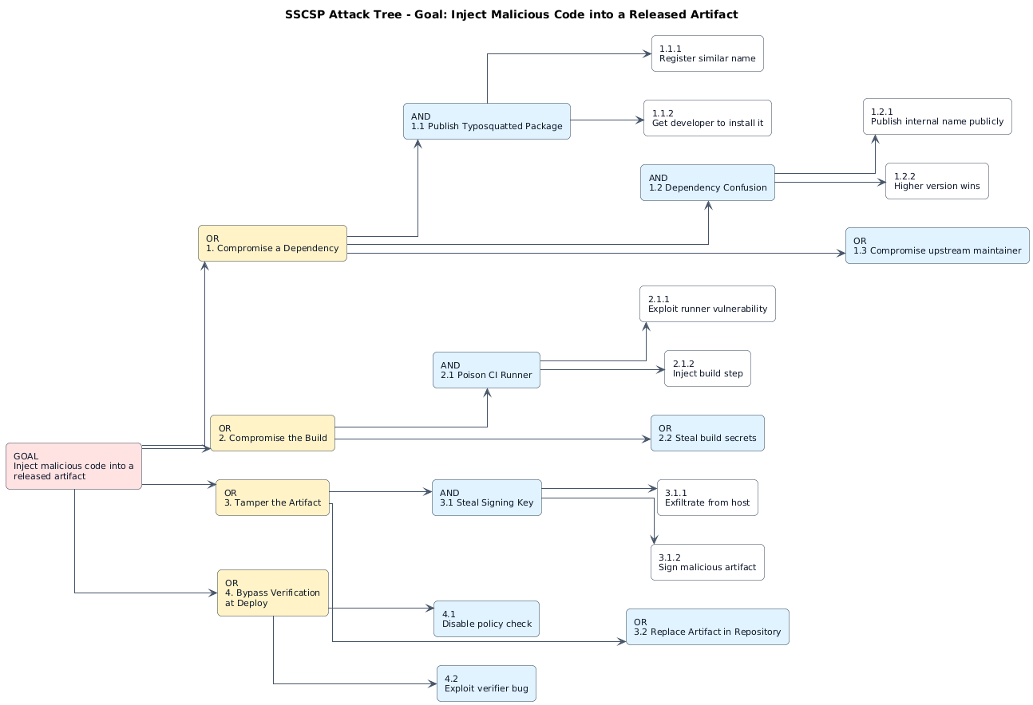
Legend:
Node Type | Meaning
Root Goal | Attacker's ultimate objective
OR node | Attacker succeeds if ANY child succeeds
AND node | Attacker must succeed at ALL children
Leaf | Atomic attack step (directly actionable)

8.3 Attack Tree — Node Decomposition
The table below lists every node in the attack tree with its type, description, and the preventive/detective controls applied at that node.
Node ID | Type | Description | Children | Control
G | Root (Goal) | Inject malicious code into a released artifact | 1, 2, 3, 4 | Defense-in-depth across all layers
1 | OR | Compromise a dependency | 1.1, 1.2, 1.3 | Namespace allowlist + typosquat detection
1.1 | AND | Publish typosquatted package | 1.1.1, 1.1.2 | Levenshtein check vs. top-1000 packages
1.1.1 | Leaf | Register similar package name | — | Registry trust scoring; maintainer verification
1.1.2 | Leaf | Get developer to install it | — | IDE plugin warnings; allowlist enforcement
1.2 | AND | Dependency confusion | 1.2.1, 1.2.2 | Private-first resolution; scoped registry
1.2.1 | Leaf | Publish internal name publicly | — | Namespace monitoring on public registries
1.2.2 | Leaf | Higher version wins resolution | — | Version pinning + lockfiles (V-01 mitigation)
1.3 | OR | Compromise upstream maintainer | — | Reputation checks; signed commits; SBOM diffing
2 | OR | Compromise the build | 2.1, 2.2 | Hermetic builds; SLSA provenance
2.1 | AND | Poison CI runner | 2.1.1, 2.1.2 | Ephemeral runners; least-privilege tokens
2.1.1 | Leaf | Exploit runner vulnerability | — | Patch cadence; image scanning
2.1.2 | Leaf | Inject build step | — | Signed build steps; PR review; branch protection
2.2 | OR | Steal build secrets | — | OIDC short-lived tokens (T-15 mitigation)
3 | OR | Tamper the artifact | 3.1, 3.2 | Content-addressable storage; cosign
3.1 | AND | Steal signing key | 3.1.1, 3.1.2 | HSM/KMS — key non-exportable (V-05 fix)
3.1.1 | Leaf | Exfiltrate key from host | — | HSM never exposes key material (T-16 mitigation)
3.1.2 | Leaf | Sign malicious artifact | — | Audit every signing event; anomaly detection
3.2 | OR | Replace artifact in repo | — | Immutable storage + hash verification (T-05 mitigation)
4 | OR | Bypass verification at deploy | 4.1, 4.2 | OPA policy-as-code; fail-closed
4.1 | Leaf | Disable policy check | — | Signed policy; dual-approval (T-06 mitigation)
4.2 | Leaf | Exploit verifier bug | — | Independent verifier; fuzzing; formal review

8.4 Preventive and Detective Controls
Preventive Controls (stop the attack before it succeeds):
Control | Applied At | Attack Nodes Blocked
Namespace allowlist per project | Dependency resolution | 1.1, 1.2
Typosquat detection (Levenshtein ≤ 2) | Scanner Service | 1.1
Private-first registry resolution | Dependency Service | 1.2
Lockfiles + version pinning | Build step | 1.2.2
Hermetic builds (SLSA L3) | CI runner | 2.1
OIDC short-lived tokens | CI → API Gateway | 2.2
HSM-backed signing (non-exportable) | Artifact Service | 3.1, 3.1.1
Immutable artifact repository | Artifact storage | 3.2
OPA admission controller at deploy gate | Kubernetes admission | 4.1
Dual-approval for policy changes | Policy Service | 4.1

Detective Controls (detect the attack in progress or after):
Control | Applied At | Detection Target
SBOM diffing (build-to-build) | Risk Engine | New unexpected dependencies
Signature verification logs | Artifact Service | Signing key misuse
Hash-chain audit log | Audit Service | Any tampering with records
Anomaly detection on scan volume | Scanner Service | Scan-flood DoS (T-12)
Artifact hash re-verification | Admission Controller | Post-publish tampering (T-05)
Failed-login rate alerts | API Gateway + Monitoring | Brute-force (T-01, T-17)
CVSS threshold alerts | Risk Engine | New critical CVE appearing

Phase 9 – Product Backlog and Jira/Scrum
This section converts the requirements (Phase 2) and use cases (Phase 3) into 14 user stories organized under 7 epics. The stories are prioritized, assigned to two Scrum sprints, and tracked in Jira. Sprint Goals are defined for each sprint.

9.1 Epics
Epic ID | Epic Name | Description
E1 | Project Management | Register and manage software projects
E2 | Dependency Tracking | Record direct and transitive dependencies
E3 | Scanning & Detection | Detect CVEs, malicious packages, secrets
E4 | Reporting & SBOM | Generate risk reports and SBOM exports
E5 | Remediation | Track and verify vulnerability fixes
E6 | Artifact Security | Sign, store and verify build artifacts
E7 | Admin & Access | Manage users, roles, policies, audit

9.2 Product Backlog
Story ID | Epic | User Story (As a… I want… so that…) | Priority | Acceptance Criteria
US-01 | E1 | As a Developer, I want to register a project so that I can track its dependencies. | High | Project created with ID; owner set; audited; visible only to owner.
US-02 | E1 | As a Developer, I want to edit project metadata so that records stay accurate. | Medium | Update persists; change is audit-logged; RBAC enforced.
US-03 | E2 | As a Developer, I want to upload a manifest so that dependencies are recorded. | High | Supported: npm, PyPI, Maven, Go, Cargo. Graph stored.
US-04 | E2 | As a Developer, I want transitive dependencies resolved so that hidden risks surface. | High | Depth ≥2 recorded; parent-child links stored.
US-05 | E3 | As a Security Analyst, I want CVE matching so that I know which dependencies are vulnerable. | Critical | OSV/NVD query returns matches in <30s for 1000 deps.
US-06 | E3 | As a Security Analyst, I want malicious-package detection so that backdoors are caught. | Critical | Typosquat + dependency-confusion detected; flagged in findings.
US-07 | E4 | As an Auditor, I want SBOM export so that I can verify composition. | High | CycloneDX and SPDX formats; signed; downloadable.
US-08 | E4 | As a Security Analyst, I want risk scores so that I can prioritize. | High | Score 0–100; CVSS + EPSS weighted; updates after each scan.
US-09 | E5 | As a Developer, I want fix suggestions so that I can patch fast. | High | Upgrade path or removal suggested per finding.
US-10 | E5 | As a Security Analyst, I want ticket tracking so that fixes are verified. | High | Lifecycle: OPEN → IN PROGRESS → FIXED → VERIFIED → CLOSED.
US-11 | E6 | As a CI/CD System, I want artifact signing so that tampering is detected. | Critical | Signature via HSM/KMS; stored with artifact; verifiable.
US-12 | E7 | As an Admin, I want RBAC so that least privilege applies. | Critical | Role matrix enforced; negative tests pass; audit every authZ failure.
US-13 | E7 | As an Auditor, I want to view the audit log so that I can verify history. | High | Hash chain visible; read-only for auditor role.
US-14 | E6 | As a CI/CD System, I want signature verification so that only trusted artifacts deploy. | Critical | Deploy blocked if signature invalid or missing.

9.3 Sprint 1 Plan
Sprint Goal:
Enable project registration, dependency recording, and CVE scanning so that a Developer can onboard a project and immediately see its vulnerability surface.
Dates: 2026-01-06 → 2026-01-17 (2 weeks)
Story ID | Story | Priority | Story Points | Subtasks
US-01 | Register project | High | 3 | dev, test, docs
US-02 | Edit project metadata | Medium | 2 | dev, test, docs
US-03 | Upload and parse manifest | High | 5 | dev, test, docs
US-04 | Resolve transitive dependencies | High | 5 | dev, test, docs
US-05 | Match versions against CVEs | Critical | 8 | dev, test, docs
US-06 | Detect malicious packages | Critical | 8 | dev, test, docs

Total Sprint 1 capacity: 31 story points

9.4 Sprint 2 Plan
Sprint Goal:
Deliver reporting, remediation, artifact signing and RBAC so that the platform can produce auditable evidence and enforce least privilege across the supply chain.
Dates: 2026-01-20 → 2026-01-31 (2 weeks)
Story ID | Story | Priority | Story Points | Subtasks
US-07 | Export SBOM | High | 5 | dev, test, docs
US-08 | Compute risk score per project | High | 5 | dev, test, docs
US-09 | Suggest fix for a finding | High | 3 | dev, test, docs
US-10 | Track remediation lifecycle | High | 5 | dev, test, docs
US-11 | Sign build artifacts | Critical | 8 | dev, test, docs
US-12 | Enforce RBAC on all endpoints | Critical | 5 | dev, test, docs
US-13 | View immutable audit log | High | 3 | dev, test, docs
US-14 | Verify signature before deploy | Critical | 5 | dev, test, docs

Total Sprint 2 capacity: 39 story points

9.5 Jira Scrum Project — Evidence
The Jira project SSCSP was created with 7 epics, 14 stories, 42 subtasks, and 2 sprints. Screenshots below show the backlog and board views.

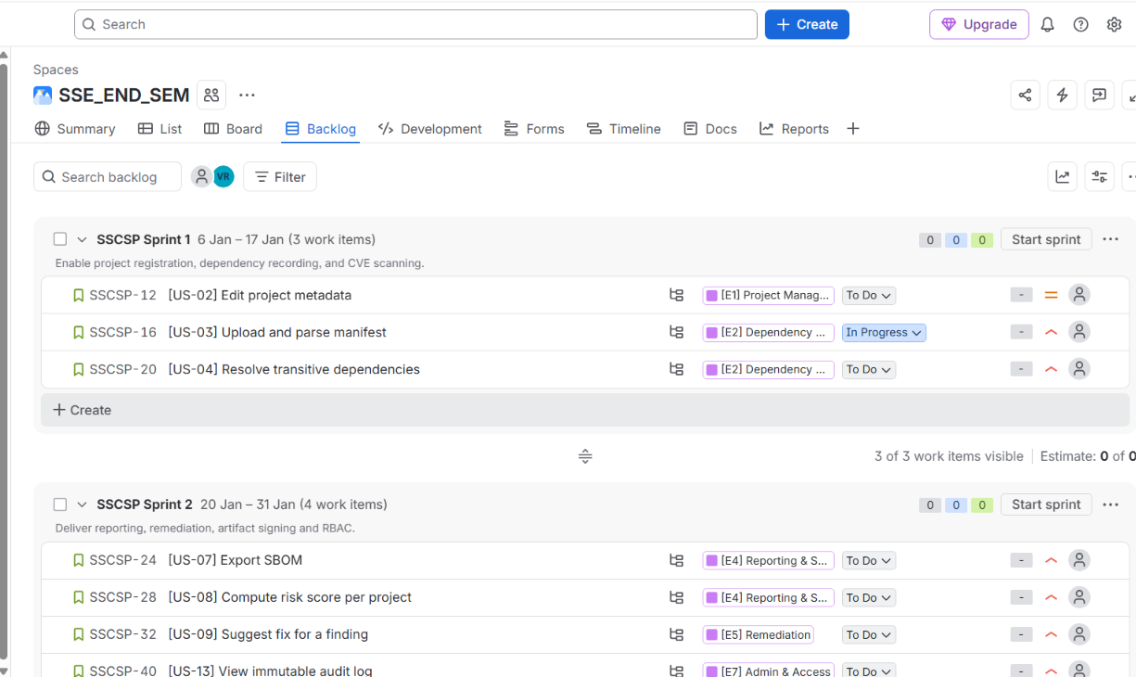

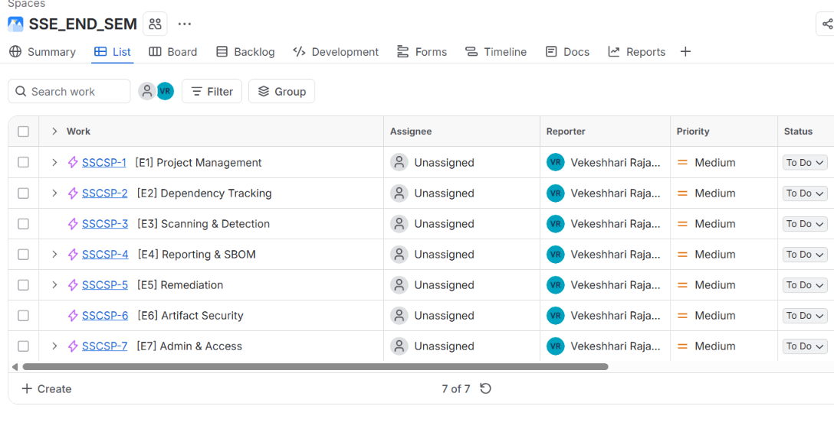

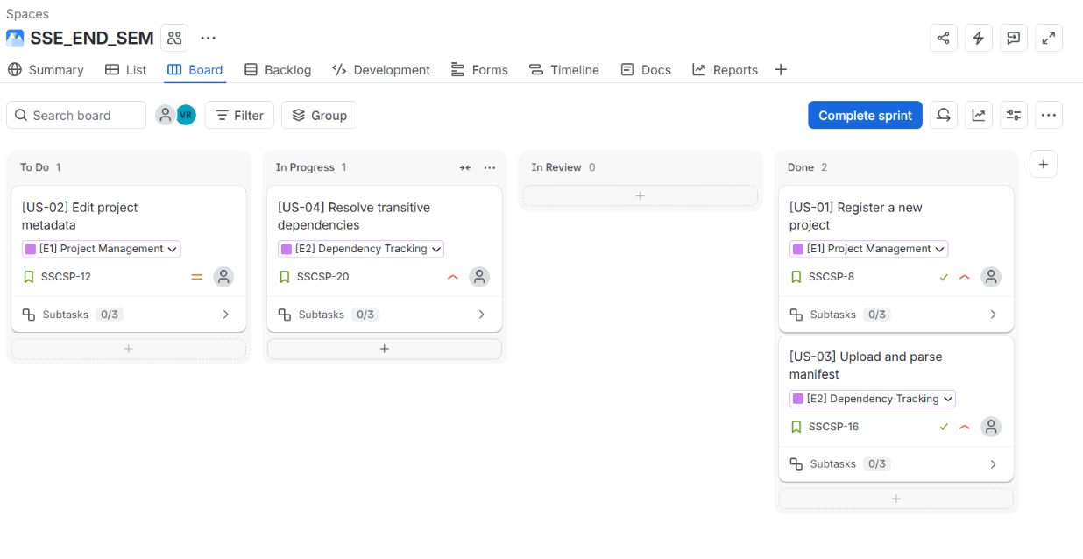

Phase 10 – Sprint Execution and Scrum Metrics
This section documents the execution of Sprint 1 and Sprint 2 in Jira: board workflow, Daily Scrum entries, burndown chart, velocity, defect metrics, Sprint Review outcomes, and Retrospective improvement actions.

10.1 Sprint Board
The board uses four columns: TO DO → IN PROGRESS → TESTING → DONE. Tasks are moved through the workflow as work progresses.

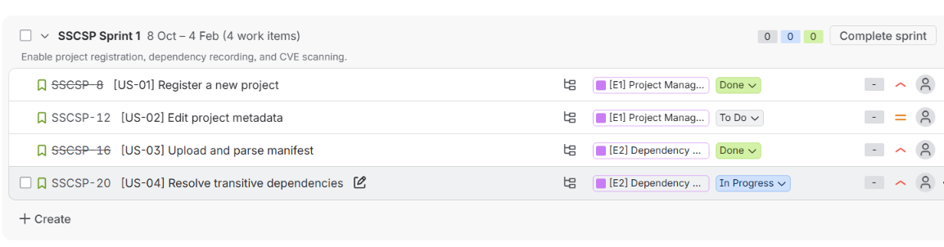
Column definitions:
Column | Meaning | Exit Criteria
TO DO | Story pulled into sprint, not started | Assignee assigned; SP estimated
IN PROGRESS | Development underway | Code written; PR opened
TESTING | Unit/integration/security tests running | All tests pass; coverage met
DONE | Meets Definition of Done | Reviewed; merged; audited; SBOM updated

10.2 Daily Scrum Entries
Three representative Daily Scrum entries from Sprint 1 are documented below. Each entry covers what was done yesterday, what will be done today, and any blockers.
Day | Team Member | Yesterday | Today | Blockers
Day 2 | Dev A | Set up project registration endpoint (US-01) | Write unit tests for US-01 | None
Day 2 | Dev B | Designed manifest parser (US-03) | Implement npm + PyPI parser | Need sample manifests
Day 2 | Analyst | Reviewed CVE feed integration design | Pair with Dev B on parser | None
Day 5 | Dev A | Completed US-01 and US-03 | Start transitive dep resolution (US-04) | None
Day 5 | Dev B | Finished OSV integration | Unit tests + false positive tuning | OSV rate limit
Day 5 | Analyst | Drafted triage UI wireframe | Review with team | None
Day 8 | Dev A | Completed US-04 | Begin CVE matching (US-05) | None
Day 8 | Dev B | Completed US-05 with 3 defects found | Fix defects D-101, D-102, D-103 | None
Day 8 | Analyst | Built typosquat test corpus | Validate detection on corpus | Need more samples

10.3 Sprint Burndown
Sprint 1 has 31 story points (SP). The table below shows remaining SP per day. Jira auto-generates the visual burndown chart.
Day | Remaining SP | Completed SP | Notes
Day 0 | 31 | 0 | Sprint start
Day 1 | 31 | 0 | Setup
Day 2 | 28 | 3 | US-01 done
Day 3 | 28 | 3 | Still on US-03
Day 4 | 23 | 8 | US-03 done
Day 5 | 18 | 13 | US-04 done
Day 6 | 18 | 13 | US-05 in progress
Day 7 | 10 | 21 | US-05 nearing completion
Day 8 | 5 | 26 | Defects D-101–D-103 found
Day 9 | 3 | 28 | Fixing defects
Day 10 | 0 | 31 | Sprint complete

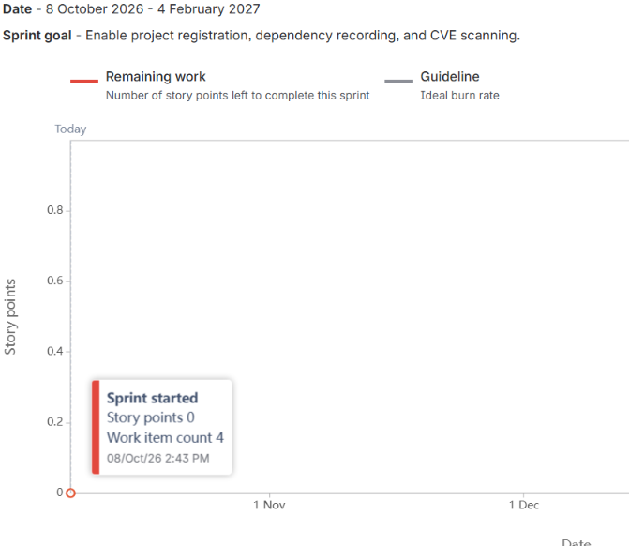

10.4 Defect Metrics
Defect ID | Sprint | Severity | Description | Status
D-101 | Sprint 1 | Critical | SQL injection in login (V-07 real) | Fixed
D-102 | Sprint 1 | High | Missing rate limit on /scan | Fixed
D-103 | Sprint 1 | Medium | Verbose error leaks schema | Fixed
D-104 | Sprint 1 | Low | UI: severity badge color inconsistency | Fixed
D-105 | Sprint 2 | Critical | Signature verify returns true on empty | Fixed
D-106 | Sprint 2 | High | Audit log hash chain broken on concurrent writes | Fixed
D-107 | Sprint 2 | Medium | SBOM export missing license field | Fixed
D-108 | Sprint 2 | Medium | RBAC: auditor could POST /audit | Carried over
D-109 | Sprint 2 | Low | UI: pagination missing on audit log | Carried over

Summary:
Metric | Value
Total defects found | 9
Defects fixed | 7
Defects carried over | 2
Escape rate to production | 0

10.5 Sprint Review Outcome
Sprint Review was held at the end of Sprint 2 with the Product Owner, Security Analyst, and stakeholders present.
Item | Detail
Demoed | CVE scan, SBOM export, ticket lifecycle, artifact signing, RBAC
Accepted | US-05, US-06, US-07, US-08, US-09, US-10, US-11, US-12, US-14
Rejected/Redo | US-13 (audit log pagination incomplete) → carry over
Stakeholder feedback | Add Go ecosystem; add vulnerability trend chart
Next sprint focus | Add Cargo ecosystem + trend dashboard

10.6 Sprint Retrospective
What went well:
• Pair programming caught 2 critical defects before merge.
• Automated SAST gate in CI blocked 3 insecure PRs.
• Sprint Goal achieved for Sprint 1 (100% capacity).
What didn't go well:
• OSV rate limits slowed Sprint 1 scanning work.
• Two defects carried over into Sprint 3.
• Threat modeling was done late in Sprint 1 (after code).
Improvement Actions (≥2):
# | Action | Owner | Target Sprint
1 | Add automated false-positive regression tests for scanner rules | Dev B | Sprint 3
2 | Run a threat-modeling spike at the START of each sprint | Analyst + Dev A | Sprint 3

