**NewHRMS Feedback and QA-Oct.28**

In **General Settings** <http://34.215.47.211/settings/?settings=general> below screenshot:

1. Label should be: **Postal or Zip Code changed**
2. What is **Company Registration**? **Name or Alice of the company**
3. How come the **Mobile Phone** label is on 2 lines and its phone input section isn’t on the same row as the **Company Phone 2** section? **changed**

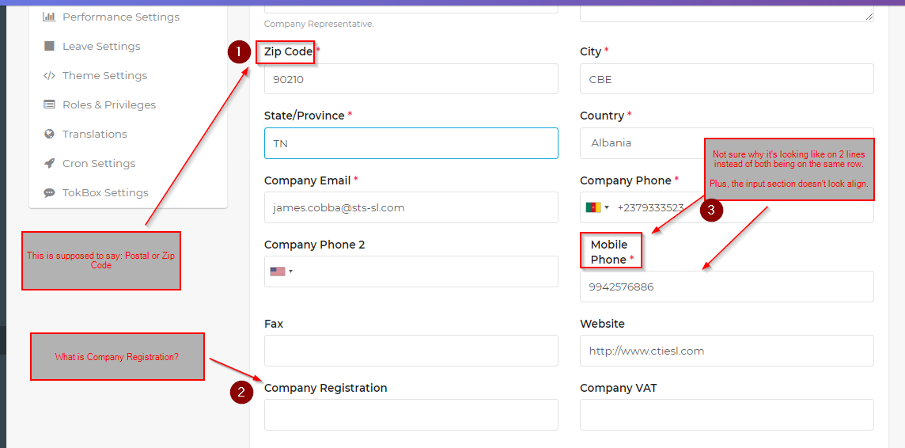

When Admin adds a New Employee <http://34.215.47.211/employees>, where it says **Zip Code**, the label should be:

**Postal or Zip Code changed**

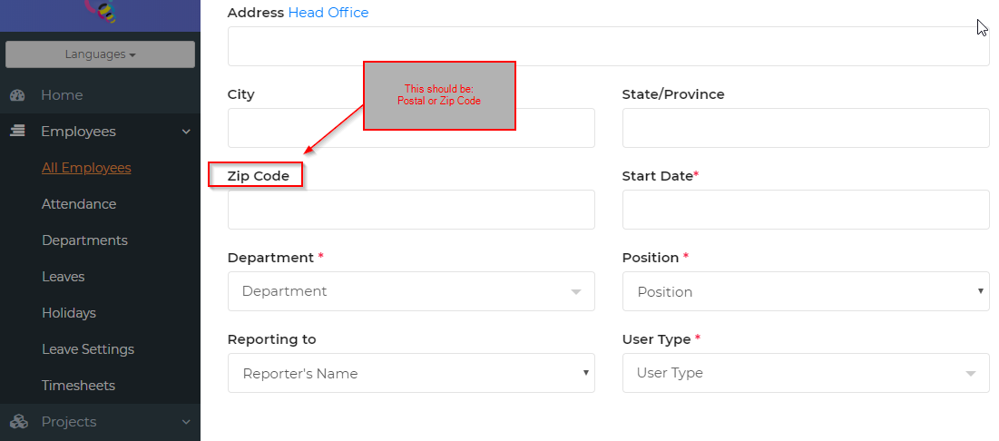

In the Employee account of [solarzane@gmail.com](mailto:solarzane@gmail.com) when they are in the **Edit Profile** section <http://34.215.47.211/employees/profile_view/306>

1. Label should be: **Postal or Zip Code changed**
2. There should be a red crossed out circle when user hover mouse over the **Department** section. **changed**

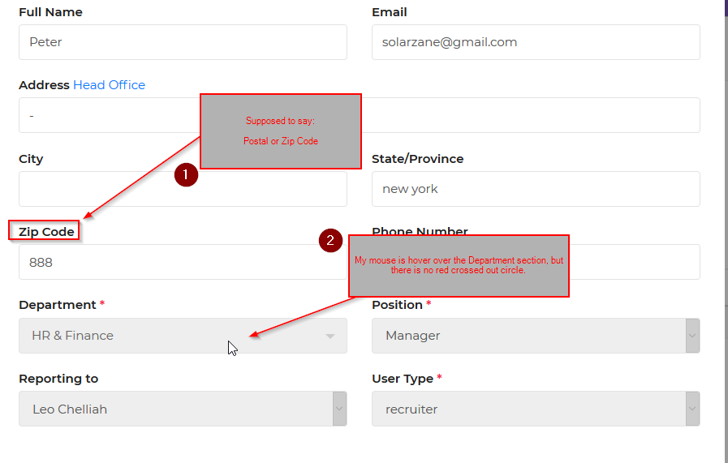

When **Admin** view/edit an **Employee** profile, it doesn’t show what the **User Type** is ie. <http://34.215.47.211/employees/profile_view/227>

1. Label should be: **Postal or Zip Code Changed**
2. Doesn’t say what the **User Type**/Role is These employees are old data’s ,user type is newly added ,so we have to update the user type for old record

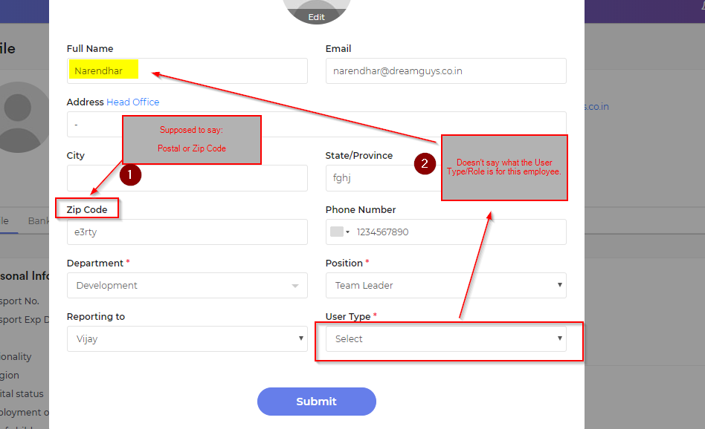

**Leave Settings** has not been moved to the **Settings** section yet. (brought up on Oct.14 doc, top of P.9) (Not done on both <https://newhrms.com/livehrms> and <http://34.215.47.211> ) **Moved**

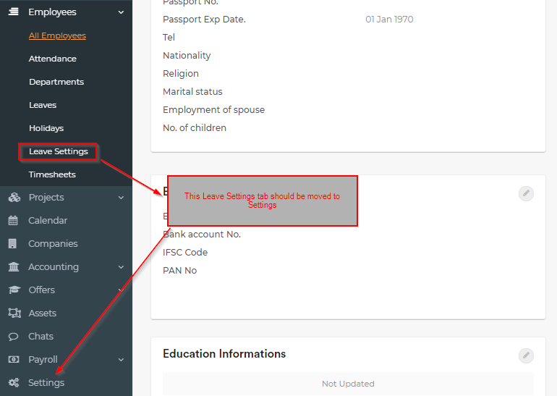

I brought up the below question in my **Feedback and QA-Oct.20 Updated** document, but yet to receive a response:

When an employee logs in ie. [solarzane@gmail.com](mailto:solarzane@gmail.com) the domain shows <http://34.215.47.211/collaborator> are we able to hide the collaborator? If not what are some options? If we remove are change the collaborator mean it will affect many functionalities, so it will take more time, so shall we take this on next phase

What would happen if the Policy is too long like the below example? If it is have more than 200 words mean it will display Read more option, click the Read more option then modal will display

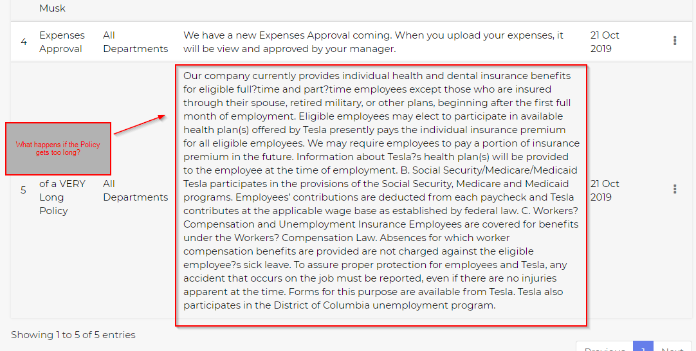

I logged in as an **Admin** and added a Policy for All Departments, but when I login as an Employee under [solarzane@gmail.com](mailto:solarzane@gmail.com), I don’t get a notification. Fixed

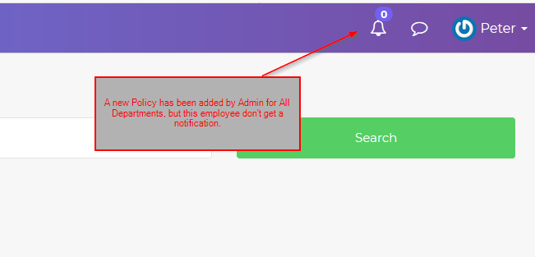

When the **Admin** is view the Employee’s profile [http://34.215.47.211/employees/profile_view/243#](http://34.215.47.211/employees/profile_view/243) :

1. What does the **Send Message** button do? It will get to chat page
2. When I clicked on the supervisor/manager’s name **Vijay**, nothing happens. Isn’t it supposed to take me to that person’s profile? It will redirect to vijay profile

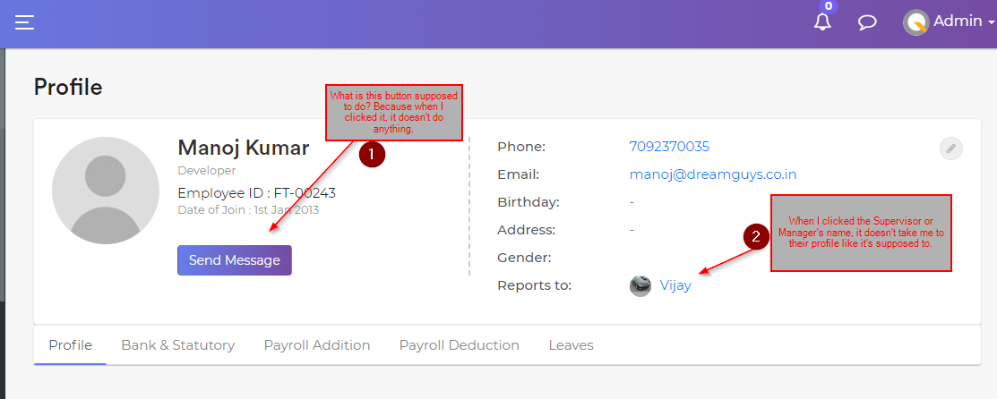

About the **Performance** modules, where is the configuration section for rating, etc?

Ie. It have displayed settings-> performance Settings->under the SMART goals

**OKRs Configuration**

Choose Your Rating Scale

 0.0 – 1.0  1-5  1-10  Custom

(Below is what happens if the radio button 1-5 is clicked from the above)

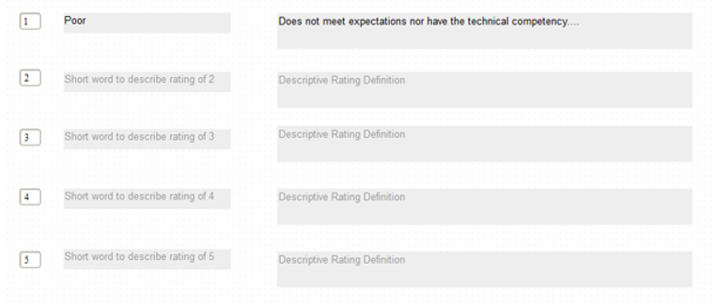



(Note: I will provide a list of **Descriptive Word** and **Definition** to make it easier for company but an Edit icon  should be added to each section so the Admin can change the **Descriptive Word** and **Definition** if they want to.