**Feedback**

1. When you logg in, sometimes you are sent here ..? **- Fixed**

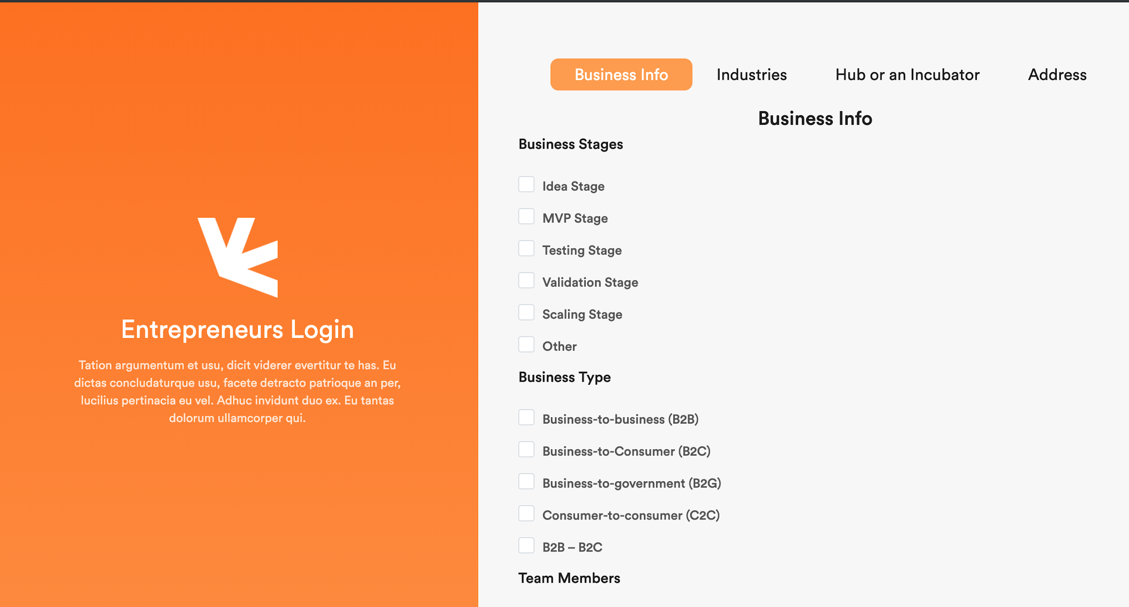

Or here

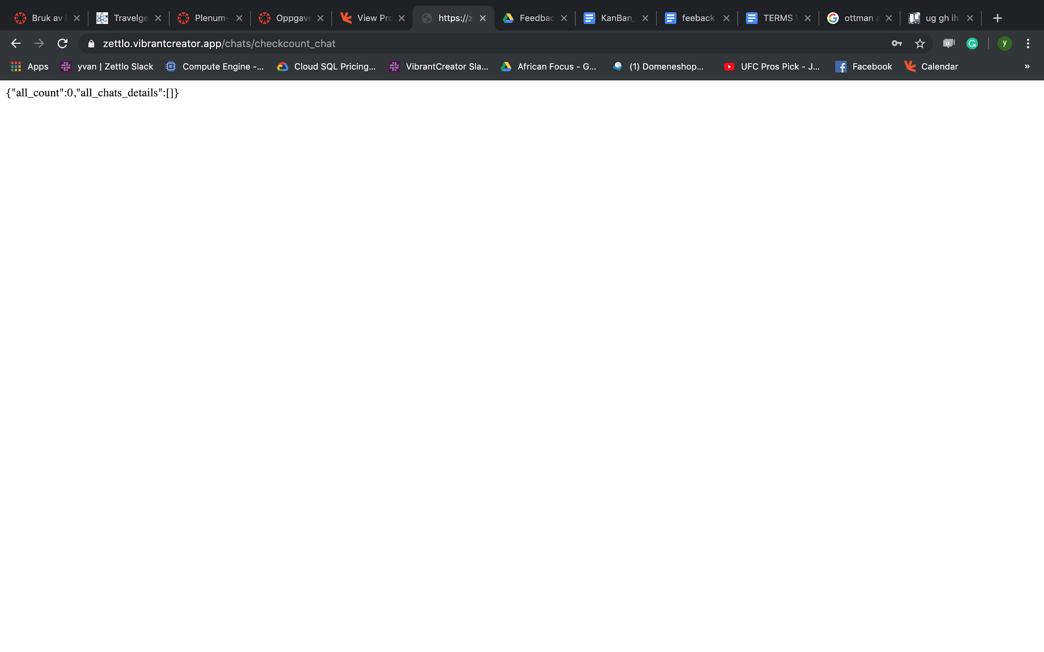

1. Look, the modules setup and names on teammembers and admin user. – Fixed

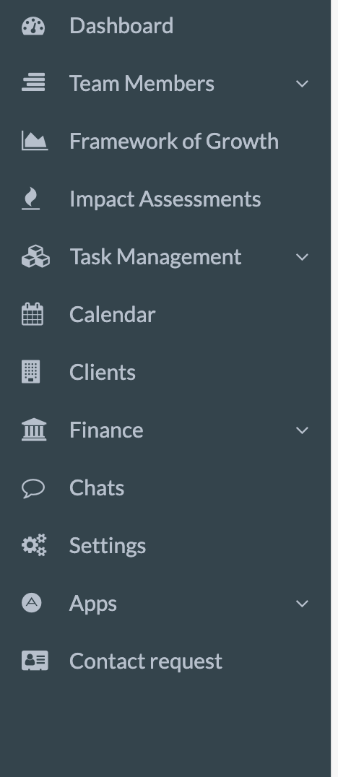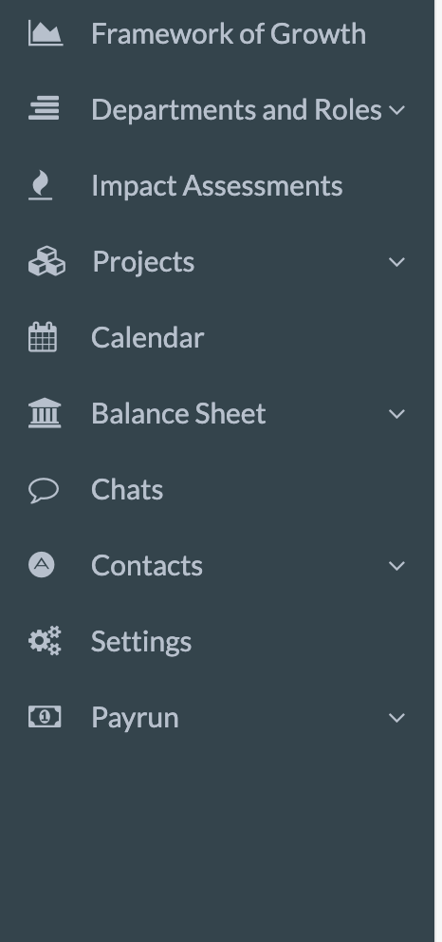

1. Why do i need to mark to add more teammembers...i should be able to add more teammembers without using ctl - click **- New Update**

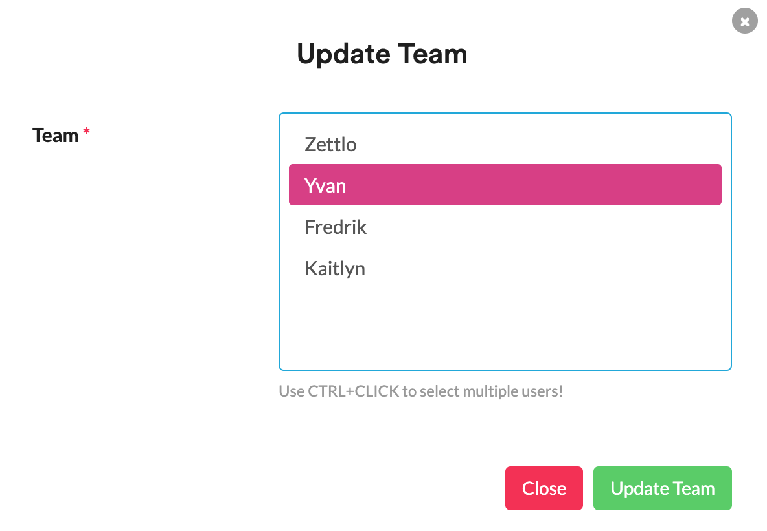

1. Task management: the confirmation boxes are popping up on each other. And sometimes when you move the boxes they fall back. – We will remove the notification as it needs some time for loading as you are trying multiple clicks in a sec.

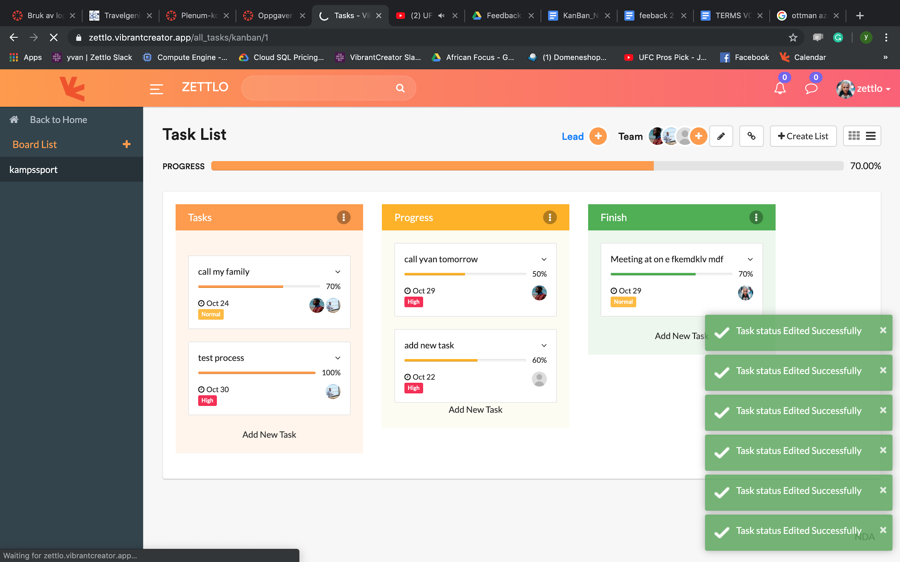

* The chat

1. Remove apps, it should just be massage that’s it. --- As APP is the main menu if it needs to move to the main menu we need additional time 1 days to update this

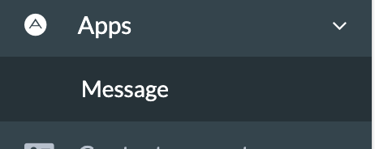 **Fixed**

1. Menu control – Not Fixed **Fixed**

* Many modules which are on the option which shouldn’t be there such as: assets, pay run, tax rates, social assessments etc.

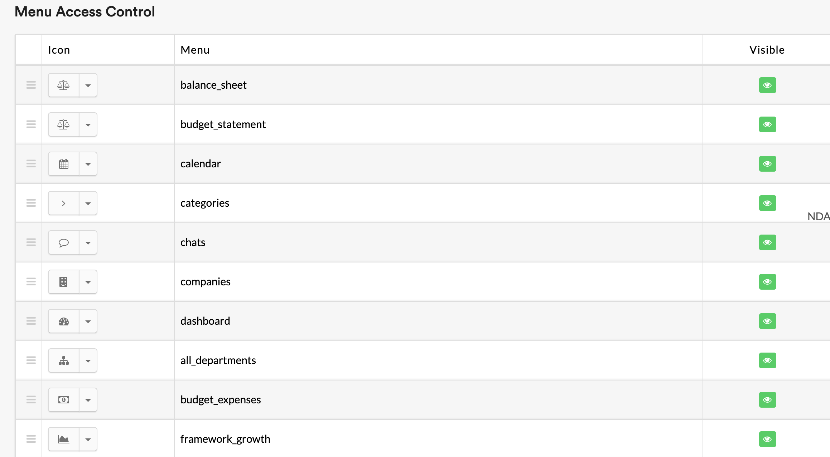

* The modules option which should be there are the ones which admin have access to...I wrote and mentioned this recently...
* When you move access to modules on team members the window pops up, it should remain in the same place. here ...



* Team members have access to settings which they shouldn’t have -- Not Fixed – fixed
* Problem on cliqs when tou are adding menus to team members – fixed

1. Timesheets are shown from other member accounts which are not connected to each other—Not Fixed **Fixed**
2. NDA should pop up first time you logg in, and then be put on the side and not in the modules – Not Fixed **Fixed**

Here

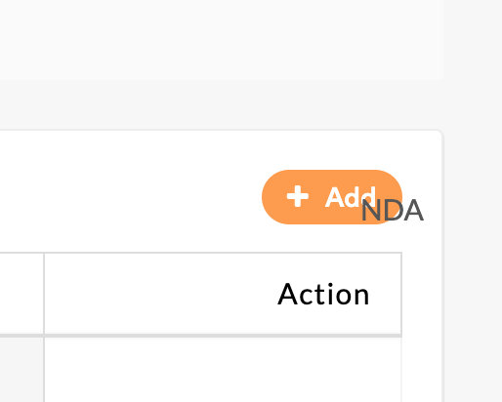not here…

* And its blocking me from cliqing on other things…

1. User agreement and policy

The text box...am adding user agreement and the policy text but it somehow limits and dont show all the text that i have added. It cuts. ----Not Fixed

* <https://drive.google.com/file/d/1CvdPdRLX7m71OTRubO_UqdHuBwxuuUg3/view?usp=sharing>
* <https://drive.google.com/file/d/1VOgLATdwMkjqbfRp508zuH2hNnOHEGQO/view?usp=sharing>

1. Impact assessment is not responsive...basically most the modules are not responsive depending on size -------design issue Not Fixed

* And when you adding on outcome...description is not showing. **Not Fixed Fixed**
* Should be able to cliqu in and see description (this is something we have been through previously)
* When adding objectives, sometimes is not popping up

1. Financials: we talked about this to be removed...still there. –**Not Fixed Fixed**

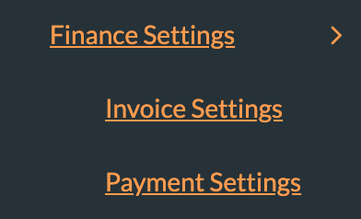

1. Adding contact person on clients….this is something we have been through before and its now not working – Asked menu list for the client once they give we will add those for clients with extra time

* Cant edit or add picture of the client?? ... From investors, select company and give connect from profile is not working Fixed
* Thing are not consistant here…

1. Investor search -- Fixed

* The setup up is not correct...we discussed this last time about what to have there



* When you clique on profile of investor you are sent to team members
* This are not things that should be shown for investor profile. **Client asked to remove the below one and when we click the investors its taking it to the team member menu selection, need to fix**

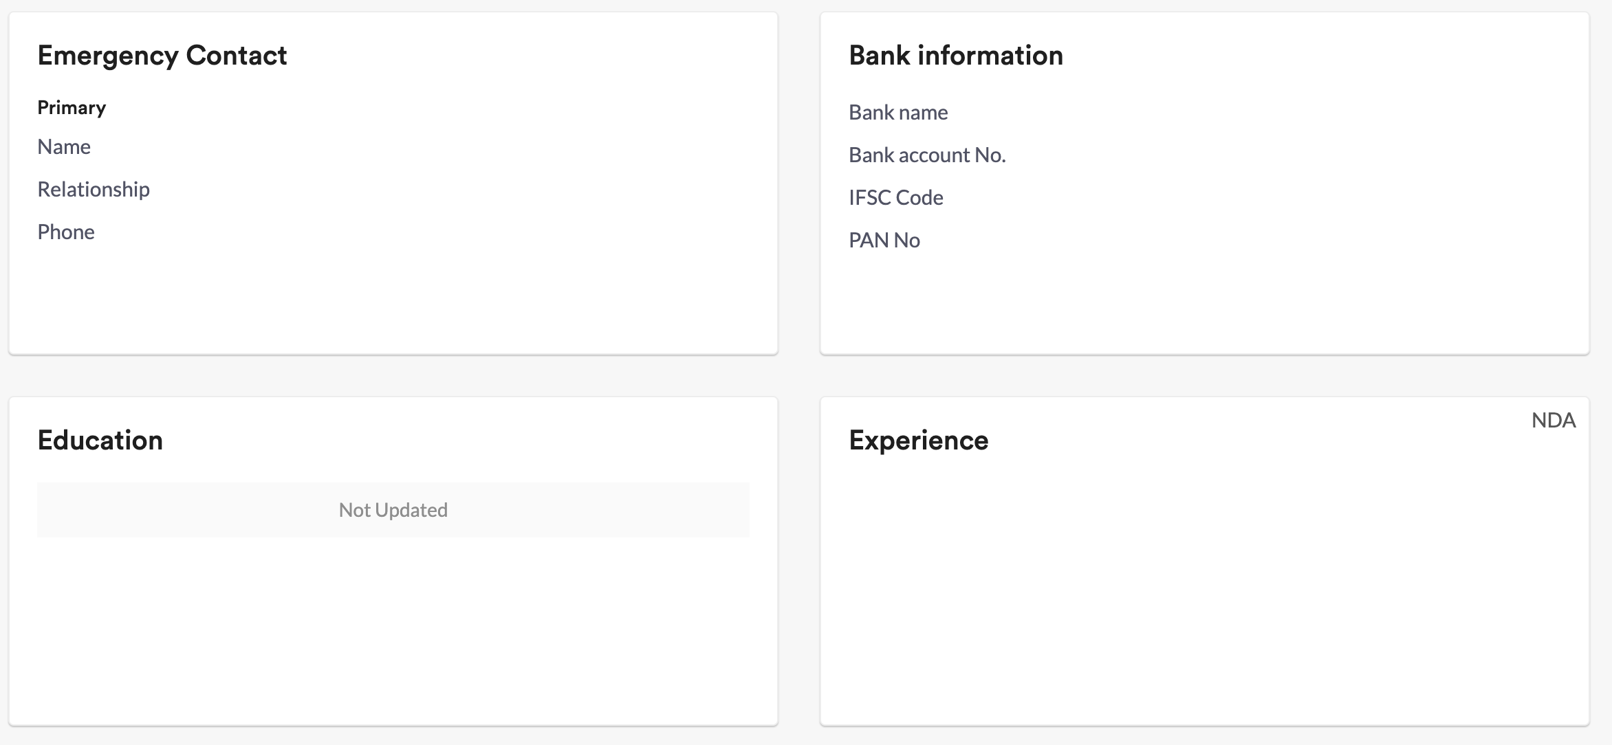 **Fixed**

* Should also show investors you have connected to a new tab **– Not required but need search option**
* Should show investors you have made connection to. And should chat...this is something which is no longer working. – Need to fix **Fixed**

1. Text box --- No Need this option for now.

We asked this to be widen on the side as well, so that its bigger on the side not downwards only. 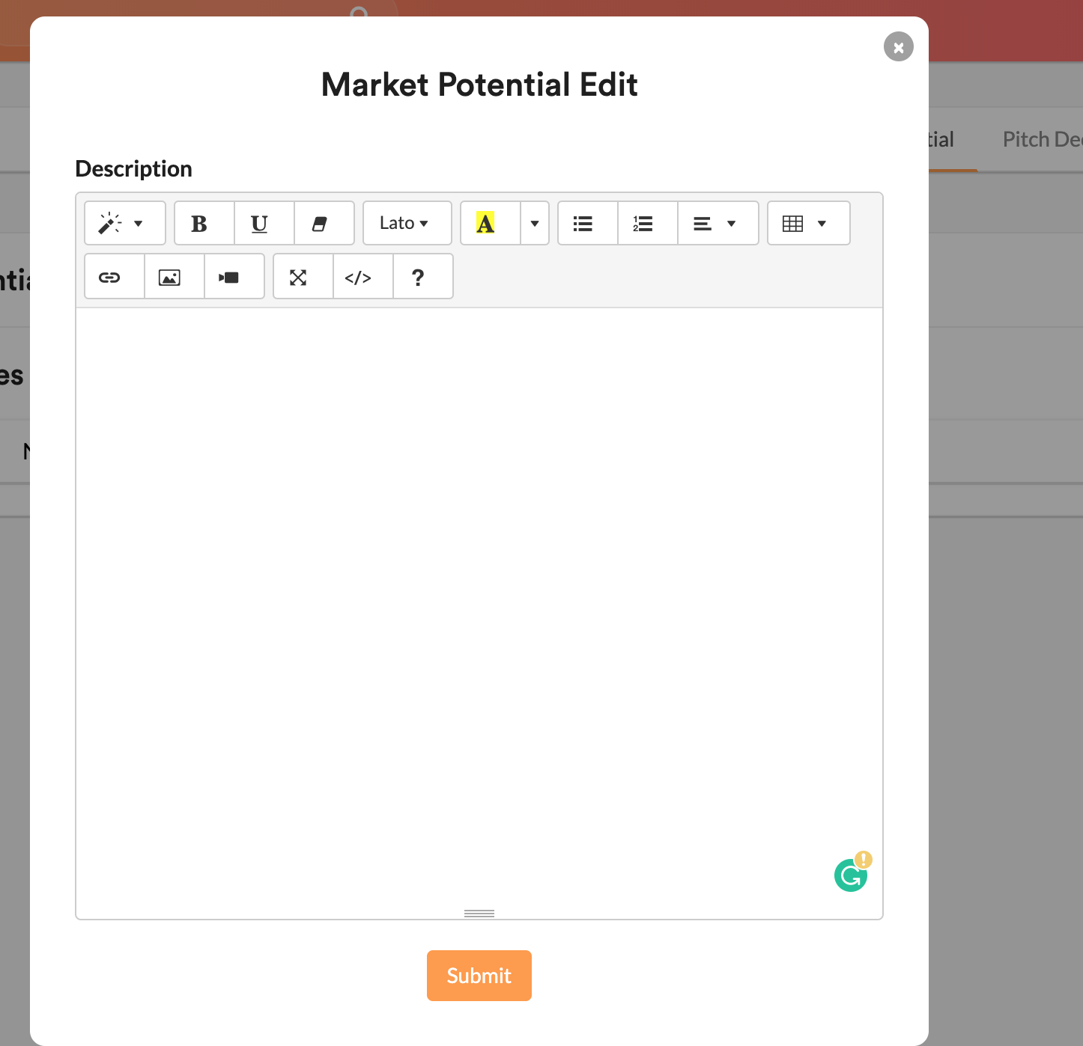

1. Team members -- Need to fix

* Projects and task management...coming up two times. **Fixed**

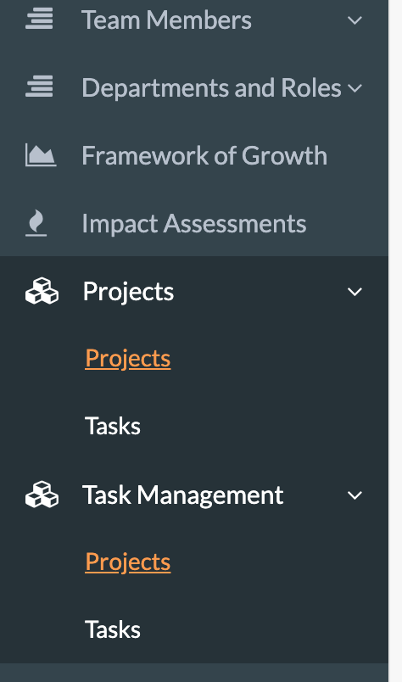

* Things are popping up two times



* This is

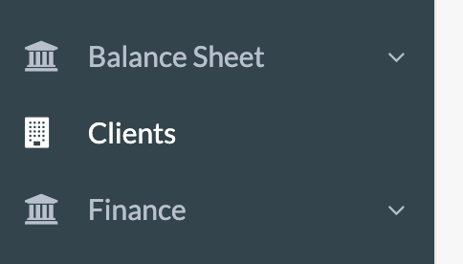

1. Creating an investor user – These are all present changes and we need additional time

* The investor logg on the logg in form the setup is not correct.
  + On title here: should be changed to: what describes you best. And they can choose multiple.
  + On company stages, business type...this is as mantioned not describing who they are but what interest they have in companies. So the overall title should be Type of companies interest, and then they can choose stages (multiple), business type (multiple) Fixed
  + On Industries...the overall title under industries should be “Industry interest”.
  + On do you have interest in investing: should get option on amount under total amount of investment (check the last document). Id they cliq no then, they shouldnt get the box up.
  + Mobile ...country code suggestion is not showing.
* The NDA doesnt pop up so they can read and agree
* Getting the notification that my email is used...this is something i mantioned that shouldnt happen. – Fixed and it is tested
* Sending connect request doesnt work. -- Fixed
* Cant add picture on investor profile. – From investors profile it needs to update not in the business side as it will be just view option
* Activity feed not working – Only admin feed will be monitored
* Top countries and top cities is not adjusting to actual campanies that exist. -- Fixed

1. Superadmin - **Fixed**

* Editing subscribers type...not working well.—Description is there to edit but it is not updatable, if it not takes time need to fix it