* NEWSFEED  
  Newsfeed links on the newsfeed page (<https://www.planetlawyer.com/feed>) according to categories and subcategories on blog posts are not complete
* CHAT  
  I’ve checked the chat and don’t see where the talks are received in the dashboard when a person sends a message or where to reply to the discussion to start the conversation. Are there features like the Tickets dropdown box: All chats, Opened, Closed, Assigned? If not, they should be installed.
* TELEPHONE NUMBER  
  By now we need to hide the phone number on the front page and the contact us page:  
     
  On the Contact Us page, instead of the phone number icon and link, we need to place Create Ticket with the Icon and link.
* The Contact Us link in the main menu we will move it to the drop-down box in HELP main Menu link to save space on Main Menu links  
  HELP   
  CREATE TICKET  
  FAQ  
  ANNOOUNCEMENTS

KNOWLEDGE BASE

CONTACT US

* FOOTER  
  Change the links for the ones below.

|  |  |
| --- | --- |
| **RESOURCES** | **SUPPORT** |
| Search Lawyers | Create Ticket |
| Login | FAQ |
| Register | Contact Us |
| Blog | Knowledge Base |
| About Us | Announcements |

* SOCIAL MEDIA  
  Add Linked In Social Api & Links
* Is Twilio Connected?  
  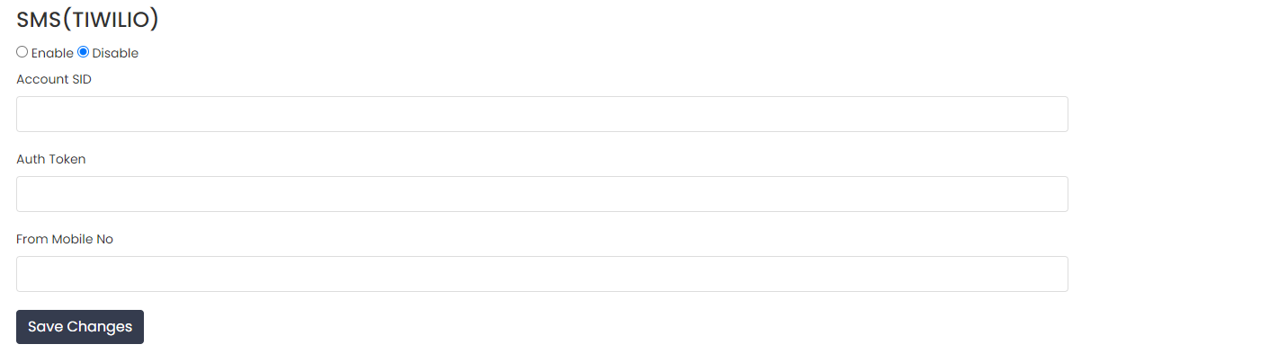

Also, can it be enabled and be sure we won’t trouble as in the past that cost money?

* CONTACT US FORM

In the Get in Touch form, please make something similar to this with the fields:  
<https://fliwin.com/test-form/>

* PHONE NUMBER FRONT PAGE  
  On the front page, please hide the phone number  
  For now, we won’t use calls. In the future, we will use it. So only hide it.
* MIRROR SERVER INFORMATION