1. Registration / Login – Register a new user and Login with it

* (Required Fields on Registration: **User Name, Password, Confirm Password** )
* Need Authorization before do main action on home page

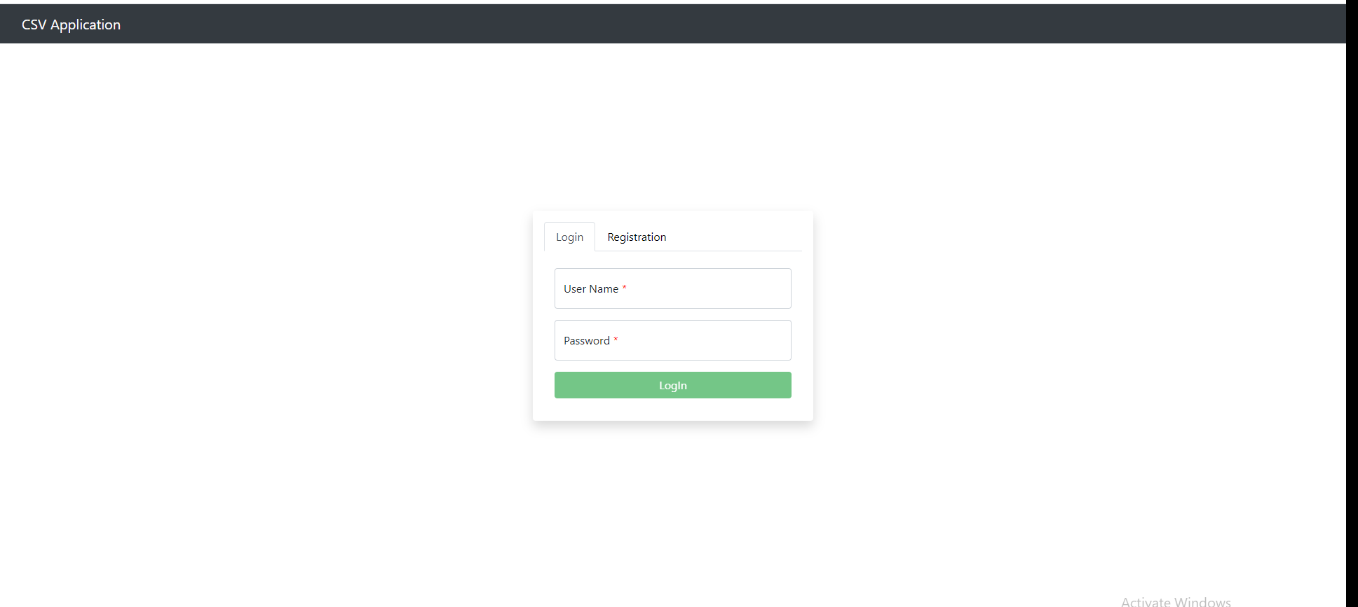

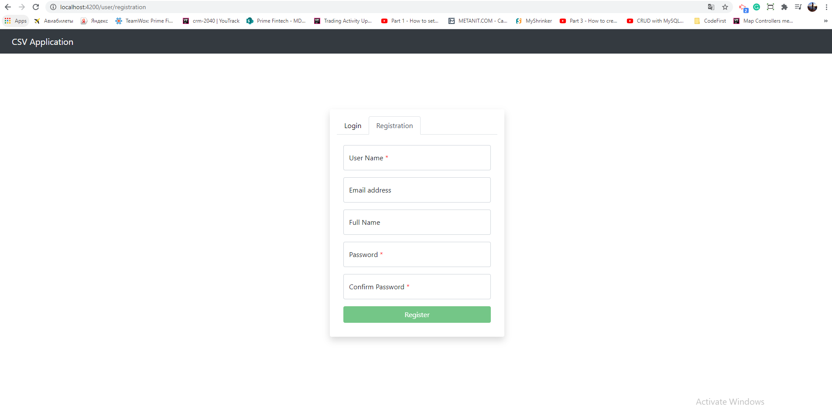

1. Login and try to upload new sales or add them manually clicking on **Add new Sale** button

* Can Upload only .csv files
* If no data active should be only **Add new Sale** button and **Upload File** buttons

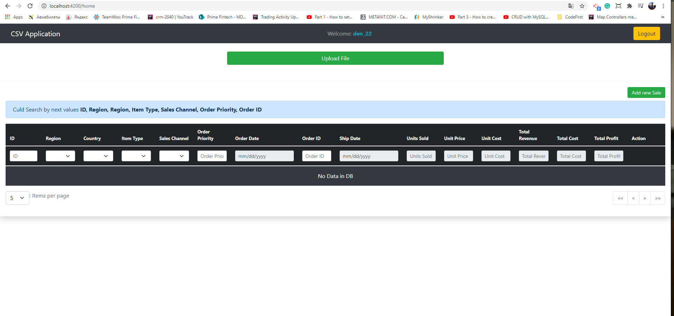

1. Click on **Upload File** button and select .csv file from site

* http://eforexcel.com/wp/downloads-18-sample-csv-files-data-sets-for-testing-sales/ 
* This file uploaded 1 - 1,5 minutes
* After upload finished it should show success or failed message and add data on Table

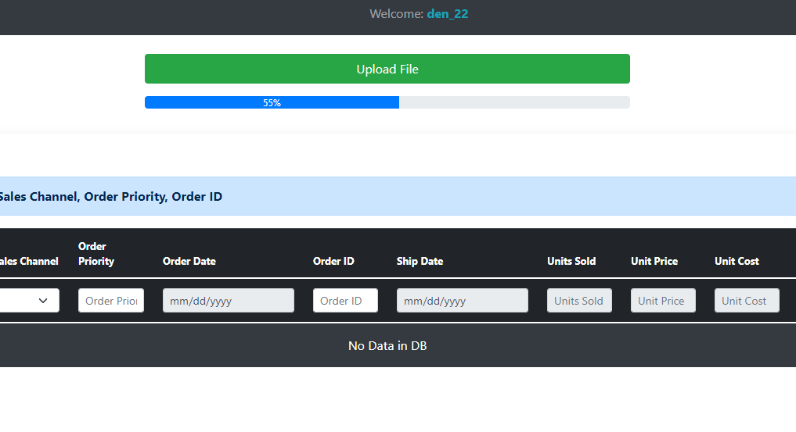

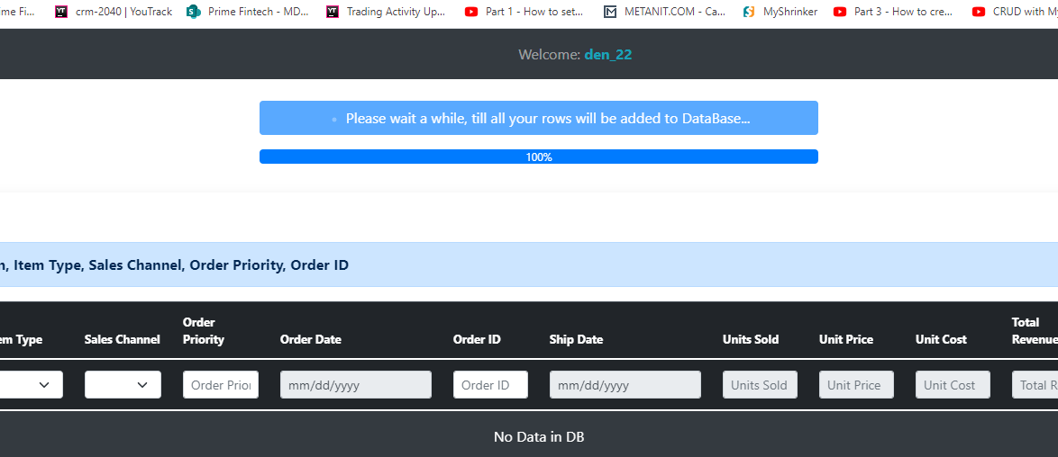

1. When data added on Table? Should be activate **search, delete, edit, clean buttons**

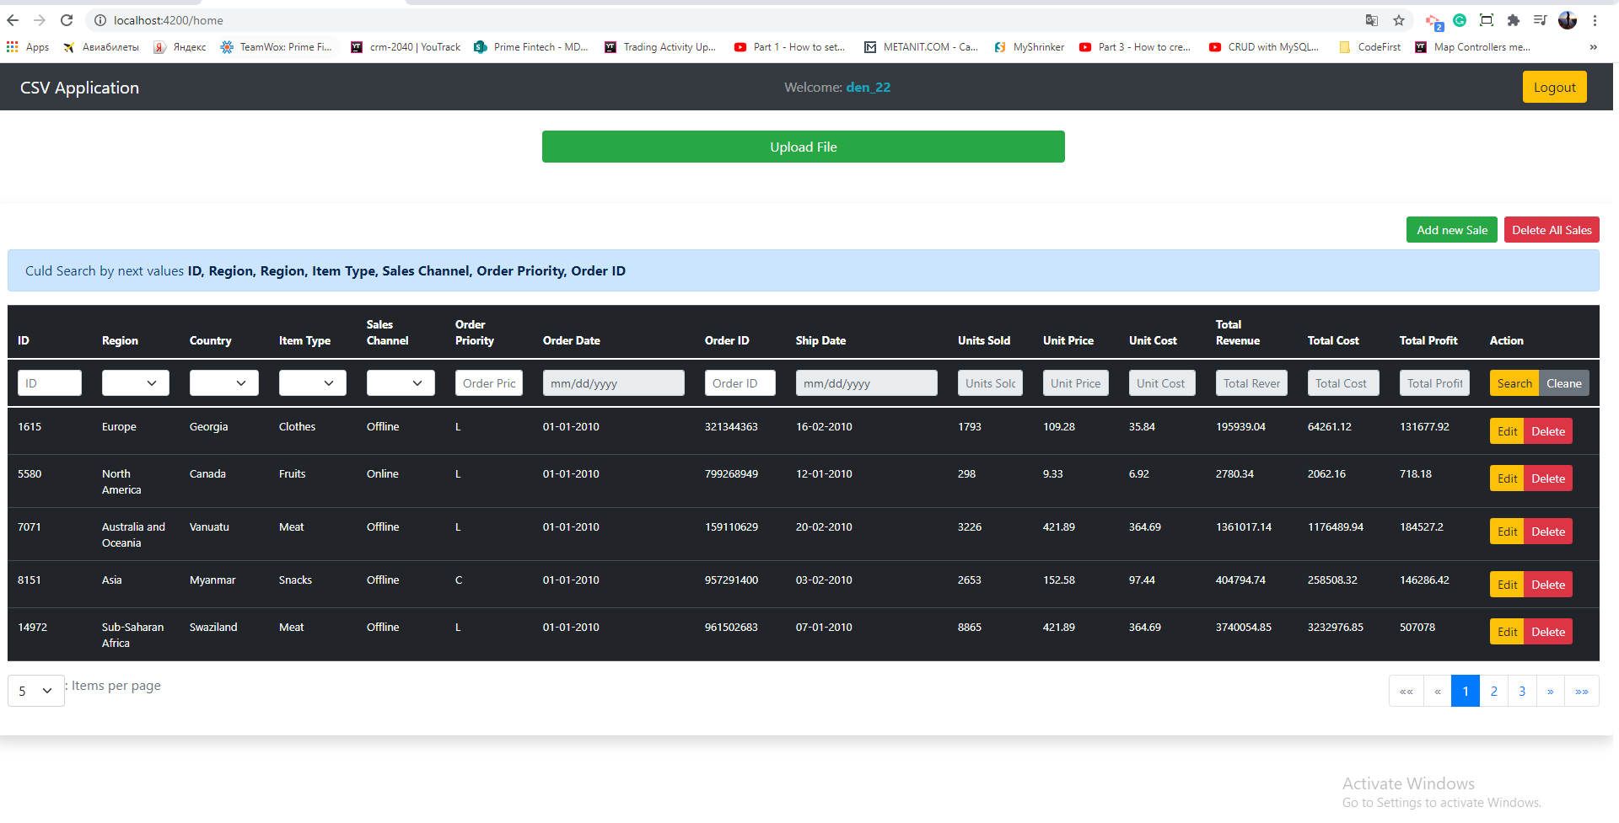

1. **EDIT CLIECK 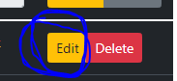 –** should hide buttons that couldn’t be use when **Edit** action is activated

* After click all row data copied on search fields for editing
* Validation **ID** field disabled because it couldn’t be changed, Save Changes button disabled till all fields will not be written in
* Click on cancel it should return all buttons back and clean fields

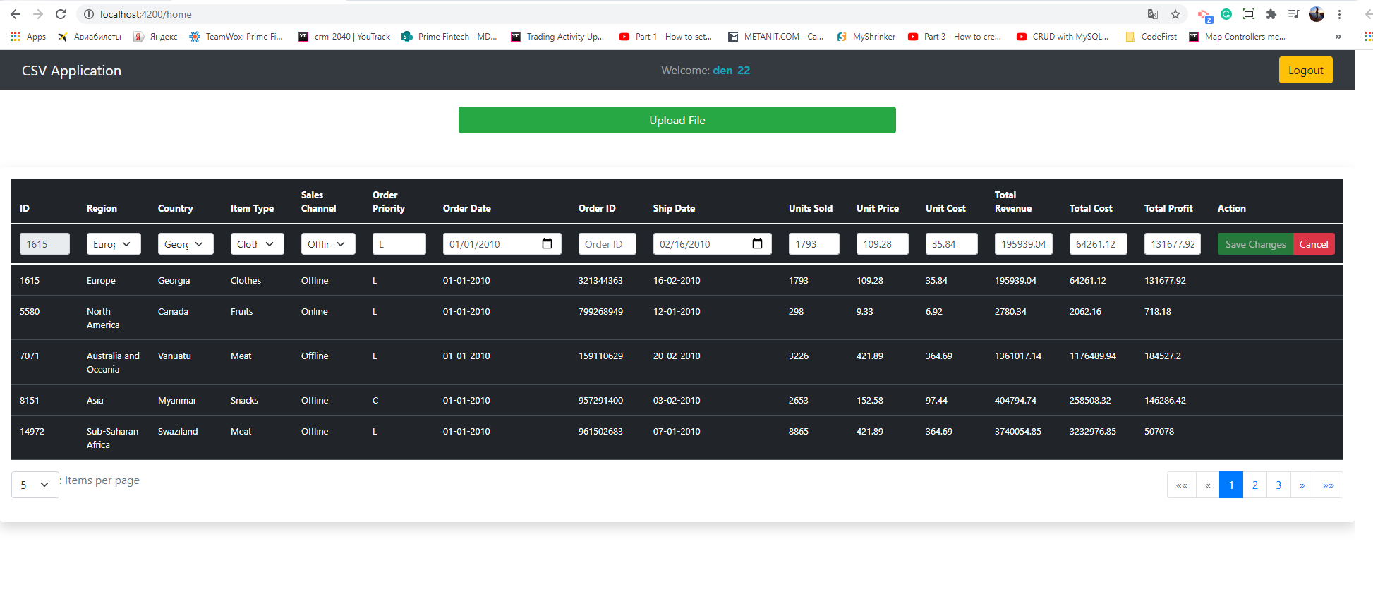

1. **DELETE CLICK 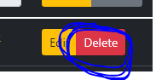 –** should hide buttons that couldn’t be use when **Delete** action is activated

* After click on the top center of the table should show alert field with notification about delete or not, selected Sale
* If click **Delete** row will be deleted and table page resorted
* If click on **Cancel**  button then return all buttons on there places and alert field hided

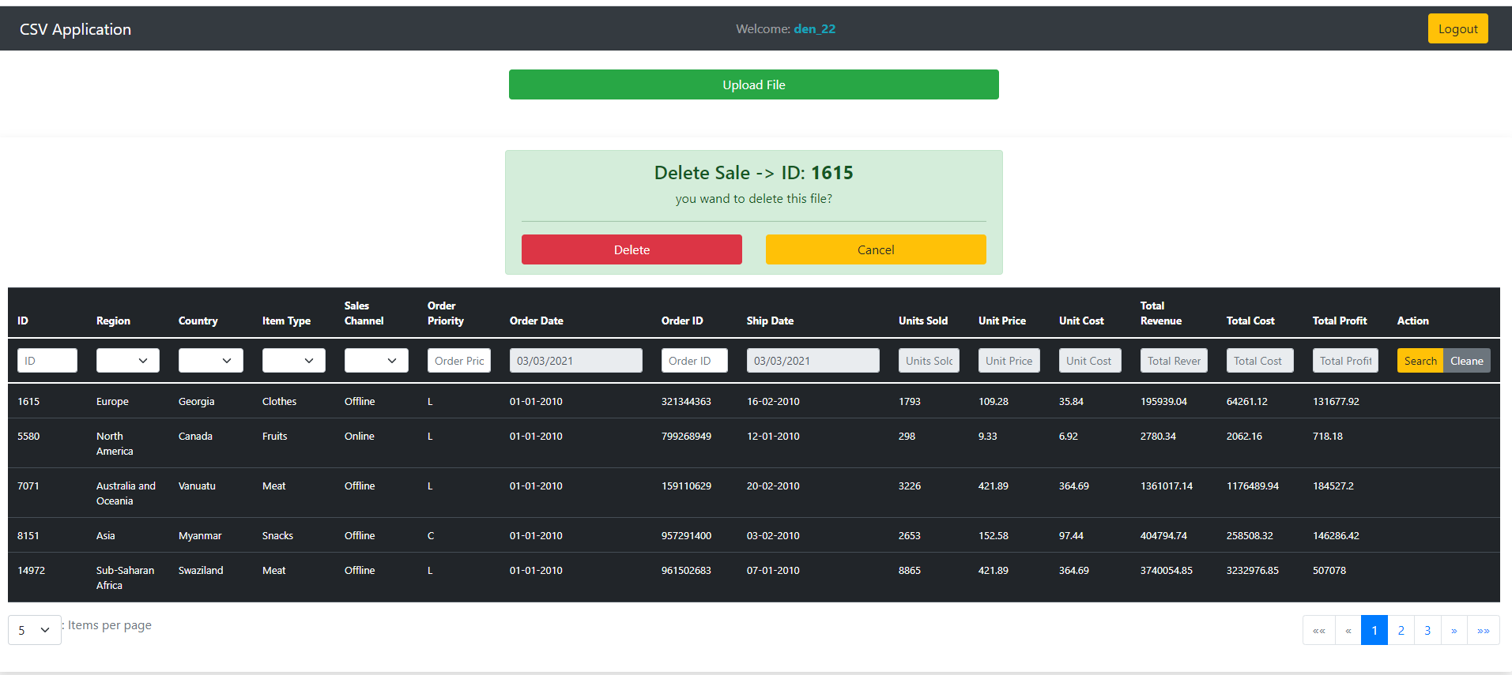

1. **Search Click –** have an alert info message with searchable fields

* Searchable fields (**ID, Region, Region, Item Type, Sales Channel, Order Priority, Order ID**)
* Click on **Clean** button- if should clean all fields
* Click on **Search** it will add new data on table by searchable dates

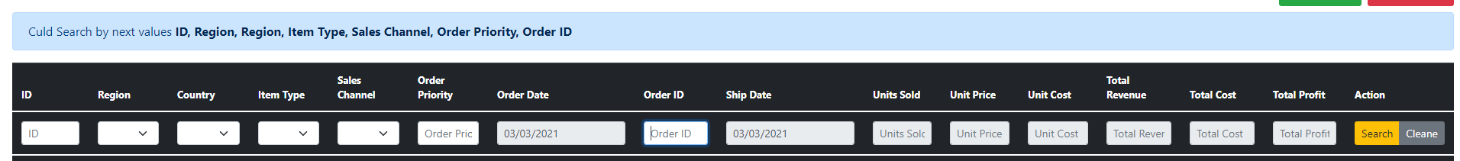

1. **Add new Sale** button click 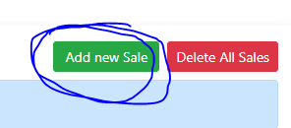**–** should hide buttons that couldn’t be use when **Adding new Sale** action is activated

* **Validation :** all fields is required, **Create** button will be disabled till validation will not be completed
* **Date by default add today date**
* **ID**  disabled it shouldn’t be added
* **CANCEL click -**  then return all buttons on there



1. **Delete All Sales** button click 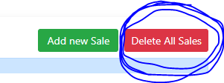**–** should hide buttons that couldn’t be use when **Delete All Sale** action is activated

* After click on the top center of the table should show alert field with notification about delete or not, All Sales rows from DB
* If click **Delete All -** all rows will be deleted and table page resorted (**IT will take 1-1.5 minutes**)
* If click on **Cancel**  button then return all buttons on there places and alert field hided

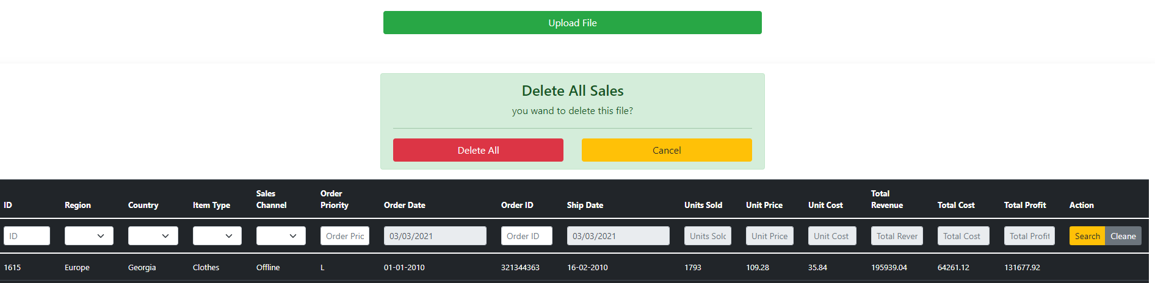

1. Click **Logout – will kill the session and you should login again if want to see home page again** 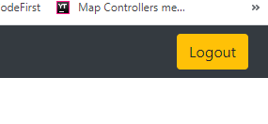
2. **Pagination loaded by Items per page**

* If change **Items per Page** it will make rebuild table
* If click on other page it will return data on next page that you clicked