BOMEM JEOL (USAGI)

Old PGA (EOL 20 years ago lol)
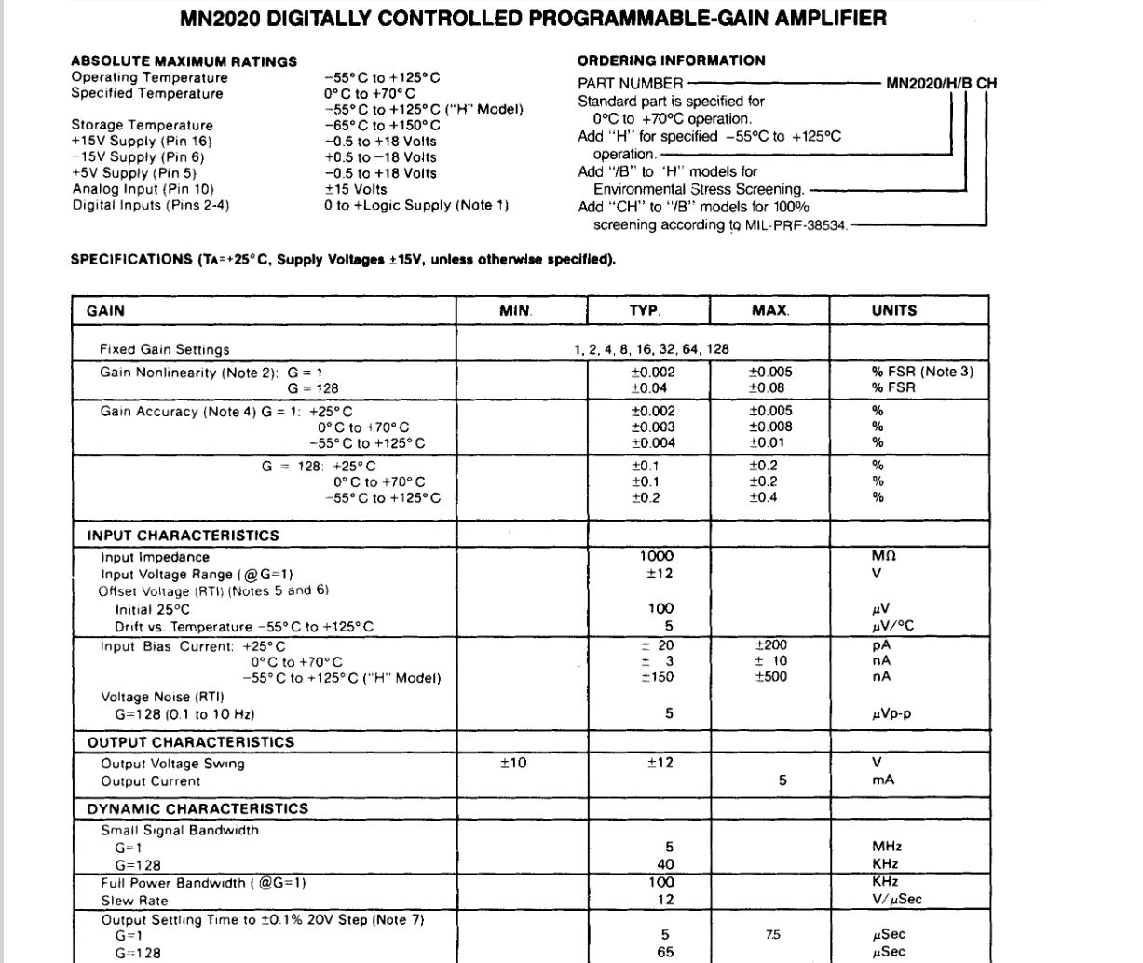
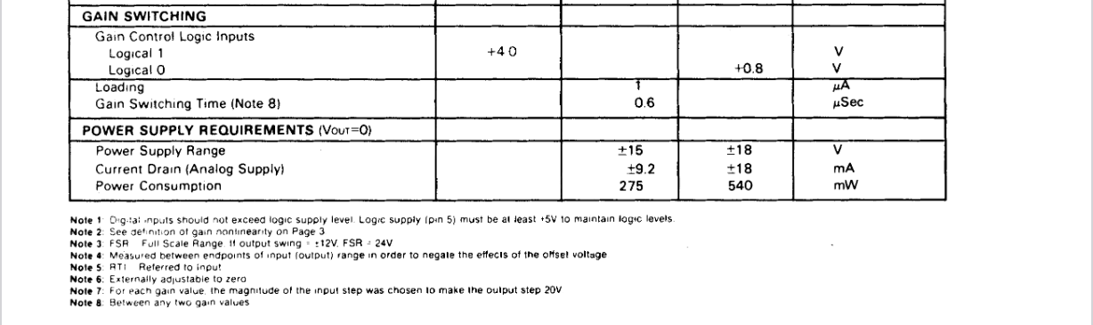
https://www.mouser.com/datasheet/2/382/mn2020-3324428.pdf
ADC used in the measurement board
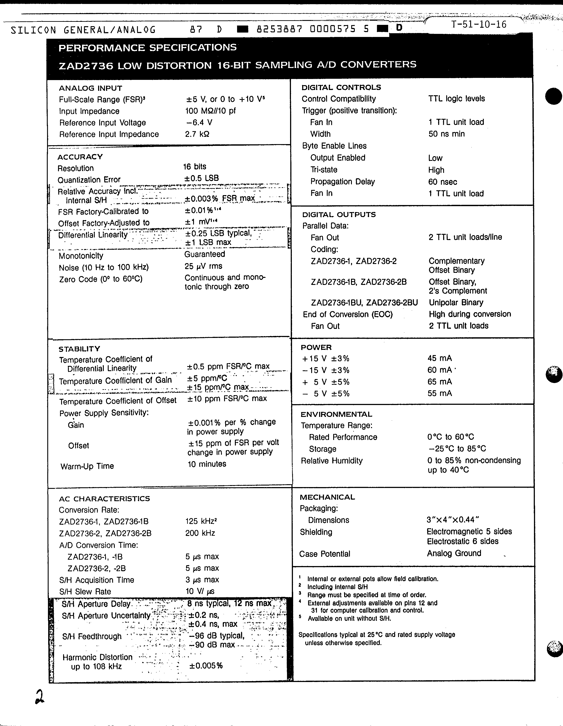

As the preamp board produces amplified signal from +-12V with added gain, the signal output range is accepted from +15V to -15V which is the supply range. The measurement board takes the signal and scales it back to the FSR of the ADC at the +-5V range.

For the PGA281 to work as the replacement there’s couple of things that needs to be taken into account. The old MNA2020 provided the correct output voltage for the signal processing without any additional circuitry. The preamp used voltage follower to buffer the output, but nothing else.

PGA281 has key requirements from the GAIN stage to the output to match or have maximum of 6V between the digital core and the output stage which means in practice that the voltage at the output is 5V to ground.

As such the output stage has to fulfill the following requirements:
- Subtract the common-mode voltage from the input
- Restore signal amplitude
- Filtering

PGA281 provides differential support which would allow much more reduction in the EMI, but to support this you’d need to convert it to single-ended at some point either way.

For better output stability, it would be preferable to drive the VOCM from a reference supply (additional bom).

Additionally the gain provided by the PGA281 wouldn’t match what the original part had.

