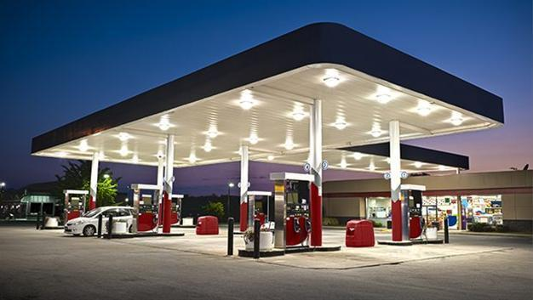

|  |
| --- |
| Petroleum  2021-2022 Spring  Cet322 final project |
|  |
| hazırlayanlar  Kaan Karameşe  Veli Kıloğlu |

# The Purpose of Project

|  |
| --- |
| **Petroleum is a web application offering opportunities for calculation and recording of fuel consumption by using SQL, reading news about automotive world , finding gas stations, monitoring fuel prices instantly.** |
| The Target of Project Our first aim when creating Petroleum is to satisfy the needs of users about their vehicles. For the nonce, users can calculate and store the average fuel consumption for their cars, search gas stations on map, and read news about automotive industry. We will work to complete our vision and offer new improvements in technology for our users. |
| ***Design Details and Highlights***     * Petroleum has a basic interface. In this way, we invite not only the young car owners, but also the elder users. * Users can create accounts and login by using their emails and passwords. |

* Users save average fuel consumptions without any distinctions on brand, model, and year. Thus, in addition to car owners, people who own any motor vehicle such as motorcycle, tractor etc. can profit by using this app.
* If users analyze the changing fuel consumption of their vehicles in long period, they can detect some problems such as their worn out spark plug.

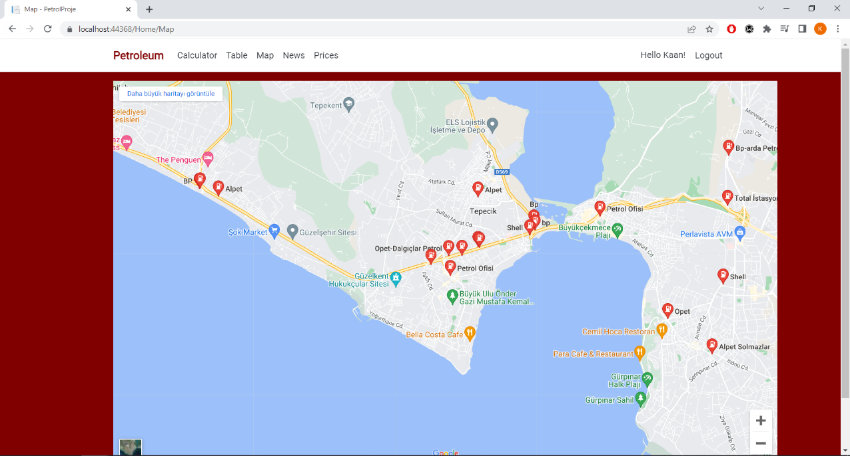

* 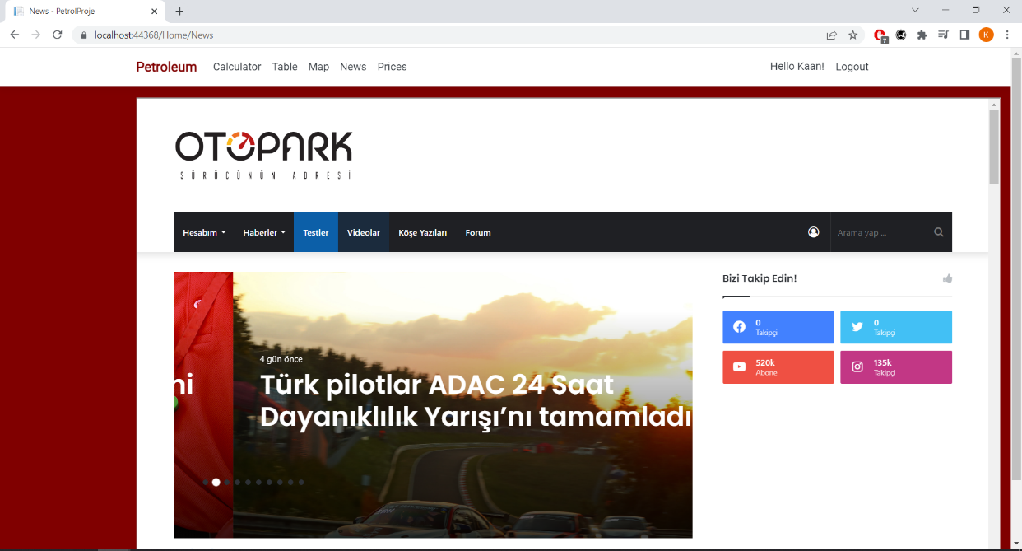In map section, users can find nearby fuel stations.
* In news section, users can read about the automotive news.

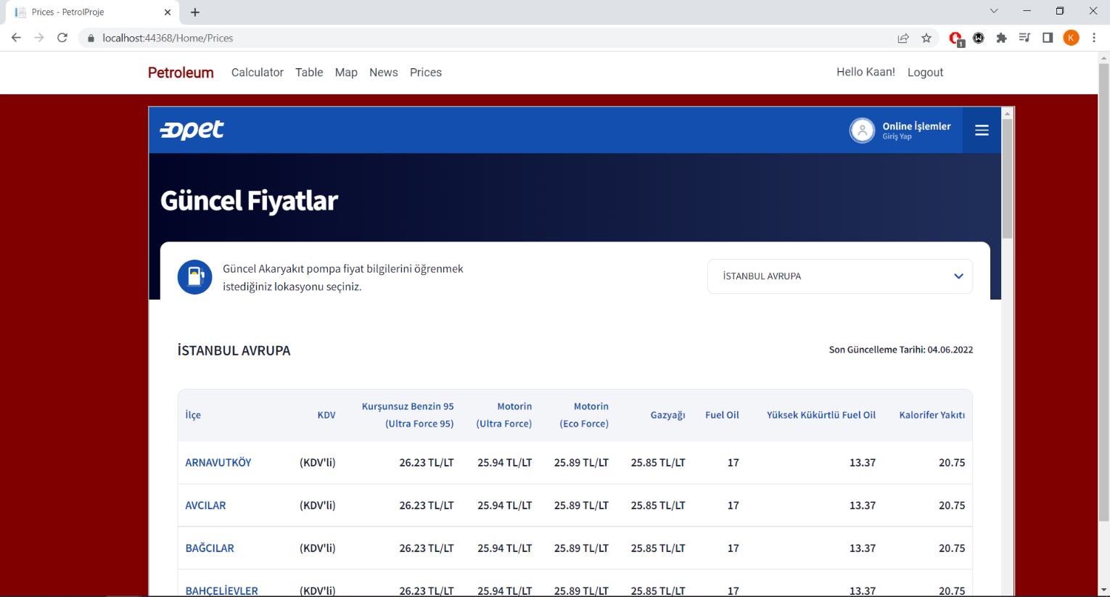

* In prices section, users can check up-to-date gas prices.

*Front Face Examples*

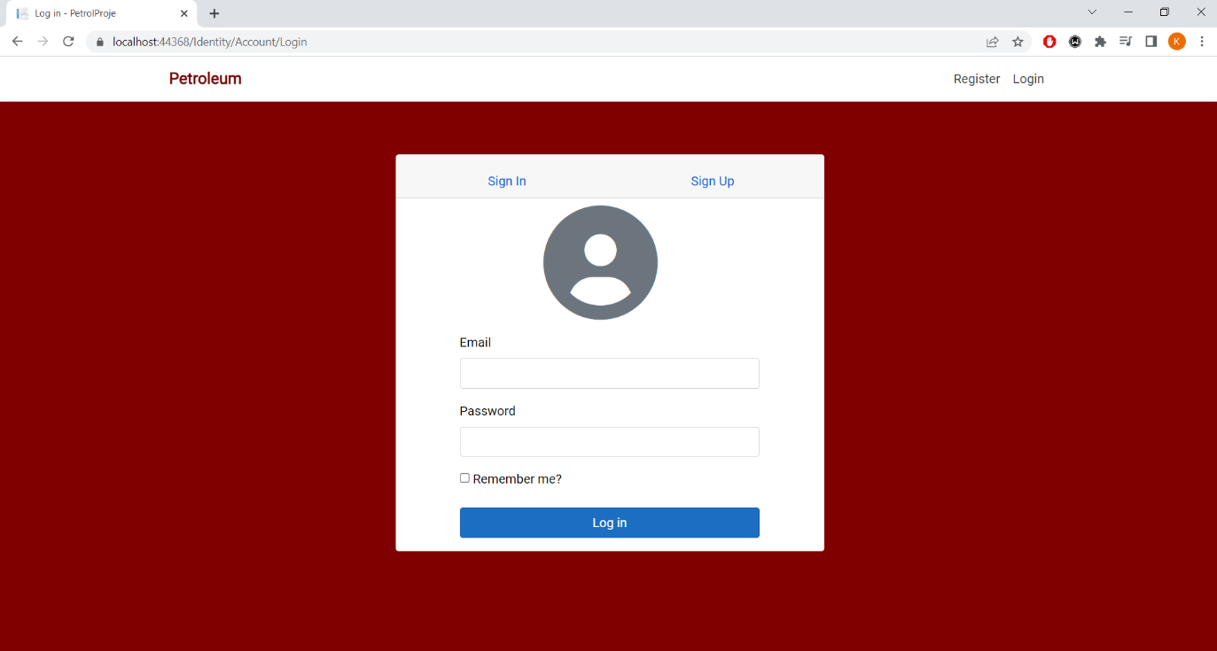

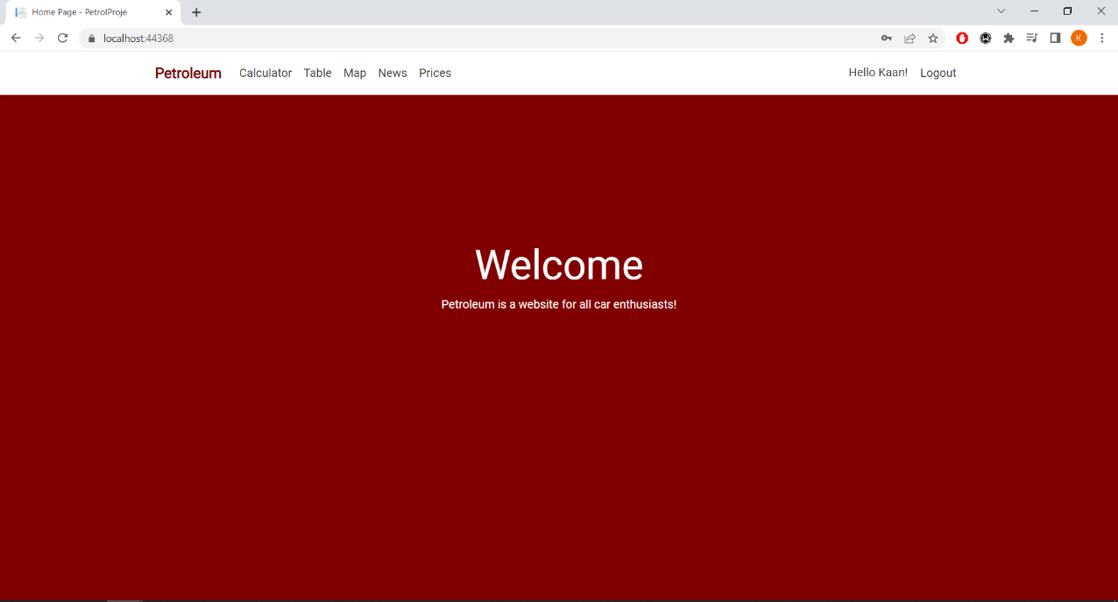

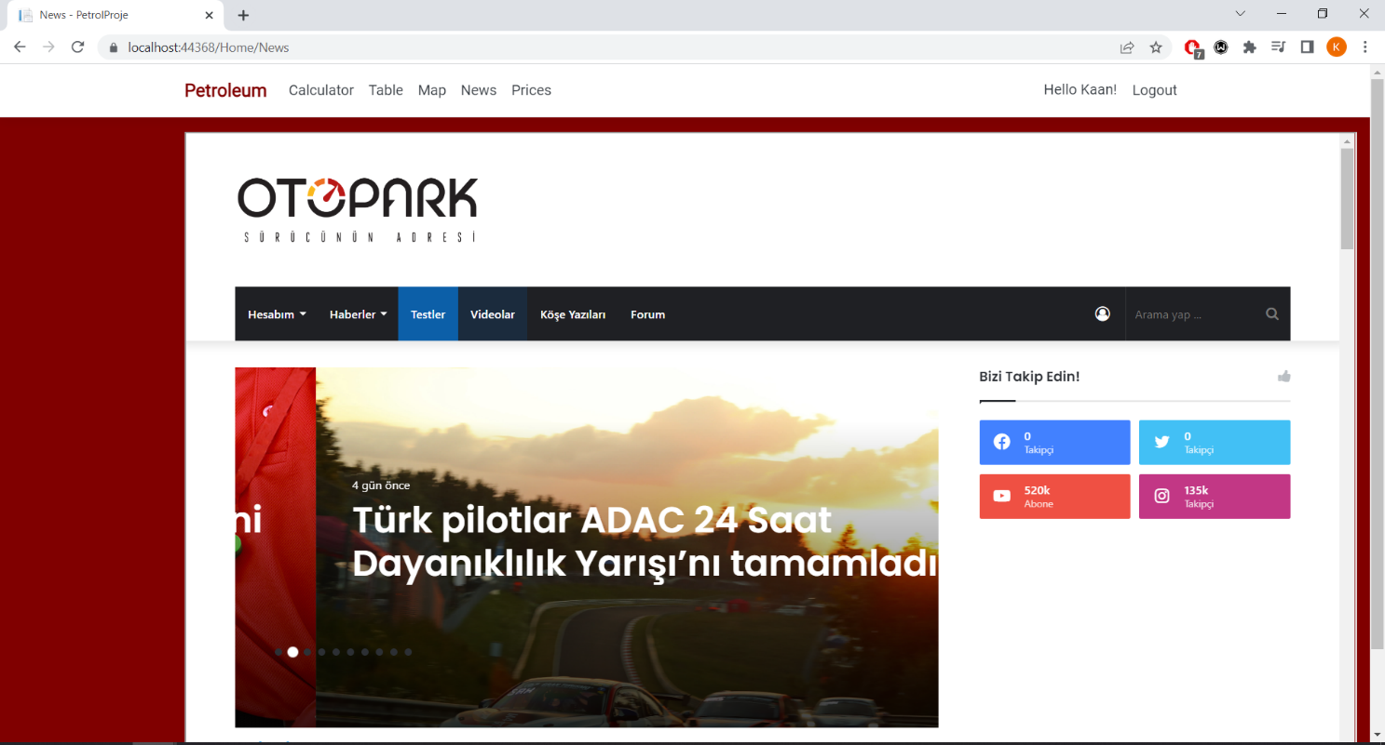

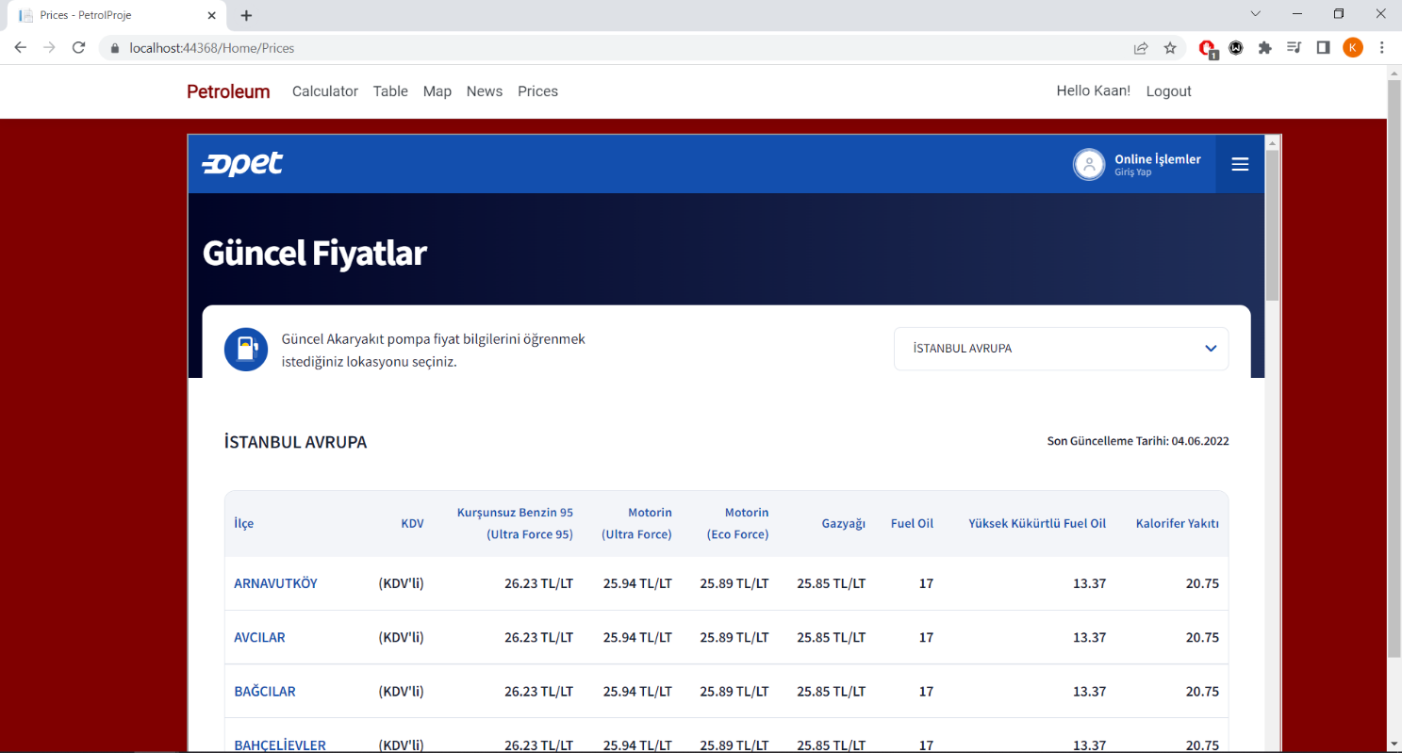

*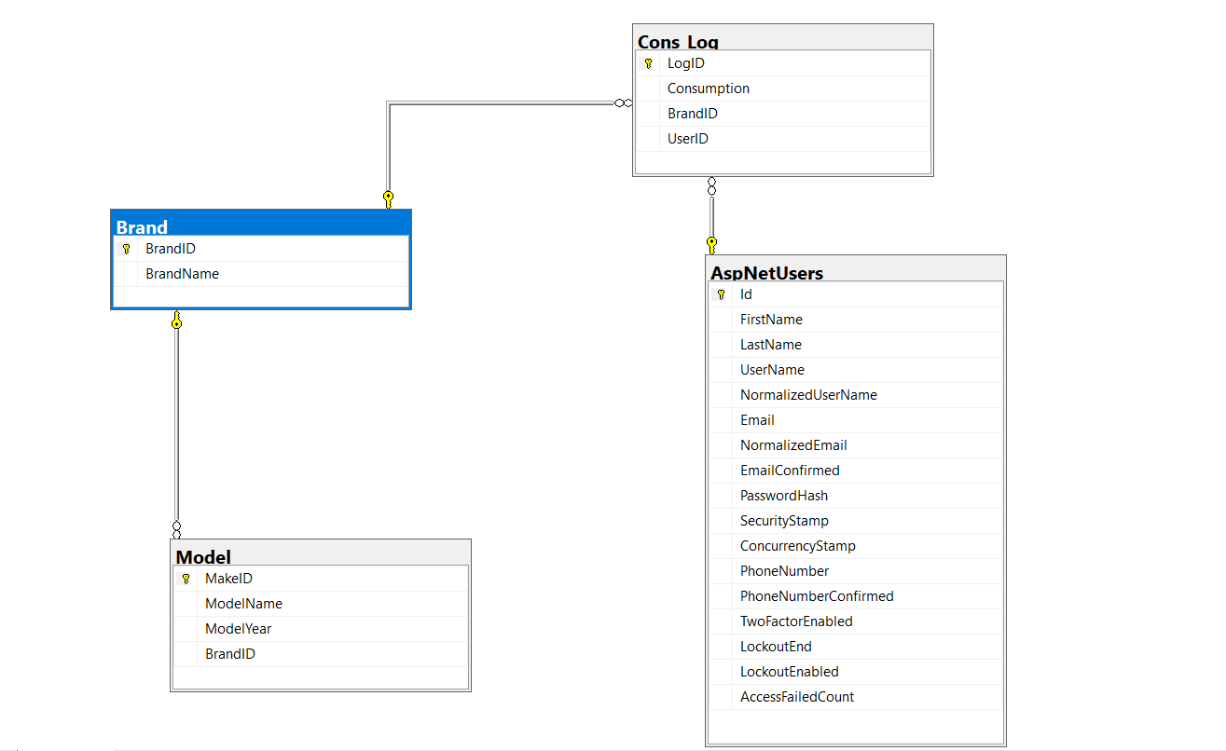Database Diagram*

*Code Examples*

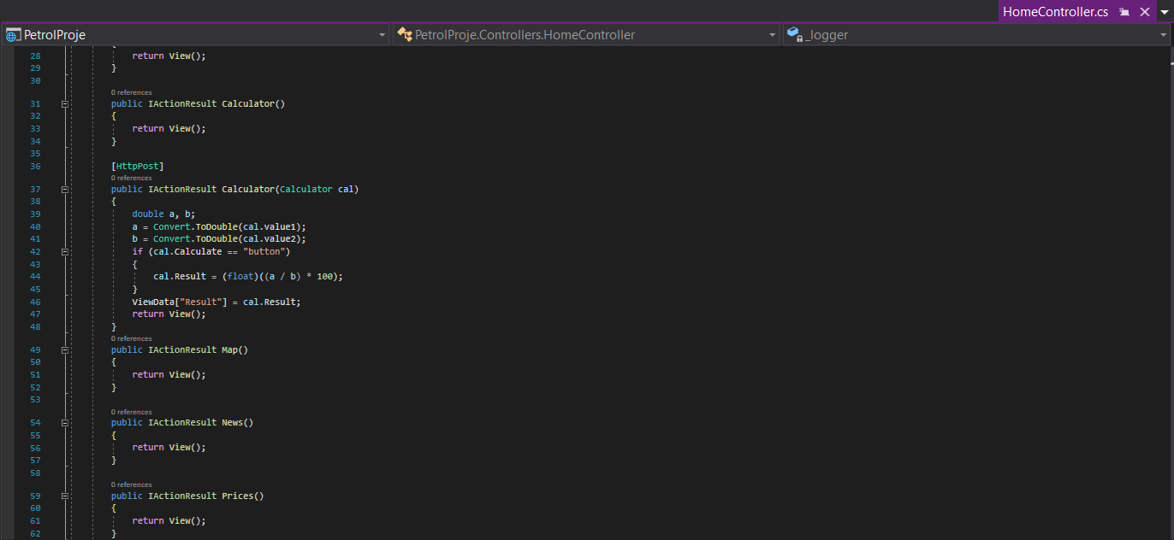

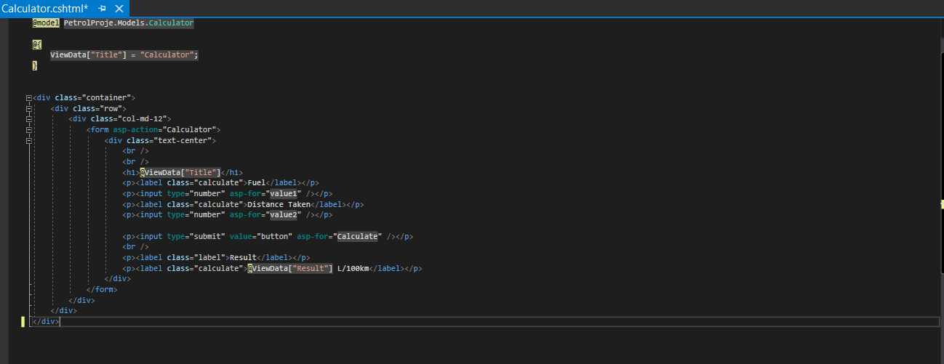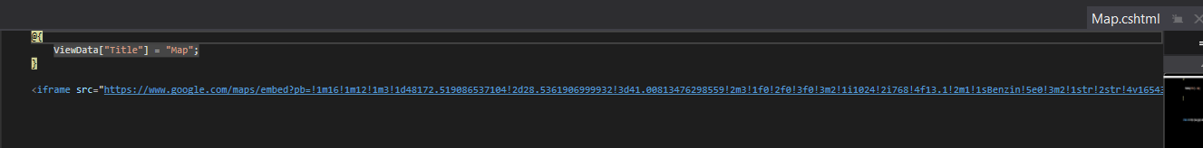

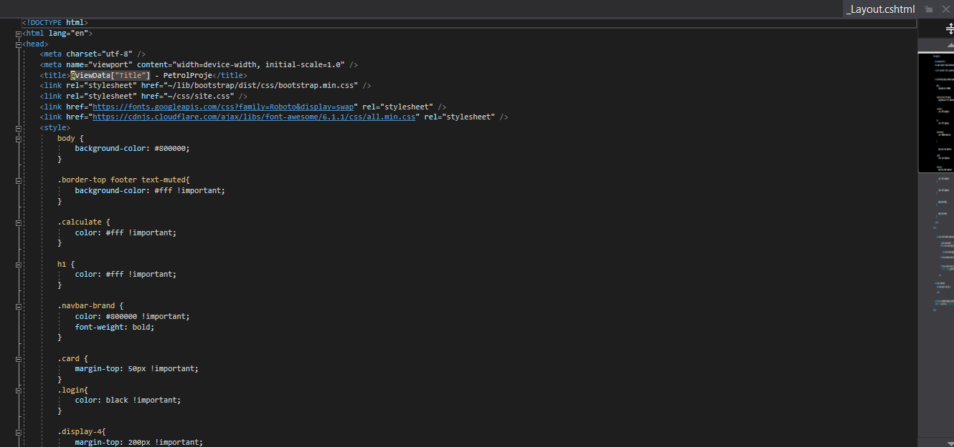

metin içeren bir resim

Açıklama otomatik olarak oluşturuldu

*metin, ekran görüntüsü, elektronik eşyalar, bilgisayar içeren bir resim

Açıklama otomatik olarak oluşturuldu*

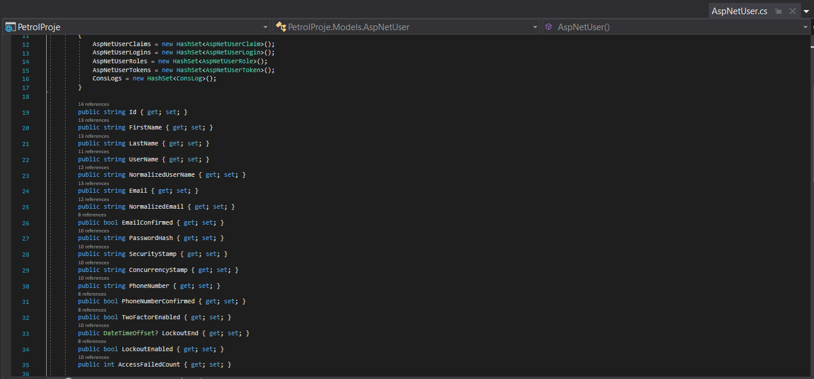

*metin içeren bir resim

Açıklama otomatik olarak oluşturuldu*

*Conclusion*

In conclusion, Petroleum is a web application which is created with the purpose of calculating and saving users’ fuel data. Thanks to basic interface, all vehicle owners in different age groups can simply use this app. Moreover, users can realize some of the problems, such as worn out spark plug or injector, on their car through analyzing recorded fuel consumption data on database. In addition to these, they can search for petrol stations nearby, read news in car world, and monitor fuel prices in Turkey.