^(([+][0-9][0-9][0-9]|0)\s?\(([0-9][0-9][0-9])\)\s?)?(\d\s?\d\s?\d\s?\d\s?\d)$

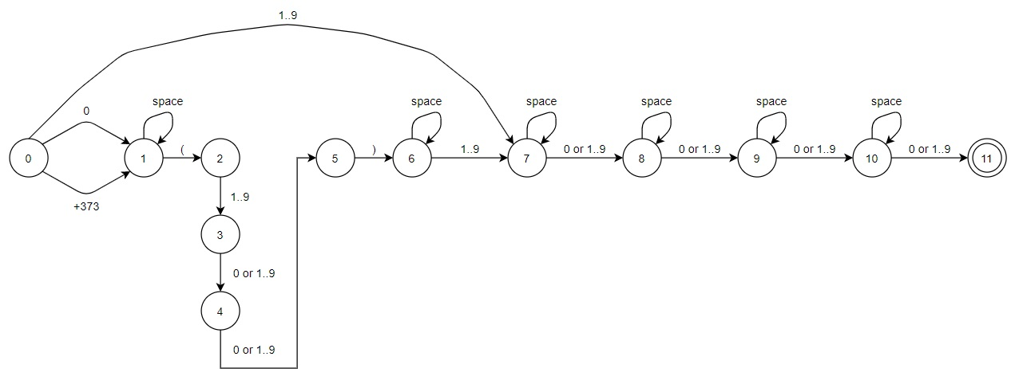

|  |  |  |  |  |  |  |
| --- | --- | --- | --- | --- | --- | --- |
|  | 0 | +373 | 1..9 | "space" | ( | ) |
| 0 | 1 | 1 | 7 | ERR | ERR | ERR |
| 1 | ERR | ERR | ERR | 1 | 2 | ERR |
| 2 | ERR | ERR | 3 | ERR | ERR | ERR |
| 3 | 4 | ERR | 4 | ERR | ERR | ERR |
| 4 | 5 | ERR | 5 | ERR | ERR | ERR |
| 5 | ERR | ERR | ERR | ERR | ERR | 6 |
| 6 | ERR | ERR | 7 | 6 | ERR | ERR |
| 7 | 8 | ERR | 8 | 7 | ERR | ERR |
| 8 | 9 | ERR | 9 | 8 | ERR | ERR |
| 9 | 10 | ERR | 10 | 9 | ERR | ERR |
| 10 | 11 | ERR | 11 | 10 | ERR | ERR |
| 11 | - | - | - | - | - | - |
| ERR | - | - | - | - | - | - |