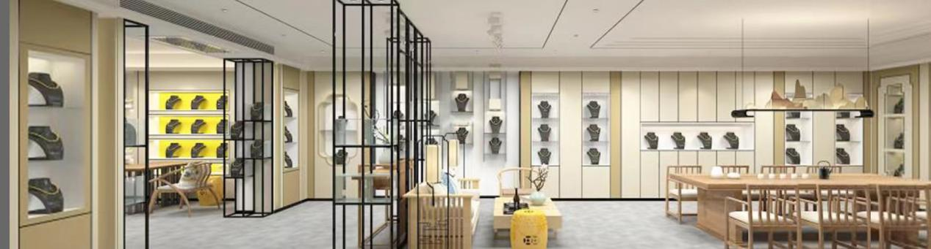

Royale Accessories Ltd. was established by Lonny Wang in 2008，who has been in the fashion (costume) jewelry industry for over 20 years. With his experience and expertise, Mr.Wang leads over 200 employees, organized into various teams including: material sourcing, design, product development, quality control, and sales. Currently the family-owned business operates a factory of 2000 square meters, where we produce every kind of fashion jewelry accessories with metal alloys, and also semi-fine jewelry using 925 sterling silver. Our factory boasts a start-to-finish work flow, meaning we have in-house control over every step of the making process from design to shipment. This is how we can assure quality, speed, and low cost.

Besides these key advantages, we also have full-time Chinese designers as well as contracted freelance designers from South Korea and abroad, we are the full package. This is why Royale has become one of the top manufacturers in China.

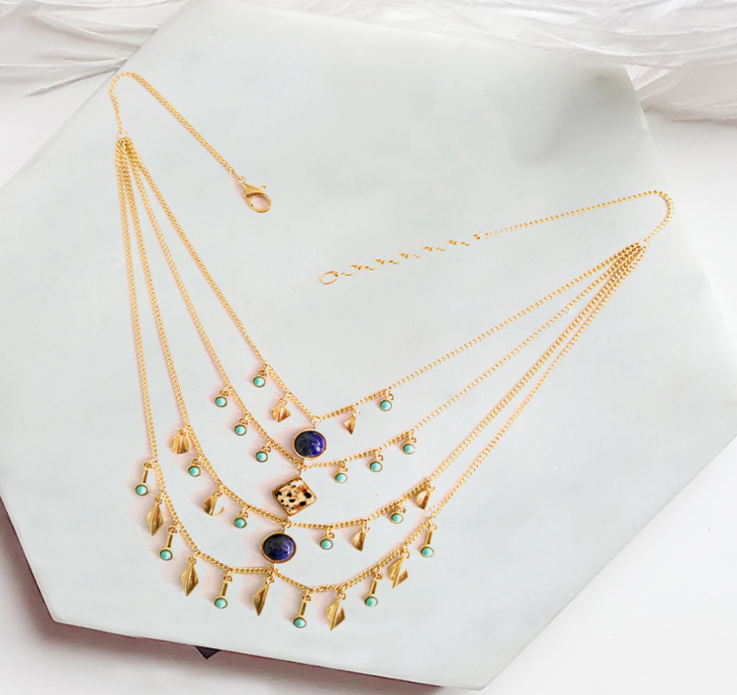

Our collection consists of fashion (costume) jewelry including but not limited to necklaces, earrings, bracelets, rings, brooches, and hair accessories. We mainly use  brass, zinc alloy,and 925 sterling silver. We meet international standards for safety and recycling. This means our jewelry is not only safe to wear but good for the environment. We are a Chinese supplier.

Contact me:+8615753671694

Electroplating and vacuum plating with gold and silver protects the jewelry from tarnishing. By using various polishing techniques, we can also give the jewelry a beautiful finish. We take our clients' intellectual property very seriously. Our own experienced designers also build out open line collections specific to each retailer's seasonal needs.

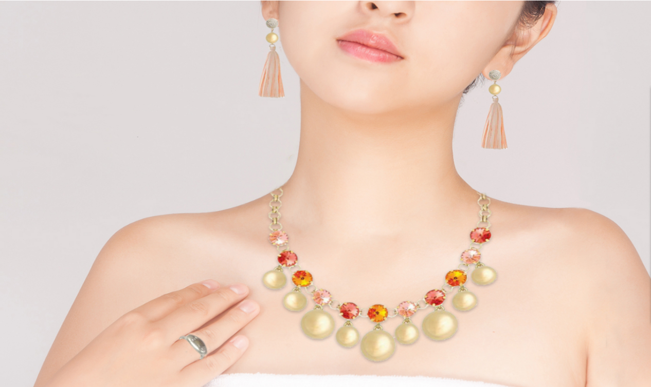

Our team of talented designers, sample duplicators, and modelers takes concept ideas from the clients and turns them into fashionable, production-ready designs. The team works very closely with the clients to ensure the created designs are a good fit for the market.

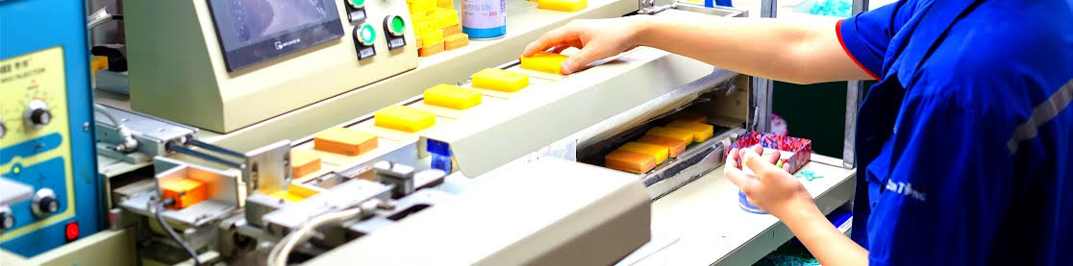

Our full time skilled workers are provided with positive working conditions in our workshops. We insist on quality control every step of the way, not just at the end, which ensures efficient and fast delivery at a low cost.

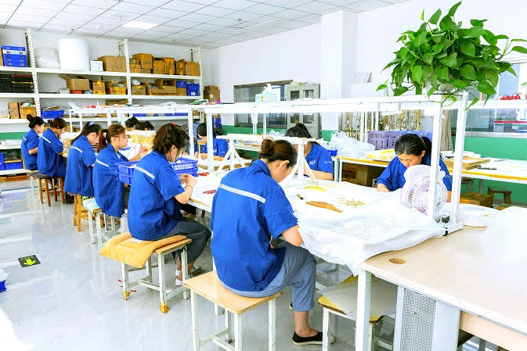

Our quality control staff perform in-line inspections for each stage of production. They take extra care checking the difficult aspects of manufacturing, such as gluing, linking, and plating. Our laboratory checks the integrity of each piece, for example the exact thickness of plating in microns, as well as checking for dangerous materials such as lead, nickel, and cadmium.

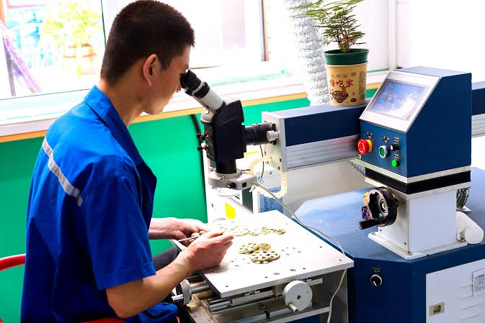

I sincerely hope we have the opportunity to cooperate.

Looking forward to your reply.

Best regards.

Email：khalifa@qdroyale.xyz

WhatsApp：+86 15753671694

LinkedIn：https://linkedin.com/in/alfellati

Calendly：https://calendly.com/alfellati