

**PROGRAMMING**

**CASE 2020**

**INTRODUCTION**

Herewith you receive the Programming case.

This case is developed in-house and we use it for all people who are in the process of a software development position. The assignment will show us your software skills and see how you would handle such a situation. The case involves a little game which you can work out in your own way. You are advised to use **React** and **TypeScript**– please use these with the IDE of your choice and provide the solution as an executable/deployed version and the source code in a git repo.

If you have any specific questions, feel free to contact me any time.

As mentioned, the cases need to be returned within a timeframe of **1 week after receipt**. Should you experience any issues whilst completing the cases, please let us know directly so we can take this in account.

Wish you every success and many thanks for taking the time to work on these!

**SQUARES DESCRIPTION**

Squares is a simple two player game where a square shaped game board is split to N*N squares. (2 <= N <= 8) Each player marks a square on their turn and at the end, the player with the biggest directly connecting squares group wins.  
  
An example:  
  
 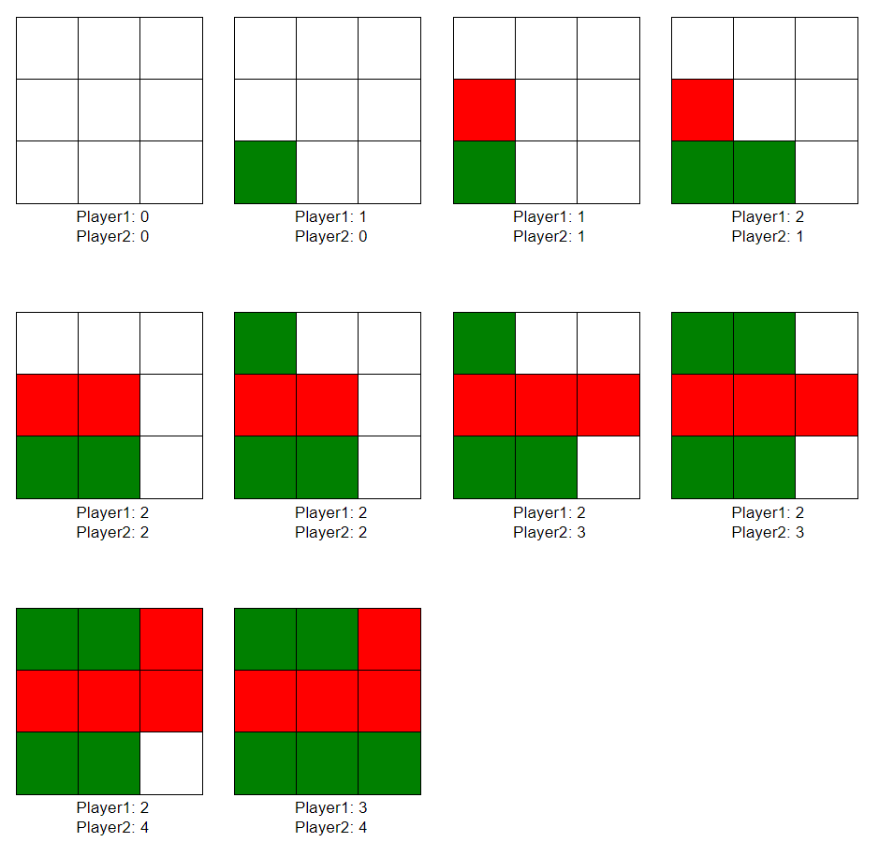

* **ASSIGNMENT**
* *Part 1*

Create an application that allows a user to play this game against a Friend. This application should present the playing surface in a visual way, provide a good/understandable user interface for the game and finally congratulate the winner.  Share your solution both as source-code and as a runnable example.

* *Part 2*

Show or explain how you structured the application, e.g. by describing or sharing architecture.

* *Part 3*

Share some insights on how you approached the visual side of the application — the user interface, the playing surface, the win-state, etc.

* *Part 4*

Do you think the game is fair? Does any player have an advantage by going first? Is this true for any board size? Is this provable?