Workshop: Petstagram
This document contains the third part of the Petstagram Workshop. Today, we will create the pet forms for our model for the project and we will implement them in our templates. After that, we will add the image functionality in the photo model, we will create the form, and inject it into the templates. Finally, we will create a comment form to add comments and a search form to search images by a name of a tagged pet.
Note: we will NOT work with the profile/ user form in the Python Web Basics Course.
The full project description of the project can be found in the Workshop Description Document.

Workshop - Part 3.1

Creating a Pet Form
In a Django project, there is NOT a forms file in the prebuilt structure. We need to add a new forms.py file inside the pet application directory:
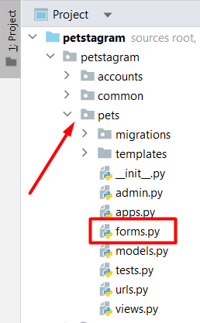
In forms.py we can implement the pet form. Because the pet already has a model in our app, we do NOT need to create the form field by field - Django can do it for us with the ModelForm class. Let us open the forms.py file, import the Pet model and create a simple Pet form from the Pet model: 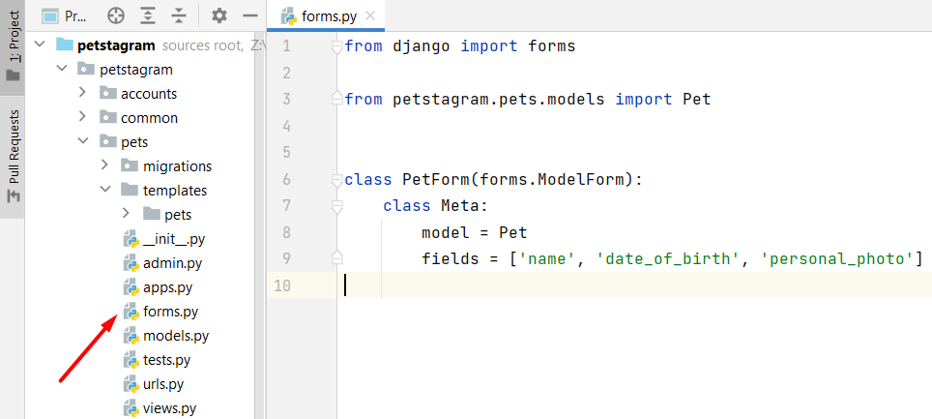
Next, let us create the form functionality in the pets/view.py. First, we will import the PetForm. Next, we will create a form that should be filled with information (request.POST is a dictionary-like object that lets you access submitted data) or should be blank. Next, we will check if the form is valid and if so - we will save the information in the database. When the information is saved, we want to redirect the user to the profile details page (for now we will set a random number for the pk). Finally, if the form is NOT valid (it is blank, or the validation fails) we want to add it to the context to be shown in the template: 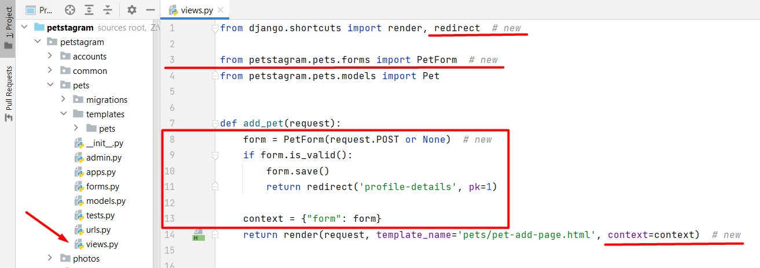
Now, it is time to add the form to the pet-add-page.html template. First, we will delete the html form and we will inject the Django form from the context - we want to show the form on separate lines, so will use the shortcut method "as_p" to show each input field on a new line (new paragraph). Next, we will set a post method to the form, and finally - we will add the CSRF token: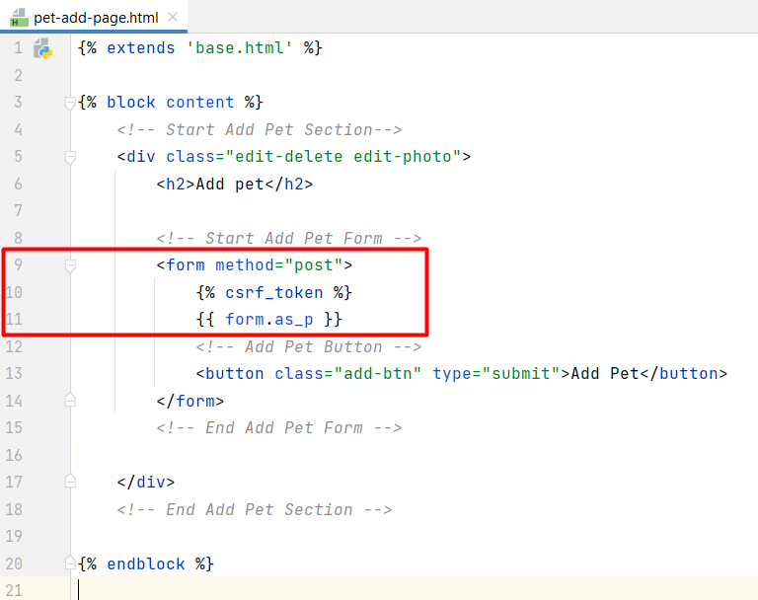
Let us check what we have done by now: 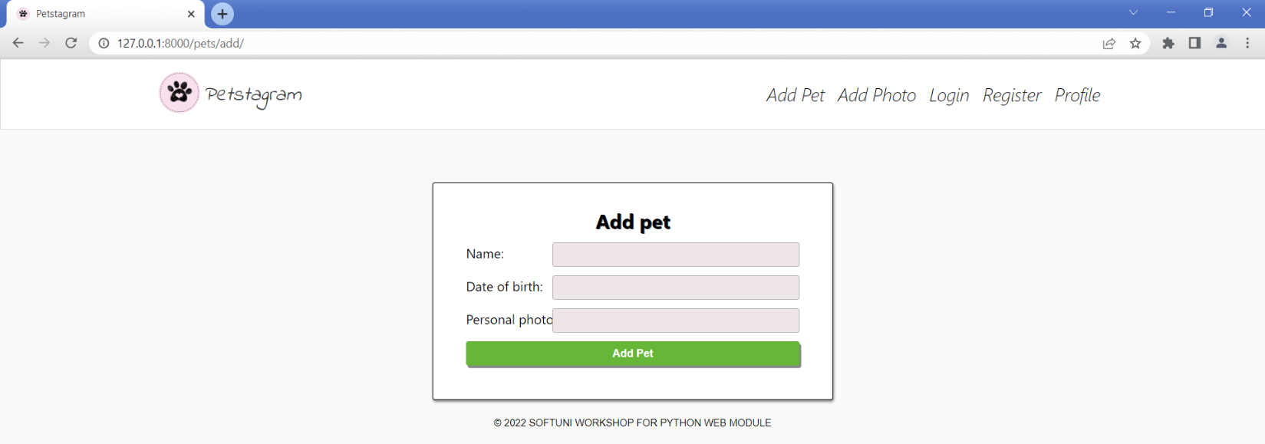
The pet form is generated and work corettly, but it can look much better. To improve the UI we can change some labels, and some placeholders and make the date field visualized with a generated calendar. Let us again open the pet/forms.py and write some code: 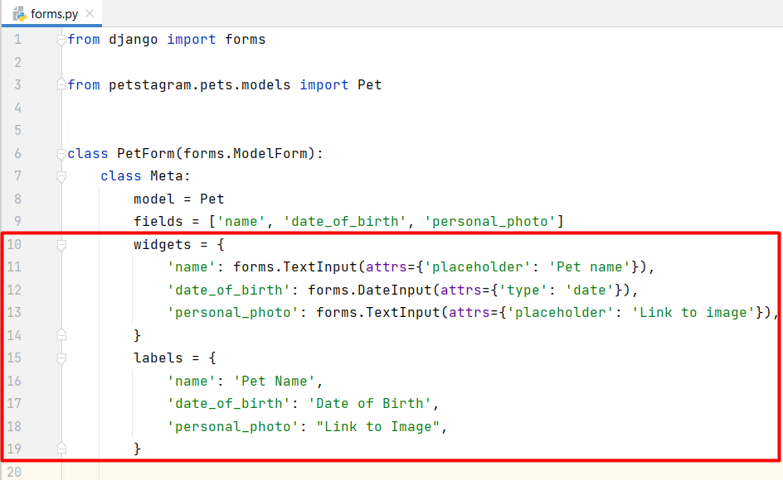
Now, the pet add page looks like that and the form works correctly: 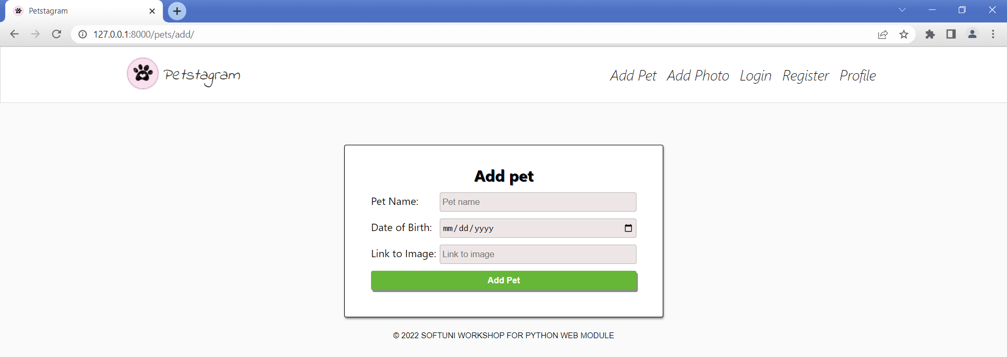

Creating a Pet Edit Form
We should add a pet edit form functionality. We should use the same fields and same formatting as in the pet creation form. So, we can use the already generated PetForm and prepopulate it with the data from the current pet we want to edit. Let us open the pets/views.py file and create the pet edit functionality. When the method is GET we will fill the form with the initial pet data, and if the method is POST - we will update the data in the concrete pet instance and will save it in the database: 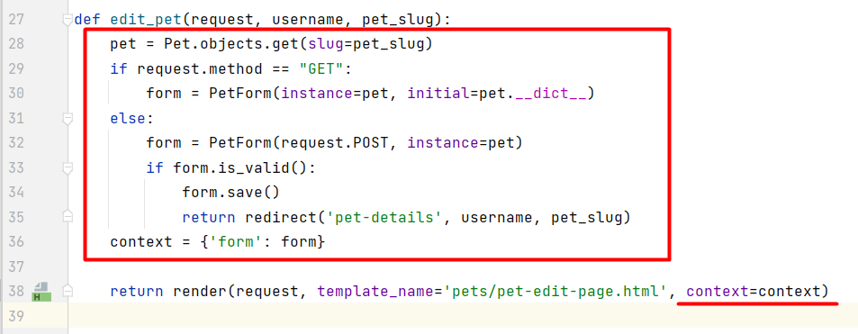
Refactor the pet-edit-page.html template: 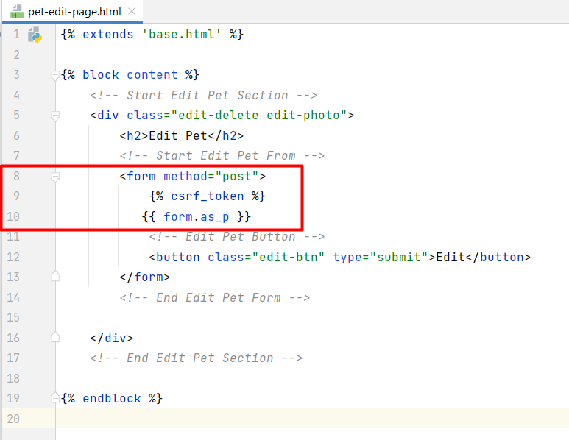

Check if the pet edit functionality works correctly: 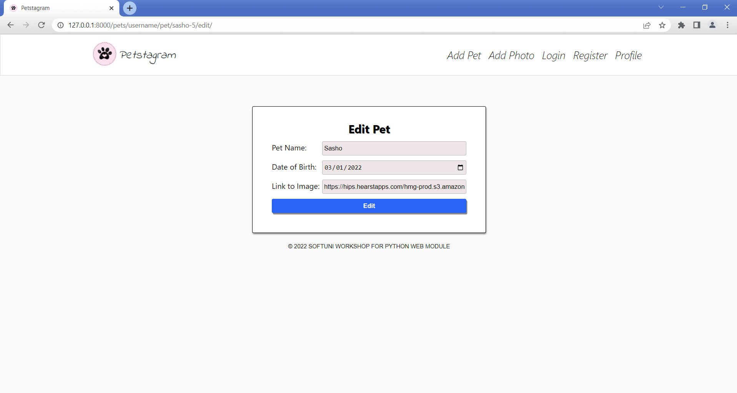

Creating a Pet Delete Form
Last for the pet form section, we will create a pet delete from and functionality. First, open the pets/forms.py file and we will add the delete form that inherits from the PetForm and disables all fields, and set them to be read-only: 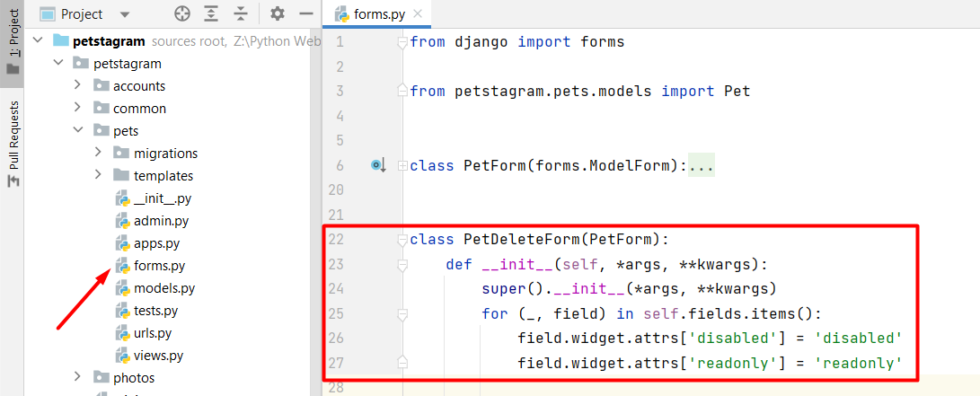
Then, we will write the view functionality. First, we will try to get the pet object we want to delete. Next, if the request method is POST we will delete it and we will redirect to the profile details page. If the method is GET we will generate a form with the initial pet data: 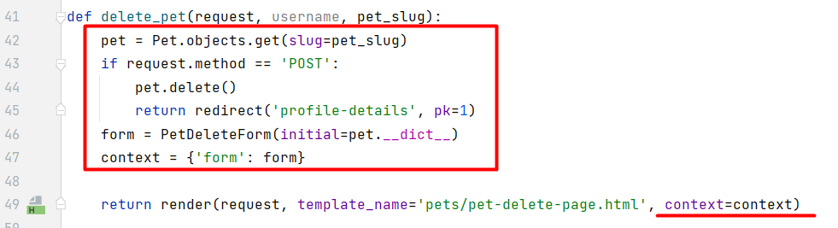
Finally, we will refactor the pet-delete-page.html template: 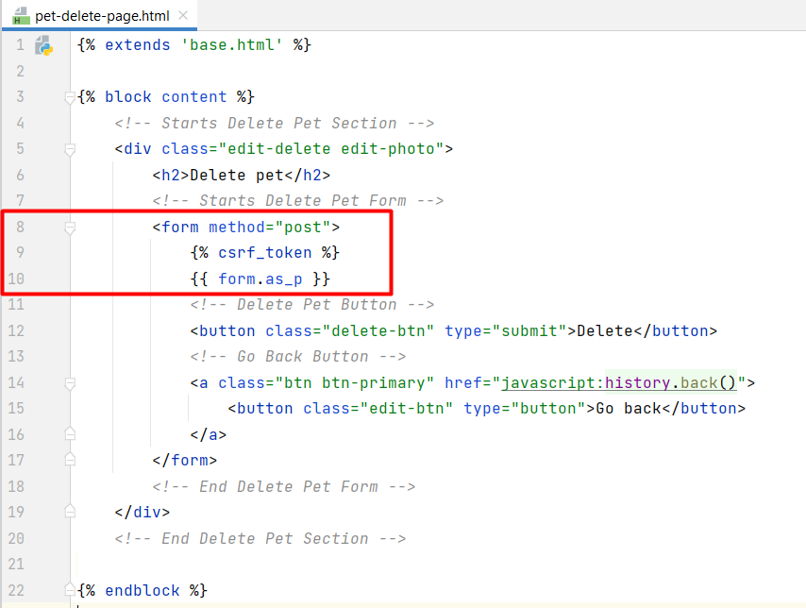
Check if the form works correctly.

Workshop - Part 3.2

Working with Media Files
Next, we want to create a photo creation and edition forms. However, first, we need to make some changes to our project to work with media files. Let us open the settings.py file and add the following settings: 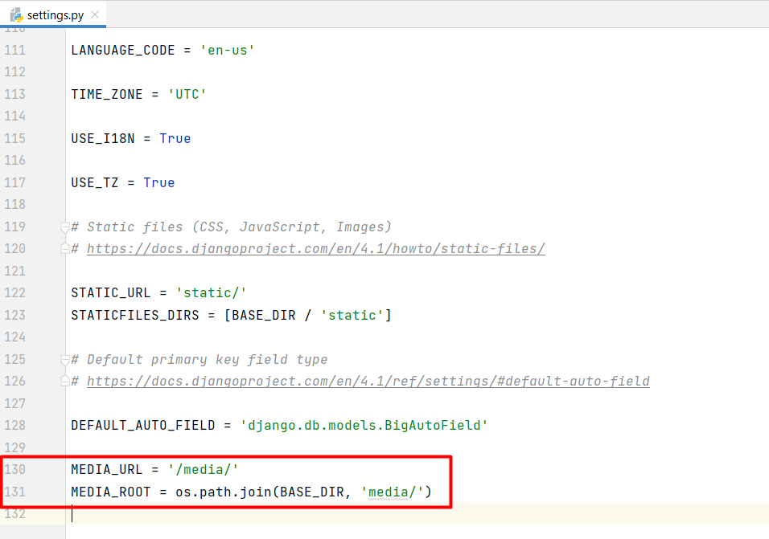
Now, we need to create a media directory on the manage.py level:
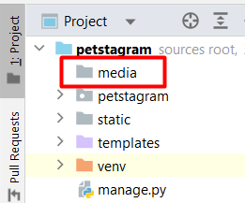
Next, let us open the photos/models.py file and add an "upload_to" argument in our photo field that will create an "images" directory in the "media" folder and will save the uploaded photos there: 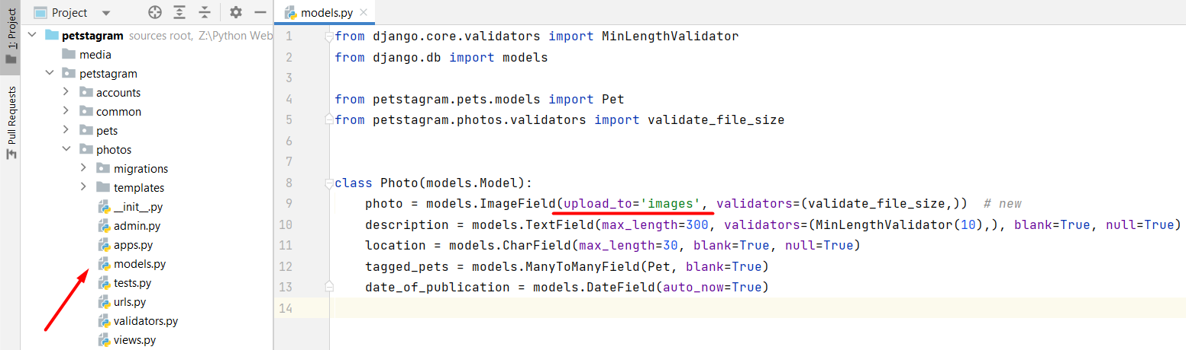
Make migrations and migrate the changes to the model.

Creating a Photo Creation Form
Let us start adding the photo creation form. Create a new forms.py file in the photos app and implement the form: 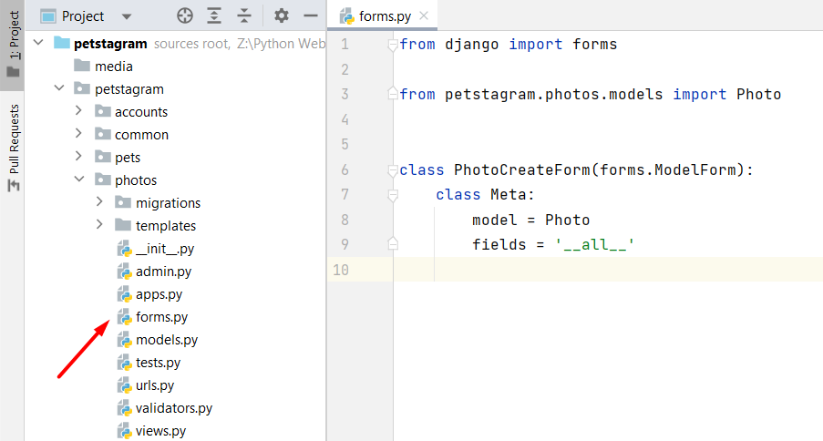
Next, add the photo form functionality in the photos/views.py file. Do not forget to add the request.FILES (it is a dictionary-like object containing all uploaded files) : 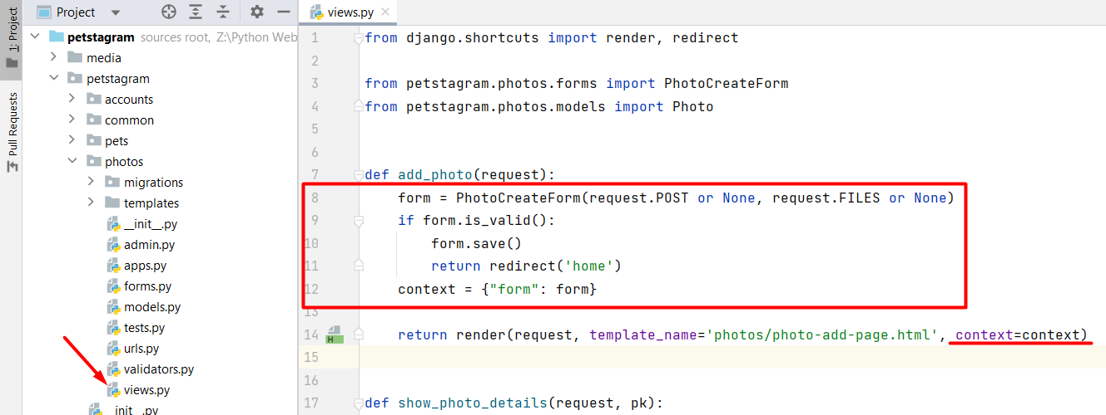
And finally - refactor the photo-add-page.html template. Note: request.FILES will only contain data if the request method is POST and the <form> has enctype="multipart/form-data":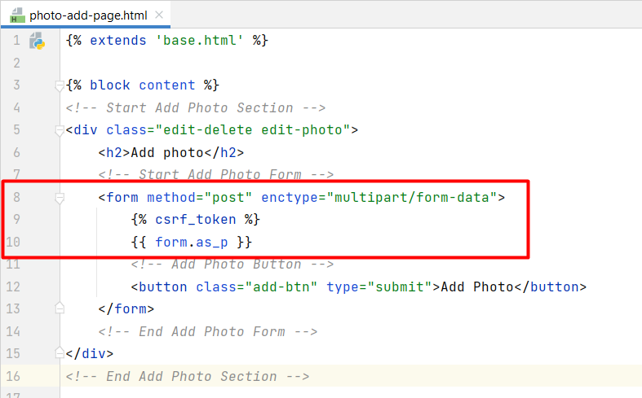
Check if the form works correctly.

Add Photo to Templates
In the settings.py file we created the implementation of the media url - it loads a url like this one: 127.0.0.1:8000/media/images/image.jpeg. However, it is not enough - to visualize media files in Django it is needed to add a special path that will find the file in the media folder and connect it to a media URL. Let us open the project/urls.py file and add the functionality:
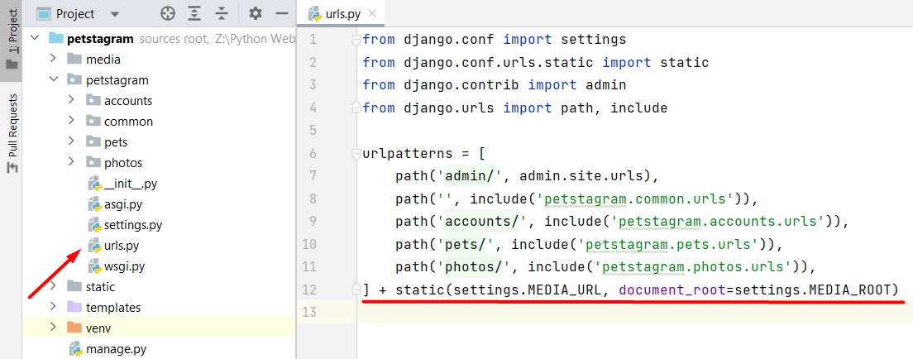
Now, it is time to refactor the template, so it visualizes the uploaded image. Let us open the common app pets-posts.html template and find the "Start Pet Photo" comment. Then, we will add only the URL of the uploaded image (Django will find it and will generate it):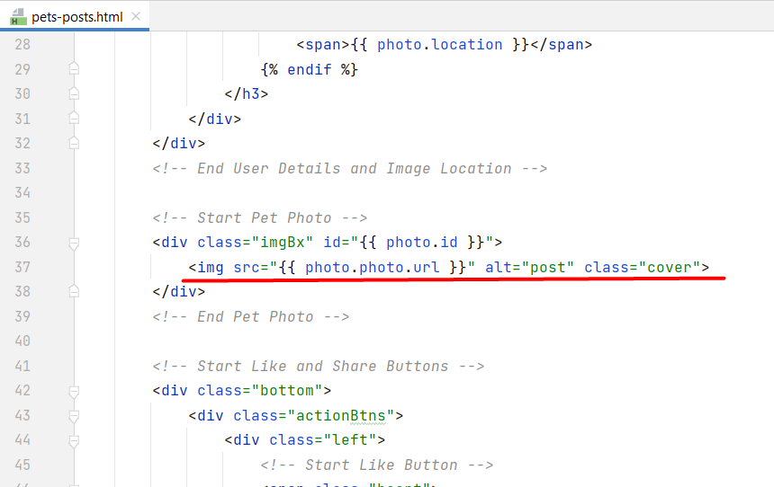
Next, open the photo-details-page.html template and add the photo URL.

Create a Photo Edit Form
Next, let us implement the photo edition form. We do NOT want to edit the photo, so we will exclude it from the form: 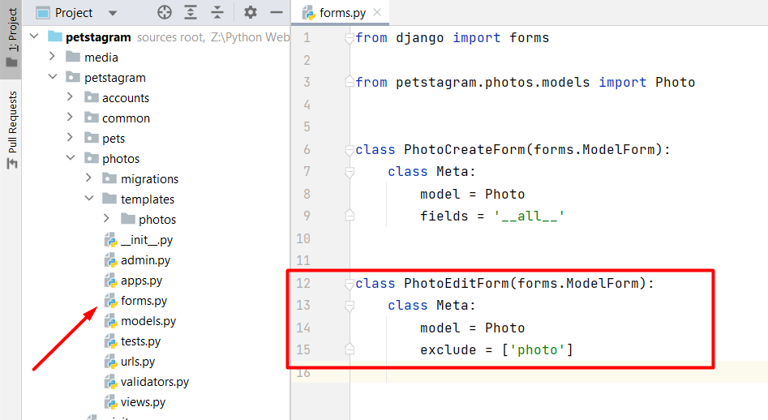
Open the photos/views.py file and add the photo edit functionality and refactor the template. When the photo is edited, the user should be redirected to the photo details page. Check if the functionality works correctly.

Deleting a Photo
Last for the photo, we will implement the photo deletion functionality. The photo is directly deleted after clicking on the delete button (on the photo details page). To start implementing the functionality, we need to create a path with a corresponding view: 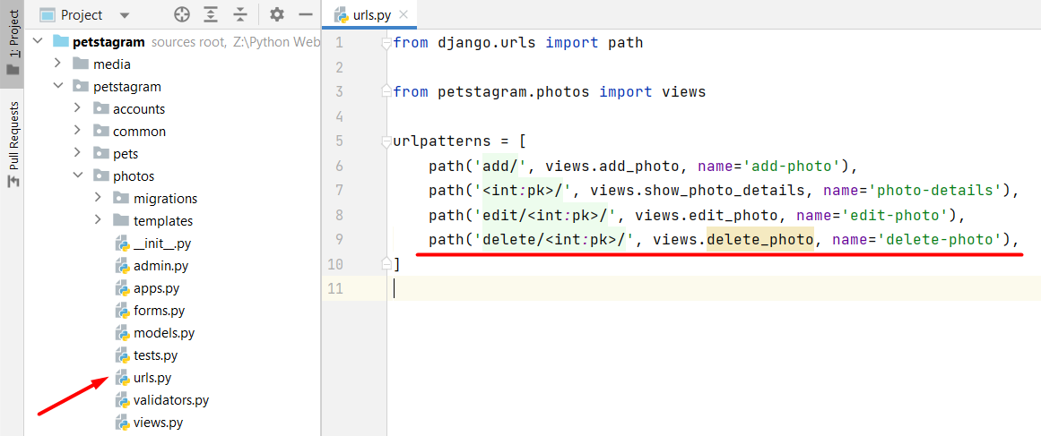
Now, let us create the delete_photo view. It gets the pk of the photo, finds the photo object, deletes it, and redirects to the home page: 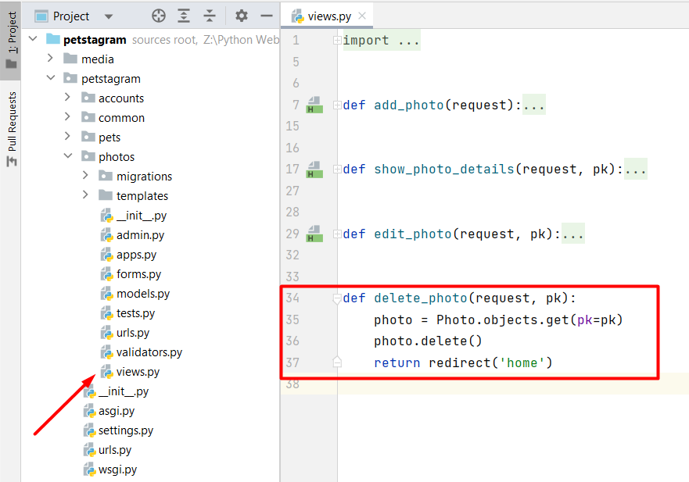
Last, let us refactor the template by adding the delete path to the delete button in the photo-details-page.html. Find the "Link to Delete Pet Photo Page" comment and add the path: 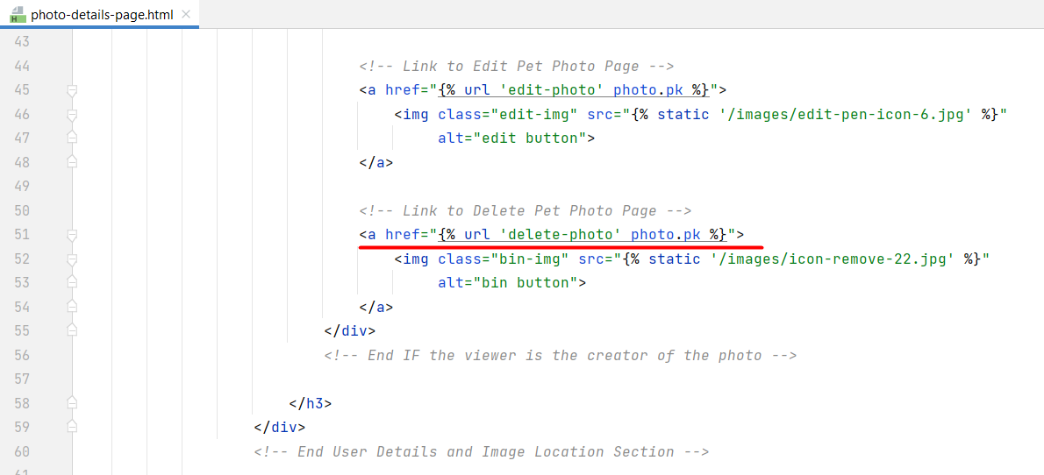

Workshop - Part 3.3

Creating a Comment Form
It is time to start implementing the comment form. In this project, our users can NOT edit or delete their comments once they post them on the app - so, the only thing needed is to add a comment creation form. Let us add a forms.py file in the common app and create the form. The only visible field we want to add is the text field. Also, it would be great to add a placeholder ("Add comment...") that will guide the user: 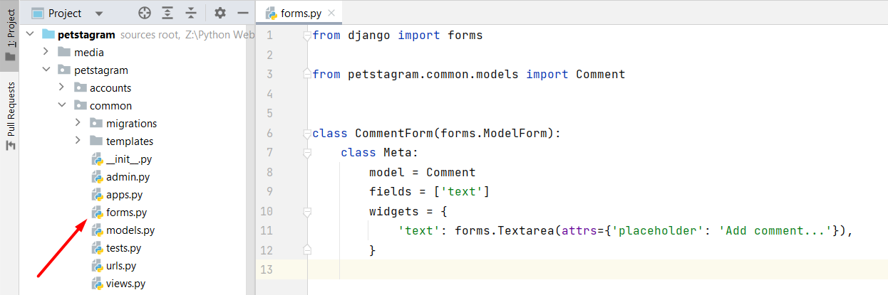
We want to generate the comment form on the Home Page, Pet Details Page, and on Photo Details Page. It means that we should add the form to 3 views (show_home_page, show_pet_details, and show_photo_details views) and 2 templates (pets-posts.html and photo-details-page.html). First, let us add it to the Home page. Open the common/views.py file and add the form: 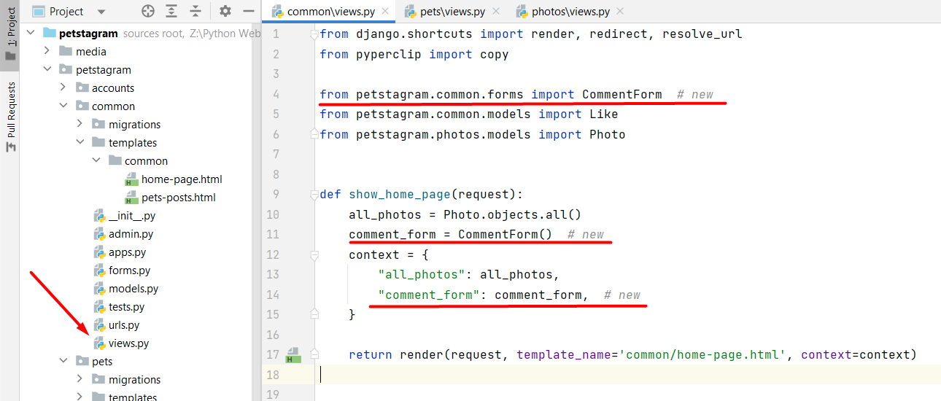
Next, we should add the comment form functionality for saving the form. The best way to do so is by creating a new view that will handle the business logic each time a user posts a comment (no matter on which of the 3 pages). First, create a new path that will accept the photo id: 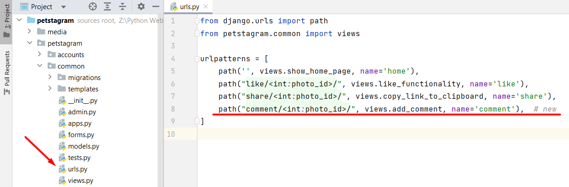
Next, create a view that accepts the comment text from the user, finds the photo by the given photo id, and injects it into the form. Then, the form is saved, and the user is redirected to the same place they last were: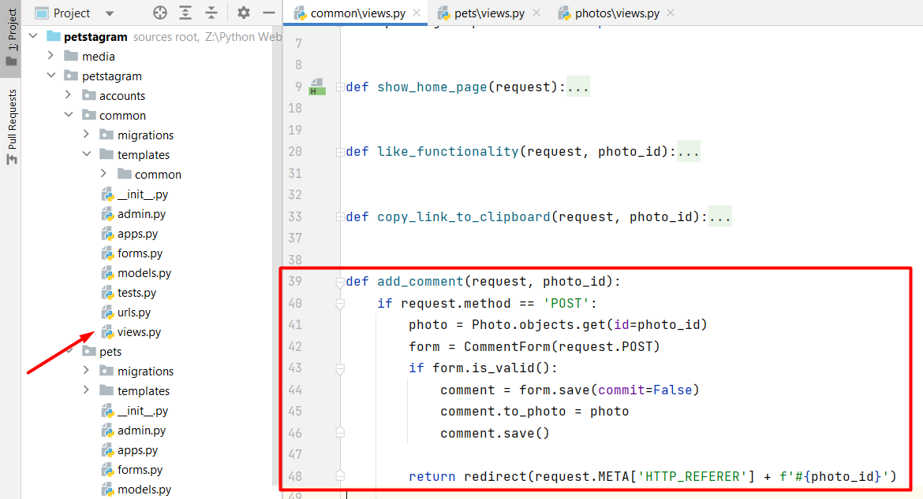
Now, we should refactor the template. Let us open the pets-posts.html template and find the "Start Add Comments Form" comment. In a difference from the other templates, here we must add an action to the form. When the form is submitted the user must be redirected to the add_comment view: 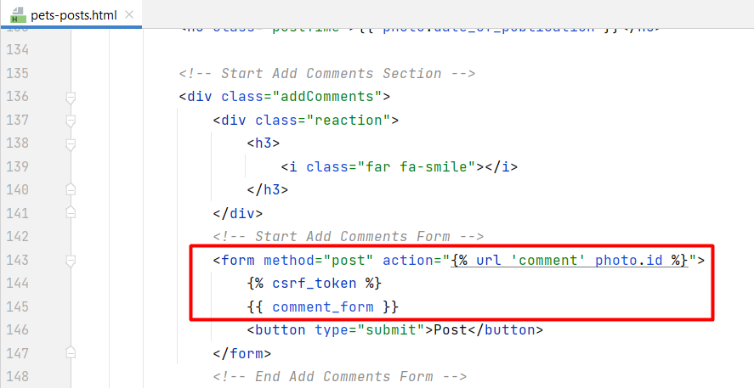
We should add the comment form to the pet details view and the photo details view with the photo details template. Check if the form works correctly on the 3 pages.

Creating a Search Form
Let us do something additional for our project. Let us add a search bar functionality. As you know, not every form in Django needs to be connected to a Model. In this case, we want to create a search form, but we do not want each search of a user to be saved to a database. So, we can start directly by creating a form. Our search bar will receive a string that will search for a pet by its name: 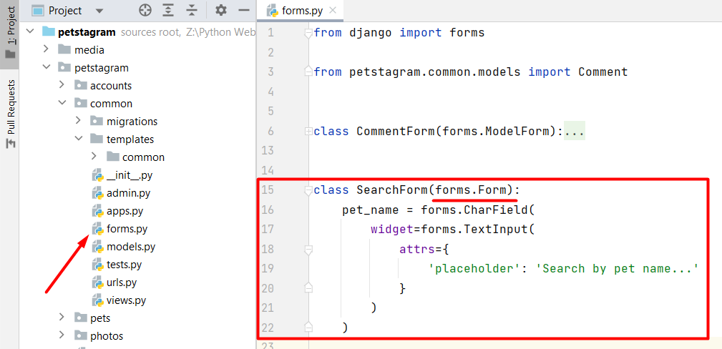
Our search form is positioned on the home page, so we do not need to create an additional path. We can directly add the search form functionality in the show_home_page view. The search form is generated in the context. And if it is filled and the method is POST, we will filter the photos to find all of them containing a tagged pet with the given name. We make the search case insensitive by filtering with the icontains lookup: 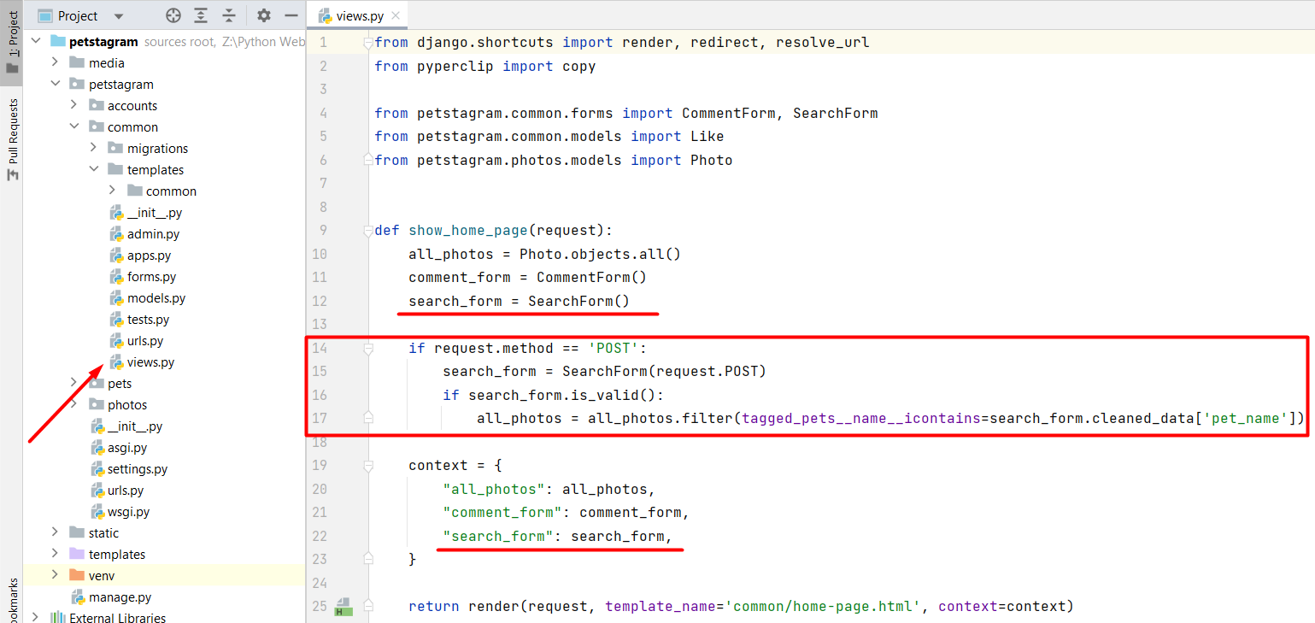
Last for this workshop, we will add the form in the template. Open the home-page.html template and add the form: 