ToDoApp
Development Plan & Completion Roadmap
Bug remediation · missing functionality · admin panel · auth · path to done
Prepared as Project Architect
ASP.NET Core 10 · MVC · EF Core · SQL Server
Branch: TodoCrudCore
Date: 14 July 2026

Contents

1. Executive Summary
ToDoApp is a multi-user task manager built on a clean, layered ASP.NET Core 10 MVC architecture (twelve projects: web, view models, services, DTOs, data/repositories, domain models, and shared infrastructure). The foundation is strong: dependency injection, a repository/service split, ASP.NET Identity with roles, a global EF query filter, antiforgery protection, and a healthy automated test suite of 80 passing tests.
The project is, however, not finished. Group management is complete end-to-end, but the Todo lifecycle has broken UI wiring, the comment feature is only half-built, several authentication flows are absent, and there is no admin panel at all despite the roles and admin account already being seeded.
This document takes stock of the current state, catalogues every outstanding bug and every missing capability, specifies an admin panel (design and functionality), and lays out a sequenced, six-phase roadmap that ends with a fully functional, deployable product. It is a plan for execution and for closing the project as finished.

At a glance
Area | Verdict
Architecture | Solid and consistent. Keep it; extend the same patterns for new work.
Groups | Complete: list, create, edit, delete, with ownership checks.
Todos | Create / list / details / complete work; edit, delete and activate are broken from the UI.
Comments | Display only. No create/edit/delete anywhere in the stack.
Auth | Register / login / logout only. No recovery, email confirm, or profile.
Admin | Not started. Roles + admin user are seeded but unused.
Tests | 80 passing (service, repository and controller layers).

2. Current Architecture
The solution follows a textbook layered design. Requests flow from controllers into services (business logic), which call repositories (data access) over a single EF Core DbContext. View models and DTOs keep the layers decoupled; shared constants, error messages and exceptions live in a common project. This separation is the project's biggest asset and every new feature below should slot into it rather than around it.
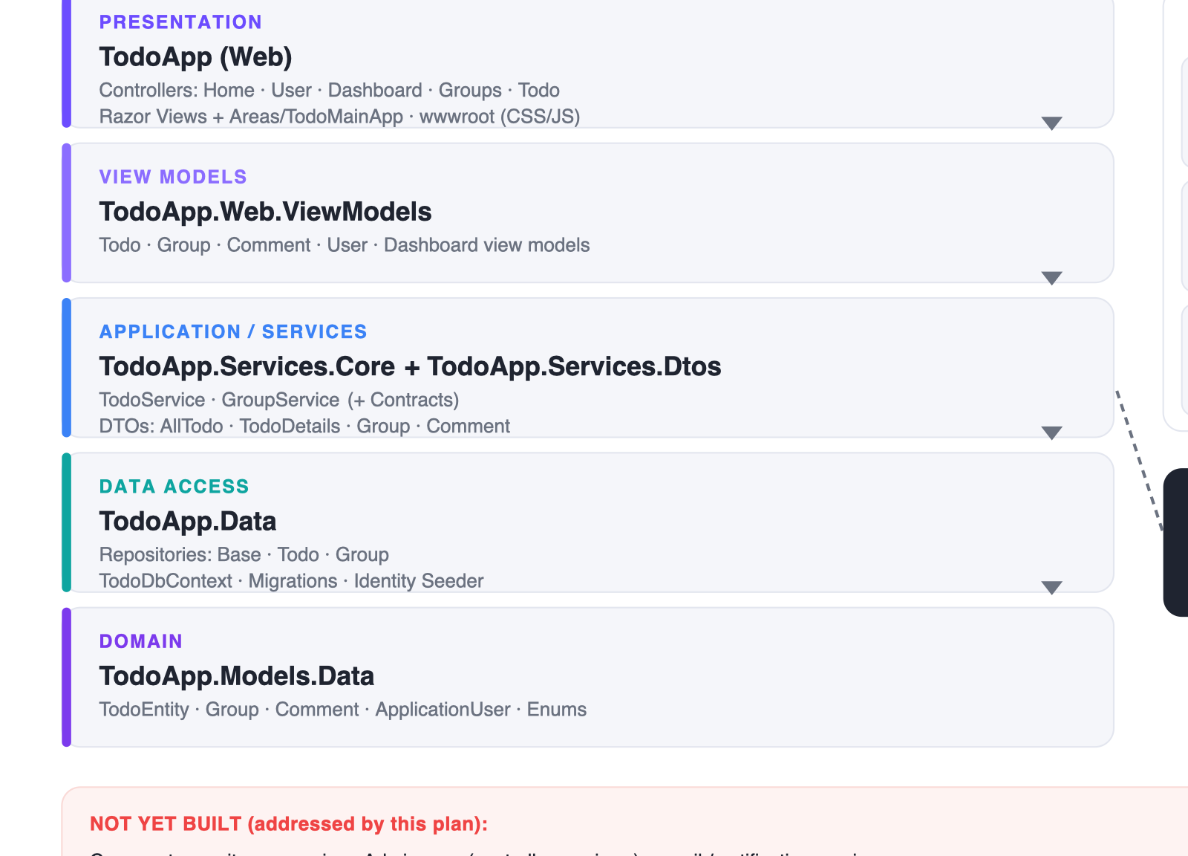
Figure 1 — Current solution architecture and the pieces not yet built.

What this means for the plan
- New comment feature = one new repository + service + controller + views, mirroring the existing Todo slice.
- Admin panel = a new MVC area that reuses the same service/repository style plus ASP.NET Identity's UserManager and RoleManager.
- Auth completion = mostly wiring existing Identity capabilities (tokens, email) into the current UserController.

3. Feature Status Overview
The map below colour-codes every user-facing capability. Green is working, red is built but broken, amber is not yet built. This is the scope of remaining work in one picture.
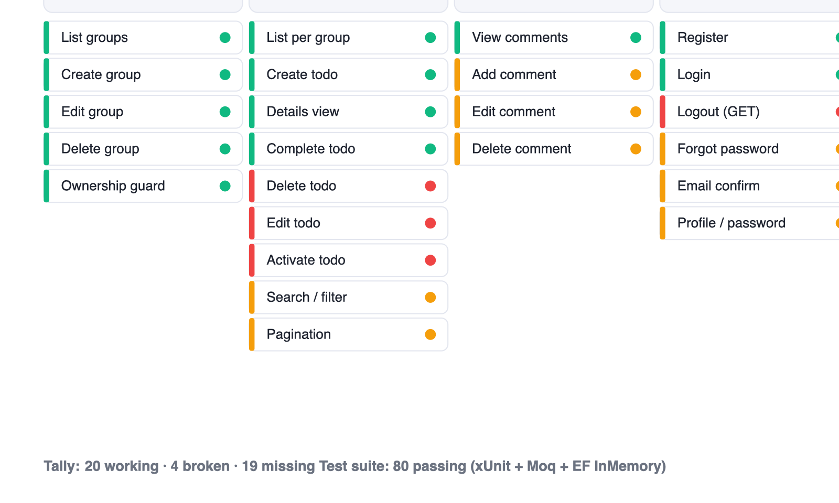
Figure 2 — Feature readiness across the whole product.

4. Outstanding Bugs
These are the defects surfaced by the multi-angle code review of the current branch and not yet fixed. They are listed worst-first. Findings 1–3 mean core Todo actions do not work from the UI at all, so they head the first phase of the roadmap.
# | Bug (file:line) | Why it happens | Severity
1 | Edit todo view is an empty stub — Views/Todo/Edit.cshtml | Edit (GET) builds a CreateEditViewModel and returns View(model), but the view has no @model or form. The edit page renders blank. | HIGH
2 | Delete todo is a GET link vs [HttpPost] — Views/Todo/Index.cshtml:140 | The delete icon is an <a> anchor (issues GET); TodoController.Delete is POST-only. Click → 404, nothing deletes. Complete/DeleteGroup beside it correctly use forms. | HIGH
3 | Activate is a GET link vs [HttpPost] — Views/Todo/Completed.cshtml:24 | Same shape as #2: an anchor GETs a POST-only action. A completed todo can never be re-opened from the UI. | HIGH
4 | Overdue todos cannot be edited — CreateEditViewModel.cs:36 | The past-due-date rule lives on the model shared by Create and Edit. Editing any overdue todo fails validation unless the date is pushed to the future. | MED
5 | Completed todo edit never saves — TodoService.cs:138 | Edit-GET loads the todo with the query filter ignored, but Edit-POST uses ignoreQueryFilter:false, so the global filter (Status==Pending) hides it → EntityNotFound → BadRequest. | MED
6 | GroupService not user-scoped (latent IDOR) — GroupService.cs:50,119 | DeleteGroupAsync/EditGroup take only the id; ownership rests solely on a controller pre-check. Any future caller that forgets it edits/deletes another user's group. | MED
7 | Brittle SaveChanges count check — GroupRepository.cs:77 | result == (1 + Todos.Count) assumes the save count equals this op's writes. Any extra tracked change makes a successful delete throw DataPersistFail. | MED
8 | Details page action buttons inert — Views/Todo/Details.cshtml:30,68,75,90 | The complete checkbox, Edit, Delete and Add-Comment are <button type=button> with no form/handler. The details page is display-only. | MED
9 | Dashboard 'View All' dead link — Dashboard/Index.cshtml:75 | Empty asp-action/controller/area → a self-referencing link. Overdue todos beyond five are unreachable. | LOW
10 | Lazy Select re-enumerated 4× — DashboardController.cs:28 | Todos is a deferred projection the view walks four times (3 Count() + foreach). Add .ToList(). | LOW
11 | Dead Guid guards (11 sites) — TodoController.cs / GroupsController.cs | id.ToString().IsNullOrEmpty() on a Guid is always false, so the intended 'missing id' check never runs. Use id == Guid.Empty. | LOW
12 | Logout is a GET — UserController.cs:164 | [HttpGet] Logout can be triggered by any link/prefetch (CSRF-style). Should be a POST form with an antiforgery token. | MED
13 | Redundant double queries — GroupsController.cs:52,132,171 | Every group edit/delete runs an existence query then reloads the same row. Folds into the user-scoped query from #6. | LOW
14 | Repeated Guid.Parse(GetUserId()!) ×16 — controllers | The same unguarded parse is copy-pasted in every action. Add BaseController.GetUserGuid() once. | LOW
15 | Leftover scaffolding usings + committed TODO block — controllers | A Blazor code-gen using, an IdentityModel.Tokens using imported only for dead code, and an 8-line personal TODO comment block at the top of TodoController. | LOW

5. Missing Functionality
Beyond the bugs, whole capabilities are absent. Each is scoped below in terms of the existing layers so it can be estimated and sequenced.

5.1 Comments
The domain entity, the DTO, the view model and the read-side display all exist, but there is no repository, service or controller — so comments can be shown, never created, edited or deleted. The 'Add Comment' and per-comment edit/delete buttons on the details page are inert.
Build: ICommentRepository + CommentRepository, ICommentService + CommentService, a CommentsController (Create/Edit/Delete, user- and todo-scoped), and real forms on Details.cshtml. Mirror the Todo slice exactly.

5.2 Todo lifecycle completion
- Build the real Edit view (form bound to CreateEditViewModel) — closes bug #1.
- Convert Delete / Activate / Complete controls to POST forms with antiforgery — closes bugs #2, #3, #8.
- Split validation so overdue todos remain editable — closes bug #4.
- Wire the Todo Details action buttons to their controller actions — closes bug #8.

5.3 List UX: search, filter, pagination
- The Todo Index search box, the All/Pending/Important tabs, and the pagination controls are static markup with no backend.
- Add a service query that accepts a search term, status/priority filter and page number; page the results and render real controls. Introduce an 'Important' concept (e.g. High priority) behind the existing tab.

5.4 Content & support pages
- About page, Feedback page and a working Support link (all present as dead nav entries or noted in the developer's own TODO list).
- Empty-state, responsive and accessibility polish across the existing views.

6. Authentication & Account — Gaps
Identity is configured well (password rules, lockout, unique email, cookie policy, seeded roles), but the account surface is minimal. The following are unfinished or unsafe.
Capability | Current state / action | Status
Register / Login | Implemented and working. | WORKING
Logout | Exists but is an HTTP GET — change to a POST form with antiforgery (bug #12). | BROKEN
Forgot / reset password | No flow at all. Add token generation + email + reset views using Identity's built-in providers. | MISSING
Email confirmation | RequireConfirmedAccount is configurable but no confirm flow exists. Add the send/confirm actions. | MISSING
Profile management | 'Profile' nav link is dead. Add view/edit profile (first/last name) and change-password. | MISSING
Manager role | Seeded but never assigned or checked anywhere. Give it meaning (admin read-only) or remove it. | MISSING
External / social login | Not present. Optional — flag as out of scope unless desired. | MISSING
Note: appsettings.json ships with empty DevSqlServer and Admin credentials — correct (no secrets committed), but the app will not start until they are supplied via user-secrets or environment variables. Document this in the README as part of closing the project.

7. Admin Panel — Design & Functionality
The application already seeds three roles (Admin, User, Manager) and an admin account, and Home/Privacy is gated by [Authorize(Roles="Admin")] — but no admin experience exists. This section specifies one: a new /Admin MVC area, restricted to the Admin role, that reuses the project's existing layered patterns.

7.1 Information architecture
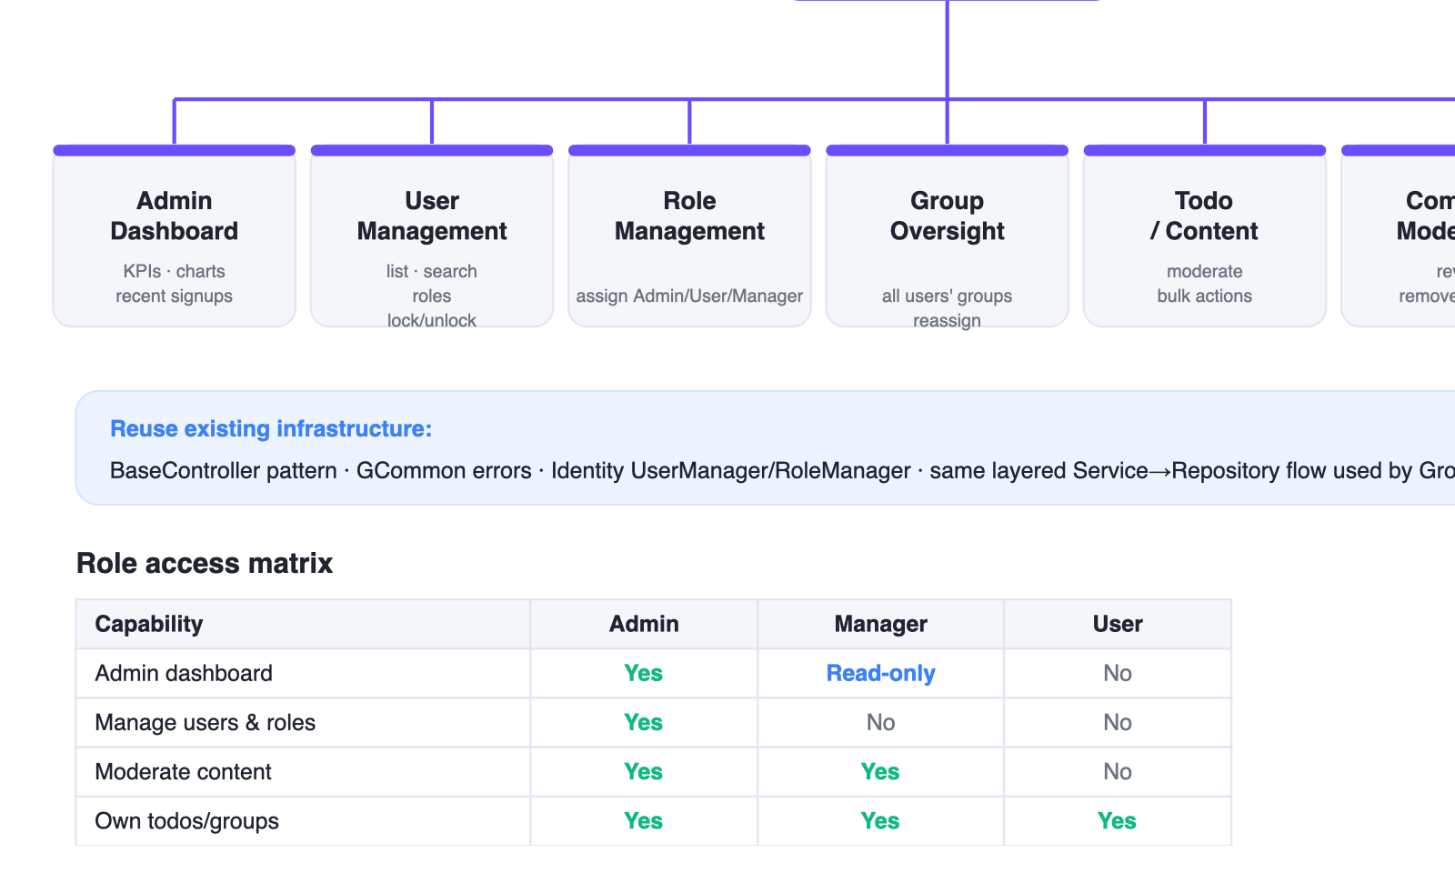
Figure 3 — Proposed admin area structure and role access matrix.

7.2 Admin dashboard
The landing screen gives an at-a-glance operational overview: headline KPIs (total users, active todos, groups, comments), a short activity trend, a status breakdown, and a recent-activity feed.
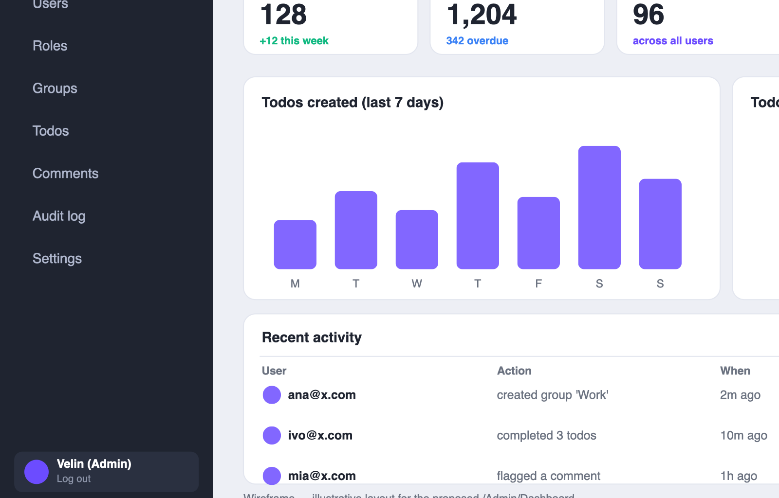
Figure 4 — Admin dashboard wireframe (illustrative).

Functionality
- KPI cards computed from existing services/repositories (add admin-scoped count queries that ignore per-user filtering).
- Todos-created trend and status split — simple aggregate queries; render server-side.
- Recent activity feed — backed by the audit log (section 7.5).

7.3 User management
The core admin tool: find any user, see their role and status, change roles, and lock or unlock accounts.
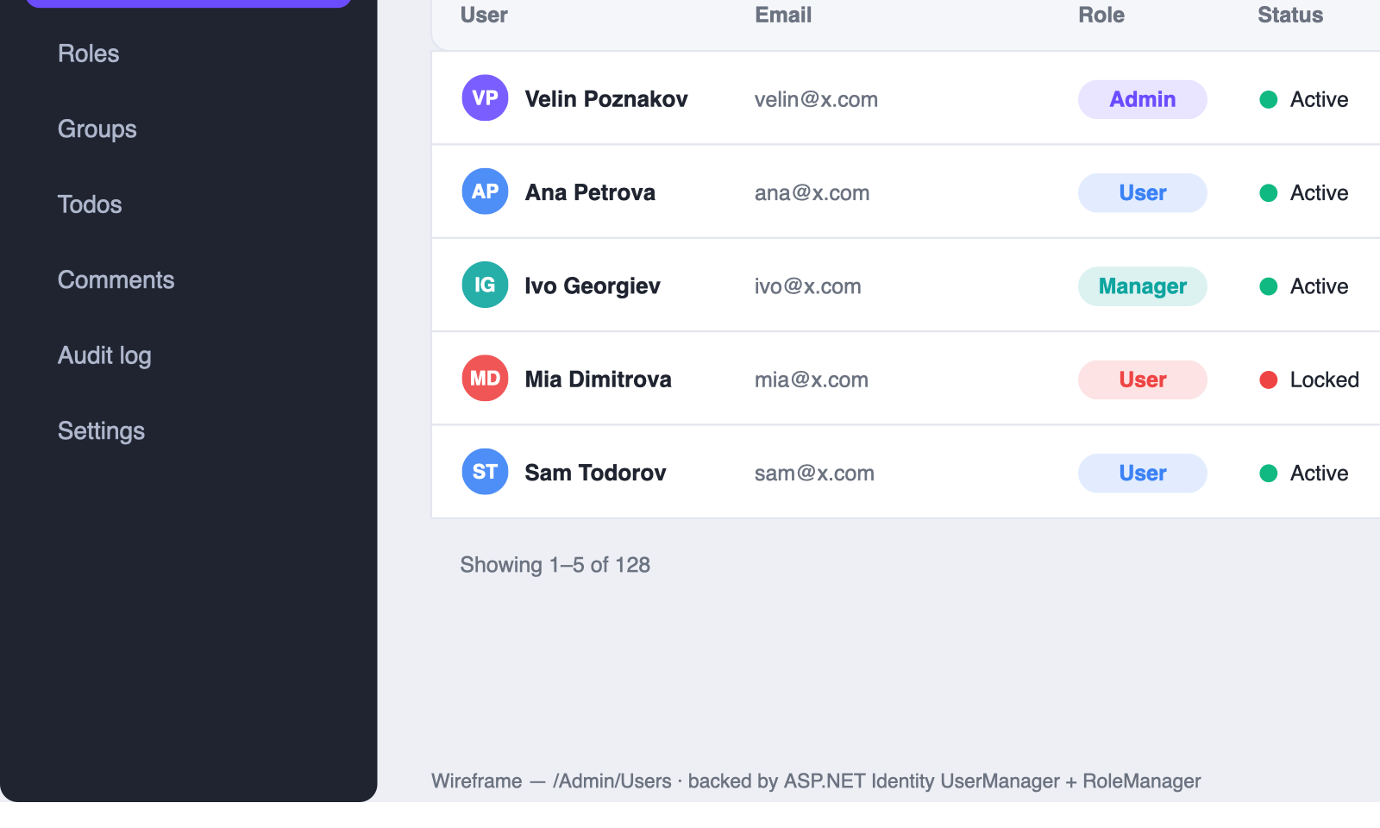
Figure 5 — Admin user management wireframe (illustrative).

Functionality
- List + search + filter users via UserManager; paginate.
- Assign / remove roles via RoleManager (Admin only).
- Lock / unlock accounts (Identity lockout end date); force password reset.
- Never expose password hashes; guard against an admin removing their own last Admin role.

7.4 Content oversight
- Groups: view all users' groups, reassign or delete orphaned data.
- Todos: cross-user list with bulk actions (delete, re-status) for moderation and cleanup.
- Comments: review and remove abusive content — depends on the comment feature (5.1).

7.5 Audit log & settings
- Audit log: record admin actions (role change, lock, delete) to a new table; surface as the dashboard's activity feed.
- Settings: expose safe application configuration (e.g. lockout thresholds) read from the existing IdentityConfiguration section.

7.6 Security & build notes
- Gate the whole area with an area-level [Authorize(Roles="Admin")] filter, not per-action attributes — the same altitude lesson as bug #6.
- Give the Manager role a concrete meaning (read-only dashboard + content moderation) or drop it to avoid dead configuration.
- Reuse BaseController, GCommon error messages and the Service→Repository flow; add admin services rather than querying the DbContext from controllers.

8. Execution Roadmap
Six sequenced phases. Bugs first (so the product works), then feature completion, then auth, then the admin panel, then content polish, then hardening and ship. The week numbers are indicative for a single developer and can compress with parallel work.
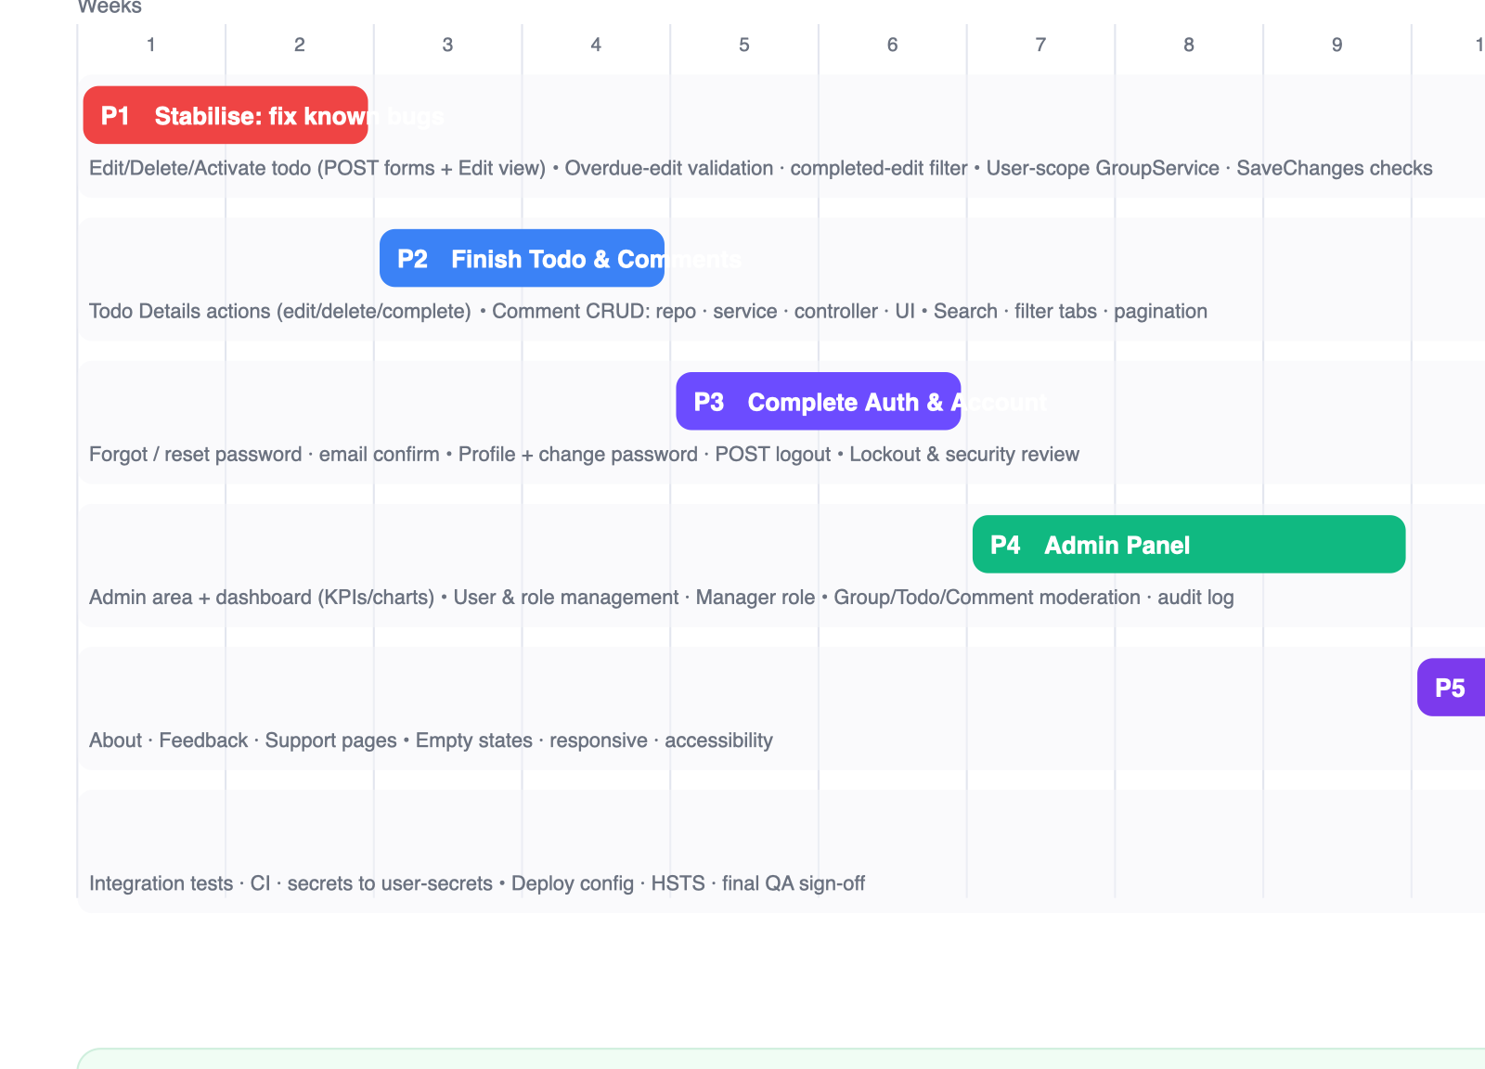
Figure 6 — Phased execution roadmap to completion.

Phase 1 — Stabilise (weeks 1–2)
Goal: Make the product actually work by clearing the known bugs.
- Build the Todo Edit view; convert Delete/Activate/Complete to antiforgery POST forms (bugs #1–3, #8).
- Fix overdue-edit validation and the completed-edit query-filter mismatch (bugs #4, #5).
- User-scope GroupService and fold in the redundant queries; replace the SaveChanges count checks (bugs #6, #7, #13).
- Sweep the low-severity cleanup: dead Guid guards, leftover usings, TODO block, GetUserGuid() helper (bugs #10, #11, #14, #15).
Exit criteria: All 15 findings resolved; regression tests added; suite green.

Phase 2 — Finish Todo & Comments (weeks 3–4)
Goal: Complete the two core content features end-to-end.
- Comment slice: repository + service + controller + Details forms (create/edit/delete).
- Wire Todo Details action buttons to their actions.
- Add search, status/priority filter tabs, and pagination to the Todo list.
Exit criteria: Todos and comments fully usable; list UX functional; tests cover the new services and controllers.

Phase 3 — Complete Auth & Account (weeks 5–6)
Goal: Make authentication production-grade.
- POST logout with antiforgery (bug #12).
- Forgot/reset password and email confirmation using Identity token providers + an email sender.
- Profile view/edit and change-password.
- Security review of lockout, cookie and antiforgery configuration.
Exit criteria: A user can recover an account and manage their profile; security review passes.

Phase 4 — Admin Panel (weeks 7–9)
Goal: Deliver the admin experience specified in section 7.
- Create the /Admin area with an area-level Admin authorization filter.
- Admin dashboard (KPIs, trend, activity feed).
- User & role management via UserManager/RoleManager; give the Manager role meaning.
- Group/Todo/Comment moderation and the audit log.
Exit criteria: Admin can manage users, roles and content; every admin action is audited.

Phase 5 — Content pages & polish (week 10)
Goal: Fill the remaining gaps and raise finish quality.
- About, Feedback and Support pages; remove dead nav links.
- Empty states, responsive layout and accessibility pass across views.
Exit criteria: No dead links; consistent look and feel; keyboard/screen-reader sane.

Phase 6 — Harden & Ship (weeks 11–12)
Goal: Close the project as finished and deployable.
- Integration tests and CI pipeline; coverage for critical flows.
- Move secrets to user-secrets/environment; document setup in the README.
- Deployment config, HTTPS/HSTS, final QA sign-off against the Definition of Done.
Exit criteria: Green CI, deployable build, Definition of Done satisfied — project complete.

9. Definition of Done
The project is finished when all of the following hold. This is the acceptance checklist for closing it out.
- Every capability in the status map (Figure 2) is green — 0 red, 0 amber.
- All 15 review findings are resolved and cannot regress (covered by tests).
- Todo lifecycle works end-to-end from the UI: create, view, edit, complete, activate, delete.
- Comment create / edit / delete work and are user- and todo-scoped.
- Auth is complete: POST logout, forgot/reset password, email confirmation, profile + change password.
- Admin panel is live: dashboard, user & role management, content moderation, audit log — Admin-gated.
- Manager role has a defined purpose (or is removed).
- Automated tests cover services, repositories and controllers for all new work; suite is green in CI.
- Secrets are supplied via user-secrets / environment, documented in the README; app runs from a clean checkout.
- Production concerns addressed: HTTPS/HSTS, antiforgery on every POST, no committed secrets, migrations apply cleanly.

Suggested milestones
Milestone | Definition
M1 — Stable | Phases 1–2 done: no known bugs, Todo + Comments complete.
M2 — Secure | Phase 3 done: authentication and account management complete.
M3 — Admin | Phase 4 done: admin panel live and role-gated.
M4 — Ship | Phases 5–6 done: polish, tests, CI, deployable — project closed as finished.
Prepared as project architect. This plan is intended to be executed by the developer; the codebase itself was not modified in producing it.

