|  |
| --- |
| Data Analysis of the 2024 Paris Olympic Games |
| TABLEAU |

# OVERVIEW

## Description of the Tableau Tool

|  |  |
| --- | --- |
|  | Tableau is a powerful data visualization and analysis tool that enables users to create interactive charts, tables, and dashboards. This software helps people better understand their data and extract valuable insights through intuitive visualizations. Tableau easily connects to various data sources, including databases, Excel files, and cloud services, making it highly flexible for different data analysis needs.  One of Tableau's key features is its ability to allow users to create customized dashboards that display multiple pieces of information in one place. These dashboards can be easily shared with others in the organization, facilitating collaboration and informed decision-making. Tableau also offers advanced functions such as data blending, real-time analytics, and the ability to create custom reports.  Tableau supports integration with programming languages such as R and Python, allowing users to expand their analytical capabilities and create customized analytical scripts. This tool has become indispensable in the business world and in many industries where data analysis is crucial for making strategic decisions. |

## Project Introduction

|  |  |
| --- | --- |
|  | This report presents insights related to the 2024 Olympic Games in Paris. The reporting was conducted using the aforementioned software “Tableau.” The dataset was taken from the website “Kaggle,” titled “Paris 2024 Olympic Summer Games.” |

Reports and Data Analysis

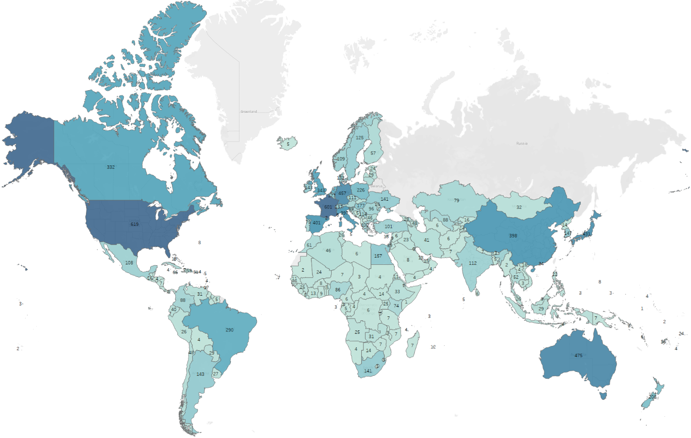

Image 1: Symbol Map

Based on the data about countries and the number of participants, a "Symbol Map" chart was used to show the global distribution of participants from over 200 countries in the 2024 Paris Olympic Games. The **United States** sent the largest delegation with nearly **600 athletes**, making it the most represented nation. On the other hand, smaller countries like Bhutan and Monaco had only a few participants. This map effectively illustrates the diversity and broad international presence at the Games, reflecting the Olympic spirit of global participation.​

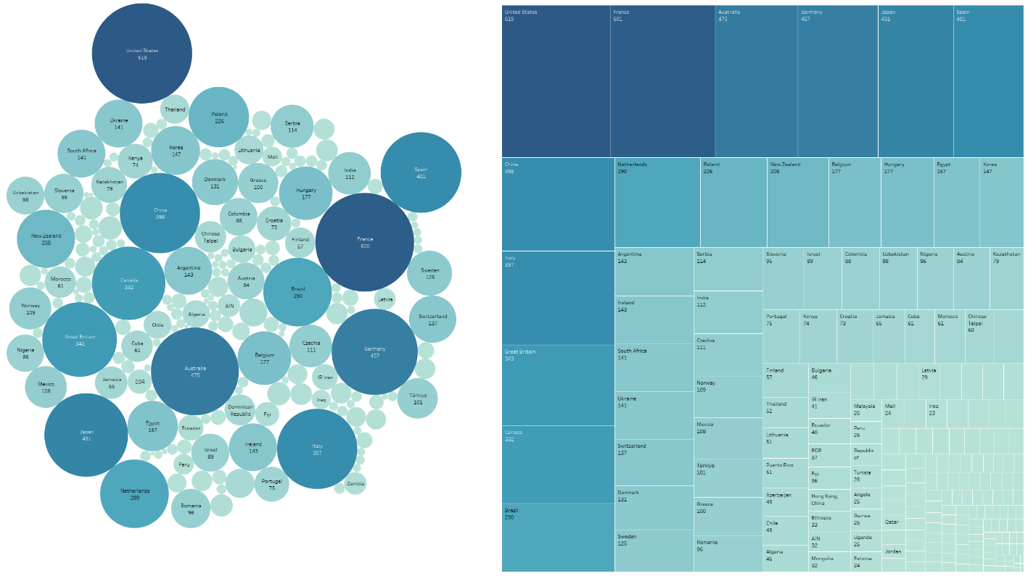

Image 2: Dashboard: Packed Bubbles + Treemaps

By combining treemaps and packed bubbles charts in Tableau, we can clearly see the total number of participants by country at the 2024 Paris Olympic Games. These charts allow us to easily identify which countries have the most and fewest athletes, with countries like the United States standing out due to the large number of participants. The charts also provide deeper insight into the ratio of participants from smaller countries, making it easier to compare nations in a visually intuitive way.

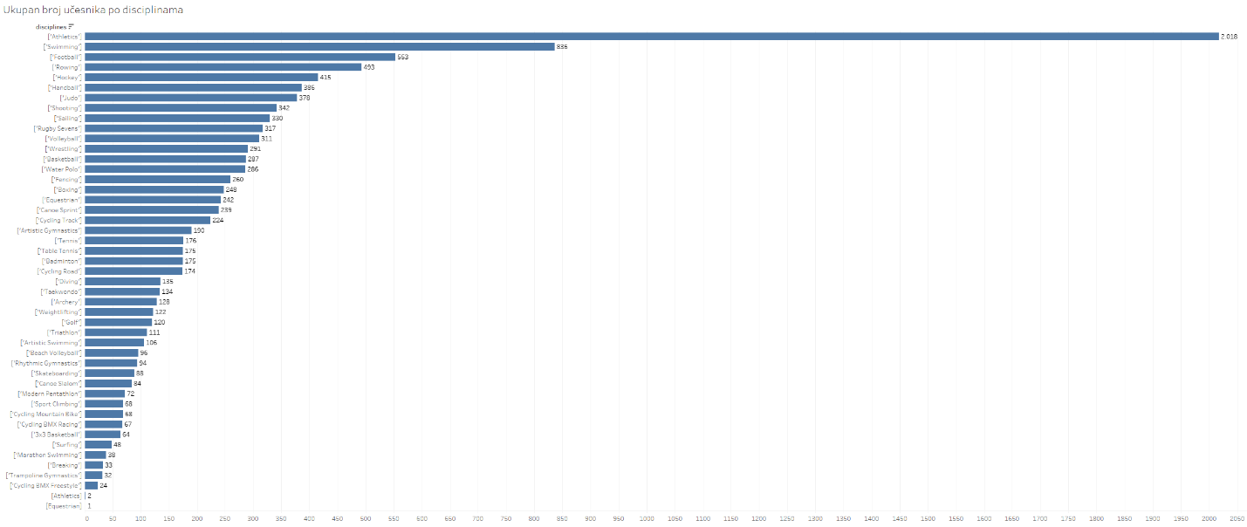

Image 3: Horizontal bars

The horizontal bar chart shows the number of participants by sports discipline at the 2024 Paris Olympic Games. The most represented discipline is **athletics** with **2,018** participants, significantly more than other disciplines. The second most popular sport is **swimming** with **836** participants, while football and rugby are also among the sports with many athletes. On the other hand, the least represented disciplines are trampoline and fencing, with relatively few competitors.

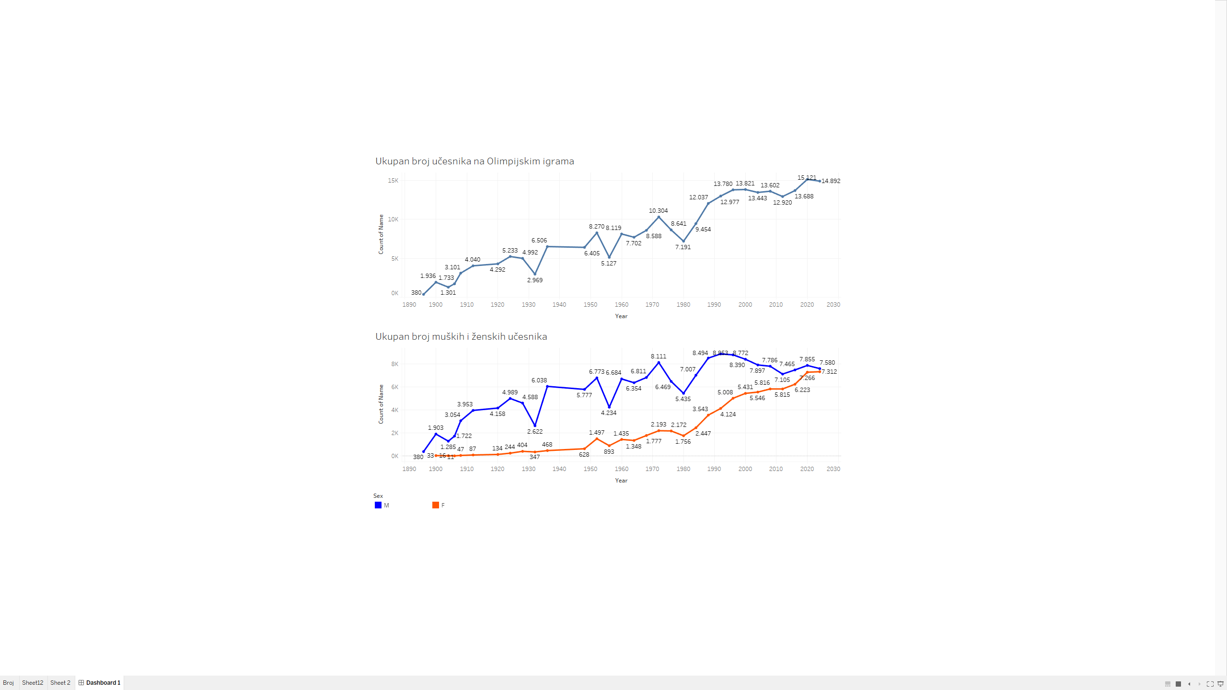

Image 4: Dashboard: Line charts

The first line graph shows the continuous growth in the number of participants at the Olympic Games from 1896 to 2024, highlighting how the Games have expanded over time. The second graph separates the data into male and female participants, showing a significant rise in female athletes, especially in recent decades. At the 2024 Olympics, the number of male and female participants is nearly equal, indicating a trend toward gender equality in sports.

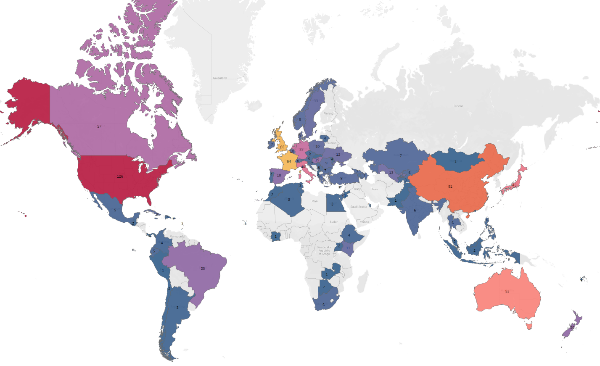

Image 5: Symbol Map

Another symbol map chart, which colors countries based on the total number of medals won, provides a visualization of the geographic distribution of success at the 2024 Paris Olympics. This chart highlights which countries were the most successful, making it easier to compare medal counts between nations. Notably, countries such as the United States, China, and the host nation France stand out as top performers. The map also reveals regional trends—for instance, the strong presence of European and North American countries among the top medal winners, while smaller nations tend to have more modest results. This visualization not only reflects athletic performance but also underscores global disparities in access to resources, training infrastructure, and athlete development programs. *Click here to view Top 10 Countries table*

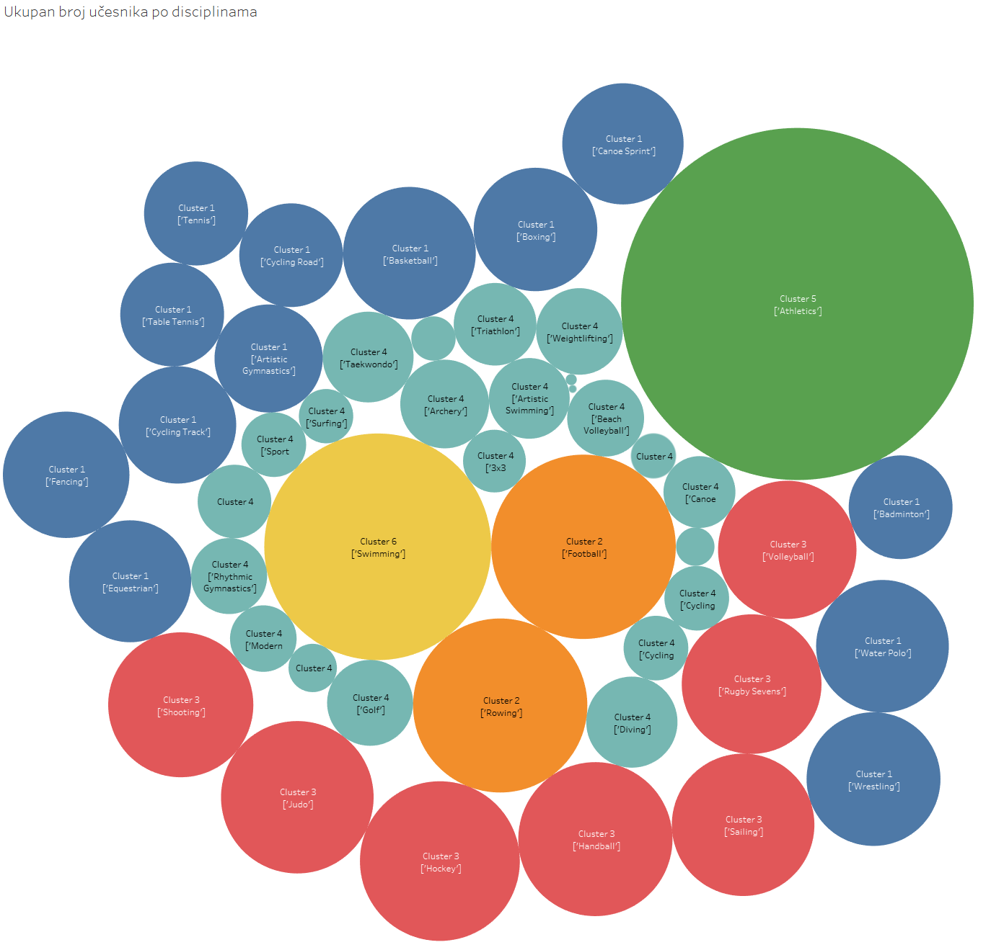

Image 6: Cluster: Packed Bubbles

Displaying data clusters based on the number of participants per discipline in Tableau enables visualization of different groups of sports based on participation levels. Dividing the clusters into six groups helps identify patterns and trends within sports disciplines, facilitating analysis of which sports attract the most participants and how the distribution varies across different clusters. This analysis can provide insight into the popularity and diversity of sports at the Olympics.

|  |  |  |  |  |  |
| --- | --- | --- | --- | --- | --- |
| **Rank** | **Country** | **Gold** | **Silver** | **Bronze** | **Total** |
| 1 | |  | | --- | | [United States](https://en.wikipedia.org/wiki/United_States_at_the_2024_Summer_Olympics) | | 40 | 44 | 42 | 126 |
| 2 | |  | | --- | | [China](https://en.wikipedia.org/wiki/China_at_the_2024_Summer_Olympics) | | 40 | 27 | 24 | 91 |
| 3 | |  | | --- | | [Japan](https://en.wikipedia.org/wiki/Japan_at_the_2024_Summer_Olympics) | | 20 | 12 | 13 | 45 |
| 4 | |  | | --- | | [Australia](https://en.wikipedia.org/wiki/Australia_at_the_2024_Summer_Olympics) | | 18 | 19 | 16 | 53 |
| 5 | |  | | --- | | [France*](https://en.wikipedia.org/wiki/France_at_the_2024_Summer_Olympics) | | 16 | 26 | 22 | 64 |
| 6 | |  | | --- | | [Netherlands](https://en.wikipedia.org/wiki/Netherlands_at_the_2024_Summer_Olympics) | | 15 | 7 | 12 | 34 |
| 7 | |  | | --- | | [Great Britain](https://en.wikipedia.org/wiki/Great_Britain_at_the_2024_Summer_Olympics) | | 14 | 22 | 29 | 65 |
| 8 | |  | | --- | | [South Korea](https://en.wikipedia.org/wiki/South_Korea_at_the_2024_Summer_Olympics) | | 13 | 9 | 10 | 32 |
| 9 | |  | | --- | | [Italy](https://en.wikipedia.org/wiki/Italy_at_the_2024_Summer_Olympics) | | 12 | 13 | 15 | 40 |
| 10 | |  | | --- | | [Germany](https://en.wikipedia.org/wiki/Germany_at_the_2024_Summer_Olympics) | | 12 | 13 | 8 | 33 |

Table 1 - Medal table

Conclusion

In conclusion, the analysis of the 2024 Paris Olympic Games using Tableau provided a clear picture of global participant distribution and the popularity of sports disciplines. The data shows a significant increase in the number of participants over time, a growing balance between male and female athletes, and variation in sport representation. These insights help us understand the dynamics and evolution of the Olympic Games, emphasizing how global sports are developing and adapting.