**Support material / *Material de Apoyo***

**Learning activity 1 / *Actividad de aprendizaje 1***

You will practice the use of the quantifiers some and any. / *Usted practicará el uso de los cuantificadores* some *y* any.

***PRESEN***

**Presentation / *Presentación***

**A.** **Definition:** Quantifiers show the quantity of a noun. They answer the question “how many / much”. Some quantifiers are used only with countable nouns, others with uncountable nouns, and others, with both. /***Definición****:* *Los cuantificadores indican la cantidad de un sustantivo. Son respuestas a la pregunta “cuánto(a) / cuántos(as)”. Algunos se pueden utilizar solo con cosas contables, otros solo con cosas incontables y otros, con ambos.*

**Some:** We use some to indicate a quantity. It can be used with countable and uncountable nouns and in affirmative sentences. / *Usamos “some” para indicar “algo de”. Se utiliza con cosas contables e incontables y en oraciones afirmativas.*

Examples */ Ejemplos:*

* There is some water in the glass.
* There are some cookies.
* There are some peanuts in the plate.
* I always drink some coffee in the morning*.*

Some can also we be used in questions when we offer or request something*. / Some también se utiliza en preguntas, cuando realizamos un ofrecimiento o una petición.*

Examples */ Ejemplos:*

* Can I have some water?
* Would you like some dessert?
* Can I get some napkins?

**Any:** We use “any” in interrogative or negative sentences. It cannot be used in affirmative sentences. ***/*** *Utilizamos “any” para indicar “algo de” en oraciones interrogativas, o “nada de” en oraciones negativas. No se puede usar en oraciones afirmativas.*

Examples */ Ejemplos:*

* Is there any fruit?
* Are there any oranges?
* There ins’t any food in the table.
* There aren’t any people in the restaurant.

In the following table has the different meaning and usage of quantifiers */ En la siguiente tabla puede observar los diferentes significados y usos de los cuantificadores.*

|  |  |  |  |  |  |  |
| --- | --- | --- | --- | --- | --- | --- |
| **Quantifies** | **Meaning** | **Countable** | **Uncountable** | **Affirmative** | **Negative** | **Interrogative** |
| **Some** | Algunos/as | X | X | X |  | X |
| **Any** | Algo de/ Ninguno | X | X |  | X | X |

**Practice / *Práctica***

1. Complete the sentences with some or any. / *Complete las oraciones con some o any.*
2. I am a vegetarian, I don’t eat any meat.
3. A: Would you like some ice cream?

B: No thanks, I can’t eat any sweet.

1. A: Do you want some onions in your burger?

B: Yes please. I love onions. But don’t put any tomatoes please.

1. Are there some vegetables for the salad?
2. There aren’t any good options in this restaurant.
3. There are some beautiful flowers in the garden.
4. A: Would you like some coffee sir?

B: No thanks, just the bill. And I need to pay by credit card, I don’t have any cash.

1. John is talking to his wife before going to the supermarket, complete the conversation with some or any. / *John está hablando con su esposa antes de ir al supermercado, complete la conversación con* some *o* any*.*

**John:** I am going to the supermarker, I need to buy some eggs, do you need (1) any products?

**Anee:** Yes please, I need (2) some bread for the dinner.

**John:** Ok, anything else?

**Anee:** Do you want (3) any dessert?

**John:** Sure.

**Anee:** Ok, please bring (4) some ice cream.

**John:** I am afraid I can’t eat (5) any dairy products this week. Remember what the doctor said? No milk at all!

**Fuente:** SENA

**Anee:** Oh, I am sorry, I completely forgot about it. Bring (6) some fruits then.

**John:** Ok dear. I´ll be back soon.

1. Look at the following picture of a supermarket cart, write a description of the products you see using there is / are and some / any. You can also describe some of the products the cart does not have. / *Observe la siguiente imagen de un carrito de supermercado, escriba una descripción de los productos que usted ve usando there is /are y some / any. También puede describir algunos de los productos que el carro no tiene.*

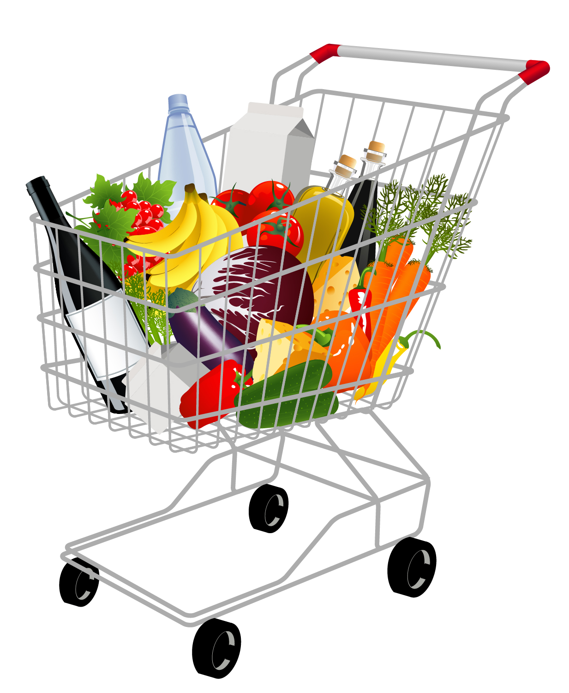

**Fuente:** SENA

There is a wine

There are some fruits

There is water

There is milk

There is any meat

There is some vegetables

**Production / *Producción***

Imagine you are going to the supermarket. Check your kitchen to see the products you need, then write sentences describing the products you need and the products you don’t need to buy using there is / are and some / any. / *Imagine que va a ir al supermercado. Revise su cocina para ver los productos que necesita, luego escriba oraciones describiendo los productos que necesita y los productos que no necesita comprar usando there is / are y some / any.*

There aren’t any fruits

There aren’t any vegetables

There aren’t any eggs

There are some cookies

There is some meat

There is some fluor

**Document control / *Control del documento***

|  |  |  |  |  |
| --- | --- | --- | --- | --- |
| **Author** | **Name** | **Position** | **Dependence** | **Date** |
| Juan Carlos Solano | Theme expert  Asesor English Dot Works - Programa de Bilingüismo | Dirección de Formación Profesional.  Dirección General | August  2014 |
| **Adaptation** | Luz Clarena Arias | Copy editor – Línea de Producción | Centro Agroindustrial. Regional Quindío | September  2014 |