Support Material / Material de apoyo

Learning activity 2 / Actividad de aprendizaje 2

Presentation / Presentación

- To express who someone was or where someone was, we use the verb be in past tense. / Para expresar quien fue alguien o en dónde estuvo, usamos la conjugación del verbo be en pasado.

- Affirmative form / Forma afirmativa

I | was | at the supermarket.
Subject | Verb in past | Complement

- Negative form / Forma negativa

I | was not | at the supermarket.
Subject | Verb in past | Complement

- Interrogative form / Forma interrogativa

Was | She | at the supermarket? | Yes, she was / No, she wasn’t.
Verb in past | Subject | Complement | Short answers

- Telling the date / Expresando la fecha

There is a difference when you write the date and when you say it. / Hay una diferencia cuando usted escribe la fecha y cuando usted dice la fecha.

  If you write | 7th March 1600 | 22 / 06 / 1939 | December 15th 2013
  You say | The seventh of March sixteen hundred. | The twenty second of June nineteen thirty-nine. | December the fifteen two thousand and thirteen or December the fifteen twenty thirteen.

Fuente de imágenes: SENA
Are there strawberries?

- Simple past is used to express actions that started and ended in the past. / El pasado simple es usado para expresar acciones que iniciaron y terminaron en el pasado.

- Affirmative form / Forma afirmativa

I | Studied | English at Sena.
Subject | Verb in past | Complement

- Negative form / Forma negativa

I | did not (didn’t) | Study | English at Sena.
Subject | Did not or didn’t | Verb in simple form | Complement

- Interrogative form / Forma interrogativa

Did | you | study | English at Sena? | Yes, I did. / No, I didn’t.
Did | Subject | Verb in simple form | complement | Short answers

Practice / Práctica

A. Tick (√) if the sentence is correct or cross (X) if it is wrong. Correct the wrong ones: / Seleccione (√) si la oración está bien o (X) si está mal. Corrija las oraciones incorrectas.

- I were born in February.
__________________________________________________

- They were in the supermarket.
__________________________________________________

- It was expensive.
__________________________________________________

- I didn’t studied math.
__________________________________________________

- Did they brought an umbrella?
__________________________________________________

- You was in my English class.
__________________________________________________

- She were a nurse at the hospital.
__________________________________________________

- Did she do her homework?
__________________________________________________

9. I didn’t wrote the report for history class.
__________________________________________________

10. Were he your teacher?
__________________________________________________

- Write the following verbs in past form. / Escriba los siguientes verbos en pasado.

Be
Become
Break
Bring
Clean
Cook
Draw
Dream
Drink
Eat
Listen
Paint
Play
Say
See
Sleep
Speak
Stop
Take
Talk
Teach
Think
Watch
Write

- Match the dates in numbers with their corresponding in letters. / Relacione las fechas en números con su correspondiente en letras.

- 06 / 19 / 1635 ___ December twenty-eight, two thousand and thirteen.

- 02 / 17 / 1854 ___ September thirty, nineteen ninety-one.

- 09 / 30 / 1991 ___ January six, two thousand.

- 01 / 06 / 2000 ___ October twenty-second, two thousand and five.

- 03 / 25 / 1295 ___ March twenty-five, twelve ninety-five.

- 10 / 22 / 2005 ___ February seventeen, eighteen fifty-four.

- 12 / 28 / 2013 ___ August twenty- third, twenty twenty-five.

- 08 / 23 / 2025 ___ June nineteen, sixteen thirty- five.

D. Answer the following questions. / Responda las siguiente preguntas.

- What did you do yesterday?
____________________________________________________________

- What did you do on the weekend?
____________________________________________________________

- Where were you born?
_____________________________________________________________

4. Where did you go last Friday?
_____________________________________________________________

5. What was the last thing you bought?
_____________________________________________________________

Production / Producción

- Look at the pictures. Write sentences about what the person did on vacation. / Mire las imágenes. Escriba oraciones sobre lo que hizo la persona en vacaciones.

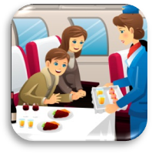

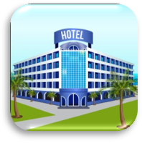



4.
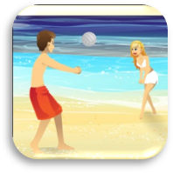
5.
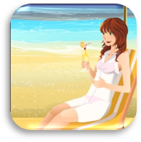
6.

7.

8.


Fuente de imágenes: SENA
Are there strawberries?

Document control / Control del documento

Author | Name | Position | Dependence | Date
Author | Ricardo Aristizabal Salinas | Theme expert  Asesor English Dot Works - Programa de Bilingüismo | Dirección de Formación Profesional.  Dirección General | August  2014
Adaptation | Luz Clarena Arias | Copy editor – Línea de Producción | Centro Agroindustrial. Regional Quindío | September  2014

