Job description

Part 1. Task :

* Full stack App .

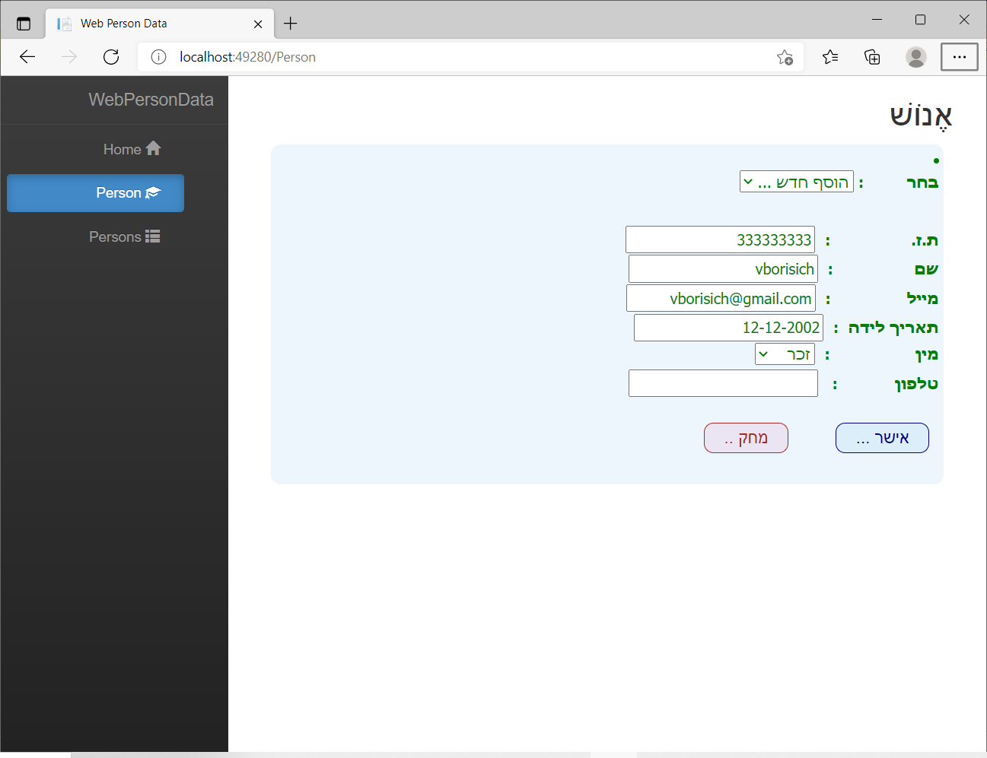

Part 2. Tools :

* MS VS 2017 . – C# , ReactJS , ASP.Core .Net-core v.2.2
* MS SQL Server Management Studio 17a
* Git & SVN .

