CSE 230 Problem Set 13

Problem 29.1: Currency
Consider the following problem definition:
A class is designed to represent currency (money). In this case, the currency is always positive and the smallest denominations are cents. This class is used in a financial application that has direct user textual input.
Please do the following
- Create a class diagram to describe the class:
Currency
- totalCents: int
+ Currency()
+ Currency(dollars: int, cents: int)
+ Currency(amount: string)
+ getDollars(): int
+ getCents(): int
+ toString(): string
+ add(amount: currency)
+ subtract(amount: Currency) : bool

- Create a DFD to illustrate how data moves into and out of the member variables. Hint: you might want to draw this out and insert a picture.

- Provide pseudocode for the methods responsible for keeping the member variables in a valid state.

Problem 29.2: Spaceship Fuel
Consider the following problem definition:
A class is designed to represent the fuel amount in a spaceship. A variety of interfaces can adjust the fuel level, including refueling stations, bonus fuel loads, and the engines that consume fuel the more they are used.
Please do the following
- Create a class diagram to describe the class:
Fuel
- fuelLevel: double
- maxFuel: double
+ getFuelLevel(): double
+ getMaxFuel(): double
+ addFuel(amount: double)
+ burnFuel(amount: double)
+ refillFuel()

- Create a DFD to illustrate how data moves into and out of the member variables. Hint: you might want to draw this out and insert a picture.
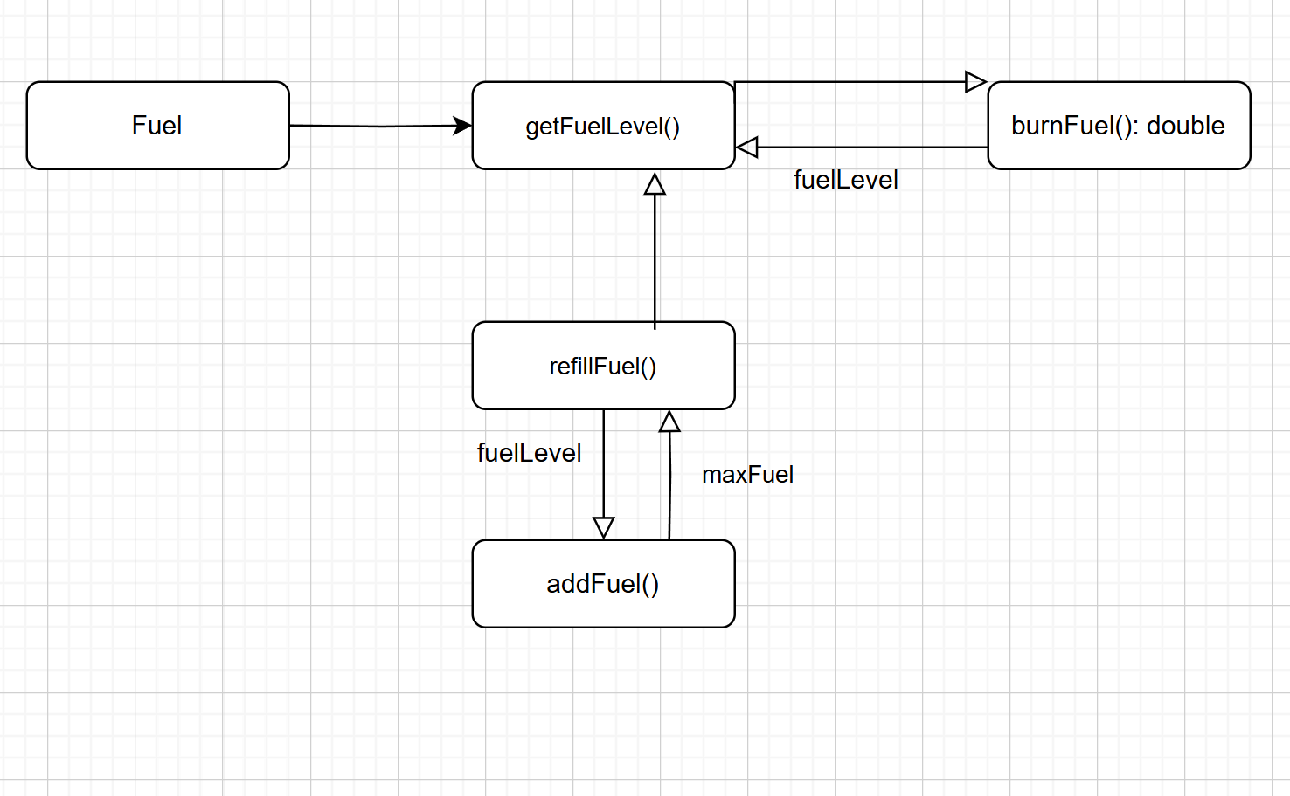
- Provide pseudocode for the methods responsible for keeping the member variables in a valid state.
Class fuel
// Member Variables
Var fuelLevel: double
Var maxFuel: double

// Constructor
METHOD Fuel(initialFuel: double, maxFuel: double )
SET maxFuel = maxCapacity
IF initialFuel > maxFuel
SET fuelLevel = maxFuel
ELSE
SET fuelLevel = initialLevel
END IF
END METHOD

// Getters
METHOD getFuelLevel(): double
RETURN fuelLevel
END METHOD

// Mutators
METHOD addFuel(amount: double)
IF amount > 0
SET newFuelLevel = fuelLevel + amount
IF newFuelLevel > maxFuel
SET fuelLevel = maxFuel
ELSE
SET fuelLevel = newFuelLevel
END IF
END METHOD

METHOD burnFuel(amount: double)
IF amount > 0
SET newFuelLevel = fuelLevel – amount
IF newFuelLevel < 0
SET fuelLevel = 0
ELSE
SET fuelLEvel = newFuelLevel
END IF
END METHOD

METHOD refillFuel ()
SET fuelLEvel = maxFuel
END METHOND

END CLASS

