V Vineeth kumar
C div
01fe16bcs250
ASSESSMENT 1 : MACHINE LEARNING LAB
PART-1
c.

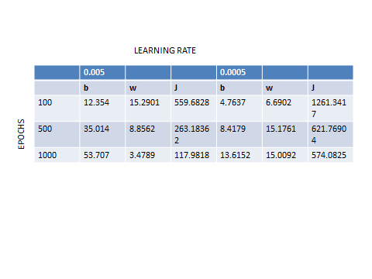

d. At epoch, 6100 for learning rate 0.005 the cost remains 15.11 for the consecutive epochs.

PART-2

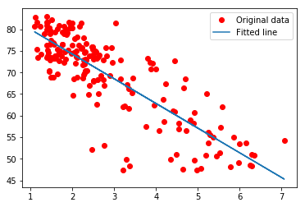
- In the above graph, x axis=epochs
Y axis=Cost function.
This particular graph is for learning rate 0.005. We observe that the cost function decreases as the epochs increase until a particular threshold value is reached. Later the value remains constant after certain epochs.
- The time taken by Batch gradient decent is less as compared to Stochastic as compared to Gradient decent.
The time complexity for Stochastic Gradient decent is C/e where C is time complexity of one sample. Whereas the time complexity of Gradient Decent is n*C*log(1/e).
Therefore, the order is Gradient Decent > Stochastic Gradient Decent > Batch Gradient Decent.
- From the table in Part-1 c. We observe that the min value of cost is for values theta0=53.707 and theta1=3.4789 with the initial values zero.

PART-3
Analysis of alogorithms with and without optimization

* Without optimization
Training cost= 2609.323 W= -0.8470079 b= 0.30191687
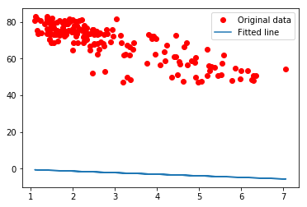

* with Gradient Descent optimization
Training cost= 30.615223 W= -2.1893163 b= 73.32755
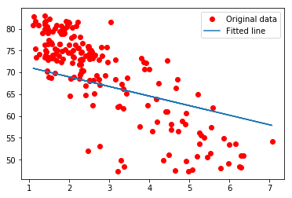

* with Adams Optimization
cost= 15.211244 W= -5.893365 b= 85.86689

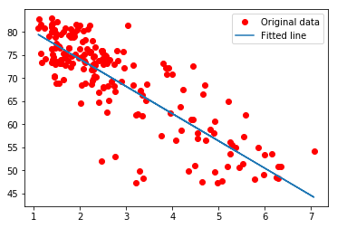

Thereby we can conclude that the cost(loss) is highly reduced after using an optimizer

