Data Structures and Algorithms Lab
07. Trees
Subject Code: 17ECSP201 Lab No: 07 Semester: III
Date: 3&5 Oct, 2017 Batch: C1&C2

DELETION CASES
----------------------------------------------------------------------------------------------------------------------------------------------

For each of the cases below presented below, bold those lines of code which gets executed. Your task is to understand which part of the code works for each of the case.

Essentially, deletion happens at following cases:
- Node may not be present
- A leaf node
- A non leaf node with 1 child
- A non leaf node with 2 children
- Root node
For each of the case presented, bold the line of execution.
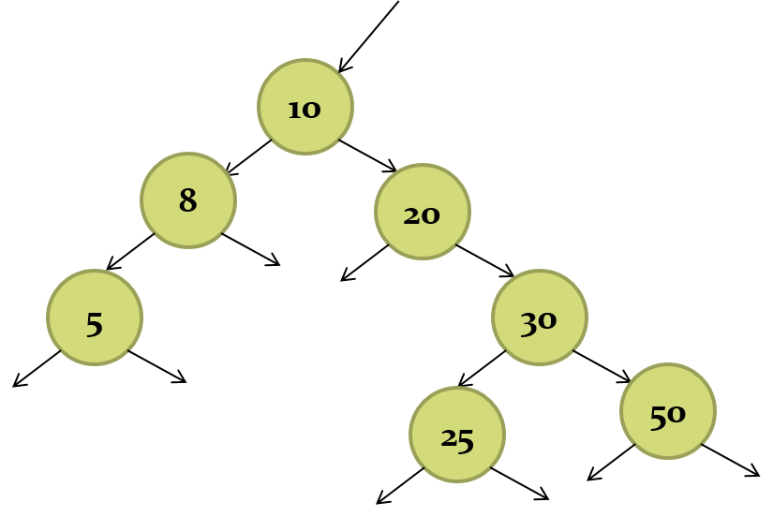
Case 01: Delete 100

NODE * delete_from_BST(NODE * root, int item)
{
NODE * currnode, *parent, *successor, *p;

if(root == NULL)
{
printf("Tree is empty\n");
return root;
}

parent = NULL;
currnode = root;
while (currnode != NULL && item != currnode->info)
{
parent = currnode;
if(item < currnode->info)
currnode = currnode->left;
else
currnode = currnode->right;
}

if(currnode == NULL) {
printf("Item not found\n");
return root;
}

if(currnode->left == NULL)
p = currnode->right;
else if (currnode->right == NULL)
p = currnode->left;
else
{
successor = currnode->right;
while(successor->left != NULL)
successor = successor->left;

successor->left = currnode->left;
p = currnode->right;
}

if (parent == NULL) {
free(currnode);
return p;
}

if(currnode == parent ->left)
parent->left = p;
else
parent->right = p;

free(currnode);
return root;
}
Case 02: Delete 5

NODE * delete_from_BST(NODE * root, int item)
{
NODE * currnode, *parent, *successor, *p;

if(root == NULL)
{
printf("Tree is empty\n");
return root;
}

parent = NULL;
currnode = root;
while (currnode != NULL && item != currnode->info)
{
parent = currnode;
if(item < currnode->info)
currnode = currnode->left;
else
currnode = currnode->right;
}

if(currnode == NULL) {
printf("Item not found\n");
return root;
}

if(currnode->left == NULL)
p = currnode->right;
else if (currnode->right == NULL)
p = currnode->left;
else
{
successor = currnode->right;
while(successor->left != NULL)
successor = successor->left;

successor->left = currnode->left;
p = currnode->right;
}

if (parent == NULL) {
free(currnode);
return p;
}

if(currnode == parent ->left)
parent->left = p;
else
parent->right = p;

free(currnode);
return root;
}
Case 03: Delete 30
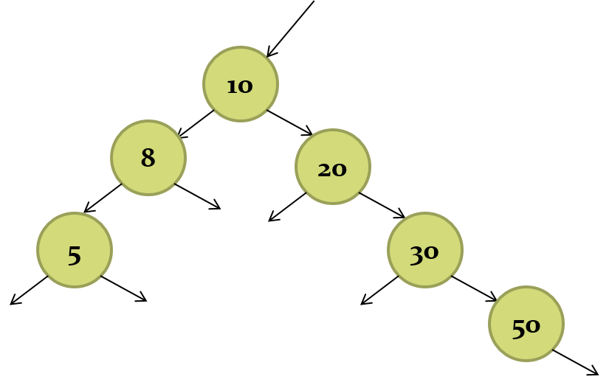
NODE * delete_from_BST(NODE * root, int item)
{
NODE * currnode, *parent, *successor, *p;

if(root == NULL)
{
printf("Tree is empty\n");
return root;
}

parent = NULL;
currnode = root;
while (currnode != NULL && item != currnode->info)
{
parent = currnode;
if(item < currnode->info)
currnode = currnode->left;
else
currnode = currnode->right;
}

if(currnode == NULL) {
printf("Item not found\n");
return root;
}

if(currnode->left == NULL)
p = currnode->right;
else if (currnode->right == NULL)
p = currnode->left;
else
{
successor = currnode->right;
while(successor->left != NULL)
successor = successor->left;

successor->left = currnode->left;
p = currnode->right;
}

if (parent == NULL) {
free(currnode);
return p;
}

if(currnode == parent ->left)
parent->left = p;
else
parent->right = p;

free(currnode);
return root;
}
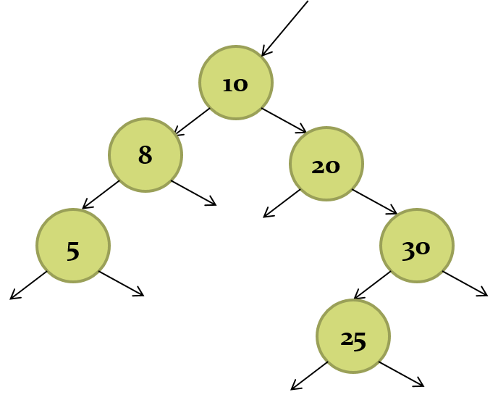
Case 04: Delete 30

NODE * delete_from_BST(NODE * root, int item)
{
NODE * currnode, *parent, *successor, *p;

if(root == NULL)
{
printf("Tree is empty\n");
return root;
}

parent = NULL;
currnode = root;
while (currnode != NULL && item != currnode->info)
{
parent = currnode;
if(item < currnode->info)
currnode = currnode->left;
else
currnode = currnode->right;
}

if(currnode == NULL) {
printf("Item not found\n");
return root;
}

if(currnode->left == NULL)
p = currnode->right;
else if (currnode->right == NULL)
p = currnode->left;
else
{
successor = currnode->right;
while(successor->left != NULL)
successor = successor->left;

successor->left = currnode->left;
p = currnode->right;
}

if (parent == NULL) {
free(currnode);
return p;
}

if(currnode == parent ->left)
parent->left = p;
else
parent->right = p;

free(currnode);
return root;
}
Case 05: Delete 30

NODE * delete_from_BST(NODE * root, int item)
{
NODE * currnode, *parent, *successor, *p;

if(root == NULL)
{
printf("Tree is empty\n");
return root;
}

parent = NULL;
currnode = root;
while (currnode != NULL && item != currnode->info)
{
parent = currnode;
if(item < currnode->info)
currnode = currnode->left;
else
currnode = currnode->right;
}

if(currnode == NULL) {
printf("Item not found\n");
return root;
}

if(currnode->left == NULL)
p = currnode->right;
else if (currnode->right == NULL)
p = currnode->left;
else
{
successor = currnode->right;
while(successor->left != NULL)
successor = successor->left;

successor->left = currnode->left;
p = currnode->right;
}

if (parent == NULL) {
free(currnode);
return p;
}

if(currnode == parent ->left)
parent->left = p;
else
parent->right = p;

free(currnode);
return root;
}
Case 06: Delete 20

NODE * delete_from_BST(NODE * root, int item)
{
NODE * currnode, *parent, *successor, *p;

if(root == NULL)
{
printf("Tree is empty\n");
return root;
}

parent = NULL;
currnode = root;
while (currnode != NULL && item != currnode->info)
{
parent = currnode;
if(item < currnode->info)
currnode = currnode->left;
else
currnode = currnode->right;
}

if(currnode == NULL) {
printf("Item not found\n");
return root;
}

if(currnode->left == NULL)
p = currnode->right;
else if (currnode->right == NULL)
p = currnode->left;
else
{
successor = currnode->right;
while(successor->left != NULL)
successor = successor->left;

successor->left = currnode->left;
p = currnode->right;
}

if (parent == NULL) {
free(currnode);
return p;
}

if(currnode == parent ->left)
parent->left = p;
else
parent->right = p;

free(currnode);
return root;
}
Case 07: Delete 10

NODE * delete_from_BST(NODE * root, int item)
{
NODE * currnode, *parent, *successor, *p;

if(root == NULL)
{
printf("Tree is empty\n");
return root;
}

parent = NULL;
currnode = root;
while (currnode != NULL && item != currnode->info)
{
parent = currnode;
if(item < currnode->info)
currnode = currnode->left;
else
currnode = currnode->right;
}

if(currnode == NULL) {
printf("Item not found\n");
return root;
}

if(currnode->left == NULL)
p = currnode->right;
else if (currnode->right == NULL)
p = currnode->left;
else
{
successor = currnode->right;
while(successor->left != NULL)
successor = successor->left;

successor->left = currnode->left;
p = currnode->right;
}

if (parent == NULL) {
free(currnode);
return p;
}

if(currnode == parent ->left)
parent->left = p;
else
parent->right = p;

free(currnode);
return root;
}

