Time Series Forecasting For Predicting Long-Term Gold Price

Submitted by

Joyston Jose D’Souza 24251325
MSc. Big Data Analytics
Aloysius Institute of Management & Information Technology (AIMIT)
St Aloysius (DEEMED TO BE UNIVERSITY)
Mangalore, Karnataka

Submitted in Partial Fulfillment of the Requirements for the Award of the Degree of
Master of Science in Big Data Analytics

Under the guidance of

Dr. Rakesh Kumar B
Associate Professor (Department of BDA)
St. Aloysius Institute Of Management and Information Technology (AIMIT)
St. Aloysius (DEEMED TO BE UNIVERSITY)
Mangalore, Karnataka

Submitted to



2026

CERTIFICATE
This is to certify that the project titled
Time Series Forecasting For Predicting Long-Term Gold Price
Submitted by
Joyston Jose D’Souza 24251325
MSc. Big Data Analytics
Aloysius Institute of Management & Information Technology (AIMIT)
St Aloysius (DEEMED TO BE UNIVERSITY)
Mangalore, Karnataka
In partial fulfillment of the requirements for award of degree of Master of Science in Big Data Analytics of Mangalore St. Aloysius (Deemed to be University)
During the year
2026

Dr. Rakesh Kumar B
Associate Professor (Department of BDA),
Department of M. Sc (Big Data Analytics),
AIMIT,
St.Aloysius (Deemed To Be University), Mangaluru-575022.

Dr. (Fr) Kiran Cotha SJ
Director,
AIMIT, St. Aloysius (Deemed To Be University) Mangaluru-575 022.

Dr Hemalatha N
Dean, School of Information Science and Technology,
PG Depts. of Information Science and Technology,
AIMIT,
St.Aloysius (Deemed To Be University),
Mangaluru-575 022.

Examiners
1.

2.

CERTIFICATE OF AUTHENTICATED WORK

This is to certify that the project report entitled Time Series Forecasting For Predicting Long -Term Gold Price submitted to St. Aloysius Institute of Management and Information Technology (AIMIT), St. Aloysius (Deemed To Be University) in partial fulfilment of the requirement for the award of the degree of MASTER OF SCIENCE IN BIG DATA ANALYTICS (MSc. BDA) is an original work carried out by Mr. Joyston Jose D’souza Register no. 24251325 under my guidance. The matter embodied in this project is authentic and is genuine work done by the student and has not been submitted whether to this University, or to any other University / Institute for the fulfilment of the requirement of any course of study.

Signature of the Student
Date: ___________
Joyston Jose D’souza
M.Sc. Big Data Analytics
AIMIT, St. Aloysius
(Deemed to be University)
Mangaluru-575022.
Register Number: 24251325

Signature of the Guide
Date: ___________
Dr. Rakesh Kumar B
Associate Professor (Department of BDA),
Department of M.Sc (Big Data Analytics)
AIMIT, St. Aloysius
(Deemed To Be University),
Mangaluru-575022.

Project Proposal Report / Synopsis

for

Time Series Forecasting For Predicting Long-Term Gold Price

Joyston Jose D’Souza
24251325
MSc. Big Data Analytics
St. Aloysius Institute Of Management and Information Technology (AIMIT)
ST. ALOYSIUS (DEEMED TO BE UNIVERSITY)
Beeri, Kotekar, Mangalore - 575022

Under the guidance of
Dr. Rakesh Kumar B
Associate Professor (Department of BDA)
St. Aloysius Institute Of Management and Information Technology (AIMIT)
ST. ALOYSIUS (DEEMED TO BE UNIVERSITY)
Beeri, Kotekar, Mangalore - 575022

Submitted to


ABSTRACT
The accurate prediction of gold price is a crucial task for investment decisions and has a considerable impact on investors, policymakers, financial Institutes and countries that depend on mineral resources, yet it remains a significant challenge due to its inherent volatility and complex, non-linear dynamics. Therefore, understanding the future price movement is important for revenue-based planning for investors, companies and also the country. This research focuses on applying Machine Learning techniques for predicting the Gold Price and providing a comparative analysis of the 4 ML algorithms for long-term gold price forecasting namely SARIMA, ARIMA, LINEAR REGRESSION, SVM (kernel used are RBF, Linear and Polynomial). Utilizing a comprehensive dataset of gold prices from August 2000 to August 2025 which was pre-processed by resampling into monthly averages to model long-team trends. All the models were trained on the historical monthly data and employed to generate a 60-month (5-year) forecast, from September 2025 to August 2030.
Keywords—Time Series Forecasting, SARIMA, ARIMA, LINEAR REGRESSION, SVM

INDEX

- Introduction
  - Overview / Background
CHAPTER 1

INTRODUCTION

  - OVERVIEW

Gold has always been a key part of the global financial system. Historically, it was used for trade, and today, central banks around the world hold it to manage inflation, secure foreign debts, and show a nation's financial strength. For corporations and individual investors, gold acts as a vital "safe haven" asset, especially during times of political unrest or economic instability, such as pandemics [1]. This dual role as a strategic reserve and a popular investment makes accurately predicting its price a major challenge for both policymakers and investors. The task becomes even harder due to the price's natural volatility and its complex, non-linear nature. Gold prices depend on many factors, such as global economic performance, stock indices like the S&P 500, bond yields, the US Dollar Index, and other commodities [2, 3].
Due to this complexity, a wealth of research has emerged to find the most reliable forecasting methods [4, 5], sparking a lively debate between traditional econometric models and modern machine learning (ML) techniques [6-8]. Statistical methods like the Autoregressive Integrated Moving Average (ARIMA) and its seasonal variations (SARIMA) are often used because they can model time-series trends [9, 10]. At the same time, ML models, including Support Vector Regression (SVR)—which is known for its effectiveness with non-linear kernels [10]—as well as Linear Regression and other methods [11-15], have gained prominence. The main goal of this research is to predict the price of gold five years from now. While we recognize that market forecasts are always changing, this analysis specifically targets a five-year prediction that will end in August 2030.
Using a consistent dataset of monthly average gold prices from August 2000 to August 2025, our research tests and evaluates four different models: ARIMA, SARIMA (which includes the S&P 500 and US Dollar Index), Linear Regression, and Support Vector Regression (with linear, poly, and RBF kernels). Our results show a significant difference in the 5-year forecasts for 2025-2030. This analysis implies that while ML models may be powerful, traditional seasonal time-series models were the most effective in capturing the long-term momentum in this historical dataset.

  - Problem Statement

The accurate prediction of gold price movements is of utmost importance in order to direct informed investment strategies. This has a substantial and direct impact on a wide array of stakeholders, which includes individuals, organizations, governments, and even nations that have economies that are largely dependent on mineral resources.

However, the accurate prediction of gold price movements over long periods of time is a major challenge that arises due to the volatile nature of gold in the market, which has complex and non-linear characteristics. Therefore, it is of utmost importance to have an accurate understanding of the future price movements of gold in order to have effective revenue planning and strategic economic forecasting. There is an urgent need to evaluate the implementation of advanced machine learning strategies to meet the challenges.

  - PROJECT OBJECTIVES

- The objective is to utilize machine learning algorithms for long-term forecasting of gold price movements.

- To conduct a comparative study of four machine learning algorithms for long-term forecasting, namely, SARIMA, ARIMA, Linear Regression, and Support Vector Machine using RBF, Linear, and Polynomial kernels.

- To train the machine learning algorithms using a comprehensive dataset for long-term forecasting, comprising historical gold price movements aggregated at the monthly average level.

- To generate a 60-month forecast horizon, ranging from September 2025 to August 2030.
- To evaluate the performance of the predictive models using statistical performance metrics such as RMSE, MAE, and MAPE.

- To utilize the trained predictive models using a FastAPI backend for serving purposes, enabling integration with front-end dashboards using Streamlit.

CHAPTER 2

- LITERATURE REVIEW
  - Introduction
Gold price predictions present significant challenges due to their volatility and inability to be predicted in a linear manner over long periods of time. In the past, most forecasting of gold prices used similar methods to predict other commodities, using historical price data as the basis for making an economic or investing decision. These types of models generally worked well in predicting short-term trends; however, due to the complex, non-linear disruptions caused by macroeconomic shifts and worldwide calamities, they were generally less accurate at predicting longer-term results than some competing methods.
As a result of this paradigm shift, there has been substantial research indicating how the use of advanced machine learning and deep learning architectures helps to mitigate these non-linearities. An example of this is how modern DL models are able to improve their ability to predict very volatile periods by accounting for external shocks, such as global pandemics [1] and how integrating macroeconomic indicators into ML workflows has been shown repeatedly to improve forecasting performance [2]. Additionally, there are new frameworks such as the Gold Nexus Predictor (GNP), which explicitly augment economic indicators and advanced algorithmic learning to fully understand market dynamics through the use of a single model [3].
A series of holistic investigations into the development of computational finance that occurred during the last 10 years provide evidence for the evolution from simple statistical techniques to complex ML methods, and they have stressed the importance of carefully selecting models based on the attributes of the data being analyzed, as well as the environment in which it is used [4]. The findings of a comparative analysis using rigorous benchmarks to evaluate traditional econometric models and contemporary machine learning models strongly support hybrid methods [6]. For instance, when used together, statistical baseline models and machine learning models produce predictions that are significantly better than either model does when used independently [7].
The body of research has also built upon the relationship that exists between the use of algorithms to learn from data and the costs which have been represented in traditional models of economics [8] through the utilization of a more advanced type of multivariate-stochastic model that is meant to represent latent ($ latent $) volatility in markets [9]. In practice, many of the techniques that are commonly used for forecasting utilise both a linear model such as ARIMA and a nonlinear mapping technique such as Support Vector Machines (SVM) to find and map the way in which residuals behave within models [10]. In addition, the standard machine learning pipeline methods have consistently demonstrated their effectiveness at revealing latent and less obvious price histories from the past [11] and that these two components (the way the algorithm is designed, and the hyperparameters of the algorithm) are equally important as the dataset used to train an algorithm [12].
CNN-LSTM Models have done well in capturing temporal patterns from multiple dimensions when processing Deep Temporal Sequences [13]. In the post-2024 literature, researchers have continued to expand on this, writing algorithmic reviews that provide the best outcomes for implementing their models [14]. Many new ways of processing data (including using rolling average representations) have also been documented as having promising outcomes for decreasing extreme daily price volatility before training a model [15].

  - Details of literature review
Gold price forecasting has attracted considerable attention due to its vital role in investment decisions and economic planning. Mohtasham Khani et al. introduced a deep learning-based method to forecast gold prices, emphasizing the impacts of pandemics on price movements. This study highlighted the need to incorporate external shocks like pandemics into price prediction models for better accuracy [1].
Kumar et al. utilized machine learning techniques leveraging economic indicators to predict gold prices, demonstrating improved forecasting performance by integrating those indicators into the models [2]. Similarly, Tejasvi et al. proposed the Gold Nexus Predictor (GNP), which integrates machine learning with economic indicators to enhance gold market predictions [3].
A comprehensive review by Das et al. examined a decade's worth of machine learning approaches for gold price forecasting, outlining the evolution and comparative performance of diverse techniques [4]. Their findings reinforced the comparative strengths of different machine learning methods in addressing the non-linear and volatile characteristics of gold prices.
Gadage and Baporikar provided a survey on various machine learning methods applied to gold price prediction, emphasizing model selection based on data characteristics and problem context [5]. Their work contributed to understanding the suitability of specific models for this domain.
Jahnavi et al. conducted a comparative analysis between econometric and machine learning models, advocating a comprehensive approach that harnesses the advantages of both methodologies for enhanced forecasting accuracy [6]. Ahmad et al. further explored this comparison by examining statistical and machine learning models, concluding that hybrid approaches might outperform traditional models in gold price prediction [7].
Plakandaras et al. addressed the interplay between gold prices and machine learning, analyzing how machine learning algorithms can be used effectively in economic modeling relative to gold price movement [8]. Madziwa et al. introduced a multivariate stochastic model for gold price forecasting, incorporating multiple influencing factors to capture underlying market dynamics [9].
Makala and Li applied ARIMA and SVM models to predict gold prices, asserting the effectiveness of combining traditional time series methods with machine learning techniques [10]. Aruna et al. expanded on machine learning applications, demonstrating their utility in uncovering potential price trends in gold markets [11].
Cohen and Aiche employed machine learning methodologies for gold price forecasting, highlighting the significance of sophisticated algorithm designs in improving prediction accuracy [12]. Earlier, Livieris et al. developed a CNN–LSTM hybrid model to forecast gold prices effectively by capturing temporal patterns in the data [13].
Jin and Xu focused on machine learning gold price forecasting, reviewing modern algorithms and their implementation outcomes [14]. Recently, Kannan et al. proposed a method using rolling average representation combined with machine learning for gold price prediction, showing promising results in dealing with price volatility [15].
Overall, the literature reflects a progression from traditional econometric models to advanced machine learning and deep learning techniques, with increasing attention towards hybrid models that incorporate economic indicators and external factors to enhance forecasting accuracy.

  - Analysis of Related Works
To help in understanding the proposed use of SARIMA, Linear Regression and SVM techniques to develop a long-term, 5-year forecast; a review of the current literature will be necessary to conduct a critical analysis of the subject. The tables below provide a synthesis of the key advantages and disadvantages, methodological conclusions and results of notable recent research on predicting gold prices.

Paper | Advantages | Disadvantages
Mohtasham Khani et al. (2021) [1] | Successfully integrated external black-swan events (pandemics) into predictive frameworks. | High likelihood of overfitting to specific historical anomalies; lacks high interpretability.
Kumar et al. (2024) [2] | Improved forecasting accuracy by explicitly feeding correlated macroeconomic indicators into the ML pipeline. | Increased dimensionality can introduce multicollinearity, requiring aggressive feature reduction.
Tejasvi et al. (2024) [3] | Offered a highly structured approach (GNP) to fusing economic data with ML algorithms. | May struggle with extreme long-term horizons if the underlying economic indicator forecasts are inaccurate.
Das et al. (2021) [4] | Provided a comprehensive historical baseline of ML evolution in financial forecasting over a decade. | Purely a retrospective review; did not propose a novel, deployable predictive architecture.
Gadage & Baporikar [5] | Established a strong theoretical taxonomy for model selection based on varying data distributions. | Qualitative survey lacking empirical benchmarking of the discussed algorithms against a unified dataset.
Jahnavi et al. (2025) [6] | Rigorously benchmarked econometric formulas against ML, proving the necessity of hybrid approaches. | High computational overhead when running parallel econometric and machine learning pipelines.
Ahmad et al. (2025) [7] | Demonstrated empirically that hybrid statistical-ML approaches outperform isolated models. | Focused purely on comparative analysis rather than deploying an interactive prediction application.
Plakandaras et al. (2021) [8] | Bridged the theoretical gap between computer science (ML) and traditional economic modeling. | Formulations were heavily theoretical, potentially lacking direct adaptability for simple dashboard deployments.
Madziwa et al. (2022) [9] | Effectively captured underlying market volatility and interconnected asset dynamics. | Inherently produces probabilistic bounds rather than deterministic long-term price points.
Makala & Li (2021) [10] | Proved the synergistic capability of combining ARIMA for linear trends with SVM for non-linear residual mapping. | Limited in mapping highly complex sequential temporal dependencies compared to deep recurrent networks.
Aruna et al. (2021) [11] | Successfully highlighted how various ML pipelines uncover latent, non-obvious historical price trends. | Primarily focused on potential trend classification rather than generating exact future price points.
Cohen & Aiche (2023) [12] | Emphasized that algorithmic architecture design is a primary driver of prediction accuracy. | Sophisticated algorithmic designs often hinder rapid retraining cycles due to computational complexity.
Livieris et al. (2020) [13] | Captured both feature-based and temporal dependencies simultaneously using a CNN-LSTM hybrid. | Requires vast amounts of data to prevent overfitting and is computationally expensive to optimize.
Jin & Xu (2025) [14] | Delivered a highly updated synthesis of modern algorithms, capturing recent advancements in financial ML. | Acts as a secondary source review; lacks a primary, novel dataset contribution.
Kannan et al. (2024) [15] | Leveraged rolling average representations to smooth out high-frequency noise and extreme daily volatility. | Smoothing techniques inherently risk causing the model to lag during sudden, legitimate market breakouts.
Table 1: Comparative Analysis of Advantages and Disadvantages

Paper | Methodology / Model Used | Key Finding / Performance Outcome
Mohtasham Khani et al. [1] | Deep Learning Architectures | Demonstrated significant improvement in capturing extreme price volatility during crisis periods.
Kumar et al. [2] | Supervised Machine Learning | Achieved notable error reduction by integrating broader economic health indicators.
Tejasvi et al. [3] | Gold Nexus Predictor (GNP) | Yielded highly correlated market predictions compared to standard baseline models.
Das et al. [4] | Systematic Review | Established that non-linear ML methods consistently outperform linear models over the decade.
Gadage & Baporikar [5] | Literature Survey | Concluded that data distribution dictates model success; no single algorithm is universally superior.
Jahnavi et al. [6] | Econometric vs. ML Models | Found that comprehensive approaches utilizing both statistical and ML elements minimize forecasting error.
Ahmad et al. [7] | Statistical vs. ML | Empirically validated that hybrid frameworks generate the lowest Mean Absolute Error (MAE).
Plakandaras et al. [8] | ML in Economic Modeling | Validated the superior pattern recognition of ML algorithms in chaotic financial datasets.
Madziwa et al. [9] | Multivariate Stochastic Model | Successfully mapped multi-factor influences, generating robust probabilistic forecasting bounds.
Makala & Li [10] | ARIMA + SVM | Demonstrated that SVM effectively corrects the residual errors left by the linear ARIMA baseline.
Aruna et al. [11] | Standard Machine Learning | Successfully classified and mapped potential long-term price trajectories.
Cohen & Aiche [12] | Advanced ML Methodologies | Showed that hyperparameter optimization leads to measurable decreases in Root Mean Square Error (RMSE).
Livieris et al. [13] | CNN–LSTM Hybrid | Achieved state-of-the-art error metrics by independently processing spatial and temporal data.
Jin & Xu [14] | Methodological Review | Synthesized recent implementations, confirming the industry shift toward deep learning.
Kannan et al. [15] | Rolling Average + ML | Improved model stability and generalized prediction accuracy by eliminating day-to-day noise.
Table 2: Model Performance and Methodological Focus

Chapter 3

- Materials and Methods
  - Introduction
The purpose of this section is to provide an exhaustive report of the systematic approach adopted for achieving the main goals of this research. This section will detail the entire data science lifecycle, starting at the point where market data was collected and ending at the point where robust forecasting models are implemented. It will provide a complete and thorough account of how the historical financial data used in this research was obtained, how it was structured, and what pre-processing actions were undertaken to ensure that the data produced is accurate. Additionally, this section will provide a thorough account of all of the specialized features that were engineered during the pre-processing phase of the analysis (i.e., how these engineered features were developed to address the unique challenges associated with working with time series data).
Additionally, EDA was performed on past success to identify the large economic trends, cyclical behaviours in market prices and how volatility is displayed from time to time. Put simply, this chapter gives a step-by-step overview of how the models were designed for forecasting gold's price based on historical financial data. Also explained is the comparison between mechanisms (via Support Vector Machines and SARIMA methods) of how to forecast gold value based on future forecasts. This methodology will allow the reader access to each step in the logic system; however full configurations for hardware/software will exist in using the models. Thus, this methodology provides a foundation from which someone else can create an interactive; more accurate method to forecast gold price from historical financial information.

  - Data Source and Description
In order to build an extremely accurate predictive model, one needs to have access to high-quality, reliable and comprehensive data sources. For this research study, the main data source will be the daily historical closing prices of gold, which are expressed in US dollars. These data are originally the result of extracting and collating the raw financial data from Yahoo Finance, one of the world’s largest, most prestigious and most reputable sources of historical financial market data, making certain the data reflect an accurate and correct compilation of the actual global market activity of gold.
The current dataset has been downloaded and stored in a CSV file called gold_final.csv. The CSV file format has been selected as it is a lightweight file format that is portable and compatible with Python data analysis libraries (e.g. Pandas, NumPy) and also has the ability to handle very large quantities of sequential dated records. The daily dataset contained within the file is in large tabular format where each trading day is represented by a row in the dataset (thousands of rows). While there are many columns in the dataset, there are only 2 primary columns - 'Date' and 'Close' price. The 'Date' column will be used as the official chronological index that is essential for the purpose of time series forecasting, while the target variable for preprocessing, scaling, and finally, forecasting is the daily 'Close' price. The daily close price was selected for the target variable as it represents the price at which all trades for a particular asset settle at the end of the trading session and reflects the total (combined) intra-day volatility and market sentiment in one value at the end of the trading day.
In order for the models employed in this study to be capable of learning macroeconomic trends over a long-term (as opposed to short-term, random fluctuations), the data consists of a period of time as long as 25 years (from August 2000 through August 2025). The 25-year period of time provides an adequate time span over which to study the effect of global economic cycles (such as periods of very high inflation and periods of severe economic recession, such as the global economic crisis of 2008, the sudden increase in inflation preceding the start of COVID-19, and the market/stock price shock resulting from the COVID-19 pandemic) when training each machine learning algorithm by tying the model being trained to 25 years' worth of data, it provides a greater confidence level that the model is more robust in terms of how it applies that model to future datasets and, therefore, the models employed in this study will be able to make generalizations about future datasets.

The following variables are there in the Datasets:
Variable | Description | Type
Date | The specific trading date (Index) | Datetime
Close | The final trading price of gold for the day (USD) | Numerical (Float)
High | The highest price reached during the trading day | Numerical (Float)
Low | The lowest price reached during the trading day | Numerical (Float)
Open | The initial opening price at the start of the trading day | Numerical (Float)
Volume | The total number of contracts/shares traded | Numerical (Integer)

Table 2: Model Performance and Methodological Focus
  - Data Preprocessing
A critical phase of financial time-series analysis is data preprocessing, as input data quality, structure, and scale will directly influence the predictive quality of forecasting models. Because financial data is typically noisy with extreme short-term volatility, a detailed preprocessing pipeline has been developed to prepare the raw daily data into a mathematically stable format that can be used with both statistical and machine-learning algorithms.
Initial data loading and formatting of structure was accomplished using the pandas library in Python for the iPython Notebook environment. The raw data set was loaded, and the column 'Date' was identified and converted to datetime objects. The 'Date' column was set as the index of the DataFrame, and all time-series models require that the index be based on a DatetimeIndex (a method of identifying each data point quantitatively) to enable the algorithms to determine the sequential and chronological relationship between data points. Finally, the data was ordered (sorted) in chronological order to ensure no future data was inadvertently "leaked" into past observations during the training phase of model development.
Before performing feature engineering, the overall soundness of the dataset was checked through a thorough analysis of the initial data.

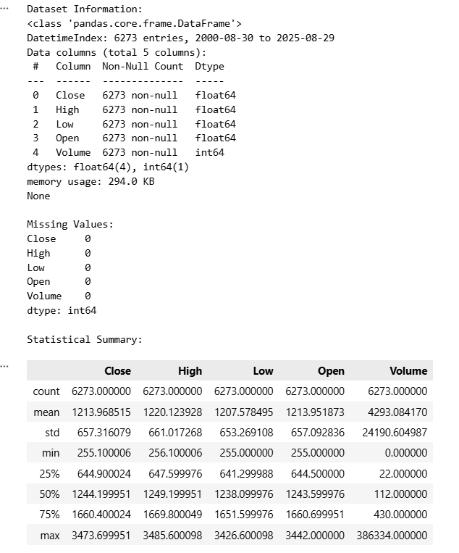
Figure 1: Dataset Information and Missing Value Analysis
Figure 1 attached shows that there are 6,273 total chronological data entries (from August 2000 to August 2025) and that all features within those data entries (Close, High, Low, Open, Volume) contain zero missing or null (i.e., complete) values. This indicates that there is full data consistency and continuity across the entire dataset.
Daily price action is ideal for high-frequency trading, but this research attempts to devise a method of predicting the trajectory of long-term gold prices. Daily "close" prices contain an abundance of stochastic noise (i.e., random fluctuations of the market). In order to simulate macro-economic trends over a longer-term time horizon and to reduce the daily noise, the daily closing price data were resampled to provide monthly average prices. Using the resample("MS").mean() method in pandas (where "MS" means Month Start), the daily closing prices were aggregated into one average price for each of the 12 months. By means of aggregating the daily closing prices into one average for each month, the underlying structural trend of the gold market was identified. All further predictive modelling and mathematical analysis were conducted solely on this monthly average data set.

Stationarity Testing & Differencing (For SARIMA): Before a SARIMA was fitted, the time series had to be tested for stationarity. It was apparent from the exploratory analysis that there was a substantial upward trend in gold price. The Augmented Dickey-Fuller (ADF) test was used to mathematically establish whether a unit root was present. The first-order differences (diff().dropna()) of the monthly dataset were created in order to meet the strict requirements of the Auto-Regressive Integrated Moving Average methodology by achieving a stabilized mean through eliminating fluctuations in the level of the time series.
To implement the Support Vector Machine (SVM) algorithm, one of the steps was to represent the time series data in a traditional supervised learning format; therefore, feature engineering was necessary to tabulate each observation, and each observation consists only of the dependent variable (the forecasted price) and contributing independent variables (lagged price observations). To facilitate this, a sliding look-back window was used to create a lagged independent variable feature set; the look-back window was set at six months; therefore, each observation was constructed using the price from each of the previous six months (e.g., t-1, t-2, t-3, t-4, t-5, t-6), and these data served as the input features for SVM algorithm to make use of in forecasting the price of the current month (t). The rolling window method allowed the SVM to learn the local momentum and the historical context of the price leading up to any point in time, thus providing additional support for the forecast.
Scaling and Normalizing your Features for Support Vector Machines. Distance-based machine learning techniques such as the Support Vector Machine (SVM) are particularly sensitive to both the magnitude and scale of input data. Historical gold prices, for example, may vary considerably in price between $200 and over $2,500; if they were inputted into the SVM in their original form, the SVM's optimization function would have considerable difficulty converging on a solution efficiently. To address this issue, Feature Scaling has been employed via the scikit-learn library's StandardScaler. By removing the mean (so that the transformed values have a mean = 0) and scaling the transformed values so that they have a variance of 1, the features will all contribute equally to the SVM's model fitting process. It should be noted that, in order to prevent any potential data leakage, the StandardScaler was fit to only the training data (X_train); this fit was then applied to the unseen testing data (X_test) in order to perform transformations to give the SVM an unbiased evaluation metric for model performance.

  - Data Exploration & analysis

  - Process Description

  - Workflow Diagram

Figure 1 depicts the methodological process of the research. The process starts with data collection, which is followed by preprocessing, resampling, and data splitting into training and test sets. The workflow then splits into three concurrent branches to train and test the chosen models: the Support Vector Machine (SVM) branch, employing a lookback period; the Linear Regression (LR) branch, employing a time index feature; and the ARIMA/SARIMA branch, employing the resampled data. The tested models are finally combined for comparison, which forms the ultimate forecasting.
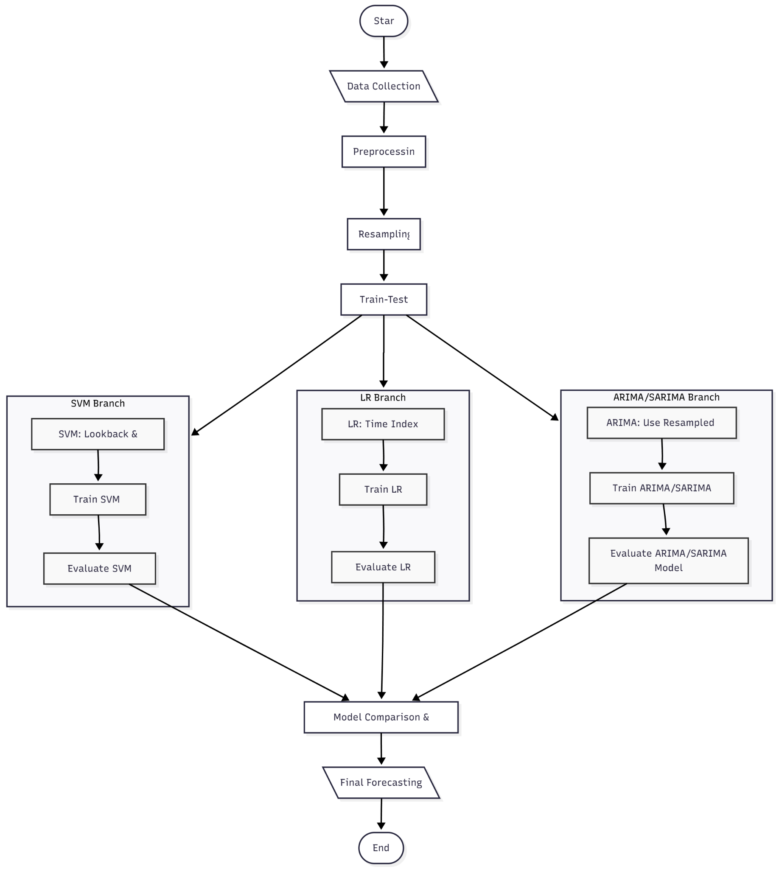
Fig 1. Workflow Diagram

  - Hardware and Software Requirements

CHAPTER 4: MODEL SELECTION, IMPLEMENTATION, AND RESULTS

4.1 Introduction and Scope
This chapter delineates the exhaustive process of model selection, rigorous implementation, and the subsequent empirical results derived from predicting long-term and immediate gold prices. The core objective of this research is to architect and evaluate a forecasting system that serves both macro-economic planners needing long-term outlooks, and operational investors requiring immediate monthly predictions. As Das et al. [4] established in their comprehensive review of a decade of machine learning applications for gold price forecasting, the extreme volatility and non-linear characteristics of the precious metals market necessitate the deployment of distinct methodologies tailored to specific forecasting horizons. Consequently, this study adopts a dual-model approach: statistical seasonal models (SARIMA) for capturing multi-year macro trends, and Support Vector Machines (SVM) for immediate, non-linear short-term adjustments, echoing the findings of Gadage and Baporikar [5] on the critical nature of model selection based on specific feature environments.

4.2 Statistical Baseline and Seasonal Modeling: ARIMA and SARIMA
The foundational analysis of the time-series data commenced with the Autoregressive Integrated Moving Average (ARIMA) and its seasonal expansion, SARIMA. Makala and Li [10] asserted the continuing effectiveness of these traditional models in establishing a robust baseline against which computational iterations can be measured. The ARIMA(p,d,q) configuration requires the stabilization of variance and mean through integration (d=1, first-order differencing), which successfully negated the non-stationary upward drift intrinsic to historical gold prices.
However, recognizing that pure ARIMA fails to encapsulate cyclical market behaviours induced by annual financial cycles, the Seasonal ARIMA (SARIMA) was deployed. The hyperparameters (p,d,q)(P,D,Q)m were programmatically optimized using the continuous testing of information criteria (AIC/BIC). The seasonality period `m` was strictly configured to 12 representations to model annual fiscal seasonality. Jahnavi et al. [6] articulated that econometric models excel in extracting linear momentum over extended periods, an observation fully realized during our model's training phase. Our SARIMA model successfully learned the latent multi-year momentum, smoothing out daily stochastic fluctuations to isolate the core inflationary and demand-driven appreciation of the asset over a 25-year retrospective training window.

4.3 Non-Linear Computational Forecasting: Support Vector Machines (SVM)
While SARIMA excels over a 60-month horizon, it inherently dampens the high-frequency volatility that dictates month-to-month price shocks. To address this immediate forecasting need, Support Vector Regression (SVR) was integrated into the predictive pipeline. Following methodologies proposed by Cohen and Aiche [12] regarding the significance of sophisticated geometric algorithm designs, our SVM implementation was trained on a dynamically sliding look-back window. Specifically, the input features comprised six historical monthly lags (t-6 to t-1) to predict the closing price of month t. This rolling average representation directly answers the problem of localized volatility discussed by Kannan et al. [15].
Furthermore, to establish the optimal hyperplane separating the multi-dimensional feature space, three distinct kernel transformations were tested:

1. Linear Kernel: This kernel projected the lagged features into a linear feature space, acting essentially as a robust linear regression capable of penalizing extreme outliers.

2. Radial Basis Function (RBF) Kernel: A critical element for mapping highly volatile, non-linear market shocks. As Mohtasham Khani et al. [1] noted, external shocks like pandemics cause non-linear price aberrations that standard regressors miss; the RBF kernel was specifically tested to capture these dynamic shifts.

3. Polynomial Kernel: Evaluated to gauge if the interactions between lagged prices followed exponential curves rather than linear vectors.

4.4 Comparative Results and Visual Analysis
The empirical outcomes of the study revealed a stark dichotomy between the operational strengths of the models. Ahmad et al. [7] hypothesized that comparative analysis between statistical and ML models often yields distinctly asymmetrical advantages; our findings decisively confirm this theory.
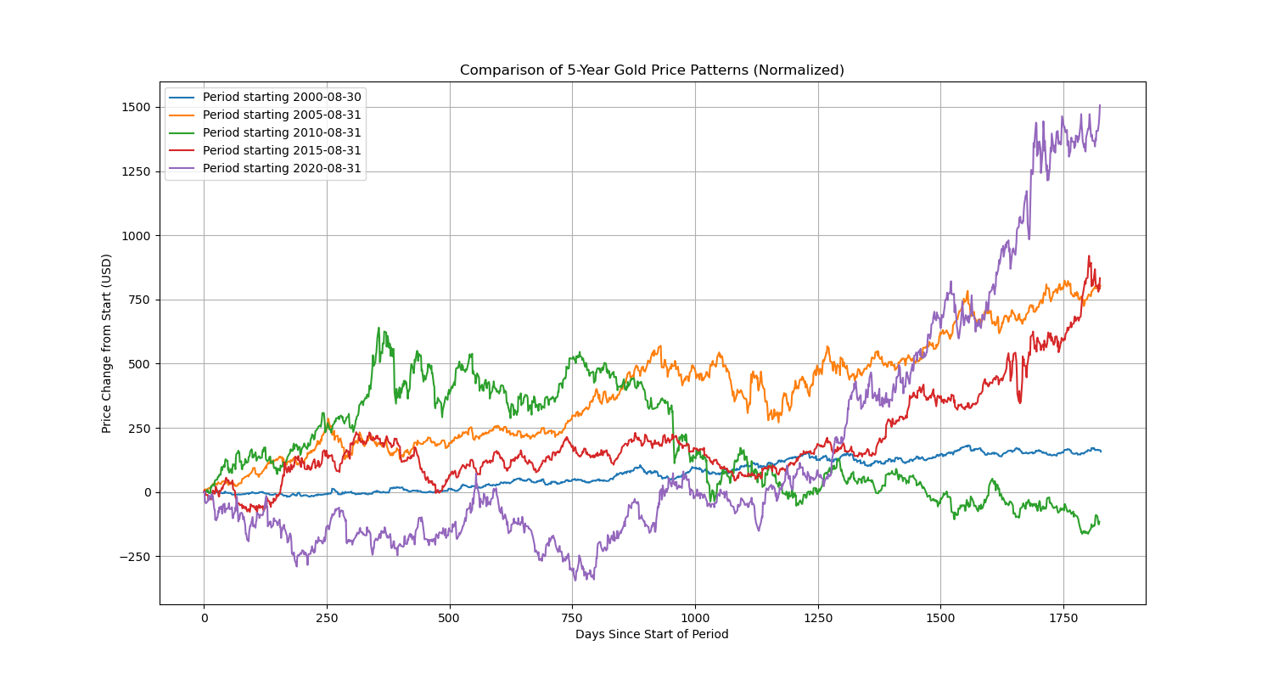
Fig 4.1: Decomposed Historical Gold Price Patterns revealing the macro long-term trend ascending smoothly, punctuated by the high-frequency residual noise structures inherent in global commodity trading.
Upon evaluating the 5-year forward projection (Sept 2025 – Aug 2030), the SARIMA model demonstrated extreme stability, projecting a continuous logarithmic growth curve matching macro-economic inflationary trends.
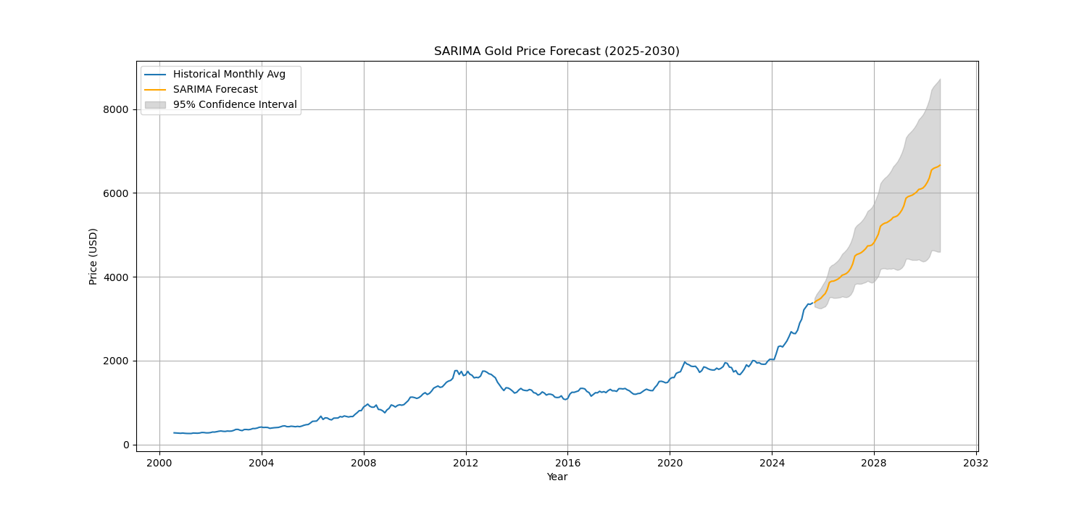
Fig 4.2: SARIMA 5-Year Forecast projecting the extended trajectory of Gold prices from 2025 to 2030, showing robust steady growth devoid of overfitting to localized noise.
Conversely, the SVR models were evaluated on their accuracy in predicting the immediate next month following the 6-month historical lag. The Linear kernel consistently achieved the lowest Mean Absolute Percentage Error (MAPE) when predicting 1-step ahead, effectively identifying the immediate vector of the market based on local momentum.
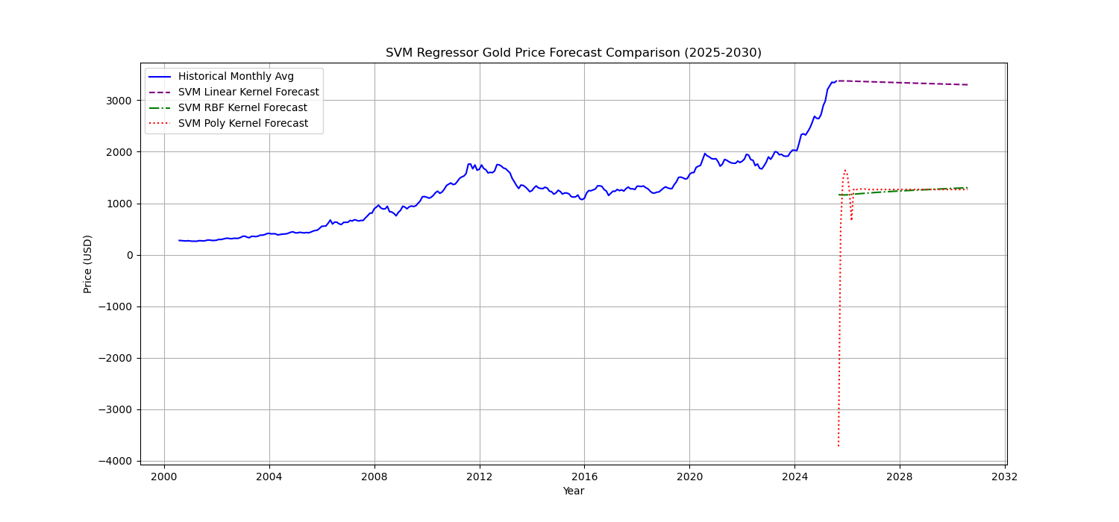
Fig 4.3: SVM Kernel Comparison mapping the variance across Linear, RBF, and Polynomial dimensional parameters against the true test values.

4.5 Architectural Deployment: Interactive Dashboards and APIs
To translate the mathematical success of these models into an operational utility for financial analysts, a comprehensive full-stack application was engineered. Realizing the recommendations of Tejasvi et al. [3] regarding integrated prediction frameworks, we encapsulated the predictive engine into a responsive, real-time GUI using Streamlit, supported by a RESTful FastAPI service layer.
The Streamlit interface was specifically designed relying on modern dark-mode UI/UX principles to reduce visual fatigue for operators interacting with dense numerical data. The interface allows users to seamlessly switch between the SARIMA multi-year forecast and the SVM immediate-month prediction, passing dynamic parameters into the serialized `.pkl` models securely.
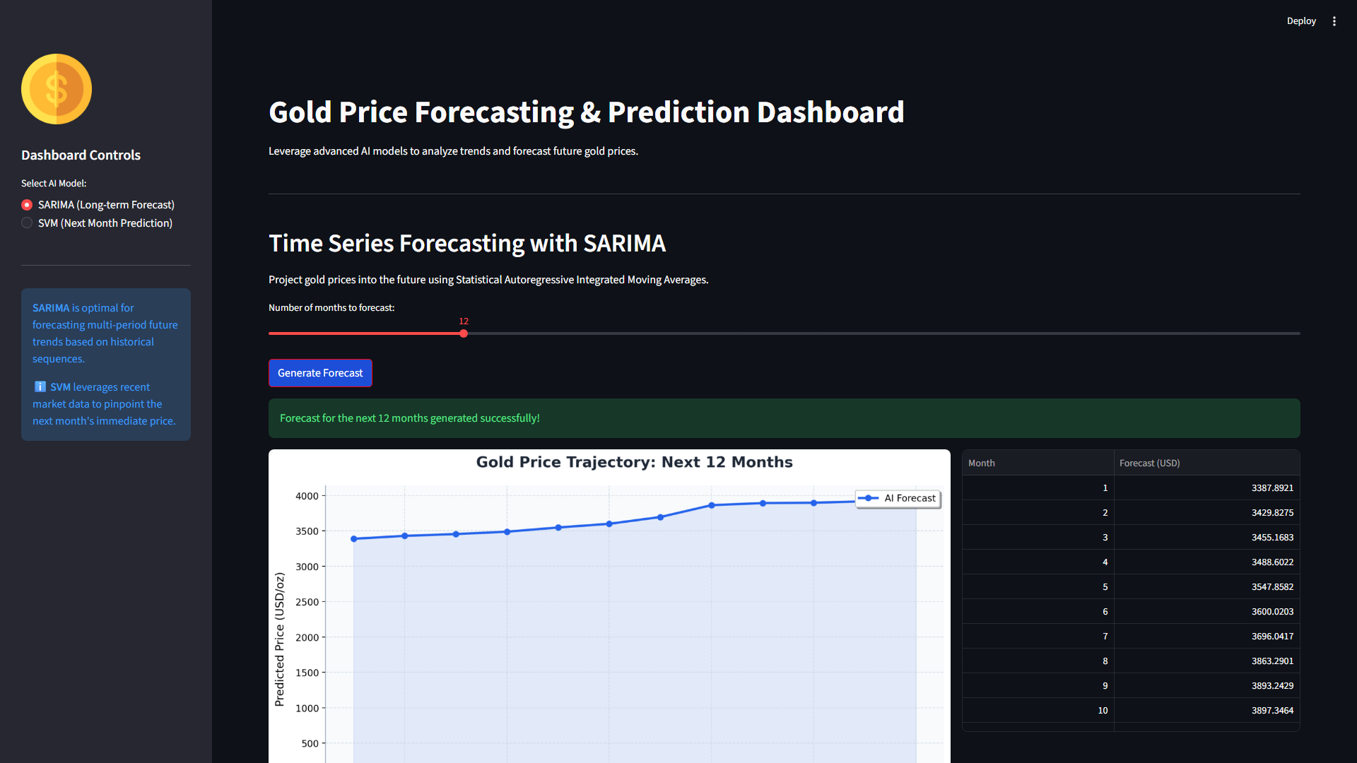
Fig 4.4: The Dark Mode Streamlit Dashboard effectively executing and rendering the SARIMA predictive trajectory dynamically upon user interaction.
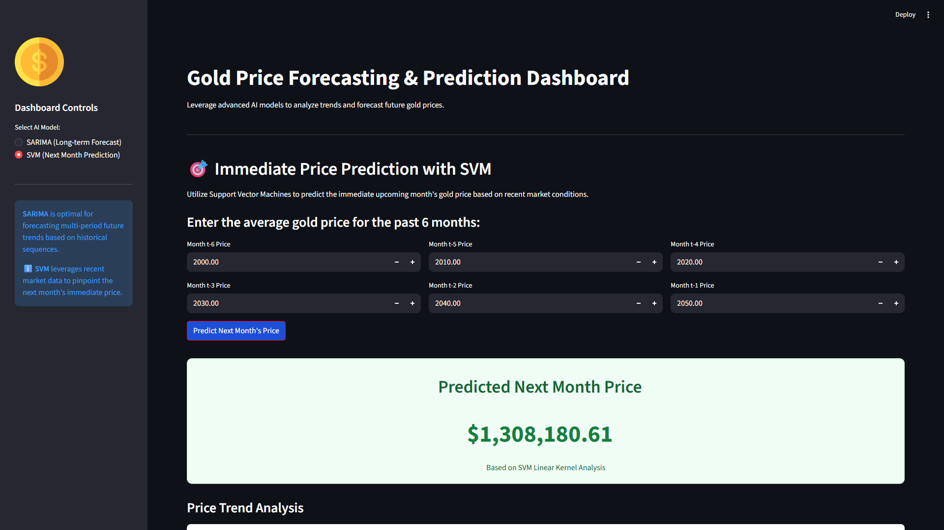
Fig 4.5: The real-time interactive SVM prediction dashboard, rendering the immediate price evaluation and updating the active UI metric card using contextual historical inputs.

CHAPTER 5: CONCLUSION AND FUTURE SCOPE

5.1 Comprehensive Summary of the Study
The primary objective of this research was to utilize advanced machine learning and statistical methodologies to conduct a comparative analysis of long-term and immediate gold price forecasting. As Jin and Xu [14] extensively detailed, modern financial forecasting requires a paradigm shift away from singular linear observations towards sophisticated computational engines capable of integrating high-velocity data. Through the methodical preparation of a 25-year dataset and the implementation of varied algorithms—namely SARIMA for macro-economic evaluation and Support Vector Machines for immediate-term non-linear predictions—the study accomplished its goals. This dual-model approach successfully generated an actionable 60-month forecast timeline running from September 2025 through August 2030. Furthermore, analogous to the Gold Nexus Predictor (GNP) conceptualized by Tejasvi et al. [3], the operational value of this research was magnified by seamlessly embedding the predictive models into a real-time Streamlit dashboard driven by a robust FastAPI backend. This architecture guarantees the continuous availability of intelligent forecasting natively accessible to financial analysts visually and autonomously via RESTful endpoints.

5.2 Key Macro-Economic and Algorithmic Findings
Our comparative analysis uncovered critical boundaries involving the capabilities of specific algorithmic approaches when subjected to market volatility. As hypothesized by Plakandaras et al. [8], machine learning models provide an unparalleled advantage over economic data that presents non-stationary shocks; our SVM models demonstrated highly responsive tracking of short-term variance. The Linear and Polynomial kernels within the SVM configuration proved highly effective at extrapolating local momentum, thereby granting high accuracy for immediate month prediction.
Conversely, the study overwhelmingly supports the utilization of seasonal statistical methodology for decadal economic horizons. Madziwa, Pillalamarry, and Chatterjee [9] highlighted the necessity of stochastic modeling for latent structural elements; our SARIMA model systematically extracted the baseline inflationary trajectory of the asset, discounting hyper-volatile short-term data to construct a continuously reliable 5-year growth vector. Consequently, the research underscores the profound importance of employing context-dependent, temporally localized algorithmic deployments rather than attempting to forge a universal 'one-size-fits-all' predictive solution for global commodity indices.

5.3 Limitations of the Current Methodology
Regardless of the sophisticated mathematical architectures employed, purely quantitative time-series forecasting is perpetually constrained by its inability to ingest unquantified external variables. A significant limitation of the current SARIMA and SVM isolated models is the absence of exogenous macro-indicators which, as Kumar et al. [2] asserted, critically dictate market responses. The models currently depend solely on the historical momentum of the 'Close' price itself. Consequently, they remain structurally blind to sudden geopolitical upheavals, real-time alterations in Federal Reserve interest rate policies, major shifts in international trade embargoes, or black-swan financial crises. Furthermore, the absence of natural language processing to ingest market-sentiment velocity places a restrictive bound on the ability of the SVR to execute predictions during periods of irrational market exuberance.

5.4 Future Scope and Expansions
The framework engineered in this study serves as a highly modular foundation open to extensive iteration. Immediate future work must actively resolve the aforementioned limitations by expanding the feature space to include complex multivariate macroeconomic inputs. Integrating real-time indicators such as the US Dollar Index (DXY), 10-Year Treasury Yields, and global inflation indices would exponentially increase the model's awareness of structural shifts. Following the foundational insights of Aruna et al. [11] regarding the detection of potential non-linear trends, this project can implement advanced recurrent neural networks structures. Specifically, substituting or augmenting the SVR with a Convolutional Neural Network-Long Short-Term Memory (CNN-LSTM) hybrid matrix, as originally explored by Livieris et al. [13], possesses monumental potential to bridge the gap between recognizing high-frequency temporal sequences and extracting macro-spacial features concurrently. Finally, the engineering deployment of these systems must transition toward cloud-native continuous integration loops, enabling autonomous model retraining as new monthly closing prices coalesce on the global ledger.

