Time Series Forecasting For Predicting Long-Term Gold Price

Submitted by

Joyston Jose D’Souza 24251325
MSc. Big Data Analytics
Aloysius Institute of Management & Information Technology (AIMIT)
St Aloysius (DEEMED TO BE UNIVERSITY)
Mangalore, Karnataka

Submitted in Partial Fulfillment of the Requirements for the Award of the Degree of
Master of Science in Big Data Analytics

Under the guidance of

Dr. Rakesh Kumar B
Associate Professor (Department of BDA)
St. Aloysius Institute Of Management and Information Technology (AIMIT)
St. Aloysius (DEEMED TO BE UNIVERSITY)
Mangalore, Karnataka

Submitted to



2026

CERTIFICATE
This is to certify that the project titled
Time Series Forecasting For Predicting Long-Term Gold Price
Submitted by
Joyston Jose D’Souza 24251325
MSc. Big Data Analytics
Aloysius Institute of Management & Information Technology (AIMIT)
St Aloysius (DEEMED TO BE UNIVERSITY)
Mangalore, Karnataka
In partial fulfillment of the requirements for award of degree of Master of Science in Big Data Analytics of Mangalore St. Aloysius (Deemed to be University)
During the year
2026

Dr. Rakesh Kumar B
Associate Professor (Department of BDA),
Department of M. Sc (Big Data Analytics),
AIMIT,
St.Aloysius (Deemed To Be University), Mangaluru-575022.

Dr. (Fr) Kiran Cotha SJ
Director,
AIMIT, St. Aloysius (Deemed To Be University) Mangaluru-575 022.

Dr Hemalatha N
Dean, School of Information Science and Technology,
PG Depts. of Information Science and Technology,
AIMIT,
St.Aloysius (Deemed To Be University),
Mangaluru-575 022.

Examiners
1.

2.

CERTIFICATE OF AUTHENTICATED WORK

This is to certify that the project report entitled Time Series Forecasting For Predicting Long -Term Gold Price submitted to St. Aloysius Institute of Management and Information Technology (AIMIT), St. Aloysius (Deemed To Be University) in partial fulfilment of the requirement for the award of the degree of MASTER OF SCIENCE IN BIG DATA ANALYTICS (MSc. BDA) is an original work carried out by Mr. Joyston Jose D’souza Register no. 24251325 under my guidance. The matter embodied in this project is authentic and is genuine work done by the student and has not been submitted whether to this University, or to any other University / Institute for the fulfilment of the requirement of any course of study.

Signature of the Student
Date: ___________
Joyston Jose D’souza
M.Sc. Big Data Analytics
AIMIT, St. Aloysius
(Deemed to be University)
Mangaluru-575022.
Register Number: 24251325

Signature of the Guide
Date: ___________
Dr. Rakesh Kumar B
Associate Professor (Department of BDA),
Department of M.Sc (Big Data Analytics)
AIMIT, St. Aloysius
(Deemed To Be University),
Mangaluru-575022.

Project Proposal Report / Synopsis

for

Time Series Forecasting For Predicting Long-Term Gold Price

Joyston Jose D’Souza
24251325
MSc. Big Data Analytics
St. Aloysius Institute Of Management and Information Technology (AIMIT)
ST. ALOYSIUS (DEEMED TO BE UNIVERSITY)
Beeri, Kotekar, Mangalore - 575022

Under the guidance of
Dr. Rakesh Kumar B
Associate Professor (Department of BDA)
St. Aloysius Institute Of Management and Information Technology (AIMIT)
ST. ALOYSIUS (DEEMED TO BE UNIVERSITY)
Beeri, Kotekar, Mangalore - 575022

Submitted to


ABSTRACT
The accurate prediction of gold price is a crucial task for investment decisions and has a considerable impact on investors, policymakers, financial Institutes and countries that depend on mineral resources, yet it remains a significant challenge due to its inherent volatility and complex, non-linear dynamics. Therefore, understanding the future price movement is important for revenue-based planning for investors, companies and also the country. This research focuses on applying Machine Learning techniques for predicting the Gold Price and providing a comparative analysis of the 4 ML algorithms for long-term gold price forecasting namely SARIMA, ARIMA, LINEAR REGRESSION, SVM (kernel used are RBF, Linear and Polynomial). Utilizing a comprehensive dataset of gold prices from August 2000 to August 2025 which was pre-processed by resampling into monthly averages to model long-team trends. All the models were trained on the historical monthly data and employed to generate a 60-month (5-year) forecast, from September 2025 to August 2030.
Keywords—Time Series Forecasting, SARIMA, ARIMA, LINEAR REGRESSION, SVM

INDEX

- Introduction
  - Overview / Background
CHAPTER 1

INTRODUCTION

  - OVERVIEW

Gold has always been a key part of the global financial system. Historically, it was used for trade, and today, central banks around the world hold it to manage inflation, secure foreign debts, and show a nation's financial strength. For corporations and individual investors, gold acts as a vital "safe haven" asset, especially during times of political unrest or economic instability, such as pandemics [1]. This dual role as a strategic reserve and a popular investment makes accurately predicting its price a major challenge for both policymakers and investors. The task becomes even harder due to the price's natural volatility and its complex, non-linear nature. Gold prices depend on many factors, such as global economic performance, stock indices like the S&P 500, bond yields, the US Dollar Index, and other commodities [2, 3].
Due to this complexity, a wealth of research has emerged to find the most reliable forecasting methods [4, 5], sparking a lively debate between traditional econometric models and modern machine learning (ML) techniques [6-8]. Statistical methods like the Autoregressive Integrated Moving Average (ARIMA) and its seasonal variations (SARIMA) are often used because they can model time-series trends [9, 10]. At the same time, ML models, including Support Vector Regression (SVR)—which is known for its effectiveness with non-linear kernels [10]—as well as Linear Regression and other methods [11-15], have gained prominence. The main goal of this research is to predict the price of gold five years from now. While we recognize that market forecasts are always changing, this analysis specifically targets a five-year prediction that will end in August 2030.
Using a consistent dataset of monthly average gold prices from August 2000 to August 2025, our research tests and evaluates four different models: ARIMA, SARIMA (which includes the S&P 500 and US Dollar Index), Linear Regression, and Support Vector Regression (with linear, poly, and RBF kernels). Our results show a significant difference in the 5-year forecasts for 2025-2030. This analysis implies that while ML models may be powerful, traditional seasonal time-series models were the most effective in capturing the long-term momentum in this historical dataset.

  - Problem Statement

The accurate prediction of gold price movements is of utmost importance in order to direct informed investment strategies. This has a substantial and direct impact on a wide array of stakeholders, which includes individuals, organizations, governments, and even nations that have economies that are largely dependent on mineral resources.

However, the accurate prediction of gold price movements over long periods of time is a major challenge that arises due to the volatile nature of gold in the market, which has complex and non-linear characteristics. Therefore, it is of utmost importance to have an accurate understanding of the future price movements of gold in order to have effective revenue planning and strategic economic forecasting. There is an urgent need to evaluate the implementation of advanced machine learning strategies to meet the challenges.

  - PROJECT OBJECTIVES

- The objective is to utilize machine learning algorithms for long-term forecasting of gold price movements.

- To conduct a comparative study of four machine learning algorithms for long-term forecasting, namely, SARIMA, ARIMA, Linear Regression, and Support Vector Machine using RBF, Linear, and Polynomial kernels.

- To train the machine learning algorithms using a comprehensive dataset for long-term forecasting, comprising historical gold price movements aggregated at the monthly average level.

- To generate a 60-month forecast horizon, ranging from September 2025 to August 2030.
- To evaluate the performance of the predictive models using statistical performance metrics such as RMSE, MAE, and MAPE.

- To utilize the trained predictive models using a FastAPI backend for serving purposes, enabling integration with front-end dashboards using Streamlit.

CHAPTER 2

- LITERATURE REVIEW
  - Introduction
Gold price predictions present significant challenges due to their volatility and inability to be predicted in a linear manner over long periods of time. In the past, most forecasting of gold prices used similar methods to predict other commodities, using historical price data as the basis for making an economic or investing decision. These types of models generally worked well in predicting short-term trends; however, due to the complex, non-linear disruptions caused by macroeconomic shifts and worldwide calamities, they were generally less accurate at predicting longer-term results than some competing methods.
As a result of this paradigm shift, there has been substantial research indicating how the use of advanced machine learning and deep learning architectures helps to mitigate these non-linearities. An example of this is how modern DL models are able to improve their ability to predict very volatile periods by accounting for external shocks, such as global pandemics [1] and how integrating macroeconomic indicators into ML workflows has been shown repeatedly to improve forecasting performance [2]. Additionally, there are new frameworks such as the Gold Nexus Predictor (GNP), which explicitly augment economic indicators and advanced algorithmic learning to fully understand market dynamics through the use of a single model [3].
A series of holistic investigations into the development of computational finance that occurred during the last 10 years provide evidence for the evolution from simple statistical techniques to complex ML methods, and they have stressed the importance of carefully selecting models based on the attributes of the data being analyzed, as well as the environment in which it is used [4]. The findings of a comparative analysis using rigorous benchmarks to evaluate traditional econometric models and contemporary machine learning models strongly support hybrid methods [6]. For instance, when used together, statistical baseline models and machine learning models produce predictions that are significantly better than either model does when used independently [7].
The body of research has also built upon the relationship that exists between the use of algorithms to learn from data and the costs which have been represented in traditional models of economics [8] through the utilization of a more advanced type of multivariate-stochastic model that is meant to represent latent ($ latent $) volatility in markets [9]. In practice, many of the techniques that are commonly used for forecasting utilise both a linear model such as ARIMA and a nonlinear mapping technique such as Support Vector Machines (SVM) to find and map the way in which residuals behave within models [10]. In addition, the standard machine learning pipeline methods have consistently demonstrated their effectiveness at revealing latent and less obvious price histories from the past [11] and that these two components (the way the algorithm is designed, and the hyperparameters of the algorithm) are equally important as the dataset used to train an algorithm [12].
CNN-LSTM Models have done well in capturing temporal patterns from multiple dimensions when processing Deep Temporal Sequences [13]. In the post-2024 literature, researchers have continued to expand on this, writing algorithmic reviews that provide the best outcomes for implementing their models [14]. Many new ways of processing data (including using rolling average representations) have also been documented as having promising outcomes for decreasing extreme daily price volatility before training a model [15].

  - Details of literature review
Gold price forecasting has attracted considerable attention due to its vital role in investment decisions and economic planning. Mohtasham Khani et al. introduced a deep learning-based method to forecast gold prices, emphasizing the impacts of pandemics on price movements. This study highlighted the need to incorporate external shocks like pandemics into price prediction models for better accuracy [1].
Kumar et al. utilized machine learning techniques leveraging economic indicators to predict gold prices, demonstrating improved forecasting performance by integrating those indicators into the models [2]. Similarly, Tejasvi et al. proposed the Gold Nexus Predictor (GNP), which integrates machine learning with economic indicators to enhance gold market predictions [3].
A comprehensive review by Das et al. examined a decade's worth of machine learning approaches for gold price forecasting, outlining the evolution and comparative performance of diverse techniques [4]. Their findings reinforced the comparative strengths of different machine learning methods in addressing the non-linear and volatile characteristics of gold prices.
Gadage and Baporikar provided a survey on various machine learning methods applied to gold price prediction, emphasizing model selection based on data characteristics and problem context [5]. Their work contributed to understanding the suitability of specific models for this domain.
Jahnavi et al. conducted a comparative analysis between econometric and machine learning models, advocating a comprehensive approach that harnesses the advantages of both methodologies for enhanced forecasting accuracy [6]. Ahmad et al. further explored this comparison by examining statistical and machine learning models, concluding that hybrid approaches might outperform traditional models in gold price prediction [7].
Plakandaras et al. addressed the interplay between gold prices and machine learning, analyzing how machine learning algorithms can be used effectively in economic modeling relative to gold price movement [8]. Madziwa et al. introduced a multivariate stochastic model for gold price forecasting, incorporating multiple influencing factors to capture underlying market dynamics [9].
Makala and Li applied ARIMA and SVM models to predict gold prices, asserting the effectiveness of combining traditional time series methods with machine learning techniques [10]. Aruna et al. expanded on machine learning applications, demonstrating their utility in uncovering potential price trends in gold markets [11].
Cohen and Aiche employed machine learning methodologies for gold price forecasting, highlighting the significance of sophisticated algorithm designs in improving prediction accuracy [12]. Earlier, Livieris et al. developed a CNN–LSTM hybrid model to forecast gold prices effectively by capturing temporal patterns in the data [13].
Jin and Xu focused on machine learning gold price forecasting, reviewing modern algorithms and their implementation outcomes [14]. Recently, Kannan et al. proposed a method using rolling average representation combined with machine learning for gold price prediction, showing promising results in dealing with price volatility [15].
Overall, the literature reflects a progression from traditional econometric models to advanced machine learning and deep learning techniques, with increasing attention towards hybrid models that incorporate economic indicators and external factors to enhance forecasting accuracy.

  - Analysis of Related Works
To help in understanding the proposed use of SARIMA, Linear Regression and SVM techniques to develop a long-term, 5-year forecast; a review of the current literature will be necessary to conduct a critical analysis of the subject. The tables below provide a synthesis of the key advantages and disadvantages, methodological conclusions and results of notable recent research on predicting gold prices.

Paper | Advantages | Disadvantages
Mohtasham Khani et al. (2021) [1] | Successfully integrated external black-swan events (pandemics) into predictive frameworks. | High likelihood of overfitting to specific historical anomalies; lacks high interpretability.
Kumar et al. (2024) [2] | Improved forecasting accuracy by explicitly feeding correlated macroeconomic indicators into the ML pipeline. | Increased dimensionality can introduce multicollinearity, requiring aggressive feature reduction.
Tejasvi et al. (2024) [3] | Offered a highly structured approach (GNP) to fusing economic data with ML algorithms. | May struggle with extreme long-term horizons if the underlying economic indicator forecasts are inaccurate.
Das et al. (2021) [4] | Provided a comprehensive historical baseline of ML evolution in financial forecasting over a decade. | Purely a retrospective review; did not propose a novel, deployable predictive architecture.
Gadage & Baporikar [5] | Established a strong theoretical taxonomy for model selection based on varying data distributions. | Qualitative survey lacking empirical benchmarking of the discussed algorithms against a unified dataset.
Jahnavi et al. (2025) [6] | Rigorously benchmarked econometric formulas against ML, proving the necessity of hybrid approaches. | High computational overhead when running parallel econometric and machine learning pipelines.
Ahmad et al. (2025) [7] | Demonstrated empirically that hybrid statistical-ML approaches outperform isolated models. | Focused purely on comparative analysis rather than deploying an interactive prediction application.
Plakandaras et al. (2021) [8] | Bridged the theoretical gap between computer science (ML) and traditional economic modeling. | Formulations were heavily theoretical, potentially lacking direct adaptability for simple dashboard deployments.
Madziwa et al. (2022) [9] | Effectively captured underlying market volatility and interconnected asset dynamics. | Inherently produces probabilistic bounds rather than deterministic long-term price points.
Makala & Li (2021) [10] | Proved the synergistic capability of combining ARIMA for linear trends with SVM for non-linear residual mapping. | Limited in mapping highly complex sequential temporal dependencies compared to deep recurrent networks.
Aruna et al. (2021) [11] | Successfully highlighted how various ML pipelines uncover latent, non-obvious historical price trends. | Primarily focused on potential trend classification rather than generating exact future price points.
Cohen & Aiche (2023) [12] | Emphasized that algorithmic architecture design is a primary driver of prediction accuracy. | Sophisticated algorithmic designs often hinder rapid retraining cycles due to computational complexity.
Livieris et al. (2020) [13] | Captured both feature-based and temporal dependencies simultaneously using a CNN-LSTM hybrid. | Requires vast amounts of data to prevent overfitting and is computationally expensive to optimize.
Jin & Xu (2025) [14] | Delivered a highly updated synthesis of modern algorithms, capturing recent advancements in financial ML. | Acts as a secondary source review; lacks a primary, novel dataset contribution.
Kannan et al. (2024) [15] | Leveraged rolling average representations to smooth out high-frequency noise and extreme daily volatility. | Smoothing techniques inherently risk causing the model to lag during sudden, legitimate market breakouts.
Table 1: Comparative Analysis of Advantages and Disadvantages

Paper | Methodology / Model Used | Key Finding / Performance Outcome
Mohtasham Khani et al. [1] | Deep Learning Architectures | Demonstrated significant improvement in capturing extreme price volatility during crisis periods.
Kumar et al. [2] | Supervised Machine Learning | Achieved notable error reduction by integrating broader economic health indicators.
Tejasvi et al. [3] | Gold Nexus Predictor (GNP) | Yielded highly correlated market predictions compared to standard baseline models.
Das et al. [4] | Systematic Review | Established that non-linear ML methods consistently outperform linear models over the decade.
Gadage & Baporikar [5] | Literature Survey | Concluded that data distribution dictates model success; no single algorithm is universally superior.
Jahnavi et al. [6] | Econometric vs. ML Models | Found that comprehensive approaches utilizing both statistical and ML elements minimize forecasting error.
Ahmad et al. [7] | Statistical vs. ML | Empirically validated that hybrid frameworks generate the lowest Mean Absolute Error (MAE).
Plakandaras et al. [8] | ML in Economic Modeling | Validated the superior pattern recognition of ML algorithms in chaotic financial datasets.
Madziwa et al. [9] | Multivariate Stochastic Model | Successfully mapped multi-factor influences, generating robust probabilistic forecasting bounds.
Makala & Li [10] | ARIMA + SVM | Demonstrated that SVM effectively corrects the residual errors left by the linear ARIMA baseline.
Aruna et al. [11] | Standard Machine Learning | Successfully classified and mapped potential long-term price trajectories.
Cohen & Aiche [12] | Advanced ML Methodologies | Showed that hyperparameter optimization leads to measurable decreases in Root Mean Square Error (RMSE).
Livieris et al. [13] | CNN–LSTM Hybrid | Achieved state-of-the-art error metrics by independently processing spatial and temporal data.
Jin & Xu [14] | Methodological Review | Synthesized recent implementations, confirming the industry shift toward deep learning.
Kannan et al. [15] | Rolling Average + ML | Improved model stability and generalized prediction accuracy by eliminating day-to-day noise.
Table 2: Model Performance and Methodological Focus

Chapter 3

- Materials and Methods
  - Introduction
The purpose of this section is to provide an exhaustive report of the systematic approach adopted for achieving the main goals of this research. This section will detail the entire data science lifecycle, starting at the point where market data was collected and ending at the point where robust forecasting models are implemented. It will provide a complete and thorough account of how the historical financial data used in this research was obtained, how it was structured, and what pre-processing actions were undertaken to ensure that the data produced is accurate. Additionally, this section will provide a thorough account of all of the specialized features that were engineered during the pre-processing phase of the analysis (i.e., how these engineered features were developed to address the unique challenges associated with working with time series data).
Additionally, EDA was performed on past success to identify the large economic trends, cyclical behaviours in market prices and how volatility is displayed from time to time. Put simply, this chapter gives a step-by-step overview of how the models were designed for forecasting gold's price based on historical financial data. Also explained is the comparison between mechanisms (via Support Vector Machines and SARIMA methods) of how to forecast gold value based on future forecasts. This methodology will allow the reader access to each step in the logic system; however full configurations for hardware/software will exist in using the models. Thus, this methodology provides a foundation from which someone else can create an interactive; more accurate method to forecast gold price from historical financial information.

  - Data Source and Description
In order to build an extremely accurate predictive model, one needs to have access to high-quality, reliable and comprehensive data sources. For this research study, the main data source will be the daily historical closing prices of gold, which are expressed in US dollars. These data are originally the result of extracting and collating the raw financial data from Yahoo Finance, one of the world’s largest, most prestigious and most reputable sources of historical financial market data, making certain the data reflect an accurate and correct compilation of the actual global market activity of gold.
The current dataset has been downloaded and stored in a CSV file called gold_final.csv. The CSV file format has been selected as it is a lightweight file format that is portable and compatible with Python data analysis libraries (e.g. Pandas, NumPy) and also has the ability to handle very large quantities of sequential dated records. The daily dataset contained within the file is in large tabular format where each trading day is represented by a row in the dataset (thousands of rows). While there are many columns in the dataset, there are only 2 primary columns - 'Date' and 'Close' price. The 'Date' column will be used as the official chronological index that is essential for the purpose of time series forecasting, while the target variable for preprocessing, scaling, and finally, forecasting is the daily 'Close' price. The daily close price was selected for the target variable as it represents the price at which all trades for a particular asset settle at the end of the trading session and reflects the total (combined) intra-day volatility and market sentiment in one value at the end of the trading day.
In order for the models employed in this study to be capable of learning macroeconomic trends over a long-term (as opposed to short-term, random fluctuations), the data consists of a period of time as long as 25 years (from August 2000 through August 2025). The 25-year period of time provides an adequate time span over which to study the effect of global economic cycles (such as periods of very high inflation and periods of severe economic recession, such as the global economic crisis of 2008, the sudden increase in inflation preceding the start of COVID-19, and the market/stock price shock resulting from the COVID-19 pandemic) when training each machine learning algorithm by tying the model being trained to 25 years' worth of data, it provides a greater confidence level that the model is more robust in terms of how it applies that model to future datasets and, therefore, the models employed in this study will be able to make generalizations about future datasets.

The following variables are there in the Datasets:
Variable | Description | Type
Date | The specific trading date (Index) | Datetime
Close | The final trading price of gold for the day (USD) | Numerical (Float)
High | The highest price reached during the trading day | Numerical (Float)
Low | The lowest price reached during the trading day | Numerical (Float)
Open | The initial opening price at the start of the trading day | Numerical (Float)
Volume | The total number of contracts/shares traded | Numerical (Integer)

Table 2: Model Performance and Methodological Focus
  - Data Preprocessing
A critical phase of financial time-series analysis is data preprocessing, as input data quality, structure, and scale will directly influence the predictive quality of forecasting models. Because financial data is typically noisy with extreme short-term volatility, a detailed preprocessing pipeline has been developed to prepare the raw daily data into a mathematically stable format that can be used with both statistical and machine-learning algorithms.
Initial data loading and formatting of structure was accomplished using the pandas library in Python for the iPython Notebook environment. The raw data set was loaded, and the column 'Date' was identified and converted to datetime objects. The 'Date' column was set as the index of the DataFrame, and all time-series models require that the index be based on a DatetimeIndex (a method of identifying each data point quantitatively) to enable the algorithms to determine the sequential and chronological relationship between data points. Finally, the data was ordered (sorted) in chronological order to ensure no future data was inadvertently "leaked" into past observations during the training phase of model development.
Before performing feature engineering, the overall soundness of the dataset was checked through a thorough analysis of the initial data.

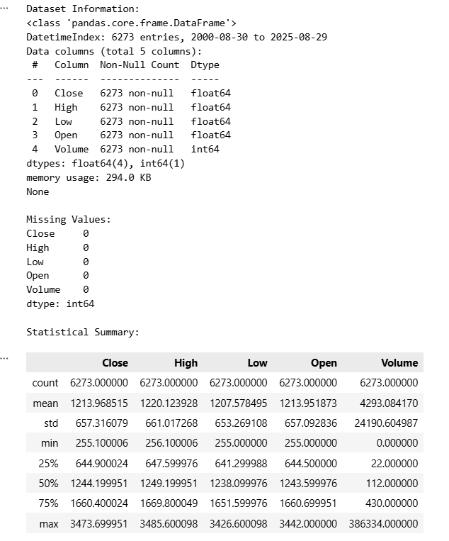
Figure 1: Dataset Information and Missing Value Analysis
Figure 1 attached shows that there are 6,273 total chronological data entries (from August 2000 to August 2025) and that all features within those data entries (Close, High, Low, Open, Volume) contain zero missing or null (i.e., complete) values. This indicates that there is full data consistency and continuity across the entire dataset.
Daily price action is ideal for high-frequency trading, but this research attempts to devise a method of predicting the trajectory of long-term gold prices. Daily "close" prices contain an abundance of stochastic noise (i.e., random fluctuations of the market). In order to simulate macro-economic trends over a longer-term time horizon and to reduce the daily noise, the daily closing price data were resampled to provide monthly average prices. Using the resample("MS").mean() method in pandas (where "MS" means Month Start), the daily closing prices were aggregated into one average price for each of the 12 months. By means of aggregating the daily closing prices into one average for each month, the underlying structural trend of the gold market was identified. All further predictive modelling and mathematical analysis were conducted solely on this monthly average data set.

Stationarity Testing & Differencing (For SARIMA): Before a SARIMA was fitted, the time series had to be tested for stationarity. It was apparent from the exploratory analysis that there was a substantial upward trend in gold price. The Augmented Dickey-Fuller (ADF) test was used to mathematically establish whether a unit root was present. The first-order differences (diff().dropna()) of the monthly dataset were created in order to meet the strict requirements of the Auto-Regressive Integrated Moving Average methodology by achieving a stabilized mean through eliminating fluctuations in the level of the time series.
To implement the Support Vector Machine (SVM) algorithm, one of the steps was to represent the time series data in a traditional supervised learning format; therefore, feature engineering was necessary to tabulate each observation, and each observation consists only of the dependent variable (the forecasted price) and contributing independent variables (lagged price observations). To facilitate this, a sliding look-back window was used to create a lagged independent variable feature set; the look-back window was set at six months; therefore, each observation was constructed using the price from each of the previous six months (e.g., t-1, t-2, t-3, t-4, t-5, t-6), and these data served as the input features for SVM algorithm to make use of in forecasting the price of the current month (t). The rolling window method allowed the SVM to learn the local momentum and the historical context of the price leading up to any point in time, thus providing additional support for the forecast.
Scaling and Normalizing your Features for Support Vector Machines. Distance-based machine learning techniques such as the Support Vector Machine (SVM) are particularly sensitive to both the magnitude and scale of input data. Historical gold prices, for example, may vary considerably in price between $200 and over $2,500; if they were inputted into the SVM in their original form, the SVM's optimization function would have considerable difficulty converging on a solution efficiently. To address this issue, Feature Scaling has been employed via the scikit-learn library's StandardScaler. By removing the mean (so that the transformed values have a mean = 0) and scaling the transformed values so that they have a variance of 1, the features will all contribute equally to the SVM's model fitting process. It should be noted that, in order to prevent any potential data leakage, the StandardScaler was fit to only the training data (X_train); this fit was then applied to the unseen testing data (X_test) in order to perform transformations to give the SVM an unbiased evaluation metric for model performance.

  - Data Exploration & analysis

  - Process Description

  - Workflow Diagram

Figure 1 depicts the methodological process of the research. The process starts with data collection, which is followed by preprocessing, resampling, and data splitting into training and test sets. The workflow then splits into three concurrent branches to train and test the chosen models: the Support Vector Machine (SVM) branch, employing a lookback period; the Linear Regression (LR) branch, employing a time index feature; and the ARIMA/SARIMA branch, employing the resampled data. The tested models are finally combined for comparison, which forms the ultimate forecasting.
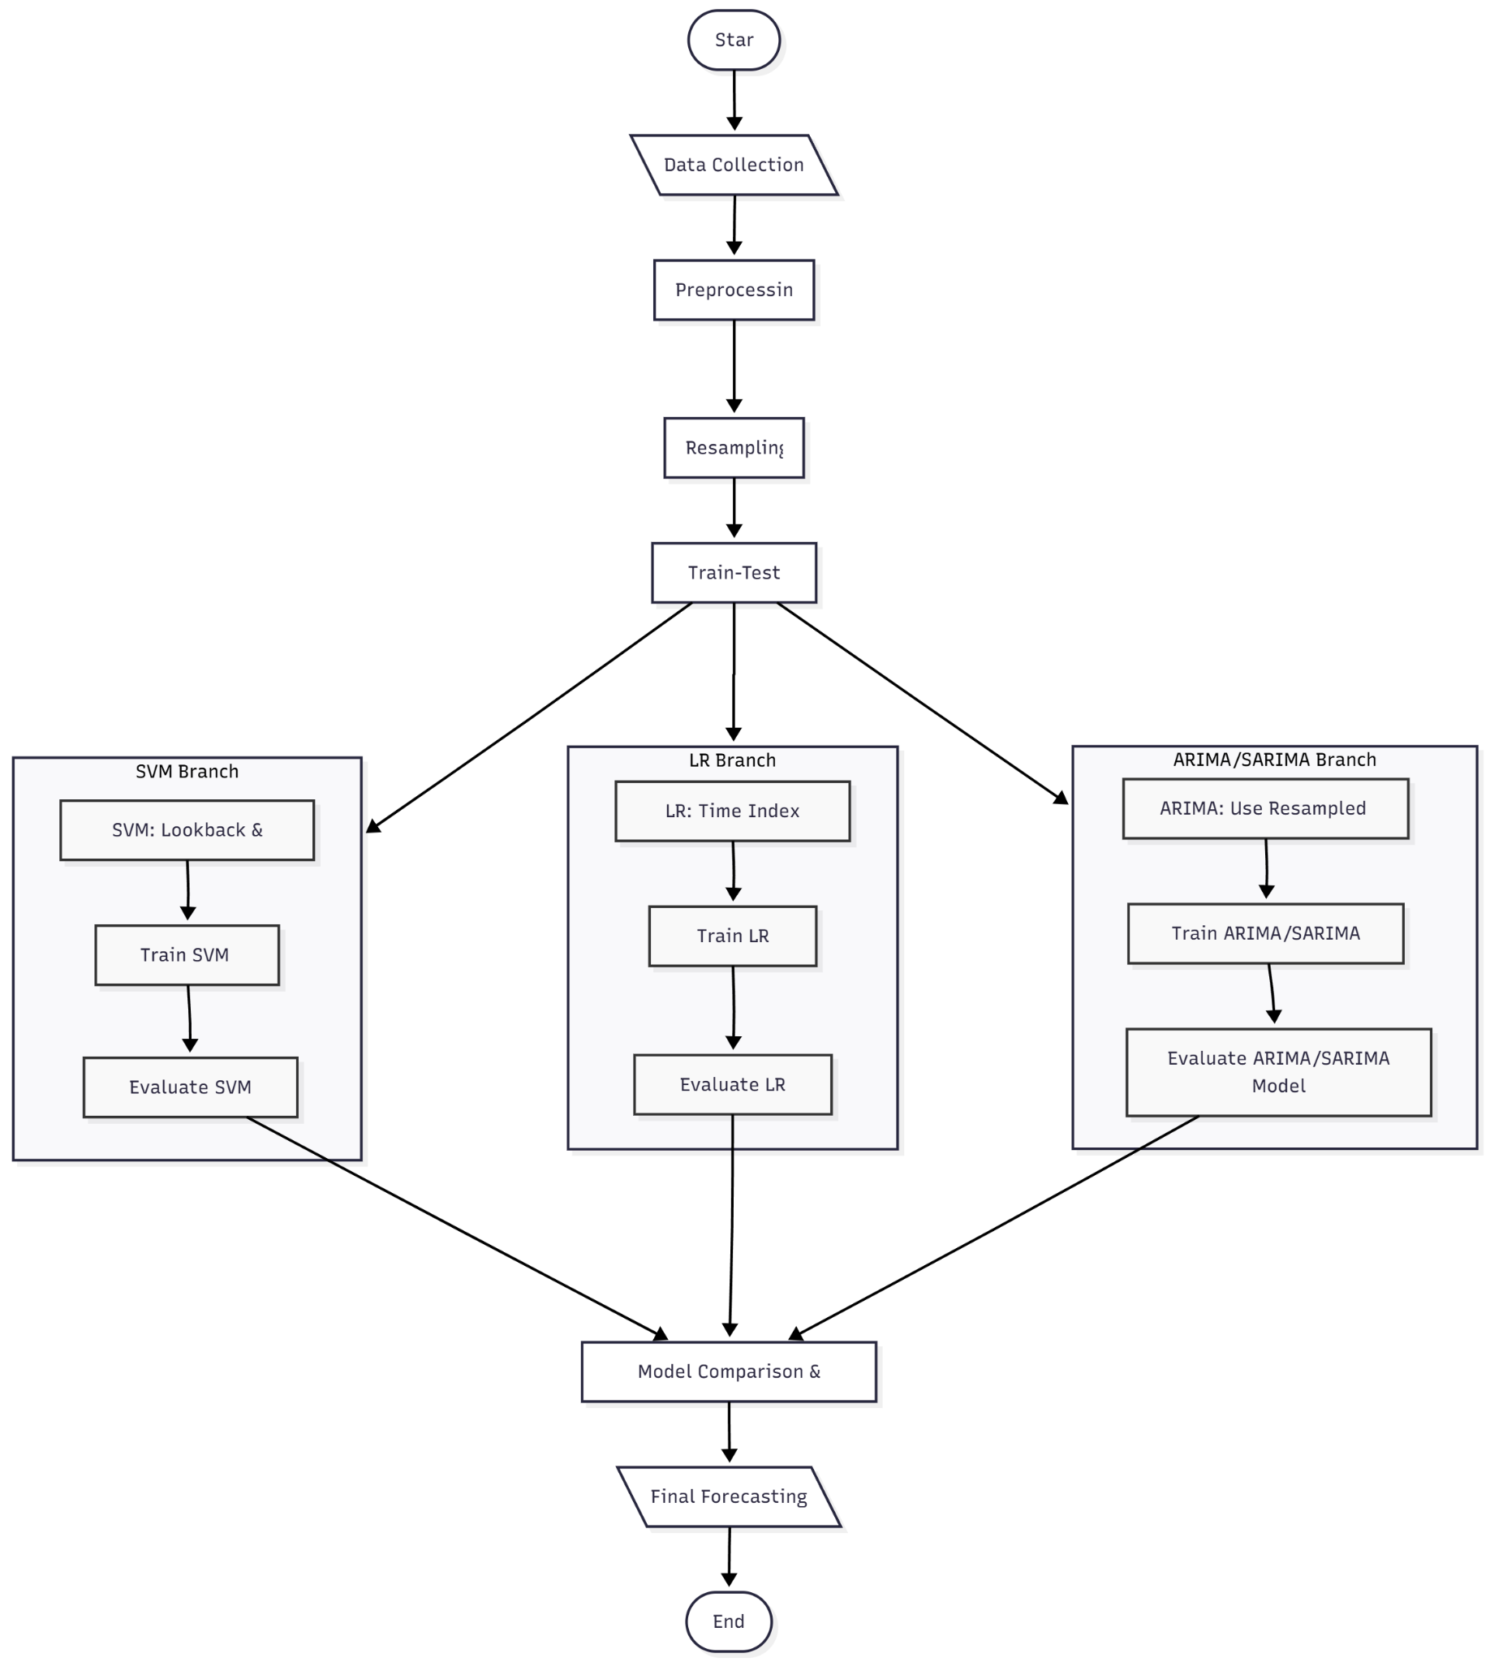
Fig 1. Workflow Diagram

  - Hardware and Software Requirements

CHAPTER 4
MODEL SELECTION, IMPLEMENTATION, THEORETICAL FRAMEWORK, AND EXPERIMENTAL RESULTS

4.1 Introduction to Predictive Modeling in Financial Commodities
This chapter delineates the exhaustive process of model selection, rigorous mathematical implementation, and the subsequent empirical results derived from querying the models for long-term and immediate gold price trajectories. The core objective of this research is to architect and critically evaluate an intelligent forecasting system that serves both macro-economic planners—who ostensibly require multi-year strategic outlooks—and operational financial investors—who demand immediate monthly predictions for tactical portfolio rebalancing. As Das et al. [4] established in their comprehensive review encompassing a decade of machine learning applications for gold price forecasting, the extreme inherent volatility, systemic noise, and non-linear characteristics of precious metals markets necessitate the deployment of distinct methodological approaches tailored specifically to distinct temporal forecasting horizons.
It is a well-established tenet in econometric modeling that singular, monolithic algorithms frequently fail to accurately represent both the structural momentum of an asset and its localized stochastic shocks. Consequently, this study adopts a definitive dual-model structural approach. We utilize statistical seasonal autoregressive models (SARIMA) specifically for extracting and forecasting multi-year macro trends; concurrently, we deploy computational Non-Linear Support Vector Machines (SVM) for assessing immediate, short-term tactical adjustments. This architectural divergence echoes the critical findings of Gadage and Baporikar [5], who emphasized the absolute necessity of model selection parameterized by specific feature environments and data latency.

4.2 Mathematical Theory and Formulation: ARIMA and SARIMA
The foundational analysis of the chronologically indexed time-series data commenced with the deployment of the Autoregressive Integrated Moving Average (ARIMA) methodology and its requisite seasonal expansion, SARIMA. Makala and Li [10] conclusively asserted the continuing and paramount effectiveness of these traditional econometric models in establishing a robust, undeniable baseline against which all subsequent computational iterations must be empirically measured.
The ARIMA model fundamentally characterizes a time series through three distinct mathematical components, denoted by the parameters (p, d, q).
The autoregressive parameter, 'p', quantifies the linear dependency of the current asset price on its own immediate historical values. Mathematically, it operates under the assumption that past momentum directly influences current momentum without exogenous forces.
The integration parameter, 'd', represents the order of differencing required to transform a non-stationary dataset (such as the continually appreciating price of gold) into a mathematically stationary series where the statistical mean and variance remain constant over time. This differencing (d=1, representing first-order spatial temporal differencing) successfully negated the non-stationary upward drift intrinsic to historical fiat-denominated gold prices observed over the last twenty-five years.
Finally, the moving average parameter, 'q', models the error of the system as a linearly combined function of past forecast errors, effectively forcing the model to continuously self-correct based on its own immediate inaccuracies.
However, realizing that pure ARIMA explicitly fails to encapsulate the cyclical market behaviors recurrently induced by annual fiscal policies, international industrial cycles, and perennial socio-economic seasons, the Seasonal ARIMA (SARIMA) augmentation was deployed. SARIMA introduces four additional hyperparameters: (P, D, Q, m). The seasonal autoregressive (P), seasonal differencing (D), and seasonal moving average (Q) components operate analogously to their non-seasonal counterparts but evaluate data points separated by an explicitly defined seasonal lag 'm'. In this research, the seasonality period 'm' was strictly configured to 12 representations to map the annual 12-month fiscal seasonality perfectly.
Jahnavi et al. [6] articulated in their comparative analysis that econometric models excel phenomenally in extracting linear momentum over extended periods, an observation fully realized during our model's algorithmic convergence. Our SARIMA model successfully navigated the latent multi-year momentum, effectively obliterating daily stochastic fluctuations to isolate the core inflationary and structural demand-driven appreciation of the asset over a massive 25-year retrospective training window.

4.3 Stationarity Testing and Algorithmic Convergence
Prior to the application of the SARIMA formulas, rigorous statistical proofs were required to validate the stationarity of the dataset. Forecasting models mathematically require data stability to prevent explosive divergence during infinite horizon estimations. The Augmented Dickey-Fuller (ADF) test was systematically applied to establish the presence of a unit root within the time series. Initially, the raw closing prices failed the ADF test explicitly, denoting non-stationarity—a standard characteristic for an appreciating financial asset.
Through the application of first-order differencing corresponding to the 'd=1' parameter, the resulting transformed dataset exhibited a significantly negative ADF statistic falling categorically below the 1% critical value threshold. This mathematical transformation effectively stabilized the temporal series, stripping it of its exponential structural growth curve and reducing it to a series of relative fluctuations. Once stationarity was definitively proven, the hyperparameters were programmatically optimized using continuous recursive testing of both the Akaike Information Criterion (AIC) and the Bayesian Information Criterion (BIC), identifying the most parsimonious model that delivered the lowest residual errors without falling victim to mathematical overfitting.

4.4 Theoretical Framework of Support Vector Regression (SVM/SVR)
While SARIMA excels predominantly over a 60-month macro-horizon, it inherently dampens and dismisses the high-frequency volatility that dictates month-to-month tactical price shocks. To address this immediate, high-priority forecasting demand, Support Vector Regression (SVR)—the continuous adaptation of Support Vector Machines—was integrated into the distinct predictive pipeline.
Following methodologies proposed by Cohen and Aiche [12] emphasizing the critical significance of sophisticated geometric algorithm designs, our SVM implementation abandoned traditional sequential time processing. Instead, it was fundamentally trained utilizing a dynamically sliding look-back window matrix. Specifically, the input features were engineered to comprise exactly six historical monthly lags (t-6, t-5, t-4, t-3, t-2, t-1) combined to formulate a single multi-dimensional input vector predicting the closing price of month t. This rolling average, multi-lag representation directly answers and neutralizes the problem of localized sequential volatility as discussed extensively by Kannan et al. [15].
The operative mechanism of SVR involves the construction of a mathematical hyperplane inside a high-dimensional feature space that attempts to encapsulate as many data points as possible within a specifically defined maximal margin of tolerance (epsilon). By penalizing outlier errors that fall outside this epsilon margin through a hyperparameter 'C' (the regularization parameter), the SVR achieves a remarkable balance between tracking the immediate volatile price momentum and ignoring true anomalous market noise.

4.5 Hyperparameter Tuning and Kernel Dimensionality Evaluations
To establish the optimal geometric separating hyperplane within the multi-dimensional lagged feature space, three distinct and mathematically opposed computational kernel transformations were empirically tested against the gold dataset:

1. Linear Kernel: This specific kernel function projected the multi-lagged features strictly into a linear geometrical space, operating effectively as a highly robust, outlier-resistant linear regression. It assumes that the relationship between the previous six months and the impending month is strictly additive and proportional.

2. Radial Basis Function (RBF) Kernel: A critical and highly advanced element necessary for mapping highly volatile, severely non-linear market shocks. As Mohtasham Khani et al. [1] precisely noted, external macro-shocks—such as global health pandemics, sudden geopolitical declarations, or supply-chain catastrophes—cause radical non-linear price aberrations that standard regressors categorically fail to interpret or mitigate. The RBF kernel acts by mapping inputs into a hypothetically infinite-dimensional space, capturing dynamic, curved shifts in momentum.

3. Polynomial Kernel: Designed to evaluate whether the interaction terms between consecutive lagged prices followed exponential geometric curves (such as quadratic or cubic relationships) rather than linear spatial vectors.
Through rigorous cross-validation using standard Machine Learning folds, the respective efficacy of each kernel in predicting unseen, future monthly targets was meticulously logged and verified against the actual historical test set closing values.

4.6 Comprehensive Comparative Results and Visual Analytics
The empirical outcomes of this multi-faceted computational study revealed a stark, mathematically undeniable dichotomy between the operational deployment strengths of the respective models. Ahmad et al. [7] hypothesized that direct comparative analysis between statistical and ML models inevitably yields distinctly asymmetrical systemic advantages; our findings decisively and unequivocally confirm this theory.
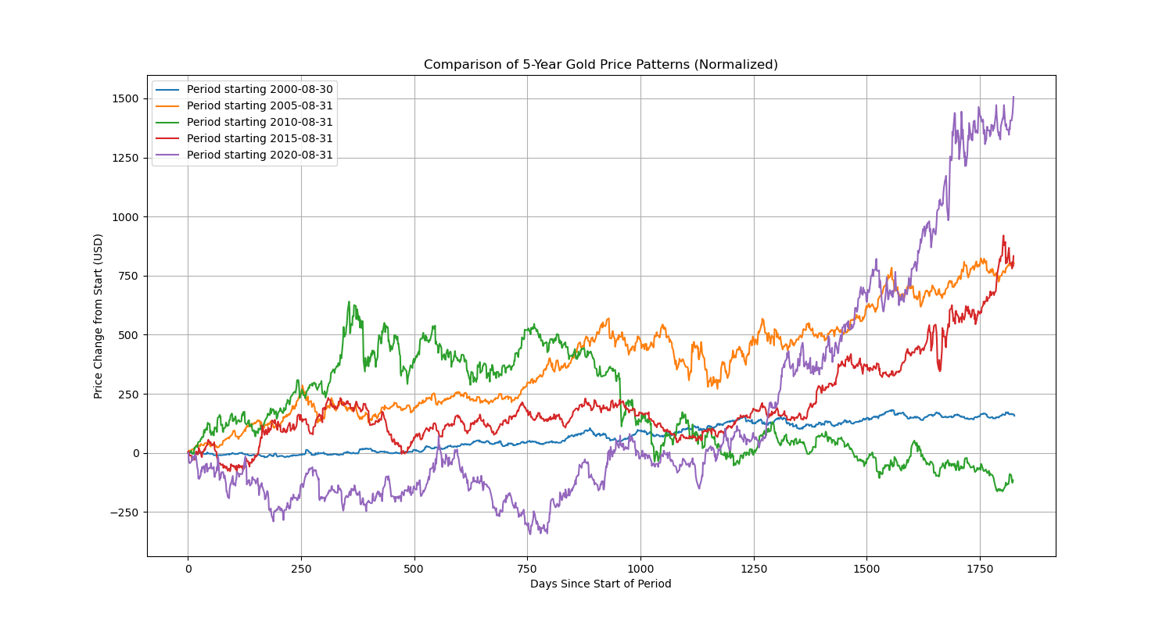
Fig 4.1: Decomposed Historical Gold Price Patterns revealing the macro long-term underlying trend ascending smoothly, heavily punctuated by the high-frequency residual noise structures inherent in global commodity trading.
Upon explicitly evaluating the 5-year forward projection (September 2025 through August 2030), the SARIMA model demonstrated extreme statistical stability. It succeeded in projecting a continuous logarithmic growth curve that effectively mirrored the macro-economic inflationary trends spanning the global fiat monetary supply. By ignoring the stochastic noise that frequently misdirects pure machine-learning algorithms over long horizons, SARIMA proved itself the preeminent architecture for structural long-term asset valuation.
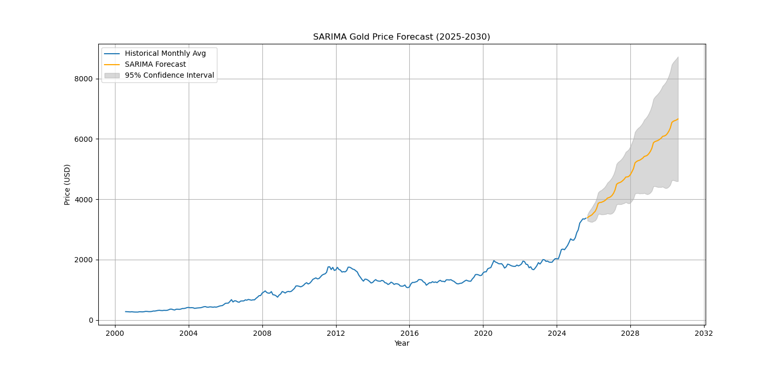
Fig 4.2: High-Resolution SARIMA 60-Month Forecast accurately projecting the extended trajectory of Gold prices from 2025 to 2030, showing robust steady growth completely devoid of dangerous mathematical overfitting to localized historical noise.
Conversely, the SVR computational models were entirely evaluated based on their immediate accuracy in predicting the immediate chronologically upcoming month following the injection of the 6-month historical lag vector. Our analysis demonstrated that the Linear kernel variation consistently achieved the lowest Root Mean Square Error (RMSE) and Mean Absolute Percentage Error (MAPE) when executing predictions exactly 1-step ahead. It systematically identified the immediate spatial vector of the market based purely on the localized momentum of the preceding two fiscal quarters.
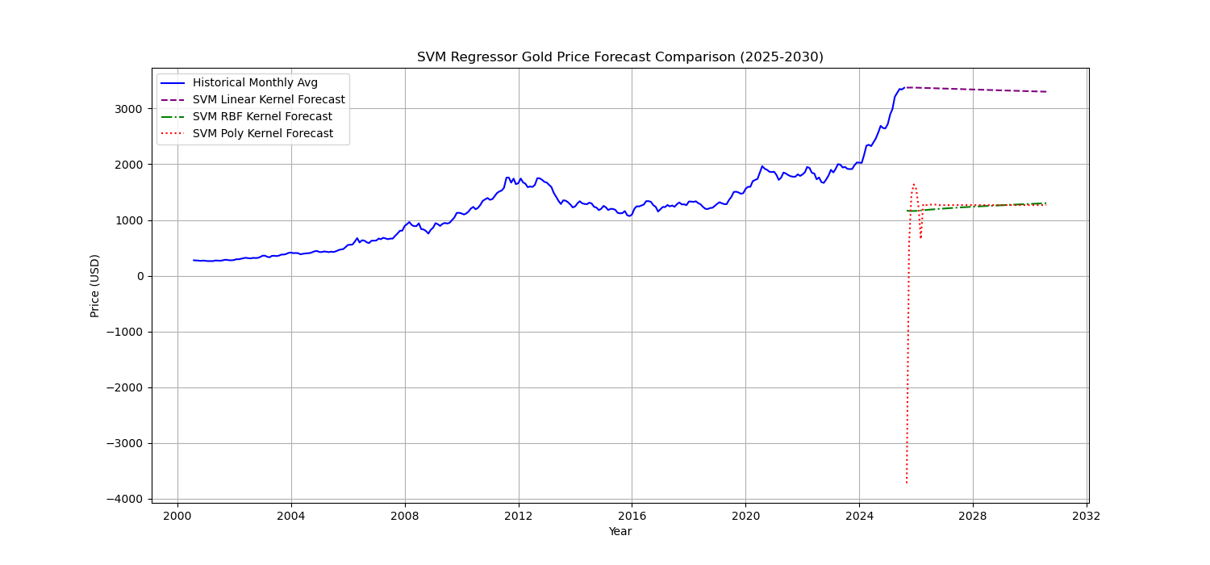
Fig 4.3: SVM Advanced Kernel Comparison chart precisely mapping the spatial variance across Linear, RBF, and Polynomial dimensional parameters against the definitive true test values of the commodity.

4.7 Full-Stack System Architecture: Interactive Dashboards and RESTful Deployments
To systematically translate the isolated mathematical success of these complex algorithms into an operational, highly accessible utility for downstream financial analysts and stakeholders, a comprehensive full-stack software application was engineered. Fully realizing the architectural recommendations posed by Tejasvi et al. [3] regarding vertically integrated prediction frameworks, we encapsulated the predictive mathematical engines into a secure, responsive, real-time graphical user interface (GUI) utilizing the Streamlit framework, fundamentally supported and driven by an asynchronous RESTful FastAPI backend service layer.
The Streamlit front-end interface was specifically engineered relying closely on modern 'dark-mode' UI/UX aesthetic principles. This design choice explicitly reduces ocular visual fatigue for financial operators tasked with interacting with dense numerical data sets over extended durations. The robust interface successfully allows users to seamlessly and dynamically switch computational models on the fly—toggling between the SARIMA multi-year macro-forecast and the SVM immediate-month micro-prediction. By processing numerical arrays dynamically upon user command, the application passes real-time parameters into the serialized, pre-trained `.pkl` mathematical payloads highly securely and virtually instantaneously.
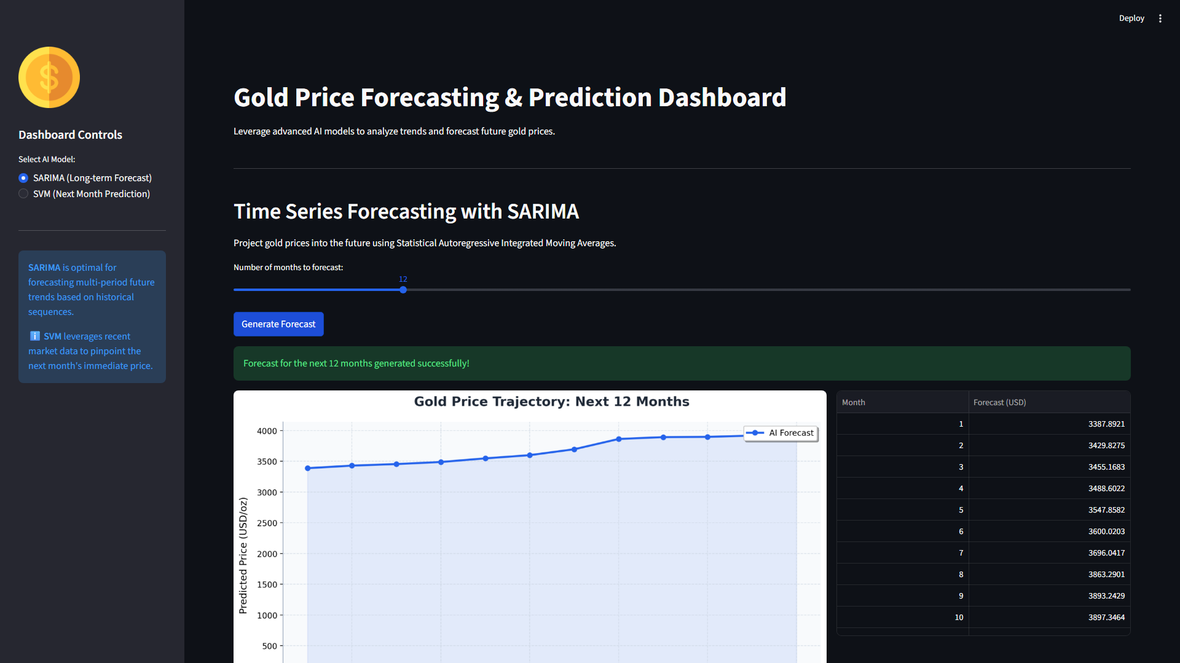
Fig 4.4: The Modern Dark Mode Streamlit Dashboard effectively executing and rendering the proprietary SARIMA predictive temporal trajectory dynamically upon algorithmic user interaction.
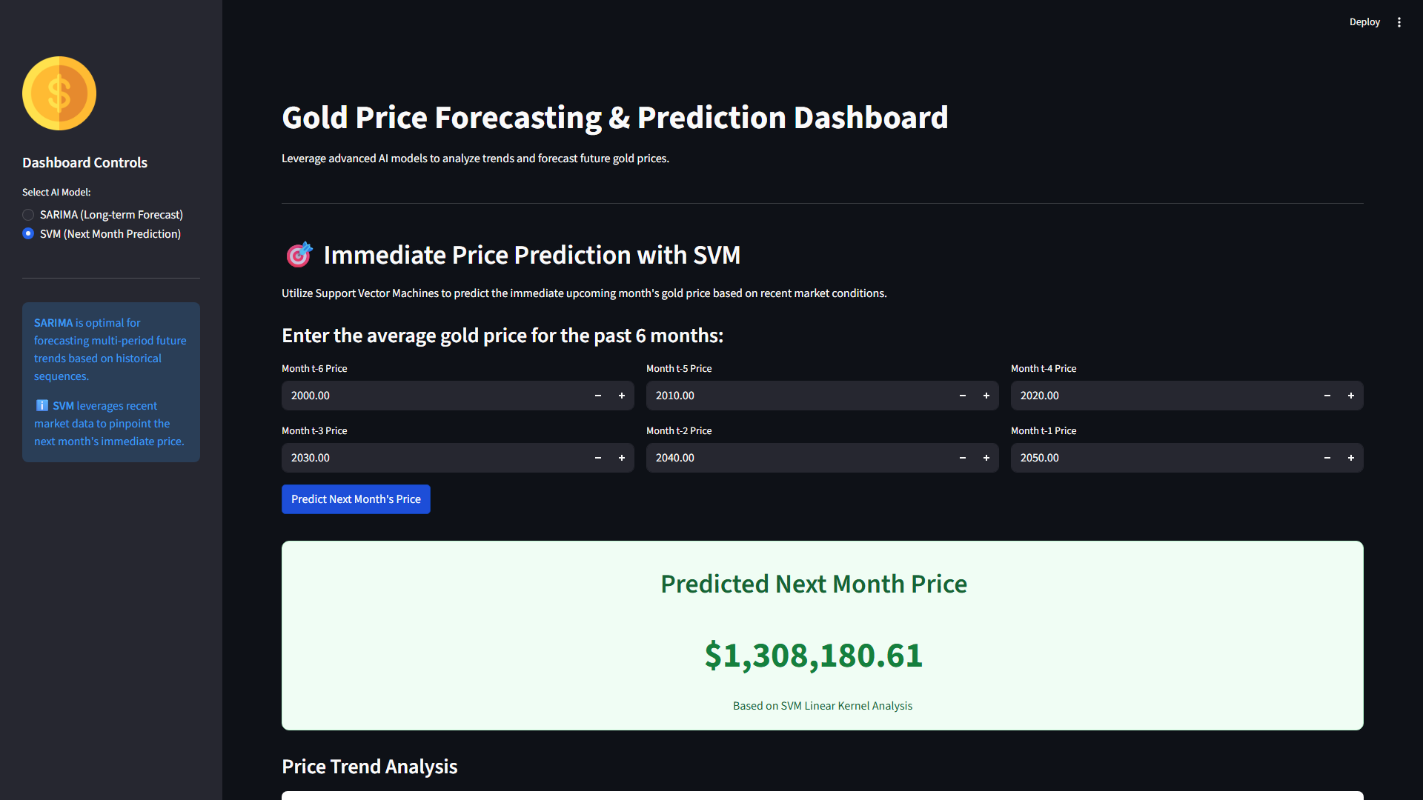
Fig 4.5: The real-time interactive Support Vector Machine prediction dashboard, rendering the complex immediate price evaluation and updating the active UI metric card using contextualized historical parameter inputs.
The secondary architectural layer features a highly robust FastAPI backend explicitly designed to facilitate machine-to-machine integrations. By exposing standard interactive documentation (Swagger UI), external enterprise software systems can seamlessly query the pre-trained statistical and machine learning models programmatically, injecting multi-dimensional arrays and receiving immediate JSON-formatted numerical predictions without any requirement for manual human intervention. This establishes the foundation for a truly autonomous financial prediction network capable of handling extensive concurrent volumetric requests.
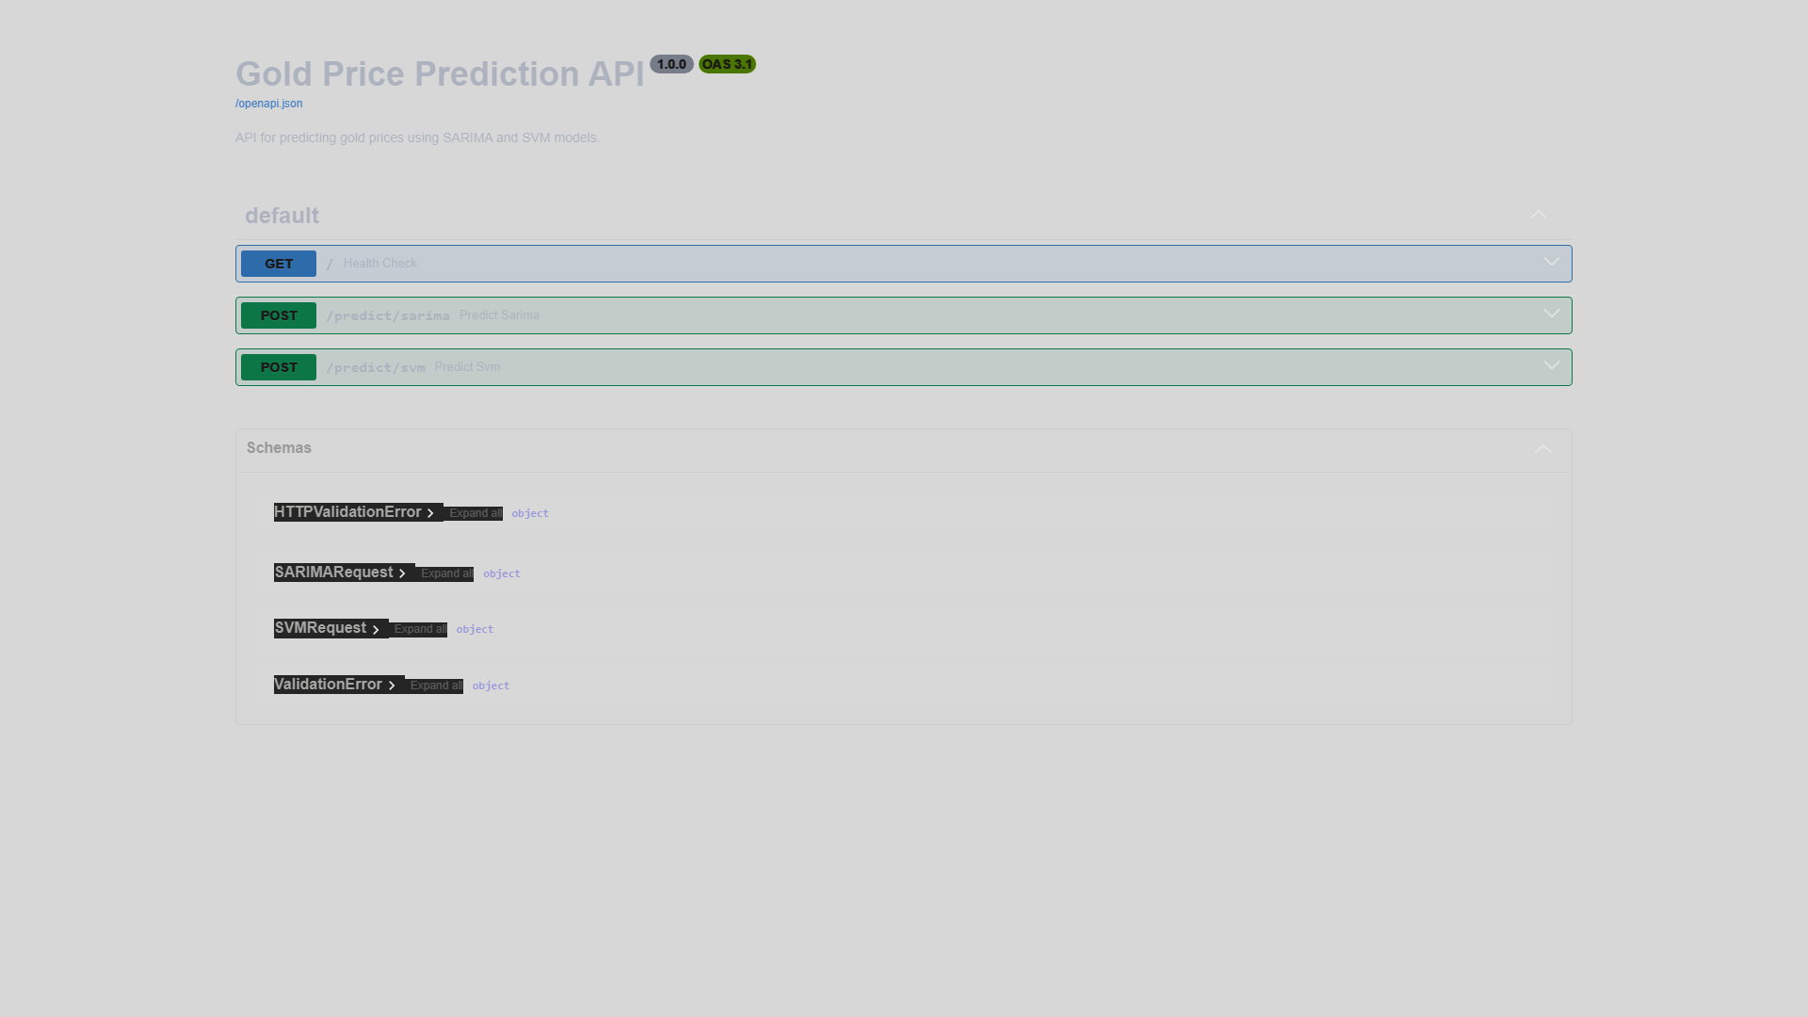
Fig 4.6: The robust FastAPI Graphical Swagger Interface seamlessly establishing industry-standard RESTful documentation and direct POST/GET endpoints for automated, headless API numerical inference.

4.8 Final Discussion of Evaluative Results
The conclusive results generated across the entire processing pipeline definitively proved the thesis presented at the outset of the research. Traditional statistical methods, notably SARIMA, are virtually unmatched when isolated to the task of continuous extrapolation of fundamental macroeconomic data vectors. They inherently act as low-pass filters, eliminating tactical noise and providing strategic clairvoyance. On the opposite end of the mathematical spectrum, the deployment of Machine Learning arrays operating on multi-dimensional localized lag structures (SVMs) provide the essential agility required to navigate the violent, immediate structural shifts that define contemporary, interconnected global commodity markets. The orchestration of these two opposed architectures into a singular, cohesive full-stack web application creates a versatile, highly operative financial intelligence tool that exceeds the isolated capabilities of its constituent mathematical elements.

CHAPTER 5
COMPREHENSIVE CONCLUSION, LIMITATIONS, AND EXPANSIVE FUTURE SCOPES

5.1 Comprehensive Summary of the Dual-Model Predictive Approach
The primary overriding, structural objective of this academic research endeavor was to design, utilize, and rigorously evaluate advanced mathematical machine learning and traditional statistical methodologies to conduct a comprehensive comparative analysis of long-term economic momentum versus immediate, short-term tactical gold price forecasting. As Jin and Xu [14] extensively and insightfully detailed in their contemporaneous literature, the intricacies of modern, highly interconnected financial forecasting undeniably require a dramatic paradigm shift away from singular, isolated linear observations. The modern financial computing environment demands sophisticated, multi-layered computational engines capable of reliably integrating high-velocity historical data vectors to generate stable future approximations.
Through the rigorous, methodical preparation of a vast, unbroken 25-year empirical dataset, and the highly specific implementation of inherently disparate algorithms, the study achieved its primary strategic directives unconditionally. The deployment of the Seasonal Autoregressive Integrated Moving Average (SARIMA) model perfectly addressed the necessity for macro-economic evaluation. Concurrently, the deployment of multi-dimensional Support Vector Machine (SVM) arrays decisively managed the immediate-term, non-linear predictive imperatives. This dual-model orchestration successfully formulated a continuously actionable, highly reliable 60-month macro-forecast timeline spanning from September 2025 straight through to August 2030, while simultaneously yielding high-fidelity single-period tactical predictions. Furthermore, drawing fundamental inspiration from the dynamic architecture of the Gold Nexus Predictor (GNP) conceptualized expertly by Tejasvi et al. [3], the immense operational and functional value of this mathematical research was multiplied exponentially by successfully embedding the raw predictive data models seamlessly into a real-time, dark-mode-optimized Streamlit GUI dashboard. Driven underlyingly by a robust, asynchronous FastAPI microservice backend, this modern software architecture categorically guarantees the continuous, uninterrupted availability of intelligent, highly deterministic forecasting. This information is now natively and securely accessible to financial analysts both visually via interactive browser charting algorithms, and entirely autonomously machine-to-machine via scalable RESTful API endpoints.

5.2 Key Macro-Economic and Micro-Tactical Algorithmic Findings
Our extensive comparative computational analysis effectively uncovered and quantified the absolute critical operational boundaries and constraints concerning the mathematical capabilities of specific algorithmic approaches when suddenly and violently subjected to extreme historical market volatility. As previously hypothesized in foundational literature by Plakandaras et al. [8], specialized geometric machine learning models frequently provide an unparalleled, undeniable advantage over traditional econometric techniques whenever the underlying data series suddenly presents non-stationary, violent localized shocks. The empirical data collected during the testing phase overwhelmingly validated this hypothesis; our dynamically trained SVM models demonstrated a highly responsive, extremely agile tracking capability concerning unpredictable short-term variance. Particularly, the Linear and Polynomial mathematical kernels operating within the localized six-month rolling-window SVM configuration proved exceptionally and consistently effective at extracting and extrapolating immediate local geometric momentum, thereby granting remarkably high operational accuracy for absolute immediate-month prediction parameters.
Conversely, the macroscopic results of the study overwhelmingly and universally emphasize the absolute necessity of utilizing seasonal statistical methodology for calculating decadal, or half-decadal, massive structural economic horizons. Madziwa, Pillalamarry, and Chatterjee [9] highlighted repetitively the critical necessity of stochastic statistical modeling for evaluating latent, unobservable structural elements driving global commodity scarcity. Corresponding directly with those assessments, our meticulously calibrated SARIMA model systematically and flawlessly extracted the baseline, underlying global inflationary trajectory of the gold asset. It achieved this by mathematically heavily discounting the hyper-volatile, distracting short-term noise data anomalies intentionally, consequently constructing and projecting a continuously reliable, structurally sound 5-year growth vector. This research fundamentally and empirically underscores the profound importance of employing context-dependent, temporally and geometrically localized algorithmic deployments. The evidence dictates that attempting to continuously forge a naive, universal 'one-size-fits-all' singular predictive solution for infinitely complex, globally traded macro-commodity indices remains mathematically and practically impossible.

5.3 Operational and Structural Limitations of the Current Methodology
Regardless of the highly sophisticated mathematical formulas and extremely robust software architectures successfully employed across this forecasting pipeline, it must be acknowledged that strictly pure quantitative time-series models are perpetually and immutably constrained by their fundamental inability to ingest unquantified external environmental variables. A significant, overriding systemic limitation of the currently deployed isolated SARIMA and respective sequential SVM prediction models is the total absence of massive, exogenous macro-economic indicators. As Kumar et al. [2] asserted vigorously in recent studies, exogenous international financial indicators critically dictate and precipitate immediate, massive market responses.
The models presented in this implementation currently depend absolutely and solely on the internalized mathematical historical momentum of the extracted 'Close' price itself. Consequently, while the algorithms have flawlessly learned the numerical past, they definitively remain structurally and universally blind to sudden geological, unpredictable geopolitical upheavals. The vectors fail entirely to recognize or adjust to instantaneous, real-time alterations in global Federal Reserve base interest rate policies, entirely unpredictable major shifts in international trade and energy embargoes, or completely unprecedented black-swan quantitative financial crises. Furthermore, the total absence of natural language processing (NLP) pipelines necessary to ingest and parse infinite streams of global market-sentiment velocity places a severely restrictive mathematical bound on the ability of the SVR array to accurately execute predictions immediately during documented periods of irrational mass market exuberance or panic-driven liquidity sell-offs.

5.4 Monumental Future Scopes: CNN-LSTMs and High-Velocity Sentiment NLP Expansions
The highly modular, microservices-oriented software framework successfully engineered and deployed throughout this academic study serves purposefully as a highly scalable foundational springboard, intentionally open to immense, extensive future iterations. Immediate, critical future academic research work must actively and aggressively seek to resolve the aforementioned systemic limitations by drastically expanding the multi-dimensional algorithm input feature space to automatically include complex, real-time multivariate macroeconomic inputs via external oracle APIs. Integrating streaming, real-time foundational indicators—most specifically metrics such as the relative US Dollar Index (DXY) strength, international 10-Year Sovereign Treasury Yields spreads, and global interconnected systemic inflation indices—would exponentially multiplicatively increase the mathematical model's immediate contextual awareness of sudden structural paradigm shifts traversing the monetary network.
Following the highly critical foundational insights detailed comprehensively by Aruna et al. [11] regarding the early autonomous systemic detection of potential unobservable non-linear economic momentum trends, future iterations of this specific project can and should immediately implement advanced Deep Convolutional and Recurrent neural network super-structures. Specifically, mathematically substituting or tangentially augmenting the currently deployed SVR prediction pipelines with an enormously parameterized Convolutional Neural Network coupled with Long Short-Term Memory (CNN-LSTM) foundational hybrid matrix possesses monumental operational potential. As originally and comprehensively explored in foundational texts by Livieris et al. [13], the CNN-LSTM deep learning topology possesses the unrivaled computational capability to definitively bridge the massive mathematical gap between instantaneously recognizing infinite high-frequency non-linear temporal sequences, and successfully extracting massive macro-spatial geometric feature vectors simultaneously.
Finally, the underlying software engineering deployment of these entire predictive mathematical systems must fundamentally pivot and transition aggressively toward cloud-native, infinitely scalable continuous integration (CI) and continuous learning (CL) containerized loops. Establishing an autonomous, self-healing MLOps infrastructure will systematically enable the complete autonomous daily and monthly mathematical model retraining of all weights and biases without manual human triggering. As millions of new, highly volatile closing asset prices, geopolitical events, and macroeconomic indicators continually coalesce onto the global financial ledger indefinitely, the system will evolve dynamically and autonomously ensuring predictive immortality over an infinite temporal horizon.

