Generating figures for the coral modeling paper, as of Jan 12, 2020

This is just a cheat sheet, and is very rough, but it should have the key steps to generating most of the figures, including all which had to be updated this month.

Note that for all figures the process can be sensitive to directory paths. In general, you want to run MATLAB in the same directory where the figure script is stored, either FigureGeneration or FigureManipulation. The main program directory (one level up) should be on the path. Where directory names are specified, it will be near the top of the file. Names should end with a directory separator character.

**Figure 1**

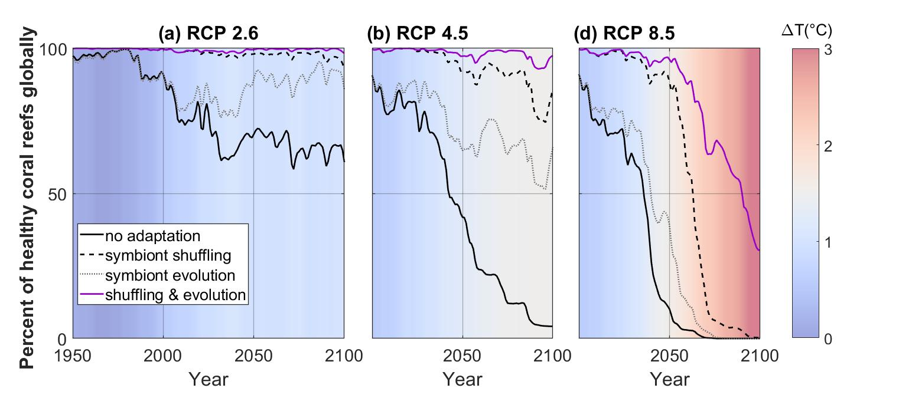

This compares the number of healthy reefs over time for various scenarios. The required data are written to one *.mat file per run, labeled by RCP, E, OA, and superAdvantage options. Symbiont introduction mode is not indicated.

Two sets of cases (no advantage and with a shuffling advantage) are run for each RCP scenario (2.6, 4.5, and 8.5 are used) using AutoRepeatModelRuns.m. Be sure to set **doDetailedStressStats=true** so the curve data will be written to the output directory. The mat files will be in a subdirectory called “bleaching”.

After each set of cases, the mat files must be copied to a directory with a unique name. Currently, D:\GitHub\Coral-Model-V12\FigureData\healthy_4panel_figure1\<*some distinctive name*>\ is used. Otherwise, outputs with the same names will overwrite the data when the model is run again.

Set 1, using default single symbiont mode (mode 0):

1. E=0
2. E=1

Set 2:

1. Mode 9 shuffling, advantage 1.0 C E=0
2. Mode 9 shuffling, advantage 1.0 C E=1

From the FigureGeneration directory, run BleachingHistory_Subplots_WithDT_Row.m after setting the relPath and shufflePath variables to match the mat file locations.

Save the figure as a *.fig and *.png or *.jpg. The saveCurrentFigure script is more reliable than the export option of the figure window in some versions of MATLAB.

**Figure 2**

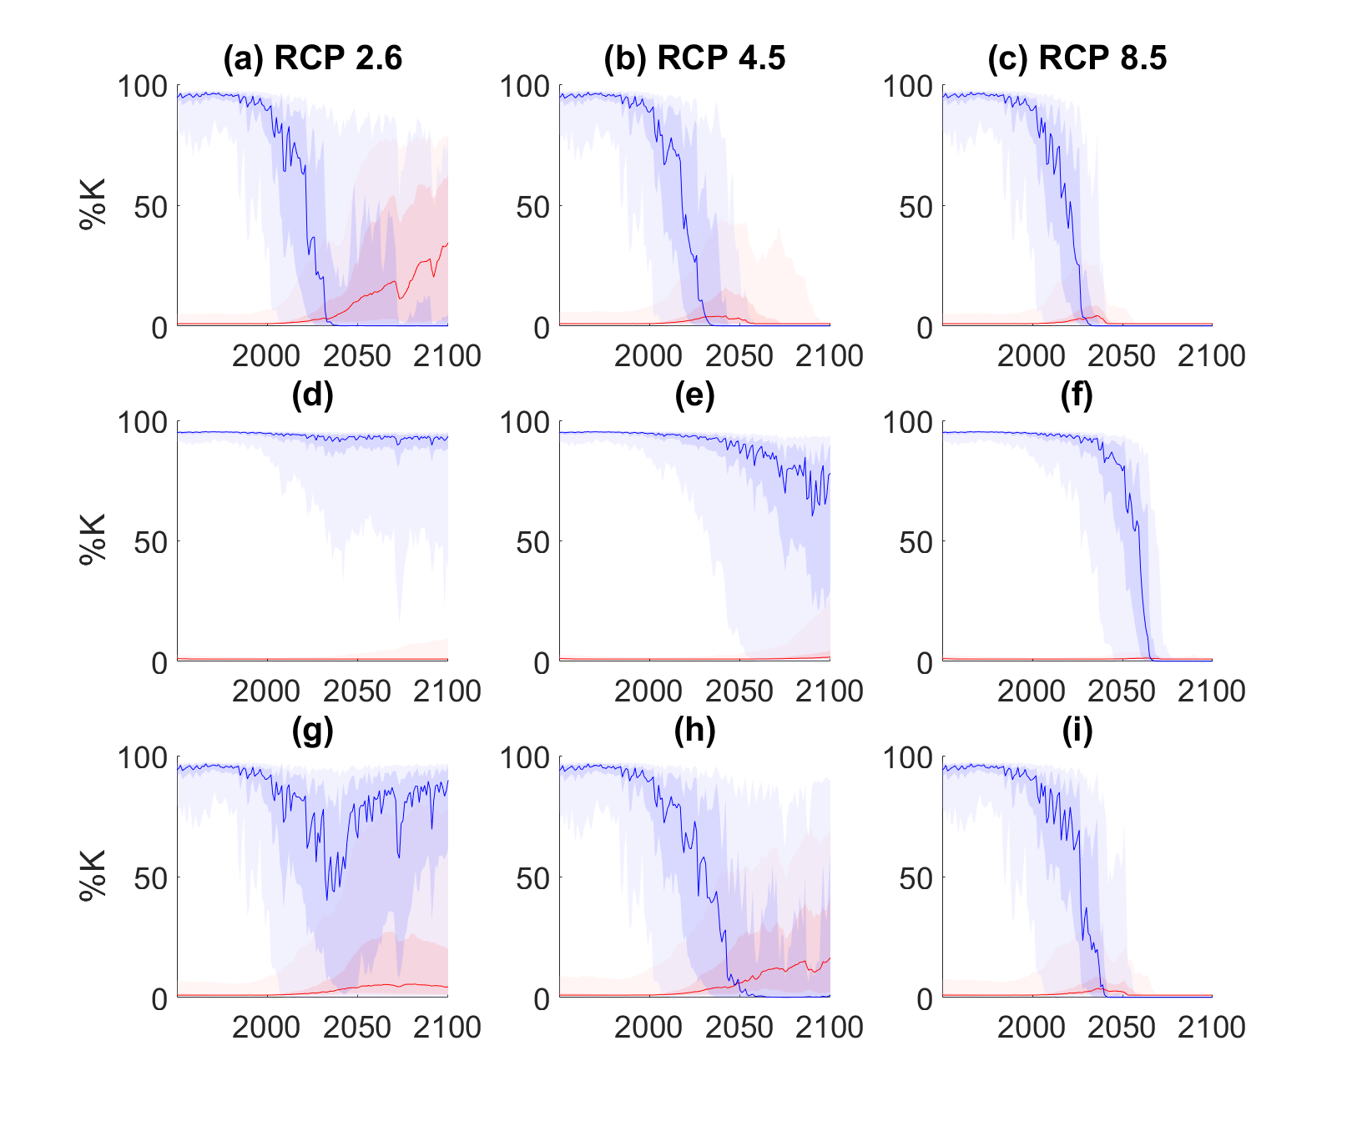

The individual panels of Figure 2 are taken unmodified from figures generated at runtime (with doCoralCoverFigure=true). The figures have names like GlobalCoralCover_rcp26_E0OA0_SymStrategy0Adv0.00C, and those needed should be gathered into a single directory from the *_map directories generated at runtime. For each of the 3 RCP values, E=0, Advantage 0; E=0, Advantage 1; and E=1, Advantage 0 are needed. In Windows, a search pattern such as filename:GlobalCoralCover_rcp??_E1OA0

Is useful. The files are combined using MergeCoverPlots_NineCases.m.

**Figure 3**

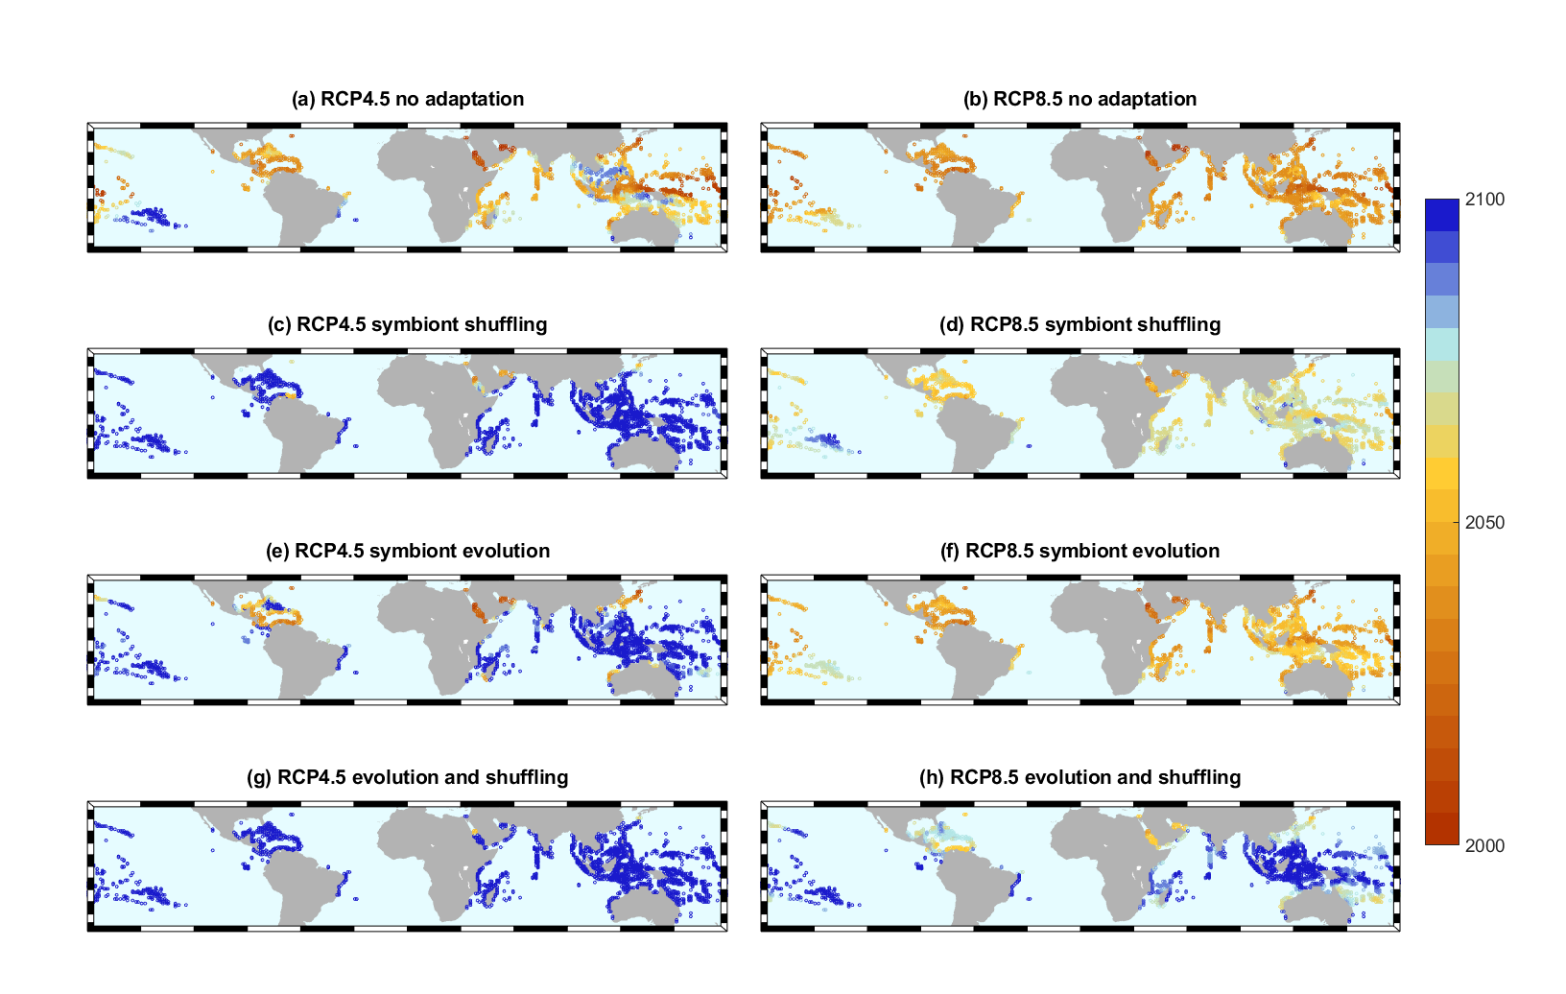

This figure shows the last year of coral survival for RCP 4.5 and 8.5 under 4 different assumptions.

The component maps are generated at run time for all cases, provided doCoralCoverMaps is true. The required 8 maps must be manually gathered into a single directory, such as FigureData/LastYearMaps_Figure3 in the model directory. Their names look like ESM2M.rcp85.E0.OA0.sM9.sA1_LastHealthyBothTypesV2.fig. On Windows:

filename:ESM2M.rcp85*LastHealthyBothTypesV2

Go to FigureManipulation, edit inputPath if necessary, and run MergeSelectedLastYearMaps_shuffle.m.

**Figure S4 (removed version)**

This takes the 4-panel figures which are generated for each reef and combines 3 pairs of them. The 6 originals should be gathered into a single directory. Then update the path name (and file names if necessary) in FigS4_4_panel_overlay.m and run the script. It will write the 3 merged versions into the same directory.

**Figure S4 (was S6) – SST analysis**

This figure shows maps with various combinations of SST, sdev(SST), and changes in those values over time. There are also RCP 4.5 and RCP 8.5 versions of each map. Combining figures manually is tedious, and combining them in a script is tricky, but a script now exists. Run everything from the FigureGeneration directory. The main script is SST_ChangeMaps_Combined.m.

* The script has some hardwired directory paths at the top. Update them to match your model location.
* At about line 13, enter the numbers of all the maps to include in the output figure. The 16 options (oddly numbered 9 to 24) are described in the comments on following lines.
* Run the script. Go for a short run.
* You will find a figure sized to fit your screen, but possibly too small to read. In the program directory (FigureGeneration) there will be a file called combinedSSTMaps.png which has the figure at higher resolution. If you want it bigger or smaller, repeat the print command echoed at the end of the script, changing the “-r” argument until you get what you want.
* Move the figure if you are making another version. Each run will overwrite the last combinedSSTMaps.png.

Note: this isn’t working as expected in June 2020. The figure comes out at different sizes, but the fonts scale differently than the maps, and every version is bad in the same way. Fortunately, the File->Export setup process works well with default settings. I deleted the little corner brackets manually from the final figure, but it is a slow process with so much data and 40 objects to delete. In the future, edit the original separate maps before combining them.

**Figure S5 – Percent healthy coral by target bleaching amount and OA**

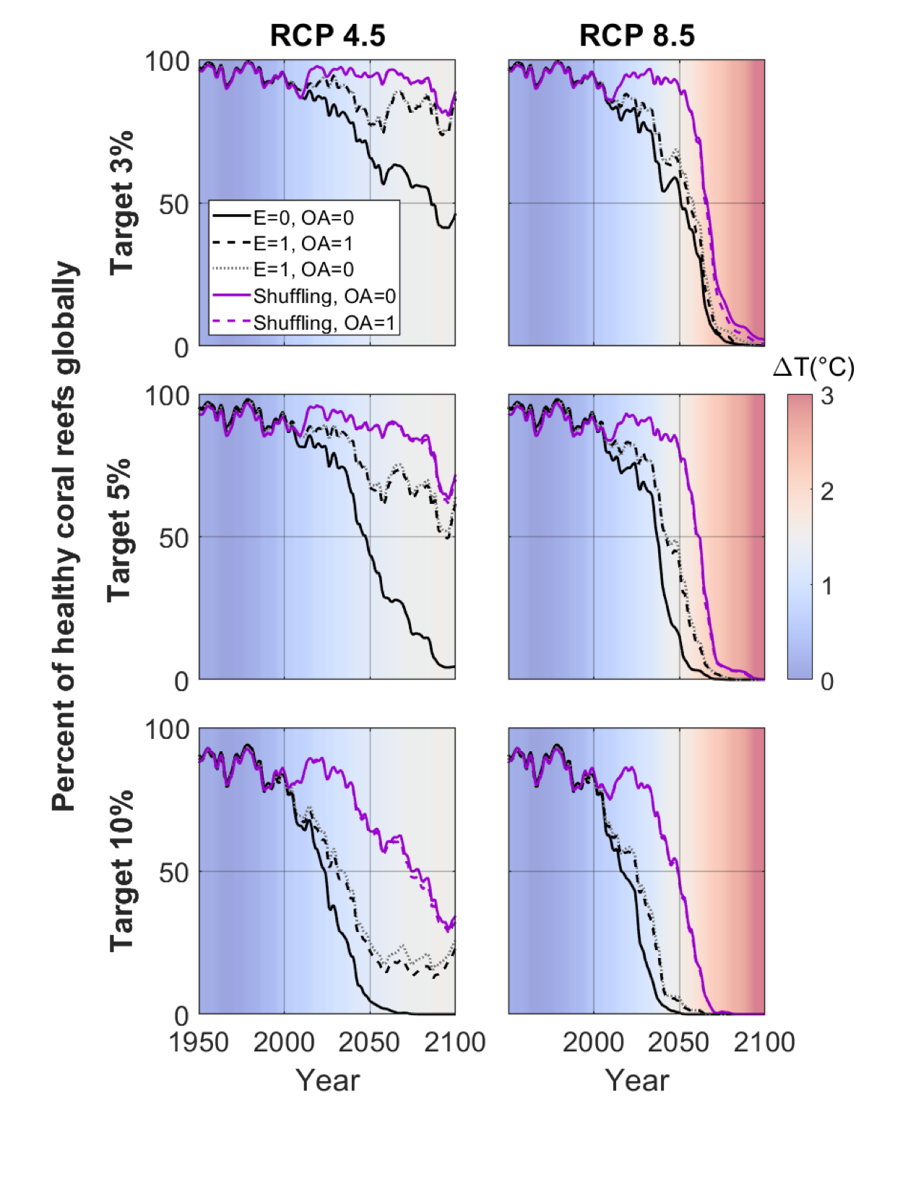

**Table 1**

The values here are manually copied from console.txt files during each run. Getting the right ones is a matter of searching for the file and selecting the required directory names. The directory names look like ESM2M.rcp60.E0.OA0.sM9.sA1.5.20200109_maps.

You will use three of four consecutive lines near the end of the file. The list entry before “1925” is to be subtracted from 100 to get “% Not Bleached”. The second line has “% Coral Cover” and the 4th times 100 is “% Heat Sensitive”.

All Reefs 6.03 11.22 4.57 11.43 15.58 28.05 1925

Global average percent coral cover: 43.6

Percent of reefs with less than 10 pct cover: 26.3

Fraction of reefs dominated by branching coral: 0.326

Table S3

A useful command line for getting more readable subsets, using the appropriate E and OA values. Run this in the containing directory for all the output files.

Similar lines can be used for the other two values in the table.

$ grep -r "coral cover" */console.txt | grep E0 |grep OA0| cut -c 7-11,25-28,90- --output-delimiter=" " | grep -v A1.2

$ grep -r "branching" */console.txt | grep E0 |grep OA0| cut -c 7-11,25-28,100- --output-delimiter=" " | grep -v A1.2 | grep -v A0.2

In this one the “awk” part prints every 6th line, because there are 6 similarly-formatted tables but we only want the last. The character range of 1330-1340 works when doDetailedStressStats is true. For the default table formats, reduce this to 106-112.

$ grep -r "All Reefs" */console.txt | grep E0 |grep OA0 | grep -v A1.2 | grep -v A0.2 | awk '!(NR%6)' | cut -c 7-11,25-28,1330-1340 --output-delimiter=" "

The color scale in the table can be duplicated in Excel by setting the following 3 colors. At 0 (255,102,102); at 45 (252,206,135); at 90 (226,237,220).

Unrelated to any specific figure, this is handy for getting and setting figure data:

% Commands like these are really handy for grabbing data from the figure on

% the screen and possibly manipulating it.

% masspop = get(gco, 'YData');

% set(gco, 'CData', cdatacopy)