This was originally made while drilling down to answer a particular question, but the notes on figure generation seem worth saving…

Comparison of the effect of updating seed values and K value. Cases:

1. Original model as of early September, 2017
2. Original K and seeds, but with new psw2 values to match the remaining cases.
3. Model with K for massive coral reduced from 7.7412E7 to 7.4125E7 **and** coral seeds at 1% and 0.1% of K for massive and branching **and** symbiont seeds of 10E-7 * Ksymbiont * C_seed for each.
4. Original model with only K changed.
5. Original model with only coral seeds changed.
6. Original model with coral and symbiont seeds changed.

Plots for 1 and 2 are already complete, in “Figures and Table” documents V4 and VX respectively.

For each we want to see

1. 4-panel damaged coral plots
2. 6-panel coral cover plots
3. Old-form plot for reef call 144, Moorea

Since this is a recurring task, I’ll document what it takes to make each plot and try to streamline it.

Plot type a:

1. Set the input values as specified in the first list of 5 items.
2. Set bleaching target to 5. Set doDetailedStressStats true.
3. Run all 16 combinations of RCP/E/OA. This is easier than skipping the unused E=0, OA=1 combination. AutoRepeatModelRuns.m skips the unwanted file.
4. This will leave mat files for each case in one directory, currently D:\CoralTest\V11Test\bleaching.
5. Copy those results to D:\GoogleDrive\Coral_Model_Steve\_Paper Versions\Figures\Survival4Panel\<*some distinctive name*>\ because they will be overwritten in the next run and may be useful in the future. In this effort, those names are
   * bleaching_OldK_OldSeed_Target5 for case 2
   * Case 3 has already been run and is in bleaching_NewSeed_Target5 from 9/23 BUT repeat it and save in bleaching_NewK_NewSeed
   * Bleaching_NewK_OldSeed_Target5 for case 4.
   * Bleaching_OldK_NewCoralSeed_Target5 for case 5.
   * Case 6
6. In FigureGeneration, run BleachingHistory_Subplots_ColorOption after setting the source directory name to match step 5.
7. This produces a figure. Save the .fig file to the same directory as the mat files (this is a change) for easy identification later.
8. Save a .png version in the same place, using my saveCurrentFigure script because File/Save export method is unreliable.
9. If the plot is for publication, hand-edit the legend colors to grayscale.

Plot type b:

1. As with a, set the inputs.
2. Set doPlots and doCoralCoverFigure to true.
3. Run at least the RPC 2.6, 4.5, and 8.5 cases, with E=0 and 1. OA is off.
4. The runs can be combined with the type a plot.
5. The plots will appear in directories with names like D:\CoralTest\V11Test\ESM2Mrcp45.E0.OA0_NF1_sM0_sA0_20170928_maps for each case. Note that the directory name has the date in it, so it constantly changes.
6. Use file search to find GlobalCoralCover*.fig in the output directories. Copy them to D:\CoralTest\V11Test\gatherCoverPlots. It may be safest to clear the directory first to ensure that old versions aren’t confused with new.
7. Use MergeCoverPlots_SixCases_3rcp_2OA.m to combine the six plots into one.
8. Save the .fig and .png files to D:\GoogleDrive\Coral_Model_Steve\_Paper Versions\Figures\CoralCover-Figure3 with distinctive names.

Plot type c:

1. Only RCP 8.5 with OA=0 and E on and off need to be run. Again, the runs can be combined with plot types and b.
2. Set 144 as a keyReef.
3. Copy the two output files, SDC_<*today’s date*>_144_normSSTrcp85_-18_-150_prop<*number between pMin and pMax*>_NF1_E0.fig and SDC_20170928_144_normSSTrcp85_-18_-150_prop<*number between pMin and pMax*>_NF1_E1.fig to D:\GoogleDrive\Coral_Model_Steve\_Paper Versions\Figures\Fig2_SSTDensityCoverDHM. Be sure they come from the OA=0 directories, not OA=1. The files in the destination directory may or may not be overwritten.
4. Update “today” to today’s date (or the date the model ran) in Merge_Two_Reef_Plots.m. Update the propx.xx value if necessary.
5. Run the script. This will overlay some lines from the E=0 figure on the E=1 figure.
6. Save .fig and .png to D:\GoogleDrive\Coral_Model_Steve\_Paper Versions\Figures\Fig2_SSTDensityCoverDHM

# Damaged Reef plot

### Original model, Case 1

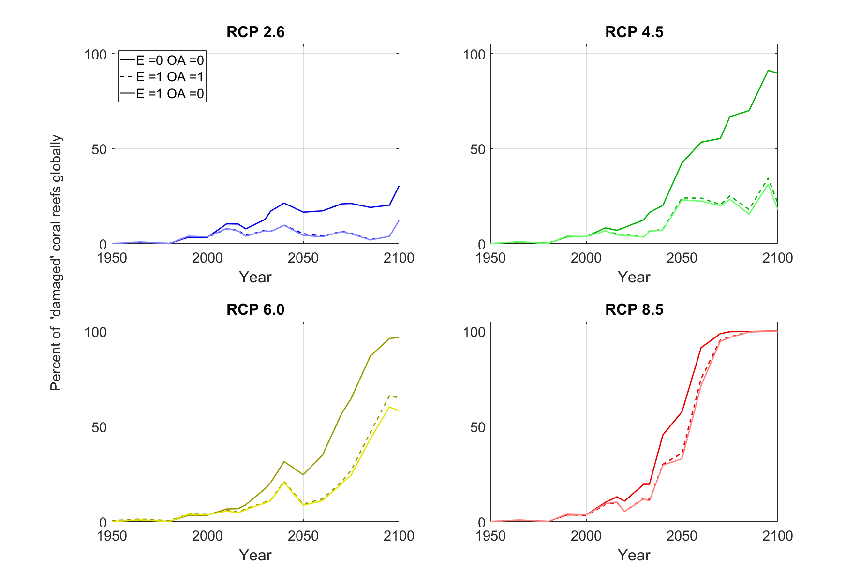

### Old K and old Seeds, but with psw2 for the new version, Case 2

Notes to try to clarify what the variables are here:

1. K drop for massive corals – on/off
2. Seed update for corals – on/off
3. Seed update for symbionts – depends on coral, so only test with new coral seeds – on/off
4. Psw2 optimization update – matched to other parameters or not?

This gives potentially 16 cases times the 16 RCP/OA/E combinations, or 256 things to look at. How do I cut it down to just reveal what we are looking for, which is: **What does K change about our results? What does the seed change about our results?**

1. Assume symbiont seeds don’t need to be tested separately.
2. Run all cases with the new psw2 do it’s not a factor.
3. Record 1985-2010 bleaching to show how much not updating psw2 matters.