计算机网络实验三可靠数据传输协议-GBN协议的设计与实现报告

姓名：叶鋆郴
学号：1120310120
邮箱：yjchit@sina.cn

实验分析：
- GBN协议数据分组格式、确认分组格式：
- 数据分组格式：Seq+Data+EOF0。其中seq为1字节，取值为0~255（故序列号最多为256个），Data<=21024字节，为传输的数据。最后一个字节EOF0，表示结尾。
B. 确认分组格式：ACK+0。ACK字段为1个字节，表示序列号数值，末尾放入0，表示数据结束。

- 协议两端程序流程图和交互过程：
- 交互过程如下图所示：
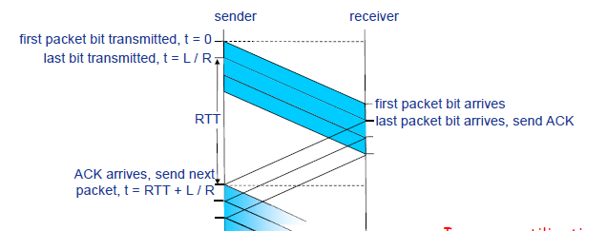
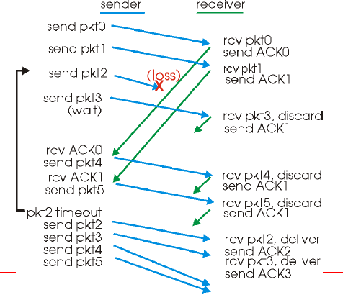
B. 两端程序流程图：
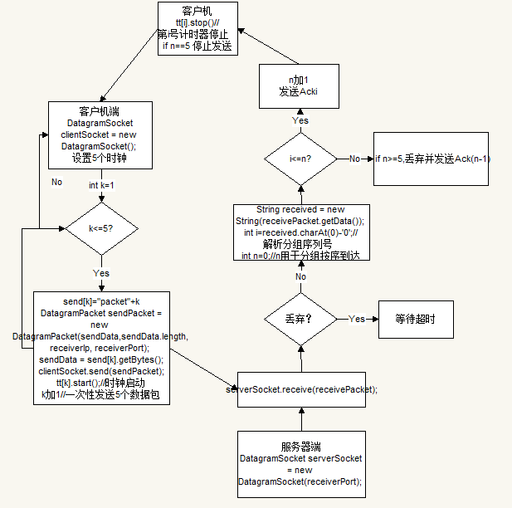
说明：客户机每次发送五个分组，并初始化计时器。然后通过收到的ACK检查发送的分组是否到达且。服务器端通过设定变量i，n，通过二者比较来一个一个的按序接收，若是由于乱序而导致后面的分组先到达，则发送当前收到的最大分组的序列号（GBN是累计确认的）这样客户机也能实现按序到达。当分组概率丢弃后，tt[i]超时，这时客户机重发。

- 数据分组丢失模拟方法，程序实现的主要类和作用：
- 数据分组丢失模拟：Math.random() < 0.9，丢失概率为0.1；
- 程序实现主要类和作用：
GBNClient类：发送分组并计时。接收确认分组，确保服务器端接收按序。根据累计确认发送服务器端需求分组，
GBNServer类：发送确认分组。确保按序接收。

- 实验验证结果如课堂展示所示。

- 源代码（）含注释：
//GBNServer服务器端：
import java.net.DatagramPacket;
import java.net.DatagramSocket;
import java.net.InetAddress;

public class GBNServer {
static int receiverPort = 5566;
public static void main(String args[]) throws Exception {
int n = 0, d = 0;
DatagramSocket serverSocket = new DatagramSocket(receiverPort);
byte[] receiveData = new byte[100];

while (true) {

DatagramPacket receivePacket = new DatagramPacket(receiveData,receiveData.length);
serverSocket.receive(receivePacket);
String received = new String(receivePacket.getData());

char b = received.charAt(0);
int i = b - '0';
if (Math.random() < 0.9) {
System.out.println("收到" + received);

if (i <= n) {
n++;
System.out.println("**************发送ack" + i);
} else {//超出范围了，不要
if (n > 0)
d = n - 1;
System.out.println("丢弃" + "并发送ack" + d);
}
byte[] sendData = new byte[100];
String temp=""+received.charAt(0);
sendData=temp.getBytes();
InetAddress IPAddress = receivePacket.getAddress();
int port = receivePacket.getPort();
DatagramPacket sendPacket = new DatagramPacket(sendData,sendData.length, IPAddress, port);
serverSocket.send(sendPacket);
}
}
}
}

//GBNClient服务器端：
import java.awt.event.ActionEvent;
import java.awt.event.ActionListener;
import java.net.DatagramPacket;
import java.net.DatagramSocket;
import java.net.InetAddress;

import javax.swing.Timer;

public class GBNClient {
static int receiverPort=5566;
static InetAddress receiverIp;
static byte[] receiveData = new byte[100];
static byte[] sendData = new byte[100];
public static void main(String args[]) throws Exception {
DatagramSocket clientSocket = new DatagramSocket();
boolean flag = false;
Timer[] tt = new Timer[5];
String[] send = new String[5];
int n = 0;
for (int k = 0; k < 5; k++)
send[k] = "packet" + k;
receiverIp = InetAddress.getByName("localhost");

for (int k = 0; k < 5; k++) {
sendData = send[k].getBytes();
DatagramPacket sendPacket = new DatagramPacket(sendData,sendData.length, receiverIp, receiverPort);
clientSocket.send(sendPacket);
ActionListener taskPerformer = new myActionListener(clientSocket,sendPacket, k);
tt[k] = new Timer(5000, taskPerformer);
tt[k].start();

}

while (flag == false) {

DatagramPacket receivePacket = new DatagramPacket(receiveData,receiveData.length);
clientSocket.receive(receivePacket);
String sentence = new String(receivePacket.getData());
char b = sentence.charAt(0);
int i = b - '0';
if (i <= n) {
n++;
System.out.println("");
System.out.println("********收到ack" + i + "，停止发送Packet" + i + "********");
tt[i].stop();
}
if (n == 5) {
System.out.println("\n所有数据发送完毕！");
}
}
}

}

class myActionListener implements ActionListener {
private DatagramSocket clientSocket;
private DatagramPacket sendPacket;
int k;

public myActionListener(DatagramSocket clientsocket,DatagramPacket sendpacket, int i) {
clientSocket = clientsocket;
sendPacket = sendpacket;
k = i;
}

public void actionPerformed(ActionEvent e) {
System.out.println("超时! \nPacket" + k + "未收到回应, 再次发送");
try {
clientSocket.send(sendPacket);
}
catch (Exception exception) {
}
};
}

