计算机网络实验二可靠数据传输协议-停等协议的设计与实现报告

姓名：叶鋆郴
学号：1120310120
邮箱：yjchit@sina.cn

实验分析：
- 停等协议分组格式：
停等协议的分组较简单，验证停等协议只需传输简单的数字集就好了，可以是简单的01编码，可以是字节。转换过程如下：
private static final int BUFFER_SIZE = 1024;
byte[] sendData = new byte[ BUFFER_SIZE ];
sendData = ByteBuffer.allocate(4).putInt( sequenceNumber ).array();

服务器端返回的ACK可以用客户机传输过去的字节再次返回进行模拟。具体过程如下：
// Send the packet data back to the client
DatagramPacket packet = new DatagramPacket( dataForSend, dataForSend.length, IPAddress, port );
serverSocket.send( packet );

// Get the message from the server's packet
int returnMessage = ByteBuffer.wrap( received.getData( ) ).getInt();

- 停等协议流程图和交互过程：
交互过程如下：
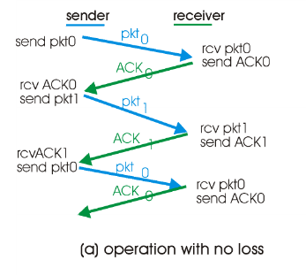
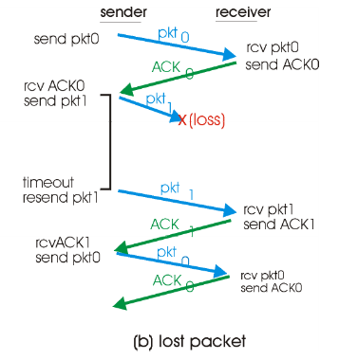

流程图如下：
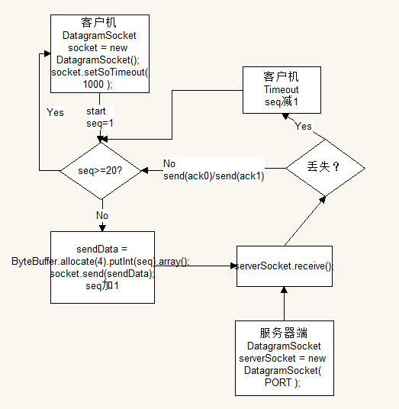
说明：
客户机首先初始化socket，设置超时时长。起始发送序列号seq=1，这里拟最大发送序列号为19。把序列号转换为字节，发送给服务器端。服务器端接收到之后，根据概率随机判断该包是否要丢弃。若不需要，则把刚接收到的包返回给客户机。若该包要丢弃，则不返回给客户机，这时客户机由于长时间无服务器响应，会发送超时，seq减一，再重新发送，这时即重发刚刚丢弃的包。

- 数据分组丢失模拟方法，程序类主要作用，UDP编程主要特点：
- 数据分组模拟丢失：可以通过java已有的库函数Math.random()。我是通过随机产生1至100的数，若是奇数则丢弃分组。故分组丢弃概率为0.5。
- 程序类主要作用：客户机端类UDPStopAndWaitClient，主要用于发送序列分组，或进行超时重发。服务器端类UDPStopAndWaitServer，主要用于接收序列分组，判断是否丢失，若不丢失则返回ACK。
- UDP编程特点：简单方便，进行可靠数据的部分自己设计，自由度高。

- 实验验证结果如上课所示。

- 源程序（含注释） ：
//客户机端：
import java.io.*;
import java.net.*;
import java.nio.*;

class UDPStopAndWaitClient{
private static final int BUFFER_SIZE = 1024;
private static final int PORT = 6789;
private static final String HOSTNAME = "localhost";
private static final int BASE_SEQUENCE_NUMBER = 0;

public static void main(String args[]) throws Exception{
// Create a socket
DatagramSocket socket = new DatagramSocket();
socket.setSoTimeout( 1000 );

// The message we're going to send converted to bytes
Integer sequenceNumber = BASE_SEQUENCE_NUMBER;

for (int counter = 0; counter < 20; counter++) {
boolean timedOut = true;

while( timedOut ){
sequenceNumber++;

// Create a byte array for sending and receiving data
byte[] sendData = new byte[ BUFFER_SIZE ];
byte[] receiveData = new byte[ BUFFER_SIZE ];

// Get the IP address of the server
InetAddress IPAddress = InetAddress.getByName( HOSTNAME );

System.out.println( "Sending Packet (Sequence Number " + sequenceNumber + ")" );
// Get byte data for message
sendData = ByteBuffer.allocate(4).putInt( sequenceNumber ).array();

try{
// Send the UDP Packet to the server
DatagramPacket packet = new DatagramPacket(sendData, sendData.length, IPAddress, 6789);
socket.send( packet );

// Receive the server's packet
DatagramPacket received = new DatagramPacket(receiveData, receiveData.length);
socket.receive( received );

// Get the message from the server's packet
int returnMessage = ByteBuffer.wrap( received.getData( ) ).getInt();

System.out.println( "FROM SERVER:" + returnMessage );
// If we receive an ack, stop the while loop
timedOut = false;
} catch( SocketTimeoutException exception ){
// If we don't get an ack, prepare to resend sequence number
System.out.println( "Timeout (Sequence Number " + sequenceNumber + ")" );
sequenceNumber--;
}
}
}

socket.close();
}
}

//服务器端：
import java.io.*;
import java.net.*;
import java.nio.*;
import java.util.*;

class UDPStopAndWaitServer{
private static final int BUFFER_SIZE = 1024;
private static final int PORT = 6789;

public static void main(String[] args) throws IOException {
// Create a server socket
DatagramSocket serverSocket = new DatagramSocket( PORT );

// Set up byte arrays for sending/receiving data
byte[] receiveData = new byte[ BUFFER_SIZE ];
byte[] dataForSend = new byte[ BUFFER_SIZE ];

// Infinite loop to check for connections
while(true){

// Get the received packet
DatagramPacket received = new DatagramPacket( receiveData, receiveData.length );
serverSocket.receive( received );

// Get the message from the packet
int message = ByteBuffer.wrap(received.getData( )).getInt();

Random random = new Random( );
int chance = random.nextInt( 100 );

// 1 in 2 chance of responding to the message
if( ((chance % 2) == 0) ){
System.out.println("FROM CLIENT: " + message);

// Get packet's IP and port
InetAddress IPAddress = received.getAddress();
int port = received.getPort();

// Convert message to uppercase
dataForSend = ByteBuffer.allocate(4).putInt( message ).array();

// Send the packet data back to the client
DatagramPacket packet = new DatagramPacket( dataForSend, dataForSend.length, IPAddress, port );
serverSocket.send( packet );
} else {
System.out.println( "Oops, packet with sequence number "+ message + " was dropped");
}
}
}
}

