# iDevAffiliate Module

You may use standard module installation procedures to install the module. Once the module is installed on your Prestashop store, you must configure the module by clicking the Configure link.



The following screen shot depicts the settings you should update before trying to use the module.

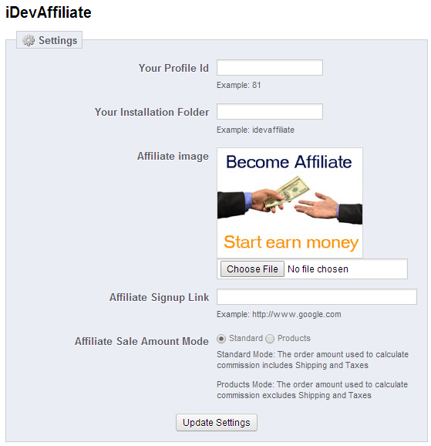

**Your Profile Id**: Locate the Profile Id by logging into your iDevAffiliate admin panel, and navigate to the Cart Integration Profiles.

**Your Installation Folder**: This is the folder name that you installed the iDevAffiliate program to. The default folder name is idevaffiliate

**Affiliate Image**: This image will be displayed in the left column of your website.

**Affiliate Signup Link**: This will allow you to link directly to the idevaffiliate signup page, or allow you to provide an alternative page about the affiliate program.

**Affiliate Sale Amount Mode**: This will control the order amount that is used by iDevAffiliate.

**Standard Mode**: The order amount used to calculate commission excludes Shipping.

**Products Mode**: The order amount used to calculate commission excludes Shipping and Taxes