Kyle Geddes

12/12/2023

Probability and Applied Statistics

Beta, Normal, and Gamma Distributions

# Normal

The Normal distribution, as defined by our textbook is $f(y) = \frac{1}{a\sqrt{2π}}e^{−(y−μ)2/(2σ2)}$ given that $-∞<y<∞$. The textbook goes on to point out that $E(Y) = μ$ and $V(Y) = σ^{2}$, as both $μ$ and $σ$ are present in the equation. The use cases for Normal Distribution are: finding the fraction of exam scores that fall between two grades, provided with the mean and standard deviation, finding variance of measurements, provided with a mean and standard deviation. An important note that the textbook makes is that, in order to compute certain Normal Distributions – Table 4, Appendix 3 must be referenced. Snippet of the page has been provided below. As well as a direct [link.](https://prnt.sc/xuzkvQQYBihm)

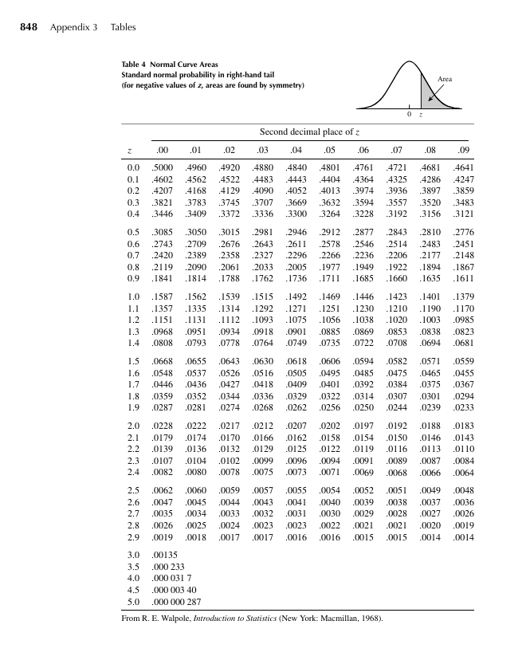

# Gamma

The Gamma Distribution is defined by the textbook as $f(y) = \left\{\frac{y^{a-1}e^{-y/β}}{βα"(α)}, 0≤y<∞ | 0 elsewhere\right\}$ where $Γ(α)=\int_{a}^{∞}{}y^{a-1}e^{-y}dy$. The textbook states Gamma Distribution is used for skewed probability. For example, the intervals between an airplane malfunction, or the interval between guests in a checkout line. Further examples include, the time to complete maintenance on a car engine, and time between patients seen at a doctors office. These results are considered skewed because they increase and decrease based upon a variety of factors. When computing a Gamma Distribution, $α$ is referred to as the shape parameter, where $β$ is referred to as the scale parameter. According to Definition 4.11 in the textbook, *exponential density function* is the gamma distribution when a = 1. $f(y) = \frac{1}{β}e^{y/β}$ where $0 ≤y<∞$.

# Beta

The Beta Distribution is defined by the textbook as $f(y) =\frac{y^{a-1}(1-y)^{β-1}}{B(a, β)}$ where $0 ≤y≤1$. Where $B(α, β) = \int_{0}^{1}{}y^{a-1}(1-y)^{β-1}dy = \frac{Γ(a)Γ(β)}{Γ(a+β)}$. The Beta Distribution is mostly used to model proportions, such as impurities in a chemical product, or proportion of time a machine is under repair. The Beta distribution graphs presented on page 195 display that the restrictive bound does not inherently limit the use of the distribution.The *incomplete beta function* is defined as $F(y) = \int_{0}^{y}{} =\frac{t^{a-1}(1-t)^{β-1}}{B(a, β)}dt == Iy (α, β)$.

# Works Cited

All information was obtained from the textbook used in class, **Mathematical Statistics with Applications**.