Talia Olsen

What have you learned? Provide evidence that you have met the course outcomes. In the syllabus it states that as a successful learner, you will be able to:
- Use functions, data structures, and other programming constructs efficiently to process and find meaning in data.
Since the course started, I’ve been using functions like select, sort and filter to process data structures like polars data frames, and then used lets-plot to visualize, analyze, and find meaning in the data.
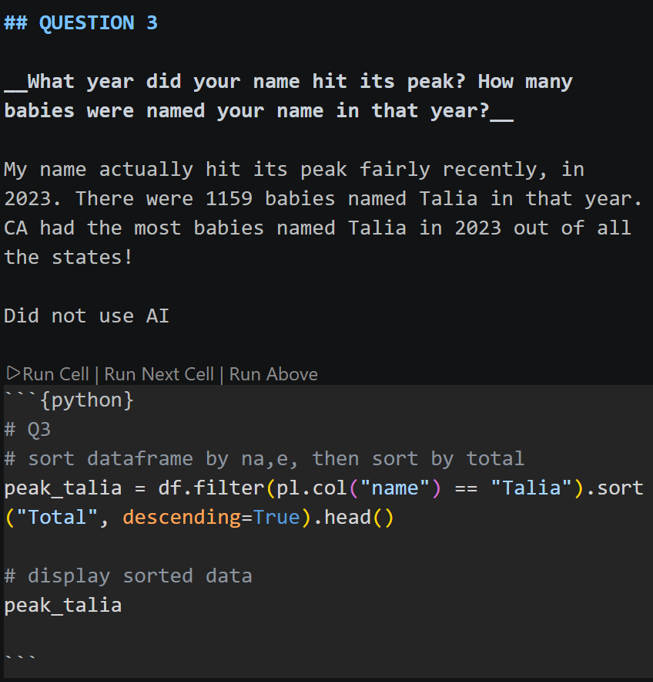
- Programmatically load data from various types of data sources, including files, databases, and remote services.
We’ve been using pl.read_csv() since project one, and we’ve been reading from URL’s as well, linking the csv’s at the destination to our dataframes. Most recently we’ve started using SQLite to start reading from a database into a dataframe.
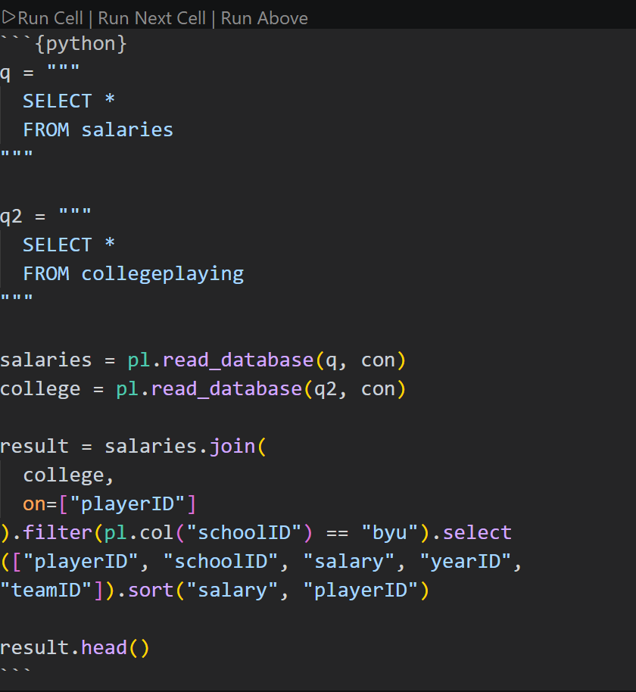
- Use data manipulation libraries to perform straightforward analysis, produce charts, and prepare data for machine learning algorithms.

We’ve used the replace, replace_null, and pl.when().then() functions to manipulate data and lets-plot ggplots to create charts. We’ve also used .join() to combine dataframes on a column. We haven’t done any validation to prep for machine learning yet.
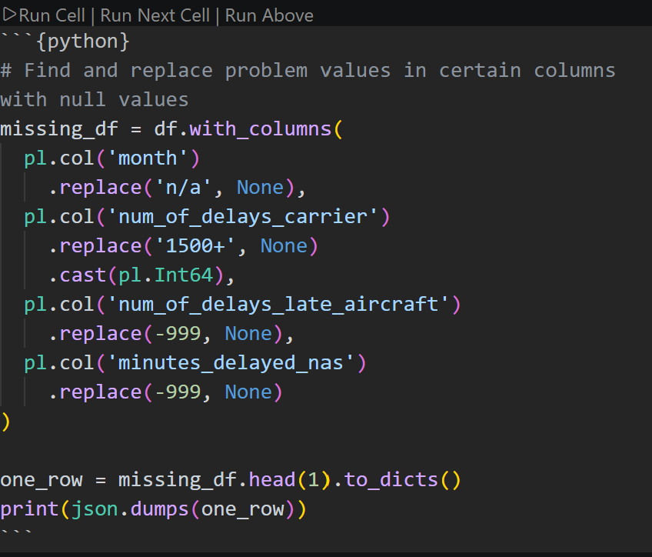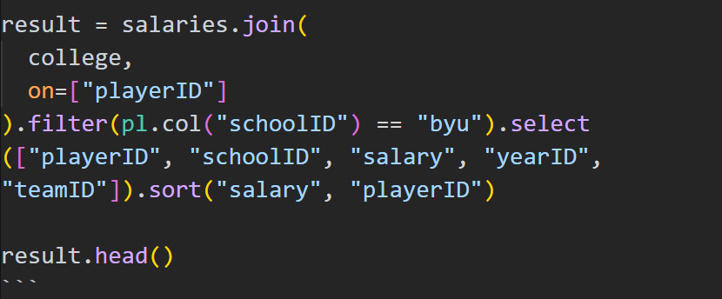
- Use machine learning libraries to discover insights, make predictions, and interpret the success of these algorithms.

We haven’t done machine learning yet.
- Use industry-leading tools to collaborate and share your work.
We use slack in our class, and classmates post their questions and respond to one another there. I know I’ve found it helpful to consult the code and message my other classmates individually to share code and advice.

The next data science course you plan on taking.
Another data science course is not in my plan, as I am a computer science major. This class fulfils a prerequisite for a calculus course in my plan.

So far I have completed 100% of the assignments, and every stretch task. I am able to complete my reading before class and understand the concepts well, always submitting my assignments on time. I like to try and complete the homework for next week on the weekend before, so that I can see where my confusion about the reading is, and pay special attention to what Brother Lewis teaches about those concepts. I’ve been able to attend every class, and have passed every competency quiz so far. I’ve completed two touch points so far, (informational interview and DS newsletter) and have plans to attend the DS Society this Wednesday. I believe I am on track to earn an A in the class.

I plan to continue reading before class, and trying the homework assignments before class. I would like to do better at using the course material outside of the course to help it better stick in my memory.

