find()
finding functions are mainly used for array of objects
want to pick the particular record from the array of objects
It will return the very first matched result form the given targeted array and stops the iteration of once condition matched
rest of iterations will not executed either remained values match with the condition
if searched value will not matched it will return undefined
If u return truthy value in the find method then only it will return matched result, if you return falsy value in the find method it will return undefined
It will not modify original array

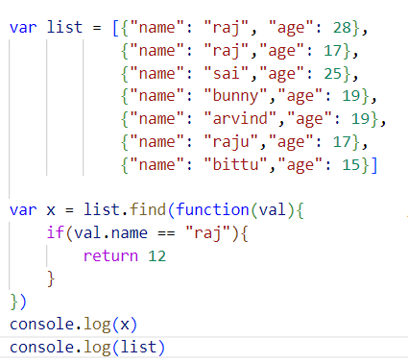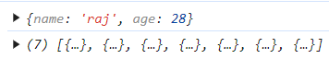

filter()
filter also work as remains map and foreach
filter method also return a new array for truthy values not considered for falsy values
If we not return anything filter will return an empty array

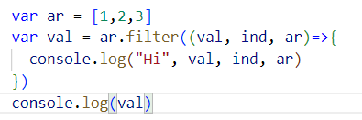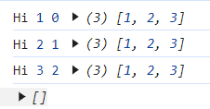

Returning array for truthy values
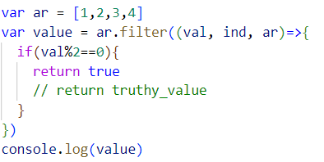

filter() method will give you all the matched elements from the given array
it will gives u matched elements, and it will iterate targeted array either if we don't have matched elements

