forEach()
forEach method takes a function as params
forEach method is a first class method cause its taking a function as parameter
at the params bracket val accepts respective targeted array values/elements for every iteration
We can do the same works as map can do but the only difference is returning
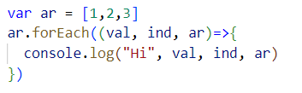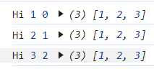
Hi prints for 3 times cause for having 3 elements so iteration happens for ar.lenght=3
val is the respected array elements, ind is the index value of every element, ar is the complete array

forEach does not return a truthy or falsy value
It always returns undefined only
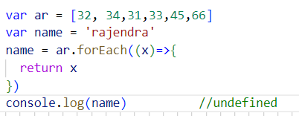

map()
map method is same as forEach with a small returning difference
Map will not modified the original array
val is the respected array elements, ind is the index value of every element, ar is the complete array

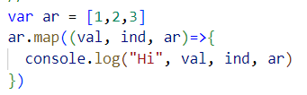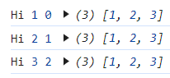

if we are not return anything in the map, so by default its return a new array with undefined
Map will returns values for truthy and undefined for falsy condition values
Array length is 3 so 3 times it will return undefined with a new array
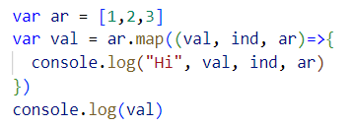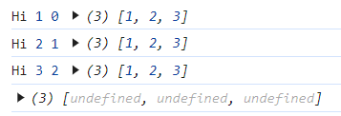
If we return something in the map method
the map method is return a new array with respected return items in the method
so we are returning a string chary in the map method, so map return a new array with chary elements
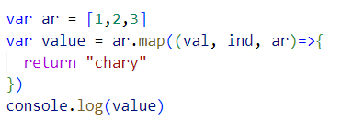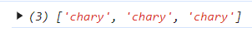

If we write a logic for find even numbers using map()
the map method return respect value to the truthy elements
and return undefined to the falsy values
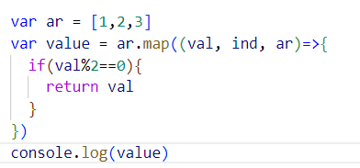

reduce()
reduce() method is used to accumulate the values in the targeted array
accumulation is adding the values with next one
Reduce is the first class function accepts 2 parameter 1.accumulator fun, 2.value
the very first time what is the value we are sending to reduce that value goes to a variable
the array elements goes to b variable for every iteration
The return value is assigned to the first param for every iteration
If we didn't return anything reduce return undefined by default
the undefined will be assigned to the first param
Reduce() method return the last returned value
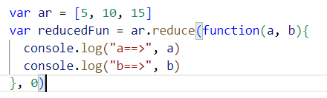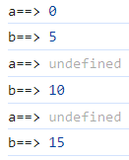

Will see if we return something
The very first time the given number will goes to first param a
From next iteration the returned value goes to the first param a
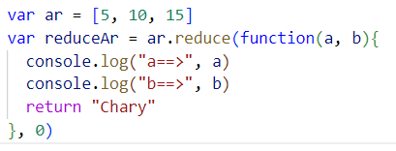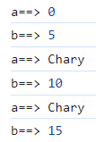

If we console inside the accumulation function and not returning anything and consoling outside of the accumulation function
The inside console Return 3 times cause the targeted array having 3 elements
The iteration when the last element of the targeted array assigned to the param, that time what is the value we are returning that value reduce method will return
The last returned value will be returned by reduce method
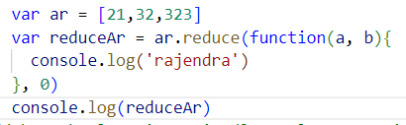

Reduce method will accumulate and return the final value
Adding all the elements in array and return the total sum value
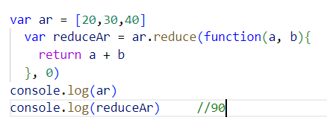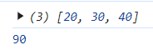

reduce() method with objects

If your pass initial value to reduce method the targeted element values assigned to b from starting itself
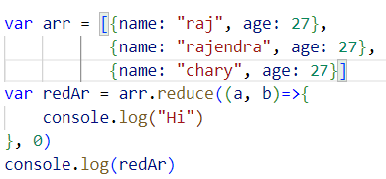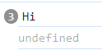

If you did not pass the initial value the very first time the first index element assigned to first param and next index element will assigned to second param
From second returned value assigned to first param or did not return anything undefined will assigned to first params

