reverse()
reverse() method printing an array elements in reverse order
Modified the original array
var ar = [10,20,30,40,50]
var revAr = ar.reverse()
console.log(ar)
Returned original modifies array
[50, 40, 30, 20, 10]
console.log(revAr)
Returned reversed array
[50, 40, 30, 20, 10]
<—--------------->

Reverse() method is returned reversed array and forEach method will iterate every element in targeted array
Rverse() method returned original array
forEach() method returned undefined
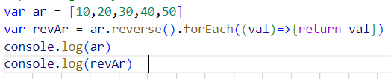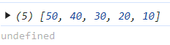
If we return or did not return, the forEach will return undefined

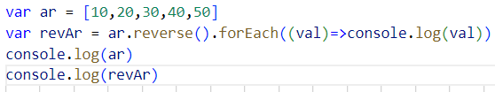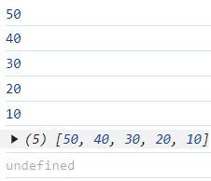

toReversed()
toReversed() method does not modified the original array
