Strings

var a = "rajendra"

console.log(a) //rajendra
console.log(a[2]) //j prints the second index element
console.log(a.length) //8
each string have its index and length
string are immutable array of character

printing all the charecters in string & in reverse
for(i = 0; i <= a.length - 1; i ++){
console.log(a[i])
} //prints individual charecters of strings

for(i = a.length - 1; i >= 0; i --){
console.log(a[i])
}

var name = 'rajendra'
console.log(name) //rajendra
console.log(name[1]) //a
name[1] = "r" //we cant modify the string charecters
console.log(name)//rajendra

//strings are immutable we cant modify the charecters of string
//but we can replace/override the string
name = 'raj'
console.log(name) //raj // but we can replace the total string

//string methods
//strings are aray of individual charecters
var a = 'rajendra'
console.dir(a) //rajendra for literals methods are not showing

var b = new String("rajendra")
console.dir(b) //now it will show the string methods

// creating of string actual method is new string()
//but we are creating with short hand syntax literlas b="raj"

//to see the string methods active, deprecate go to javascript methods=mdn link

//at() & charAt()
var a = 'rajendra'
var b = a.charAt(2)
var c = a.at(2)
console.log(b) //j
console.log(c) //j

console.log(a.charAt(-2)) //doesnot give anything
console.log(a.at(-2)) //r
//char at doesnot give the charecter at -negative index
//at() gives you the charecter at -negative index

console.log(a.charAt(100)) //doesnot give anything
console.log(a.at(100)) //undefined
//char at doesnot give the charecter at unknown index
//at() gives you the undefined at unknown index

//charCodeAt()
var a = 'rajendra'
var b = a.charCodeAt(2)
console.log(b) //106
//charCodeAt() method returns the ASCII code of the charecter
console.log(a.charCodeAt(8)) //NaN
console.log(a.charCodeAt(-1)) //NaN
//when u try to check the not existed index code it will retutn NaN
//when u try to check the -index code it will retutn NaN

//endsWith()
var a = 'rajendra'
var b = a.endsWith("a")
console.log(b) //true
console.log(a.endsWith("w")) //false
//endsWith() method will check the string, whether ends with the given charecter or not
//if yes return true and if no return false
console.log(a.endsWith("dra")) //true

//replace()
var a = 'rajendra'
var b = a.replace("a", "b")
console.log(b) //rbjendra
console.log(a) //rajendra
//replace() method return a new string with replacing the given charecter
//can not modify the original string

//replaceAll()
var a = 'rajendra'
var b = a.replaceAll("a", "b")
console.log(b) //rbjendrb
console.log(a) //rajendra
//replaceAll() method will return a new string with replacing all the charecters with the given charecter

In the browser we have 2 types of memories store the data
1.constant pool
2.Heap memory
Primitive data types stored in the constant pool
Numbers, strings, booleans
Non-primitive data types are stored in the heap memory
Arrays, objects, functions
When we declare x variable with value 100
The value stored in the constant pool and x will declared in the variable stack
X will addressed to the 100 value in the memory
X will holding the 100 reference

When we declare y variable with value 200
The value stored in the constant pool and x will declared in the variable stack
y will addressed to the 200 value in the memory
y will holding the 200 reference
If we declare a z variable is 100
Z will be declared in the variable stack and 100 addressed to the z
Instead of create a new memory javascript will give existing reference the new declarations
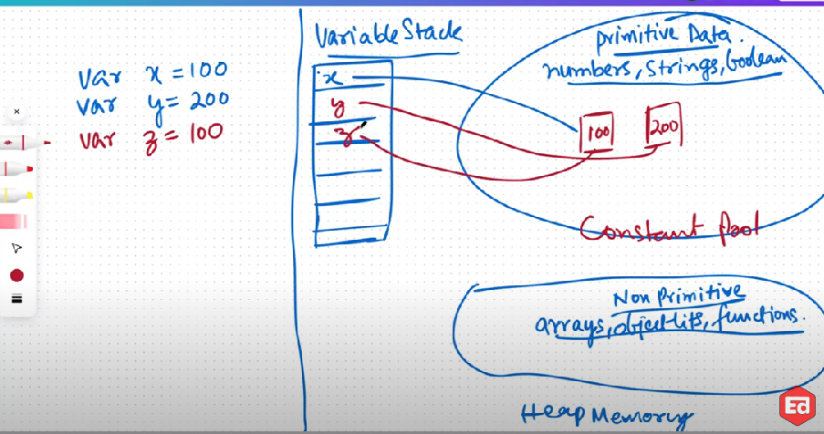
If i declare a variable p with sai again memory created for sai and the address will pointing to the p in the variable stack
Again declaring a new variable with 200 value the existing 200 value pointing to the new declaration instead of creating new memory

If we modify the characters in the sai that reference holding by multiple variables so that string value not allowing us to modify the existing value
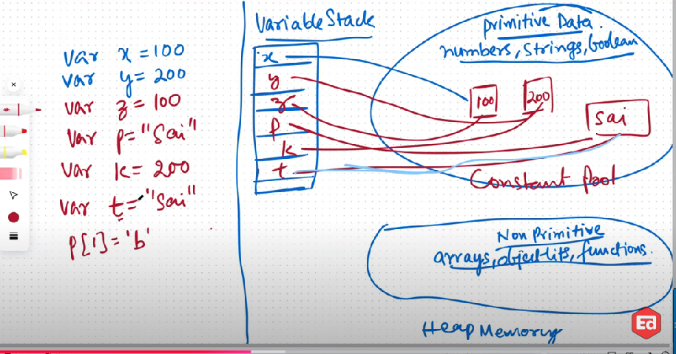
We can't modify the strings but we can update the string value
If we assign a new string to p
The memory create for that new value and pointing to p
If i update the x as 500
Memory will created for 500 and x is holding the 500 reference
If we declare initially one value and later we update the variable so that initial value will be erased through garbage collector
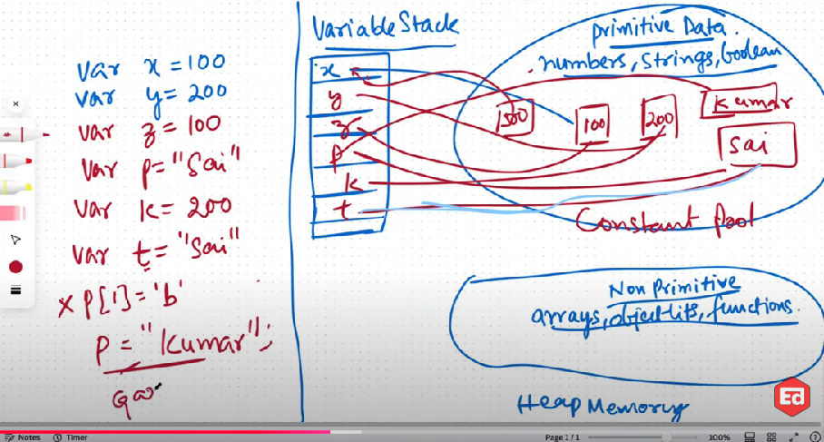

Arrays and objects
When we are declaring an array with ar declaration memory created for array value and ar will be declared in the variable stack
Ar pointing to array value
And the same array values we are creating again to the br this time the memory created a new array value to br instead of pointing to the existing array value
And when we are cr = ar the browser declared cr in the variable and pointing to ar address instead of creating new value
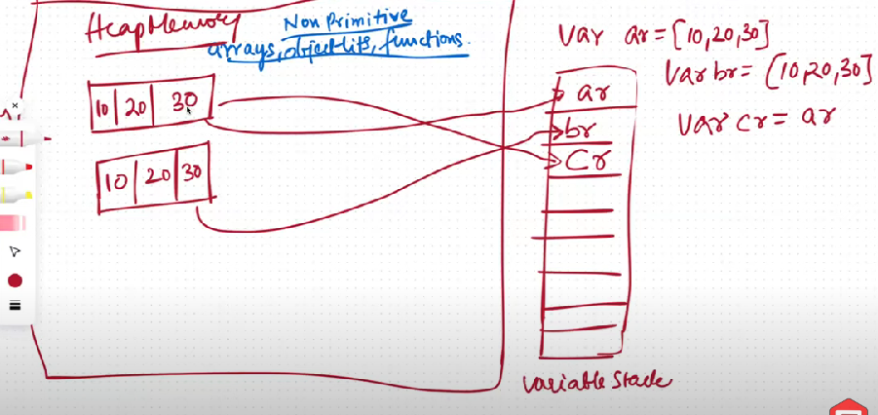
If we change the ar automatically cr also updated cause the ar and cr pointing to the reference address
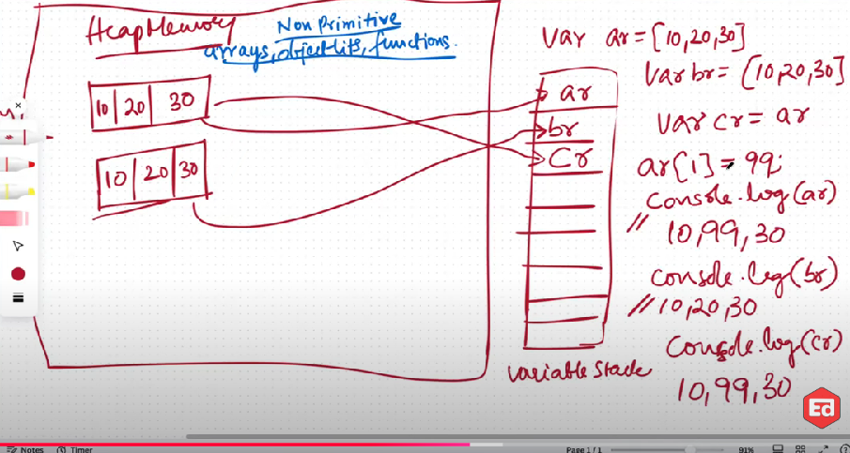
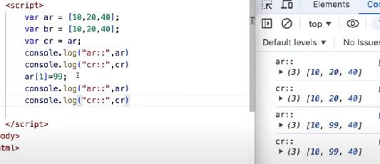

If we change in teh nested values the browser will update the nested value with update value
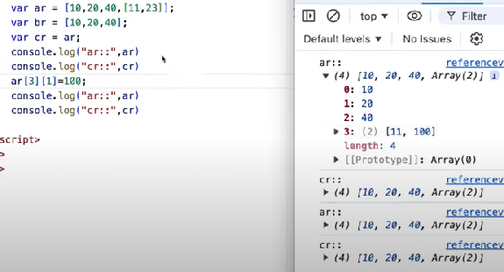

The consoling update nested value is proble with console
The values are same upto update the new value
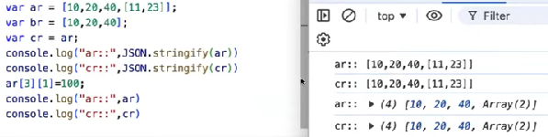

What is ar
Ar is holding the reference of the array
Cr also having the reference of array

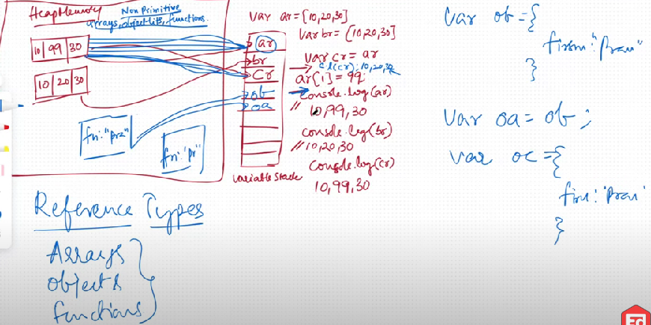

Referential equality

When ever we are trying to check the equality of numbers it will check with reference and the value
var ar = [1]
var br = [1]
var cr = ar
console.log(ar == br) //false
Ar and br both are having same numbers but both are difference references
console.log(ar == cr) //true
Ar and cr both are pointing to same ference and so true

