GIT

Git and Git hub both are not same

We learn 4 points
1.vcs & repos
2.staging area & commits
3.branches
4.ises & prs

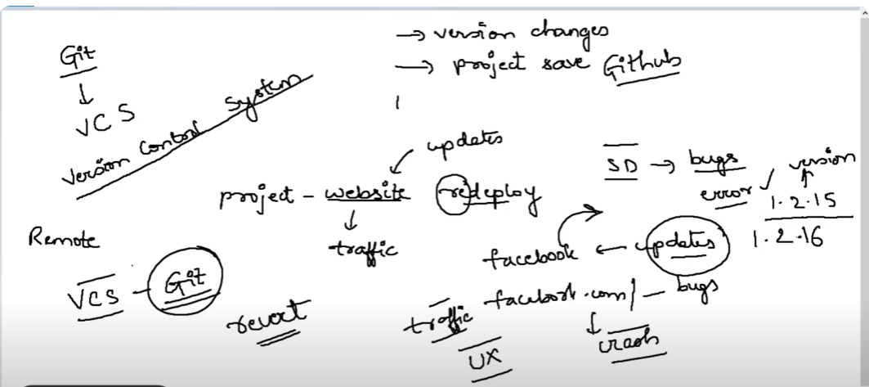

To install the git git-scm.com/download
Depends on Our computer bits

A repo is a project folder or a project in a remote server

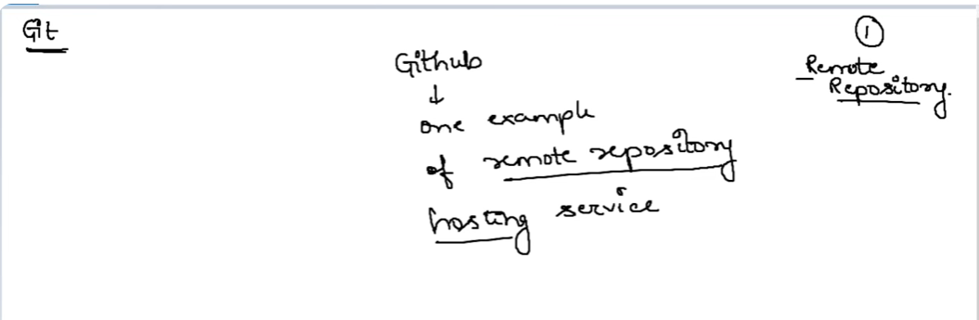

Create a folder from that folder open cmd
Give git init – iam initialising my folder a git repo

Give git status– to check the status of the git

Create a txt file and check the status again it will give u the untracked file details
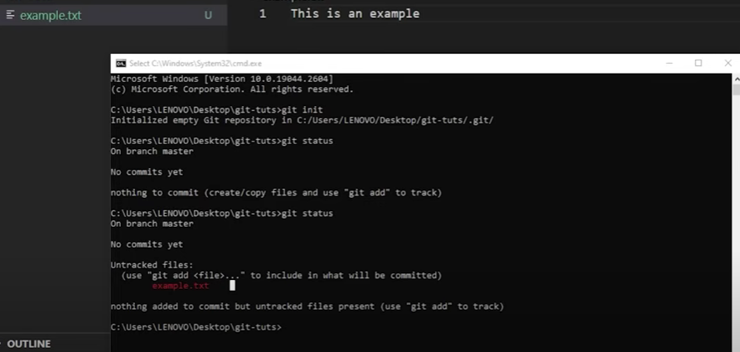

Where the working files untracked files could be placed that area called working area
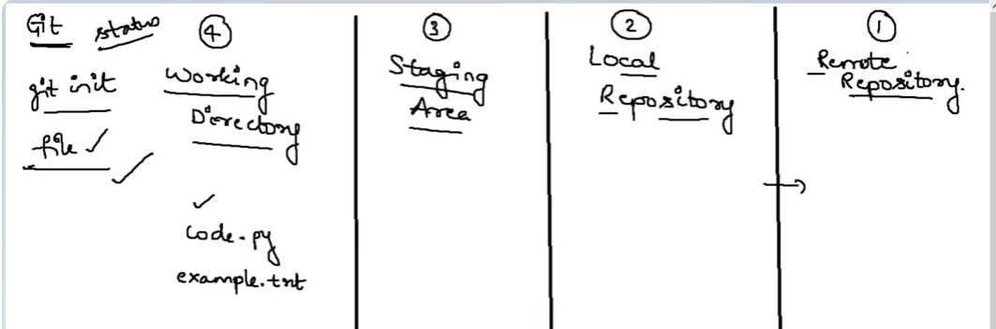
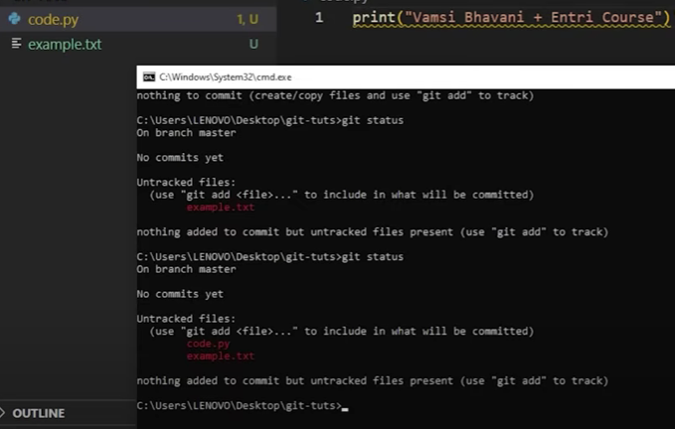

Our files should be saved in local before pushing into remote reporitsry

Staging area is in between the local repo and remote repo

Staging are will help us to push the files what we need to push into remorse repo by executing the commit
Add the files and give the command
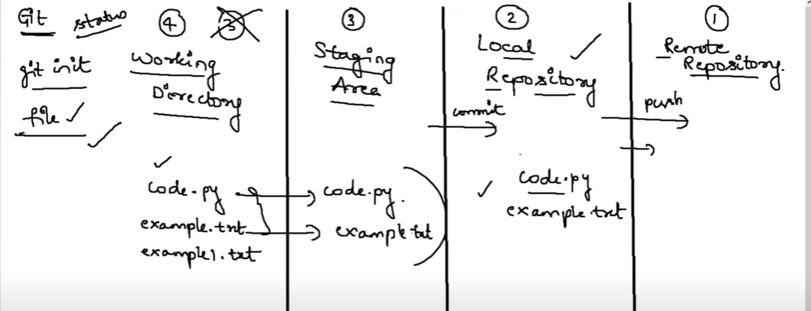

We are passing the files to staging ara as single single files
And from staging area to locav repo and local to remote repo will send as batch
We can stage our files by using add command
When ur using add then files are no more in working directory
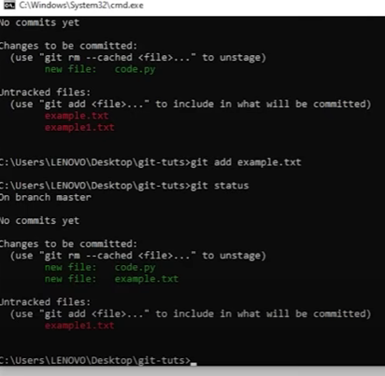

Once files are in staging area will send the files as batch from staging to local repo using commit command along with message

We can give the origin repo link to our local repo to understanding our local repo does not knowing there origin repo

Pushing our code to origin branch

To check current branch status

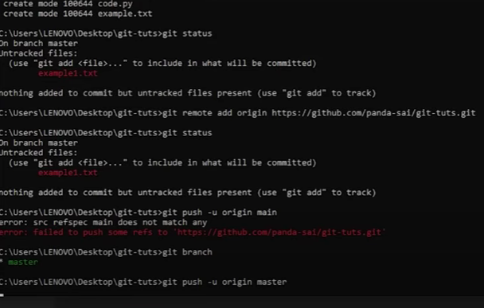
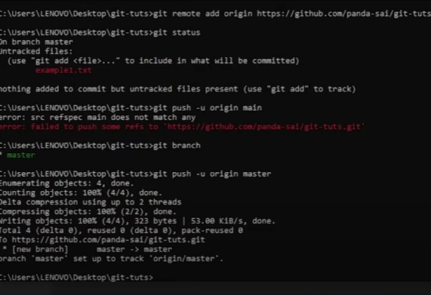
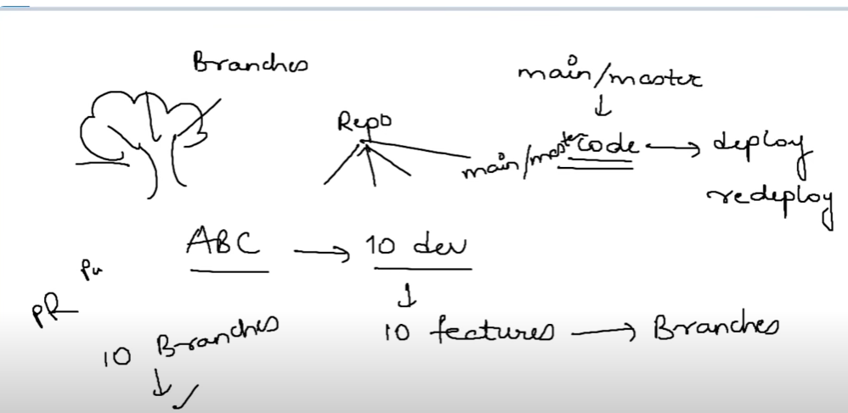

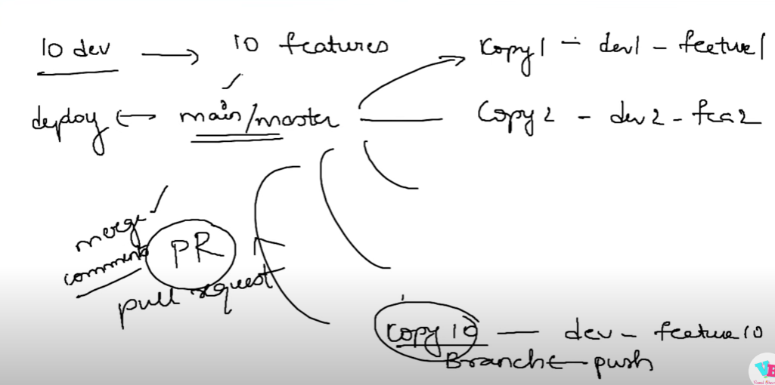

Git checkout basically used for jump into one branch to anethor branches

If brach is not created before
so we can create a branch while jumping
So if we give git checkout -b “branch name” – we can create branch given name and jumped into that

So one file in copy branch and does not in master so we merge the file into master
Click compair and pull request
After that write the info message and click the create pull request
Pushing one repo branch to anethor repo by adding remote to the existing repo
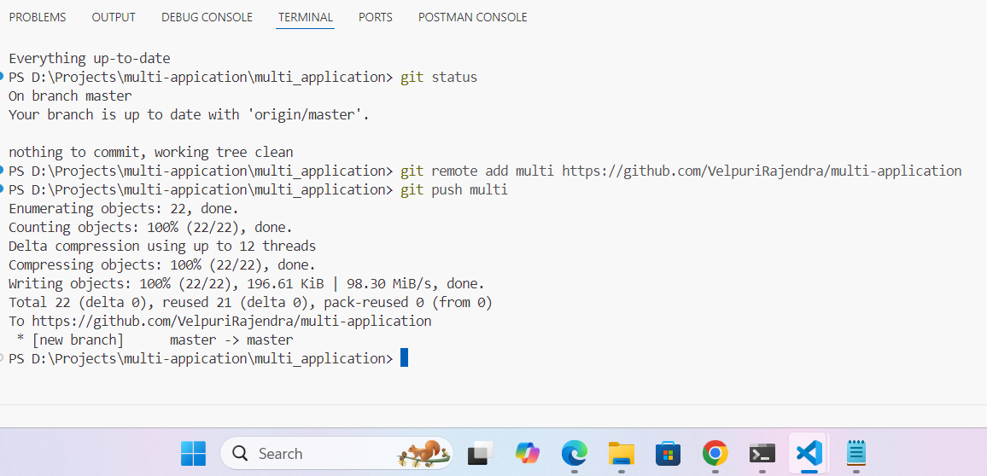
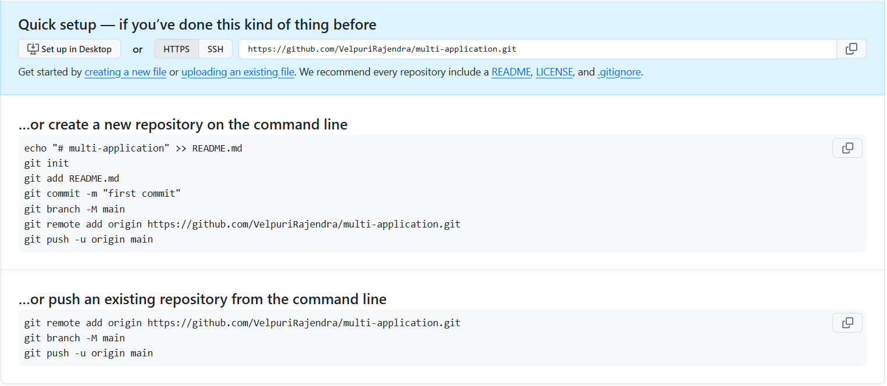

Configuring the username and password