
First Enterprise

LOAN APPLICATION FORM

Enterprise Loan East Midlands (ELEM) provides loans to new and existing businesses that are making a positive contribution to the social, economic and environmental well-being of their local and wider community.

The application process is simple: fill out this form and submit it with the required documents.

As part of the process, we will conduct the necessary anti-money laundering checks, require an open banking connection, and will perform a soft credit check on all Directors. In the event that we require a hard credit check we will request additional consent.

We aim to give you a prompt response but may request further information to make a fair assessment of your proposal.

If you have any queries at this stage, you should discuss them with the Investment Manager you have been assigned or contact us on 0115 942 3772 or you can email reception@first-enterprise.co.uk.

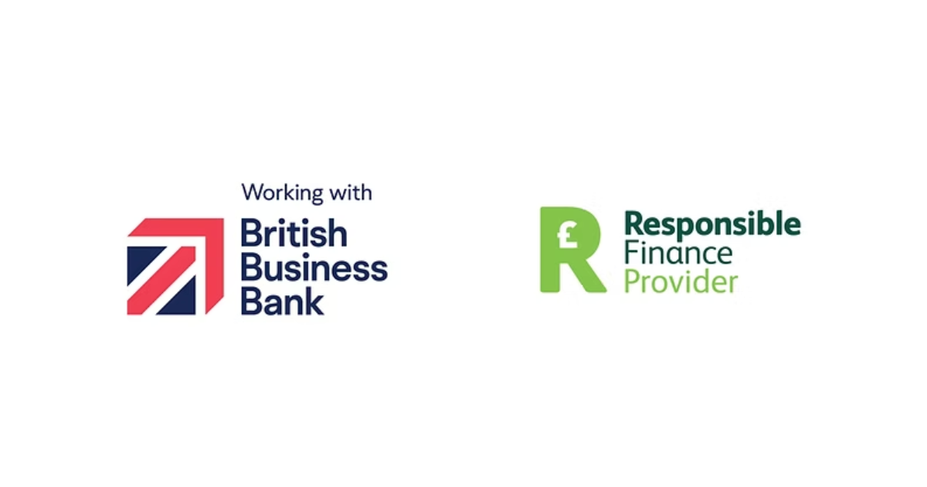

LOAN APPLICATION FORM

KEY INFORMATION – Please provide key information about you and your business

Where did you hear about us?

Have you applied for a Business Loan from us before? | YES/NO – If yes, please provide details including when and amount in your  business plan

Applicant Information

Registered business name

Trading name (if different)

Registered business address and postcode

Trading address (if different)

Legal entity type | Sole Trader / Partnership / Limited Company / LLP / CIC
Company Number
(For Ltd Co/LLP)
VAT Registration Number and/or Unique Tax Reference.
(If Sole Trader/Partnership)

SIC code

Trading start date

Please include a brief description of how the company generates revenue

Local authority (where you pay business rates)

Business telephone number

Business email address

Website Address (if available)

We operate an Equal Opportunities policy and to help us monitor the effectiveness of this policy, we ask that all applicants complete this section. Please note that any information given in this section will NOT affect the processing of your application.

Ethnic Origin (please tick the relevant box which best describes the ethnic group you belong to) If there is more than one applicant, each to complete and initial against the appropriate box.

White British |  | White Irish |  | White (other) |  | Black Caribbean
Other Asian |  | Mixed (other) |  | Indian |  | Pakistani
Caribbean |  | African |  | Black (other) |  | Chinese
Black British |  | Asian British |  | Other (please specify)
Black African |  | Bangladeshi |  | Prefer not to Say

Do you have a disability? Yes/No

If you require additional support with your application, please discuss this with your Investment Manager

Contact Details

Contact Name

Contact Telephone Number

Contact Email Address

Position within the business

Director Details

Title
Full name
Mobile number
Email address
Date of birth
National Insurance number
Relationship status
Number of dependents
Residential status
Address including postcode
Move in date
Previous address (if less than 3 years)
Previous move in date
Monthly income after tax
Gross annual income

Title
Full name
Mobile number
Email address
Date of birth
National Insurance number
Relationship status
Number of dependents
Residential status
Address including postcode
Move in date
Previous address (if less than 3 years)
Previous move in date
Monthly income after tax
Gross annual income

Title
Full name
Mobile number
Email address
Date of birth
National Insurance number
Relationship status
Number of dependents
Residential status
Address including postcode
Move in date
Previous address (if less than 3 years)
Previous move in date
Monthly income after tax
Gross annual income

Title
Full name
Mobile number
Email address
Date of birth
National Insurance number
Relationship status
Number of dependents
Residential status
Address including postcode
Move in date
Previous address (if less than 3 years)
Previous move in date
Monthly income after tax
Gross annual income

Loan Information

Loan Amount
Purpose of Loan
Required Term (1 to 5 years)
Preferred payment of arrangement fee | (upfront, netting off the loan or adding to the loan)
Independent Legal Advice | (please provide your solicitors details if taking ILA, or state you will be waiving)
Were you introduced by a broker? | (If yes, please provide details)

Business Information

Is your business in scope of Northern Ireland (NI) protocol – i.e., are you are GB borrower or an NI borrower? | GB borrower / NI Borrower  Please delete as applicable
How many employees do you have?

How many jobs are you safeguarding with this loan?

Are you creating any jobs with this loan?
Please include your turnover for the last 2 financial years

As part of our assessment, we will perform soft credit searches on Directors, or individuals if you are a sole trader. In some instances we may require a full (hard) search. If we require a full search we will contact you for consent.

Credit History

Please answer the following questions truthfully, as the answers will have a bearing on our ability to progress your application.

Has the business been subject to any insolvency proceedings, such as Company Voluntary Administration, or County Court Judgments? | YES / NO | If yes, please provide full details.
Have the Directors/Owners ever been associated, personally or as an official, with a failed business enterprise? | YES / NO | If yes, please provide full details.
Have the directors/owners personally been subject to any insolvency proceedings, such as Bankruptcy, an IVA, CCJ or Debt Management Plan? | YES / NO | If yes, please provide full details including amount and date.

Business Support

Please confirm if you have previously received any de minimis support through grants or business support. | YES / NO | If yes, please certify and provide details.
Please confirm if you have received any other government guaranteed loan facilities (such as CBILS, RLS or Bounce Back Loans) | YES / NO | If yes, please certify and confirm Lender Name, Date, Amount and Term.

Subsidy Support

Please detail below the amount of previous relevant subsidy received in the current and previous two fiscal years. Alternatively, please self-certify if this is not applicable. Please be aware that you will be receiving a subsidy as a consequence of any new government guarantee schemes.

The Subsidy Control Act (2022), under SPEIA, limits organisations to £300,000 in state aid or subsidies over any rolling three-year period.

Originator(s), amount(s) and date(s) of previous relevant subsidy(ies):

Or confirm this is not applicable:

I, __________________________________________ (Print Name) certify that the details provided above are correct.

Signature(s): | Date:

Declaration

We need you to complete our standard declaration. You are then ready to submit your completed application form, along with any supporting documents to your business Advisor.

I confirm that business finance was declined from ………………..……….....………..……….. bank at …………………………….. branch.

If you have any evidence such as a bank decline letter / email please include this in your application.

I hereby declare that the foregoing statements are correct to the best of my knowledge and belief, that I have not been adjudicated bankrupt, nor made any composition with my creditors or no judgment exists against me, and that I will accept the conditions upon which Enterprise Loans East Midlands is prepared to give any assistance and understand that any false information given could result in repayment of the monies paid to me in full immediately or prosecution. I confirm that I am not involved or in any way connected with any activity that is not suitable to be
supported from public funds.

I further declare that the assistance which is the subject of this application will be used solely for the purpose stated above and proof will be supplied to confirm the amount spent. I will continue to work with Enterprise Loans East Midlands for the development of the business. I confirm that information on my bank account may be released to Enterprise Loans East Midlands at any time in relation to the repayment of funds on this application.

I understand the loan is discretionary and should not be regarded as automatic in any circumstances. If successful, the loan will be granted in the name of the business. I understand that if I do not make the loan repayments as and when they are due that Enterprise Loans East Midlands may take legal action to recover the money due.

SIGNATURE(S): DATE:

Enterprise Loans is committed to reducing its carbon footprint. We therefore send out Annual Statements via email address provided above.
Please let us know if you would prefer to receive a hard copy.

Or

If there is an alternative email address you would like Private & Confidential information to be sent to:

_______________________________________________________

DATA CONSENT

To be able to proceed with your loan application we firstly require your consent to hold your data.

Privacy Statement

As a responsible lender, Enterprise Loans is committed to safeguarding the information we collect in support of the SME businesses we serve. The data you provide is used for the assessment, disbursement, and ongoing monitoring of business loans. We only share the necessary information with a select group of trusted partners who are essential to our operations, including statutory reporting to investors. Enterprise Loans receives support from various funding organisations, which require information about you and your business to process, monitor, and evaluate their specific funding programs. This may also help in developing new services and ensuring fraud prevention. If you have any questions about where your data is held, please contact your Investment Manager. Your privacy and security are our priorities.
Additionally, we may use your information to identify and offer you financial products and services that best suit your needs. For more details about how your data is used, how we maintain its security, or your rights regarding your personal information, please consult your Investment Manager.

We now need you to ‘opt in’ to allow is to hold your data. Please tick the following boxes if you agree.

☐ I/ We consent to ELEM holding my / our data for the purpose of assessing, disbursing, and monitoring business loans.

☐ I / We consent to ELEM sharing this information with its affiliated organisations for the purposes detailed above.

☐ I / We authorise ELEM to make any credit reference and other enquiries in accordance with normal procedures for this application.

☐ I / We agree that ELEM, and affiliated organisations, may use our name in its publicity material and in the provision of data for funders

Marketing:

☐ I / We consent to receive further communications from ELEM regarding related services and products that I might be interested in

☐ I / We consent to receive communications from affiliated organisations regarding services and products that might be interested in

I consent to being contacted via the following methods: ☐ Post ☐ Email ☐ Telephone

Signature(s): Date:

Client & Customer Charter & Minimum Standards

First Enterprise is committed to delivering fair, accessible, and high-quality loan services to underserved communities. We specialise in providing loans to ethnic minority entrepreneurs, female founders, and businesses located in areas of deprivation. Our mission is to support economic growth and business sustainability through the responsible delivery of loans funded by a variety of public and private sources.

Our Commitments
We will:
- Be friendly, approachable, professional, and transparent in all our interactions.
- Deliver loan services that provide good value and are tailored to the needs of our clients.
- Continuously improve our services based on client feedback and performance evaluations.
- Treat everyone fairly and with respect, ensuring inclusivity and accessibility.
- Respond promptly and effectively to enquiries and concerns.
- Work collaboratively with funding partners to ensure the best outcomes for our clients.
- Learn from complaints and use them to improve our services.

Service Delivery Standards
We will:
- Clearly identify and understand the financial needs of our clients.
- Ensure our team has the skills and knowledge to deliver high-quality loan services.
- Refer clients to external support services when needs fall outside our remit.
- Maintain high levels of client satisfaction and regularly review our performance.
- Clearly communicate mutual responsibilities and expectations.
- Regularly review our service delivery to ensure we meet our commitments.

Communication Standards
We aim to provide a responsive and respectful communication experience across all channels:
Visitors
Our office is open 9.00am - 5.00pm, Monday to Friday (excluding Bank Holidays).
Appointments are preferred, but we will accommodate walk-ins where possible.
Our reception area is welcoming, accessible, and informative.

Face-to-Face
Staff will be knowledgeable and courteous.
If a query is outside their remit, they will ensure a timely and accurate response is provided.

Telephone
Calls will be answered promptly during office hours.
Voicemails will be responded to as soon as possible with clear updates.

Written Communication
Emails and letters will be acknowledged within 5 working days.
Detailed responses will include a named contact and expected timelines.

Website
Our website will be updated regularly to ensure accurate and relevant information is available.

Complaints Procedure
We are committed to resolving complaints quickly and fairly. If you have a concern or complaint, you can contact us via:
Phone: 0115 942 3772
Email: reception@first-enterprise.co.uk
Post: 6 Sherwood Rise, Nottingham NG7 6JF

If the issue is not resolved, you may escalate it to the Executive Director or Deputy Director. They will investigate and respond within 5 working days. If necessary, a proposed solution will be provided within a further 5 working days. If you remain dissatisfied, you may contact the relevant funding organisation or the Financial Ombudsman Service.

Client Expectations
We expect our clients to:
- Attend scheduled appointments or notify us in advance if unable to attend.
- Collaborate with our team to complete required documentation and processes.
- Understand that we provide loan services only and may refer to external support where appropriate.
- Respect our staff and processes to ensure a positive experience for all clients.

First Enterprise – Standard Terms and Conditions

Application Process

Applications must be submitted using the official First Enterprise Loan Application Form.

The application must include the following documentation:
- Certified annual accounts for up to 3 years (or as many as available if trading for less than 3 years)
- Management accounts showing financial position at the time of application
- Six months of the most recent and consecutive business bank statements
- Cash-flow projections for a minimum of 12 months
- Statement of assets & liabilities for Directors
- A comprehensive business plan outlining current operations, future plans, and rationale for the loan

The business plan should address:
- Business activities and operations
- Personal investment by owners/directors
- Current business status and future vision
- Reason for loan request and intended use of funds
- Number of employees

In addition we will need to complete the following
- Anti-money laundering checks
- Personal credit searches on all Directors
- Open banking connection for business accounts

Eligibility
Loans are available to Limited Companies, Sole Traders, CICs, and Partnerships.

Ineligible sectors include:
- Property investment and development
- FCA regulated industries where the loan purpose is lending
- Services already covered by local schemes (e.g., education, social welfare, sports, leisure, cultural facilities)
- Ethically unsound businesses
- Public sector bodies and state-funded primary/secondary schools

Loan Amounts
- Loans range from £25,001 to £250,000, subject to fund eligibility, with a maximum exposure per client of £350,000.

Loan Term
- Loans are typically offered over 1 to 5 years, depending on criteria
- No penalties apply for early repayment
- Applicants must have been declined by their existing bank

Interest Rate
- Loans are offered at a fixed or variable interest rate for the term of the loan
- Interest is payable by the borrower
- Please consult your Investment Manager for current rates

Security
- First Enterprise may utilise a government guarantee for eligible loans
- Borrowers remain fully responsible for 100% repayment of the loan
- Additional security such as Debentures and Personal Guarantees (PGs) may be required
- Second legal charges may be requested where relevant
- Independent legal advice is recommended for PGs, and associated costs are borne by the borrower

Fees
- An arrangement fee applies to all loans and may be paid before drawdown, added to the loan, or netted off the loan payment
- Additional security costs (if applicable) are also the responsibility of the borrower

Reporting
- Loans are monitored monthly
- Clients must provide financial updates and impact metrics (e.g., jobs created/safeguarded) to meet funder requirements

Charges
- First Enterprise may charge for missed payments, cancelled direct debits, or any additional loan administration work as required. You will be notified of these charges should they apply
- Persistent missed payments will result in debt collection activities. You will be liable for any debt recovery costs, including court costs

