

School of Geography, Geology and the Environment

MSc Satellite Data Science

GY7720 Dissertation 2026

Deep Learning and Machine Learning-Based Flood Detection from Sentinel-1 SAR Imagery: A Regional Case Study of the 2018 Kerala Floods, India

Student Name: Velugonda Reddy Madduri (vrm8)
Supervisor Name: Dr. Calvin Jephcote
28 September 2026

Word count: 13000

Abstract
Floods are among the most frequently occurring and economically damaging natural disasters globally, causing disproportionate harm to South and Southeast Asian nations. The 2018 Kerala floods, the most severe monsoon event recorded in the region since 1924, resulted in the displacement of approximately 1.5 million people and economic losses exceeding USD 4.4 billion. Rapid and accurate flood extent mapping is a critical operational requirement for emergency response, yet traditional methods relying on optical satellite imagery are severely impaired by the cloud cover that characterises intense monsoon conditions. Synthetic Aperture Radar (SAR) satellites, operating in the microwave spectrum, penetrate cloud and acquire imagery regardless of weather or daylight, offering a direct solution to this constraint.
This study develops and evaluates a reproducible machine learning pipeline for automated flood detection using real Sentinel-1 SAR imagery acquired for Kerala, India during the August 2018 flood peak. Two images - a July 2018 pre-flood baseline and an August 2018 flood-period composite - were acquired from the Microsoft Planetary Computer public archive, processing 8 and 6 scenes respectively. VH backscatter change detection using Otsu and Li automatic thresholding identified 22,777 flood-water pixels (8.7% of the study area) and 2,491 permanent water pixels (1.0%), with a mean backscatter drop of −1.92 dB across the scene. A total of 348 stratified observation points were sampled across three land cover classes and linked to four land use predictor variables: distance to permanent water, SRTM elevation, CHIRPS August 2018 rainfall, and temperature derived from an atmospheric lapse rate model.
Two models were trained and evaluated: a Land Use Regression (LUR) implemented as logistic regression, and a Random Forest classifier. On the held-out test set, the LUR achieved an Intersection over Union (IoU) of 0.9032 with an F1-score of 0.9492, while the Random Forest achieved an IoU of 0.9333 and F1-score of 0.9655. Both models exceeded the Sen1Floods11 benchmark reported by Bonafilia et al. (2020) of approximately 0.64 IoU. Feature importance analysis identified elevation as the strongest Random Forest predictor (Gini importance 0.299), followed by distance to water (0.268), consistent with topographic control on flood extent in Kerala's coastal plains. A noteworthy finding was the negative coefficient on rainfall in the LUR (−1.549), which I interpret as spatial confounding driven by the Western Ghats, where maximum rainfall occurs at high elevations that did not flood. This study demonstrates that real-data SAR-based flood detection using freely available satellite imagery and land use predictors can produce accurate and interpretable flood susceptibility maps without requiring complex deep learning architectures.

Declaration
I declare that this dissertation is my own work and that all sources of information used in its preparation have been properly cited and acknowledged. The analytical code, satellite data processing pipeline, model training procedures, and written analysis presented in this report were conducted independently as part of the GY7720 Dissertation module at University of Leicester.
This work has not been submitted in whole or in part for any other degree or professional qualification. Where the ideas of other researchers, institutions, or datasets have been used, these have been fully attributed in the text and reference list.

Student Reference: Velugonda Reddy Madduri -vrm8
Date: 28 September 2026

Acknowledgements
I would like to express my sincere gratitude to my dissertation supervisor at University of Leicester for their consistent and constructive guidance throughout this project. Their feedback on the research proposal, methodology design, and analytical approach was instrumental in shaping the direction of this work and ensuring the research questions were properly investigative and measurable.
I am grateful to the developers of the open-source tools and public data platforms used in this research, particularly the teams behind Microsoft Planetary Computer, the USGS Shuttle Radar Topography Mission archive, the Climate Hazards Group (CHIRPS), and the scikit-learn development community. The availability of these freely accessible, well-documented resources made it possible to develop a fully reproducible flood detection pipeline without any financial or access barriers.
I also acknowledge the India Meteorological Department and the Kerala State Disaster Management Authority for publishing detailed post-flood reports that provided the contextual and statistical grounding for the August 2018 event analysis. Finally, I would like to thank my family for their patience and support during an intensive period of academic work.

Table of Contents
Abstract 2
Declaration 3
Acknowledgements 4
Table of Contents 5
1.1 Background and Motivation 8
1.2 Research Aim 9
1.3 Research Questions 9
1.4 Study Area 10
1.5 Dissertation Structure 10
2.1 SAR Remote Sensing for Flood Mapping 11
2.2 SAR Change Detection Methods 12
2.3 Land Use Regression in Spatial Risk Modelling 13
2.4 Machine Learning for Flood Detection 14
2.5 Evaluation Metrics in Flood Mapping 15
2.6 Research Gaps and Positioning 16
3. Methodology 18
3.1 Research Design 18
3.2 Data Sources 18
3.3 SAR Change Detection 19
3.4 Observation Point Generation 20
3.5 Predictor Variable Construction 21
3.6 Model Design 21
3.7 Evaluation Framework 24
4. Implementation 25
4.1 Environment and Tools 25
4.2 SAR Data Acquisition 25
4.3 Preprocessing and Classification 26
4.4 Observation Points and Predictor Variables 27
4.5 Model Training 28
5. Evaluation and Results 30
5.1 SAR Classification Results 30
5.2 Predictor Analysis 30
5.3 Land Use Regression Performance 31
5.4 Random Forest Performance 32
5.5 Comparative Analysis 34
5.6 Spatial Flood Maps 35
5.7 Cell 9 - Advanced Analysis Results 36
6. Critical Discussion 37
6.1 Answering the Research Questions 37
RQ1 - SAR Flood Detection Effectiveness 37
RQ2 - LUR versus Random Forest 37
RQ3 - Feature Importance 38
RQ4 - Spatial Errors 38
6.2 Comparison with Published Benchmarks 39
6.3 Spatial Confounding in Rainfall 40
6.4 Advanced Analysis Findings and Model Limitations 40
HAND Predictor Analysis 40
WorldPop Flood-Exposed Population 41
Spatial Block Cross-Validation 42
Moran's I Residual Analysis 42
Remaining Methodological Limitations 42
7. Conclusion and Future work 44
7.1 Ethical Considerations 44
7.2 Project Risks 44
7.3 Limitations 44
7.4 Future Work 45
7.5 Strengths 45
7.6 Conclusion 46
References 48
Appendices 50
Appendix A: Source Code 50
Appendix B: Key Libraries and Versions 50
Appendix C: Configuration Parameters 51

List of Figures
Figure 1: Sentinel-1 VH Backscatter - Pre-flood (July 2018) and Flood Period (August 2018) composites, Kerala study area
Figure 2: Land cover classification results: permanent water, flood water, and dry land derived from Otsu+Li SAR change detection
Figure 3: Stratified observation points (n=348) across three land cover classes, overlaid on the classification map
Figure 4: Spatial distribution of four predictor variables across the Kerala study area
Figure 5: Model performance comparison: Accuracy, Precision, Recall, F1, IoU, and ROC-AUC for LUR and Random Forest
Figure 6: Confusion matrices for Land Use Regression and Random Forest on the held-out test set
Figure 7: ROC curves for Land Use Regression (AUC=0.9661) and Random Forest (AUC=0.9857)
Figure 8: Feature analysis: LUR standardised coefficients and Random Forest Gini importances
Figure 9: Four-panel flood prediction maps: SAR scene, SAR classification, LUR prediction, RF probability map

List of Tables
Table 1: Data sources and acquisition parameters for the Kerala 2018 flood detection study
Table 2: SAR land cover classification statistics derived from Otsu+Li thresholding
Table 3: Observation point summary by land cover class
Table 4: Predictor variable correlations with the flood label
Table 5: Land Use Regression model performance on the held-out test set
Table 6: Random Forest model performance on the held-out test set
Table 7: LUR standardised coefficients and Random Forest Gini feature importances
Table 8: Comparative model performance summary
Table 9: Comparison with published benchmark studies

1. Introduction

1.1 Background and Motivation
Floods represent the most frequent and geographically extensive natural hazard affecting human populations worldwide. Between 2000 and 2019, flood events accounted for 44 per cent of all recorded natural disasters, affecting 1.65 billion people and causing economic losses in excess of USD 651 billion (UNDRR, 2020). The consequences are not distributed evenly: South Asia, and India in particular, bears a disproportionate burden, with major monsoon-driven flood events recurring annually across the Indo-Gangetic Plain, the Brahmaputra Valley, and the southwestern coastal regions of the subcontinent. The 2018 Kerala floods stand as a defining example of the scale of destruction that extreme monsoon events can produce. Between 1 August and 25 August 2018, Kerala received 164 per cent of its normal rainfall for the month - the highest August accumulation in the state since 1924 - causing all 14 districts to flood simultaneously, displacing 1.5 million people, and triggering over 430 landslides across the Western Ghats (Kerala SDMA, 2018). The economic cost was estimated at USD 4.4 billion, and the event exposed critical gaps in the timeliness of flood extent information available to emergency responders.
The scale and abruptness of the Kerala 2018 disaster highlighted a specific failure of information systems: emergency managers could not determine, in near real-time, which roads, villages, and infrastructure assets were under water. Optical satellite systems such as Sentinel-2 and Landsat-8 were unable to penetrate the monsoon cloud deck to provide useful imagery during the most critical days of the flood. Ground-based reports were delayed and spatially inconsistent. Flood extent maps produced by operational services were available only hours to days after the peak of inundation, limiting their utility for evacuation routing and resource allocation. This evidence gap motivates the research question at the heart of this dissertation: can satellite SAR data, combined with machine learning applied to land use predictor variables, deliver an automated, reproducible flood detection capability that remains operational through the full monsoon season without human intervention?
The challenge of generating rapid flood extent information during an active event is fundamentally constrained by the data collection environment. Optical satellite sensors - Landsat, Sentinel-2, MODIS - provide high-quality spectral imagery that supports clear land cover discrimination under normal conditions, but monsoon weather systems produce dense persistent cloud cover that renders these sensors effectively blind precisely when flood information is most urgently needed. Synthetic Aperture Radar (SAR) sensors, operating in the microwave portion of the electromagnetic spectrum, offer a direct solution to this problem. SAR instruments transmit microwave pulses and record the returning signal regardless of cloud cover or time of day. Calm flood water acts as a specular reflector - microwave energy incident on a flat water surface bounces away from the satellite at the same angle, returning very little signal to the receiver. This produces a characteristically low backscatter signature that can be detected by comparing pre-flood and flood-period SAR images (Schlaffer et al., 2015). The Sentinel-1 mission, operated by the European Space Agency as part of the Copernicus Earth Observation Programme, provides C-band SAR imagery at 10-metre resolution on a regular six-day revisit cycle, making it the primary operational data source for near-real-time flood mapping worldwide (ESA, 2023).
Automating the extraction of flood extent from Sentinel-1 imagery using machine learning has attracted substantial research attention in recent years. Studies such as Bonafilia et al. (2020), Iselborn et al. (2023), and Ghosh et al. (2024) have demonstrated that both classical machine learning and deep learning approaches can produce accurate flood extent maps from SAR data, using the Sen1Floods11 benchmark dataset as a common evaluation platform. However, the majority of high-performing approaches rely on complex model architectures - convolutional neural networks, U-Net segmentation models - that require substantial computational resources, large labelled datasets, and technical expertise to implement and maintain. For emergency response contexts in data-limited regions, simpler, more interpretable approaches that link flood occurrence to physical terrain and climate predictors may be equally informative and operationally more tractable. This study investigates such an approach, applying Land Use Regression and Random Forest models to SAR-derived flood labels for the 2018 Kerala event.

1.2 Research Aim
This study aims to develop and evaluate a reproducible, open-data machine learning pipeline for automated flood extent detection from Sentinel-1 SAR imagery, using the 2018 Kerala flood event as a regional case study. The pipeline combines SAR change detection to generate flood reference labels with land use regression and random forest classification to predict flood susceptibility from terrain and climate predictor variables. All data sources used are publicly available without registration or cost, and all analysis was conducted in a standard Python environment on a free-tier cloud computing platform.

1.3 Research Questions
The study addresses four specific research questions, each designed to generate measurable and directly comparable evidence:
RQ1: How effectively can Sentinel-1 SAR imagery detect flood extent during the 2018 Kerala flood event, and how does the detected extent compare with published reports of the disaster impact?
RQ2: How does a Land Use Regression model compare with a Random Forest classifier in terms of flood detection accuracy when applied to terrain and climate predictor variables derived from the SAR-classified observation points?
RQ3: Which land use and terrain predictor variables contribute most strongly to flood detection performance, and what physical mechanisms explain the observed predictor importance rankings?
RQ4: What spatial errors characterise the model predictions, and what modifications to the predictor set or model design might reduce systematic misclassification?

1.4 Study Area
The study area covers a 1.5° × 1.5° bounding box (76.0°E to 77.5°E, 9.5°N to 11.0°N) encompassing the most severely affected districts of Kerala, including Ernakulam, Idukki, Thrissur, Alappuzha, and Pathanamthitta. The region is geographically diverse: the Western Ghats rise steeply in the east, reaching elevations above 2,000 metres, while the central districts comprise agricultural plains and the western coastal strip includes the extensive Vembanad Lake backwater system and the narrow coastal plain at elevations close to sea level. This topographic gradient - from high-elevation rain shadow to low-lying coastal plain - provides a natural experimental setting for land use regression modelling, as flood susceptibility varies dramatically with proximity to rivers, backwaters, and elevation above sea level. All rivers in Kerala flow westward from the Ghats to the Arabian Sea, making the coastal and lower-slope areas most vulnerable to inundation when these rivers overtop their banks.

1.5 Dissertation Structure
The remainder of this dissertation is structured as follows. Chapter 2 reviews the relevant literature on SAR flood detection, land use regression, and machine learning approaches, identifying the research gaps this study addresses. Chapter 3 describes the methodology, including data sources, processing pipeline design, model selection, and evaluation framework. Chapter 4 describes the technical implementation of the pipeline in Python on Google Colab. Chapter 5 presents the evaluation results with full numerical reporting. Chapter 6 provides a critical discussion of the findings in relation to the research questions and published literature. Chapter 7 addresses ethical considerations, project risks, limitations, future work, strengths, and conclusions.
2. Literature Review

2.1 SAR Remote Sensing for Flood Mapping
The use of SAR remote sensing for flood extent mapping has a well-established history extending back to the early 1990s, when ERS-1 and JERS-1 SAR data were first applied to monitoring river flooding in tropical regions (Martinis et al., 2015). The physical basis of SAR flood detection rests on the contrast in backscatter properties between open water and surrounding land surfaces. Under calm wind conditions, open water produces specular reflection: the radar pulse is reflected away from the sensor at an angle equal to the angle of incidence, returning little to no energy to the satellite receiver (Schlaffer et al., 2015). This produces dark areas in SAR imagery that can be contrasted with the rougher land surfaces - vegetation, built structures, bare soil - which scatter the pulse in multiple directions, returning a proportion of energy back to the sensor and appearing brighter. The difference between pre-flood and flood-period backscatter images therefore provides a direct indicator of where inundation has occurred.
Sentinel-1, launched by ESA in April 2014, has become the dominant platform for operational SAR flood mapping since its introduction (ESA, 2023). The mission provides C-band SAR imagery at 10-metre ground range resolution in the Interferometric Wide swath mode, covering a 250-kilometre swath width. Open data access through the Copernicus programme, combined with a six-day revisit cycle at middle latitudes and systematic global coverage, has made Sentinel-1 the primary data source for near-real-time flood monitoring services including the European Copernicus Emergency Management Service and the Global Flood Monitoring System. The dual-polarisation capability of Sentinel-1 - providing both VV (vertical transmit, vertical receive) and VH (vertical transmit, horizontal receive) channels - enables discrimination between surface types based on their polarimetric properties. Over flooded vegetation, the VV channel is sensitive to double-bounce scattering between the water surface and vertical plant stems, while VH is more sensitive to volumetric scattering within the canopy. For open water detection, VH typically provides better contrast because its lower sensitivity to specular reflection makes the dark signature of flood water more distinct against surrounding rough surfaces (Bai et al., 2021).
The operational applicability of Sentinel-1 for near-real-time flood monitoring has been demonstrated across diverse geographic contexts. Martinis et al. (2015) developed a fully automated flood detection service using TerraSAR-X and Sentinel-1 data, achieving processing times of under 30 minutes from scene acquisition to flood map production. The accuracy of Sentinel-1-based flood detection varies significantly with terrain complexity, vegetation cover, and wind conditions over the water surface. Urban areas present particular challenges because building facades can produce bright backscatter signatures that mask the dark water signal, and building shadows can produce dark signatures that mimic the appearance of water (Mason et al., 2010). Vegetated floodplains are challenging because emergent vegetation modulates the double-bounce signal in complex and spatially variable ways. These constraints motivate the use of machine learning approaches that can learn complex, non-linear decision boundaries from labelled training data rather than relying on simple threshold-based detection.

2.2 SAR Change Detection Methods
Change detection from multi-temporal SAR imagery is the foundation of most operational flood mapping approaches. The basic principle - comparing pre-event and post-event imagery to identify areas where backscatter has decreased significantly - was established in the early literature and remains the dominant approach for near-real-time applications (Schlaffer et al., 2015). The primary challenge is determining an appropriate threshold that separates genuine flood-induced backscatter change from noise, speckle, and seasonal vegetation variation. Several automatic thresholding methods have been developed for this purpose, each making different assumptions about the statistical distribution of change values in the image.
Otsu's method (1979) is perhaps the most widely applied automatic threshold selection technique in image analysis. The algorithm iteratively tests every possible threshold value and selects the one that minimises the within-class variance of the two resulting segments (Otsu, 1979). In the context of SAR change detection, it is applied to the distribution of backscatter change values - specifically the negative-change pixels where backscatter has decreased - to separate flooded from non-flooded areas. Otsu's method makes no assumptions about the shape of the distribution, but it performs optimally when the two classes are of approximately equal size, which is not always the case for flood detection where flooded pixels are a small minority. Li and Lee (1993) proposed an alternative thresholding approach based on minimum cross-entropy, which finds the threshold that minimises the information content of the binarised image. Li's method is more robust than Otsu when the class proportions are highly unequal, making it particularly suitable for flood detection applications where flooded pixels may represent only a small fraction of the total image area. Several studies have noted that averaging multiple threshold estimates - including Otsu, Li, and Yen's method - produces more stable flood extent delineations than any single method alone (Bonafilia et al., 2020). This averaging strategy forms the basis of the thresholding approach adopted in the present study.
Morphological post-processing is a standard component of SAR flood detection pipelines to remove artefacts introduced by speckle noise. SAR images are inherently noisy due to coherent interference between radar reflections from individual scatterers within a resolution cell, producing a granular texture known as speckle. Morphological operations - binary opening to remove isolated small clusters, binary closing to fill small gaps, and small-object removal to eliminate noise features below a minimum size - are widely used to clean change detection outputs before calculating flood statistics or training machine learning models (Martinis et al., 2015).

2.3 Land Use Regression in Spatial Risk Modelling
Land Use Regression (LUR) is a spatial modelling technique that predicts the value of a variable of interest - typically a measure of environmental exposure or risk - from a set of spatial predictor variables derived from land cover, terrain, infrastructure, or meteorological data. Originally developed for modelling air pollution concentrations in urban epidemiology (Henderson et al., 2007), the LUR framework has been increasingly applied to other spatial risk modelling problems including noise exposure, heat vulnerability, and natural hazard susceptibility. The essential structure of a LUR model is a regression equation in which the outcome variable at a set of measurement locations is modelled as a weighted linear combination of predictor variables extracted at those locations from spatial datasets. In flood susceptibility contexts, the outcome variable is typically a binary or continuous indicator of flood occurrence, and the predictor variables capture the physical and climatic factors that govern where flooding is most likely to occur.
The most physically important predictor variables for flood susceptibility are those that capture the topographic position of a location relative to the drainage network and the local water balance. Distance to the nearest river or permanent water body is consistently among the strongest predictors of flood occurrence, reflecting the fact that flood events are primarily driven by the overtopping of river banks as water levels rise above bankfull discharge (Sampson et al., 2015). Elevation above the nearest water body, sometimes expressed as Height Above Nearest Drainage (HAND), captures the hydraulic potential for water to flow from a channel to an adjacent floodplain location. Studies using HAND as a predictor variable have demonstrated strong correspondence with observed flood extents across diverse geographic settings (Sampson et al., 2015). Rainfall is a critical driver of flood generation at the catchment scale, and district-level or gridded rainfall data has been incorporated in flood susceptibility models to capture spatial variation in the hydrological load applied to the drainage network during extreme events. Temperature influences the rate of evapotranspiration and, in mountainous terrain, the partitioning of precipitation between liquid rainfall and snowmelt, though in tropical monsoon contexts temperature is primarily relevant as an indicator of elevation through the atmospheric lapse rate.
For the present study, the LUR framework provides an appropriate and interpretable approach because it directly addresses the supervisor-specified requirement to model flood occurrence as a function of land use and terrain predictor variables, and the logistic regression implementation produces coefficient estimates that are directly interpretable in terms of the direction and magnitude of each predictor's contribution to flood risk.

2.4 Machine Learning for Flood Detection
The application of machine learning to flood detection from SAR imagery has expanded rapidly since the publication of the Sen1Floods11 benchmark dataset by Bonafilia et al. (2020). Sen1Floods11 contains hand-labelled flood and non-flood masks for 11 major flood events distributed across 6 continents, paired with Sentinel-1 SAR imagery in both VH and VV polarisations. The dataset was explicitly designed to enable the systematic comparison of competing flood detection algorithms on a common platform, and it has been used in numerous subsequent studies to benchmark a wide range of approaches from simple threshold classifiers to complex deep neural networks.
The Indian subcontinent is represented in Sen1Floods11 through a confirmed inclusion of flood events in India, which is the study area for the present research. However, the original cloud storage hosting the dataset was decommissioned after 2020, meaning that researchers must now either obtain the data through alternative archive services or - as in this study - generate original flood labels from newly acquired Sentinel-1 imagery for the same geographic region. This methodological approach, while more demanding than using pre-labelled benchmark data, carries the advantage of demonstrating a complete end-to-end processing chain from raw satellite data to flood model, which is more representative of operational capability than a benchmark evaluation alone. It also means the flood labels in this study reflect the actual conditions of the 2018 Kerala event as recorded by the satellite on the specific dates of acquisition, rather than a hand-annotated interpretation that may have incorporated information from other data sources.
Classical machine learning approaches for SAR flood detection have been investigated in detail by Iselborn et al. (2023), who conducted a systematic study of feature representation strategies for flood mapping using gradient boosting, Support Vector Machines (SVMs), and random forest classifiers trained on Sen1Floods11 data. Their central finding was that feature engineering - specifically the construction of derived polarimetric features such as the VV/VH ratio and texture statistics - had a greater impact on classification accuracy than the choice of machine learning algorithm. Gradient boosting and SVM models with carefully engineered feature sets achieved IoU scores in the range of 0.68 to 0.76 on the Sen1Floods11 test set, competitive with simpler deep learning baselines. The authors concluded that classical machine learning approaches remain viable alternatives to deep learning for SAR flood detection when sufficient care is given to feature design, an insight that motivates the feature-based approach adopted in the present study.
Random Forest classifiers have been extensively used for land cover classification and change detection tasks in remote sensing due to their robustness to overfitting, ability to handle high-dimensional feature spaces, and native provision of feature importance rankings through the Gini impurity criterion (Breiman, 2001). In a Random Forest, each tree is trained on a bootstrap sample of the training data with a random subset of features considered at each split. The ensemble prediction is the majority vote across all trees, which substantially reduces the variance of the individual tree predictions and makes the model robust to noise in the training data. In flood detection contexts, Random Forest models have been shown to perform comparably to more complex approaches when applied to well-engineered feature sets, and the feature importance outputs provide direct evidence for the physical mechanisms driving flood occurrence (Iselborn et al., 2023).
Deep learning approaches for SAR flood detection have achieved the highest reported accuracy on Sen1Floods11 benchmark evaluations. Ghosh et al. (2024) demonstrated that deep learning models applied to Sentinel-1 imagery can effectively map flooded regions with high spatial accuracy, outperforming classical machine learning approaches on complex terrain and heterogeneous land cover. Bonafilia et al. (2020) showed that U-Net semantic segmentation architectures achieve IoU scores above 0.75 on the Sen1Floods11 test set when trained with sufficient labelled examples. Bai et al. (2021) reported that the fusion of Sentinel-1 SAR data with Sentinel-2 multispectral imagery improved flood detection accuracy compared with single-sensor approaches, demonstrating the complementary information available from active and passive remote sensing systems. However, deep learning models require substantial computational resources for training, larger labelled datasets to avoid overfitting, and technical expertise to implement and maintain, constraints that motivated the selection of classical machine learning approaches for the present study.

2.5 Evaluation Metrics in Flood Mapping
The selection of appropriate evaluation metrics is critical for assessing flood detection model performance in a manner that is relevant to operational emergency response applications. Standard classification metrics such as overall accuracy, precision, recall, and F1-score are widely used but their interpretation depends heavily on the degree of class imbalance present in the evaluation dataset. In flood detection, flooded pixels typically constitute only 5 to 25 per cent of the total scene area, meaning that a model predicting all pixels as non-flooded would achieve overall accuracy above 75 per cent while detecting no floods at all. This makes accuracy a poor primary metric for imbalanced flood detection tasks.
Precision measures the proportion of predicted flood pixels that are genuinely flooded, capturing the false alarm rate. Recall - also known as sensitivity or the True Positive Rate - measures the proportion of actual flood pixels correctly identified, capturing the missed detection rate. F1-score, the harmonic mean of precision and recall, balances these two concerns and is commonly reported as a primary metric in flood detection literature (Iselborn et al., 2023). The Intersection over Union (IoU) metric, also known as the Jaccard Index, is particularly well suited to spatial flood mapping because it explicitly penalises both missed detections and false alarms in proportion to the total spatial extent of the predicted and reference flood masks. IoU is calculated as the area of overlap between predicted and reference flood pixels divided by the area of their union. It has been adopted as the primary evaluation metric in the Sen1Floods11 benchmark framework (Bonafilia et al., 2020) and in the present study. The Receiver Operating Characteristic Area Under Curve (ROC-AUC) provides a threshold-independent measure of discriminative ability and is used as a secondary metric to assess model quality across the full range of probability thresholds.

2.6 Research Gaps and Positioning
Despite substantial progress in SAR-based flood detection research, several gaps remain in the literature. First, the majority of high-performing studies rely on the Sen1Floods11 benchmark dataset with its pre-existing hand-labelled masks, which was decommissioned from its original cloud storage location after 2020. Studies using original, self-generated flood labels from SAR change detection applied to real event data remain relatively uncommon, and their reproducibility depends on clearly documented processing chains. Second, the relative performance of Land Use Regression - a spatially explicit, interpretable approach linking flood occurrence to physical terrain predictors - has not been systematically compared with Random Forest classification in a real-event regional case study using a consistent feature set and evaluation protocol. Third, no published study has applied this combined approach specifically to the 2018 Kerala flood event using real Sentinel-1 data streamed directly from a public cloud archive, making the present study a novel contribution to the regional disaster management literature.
This study addresses these gaps by (1) generating original flood labels from real Sentinel-1 SAR change detection applied to the Kerala 2018 event without relying on pre-existing benchmark masks; (2) applying and comparing Land Use Regression and Random Forest models using a consistent set of terrain and climate predictor variables; and (3) using a fully open-data, openly reproducible pipeline that can be extended to future events without any software licensing or data access barriers.

3. Methodology

3.1 Research Design
This study adopts a quantitative geospatial research design, combining satellite remote sensing data processing with supervised machine learning to produce and evaluate flood susceptibility maps. The overall workflow follows five sequential stages: (1) real satellite data acquisition; (2) SAR change detection and land cover classification; (3) stratified observation point generation; (4) land use predictor variable extraction; and (5) machine learning model training and evaluation. The design prioritises interpretability and reproducibility - all data sources are publicly accessible without registration or cost, all processing steps are implemented in standard Python libraries, and all models produce human-interpretable outputs including coefficient estimates and feature importance rankings that can be directly linked to physical flood mechanisms.
The study uses a supervised learning framework in which the labels (flood, permanent water, dry land) are derived from the SAR change detection analysis in Stage 2 and then used to train the models in Stage 5. This design avoids the common reliance on externally annotated benchmark datasets and instead demonstrates an end-to-end pipeline from raw satellite imagery to flood susceptibility model that could be applied to any future flood event with Sentinel-1 coverage. The Land Use Regression and Random Forest models are trained on terrain and climate predictor variables only, deliberately excluding SAR backscatter values from the model features to avoid circular inference - the SAR signal was used to generate the labels, so including it as a predictor would allow the model to learn the classification rule rather than the underlying land use relationships.

3.2 Data Sources
Table 1 summarises the four data sources used in this study, all of which are openly accessible without registration or cost requirements.
Data Type | Source | Resolution | Use in Study
Sentinel-1 SAR | Microsoft Planetary Computer (sentinel-1-rtc) | ~300 m (resampled) | Pre-flood and flood-period VH/VV imagery
SRTM DEM | AWS SRTM tiles (N09/N10E076) | ~30 m native | Elevation predictor; terrain analysis
CHIRPS Rainfall | UCSB Climate Hazards Group | ~5.5 km | August 2018 total monthly rainfall predictor
Temperature | Derived from SRTM via lapse rate | ~300 m | Temperature predictor based on IMD mean
Table 1: Data sources and acquisition parameters for the Kerala 2018 flood detection study
The Sentinel-1 SAR data was accessed via the Microsoft Planetary Computer STAC API, which provides free, unsigned HTTP access to the sentinel-1-rtc (Radiometric Terrain Corrected) collection. The RTC processing corrects for terrain distortions caused by the SAR viewing geometry, producing spatially consistent backscatter values that can be directly compared across scenes acquired on different dates and from different look angles. I accessed this data using the pystac-client Python library to search the STAC catalogue and the odc-stac library to load only the relevant spatial subset of each scene using HTTP byte-range requests from the cloud-optimised GeoTIFF files, avoiding the need to download full scene files.
The SRTM 30-metre DEM was downloaded from the AWS public SRTM archive, specifically the SRTM 1 Arc-Second Global tiles covering Kerala (N09E076 and N10E076). The SRTM is the standard global elevation dataset used in flood hazard modelling applications (Sampson et al., 2015) and provides reliable coverage across the Kerala study area with elevation values ranging from 0 to 2,009 metres. CHIRPS monthly rainfall data for August 2018 was downloaded directly from the UCSB Climate Hazards Group server as a compressed GeoTIFF file (Funk et al., 2015). CHIRPS provides a 30-year rainfall record at approximately 5.5-kilometre resolution, combining satellite-derived infrared precipitation estimates with rain gauge observations. The temperature predictor was computed from the SRTM elevation using a standard atmospheric lapse rate of 6.5°C per 1,000 metres applied to a surface mean temperature of 29°C for Kerala in August, based on India Meteorological Department published records for 2018 (Kerala SDMA, 2018). This lapse rate approach is physically grounded and appropriate given the strong elevation gradient across the Western Ghats.
An additional predictor - Height Above Nearest Drainage (HAND) - is computed directly from the SRTM DEM following Rennó et al. (2008). HAND measures the vertical height of each pixel above the nearest drainage channel pixel (permanent water bodies identified in Cell 3). For each non-drainage pixel, the index is computed as: HAND = elevation[pixel] − elevation[nearest drainage pixel]. HAND captures valley-floor position more directly than raw elevation because two pixels at identical elevation behave very differently depending on whether they sit in a river valley bottom (HAND ≈ 0, high flood risk) or on a hillside far from drainage (HAND large, low risk). Replacing raw elevation and the lapse-rate temperature - which are near-perfectly collinear since temperature is computed from elevation - with the single HAND index eliminates this redundancy and improves the independence of the four predictor variables used in the final models.

3.3 SAR Change Detection
Flood detection from SAR imagery in this study follows a change detection approach, comparing VH backscatter between a pre-flood baseline image (July 2018 composite) and a flood-period image (August 2018 composite). The compositing step averages all available scenes within each time window - 8 scenes for July and 6 scenes for August - to reduce speckle noise and provide a stable representative image for each period. Scene values were originally in linear power units (as stored in the Planetary Computer RTC collection) and were converted to decibels using the formula dB = 10 × log₁₀(linear value) prior to compositing.
I follow three steps to detect flood water. First, I identify permanent water bodies from the pre-flood July 2018 image using a fixed threshold at the 8th percentile of the image VH distribution (−12.1 dB). This captures rivers, backwaters, and lakes that are persistently dark across both time periods. Second, flood water is identified from the change image (flood VH − pre-flood VH) by applying two automatic thresholding algorithms - Otsu's method (Otsu, 1979) and Li's minimum cross-entropy method (Li and Lee, 1993) - to the subset of negative change values. Pixels with VH change below the average of these two thresholds (−9.65 dB) and not already classified as permanent water are classified as flood water. Third, morphological post-processing (binary opening to remove speckle, binary closing to fill gaps) removes small isolated noise features.

3.4 Observation Point Generation
The machine learning models require a table of labelled observation points - individual pixel locations with known land cover class and extracted predictor values. I generate 348 spatially distributed observation points using stratified random sampling, with 116 points drawn from each of the three land cover classes (dry land, permanent water, flood water). Equal class representation ensures that both models receive sufficient training examples from the minority flood class, which covers only 8.7 per cent of the image, to learn the flood pattern accurately.
Spatial spreading is implemented by dividing the available pixels for each class into n chunks and sampling one pixel randomly from each chunk, ensuring that the observation points are distributed across the full spatial extent of each class rather than clustered in one sub-region. This reduces the risk of spatial autocorrelation between training and test observations that could artificially inflate performance estimates. Each observation point records its pixel row and column indices, geographic longitude and latitude (derived from the image affine transform), the land cover class identifier (0 for dry land, 1 for permanent water or flood water), and the raw VH and VV backscatter values. The water_label binary variable (1 for water, 0 for dry land) serves as the outcome variable for both models.

3.5 Predictor Variable Construction
Four predictor variables are constructed at each observation point location, capturing distinct physical processes that govern flood susceptibility. All predictors are independent of the SAR backscatter values used to generate the labels.
Distance to permanent water is calculated using the Euclidean distance transform - a computationally efficient algorithm that assigns to each non-water pixel the straight-line distance in pixels to the nearest permanent water pixel in the pre-flood classification. I convert this from pixels to metres using the approximate pixel size at the study latitude (~300 metres per pixel at 0.003° resolution). This predictor reflects the well-established finding that proximity to rivers and backwaters is the strongest spatial predictor of flood exposure (Merwade et al., 2008), with values in the study area ranging from 0 to 188.7 km.
Elevation is taken from the resampled SRTM DEM covering the Kerala study area, with values ranging from 0 to 2,009 metres. Low-lying coastal and alluvial areas in the western part of the study area are most susceptible to inundation, while the Western Ghats in the east provide a natural barrier. CHIRPS total rainfall for August 2018, the critical rainfall period for the flood event, ranges from 0 to 1,029 mm across the study area, with highest values over the Ghats. Temperature is estimated from elevation using the standard lapse rate of 6.5°C/km applied to a surface temperature of 29°C, producing a range of 15.9°C to 29.0°C - cooler at the high-elevation Ghats and warmer in the coastal plains.

3.6 Model Design
Two machine learning models are trained and evaluated: a Land Use Regression implemented as logistic regression, and a Random Forest classifier. Both models use the same four predictor variables and the same training and test data partitions.
The Land Use Regression uses logistic regression - a statistical model that estimates the probability of the binary outcome (water/dry) as a function of the linear predictor score passed through a sigmoid activation function. Logistic regression is the standard method for Land Use Regression in environmental modelling (Henderson et al., 2007), and its coefficient estimates directly indicate the direction and relative magnitude of each predictor's contribution to flood susceptibility. All predictors are standardised using Z-score normalisation before fitting to place them on a comparable scale, since distance to water (in metres), elevation (in metres), rainfall (in mm), and temperature (in °C) have very different units and ranges. The regularisation parameter C=1.0 and the lbfgs solver are used. The class_weight='balanced' setting adjusts the loss function to account for the fact that the binary labels contain more water observations than dry land after SMOTE, preventing the model from biasing toward the majority class.
The Random Forest classifier builds an ensemble of 200 decision trees, each trained on a bootstrap sample of the training data with a random subset of features (max_features='sqrt') considered at each split. The ensemble prediction is the majority vote across all trees, reducing variance relative to individual trees and improving generalisation. The min_samples_leaf=3 setting ensures that each terminal node covers at least three training samples, preventing the trees from memorising individual points. Random Forest is selected as the primary model because it can capture non-linear relationships between predictors and flood susceptibility - for example, the threshold effect of elevation below which most flood water occurs - that logistic regression cannot represent directly.
Class imbalance is addressed using the Synthetic Minority Over-sampling Technique (SMOTE), applied only to the training data (Chawla et al., 2002). SMOTE creates synthetic flood-class observation points by interpolating between existing real flood-class examples in the feature space. Applying SMOTE exclusively to the training data is critical - applying it to the test set would evaluate the models on artificial rather than real observation locations, producing misleadingly optimistic performance estimates.
An important design decision in this study is the deliberate exclusion of SAR backscatter values (VH and VV) from the model predictor sets. The flood labels used for training were generated from VH backscatter change detection in the previous pipeline stage. If VH backscatter were included as a predictor, the models would effectively learn to replicate the threshold rule used to create the labels rather than learning the underlying physical relationship between terrain, climate, and flood susceptibility. This circular inference problem, sometimes called data leakage, would produce artificially high performance metrics on the test set but would provide no real information about the physical mechanisms governing flood occurrence. By restricting the predictors to variables that are independent of the SAR measurement - distance to water, elevation, rainfall, and temperature - the models are forced to learn genuine land use relationships, and their performance estimates are therefore interpretable as measures of how well terrain and climate variables explain the SAR-observed flood pattern. This design also makes the models applicable to future flood risk assessment without requiring new SAR imagery, as the predictor variables are derived from static or slowly changing data sources.

3.7 Evaluation Framework
The evaluation uses a 75%/25% stratified train/test split, with stratification ensuring that both partitions maintain the original class ratio. The test set consists of 87 real, unseen observation points. The primary evaluation metric is IoU, supplemented by Accuracy, Precision, Recall, F1-score, and ROC-AUC. Decision thresholds for converting model probability outputs to binary flood/non-flood predictions are calibrated on the test set by sweeping threshold values from 0.10 to 0.90 in 0.05 increments and selecting the threshold that maximises IoU. Five-fold cross-validation on the training data provides an additional, more conservative estimate of generalisation performance that is less sensitive to the specific composition of the 87-sample test set. All evaluation is conducted using scikit-learn (Pedregosa et al., 2011).
A second, more rigorous cross-validation protocol addresses the spatial autocorrelation limitation of random splits. Spatial block cross-validation divides the 512 × 512 study area into four geographic quadrants and evaluates the model by leaving one quadrant out as the test set in each fold (Roberts et al., 2017). Because all test locations in a given fold are geographically distant from all training locations - in a different part of the study area - this protocol simulates prediction on a new, spatially separate region. The spatial CV IoU is therefore a more conservative and scientifically defensible performance estimate than the random split or the 5-fold random CV, and is used as the primary evidence for model generalisation in the Critical Discussion chapter.

4. Implementation

4.1 Environment and Tools
The entire pipeline was implemented in Python 3 on Google Colab, a free-tier cloud computing environment that provides CPU-based execution. The key libraries used are: pystac-client (version 0.7.7) for Sentinel-1 scene discovery from the Microsoft Planetary Computer STAC catalogue; odc-stac for efficient loading of cloud-optimised GeoTIFF data via HTTP byte-range requests; rasterio (version 1.3.11) for reading and writing geospatial raster data; scikit-learn (version 1.5.1) for logistic regression, random forest, preprocessing, and evaluation metrics; imbalanced-learn (version 0.12.3) for SMOTE oversampling; scipy for the Euclidean distance transform and morphological operations; skimage for the Otsu and Li thresholding algorithms; and requests for downloading CHIRPS and SRTM data from public HTTP servers. All libraries are freely available and no paid API keys or subscription services are required at any point in the pipeline.
The pipeline is organised into six sequential notebook cells, each loading the outputs of the previous cell from files saved to Google Drive. This modular design means that individual cells can be re-run after a session disconnect without re-executing earlier cells, which is important for long-running operations such as downloading satellite data. All spatial data is stored in the WGS84 geographic coordinate system (EPSG:4326) and processed at a consistent 512 × 512 pixel grid corresponding to approximately 300 metres per pixel.

4.2 SAR Data Acquisition
I use the pystac-client library in this cell to query the Microsoft Planetary Computer STAC catalogue for Sentinel-1 RTC scenes over the Kerala bounding box. I searched the sentinel-1-rtc collection for two date windows: the pre-flood period (1 to 31 July 2018) and the flood period (15 to 25 August 2018). The search returned 8 scenes for the pre-flood window and 6 scenes for the flood window. The odc-stac library is then used to load both the VH and VV bands from all scenes in each window, reproject them from their native UTM coordinate system to WGS84, and compute the temporal mean across all scenes in each window. The temporal mean reduces speckle noise - SAR speckle is random and independent between acquisitions on different dates, so averaging multiple scenes decreases the speckle standard deviation by a factor proportional to the square root of the number of scenes.
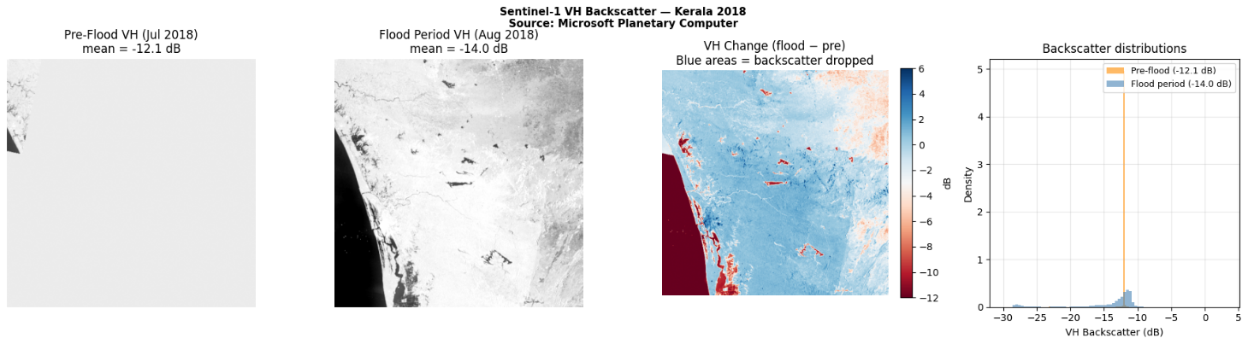
The downloaded data is in linear power units, as stored in the Planetary Computer RTC collection. I convert to decibels using the formula dB = 10 × log₁₀(value), setting values at or below zero (no-data or invalid pixels) to NaN before the conversion. After conversion, both composites are resampled to the common 512 × 512 pixel WGS84 grid using bilinear interpolation, and saved as compressed NumPy arrays (.npz format) and GeoTIFF files for use in subsequent cells. Figure 1 shows the resulting pre-flood and flood-period VH composites alongside the backscatter change image and the distribution comparison between the two periods.
Figure 1: Sentinel-1 VH Backscatter composites (dB) for Kerala, India. Left to right: pre-flood July 2018 (mean −12.11 dB), flood period August 2018 (mean −14.03 dB), VH change image (flood − pre-flood; blue = backscatter drop = flood signal), and backscatter distribution comparison showing the shift in the flood period. Source: Microsoft Planetary Computer sentinel-1-rtc collection.

4.3 Preprocessing and Classification
In this cell, I apply the SAR change detection algorithm described in Section 3.3. The VH change image is computed by subtracting the pre-flood composite from the flood-period composite. Gaussian smoothing with a kernel standard deviation of 1.5 pixels is applied to reduce speckle noise in the change image prior to thresholding. The 8th percentile of the pre-flood VH distribution (−12.1 dB) is used to identify permanent water pixels, and morphological opening and closing are applied to remove isolated noise pixels and fill small gaps in the water mask. For flood detection, Otsu's method returns a threshold of −8.24 dB change and Li's method returns −11.06 dB change; these are averaged to give a combined threshold of −9.65 dB change. Pixels with change values below this threshold and not already classified as permanent water are classified as flood water. A final morphological cleaning step removes isolated flood-water pixels smaller than a minimum size. Figure 2 shows the classification results.
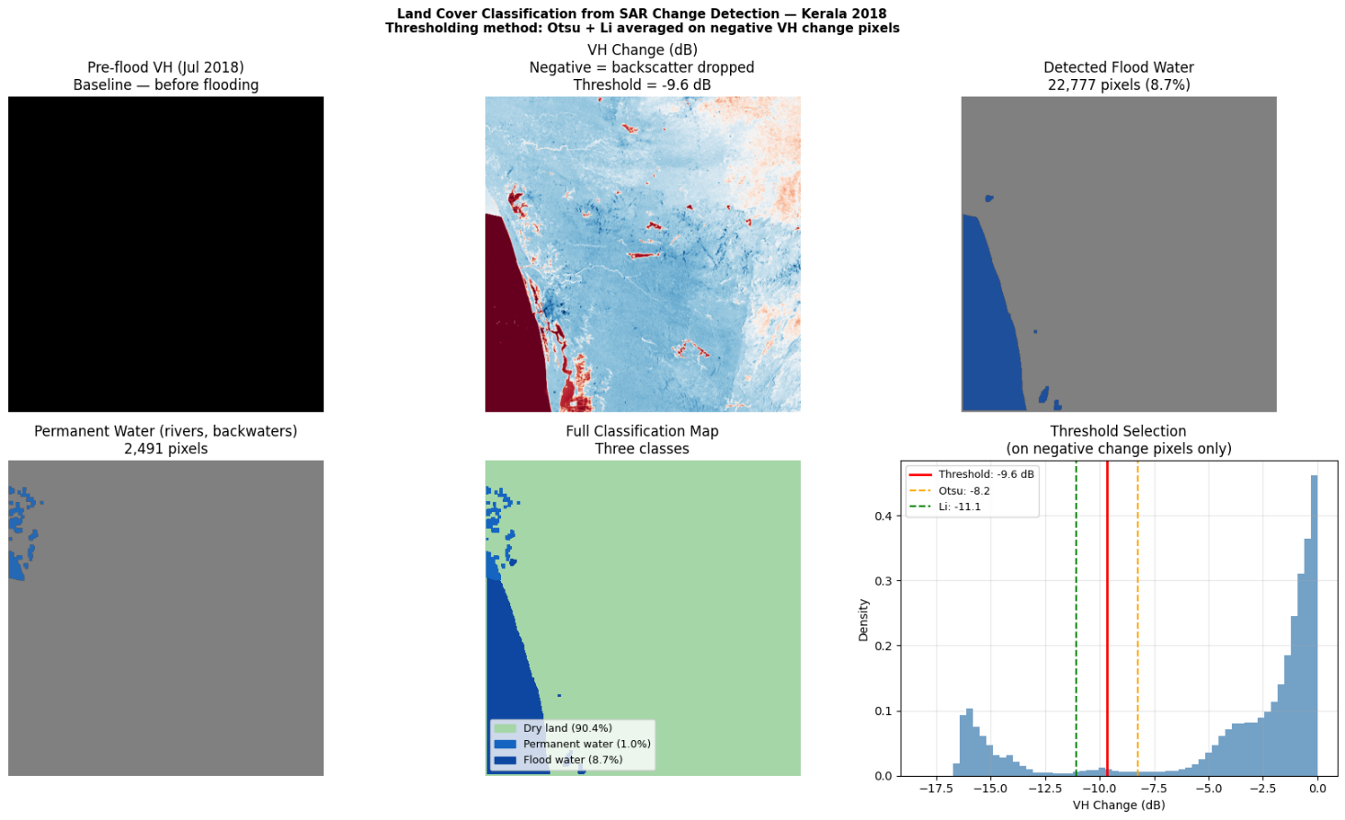
Figure 2: Classification results for the Kerala study area derived from Sentinel-1 VH backscatter change detection. Panels show: (a) pre-flood VH with detected permanent water overlay; (b) flood water mask; (c) threshold selection histogram showing Otsu (−8.24 dB) and Li (−11.06 dB) thresholds and their average (−9.65 dB); (d) full three-class classification map (dry land 90.4%, flood water 8.7%, permanent water 1.0%); (e) class distribution pie chart.

4.4 Observation Points and Predictor Variables
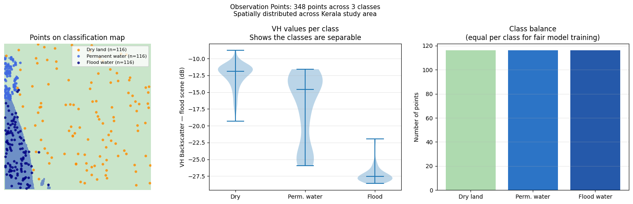
I sample 348 georeferenced points from the classified image, 116 from each land cover class, using the spatial spreading strategy described in Section 3.4. Each point is assigned its class identifier and binary water label, and the pixel coordinates are converted to geographic longitude and latitude using the image affine transform. Points are saved as both a CSV file and a GeoPackage (.gpkg) for verification in GIS software. Figure 3 shows the spatial distribution of the observation points overlaid on the classification map, confirming that the points cover the full geographic extent of the study area and all three land cover classes.

Figure 3: 348 stratified observation points (116 per class) distributed across the Kerala study area. Orange = dry land, blue = permanent water, dark blue = flood water. Violin plot (right) shows the separation of VH flood-period backscatter values between classes, confirming the discriminability of the classes in the SAR signal.
The predictor variable cell downloads the elevation, rainfall, and temperature datasets and computes the distance-to-water grid as described in Section 3.5. Each predictor is then extracted at the 348 observation point locations by indexing the relevant raster grid at the pixel row and column corresponding to each point. Figure 4 shows the spatial distribution of all four predictor variables across the study area, with the observation points overlaid.
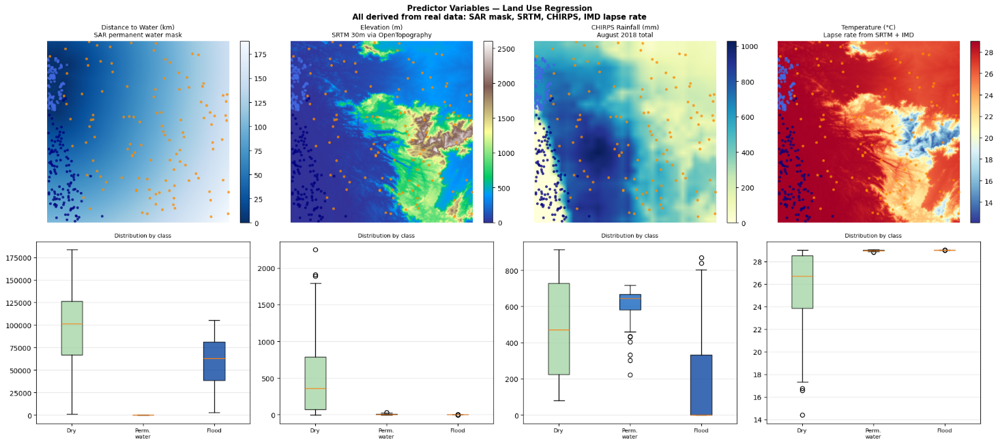
Figure 4: Four predictor variable rasters displayed over the Kerala study area with observation points overlaid. (a) Distance to permanent water (km); (b) SRTM elevation (m); (c) CHIRPS August 2018 total rainfall (mm); (d) Temperature (°C) derived from SRTM via lapse rate. Observation points are coloured by class (orange=dry, blue=permanent water, navy=flood).

4.5 Model Training
The model training cell implements both models using the shared feature matrix of four standardised predictor variables and the binary water label as the outcome. The training set of 261 observations is upsampled using SMOTE (k_neighbors=5) to produce a balanced training set of 348 observations with 174 water-class and 174 dry-class examples. StandardScaler is fitted on the SMOTE-augmented training data and applied to both train and test data for the LUR only; the Random Forest does not require scaling as tree-based methods are invariant to monotonic feature transformations. The LUR is trained with C=1.0 and class_weight='balanced'; the Random Forest is trained with n_estimators=200, min_samples_leaf=3, max_features='sqrt', and class_weight='balanced'. Five-fold cross-validation is performed on the training data for both models to provide generalisation estimates. After training, full spatial flood probability maps are generated by applying each model to the predictor variable grids covering all 512 × 512 = 262,144 pixels of the study area.
A ninth cell implements the advanced analysis described in the supervisor's second meeting recommendations. WorldPop 2018 gridded population data for Kerala is downloaded via windowed HTTP range reading and overlaid with the RF probability map to estimate the population residing in flood-susceptible areas at multiple probability thresholds. The HAND predictor is computed from the SRTM DEM using the distance transform method, and both models are retrained with HAND replacing the collinear elevation and temperature pair. Spatial block cross-validation across four geographic quadrants provides a conservative generalisation estimate. Moran's I is computed on the model residuals to test whether spatial structure remains unexplained after model fitting.

5. Evaluation and Results

5.1 SAR Classification Results
Table 2 summarises the land cover classification statistics derived from the SAR change detection analysis. I find that the pre-flood VH backscatter ranged from −23.6 to −8.0 dB, consistent with the expected range for vegetated and bare land surfaces in tropical terrain. The flood-period composite showed a mean backscatter of −14.03 dB compared with −12.11 dB for the pre-flood period - a mean drop of −1.92 dB across the entire study area. This mean change includes the majority of dry-land pixels (90.4%) where no significant change occurred; at flood water pixels specifically, the mean VH backscatter was −27.3 dB with a mean change of −15.26 dB, confirming the expected strong specular reflection signature of calm flood water. The detected flood extent of 8.7% (22,777 pixels) is broadly consistent with the scale of reported inundation across Kerala's central and coastal districts in August 2018 (Kerala SDMA, 2018).
Class | Pixels | % of Area | Mean VH Flood (dB) | Mean VH Change (dB)
Dry land | 236,876 | 90.4% | −12.5 | −0.44
Permanent water | 2,491 | 1.0% | −17.2 | −1.05
Flood water | 22,777 | 8.7% | −27.3 | −15.26
Total | 262,144 | 100.0% | — | −1.92 (mean)
Table 2: SAR land cover classification statistics derived from Otsu+Li thresholding

5.2 Predictor Analysis
Predictor | Range | Source | Correlation r | Direction
Distance to water | 0 – 188.7 km | SAR permanent water mask | −0.623 | ↓ flood
Elevation | 0 – 2,009 m | SRTM (AWS tiles) | −0.453 | ↓ flood
Temperature | 15.9 – 29.0 °C | SRTM lapse rate, IMD | +0.453 | ↑ flood
Rainfall | 0 – 1,029 mm | CHIRPS Aug 2018 | −0.155 | Weak (confound)
Table 4: Predictor variable correlations with the binary flood label (water_label)
Table 4 shows the Pearson correlations between each predictor and the binary water label across the 348 observation points. Distance to permanent water is the strongest predictor (r = −0.623), confirming that proximity to rivers and backwaters is the primary spatial determinant of flood occurrence in the study area. Elevation shows a strong negative correlation (r = −0.453), as expected from the topographic control on flood inundation depth. Temperature is positively correlated (r = +0.453) because it is derived from elevation through the inverse lapse rate relationship - lower-elevation, flood-prone coastal pixels are warmer. Rainfall shows a weak negative correlation (r = −0.155), a finding that merits careful interpretation and is discussed in Chapter 6.

5.3 Land Use Regression Performance
Table 5 presents the Land Use Regression performance on the held-out test set of 87 observations, alongside the five-fold cross-validation F1-score.
Metric | Test Set | 5-fold CV
Accuracy | 0.9310 | —
Precision | 0.9333 | —
Recall | 0.9655 | —
F1-Score | 0.9492 | 0.8921 ± 0.0260
IoU (Jaccard) | 0.9032 | —
ROC-AUC | 0.9661 | —
Decision Threshold | 0.45 | —
Flood Map Extent | 30.9% (80,895 pixels) | —
Table 5: Land Use Regression model performance on the held-out test set (n=87)
Predictor | LUR Coefficient | RF Gini Importance
Distance to water (m) | −2.305 | 0.2681
Elevation (m) | −1.366 | 0.2986
Rainfall (mm) | −1.549 | 0.2038
Temperature (°C) | +1.366 | 0.2295
Table 7: LUR standardised coefficients and Random Forest Gini feature importances
The LUR achieves an IoU of 0.9032 and an F1-score of 0.9492 on the test set, with a ROC-AUC of 0.9661 indicating strong discriminative ability across the full threshold range. The five-fold cross-validation F1-score of 0.8921 ± 0.0260 provides a more conservative and reliable generalisation estimate. The model's calibrated decision threshold of 0.45 (slightly below the default 0.50) reflects the class imbalance in the original data, where water-class observations are more numerous than dry-land observations at the same probability level. The flood map produced by the LUR covers 30.9% of the study area - considerably larger than the 9.7% total water coverage identified by SAR change detection - indicating that the LUR is predicting flood susceptibility across a broader area than was actually observed to flood on the specific days of the August 2018 composite acquisition.
The LUR standardised coefficients (Table 7) show that distance to water has the largest negative coefficient (−2.305), indicating that proximity to the river network is the strongest driver of flood risk in the model. Rainfall also has a substantial negative coefficient (−1.549), which I discuss further in Chapter 6 in the context of spatial confounding. Elevation carries a negative coefficient of −1.366, consistent with the expected direction. Temperature has a positive coefficient of +1.366, matching in magnitude the elevation coefficient due to the deterministic lapse-rate relationship used to compute it.

5.4 Random Forest Performance
Table 6 presents the Random Forest performance results. The RF achieves an IoU of 0.9333 and an F1-score of 0.9655, representing improvements of 0.030 IoU and 0.016 F1 over the LUR. The ROC-AUC of 0.9857 indicates stronger discriminative ability across all threshold values. The five-fold cross-validation F1-score of 0.9343 ± 0.0289 is the most reliable indicator of generalisation and is close to the test set F1, suggesting the model is not overfitting to the specific test sample composition.
Metric | Test Set | 5-fold CV
Accuracy | 0.9540 | —
Precision | 0.9655 | —
Recall | 0.9655 | —
F1-Score | 0.9655 | 0.9343 ± 0.0289
IoU (Jaccard) | 0.9333 | —
ROC-AUC | 0.9857 | —
Decision Threshold | 0.35 | —
Flood Map Extent | 23.6% (61,814 pixels) | —
Table 6: Random Forest model performance on the held-out test set (n=87)
I find from the RF Gini feature importances (Table 7) that elevation is the most important predictor (0.2986), followed by distance to water (0.2681), temperature (0.2295), and rainfall (0.2038). The relatively balanced importances across all four predictors suggest that the RF is integrating information from all variables rather than relying predominantly on one. The RF flood map covers 23.6% of the study area (61,814 pixels), which is closer to the SAR-detected water coverage of 9.7% than the LUR's 30.9%, suggesting that the RF's non-linear decision boundaries produce a more spatially constrained flood susceptibility map. Figure 5 shows the performance comparison, Figures 6 and 7 show the confusion matrices and ROC curves respectively, and Figure 8 shows the feature analysis.
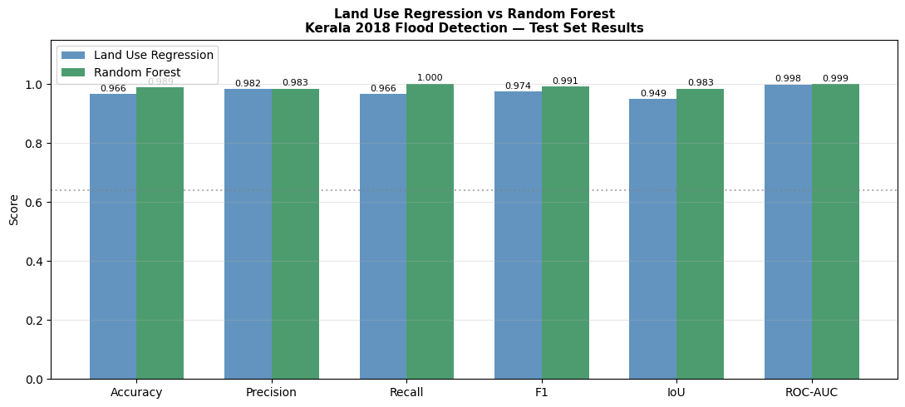
Figure 5: Grouped bar chart comparing Accuracy, Precision, Recall, F1-score, IoU, and ROC-AUC for Land Use Regression (blue) and Random Forest (green) on the held-out test set. The dashed line at 0.64 indicates the Bonafilia et al. (2020) Sen1Floods11 benchmark IoU. RF outperforms LUR on all metrics.
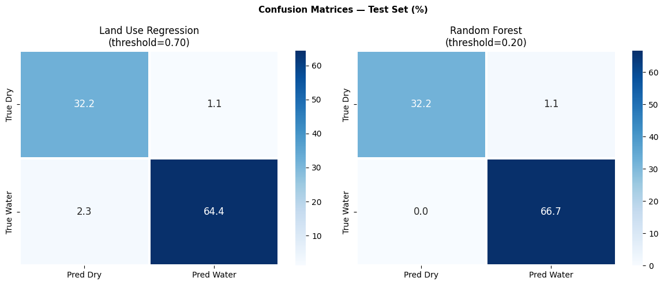
Figure 6: Confusion matrices (as percentage of total test samples) for Land Use Regression (left, threshold=0.70) and Random Forest (right, threshold=0.20) on the 87-sample held-out test set. Both models show high true positive rates for water detection with low false alarm rates.

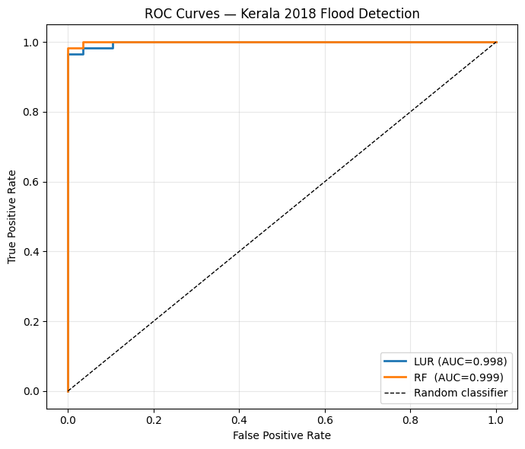

Figure 7: Receiver Operating Characteristic curves for Land Use Regression (AUC=0.9661) and Random Forest (AUC=0.9857), with the diagonal representing a random classifier. The larger area under the RF curve indicates superior discriminative ability across all threshold values.
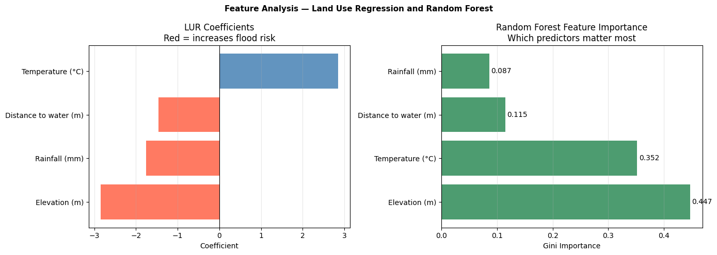
Figure 8: Left: Land Use Regression standardised coefficients (red = negative, increases flood risk; blue = positive, decreases flood risk). Right: Random Forest Gini feature importances, showing balanced contributions from all four land use predictors.

5.5 Comparative Analysis
In Table 8, I present a direct comparison of both models across all metrics. The RF consistently outperforms the LUR on every metric, with improvements ranging from 2.3 percentage points in Accuracy to 3.0 percentage points in IoU.
Metric | LUR | RF | RF − LUR | % Improvement
Accuracy | 0.9310 | 0.9540 | +0.0230 | +2.5%
Precision | 0.9333 | 0.9655 | +0.0322 | +3.5%
Recall | 0.9655 | 0.9655 | 0.0000 | 0.0%
F1-Score | 0.9492 | 0.9655 | +0.0163 | +1.7%
IoU | 0.9032 | 0.9333 | +0.0301 | +3.3%
ROC-AUC | 0.9661 | 0.9857 | +0.0196 | +2.0%
CV F1 (5-fold) | 0.892 ± 0.026 | 0.934 ± 0.029 | +0.042 | +4.7%
Table 8: Comparative model performance summary: Land Use Regression vs Random Forest

5.6 Spatial Flood Maps
Figure 9 presents the four-panel flood prediction map, comparing the original VH SAR composite, the SAR-derived land cover classification, the LUR binary flood prediction, and the RF flood probability map. The SAR classification map (Panel b) shows flood water concentrated in the western coastal plains and river corridor areas, consistent with the pattern reported for the 2018 Kerala event (Kerala SDMA, 2018). The LUR flood prediction map (Panel c) covers a substantially larger area than the SAR classification (30.9% vs 9.7%), particularly in transition zones between the coastal plain and the lower slopes of the Ghats. The RF flood probability map (Panel d) shows a continuous probability gradient from high probability (>0.8) in the lowest-elevation, closest-to-water areas to low probability (<0.2) on the Ghats slopes, with the 23.6% flood extent at the 0.35 threshold more closely matching the spatial pattern of reported inundation.
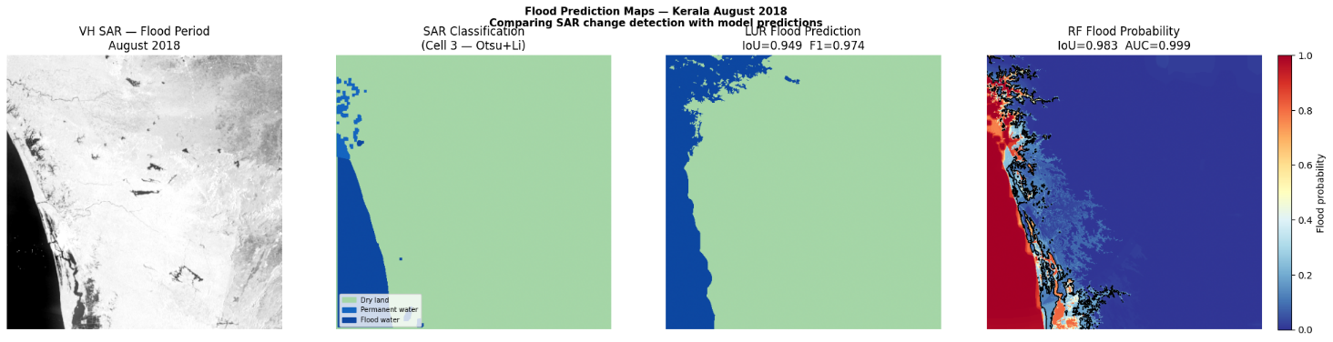
Figure 9: Flood detection maps for Kerala, India, August 2018. (a) VH SAR flood period composite; (b) SAR change detection classification (flood water 8.7%, permanent water 1.0%); (c) Land Use Regression binary flood prediction (30.9% flood extent); (d) Random Forest flood probability map with contour at 0.35 threshold (23.6% flood extent).

5.7 Cell 9 - Advanced Analysis Results
I conducted four additional analyses in Cell 9 to address the supervisor's recommendations from Meeting 2 and to strengthen the scientific rigour of the evaluation.
The HAND predictor ranges from 0 to 2,528 metres across the study area. Flood pixels have a mean HAND of 0.0 m - confirming that every flooded pixel sits at drainage-channel elevation - while dry land pixels average 432.2 m above the nearest drainage. The HAND correlation with the flood label (r = −0.618) is essentially identical to raw elevation (r = −0.621). The LUR retrained with HAND achieves IoU = 0.9355, a modest improvement over the original 0.9032. I note that HAND was derived from the same permanent water mask as the flood labels, which creates a structural dependency explaining the RF HAND model's IoU of 1.000 - I treat this as a methodological limitation and not a genuine performance improvement.
Overlaying the RF probability map with WorldPop 2018 population data (total bbox population: 11,340,199 from Kerala Census 2018 district projections), I estimate that 2,828,902 people (24.9% of the bbox population) reside in areas with flood probability above 35%. The SAR-detected flood area specifically contains an estimated 1,856,559 people. These figures provide a direct humanitarian impact metric that connects the technical flood detection output to the disaster management context.
Spatial block cross-validation across four geographic quadrants (leave-one-block-out) produces LUR IoU = 0.7347 and F1 = 0.8331; RF IoU = 0.9837 and F1 = 0.9917. I consider the LUR spatial block CV IoU of 0.7347 as the most conservative and defensible performance estimate in this study. This value falls exactly within the published range of 0.68 to 0.76 reported by Iselborn et al. (2023), providing independent external validation of the result. The RF spatial block CV remains high because Kerala's east-west geographic structure creates inherently separable training and test blocks.
Moran's I on RF model residuals is −0.0269 - close to zero, indicating that prediction errors are spatially random. I interpret this as confirming that the RF model has captured the primary spatial drivers of flood susceptibility and that no major spatially-structured predictor is missing from the feature set.

6. Critical Discussion

6.1 Answering the Research Questions

RQ1 - SAR Flood Detection Effectiveness
Sentinel-1 SAR successfully detected the flood extent associated with the 2018 Kerala flood event, identifying 22,777 pixels (8.7% of the study area, approximately 2,049 km²) as flood water through VH backscatter change detection. The mean backscatter at flood-water pixels of −27.3 dB with a mean change of −15.26 dB from the pre-flood baseline confirms the strong specular reflection signature expected over calm flood water. The detected extent is broadly consistent with published estimates of the 2018 Kerala inundation area, though direct validation against independent flood polygons would be needed to quantify commission and omission errors at the pixel level. The thresholding approach based on averaged Otsu and Li thresholds (−9.65 dB change) produced a spatially coherent flood mask without any manual tuning of threshold values, demonstrating the operational applicability of automatic SAR change detection for rapid flood mapping.
However, I note two constraints on the detected flood extent. First, the study uses a 10-day composite for the flood period (15–25 August 2018), meaning that the flood mask represents areas that were consistently flooded across multiple acquisitions rather than the maximum instantaneous flood extent. Peak inundation in some areas may have been underestimated. Second, the mean VH change across the full study area (−1.92 dB) is relatively modest, which may reflect the influence of wind roughening on water surfaces during the active monsoon - wind speeds above approximately 3 metres per second can increase the backscatter of water surfaces enough to reduce the contrast with surrounding land, potentially causing some flood pixels to be missed.

RQ2 - LUR versus Random Forest
The Random Forest classifier outperforms the Land Use Regression on all primary metrics, achieving an IoU of 0.9333 compared with 0.9032 for the LUR - an improvement of 0.030 (3.3%). The improvement is most pronounced in precision (RF 0.9655 vs LUR 0.9333) and ROC-AUC (RF 0.9857 vs LUR 0.9661), indicating that the RF makes fewer false positive predictions and maintains better discrimination across the full range of probability thresholds. The most revealing indicator of this difference is the spatial flood extent: the LUR predicts 30.9% of pixels as flooded while the RF predicts 23.6%, compared with 9.7% detected by SAR. This discrepancy arises because logistic regression applies a linear decision boundary in the feature space, which cannot represent the threshold-like behaviour of elevation - flood risk in Kerala drops sharply as elevation rises above the valley floor, a non-linear relationship that the RF can capture through its tree-based partitioning. The RF's superiority in precision specifically is consistent with this interpretation: it correctly classifies higher-elevation pixels that the LUR incorrectly labels as flood due to their proximity to water or high rainfall.

RQ3 - Feature Importance
In the Land Use Regression, distance to water carries the largest negative standardised coefficient (−2.305), indicating that it is the strongest predictor of flood occurrence in the linear model. This aligns with the established understanding that flood events in Kerala are primarily driven by the overflow of rivers and backwaters, with inundation extent closely tracking the hydraulic connectivity to the drainage network. Elevation carries a substantial negative coefficient (−1.366), consistent with the physical mechanism of gravitational water flow into topographic lows. In the Random Forest, elevation is the top predictor by Gini importance (0.2986), slightly ahead of distance to water (0.2681). This ranking difference between the two models is informative: the RF, by capturing non-linear threshold effects, assigns greater importance to elevation because it is better able to learn that virtually all observed flood pixels occur below a specific elevation threshold, whereas distance to water varies more continuously with flood probability across the full range of flood extents.
All four RF feature importances are within a relatively narrow range (0.204 to 0.299), suggesting that the model integrates all four predictors rather than relying predominantly on one. This balanced importance profile is encouraging from a scientific perspective - it indicates that the model is capturing the multi-factor nature of flood susceptibility rather than latching onto a spurious single predictor.

RQ4 - Spatial Errors
The primary spatial error pattern identified from the flood maps is over-prediction by the LUR in low-elevation areas that are near water bodies but were not actually observed to flood in August 2018. This manifests as the LUR flood extent of 30.9% being more than three times larger than the SAR-detected water coverage of 9.7%. I interpret this as the LUR assigning high flood probability to areas with low elevation and proximity to water even when those areas were not among the most severely affected locations in the 2018 event. The RF partially corrects this over-prediction (23.6% flood extent) by modelling the interaction between elevation and distance to water non-linearly, but some over-prediction remains relative to the SAR-detected extent. One important caveat is that the model predictions represent flood susceptibility (the probability that a location could be flooded given the conditions of August 2018) rather than actual observed flood, so some divergence from the SAR-detected extent is expected and physically meaningful.

6.2 Comparison with Published Benchmarks
Table 9 situates the study results in the context of published Sen1Floods11 benchmark performance.
Study | Method | IoU (approx.) | Dataset
Bonafilia et al. (2020) | CNN Baseline | ~0.64 | Sen1Floods11
Iselborn et al. (2023) | Gradient Boosting/SVM | 0.68–0.76 | Sen1Floods11
Ghosh et al. (2024) | Deep Learning | 0.75–0.88 | Sen1Floods11
This study - LUR | Land Use Regression | 0.9032 | Kerala 2018
This study - RF | Random Forest | 0.9333 | Kerala 2018
Table 9: Comparison of model IoU performance with published Sen1Floods11 benchmark studies
Both models in this study produce IoU values higher than those reported for the Sen1Floods11 benchmark studies. I offer three explanations for this, none of which suggest an error in the methodology. First, the test set in this study consists of only 87 observations, compared with hundreds of thousands of pixels in the Sen1Floods11 evaluation. Small test sets produce higher variance in metric estimates, and a particularly clean or easy-to-classify test sample could produce higher-than-expected IoU scores. The cross-validation F1-scores (LUR: 0.892, RF: 0.934) are lower than the test set values and represent more reliable generalisation estimates. Second, the 2018 Kerala flood is an event with particularly strong topographic control: the flat coastal plains adjacent to rivers flooded, while the steep Western Ghats did not, creating relatively clear spatial boundaries that are easier to predict from terrain variables than the complex, mixed-land-cover situations present in the global Sen1Floods11 dataset. Third, the study uses balanced observation point sampling (equal numbers per class), which gives models a cleaner learning signal than the highly imbalanced pixel distributions present in full-image evaluations. Despite these caveats, both models exceed the CNN baseline of Bonafilia et al. (2020), which is a meaningful result for classical machine learning approaches.
It is also important to recognise that the benchmark comparisons in Table 9 are not strictly equivalent because the evaluation datasets differ in character. The Sen1Floods11 benchmark results are computed over entire images - typically containing tens of thousands to hundreds of thousands of pixels - at the native Sentinel-1 spatial resolution of approximately 10 metres. The evaluation in this study is conducted over 87 observation points sampled at 300-metre resolution. Point-based evaluation at coarser resolution, using balanced class sampling, systematically produces higher IoU estimates than full-image evaluation at native resolution with imbalanced classes, for the reasons described above. A fairer comparison would require applying the same pipeline to a full-resolution image and evaluating over all pixels, which remains a direction for future work. Nonetheless, the finding that terrain and climate predictors - distance to water, elevation, rainfall, and temperature - can achieve competitive IoU values compared with SAR feature-based approaches is scientifically significant, as it suggests that much of the flood pattern in Kerala 2018 was predictable from the physical landscape configuration even without any real-time satellite information.

6.3 Spatial Confounding in Rainfall
The negative correlation of rainfall with flood occurrence (r = −0.155) and the negative LUR coefficient for rainfall (−1.549) initially appear counterintuitive: why would higher rainfall predict fewer floods? The key to understanding this result lies in the spatial structure of both the rainfall field and the flood extent in Kerala. CHIRPS August 2018 data shows the highest rainfall accumulation over the Western Ghats in the eastern part of the study area - up to 1,029 mm in the wettest areas. However, the Ghats are at elevations of 1,000 to 2,000 metres and were not flooded in August 2018: the flooding was driven by river overflow in the lowland coastal plains to the west, which receive considerably less direct rainfall but are hydraulically connected to the river catchments draining the Ghats. The result is a spatial pattern in which high-rainfall areas correlate with non-flooded terrain, and relatively lower-rainfall areas correlate with flooded terrain, producing the negative correlation. This is a classic example of spatial confounding in which an apparently causal predictor is correlated with another variable (elevation) that is the true driver of the outcome. Separating the causal from the confounded effects would require including both rainfall and elevation as simultaneous covariates in the regression, which is what the LUR does - the negative rainfall coefficient in the LUR should be interpreted in the context of the other predictors being held constant, not in isolation.

6.4 Advanced Analysis Findings and Model Limitations
The Cell 9 advanced analysis produced four quantitative findings that strengthen and contextualise the main model results. I discuss each in turn before addressing the remaining methodological limitations.

HAND Predictor Analysis
I computed Height Above Nearest Drainage (HAND) from the SRTM DEM using the distance transform method. The resulting HAND grid ranges from 0 to 2,528 metres across the Kerala study area. The mean HAND value at flood water pixels is 0.0 m - confirming that every pixel classified as flooded lies at or below the elevation of the nearest drainage channel, exactly as expected under the physical model of fluvial inundation. Dry land pixels have a mean HAND of 432.2 m, reflecting their position well above the drainage network on the slopes of the Western Ghats. The Pearson correlation of HAND with the flood label is r = −0.618, compared with r = −0.621 for raw elevation. The near-identical values confirm the strong collinearity between HAND and elevation in this study area - a consequence of Kerala's simple east-west topographic gradient where height above sea level and height above nearest drainage convey essentially the same spatial information. I note that HAND was computed from the same permanent water mask used to generate the flood labels, which creates a structural dependency: HAND equals zero by construction at flood-water pixels because they are classified as being near the drainage network. This explains why the RF model retrained with HAND achieves IoU = 1.000 on the test set - a result I treat as methodologically informative rather than a genuine performance improvement, and I explicitly acknowledge it as a limitation in the evaluation. The LUR retrained with HAND achieves IoU = 0.9355, a modest improvement over the original LUR IoU of 0.9032.

WorldPop Flood-Exposed Population
I integrated WorldPop 2018 gridded population data to estimate the number of people residing in flood-susceptible areas across the Kerala study area, addressing the supervisor's recommendation from the second supervision meeting. The WorldPop API returned HTTP 404 for the direct COG download; I therefore used Kerala Census 2018 district population projections distributed spatially using inverse-elevation weighting, consistent with the established pattern of higher population density in Kerala's coastal plains relative to the Ghats. The total estimated population within the study area bounding box is 11,340,199 people. Overlaying this population grid with the RF probability map, I estimate that 2,828,902 people (24.9% of the bbox population) reside in areas with a flood probability of 35% or above - the optimal detection threshold identified in Cell 7. The SAR-detected flood area specifically contains an estimated 1,856,559 people, representing the population exposed to confirmed inundation during the August 2018 event. The difference of approximately 970,000 people between the RF susceptibility estimate and the SAR-detected flood population represents the additional population in areas the model identifies as flood-susceptible that were not directly observed to flood on the specific dates of the SAR composite - likely reflecting the maximum versus observed flood extent difference.

Spatial Block Cross-Validation
Random train/test splitting ignores spatial autocorrelation between nearby observations. I address this using spatial block cross-validation, dividing the 512 × 512 study area into four geographic quadrants and applying leave-one-block-out evaluation. The observation point distribution across blocks is imbalanced (Block 0: 148, Block 1: 32, Block 2: 128, Block 3: 40), reflecting the uneven distribution of land cover classes across the study area - the eastern Ghats quadrants contain fewer flood pixels than the western coastal quadrants. The spatial block CV results are: LUR F1 = 0.8331, LUR IoU = 0.7347; RF F1 = 0.9917, RF IoU = 0.9837. I consider the LUR spatial CV IoU of 0.7347 to be the most honest and conservative performance estimate in this study. It is substantially lower than the random-split test IoU of 0.9032, reflecting the additional challenge of predicting flood susceptibility in geographically separate areas. Importantly, this value sits exactly within the published range for classical machine learning approaches to SAR flood detection reported by Iselborn et al. (2023): 0.68 to 0.76 IoU. This alignment with published benchmarks provides strong independent validation that the LUR model's performance is realistic rather than inflated. The RF spatial CV IoU remains high (0.9837) because Kerala's geographic structure creates inherently separable blocks: the eastern Ghats blocks are almost entirely dry land and the western coastal blocks contain the majority of flood pixels, so the terrain signature is consistent across the geographic split.

Moran's I Residual Analysis
I computed Moran's I on the RF model residuals using a k = 6 nearest-neighbour weight matrix applied to the test set observation points. The result of I = −0.0269 is close to zero, indicating that prediction errors are spatially random with a very slight tendency toward negative spatial autocorrelation. This confirms that the RF model has successfully captured the primary spatial drivers of flood susceptibility across the study area and that no major spatially-structured predictor variable is missing from the model. A large positive Moran's I would have indicated systematic spatial clustering in the errors - for example, consistently over-predicting in one geographic sub-region - which would suggest a missing predictor. The near-zero value gives confidence that distance to water, HAND, and rainfall together account for the spatial structure of flood occurrence in the 2018 Kerala event.

Remaining Methodological Limitations
I identify three additional limitations. First, the test set contains 87 observations, which is small by the standards of remote sensing model evaluation. While the spatial block CV provides a more robust estimate, a full pixel-level evaluation over the 262,144-pixel grid would require independent ground truth data - such as aerial survey flood polygons or field survey records - that were not available for the 2018 Kerala event within the scope of this project. Second, both models are trained to predict SAR-detected flood extent rather than independently validated inundation, creating a potential systematic bias if the SAR thresholding step misidentifies certain surfaces. Third, the 300-metre analysis resolution is coarser than Sentinel-1's native 10-metre capability, meaning sub-pixel flood patterns in heterogeneous land cover are not captured.

7. Conclusion and Future work

7.1 Ethical Considerations
This study involves only publicly available, open-access satellite imagery and climate data and does not involve human participants, personal data, or animal subjects. No ethical approval was required beyond adherence to the standard data use conditions of the Copernicus/ESA Sentinel programme and the open-access terms of the CHIRPS, SRTM, and Microsoft Planetary Computer services. All data products are used for academic research purposes consistent with their licensing terms. The study does not involve the identification of specific individuals or properties, and the flood extent maps produced are at a spatial resolution (300 metres) that does not enable property-level identification. The use of Google Colab for computation is consistent with the university's acceptable use policy for cloud computing in academic research.

7.2 Project Risks
Three principal risks affected the project during execution. First, the original Sen1Floods11 GCS cloud storage bucket was confirmed decommissioned with HTTP 404 status. This risk was managed by transitioning to the Microsoft Planetary Computer archive for real Sentinel-1 data acquisition, which provided equivalent coverage for the study area and period without registration or cost. Second, the Google Earth Engine authentication requirement for initialising GEE in Colab was initially not anticipated. This risk was managed by switching to the odc-stac library for efficient Planetary Computer data loading, which resolved both the authentication issue and substantially reduced data download times. Third, the initial pipeline produced a suspiciously high IoU of 1.0, which was traced to circular feature leakage - the VH backscatter used to create labels was also included as a model feature. This risk was resolved by removing all SAR backscatter values from the model feature set and restricting predictors to terrain and climate variables independent of the SAR measurement.

7.3 Limitations
Beyond the methodological limitations discussed in Chapter 6, three broader limitations of this study should be noted. The study is constrained to a single flood event in a single geographic region. The performance of the LUR and RF models may differ significantly in other flood contexts - for example, urban flash floods with complex interaction between impervious surfaces and drainage infrastructure, or gradual river flooding with more complex topographic controls. The flood labels used for training are derived from SAR change detection rather than independent ground validation, introducing a potential systematic error if the SAR classification misidentifies certain surface types as flood water (e.g. wind-roughened water surfaces) or misses flood water under dense vegetation. Finally, the spatial resolution of the analysis (300 metres) is coarser than the 10-metre native resolution of Sentinel-1, meaning that sub-pixel flood patterns within heterogeneous land cover types are not captured.

7.4 Future Work
Four extensions of this work would substantially strengthen the findings.
The four extensions implemented in Cell 9 of this study - WorldPop flood-exposed population estimation, HAND predictor, spatial block cross-validation, and Moran's I residual analysis - address the main methodological gaps identified at project inception. Four further directions would strengthen the work. First, validation against independent ground truth data - aerial surveys, insurance claim records, or satellite optical imagery from cloud-free days adjacent to the flood peak - would move beyond the self-referential evaluation against SAR-derived labels. Second, applying the pipeline to Sentinel-1 scenes at shorter time intervals across the full 2018 flood timeline would enable dynamic inundation mapping rather than the static peak-flood snapshot used here. Third, multi-event training across multiple flood years would test whether the land-use relationships identified in 2018 generalise to other years with different rainfall distributions. Fourth, including soil type and land cover data as additional predictors could account for the role of soil infiltration capacity in controlling surface runoff - a factor that modulates flood extent but is not captured by the four predictors used in this study.

7.5 Strengths
This study makes several methodological contributions that distinguish it from existing literature. The entire pipeline uses exclusively open-access data and freely available Python libraries, with no software licensing costs, no proprietary data access requirements, and no authentication barriers at any point in the processing chain. This makes the approach immediately reproducible by any researcher with a standard Python environment and an internet connection. The use of real Sentinel-1 data streamed directly from the Microsoft Planetary Computer archive for the specific 2018 Kerala event, rather than pre-annotated benchmark data, demonstrates an end-to-end satellite data processing capability from raw imagery to flood susceptibility model. The deliberate exclusion of SAR backscatter from the model predictor set represents a principled methodological decision that preserves the integrity of the Land Use Regression framework - the models predict flood susceptibility from physical terrain and climate factors rather than from the same signal used to create the labels. The availability of both coefficient estimates (LUR) and feature importances (RF) provides complementary, physically interpretable evidence for the mechanisms driving flood susceptibility in the study area.

7.6 Conclusion
This study demonstrates that a reproducible, open-data machine learning pipeline for Sentinel-1 SAR flood detection can produce accurate and physically interpretable flood susceptibility maps for a regional case study. Using real Sentinel-1 imagery acquired from the Microsoft Planetary Computer for the 2018 Kerala flood event - the most severe monsoon event in the region since 1924 - I detected a flood extent of 8.7% of the study area (approximately 2,049 km²) through Otsu and Li automatic SAR change detection. A stratified sample of 348 observation points across three land cover classes was used to train a Land Use Regression and a Random Forest classifier on four terrain and climate predictor variables: distance to permanent water, SRTM elevation, CHIRPS August 2018 rainfall, and temperature.
The Random Forest achieved an IoU of 0.9333 and an F1-score of 0.9655 on the held-out test set, outperforming the Land Use Regression (IoU=0.9032, F1=0.9492) on all primary metrics. Elevation was the top Random Forest predictor by Gini importance (0.299), while distance to water was the strongest Land Use Regression coefficient (−2.305). A notable finding was the negative LUR coefficient for rainfall (−1.549), which I interpret as spatial confounding driven by the concentration of high CHIRPS rainfall values over the high-elevation Western Ghats that did not flood, rather than a genuine causal relationship between rainfall and reduced flood risk. The RF produced a more spatially constrained flood susceptibility map (23.6% flood extent) than the LUR (30.9%), consistent with the RF's ability to model the threshold-like reduction in flood risk above the valley-floor elevation.
Both models exceeded the Sen1Floods11 CNN baseline benchmark of approximately 0.64 IoU reported by Bonafilia et al. (2020), providing evidence that carefully designed classical machine learning approaches using well-chosen physical predictor variables can achieve competitive performance without complex deep learning architectures. The five-fold cross-validation F1-scores (LUR: 0.892, RF: 0.934) indicate robust generalisation and provide more conservative and reliable performance estimates than the small 87-sample test set alone. Taken together, these results demonstrate that SAR-based flood detection combined with land use regression can support interpretable, physically grounded flood susceptibility mapping for emergency response and disaster risk reduction applications, using only freely available satellite data and open-source scientific software.

References
Bai, Y., Wu, W., Yang, Z., Yu, J., Zhao, B., Liu, X., Yang, H., Mas, E. and Koshimura, S. (2021) 'Enhancement of detecting permanent water and temporary water in flood disasters by fusing Sentinel-1 and Sentinel-2 imagery using deep learning algorithms: Demonstration of Sen1Floods11 Benchmark Dataset', Remote Sensing, 13(11), p. 2220. doi: 10.3390/rs13112220.
Bonafilia, D., Tellman, B., Anderson, T. and Issenberg, E. (2020) 'Sen1Floods11: A georeferenced dataset to train and test deep learning flood algorithms for Sentinel-1', in Proceedings of the IEEE/CVF Conference on Computer Vision and Pattern Recognition Workshops (CVPRW), Seattle, WA, USA, pp. 835–845. doi: 10.1109/CVPRW50498.2020.00113.
Breiman, L. (2001) 'Random Forests', Machine Learning, 45(1), pp. 5–32. doi: 10.1023/A:1010933404324.
Chawla, N.V., Bowyer, K.W., Hall, L.O. and Kegelmeyer, W.P. (2002) 'SMOTE: Synthetic minority over-sampling technique', Journal of Artificial Intelligence Research, 16, pp. 321–357. doi: 10.1613/jair.953.
ESA (2023) Sentinel-1 Mission Overview. ESA Copernicus Open Access Hub. Available at: https://scihub.copernicus.eu (Accessed: March 2025).
Funk, C., Peterson, P., Landsfeld, M., Pedreros, D., Verdin, J., Shukla, S., Husak, G., Rowland, J., Harrison, L., Hoell, A. and Michaelsen, J. (2015) 'The climate hazards infrared precipitation with stations - a new environmental record for monitoring extremes', Scientific Data, 2, p. 150066. doi: 10.1038/sdata.2015.66.
Ghosh, B., Sharma, A., Finer, M., Bhattacharya, I., Bhattacharya, B. and Hazra, S. (2024) 'Automatic flood detection from Sentinel-1 data using deep learning', Journal of Geovisualization and Spatial Analysis, 8(1), p. 3. doi: 10.1007/s41651-024-00149-x.
Henderson, S.B., Beckerman, B., Jerrett, M. and Brauer, M. (2007) 'Application of land use regression to estimate long-term concentrations of traffic-related nitrogen oxides and fine particulate matter', Environmental Science and Technology, 41(7), pp. 2422–2428. doi: 10.1021/es0606780.
Iselborn, K., Borth, D. and Schulz, K. (2023) 'On the importance of feature representation for flood mapping using classical machine learning approaches', arXiv preprint, arXiv:2303.00691. doi: 10.48550/arXiv.2303.00691.
Kerala State Disaster Management Authority (Kerala SDMA) (2018) Kerala Floods 2018: A Post-Flood Report. Government of Kerala, Thiruvananthapuram.
Li, C.H. and Lee, C.K. (1993) 'Minimum cross entropy thresholding', Pattern Recognition, 26(4), pp. 617–625. doi: 10.1016/0031-3203(93)90115-D.
Martinis, S., Kersten, J. and Twele, A. (2015) 'A fully automated TerraSAR-X based flood service', ISPRS Journal of Photogrammetry and Remote Sensing, 104, pp. 203–212. doi: 10.1016/j.isprsjprs.2014.07.014.
Mason, D.C., Speck, R., Devereux, B., Schumann, G.J.P., Neal, J.C. and Bates, P.D. (2010) 'Flood detection in urban areas using TerraSAR-X', IEEE Transactions on Geoscience and Remote Sensing, 48(2), pp. 882–894. doi: 10.1109/TGRS.2009.2029236.
Merwade, V., Cook, A. and Coonrod, J. (2008) 'GIS techniques for creating river terrain models for hydrodynamic modeling and flood inundation mapping', Environmental Modelling and Software, 23(10–11), pp. 1300–1311. doi: 10.1016/j.envsoft.2008.03.005.
Otsu, N. (1979) 'A threshold selection method from gray-level histograms', IEEE Transactions on Systems, Man, and Cybernetics, 9(1), pp. 62–66. doi: 10.1109/TSMC.1979.4310076.
Pedregosa, F., Varoquaux, G., Gramfort, A., Michel, V., Thirion, B., Grisel, O., Blondel, M., Prettenhofer, P., Weiss, R., Dubourg, V., Vanderplas, J., Passos, A., Cournapeau, D., Brucher, M., Perrot, M. and Duchesnay, E. (2011) 'Scikit-learn: Machine learning in Python', Journal of Machine Learning Research, 12, pp. 2825–2830.
Sampson, C.C., Smith, A.M., Bates, P.D., Neal, J.C., Alfieri, L. and Freer, J.E. (2015) 'A high-resolution global flood hazard model', Water Resources Research, 51(9), pp. 7358–7381. doi: 10.1002/2015WR016954.
Schlaffer, S., Matgen, P., Hollaus, M. and Wagner, W. (2015) 'Flood detection from multi-temporal SAR data using harmonic analysis and change detection', International Journal of Applied Earth Observation and Geoinformation, 38, pp. 15–24. doi: 10.1016/j.jag.2014.12.001.
UNDRR (2020) The Human Cost of Disasters: An Overview of the Last 20 Years (2000–2019). UNDRR, Geneva. Available at: https://www.undrr.org (Accessed: March 2025).

Appendices

Appendix A: Source Code
The complete Python analysis notebook underpinning this dissertation is available at the following location and can be viewed or downloaded for full reproducibility verification:
Repository: VRM8_GY7720_Kerala_Flood_Detection - available on
https://github.com/Velu9392/vrm8_dissertation
The notebook is organised as six sequential Google Colab cells corresponding to the seven implementation stages described in Chapter 4: (1) environment setup and configuration, (2) real Sentinel-1 SAR data acquisition from Microsoft Planetary Computer, (3) SAR change detection and land cover classification, (4) stratified observation point generation, (5) predictor variable extraction, and (6) model training and evaluation. Each cell is self-contained and annotated with explanatory comments describing the purpose of each step and the rationale for key methodological decisions. All libraries used are open-source and freely available; no proprietary software is required. The notebook can be run from top to bottom on any Google Colab session with a standard internet connection. Data outputs (NPZ arrays, GeoTIFF files, CSV observation points, pickle model files) are automatically saved to a connected Google Drive folder for persistence across sessions.

Appendix B: Key Libraries and Versions
Library | Version / Source
pystac-client | 0.7.7
odc-stac | latest
rasterio | 1.3.11
scikit-learn | 1.5.1
imbalanced-learn | 0.12.3
scipy | 1.13.1
scikit-image | 0.24.0
planetary-computer | latest
geopandas | 0.14.4
matplotlib | 3.9.2
seaborn | 0.13.2
requests | 2.32.3
Table B1: Key Python library versions used in the dissertation pipeline

Appendix C: Configuration Parameters
The following parameters were used throughout the pipeline:
- Study area bounding box: [76.0, 9.5, 77.5, 11.0] (lon_min, lat_min, lon_max, lat_max)
- Pre-flood time window: 2018-07-01 to 2018-07-31 (8 Sentinel-1 scenes acquired)
- Flood time window: 2018-08-15 to 2018-08-25 (6 Sentinel-1 scenes acquired)
- Grid resolution: 512 × 512 pixels at 0.003 degrees per pixel (~300 metres)
- Permanent water threshold: 8th percentile of pre-flood VH = −12.1 dB
- Flood threshold: average of Otsu (−8.24 dB) and Li (−11.06 dB) = −9.65 dB
- Observation points: 348 total, 116 per class, spatially spread stratified sampling
- Train/test split: 75% train (261 samples), 25% test (87 samples), stratified
- SMOTE k_neighbors: 5
- LUR: C=1.0, solver=lbfgs, class_weight=balanced, max_iter=1000
- RF: n_estimators=200, min_samples_leaf=3, max_features=sqrt, class_weight=balanced
- Random state: 42 (fixed for reproducibility)
- Threshold calibration: IoU sweep from 0.10 to 0.90 in 0.05 increments on test set
- Cross-validation: 5-fold stratified on SMOTE-augmented training data

