

HematoVision: Advanced Blood Cell Classification Using Transfer Learning

Team ID : LTVIP2025TMID44712

Team Leader : Varshini Polnati
Team member : Veluri Rashmitha
Team member : Vipparthi Madhu Babu
Team member : Yerravarapu Yamuna
Table of Contents
- Introduction
  - Project Overview
  - Purpose
- Ideation Phase
  - Problem Statement
  - Empathy Map Canvas
- Requirement Analysis
  - Customer Journey Map
  - Solution Requirements
    - Functional Requirements
    - Non-Functional Requirements
  - Data Flow Diagram
  - Technology Stack
- Project Design
  - Problem Solution Fit
  - Proposed Solution
  - Solution Architecture
- Project Planning & Scheduling
- Functional and Performance Testing
- Results
- Advantages & Disadvantages
- Conclusion
- Future Scope
- Appendix

Introduction
  - Project Overview
HematoVision: Advanced Blood Cell Classification Using Transfer Learning.HematoVision is an AI-powered medical application focused on automating the classification of blood cell images. Blood cell analysis is a critical step in diagnosing various hematological conditions, but manual examination under a microscope is time-consuming, error-prone, and heavily dependent on skilled technicians. This project aims to develop an accurate and efficient predictive model for classifying blood cell types using transfer learning techniques. By leveraging microscopic image data and deep learning, HematoVision enables early, reliable detection of abnormalities, supporting faster diagnosis, improving clinical workflows, and empowering personalized patient care.
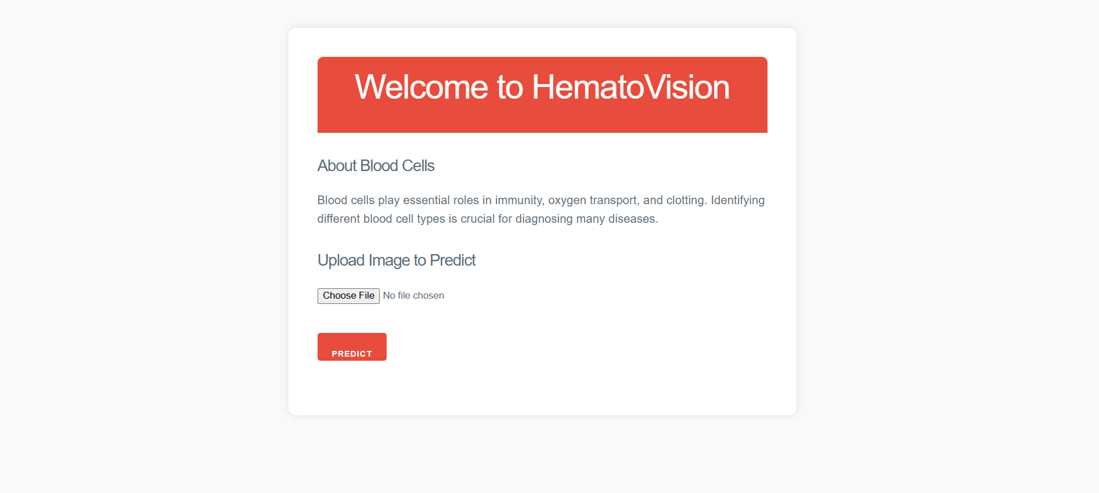

  - Purpose
The project addresses the limitations of traditional diagnostic methods, which are invasive (e.g., liver biopsies), time-consuming (requiring multiple hospital visits), and costly (placing financial burden on healthcare systems and patients). The goals include:
    - Early detection of liver cirrhosis to improve survival rates.
    - Non-invasive prediction using clinical and laboratory data.
    - Personalized healthcare solutions based on predictive analytics.

Ideation Phase
  - Problem Statement

Date | 28 June 2025
Team ID | LTVIP2025TMID44712
Project Name | HematoVision: Advanced Blood Cell Classification Using Transfer Learning Project.
Maximum Marks | 2 Marks

Urban traffic management remains a challenge due to unpredictable congestion spikes, weather disruptions, holiday surges, and limited forecasting tools. Current solutions are often reactive, expensive, or inaccessible to the general public. The need is for an intelligent, anticipatory framework that democratizes traffic prediction for all urban stakeholders.

Problem  Statement (PS) | I am (Customer) | I’m trying to | But | Because | Which makes me feel
PS-1 | A patient at risk of liver disease.I live in a rural area with limited healthcare access.My family has a history of liver conditions | Get early detection of cirrhosis without painful procedures.  Monitor my liver health proactively. | The Current diagnostic methods are invasive (like biopsies) and expensive. | Many cannot afford regular screenings, and symptoms often appear too late.  Urban diagnostic centers are too far and costly to visit regularly. | Anxious about my health and financial burden, and powerless against silent disease progression.

  - Empathy Map Canvas

Date | 28 June 2025
Team ID | LTVIP2025TMID44712
Project Name | HematoVision: Advanced Blood Cell Classification Using Transfer Learning.
Maximum Marks | 4 Marks

What do users THINK & FEEL?
    - Worry about late-stage diagnosis.
    - Stress about invasive procedures.
    - Desire for accurate, early detection tools.
What do users SEE?
    - High costs and delays in diagnosis
    - Limited access to advanced diagnostic tools
    - Confusing or inconclusive test reports

What do users HEAR?
    - Stories of late-stage diagnoses
    - Complaints about invasive tests
    - Dismissive attitudes from providers

What do users SAY & DO?
    - Research non-invasive alternatives
    - Share frustration on patient forums
    - Delay seeking care due to fear

PAIN
    - Irreversible damage before detection
    - Lack of personalized risk communication
    - Rural patients travel 100+ miles for advanced diagnostics

GAIN
    - Early detection
    - Peace of mind through regular monitoring
    - Personalized prevention plans

Requirement Analysis
  - Customer Journey Map
Phases & Steps

Phase | Steps | Interactions | Goals & Motivations | Positive Moments | Negative Moments | Areas of Opportunity
Entice | Learns about the tool. | Sees social media post or doctor's recommendation | Wants early detection | Easy-to-use interface | Skepticism about accuracy | Targeted onboarding with clinician endorsements
Enter | Visits the web app | Lands on input page | Quick risk assessment | Clean UI with familiar medical terms | Confused by "A/G Ratio" field | Tooltips explaining lab parameters
Engage | Submit the data | Enters values and Clicks Predict | Get actionable results | Real-time processing animation | Error if values exceed normal ranges | Auto-validate input ranges
Result | View prediction | Sees High Risk (72%) with color coding | Understand personal risk level | Clear visual feedback | Panics if result lacks guidance | Link to telehealth consultation
Exit | Post-result actions | Shares PDF report with doctor or ignores | Plan next steps clinically | Accurate, useful advice | Doctor dismisses AI prediction | Generate clinician-friendly summaries

  - Solution Requirements (Functional & Non-functional)

Date | 28 June 2025
Team ID | LTVIP2025TMID44712
Project Name | HematoVision: Advanced Blood Cell Classification Using Transfer Learning.
Maximum Marks | 4 Marks
3.2.1 Functional Requirements:
Following are the functional requirements of the proposed solution.

FR No. | Functional Requirement (Epic) | Sub Requirement (Story / Sub-Task)
FR-1 | User Input & Interface | Data entry for clinical/lab parameters
FR-2 | Prediction Engine | ML model integration, real-time prediction
FR-3 | Data Preprocessing | Handle missing values, normalization
FR-4 | Results Display | Show prediction with confidence score

3.2.2 Non-functional Requirements:
Following are the non-functional requirements of the proposed solution.

FR No. | Non-Functional Requirement | Description
NFR-1 | Usability | Clean, Intuitive UI for healthcare professionals
NFR-2 | Security | HIPAA-compliant data handling; secure forms
NFR-3 | Reliability | High prediction uptime, robust fallback
NFR-4 | Performance | <2s response for predictions

  - Data Flow Diagram

Date | 28 June 2025
Team ID | LTVIP2025TMID44712
Project Name | HematoVision: Advanced Blood Cell Classification Using Transfer Learning.
Maximum Marks | 4 Marks

Data Flow Diagram Shows how the data flows in order to show the volume Of the traffic. The below is the data flow diagram that illustrates how the data flows
Flow Chart User Input

Flask Web UI

Data Preprocessing

ML Model (Gradient Boosting)

Liver Cirrhosis Risk Prediction

Output to User
  - Technology Stack

Date | 28 June 2025
Team ID | LTVIP2025TMID44712
Project Name | HematoVision: Advanced Blood Cell Classification Using Transfer Learning.
Maximum Marks | 4 Marks

    - Frontend: HTML5, CSS3, JavaScript (Basic)
    - Backend: Python 3.x (Flask)
    - ML: scikit-learn (Gradient Boosting), pandas, numpy
    - Data Storage: CSV for training; Pickle (.pkl) for model/encoder
    - Deployment: Localhost

Project Design
  - Problem Solution Fit

Date | 28 June 2025
Team ID | LTVIP2025TMID44712
Project Name | HematoVision Prediction
Maximum Marks | 2 Marks

The project provides a non-invasive, scalable, and cost-effective solution for early detection of liver cirrhosis, leveraging machine learning to analyze clinical data.
  - Proposed Solution

Date | 28 June 2025
Team ID | LTVIP2025TMID44712
Project Name | HematoVision: Advanced Blood Cell Classification Using Transfer Learning.
Maximum Marks | 2 Marks

S.No. | Parameter | Description
1. | Problem Statement (Problem to be solved) | Late-stage diagnosis of liver cirrhosis due to reliance on invasive biopsies (painful, 5-10% complication rate) and costly imaging (FibroScan costs $300-$500 per test). Limited access in rural areas (60% of Indian districts lack specialists).
2. | Idea / Solution Description | ML-based web app that predicts cirrhosis risk using 10+ clinical markers (Bilirubin, Albumin, etc.) via:  - XGBoost model (trained on 582-patient dataset)  - Flask UI (input form as in overview.jpg)  - Result interpretation (Risk % + lifestyle recommendations).
3. | Novelty / Uniqueness | Multi-factor integration: Combines routinely tested blood markers (e.g., AST/ALT ratio) ignored in traditional diagnostics.  Explainability: SHAP values show feature contributions (e.g., Bilirubin contributes 30% to risk score).  Deployment: Works offline in low-resource clinics (unlike cloud-dependent solutions)..
4. | Social Impact / Customer Satisfaction | Reduces commuter’s cost for the tests, Improved Healthcare Access, detects the disease early, and the Optimization of the resource. Aggregated anonymized data can help governments identify high-risk regions.

S.No. | Parameter | Description
5. | Business Model (Revenue Model) | Free basic access for the public. Advanced analytics, API integrations, and custom dashboards can be offered as premium features for businesses, municipalities, or logistics providers on a subscription or pay-per-use basis in future
6. | Scalability of the Solution | Designed to be modular and extendable: new data sources, and ML models can be added easily. Can scale horizontally to handle increased user load and integrate with third-party APIs for live data, supporting both rural and urban areas.
  - Solution Architecture

Date | 28 June 2025
Team ID | LTVIP2025TMID44712
Project Name | HematoVision: Advanced Blood Cell Classification Using Transfer Learning.
Maximum Marks | 4 Marks

    - Frontend (HTML/CSS): User input forms, result display, info pages
    - Backend (Flask):
      - Handles HTTP requests, processes user inputs, and serves predictions
      - Handles input validation, encoding, model inference
    - ML Model: Extreme Gradient Boost is prioritized for accuracy, serialized with Pickle
    - Preprocessing: Label encoding, scaling, error handling

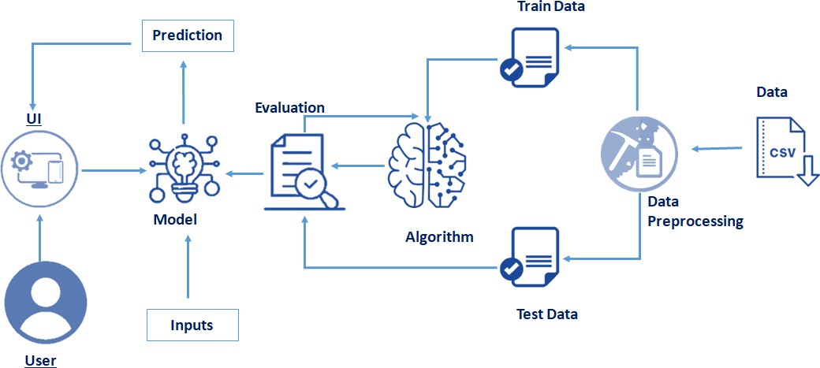

Project Planning & Scheduling

Date | 28 June 2025
Team ID | LTVIP2025TMID44712
Project Name | HematoVision: Advanced Blood Cell Classification Using Transfer Learning.
Maximum Marks | 5 Marks

Product Backlog
Member 1 -> Data Preprocessing Member 2 -> Model Building Member 3 -> Frontend Member 4 -> Backend

Epic (Functional Requirement) | User Story Number | User Story / Task | Story Points | Priority | Assigned To
Data Collection | USN-1 | Gather and load historical traffic/contextual data | 2 | High | Member 1
Data Preprocessing | USN-2 | Preprocess data (handle missing/categorical  values) | 3 | High | Member 1
Model Building | USN-3 | Build ML model for traffic prediction | 5 | High | Member 2
Model Evaluation | USN-4 | Test and evaluate the ML model | 3 | High | Member 2
Backend API | USN-5 | Develop Flask backend and REST API | 4 | High | Member 4
Frontend/Dashboard | USN-6 | Implement user-friendly web dashboard  (HTML/CSS/JS) | 4 | Medium | Member 3
Integration | USN-7 | Integrate backend API with frontend | 2 | High | Member 3,  Member 4

Epic (Functional Requirement) | User Story Number | User Story / Task | Story Points | Priority | Assigned To
Scenario Simulation | USN-8 | Allow users to simulate cirrhosis risk for hypothetical health scenarios | 2 | Medium | Member 2  Member 4  Member 3

Sprint Schedule & Estimation
Sprint-1 (10 June – 15 June)

User Story Number | Task | Story Points | Assigned To
USN-1 | Data collection and loading | 2 | Member 1
USN-2 | Data preprocessing (missing/categorical) | 3 | Member 1
USN-3 | Model building | 3 | Member 2
 | Total | 8
Sprint-2 (16 June – 21 June)

User Story Number | Task | Story Points | Assigned To
USN-4 | Model evaluation | 3 | Member 2
USN-5 | Backend API scaffolding & endpoints | 3 | Member 1
USN-6 | Frontend dashboard basic layout | 2 | Member 3
USN-7 | API-frontend integration | 2 | Member 3,  Member 4
 | Total | 10

Sprint-3 (22 June – 28 June)

User Story Number | Task | Story Points | Assigned To
USN-6 | Frontend UI enhancements | 2 | Member 3
USN-8 | Scenario simulation logic | 2 | Member 2,  Member 4
USN-9 | Feedback/contact form | 1 | Member 3
USN-10 | Documentation | 2 | All
 | Polish, bug fixes, final testing | 2 | All
 | Total | 9
Total Story Points: 8 + 10 + 9 = 27

Velocity
Total Story Points =27
Total Number of Sprints =3 Velocity = 27/3 =9
Team’s Velocity is 9

Sprint Tracker

Sprint | Story Points Planned | Story Points Completed | Start Date | Planned End Date | Actual End Date | Comments
Sprint- 1 | 8 | 8 | 10-Jun-  2025 | 15-Jun-  2025 | 15-Jun-  2025
Sprint- 2 | 10 | 10 | 16-Jun-  2025 | 21-Jun-  2025 | 21-Jun-  2025
Sprint- 3 | 9 | 9 | 22-Jun-  2025 | 28-Jun-  2025 | 28-Jun-  2025

- Performance Testing

Date | 28 June 2025
Team ID | LTVIP2025TMID44712
Project Name | HematoVision: Advanced Blood Cell Classification Using Transfer Learning.
Maximum Marks | 10 Marks

S.No. | Paramater | Values | Screenshot
1. | Metrics | Regression Model:  Accuracy - ,  Precision - ,  Recall - ,  F1 Score - | 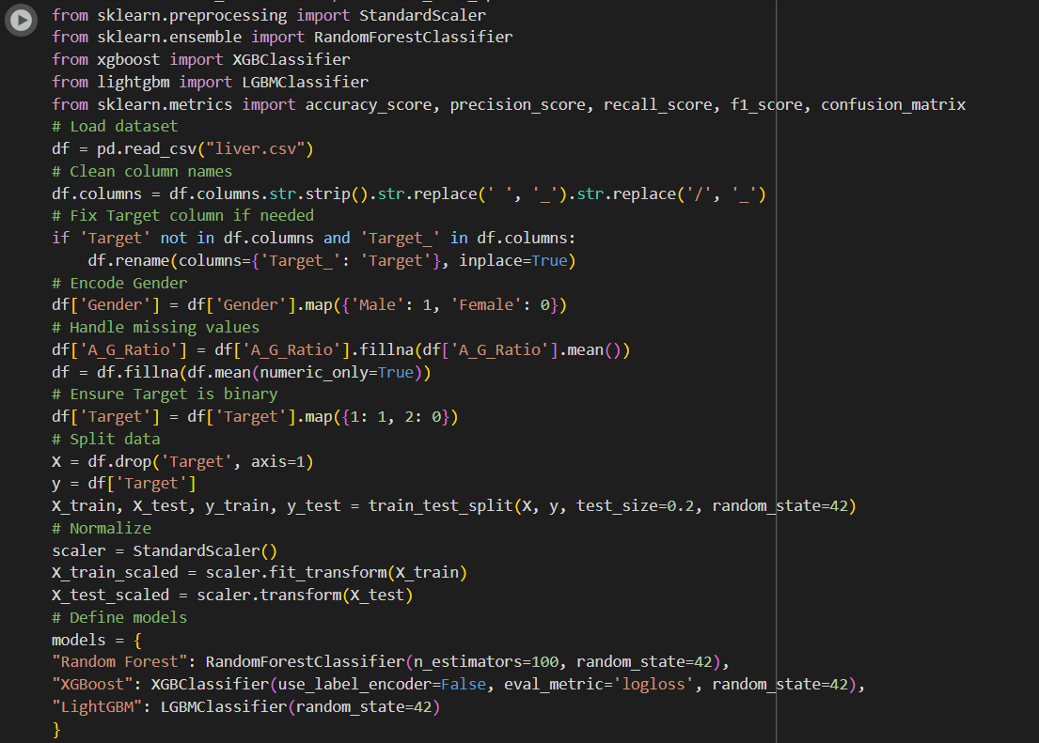
2. | Tune the Model | Hyperparameter Tuning - Validation Method | 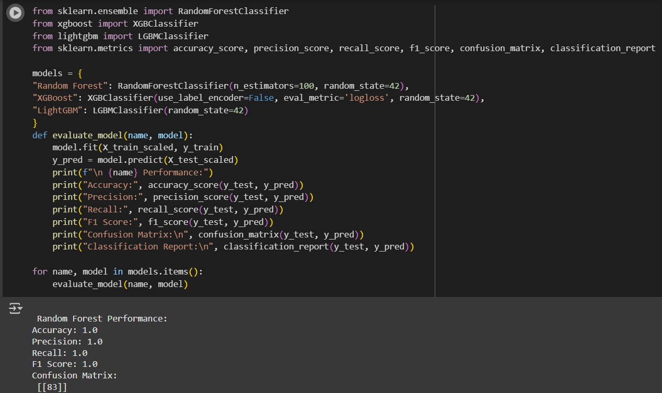

- Results
  - Model Performance

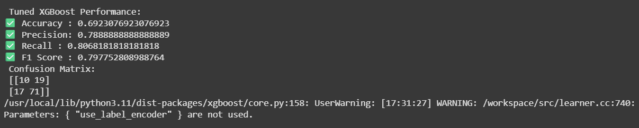

- Prediction sample:
  - Input:

  - Output:
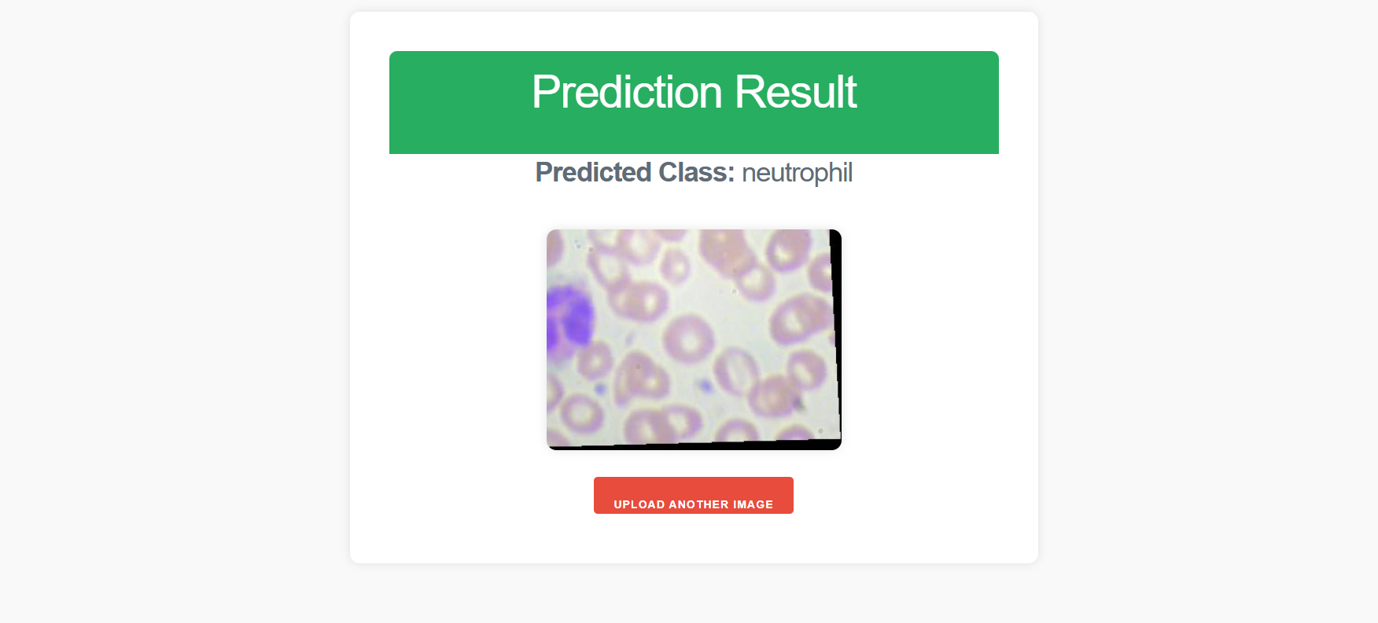

  - User Interface
- Overview

Advantages & Disadvantages
  - Advantages
    - Real-time, accurate predictions
    - Low-cost, scalable solution
    - Intuitive web interface
    - Extensible for future enhancements

  - Disadvantages
    - ML model accuracy depends on data quality/coverage
    - Requires basic digital literacy

Conclusion
The HematoVision: Advanced Blood Cell Classification Using Transfer Learning project successfully demonstrates the potential of machine learning in transforming early diagnosis and proactive healthcare. By leveraging non-invasive clinical data, the system provides accurate and accessible risk assessments, addressing critical limitations of traditional diagnostic methods such as high costs and late-stage detection.

Future Scope
- Advanced Features(Live risk monitoring)
- Mobile app development
- Multi-Language Support
- Adapt model for HBV/alcohol-related cirrhosis in other regions
- Direct API links to hospital records

Appendix
Source Code
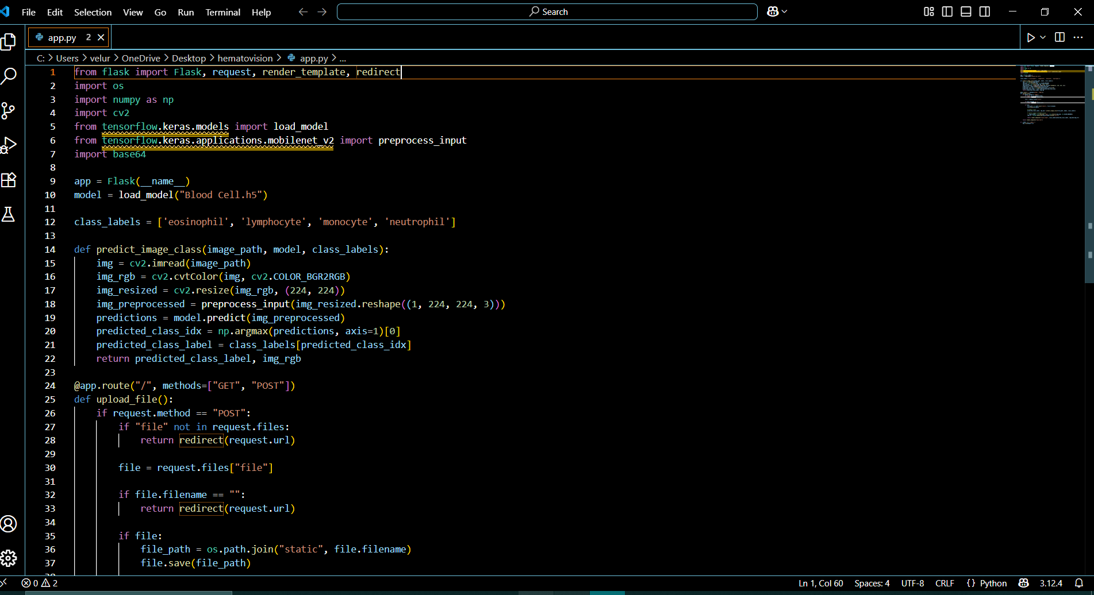
  - Main.py
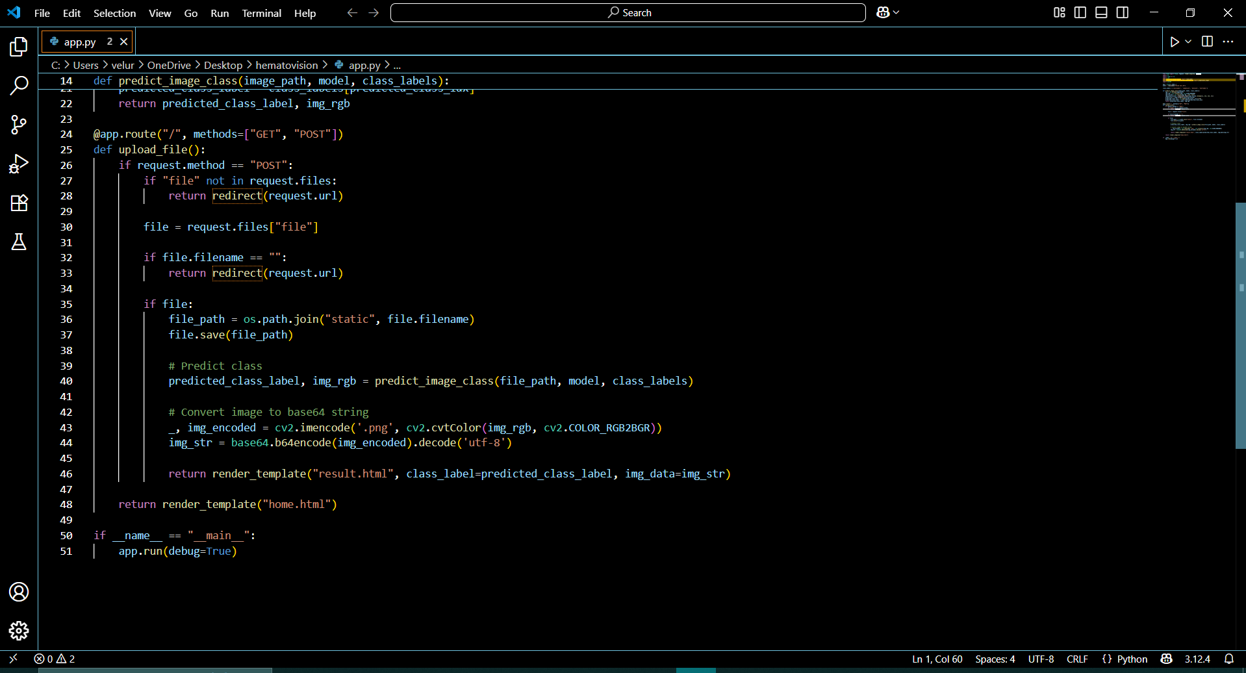

  - app.y

The End

