WordWeft Website Design Reference
The current visual direction for WordWeft’s landing, account, browse, search, story details, and reader exploration. Use the approved page decisions as the visual baseline; the reader concepts below remain open for selection and refinement.

Landing page
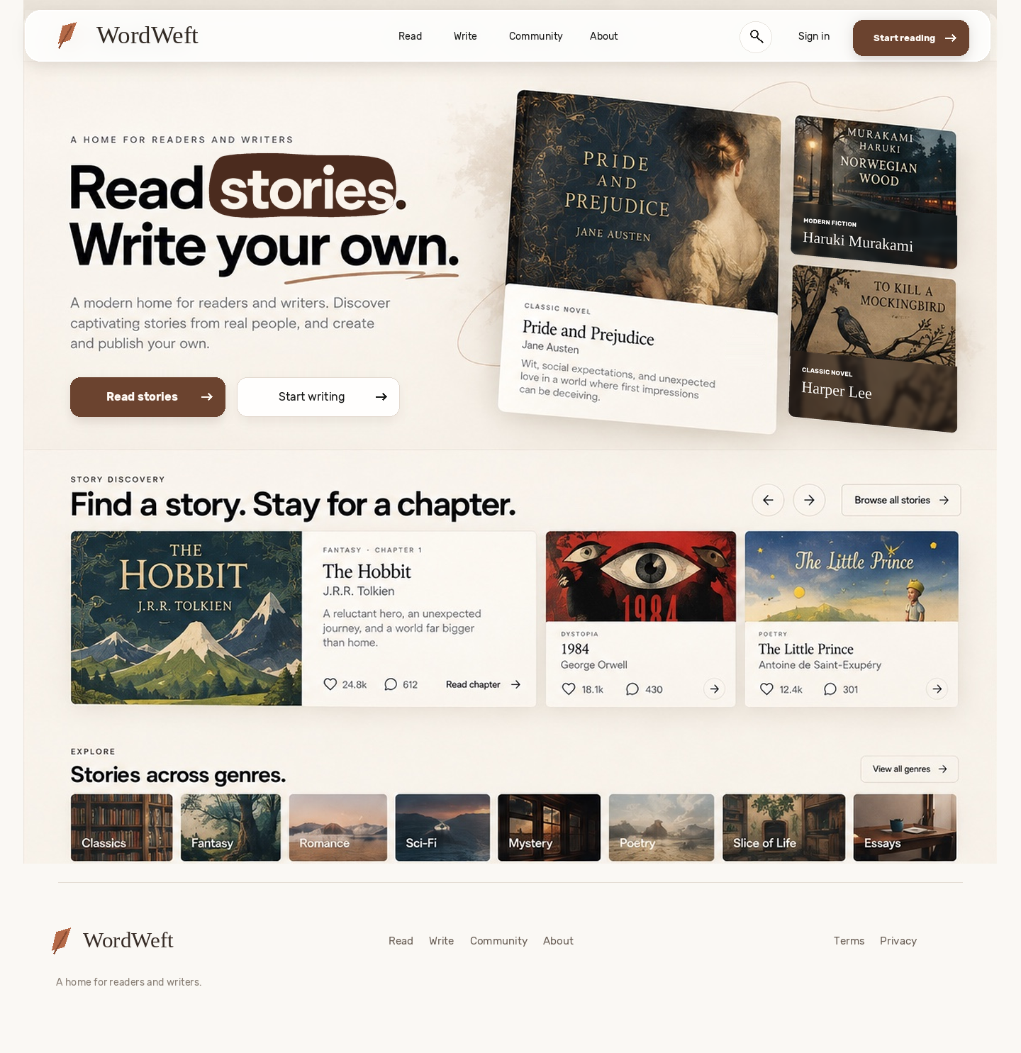
Current reviewed landing page, 27 September 2026. Further refinements are expected.

Landing page decisions
Composition. A warm paper canvas, generous space, a clear reading and writing path, and a right-side cluster of three story covers. Keep the faint line work and subdued brown atmosphere behind the hero. The bottom story discovery, genre tiles, and restrained footer follow the pictured arrangement.
Navigation. The top bar floats above the canvas with a softly translucent, lightly blurred surface. Background detail should remain faintly visible through it. Its corners are generous and its separation from the page is subtle.
Hero headline. Use the strong Rubik-style sans-serif headline. “Stories” sits in an irregular, flat dark-brown shape with light lettering; the full stop sits outside it. In the working site, cycle Stories, Novels, Poems, and Essays through this same place with a short vertical transition. Keep the heading legible while motion is paused and provide a reduced-motion state.
Hero covers. The three covers are visual storytelling elements, not buttons. Do not show arrows on them. The large cover retains its editorial caption. The two small covers retain their own cover-title artwork, with the genre and author placed on a restrained dark glass layer at the bottom. Follow each cover’s slight angle, preserve smooth rounded edges, and avoid repeated titles or visible white caption remnants.
Actions. Use the naturally lifted brown primary and pale secondary buttons established on the account pages. Lift comes from restrained surface separation and a very short contact shadow, without a thick base, bevel, glow, or mechanical button effect.
Story discovery and genres. Preserve the current illustrated cover imagery in story discovery and the natural image-backed genre strip. Keep edges soft and avoid turning every item into a heavy, hard-cornered box.
The landing image is a visual reference, not a working responsive or motion specification. Story titles and counts shown in the mockup are illustrative.

Shared design language
Character. Quiet editorial layout, warm paper tones, dark readable type, and deliberate white space. The account screens remain the strongest reference for forms, typography, and buttons.
Color. Account surfaces use paper #FBFAF7, ink #171817, muted copy near #77726E, and warm brown #6B432F for primary actions and links. The landing accent behind “Stories” uses a deeper flat brown near #4B2B1E.
Typography. Rubik is the primary sans serif for headings, labels, fields, and controls. The WordWeft wordmark and story-cover details provide restrained serif contrast. Avoid adding decorative font families.
Arrow controls. Use the softly translucent circular arrow control established on the landing and browse pages for small forward or browse actions, including search result rows and related links. Keep its fine border, modest size, and restrained brown arrow. The arrow inside a filled primary button remains inline with its button label.
Imagery. Use real or public-domain artwork with a clear source. The account-page artwork strip uses three Metropolitan Museum of Art Open Access prints, object IDs 53681, 45294, and 55020. Avoid AI-generated illustration and decorative physical book stacks.

Create account
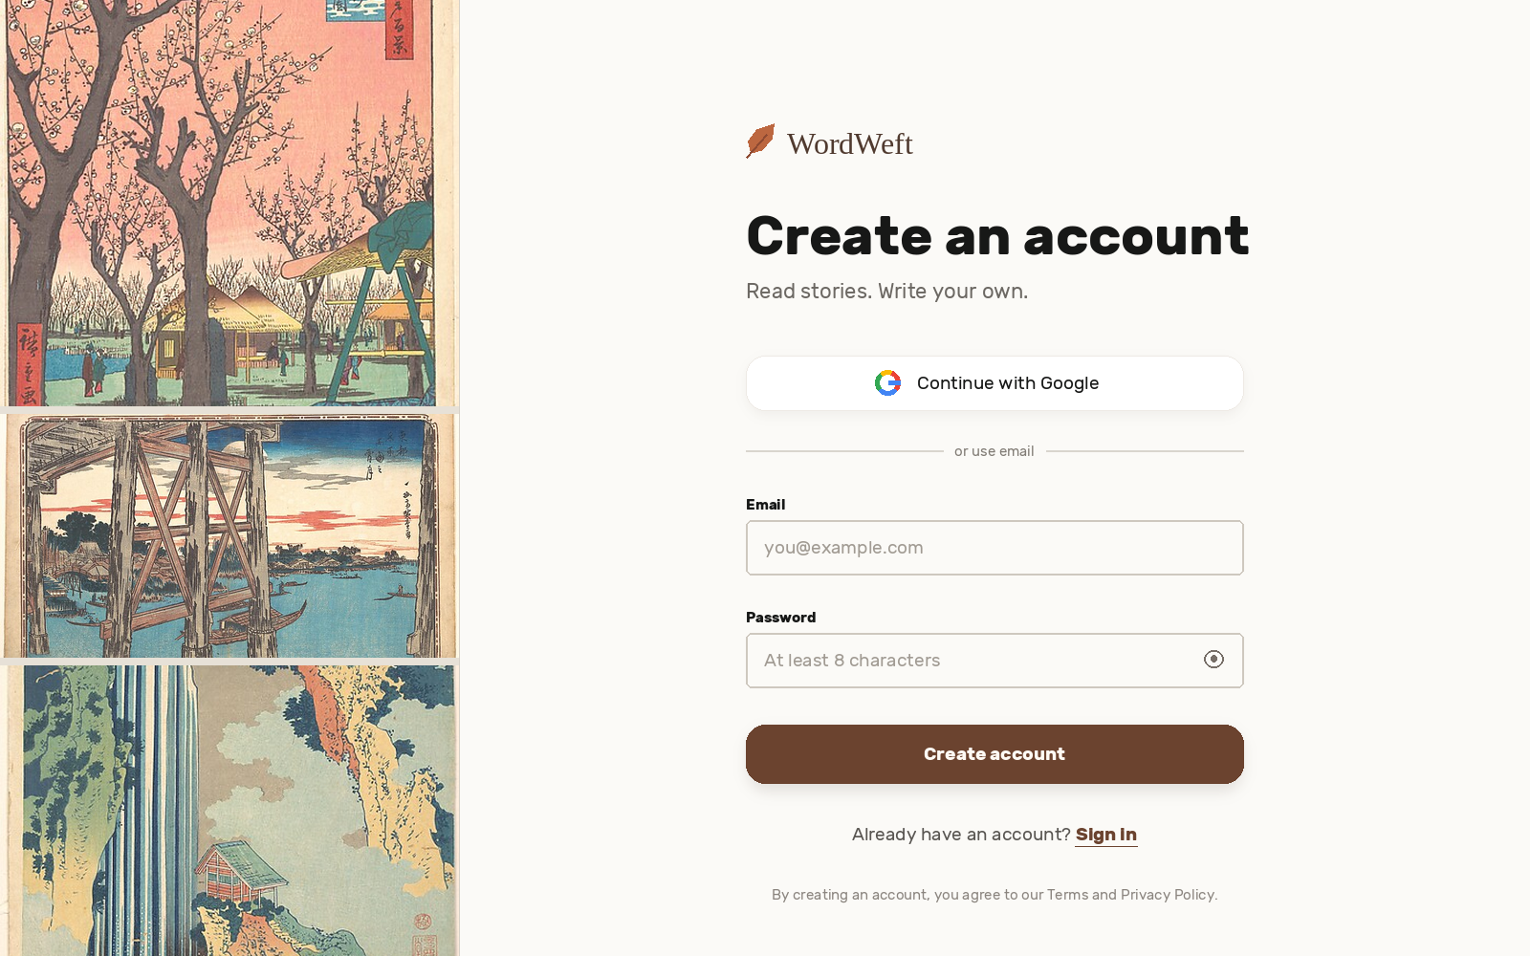
Approved create-account screen, 1600 × 1000 concept image.
Layout. Artwork fills roughly 30% of the left side. The form occupies the generous right side without a surrounding card.
Form. Wordmark, direct heading and one-line subtitle, Google option, email divider, labeled email and password fields, primary action, sign-in link, and short terms line. Labels remain visible outside fields.
Buttons. A full-width warm-brown primary button and a white Google button. Rounded corners and a very short, soft contact shadow create a natural lift. No bevel, thick base, glow, hard shadow, or mechanical pressed-button effect.

Sign in
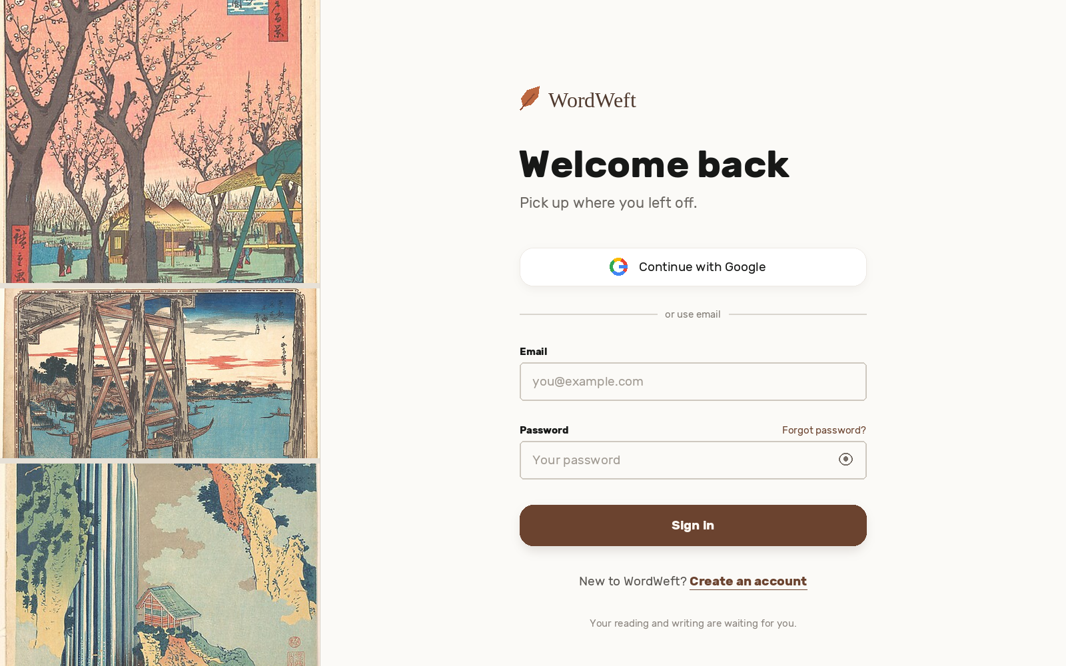
Approved sign-in screen, 1600 × 1000 concept image. Preferred reference for future account pages.
Form. Keep the same grid, field sizes, spacing, typography, artwork strip, and button treatment as Create account. Change only the heading, subtitle, password help, action, account-switch link, and closing line.
Controls and motion. The eye icon is functional. Focus, error, loading, and mobile states still need interaction design. Any artwork transition or button response should be small and respect reduced-motion settings.
Future edits. Record an approved change here and apply it consistently to relevant pages. Keep approval specific to the area discussed. Do not treat illustrative story titles or artwork as real catalogue claims.

Browse stories
Current browse-stories concept, 27 September 2026. Use this image as the page-layout reference for now; production artwork must still follow the sourced, human-made imagery rule below.
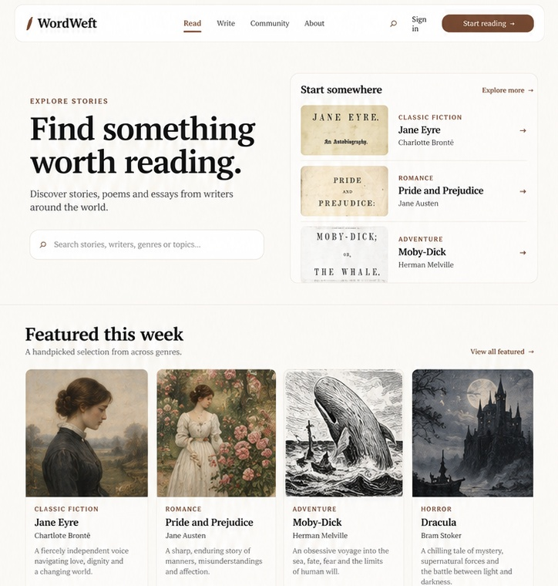
Browse-stories page, upper section: navigation, discovery hero, Featured this week, and the beginning of Browse by genre.

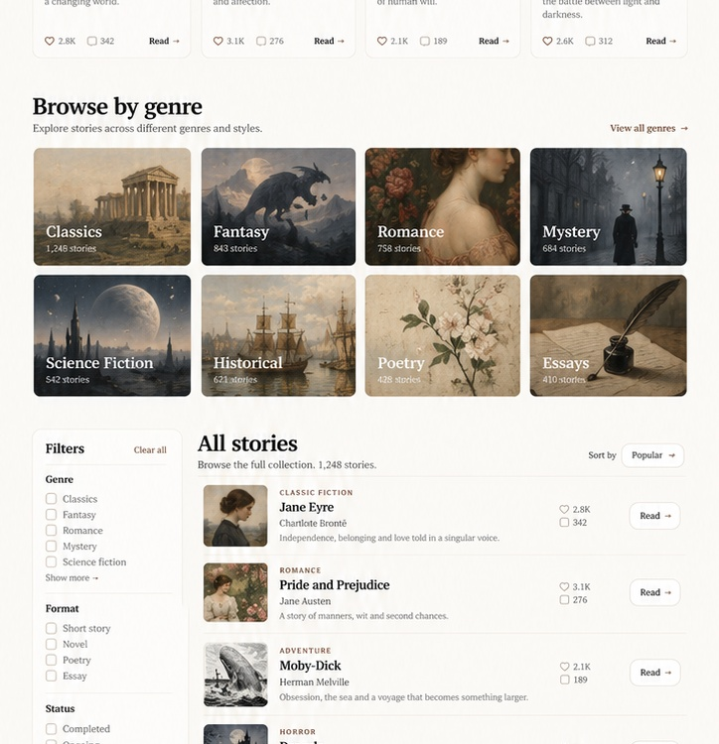
Browse-stories page, middle section: Browse by genre, filters, and the main story catalogue.
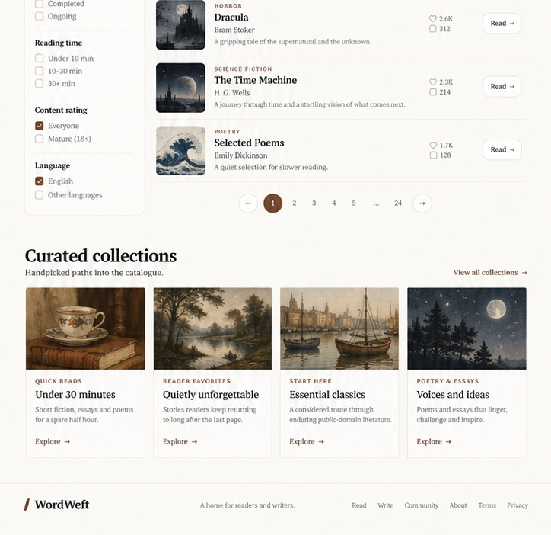
Browse-stories page, lower section: continuation of the catalogue, pagination, curated collections, and footer.

Browse stories decisions
Purpose. This is the main discovery page for stories, poems, essays, and other readable work. It should feel like a reading catalogue rather than a physical-book shop.
Hero. Keep the hero quiet and useful: “Find something worth reading.”, one short supporting line, a prominent search field, and a restrained “Start somewhere” panel. Do not use physical-book stacks, 3D books, or decorative landscape backgrounds.
Page order. Featured this week appears before Browse by genre. The catalogue follows beneath with filters and sorting, then curated collections and the standard footer.
Filters and sorting. Use filters for genre, format, status, reading time, content rating, and language. Sorting belongs with the full catalogue and should stay compact, with options such as Popular, Newest, and Recently updated.
Story presentation. Story content is shown as flat digital/editorial cards and rows, never as photographed or rendered physical books. Engagement metadata stays secondary to title, author, format, and description.
Imagery. Use only existing human-made artwork, historical scans, or other clearly sourced real imagery. Never generate covers, genre art, author portraits, hero art, or decorative artwork with AI. Genre artwork should meaningfully communicate the category rather than act as random decoration.
Design language. Continue the warm paper canvas, Rubik-led typography, dark readable ink, warm brown actions, rounded surfaces, restrained shadows, and generous spacing established elsewhere in this reference.
Canva reference. Open the current Browse Stories design in Canva. The Canva version is the source of truth for the exact final artwork placements and sourced visual assets.
Future edits. When this page changes, update the Canva design and this reference together. Do not treat illustrative story counts, engagement numbers, or placeholder catalogue entries as production data.

Search
Desktop search concepts, 27 September 2026. These show the initial search page and an active query with mixed story and writer results. The examples and counts are illustrative.
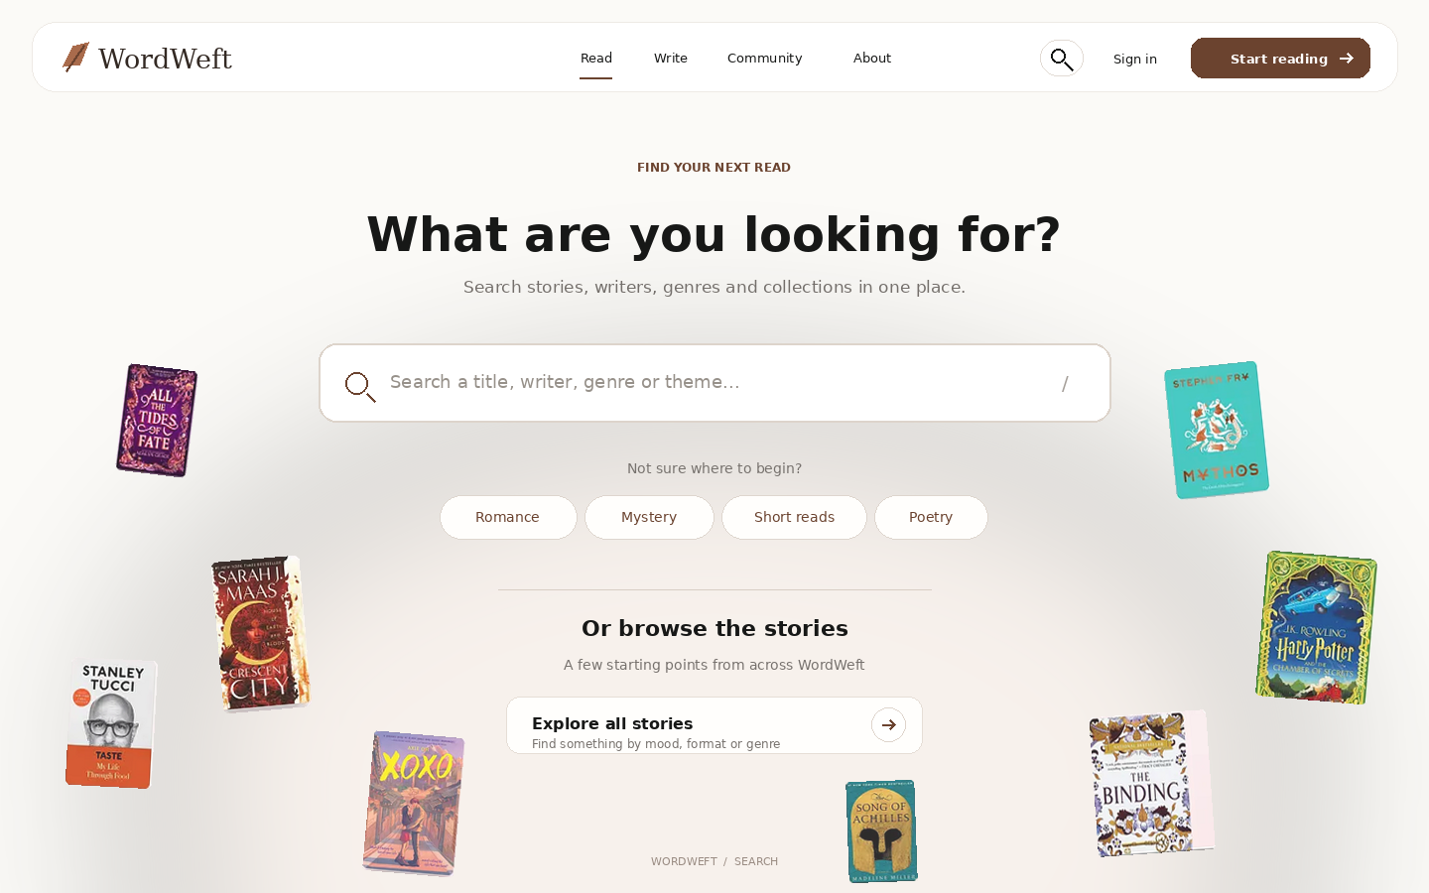
Initial state: a prominent universal search field, a few genre shortcuts, and flat cover images around the edges. The central search field remains clear and usable.

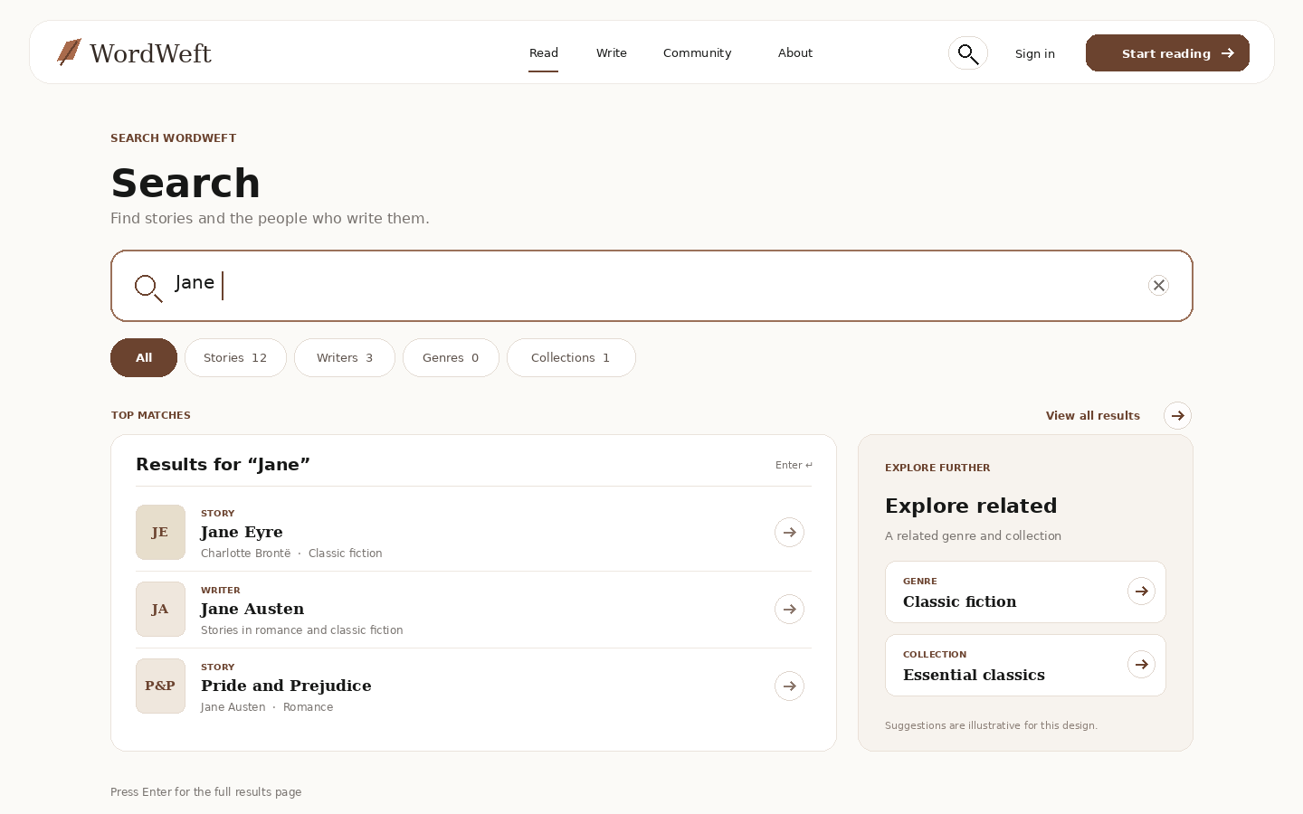

Search decisions
Scope. The field searches story titles, writers, genres, collections, and relevant themes. The typed state groups matching content and offers category tabs. Related genres or collections are labeled separately from direct matches.
Consistency. Use the same floating navigation, warm paper background, dark ink, warm brown accent, Rubik-led headings and controls, restrained serif treatment for story titles and the wordmark, soft corners, and short shadows as the approved pages. The search page uses the shared circular arrow control for result rows and secondary browse links.
Imagery. The scattered covers are flat, static cutouts based on the supplied inspiration screenshot. They are visual atmosphere, not shop products or clickable book objects. Replace illustrative cover cutouts with individually sourced, human-made assets before production; do not generate imagery with AI.
Interaction. The blank state offers direct search and browse shortcuts. Typing moves attention to suggestions and matching content. Enter opens the full results view; a clear control removes the query. Keep keyboard focus visible and ensure category tabs, results, and clear controls are reachable with a keyboard.
Responsive behavior. On narrow screens, reduce or remove edge imagery, keep the search field and suggestions full width, and stack related suggestions below the direct matches. Do not let cover imagery obscure controls.
Status. These two desktop images are the current search concepts. Search result counts, example writers, titles, and collections shown are mock content, not catalogue claims.

Story details page
Current editorial split direction, 27 September 2026. The same story page has a new reader state and a returning reader state. These visuals are for review; story and engagement data are illustrative.
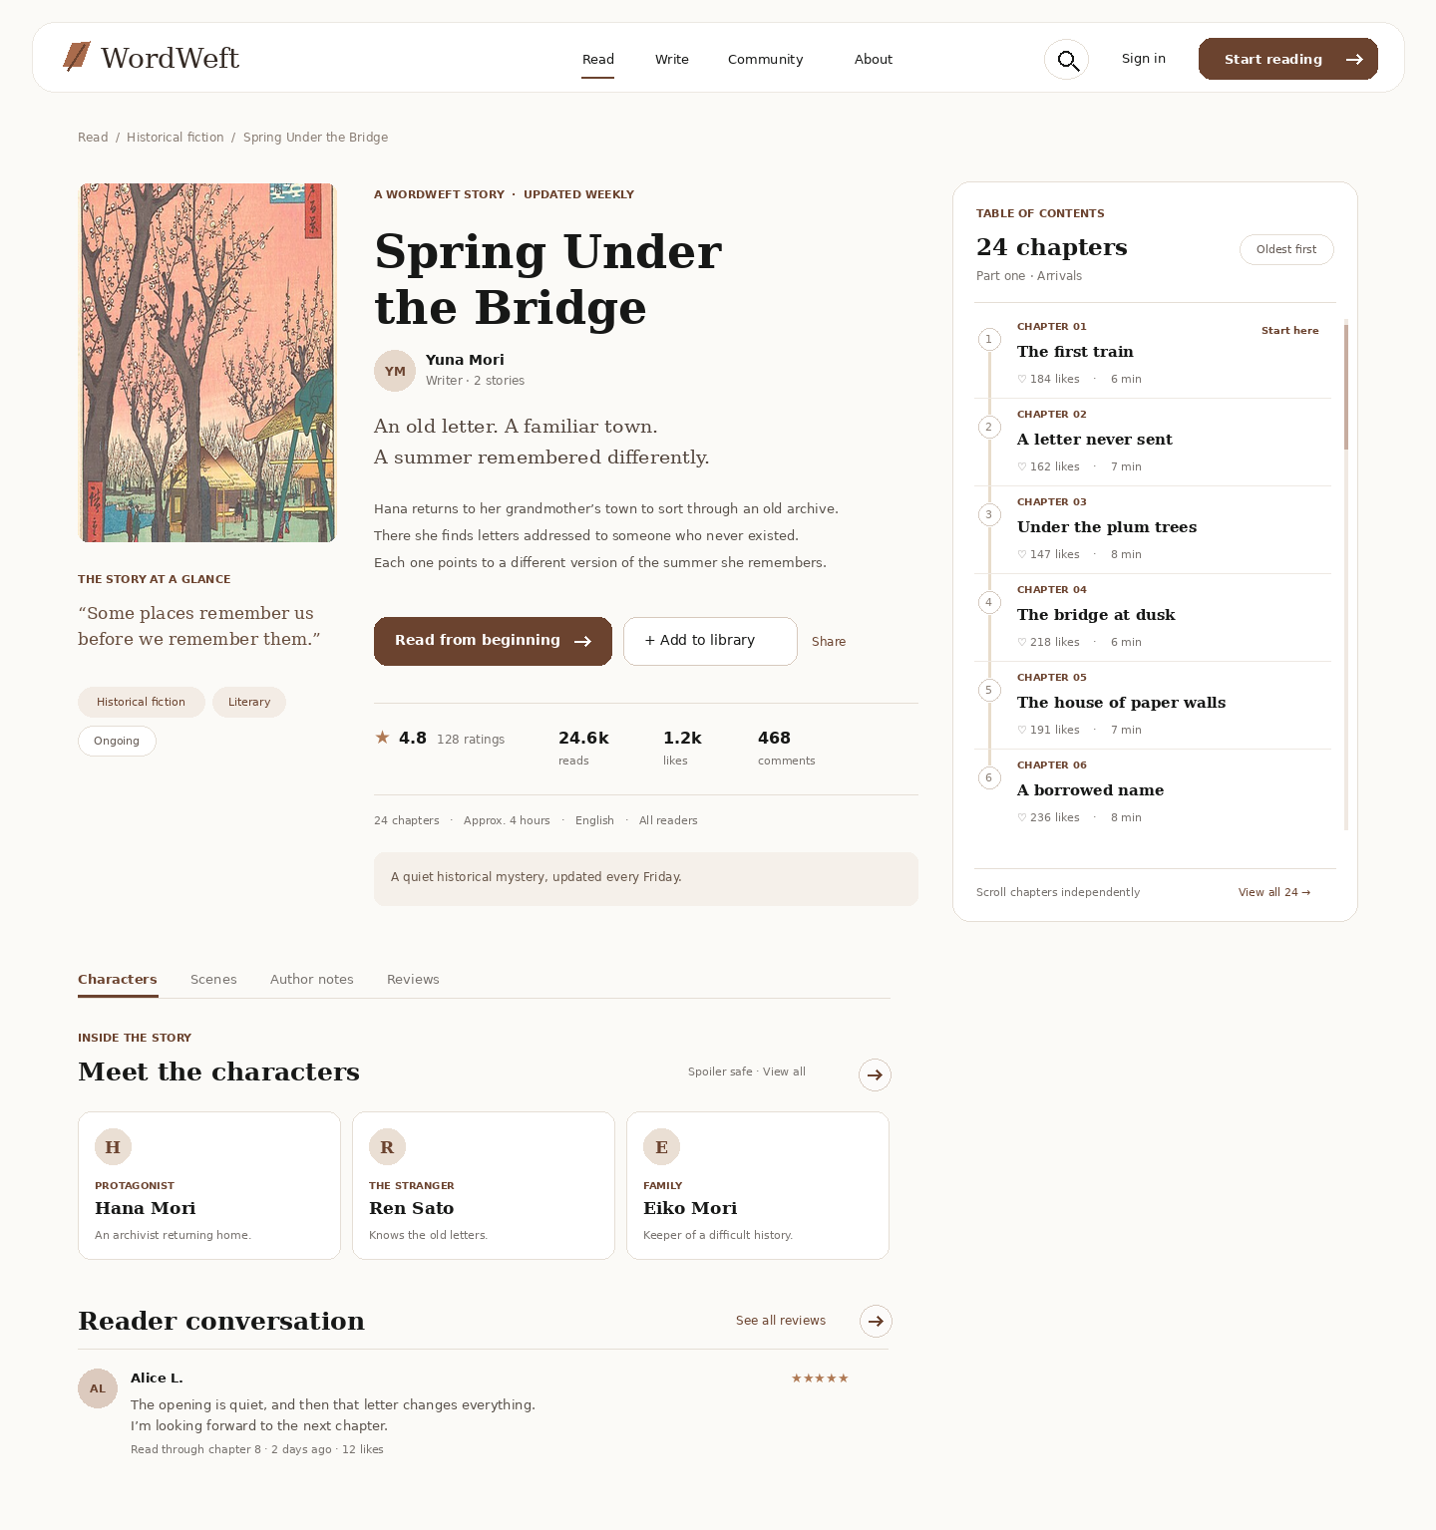
New reader: the first chapter is the starting point. The story action reads “Read from beginning,” with Add to library and a labeled Share action alongside it.

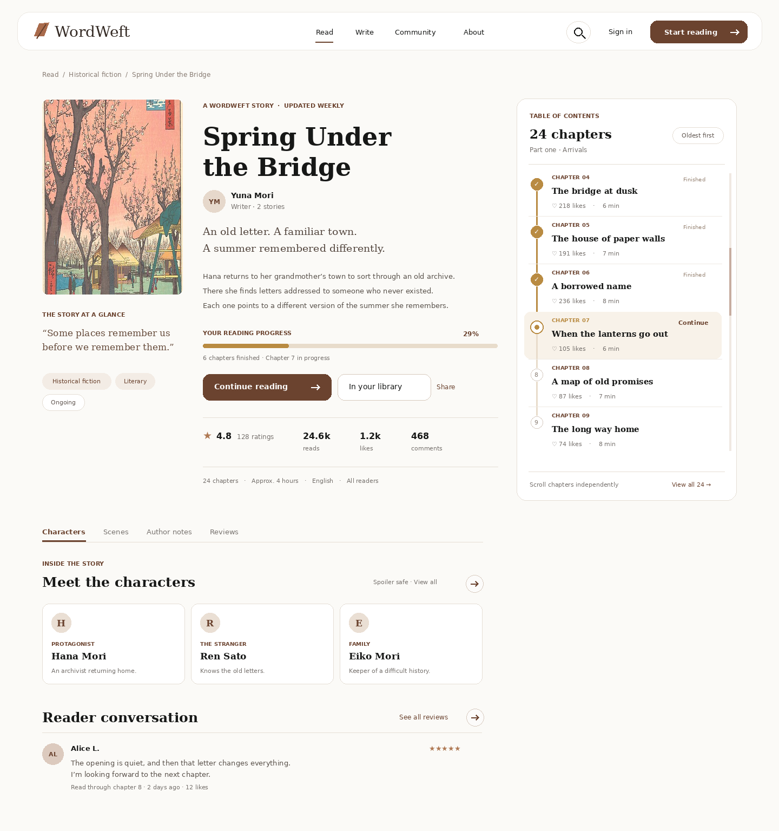
Returning reader: the action becomes “Continue reading.” Overall progress and the current chapter are visible, and completed chapters are marked on the chapter rail.

Story details decisions
Layout. Use the editorial split: flat story artwork and quick context at left, title, author, synopsis, actions and metrics in the centre, and the chapter list in the right rail. The page continues down to characters, scenes, public author notes, and reader conversation.
Chapter list. On desktop, the chapter area has its own bounded scroll region while the page itself scrolls to lower sections. Rows have room for number or completion marker, title, reading time, and chapter likes. Use a gentle scrollbar and a link to the complete contents. The list can start at Chapter 1 for new readers and near the current chapter for returning readers.
Reading state. For returning readers, use a subdued warm gold progress line that fits WordWeft’s brown palette. Completed chapter markers use the same gold, the current chapter has a distinct outline and surface tint, and unread chapters remain neutral. The overall percentage and “chapters finished” line accompany the progress bar.
Actions. Keep one clear primary reading action. Add to library or In your library is secondary. Share must be labeled; do not place an unexplained arrow button after the library action. Existing small circular arrow controls remain appropriate for browse and view-all links.
Story guide and safety. Characters, scenes, and author notes are separate tabs below the hero. Show only published, reader-facing notes. If guide details reveal plot, gate them to the reader’s chapter progress or mark them clearly as spoilers.
Imagery and data. The concept uses the historical Japanese print already present in the approved account artwork strip. Production story artwork needs its own human-made source and permission or open-access status. Names, chapter counts, likes, ratings, and comments in these concepts are mock content.

Chapter reading exploration
Three desktop directions and one chapter-end state for review, 27 September 2026. The prose and engagement numbers are illustrative. None of these reader variants is marked as selected.

Quiet paper
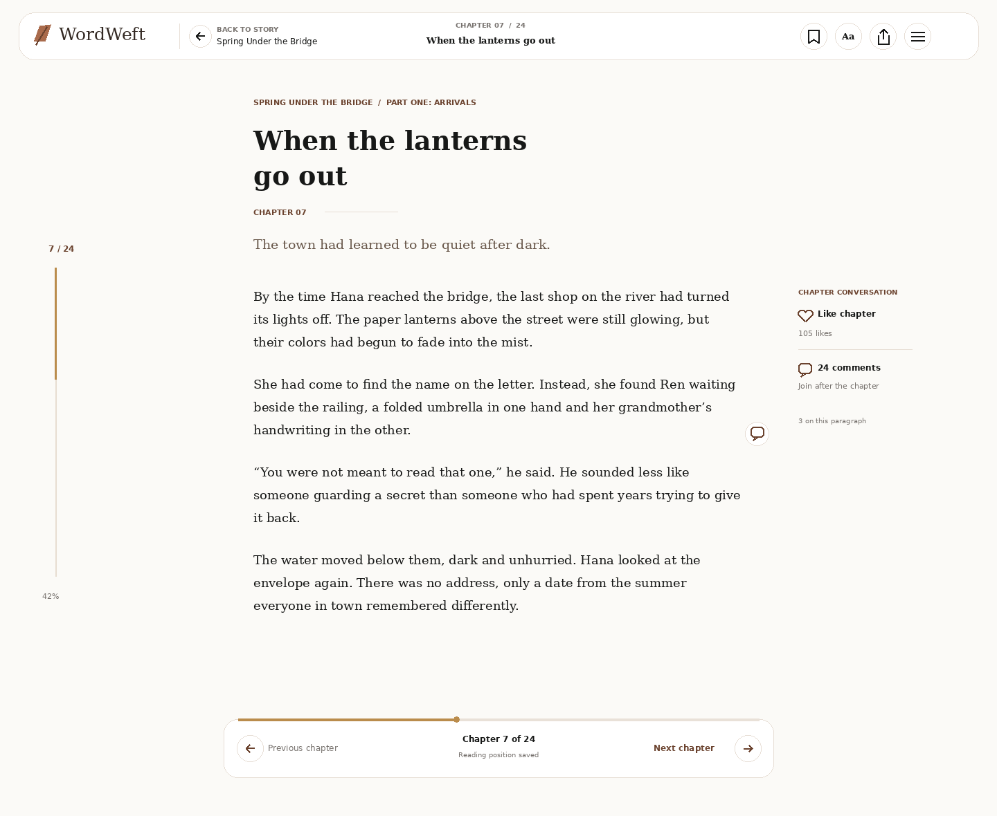
The chapter owns the screen. A readable central column, restrained position rail, margin paragraph-comment marker, chapter like and comment actions, and a small previous/next dock leave the surrounding space calm.

Companion
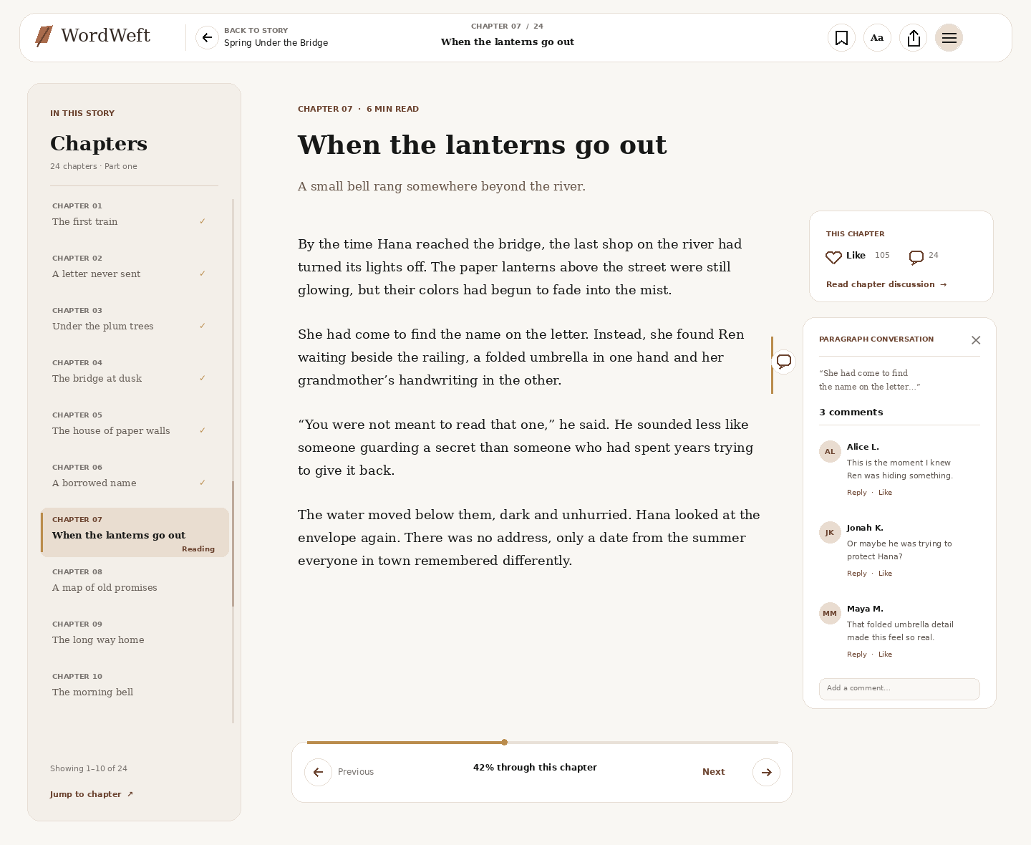
A separately scrolling chapter index stays at left. A selected paragraph opens its discussion to the right while the paragraph remains visible. Chapter-level likes and discussion live above that thread.

Night and preferences
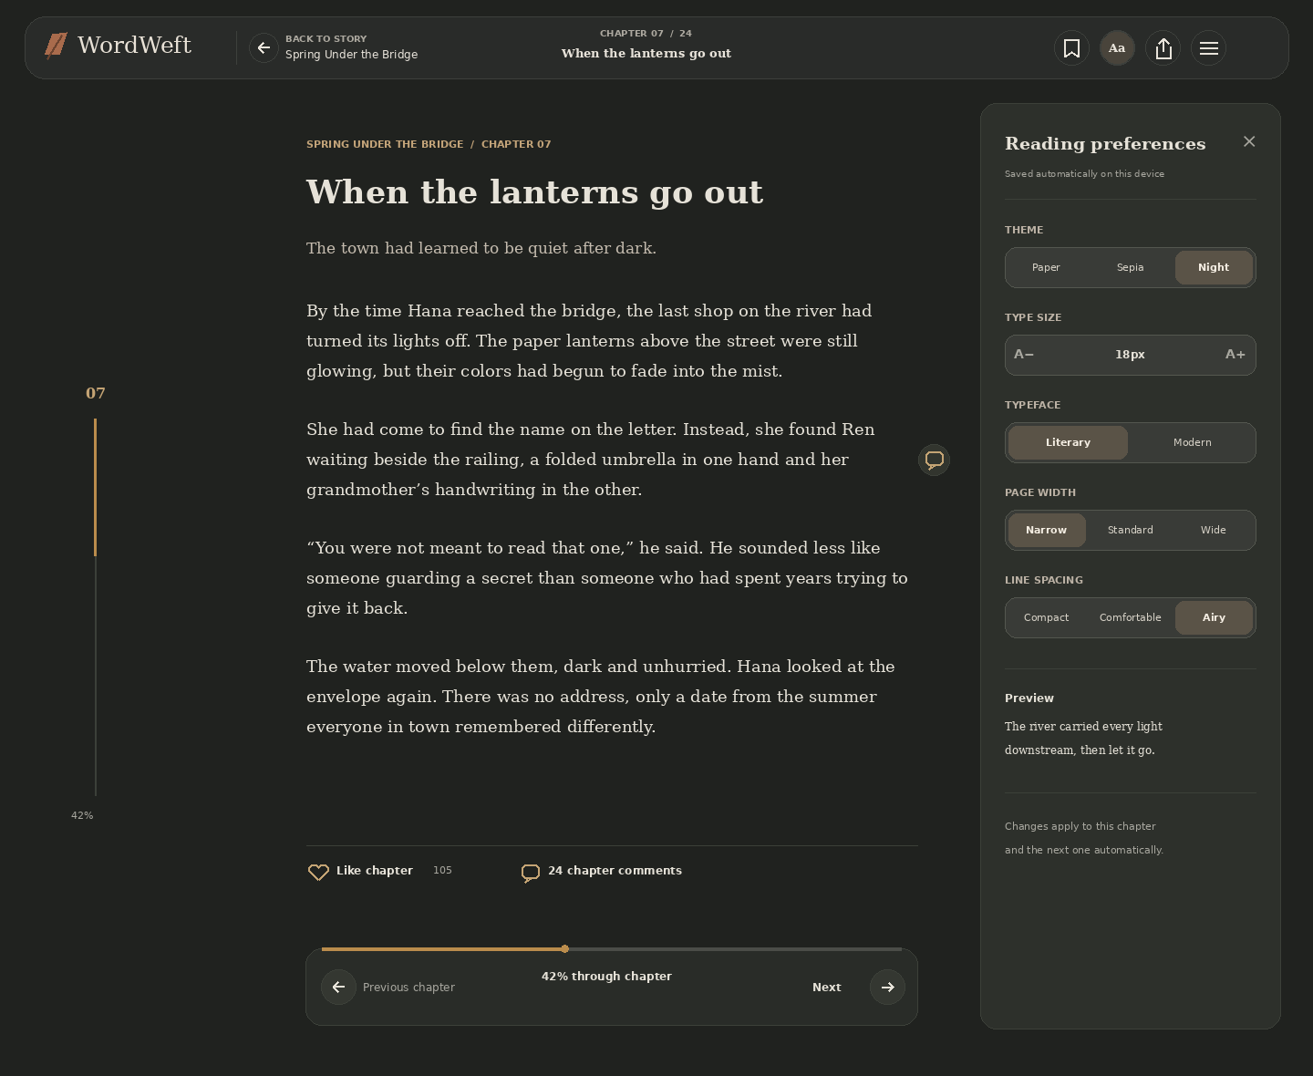
The dark theme shows the same reading structure with the desktop preference panel open. It carries the mobile choices: Paper, Sepia, Night; type size; Literary or Modern; Narrow, Standard, Wide; Compact, Comfortable, Airy. Preferences save automatically on this device.

Chapter end and discussion
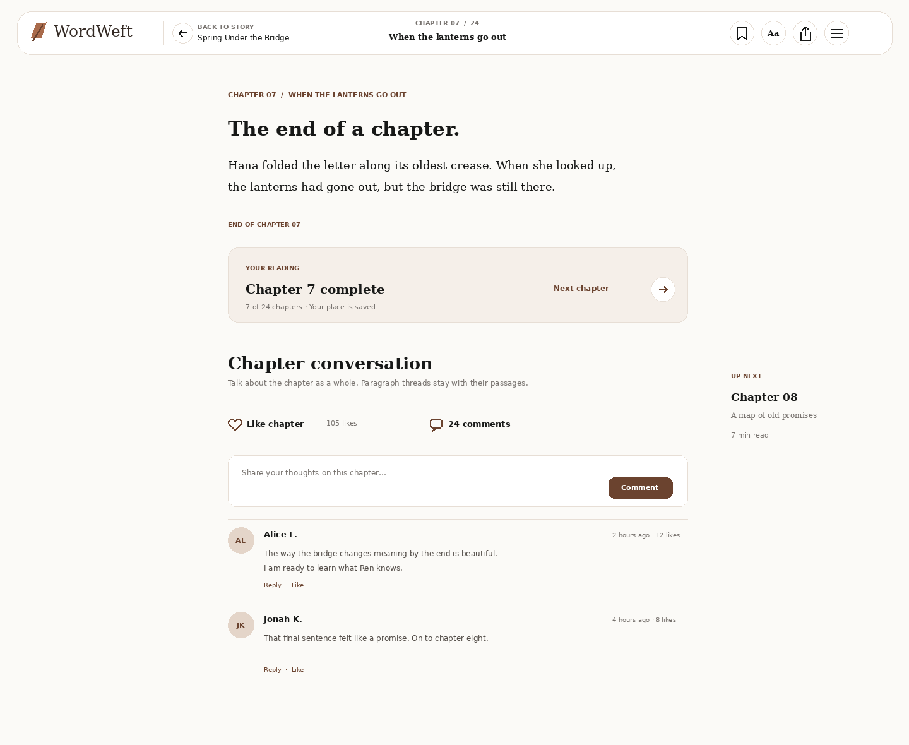
The chapter ends before the larger discussion surface. Completion, next chapter, a chapter like, a comment composer, and chapter comments become visible without interrupting the prose above.

Reader interaction notes
Navigation. Back to story returns to the book details page. The chapter index opens from the list icon, while previous and next chapter actions remain labeled and use the established translucent circular arrow control.
Discussions. A chapter like and chapter comments belong to the whole chapter. Paragraph-specific markers belong in the outer text margin and open a contextual thread anchored to the selected paragraph. Keep the reading position when the thread opens or closes.
Reader controls. The Aa control opens the five groups shown in the supplied mobile screenshot. A narrower central measure remains useful on desktop; the spare width can hold optional context or a thread rather than stretching the prose.
Progress and spoilers. A subtle warm gold line indicates the current chapter position. Chapter completion and saved place are distinct. Story context and reader comments should respect progress and make spoiler disclosure deliberate.

