

Integration Guide for GPT-4o-mini and MongoDB

December 30

Eparampara Technologies
Authored by: Velvizhi S

Table of Contents

- Introduction
- Prerequisites
- Libraries Required
- Step-by-Step Integration

Step 1: Set Up MongoDB Connection
Step 2: Fetch Data from MongoDB
Step 3: Set Up GPT-4o-mini API Access
Step 4: Integration Workflow
Step 5: Flask API Implementation

- Enhancements
6. Testing
7. Troubleshooting

Introduction

This document outlines the steps to integrate the GPT-4o-mini model with a MongoDB database for data retrieval and natural language processing. The guide is designed to assist developers in building robust workflows for data-driven applications.

Prerequisites
✅ MongoDB Instance: Ensure you have a running MongoDB instance with a database and collection set up.

🐍 Python Environment: Set up a Python environment with the required libraries installed.

🔑 API Access: Access to the GPT-4o-mini model API (or your local model setup).

🌐 Flask Framework: Ensure Flask is installed for building the API.
Libraries Required

pip install pymongo
pip install openai
pip install flask python-dotenv

Step-by-Step Integration

Step 1: Set Up MongoDB Connection
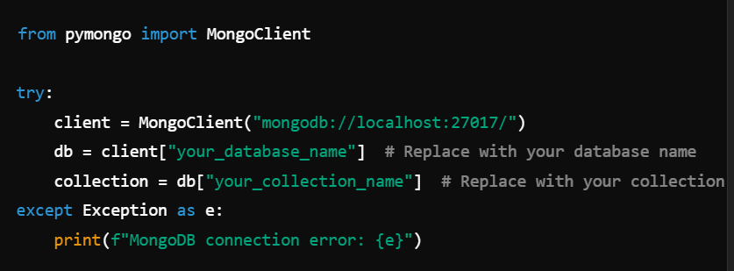

Step 2: Fetch Data from MongoDB
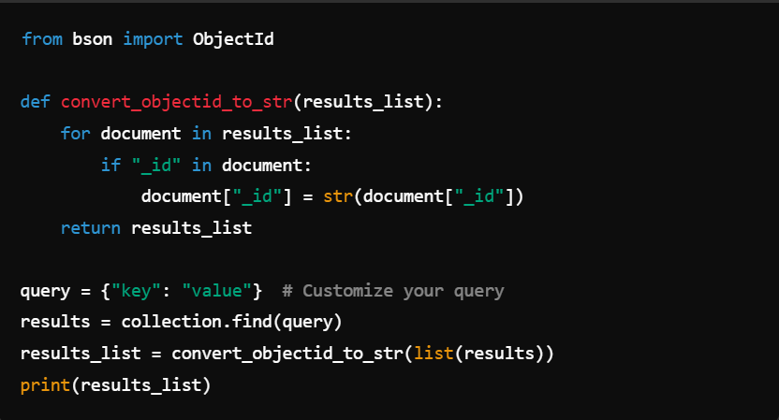
Step 3: Set Up GPT-4o-mini API Access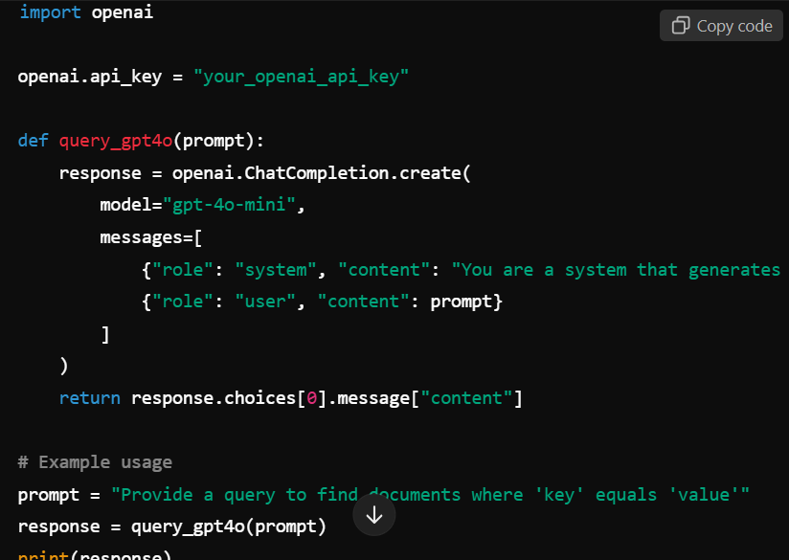
Step 4: Integration Workflow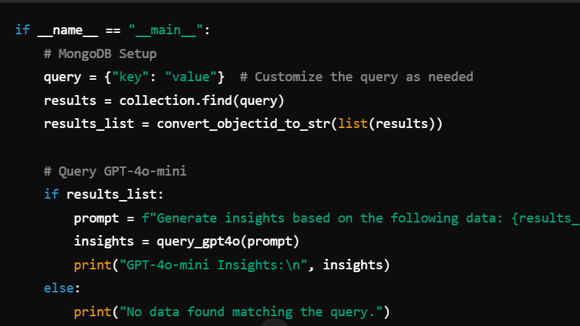
Step 5: Flask API Implementation

from flask import Flask, request, jsonify
import openai
from pymongo import MongoClient
import ast
from bson import ObjectId

app = Flask(__name__)

# MongoDB setup
openai.api_key = "your_openai_api_key"
try:
client = MongoClient("mongodb://localhost:27017/")
db = client["your_database_name"] # Replace with your database name
collection = db["your_collection_name"] # Replace with your collection name
except Exception as e:
print(f"MongoDB connection error: {e}")

# Helper function to handle ObjectId serialization
def convert_objectid_to_str(results_list):
for document in results_list:
if "_id" in document:
document["_id"] = str(document["_id"])
return results_list

@app.route('/generate', methods=['POST'])
def generate_response():
data = request.get_json()
user_message = data.get('message')

if not user_message:
return jsonify({"error": "No message provided"}), 400

try:
completion = openai.ChatCompletion.create(
model="gpt-4o-mini",
messages=[
{"role": "system", "content": "You are a system that generates PyMongo queries based on user instructions."},
{"role": "user", "content": user_message}
]
)
ai_response = completion.choices[0].message.get('content', '')

query = ast.literal_eval(ai_response)
if isinstance(query, list):
results = list(collection.aggregate(query))
elif isinstance(query, dict):
results = list(collection.find(query))
else:
return jsonify({"error": "Invalid query format"}), 400

results = convert_objectid_to_str(results)
return jsonify({"results": results, "generated_query": query}), 200

except Exception as e:
return jsonify({"error": "An error occurred", "details": str(e)}), 500

if __name__ == '__main__':
app.run(debug=True)

Enhancements

⚠️ Handling Error: Implement robust error handling for MongoDB connection and GPT API calls.

🗂️ Data Formatting: Format MongoDB data (e.g., JSON or tabular format) for better GPT input.

⏩ Pagination: Handle large datasets by paginating MongoDB queries.

🌐 Environment Variables: Store sensitive data like API keys in environment variables using python-dotenv.
Testing

- 🧪 Unit Test: Validate individual functions for MongoDB and GPT integration.
- 🔄 End-to-End Test: Test the entire workflow with sample data to ensure smooth operation.

Troubleshooting

- 🚧 Connection Errors: Verify MongoDB URI and credentials.
- 🛠️ Empty Responses: Check the query syntax and ensure data exists in the collection.
- ❌ API Errors: Review GPT-4o-mini API response messages for specific issues.

Summary and Next Steps

This documentation provides a comprehensive guide for integrating GPT-4o-mini with MongoDB.
As a next step:

- Explore deploying this integration in production environments, monitoring performance, and scaling workflows for larger datasets.

- Fine-tune the GPT-4o-mini model to answer any MongoDB database-related questions based on your specific database structure and content, enabling it to provide tailored responses and insights.

Contact Information:
For further assistance, contact velvizhi1518@gmail.com.

