Project Report: Dynamic MongoDB Query Executor and Visualizer

1. Project Overview
The Dynamic MongoDB Query Executor and Visualizer is a web-based application that allows users to interact with MongoDB databases using natural language queries. The system processes these queries, executes them, and presents the results in interactive visualizations, such as bar charts, pie charts, line charts, and more.

2. Technologies Used
• Flask: A Python web framework for handling HTTP requests and rendering templates.
• MongoDB: A NoSQL database for storing and retrieving data.
• Cohere API: Natural language processing (NLP) model for interpreting and converting user input into MongoDB queries.
• Plotly: A library for generating interactive data visualizations.
• Pandas: A Python library used for data manipulation and processing.

3. Objectives
• Dynamic Query Generation: Allow users to input natural language queries, which are then converted into MongoDB queries and executed.
• Data Visualization: Display the query results using interactive visualizations such as bar charts, pie charts, and line charts.
• User Interaction: Provide a web interface for users to input queries, select visualization types, and view data results.

4. System Architecture

4.1 Frontend (UI/UX)
The Frontend of the application is designed using HTML and CSS, and it is rendered dynamically using Flask templates. It allows users to input queries, select the type of plot, and view the results in a tabular and visual format.

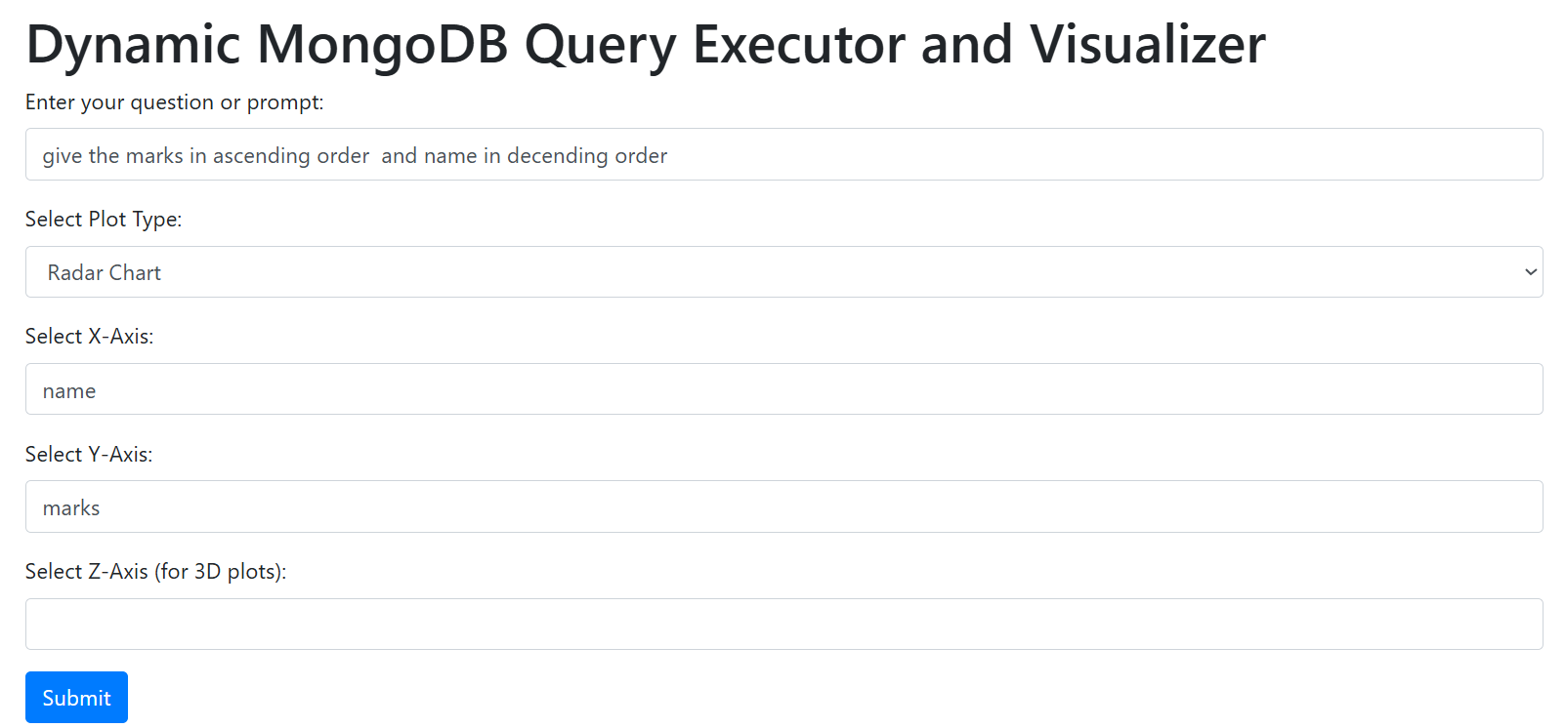

4.2 Backend
The backend consists of:
• Flask to handle user requests and render HTML templates.
• MongoDB and pymongo to execute queries on the database.
• Cohere API for converting user queries into MongoDB queries.
• Pandas for processing data and Plotly for generating interactive visualizations.

5. Features

5.1 Dynamic Query Generation
The system leverages the Cohere API to process natural language queries entered by the user and converts them into MongoDB queries.

5.2 Data Retrieval
The generated MongoDB query is executed using pymongo, and the results are returned in a pandas DataFrame for easy manipulation and display.

5.3 Data Visualization
Users can view the data in the following formats:
• 1D Data
• Bar Chart
• Line Chart
• Scatter Plot
• Histogram
• Pie Chart
• Area Chart
• Box Plot
• Bubble Chart
• Heatmap
• Violin Plot
• Treemap
• Funnel Chart
• Radar Chart
• Sunburst Chart
• Density Plot
• 3D Scatter Plot
• 3D Surface Plot
These visualizations are interactive and generated using Plotly.

5.4 Interactive Interface
The web interface allows users to:
• Input a query in natural language.
• Select a visualization type.
• View the query results in a table format.
• View interactive charts generated based on the data.

6. Workflow of the Application
1. User Input: The user enters a natural language query.
2. Query Interpretation: The input is sent to Cohere API to generate the corresponding MongoDB query.
3. Database Query Execution: The MongoDB query is executed using pymongo.
4. Data Processing: The query results are processed using pandas to create a DataFrame.
5. Data Visualization: The data is visualized in an interactive plot using Plotly.
6. Display: The results and plots are displayed in the browser.

Output:
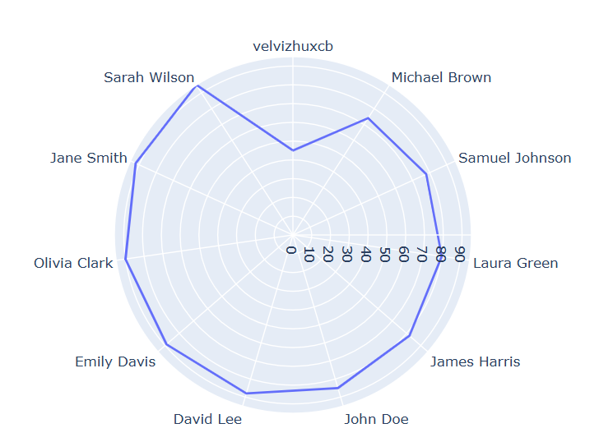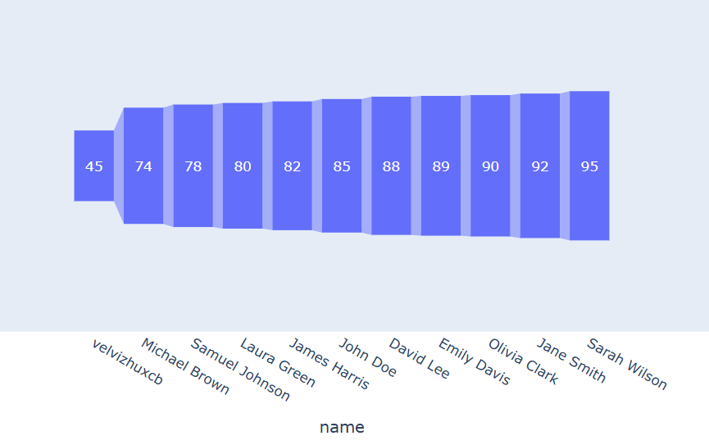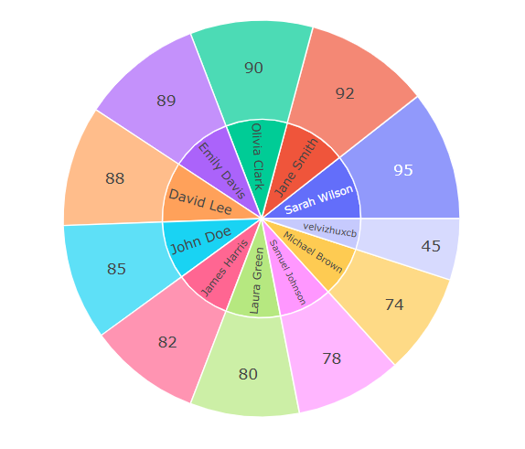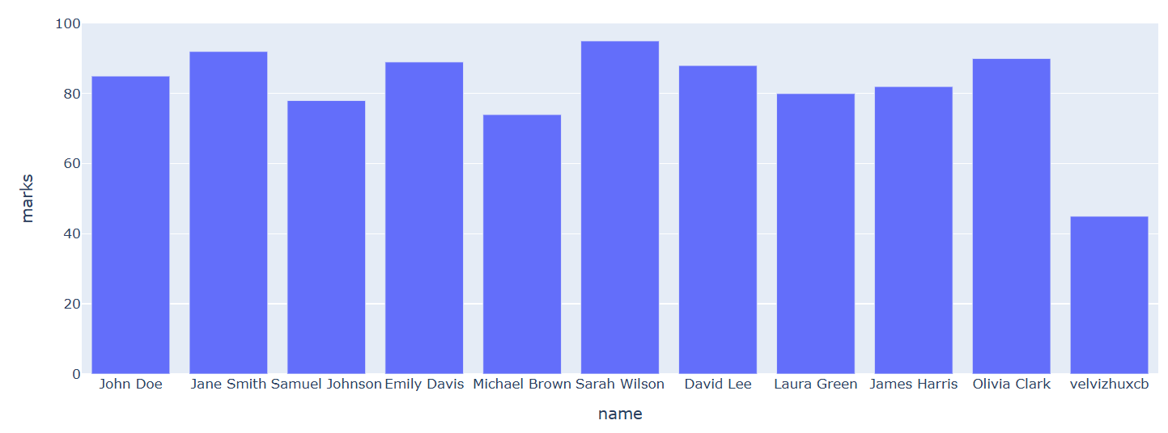

7. Code Implementation

7.1 Flask Application (app.py)
```python
from flask import Flask, render_template, request
import pymongo
import plotly.express as px
import plotly.graph_objects as go
import pandas as pd
from cohere import Client
app = Flask(__name__)
# MongoDB connection
client = pymongo.MongoClient("mongodb://localhost:27017/")
db = client['your_database']
collection = db['your_collection']
# Cohere API setup
api_key = "your_cohere_api_key"
cohere_client = Client(api_key)
@app.route('/getQuery', methods=['GET', 'POST'])
def home():
if request.method == 'POST':
# User inputs from the form
query = request.form['query']
plot_type = request.form['plot_type']
x_axis = request.form['x_axis']
y_axis = request.form['y_axis']
# Cohere NLP query generation
generated_query = generate_query(query)
# Execute the MongoDB query
data = execute_mongo_query(generated_query)
# Prepare the data for visualization
df = pd.DataFrame(data)
# Generate the plot based on the selected type
plot = generate_plot(df, plot_type, x_axis, y_axis)
return render_template('index.html', data=df.to_html(), plot=plot)
return render_template('index.html')
def generate_query(user_query):
# Generate MongoDB query from the user's natural language input
response = cohere_client.generate(
model='command-xlarge-2023-07-25',
prompt=f"Convert the following question into a MongoDB query: {user_query}",
max_tokens=200
)
return response.generations[0].text
def execute_mongo_query(query):
# Execute MongoDB query and return results
result = collection.find(query)
return list(result)
def generate_plot(df, plot_type, x_axis, y_axis):
if plot_type == 'Bar Chart':
fig = px.bar(df, x=x_axis, y=y_axis)
elif plot_type == 'Line Chart':
fig = px.line(df, x=x_axis, y=y_axis)
elif plot_type == 'Pie Chart':
fig = px.pie(df, names=x_axis, values=y_axis)
elif plot_type == 'Scatter Plot':
fig = px.scatter(df, x=x_axis, y=y_axis)
else:
fig = go.Figure()
return fig.to_html(full_html=False)
if __name__ == '__main__':
app.run(debug=True)
```

8. Challenges Faced
• NLP Query Interpretation: Fine-tuning the model for accurate query generation was challenging.
• Complex Query Handling: Managing advanced queries with multiple conditions required careful mapping to MongoDB query syntax.
• Plot Customization: Customizing the appearance of plots to fit various use cases (e.g., 3D charts) was time-consuming.

9. Future Enhancements
• Support for Multiple Collections: Integrate the ability to combine data from multiple MongoDB collections. This would allow users to perform cross-collection queries and visualize the combined data for deeper insights and analytics.
• Advanced Query Options: Enhance the NLP model to handle more complex queries.
• Real-Time Data Visualization: Integrate live data feeds or schedule periodic data updates so that users can visualize real-time data directly from the MongoDB database.
• User Authentication: Implement authentication to allow users to save their queries

10. Conclusion
The Dynamic MongoDB Query Executor and Visualizer project demonstrates an efficient and user-friendly approach to data querying and visualization. By using advanced NLP models, it simplifies the process of interacting with MongoDB databases, enabling users to create meaningful visualizations from complex data with ease.

