**ArrayCabinet**

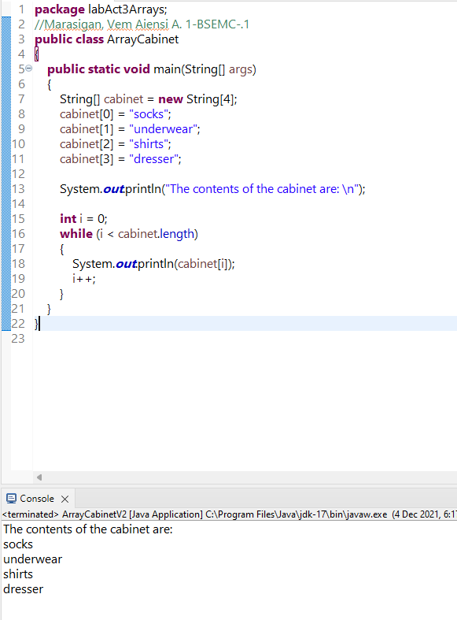

Video Link: <https://drive.google.com/file/d/1BOi1HI4QWULUWwmmOo5Xa-lnyaZmy8mX/view?usp=sharing>

**ArrayCabinetV2**

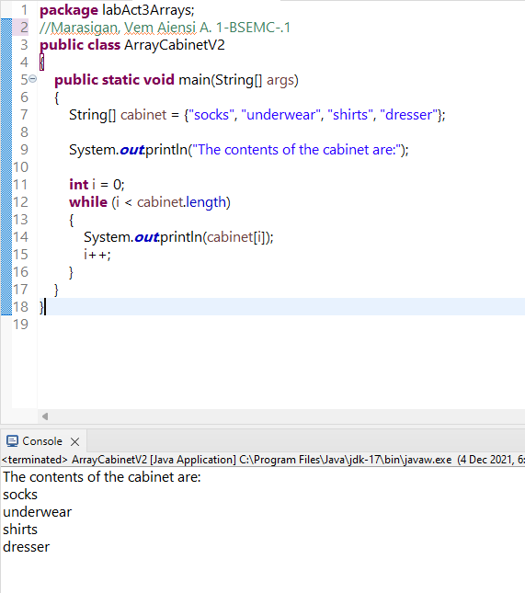

Video Link: <https://drive.google.com/file/d/1KrE41x_6HnIz2qaRhd998oCUKCyNIRNW/view?usp=sharing>

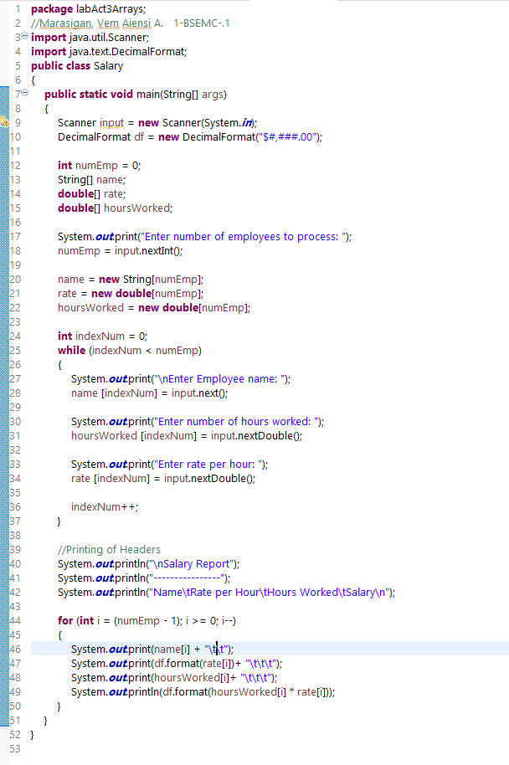

Sample Input & Output of Program **Salary**

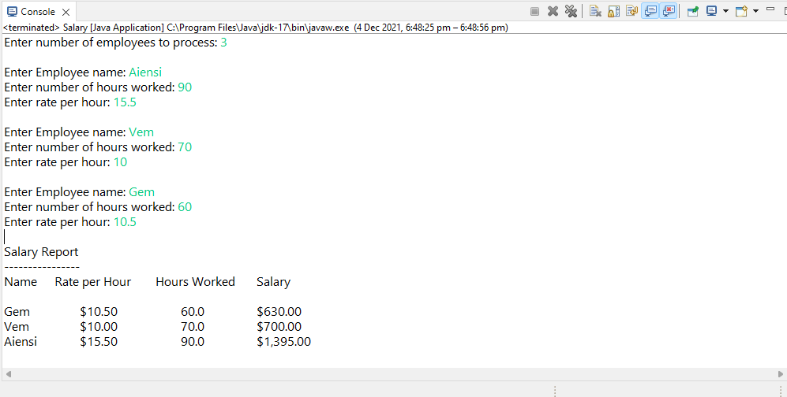

Video Link: <https://drive.google.com/file/d/1iVx__1zcxrGoXk1fk_aeW5r7GXlOwmB5/view?usp=sharing>

**SimulateEx18**

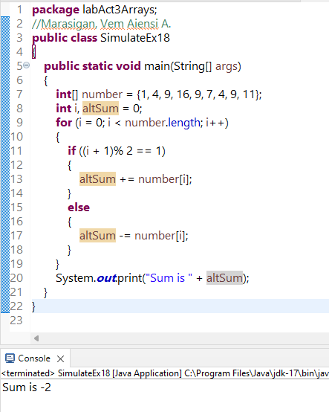

Video Link: <https://drive.google.com/file/d/1wsbrG1rU9ups3Aq1hb9qafQrCfbwfiaP/view?usp=sharing>