**Intermediate Programming - File Handling**

**1 – BSCS -.2 | Marasigan, Vem Aiensi A.**

**1.**

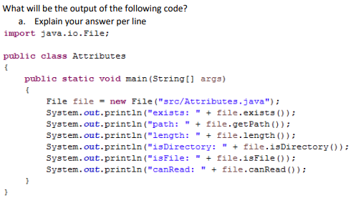

The output will be:

exists: true

path: src\Attributes.java

length: 470

isDirectory: false

isFile: true

canRead: true

1.   
   //This imports the File class in the program.

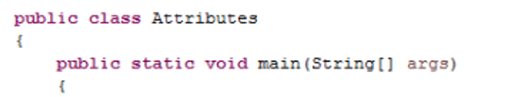  
//This is the class and its main method.

  
//This instantiates a File object as file and creates a file named Attributes.java in the src folder.



//Prints the word “exists: “ concatinated with the resulting boolean answer from the method exists() which tests whether the file exists and returns a boolean expression(which is true in the program’s case) .

Output of the line is

exists: true



//Prints the word “path: “ concatinated with the method getPath() which provides the file’s path.

Output of the line is

path: src\Attributes.java



//Prints the word “length: “ concatinated with the method length() which returns a long value that refers to the size of the file in bytes.

Output of the line is

length: 470



//Prints the word “isDirectory: “ concatinated with the resulting boolean answer from the method isDirectory() which tests whether the file denoted by this abstract pathname is a directory.

Output of the line is

isDirectory: false

  
//Prints the word “isFile: “ concatinated with the resulting boolean answer from the method isFile() which tests whether the file is a normal file, meaning that it is not a directory.

Output of the line is

isFile: true

  
//Prints the word “canRead: “ concatinated with the resulting boolean answer from the method canRead() which tests whether the file is readable or not

Output of the line is

canRead: true

**2.**

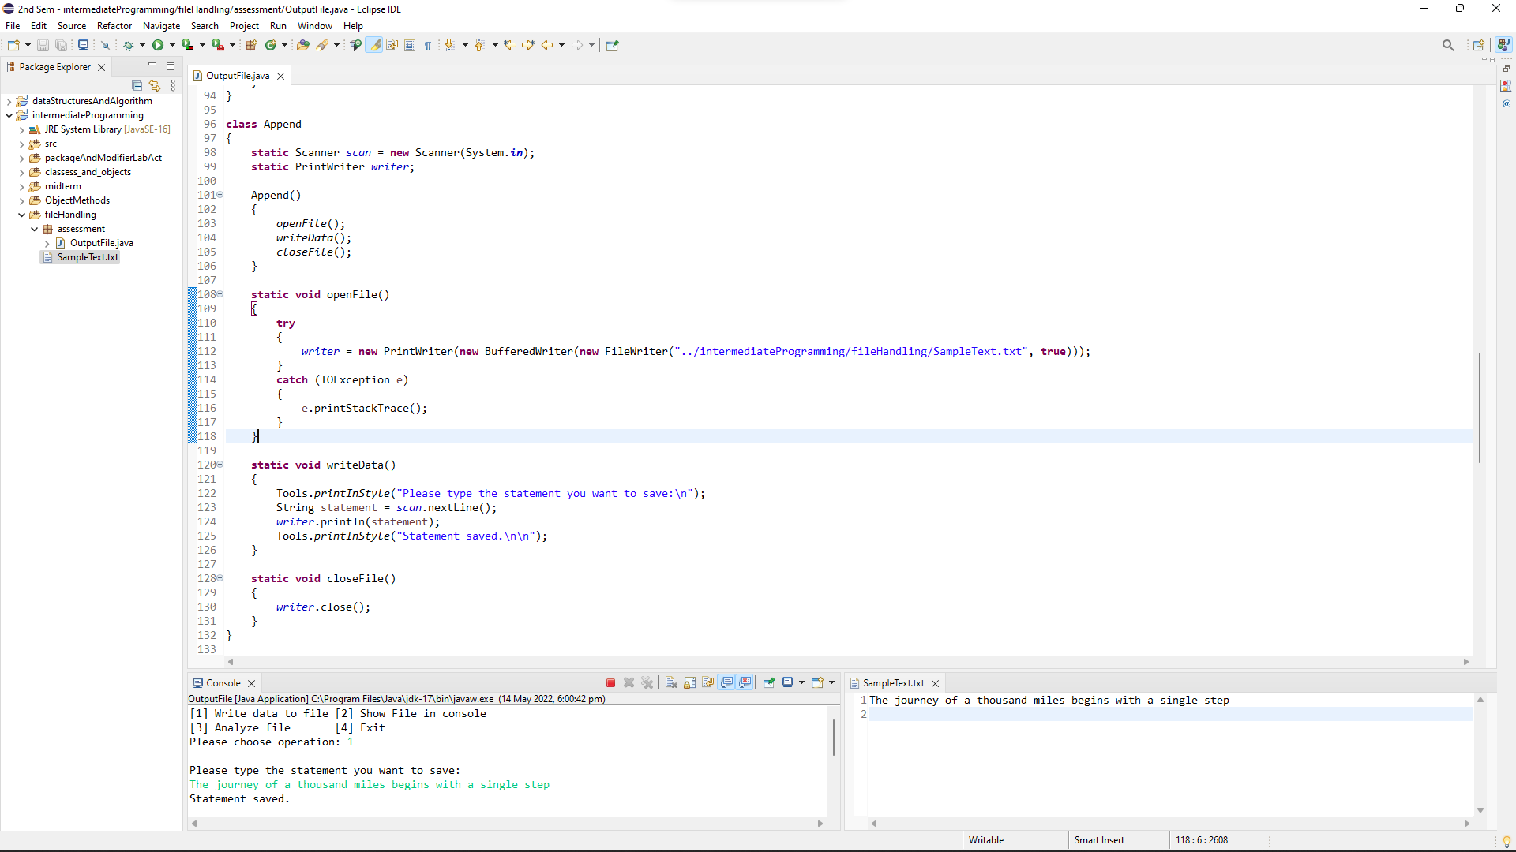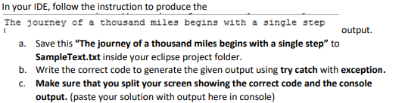

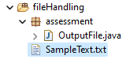

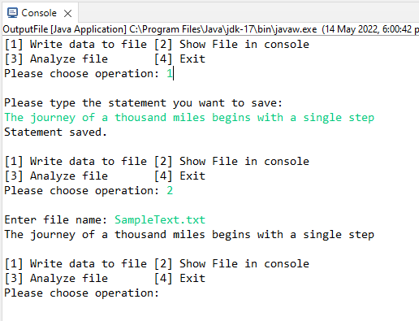

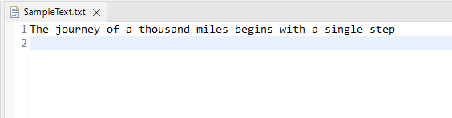

**3.**



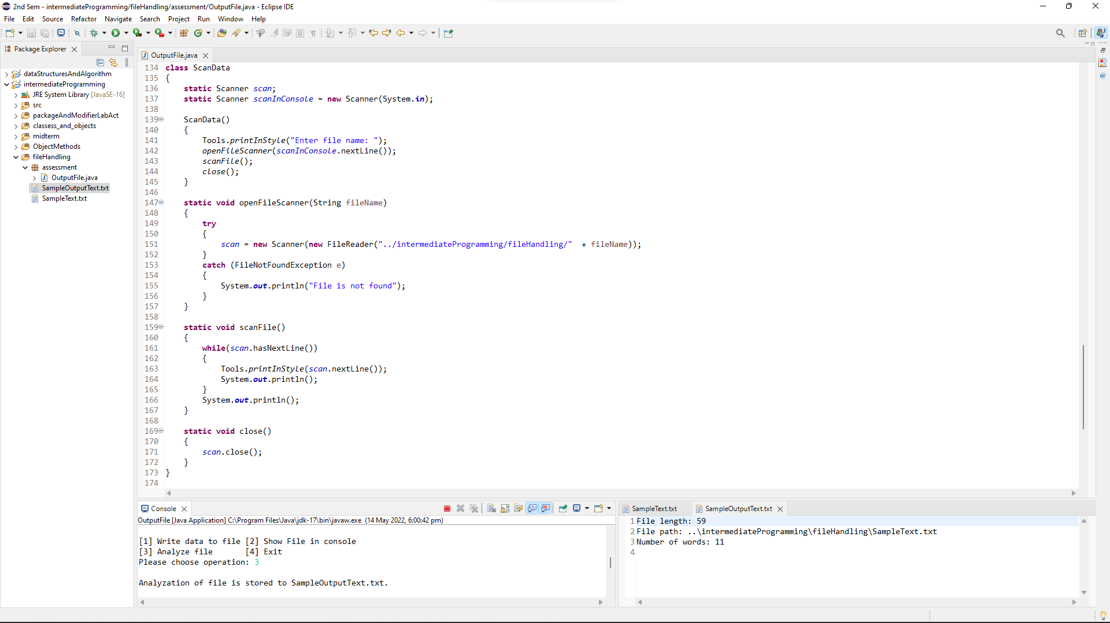

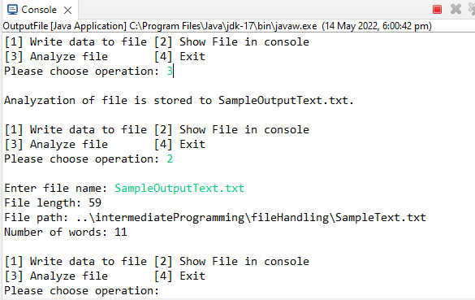

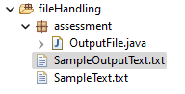

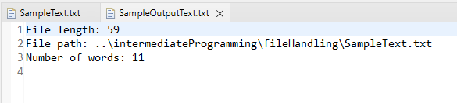

**4.**

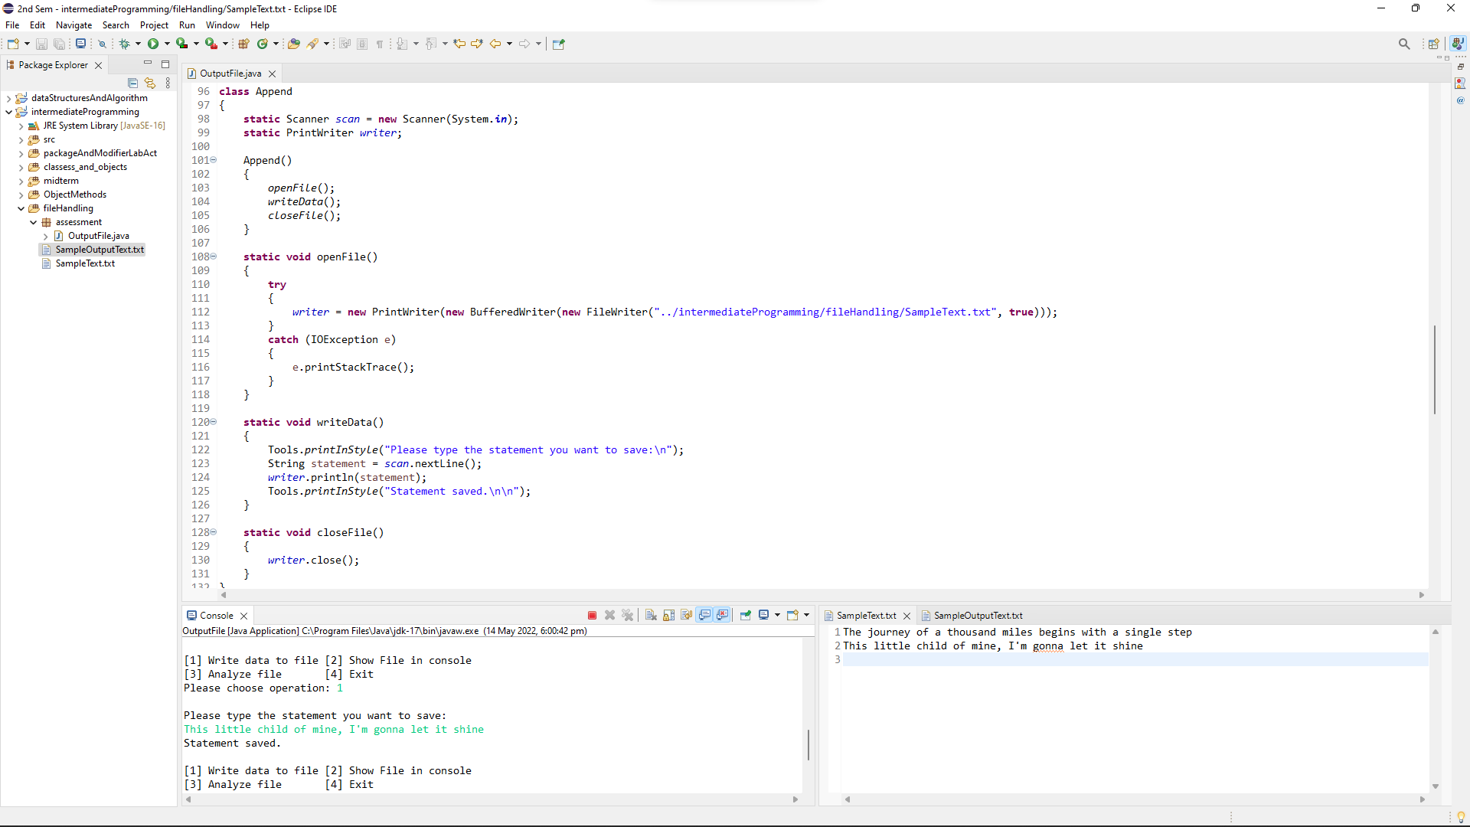****

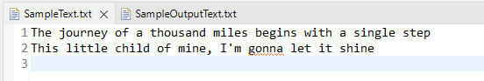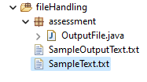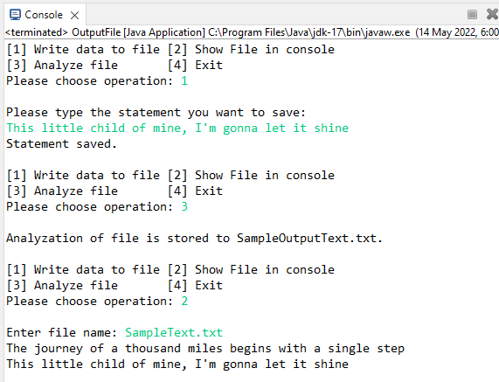

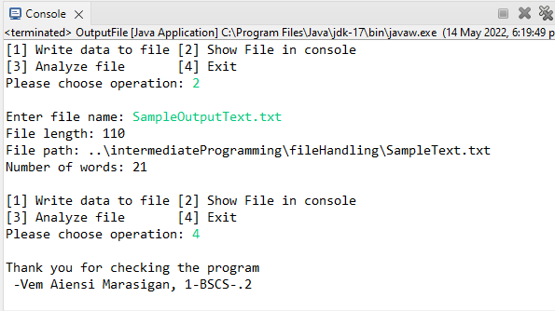

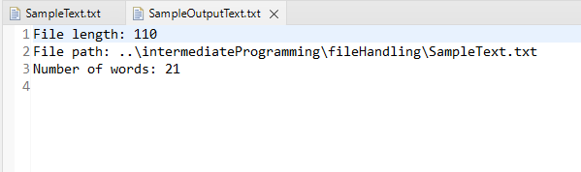

**SOURCE CODE**

**package** assessment;

//Marasigan, Vem Aiensi A. | 1-BSCS-.2

**import** java.io.BufferedWriter;

**import** java.io.File;

**import** java.io.FileNotFoundException;

**import** java.io.FileReader;

**import** java.io.FileWriter;

**import** java.io.IOException;

**import** java.io.PrintWriter;

**import** java.util.Scanner;

**import** java.util.concurrent.TimeUnit;

**public** **class** OutputFile

{

**static** Scanner *scan* = **new** Scanner(System.***in***);

**static** **int** *choice* = 0;

**public** **static** **void** main(String[] args)

{

*optionLoop*();

Tools.*end*();

}

**static** **void** optionLoop()

{

System.***out***.print("[1] Write data to file [2] Show File in console\n"

+ "[3] Analyze file [4] Exit\n"

+ "Please choose operation: ");

*choice* = *scan*.nextInt();

System.***out***.println();

**switch**(*choice*)

{

**case** 1: **new** Append(); **break**;

**case** 2: **new** ScanData(); **break**;

**case** 3: **new** Analyze(); **break**;

**case** 4: **return**;

}

*optionLoop*();

}

}

**class** Analyze

{

Analyze()

{

*openFile*();

*analyzeFile*();

*close*();

}

**static** Scanner *scanner1*;

**static** PrintWriter *writer*;

**static** File *file*;

**static** String[] *words*;

**static** String *scannedText*, *statement*;

**static** **void** openFile()

{

**try**

{

*file* = **new** File ("../intermediateProgramming/fileHandling/SampleText.txt");

*scanner1* = **new** Scanner(**new** FileReader("../intermediateProgramming/fileHandling/SampleText.txt"));

*writer* = **new** PrintWriter("../intermediateProgramming/fileHandling/SampleOutputText.txt");

}

**catch** (FileNotFoundException e)

{

System.***out***.println("File creation failed");

}

}

**static** **void** analyzeFile()

{

*scannedText* = ""; //resets the data for a new fresh scan

**while**(*scanner1*.hasNextLine())

{

*scannedText* += *scanner1*.nextLine();

*scannedText* += " "; //essential for word separations

}

*words* = *scannedText*.split(" ");

*writer*.println("File length: " + *file*.length());

*writer*.println("File path: " + *file*.getPath());

*writer*.println("Number of words: " + *words*.length);

Tools.*printInStyle*("Analyzation of file is stored to SampleOutputText.txt. \n\n");

}

**static** **void** close()

{

*writer*.close();

*scanner1*.close();

}

}

**class** Append

{

**static** Scanner *scan* = **new** Scanner(System.***in***);

**static** PrintWriter *writer*;

Append()

{

*openFile*();

*writeData*();

*closeFile*();

}

**static** **void** openFile()

{

**try**

{

*writer* = **new** PrintWriter(**new** BufferedWriter(**new** FileWriter("../intermediateProgramming/fileHandling/SampleText.txt", **true**)));

}

**catch** (IOException e)

{

e.printStackTrace();

}

}

**static** **void** writeData()

{

Tools.*printInStyle*("Please type the statement you want to save:\n");

String statement = *scan*.nextLine();

*writer*.println(statement);

Tools.*printInStyle*("Statement saved.\n\n");

}

**static** **void** closeFile()

{

*writer*.close();

}

}

**class** ScanData

{

**static** Scanner *scan*;

**static** Scanner *scanInConsole* = **new** Scanner(System.***in***);

ScanData()

{

Tools.*printInStyle*("Enter file name: ");

*openFileScanner*(*scanInConsole*.nextLine());

*scanFile*();

*close*();

}

**static** **void** openFileScanner(String fileName)

{

**try**

{

*scan* = **new** Scanner(**new** FileReader("../intermediateProgramming/fileHandling/" + fileName));

}

**catch** (FileNotFoundException e)

{

System.***out***.println("File is not found");

}

}

**static** **void** scanFile()

{

**while**(*scan*.hasNextLine())

{

Tools.*printInStyle*(*scan*.nextLine());

System.***out***.println();

}

System.***out***.println();

}

**static** **void** close()

{

*scan*.close();

}

}

**class** Tools

{

**static** **void** printInStyle(String s)

{

**try**

{

**for** (**int** count = 0; count<s.length(); count++)

{

System.***out***.print(s.charAt(count));

TimeUnit.***MILLISECONDS***.sleep(20);

}

}

**catch** (Exception e)

{

}

}

**static** **void** end()

{

*printInStyle*("Thank you for checking the program\n"

+ " -Vem Aiensi Marasigan, 1-BSCS-.2");

}

}

**VIDEO FOR RUNNING:**<https://drive.google.com/file/d/1l_ihL1HAUUjiZ_HafxlINRi4CjvrcSr4/view?usp=sharing>