While Loop – **IloveYou**

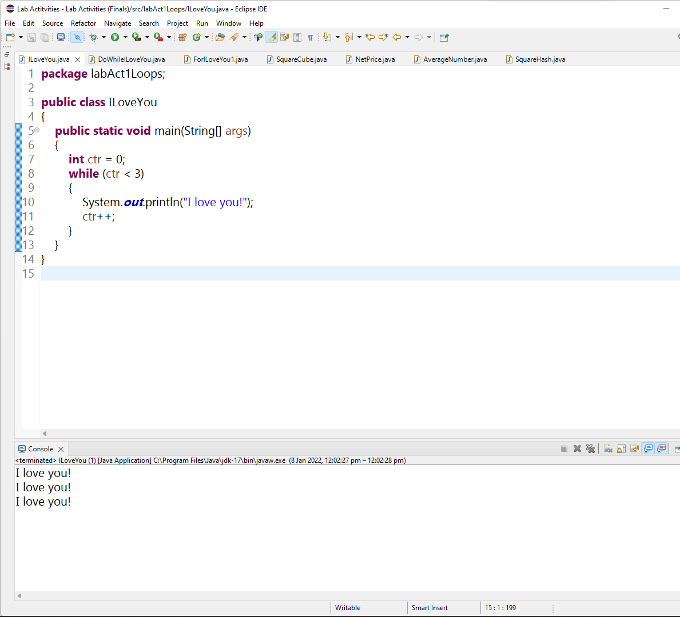

Video Link:

<https://drive.google.com/file/d/1c0WZYAGlzGLehMRxU8bklN72lz-BQxIQ/view?usp=sharing>

Do-while Loop – **DoWhileILoveYou**

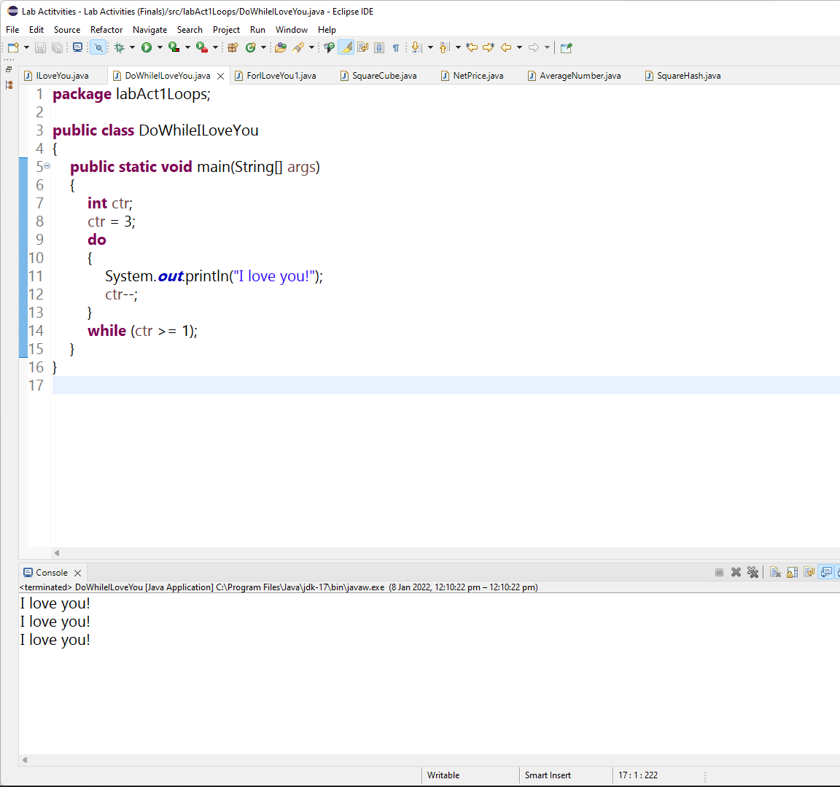

Video Link:

<https://drive.google.com/file/d/140xGMEXwDgbCU8yPqWrX745W6VpQ-uXo/view?usp=sharing>

For Loop – **ForILoveYou1**

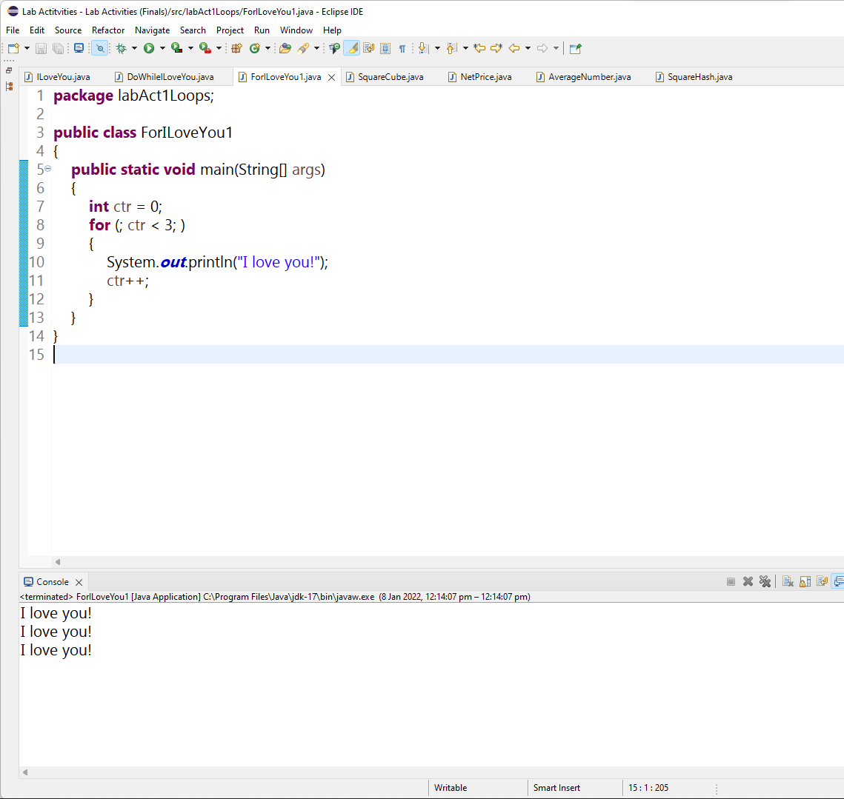

Video Link:

<https://drive.google.com/file/d/1-L5vrTf3sxJZowwQGpEnpA8dFouIbEhP/view?usp=sharing>

**SquareCube**

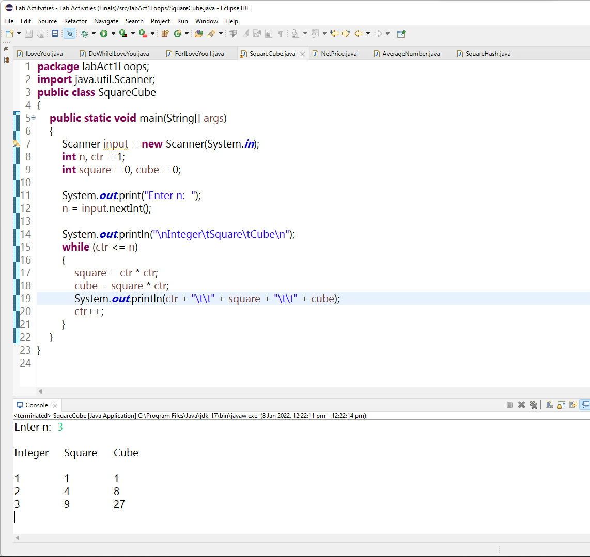

Video Link:

<https://drive.google.com/file/d/1X-7YQrLGm82MQrCgkvXIxkSd_rMghDZc/view?usp=sharing>

**SumOdd**

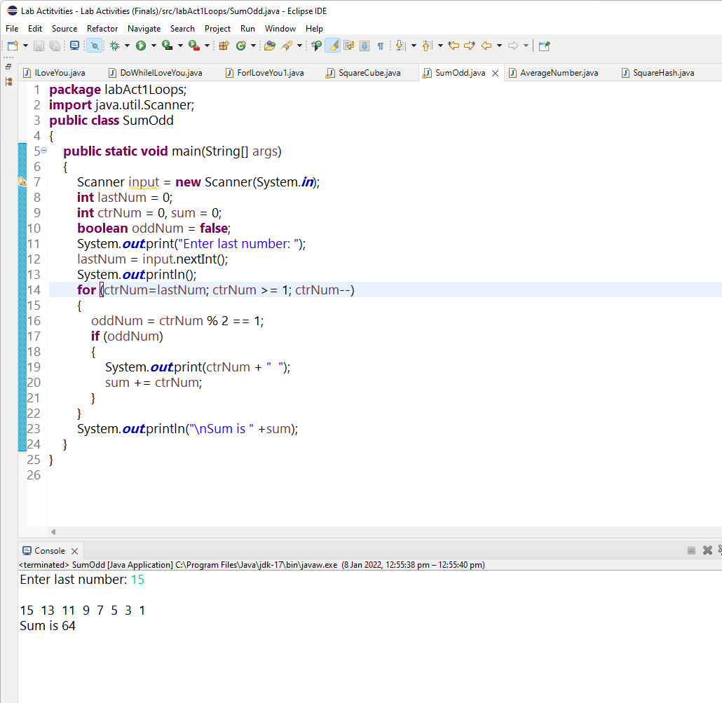

Video Link:

<https://drive.google.com/file/d/1YIU9G79ZvONLftLRH-ivg1hWNVSvlhTu/view?usp=sharing>

Break Statement - **AverageNumber**

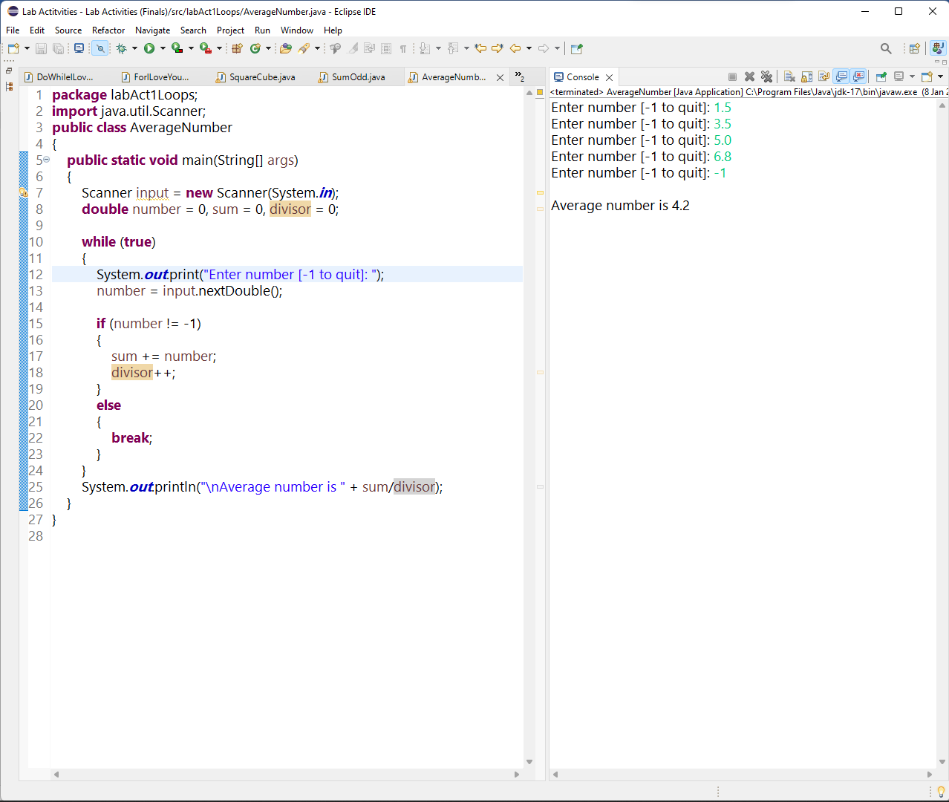

Video Link:

<https://drive.google.com/file/d/187738_vEFuwAbo4TT0Vhot3LeMJiuYEo/view?usp=sharing>

Loop within a Loop – **SquareHash**

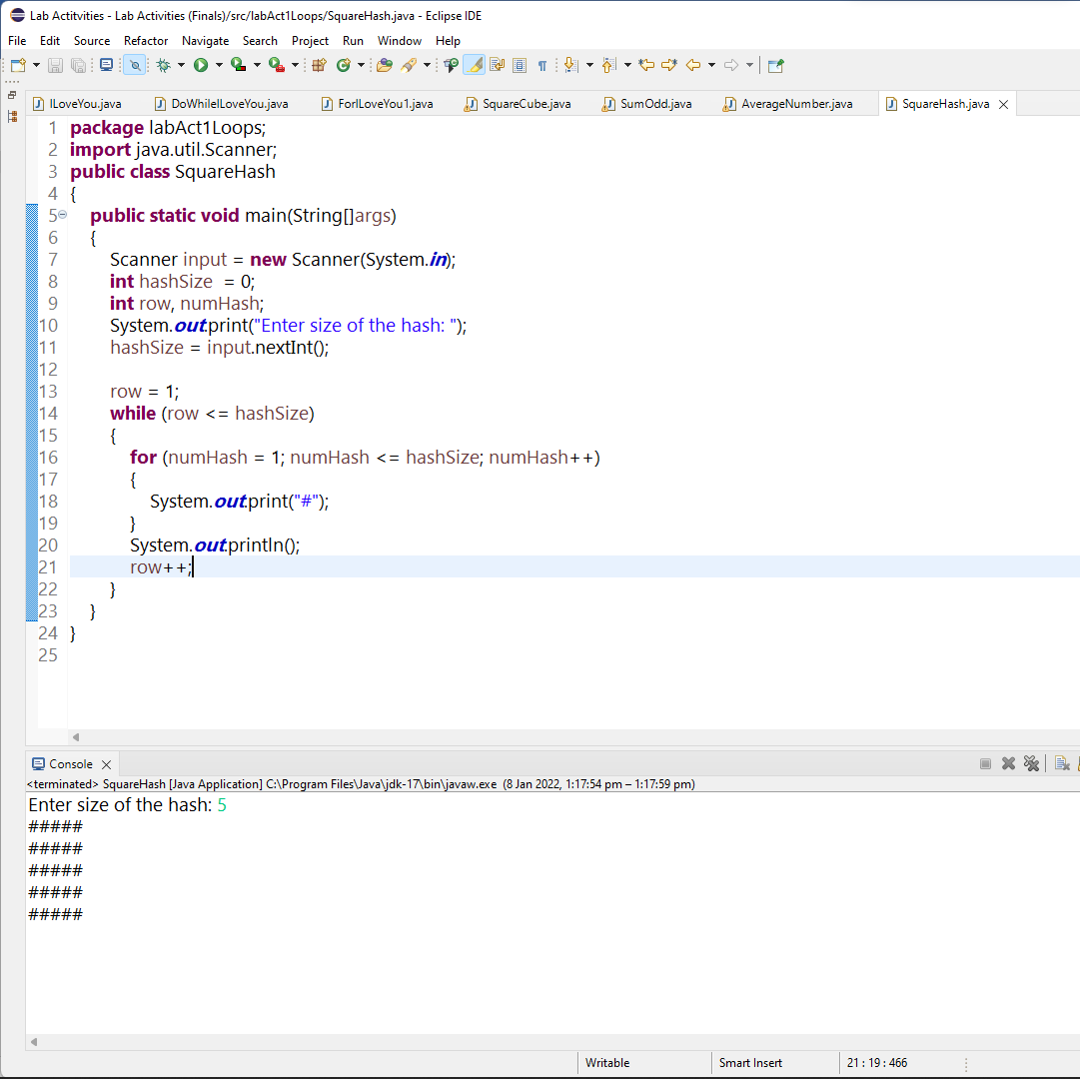

Video Link:

<https://drive.google.com/file/d/1jdWjuiVepyJeiDERk-kAupJ52mZT-a7K/view?usp=sharing>

**SimulateEx7**

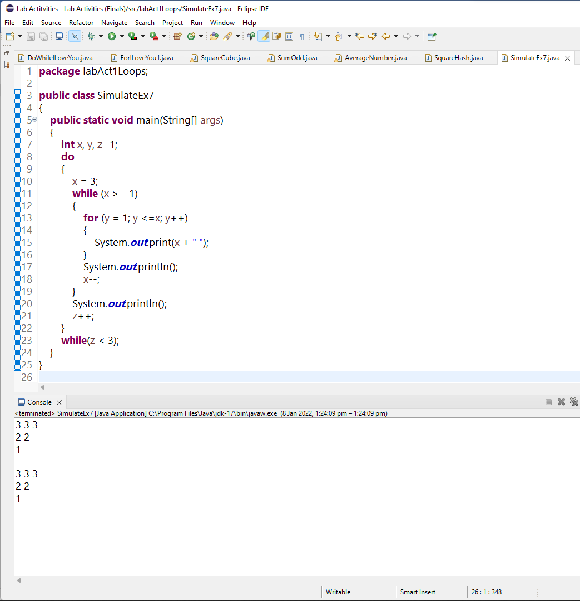

Video Link:

<https://drive.google.com/file/d/1W6btOX77c2Kq5KbeS7r3EsEGtIQKmNfg/view?usp=sharing>

Nested Loop – **Inverted Triangle**

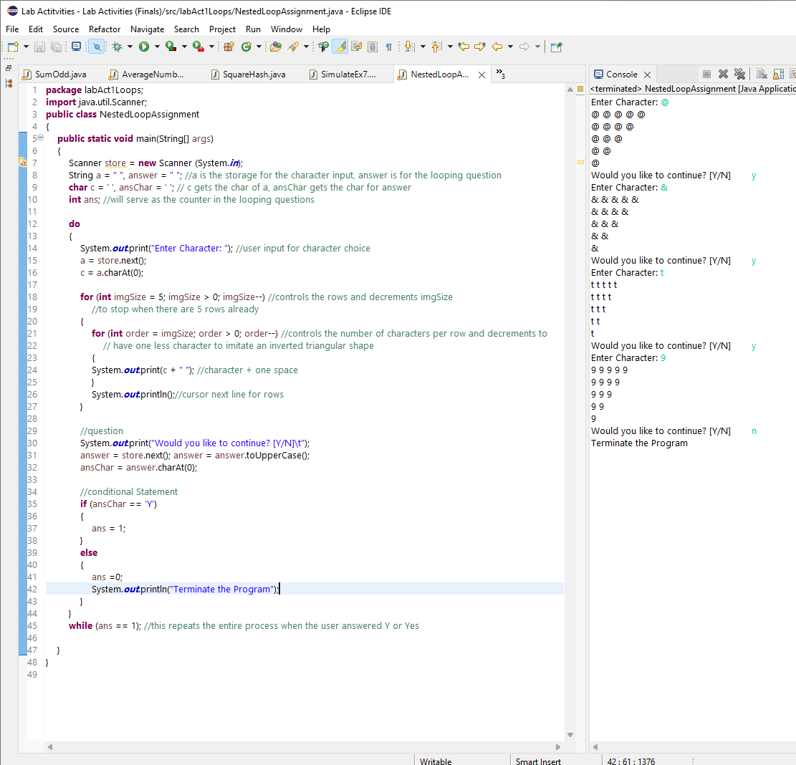

Video Link:

<https://drive.google.com/file/d/19M5_IlxgsorfLqk7s55-eKLk3yoYVFmN/view?usp=sharing>