**PowerAndSqrt (**main method only**)**

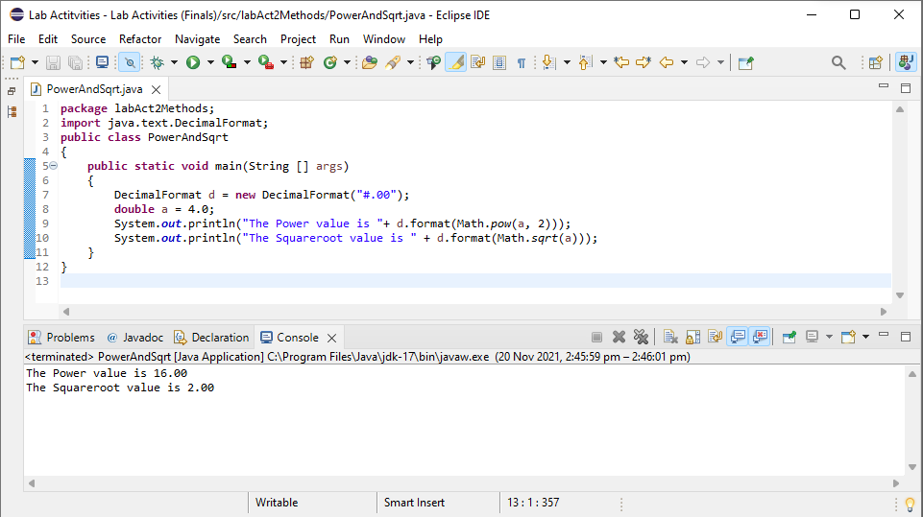

**Border (**using separate methods**)**

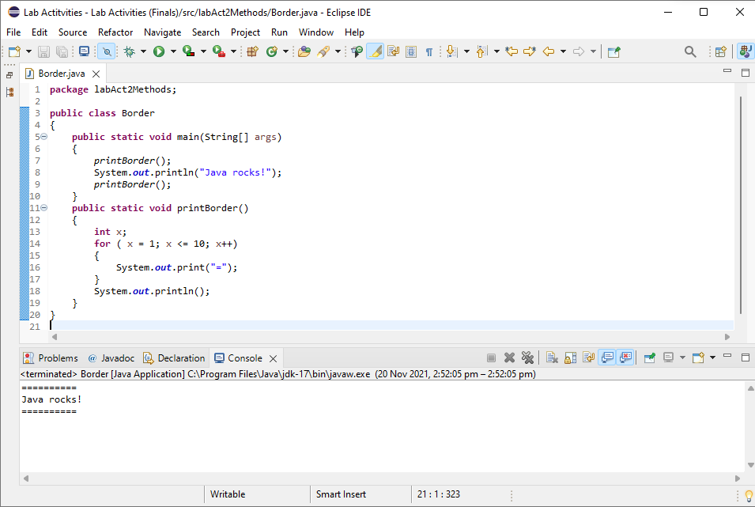

**CD (**using separate methods with return value**)**

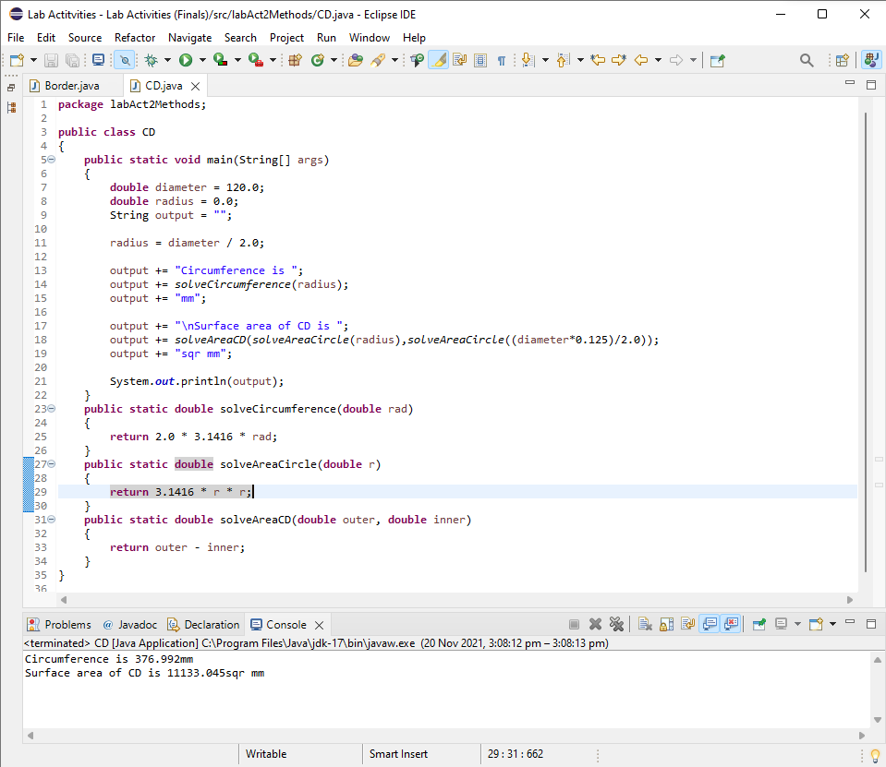

**Bonus Activity (**ver**)  
Video Link:** <https://drive.google.com/file/d/1ZZTM3SnYEP60N9jVymwuz5Ze-lhqbuTy/view?usp=sharing>

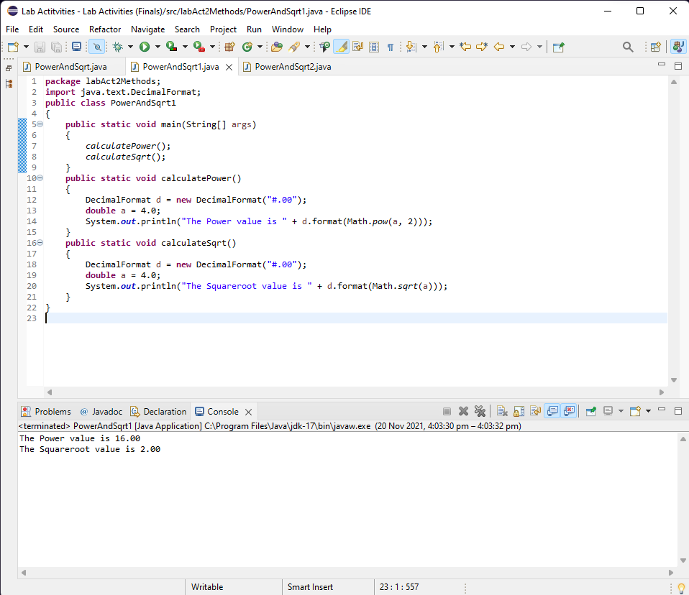

**Bonus Activity (**ver2**)  
Video Link:** <https://drive.google.com/file/d/1HlJVjZcRdFc6hMUvQBz9Bkqq2NixXO54/view?usp=sharing>

