**CODE:**

<html>

<title>My SlamBook</title>

<body>

<style> tr, td{padding-bottom:5px; padding-left:30px;}</style>

<h1 style="text-align:center">My Slambook</h1>

<form action="">

<fieldset>

<legend><b>PERSONAL INFO</b></legend>

<table >

<tr>

<td style="width:30%">NAME:

</td>

<td><input type="text" name="Name" value="" size="60"><br>

</td>

</tr>

<tr>

<td>NICKNAME:

</td>

<td><input type="text" name="nickname" value="" size="60"><br>

</td>

</tr>

<tr>

<td>ADDRESS:

</td>

<td><input type="text" name="adress" value="" size="60"><br>

</td>

</tr>

<tr>

<td>BIRTHDAY:

</td>

<td><input type="text" name="birthday" value="" size="60"><br>

</td>

</tr>

<tr>

<td>GENDER:

</td>

<td><input type="radio" id="male" name="gender" value="Male" >

<label for="male">Male</label>

<input type="radio" id="female" name="gender" value="Female">

<label for="female">Female</label><br></p>

</td>

</tr>

<tr>

<td>MOTTO:

</td>

<td><textarea rows="2" cols="59"></textarea>

</td>

</tr>

<tr>

<td>HOBBIES:

</td>

<td><input type="text" name="hobbies" value="" size="60">

</td>

</tr>

<tr>

<td>SKILLS:

</td>

<td><input type="text" name="skills" value="" size="60">

</td>

</tr>

<tr>

<td>GOALS:

</td>

<td><textarea rows="2" cols="59"></textarea>

</td>

</tr>

</table>

</fieldset>

<br>

<fieldset>

<legend>

<b>FAVES:</b></legend>

<table>

<tr>

<td style="width:30%">COLORS:

</td>

<td><input type="checkbox" id="color" name="color1" value="Red">

<label for="color"> Red</label>

<input type="checkbox" id="color" name="color2" value="Black">

<label for="color"> Black</label><br>

<input type="checkbox" id="color" name="color3" value="Pink">

<label for="color"> Pink</label>

<input type="checkbox" id="color" name="color4" value="Yellow">

<label for="color"> Yellow</label><br>

<input type="checkbox" id="color" name="color5" value="Blue">

<label for="color"> Blue</label>

<input type="checkbox" id="color" name="color6" value="Green">

<label for="color"> Green</label><br>

<input type="checkbox" id="color" name="others" value="Others">

<label for="color"> Others</label>

<label for="others">Please Specify: </label><input type="text" id="others" name="others" value="" size="15">

<br>

</td>

</tr>

<tr>

<td>PET:

</td>

<td><input type="text" name="pet" value="" size="60">

</td>

</tr>

<tr>

<td>CARTOON MOVIE:

</td>

<td><input type="text" name="cmovie" value="" size="60">

</td>

</tr>

<tr>

<td>CARTOON CHARACTER:

</td>

<td><input type="text" name="cchar" value="" size="60">

</td>

</tr>

<tr>

<td>FOOD:

</td>

<td><input type="text" name="food" value="" size="60">

</td>

</tr>

<tr>

<td>RESTAURANT:

</td>

<td><input type="text" name="resto" value="" size="60">

</td>

</tr>

<tr>

<td>WHY DO YOU LIKE<br> ME AS YOUR FRIEND?

</td>

<td><textarea rows="2" cols="59"></textarea>

</td>

</tr>

<tr>

<td>MESSAGE FOR ME:

</td>

<td><textarea rows="2" cols="59"></textarea>

</td>

</tr>

<tr>

<td><input type="submit" value="SEND"> <input type="reset" value="CLEAR">

</td>

</tr>

</table>

</form>

</body>

</html>

**OUTPUT:**

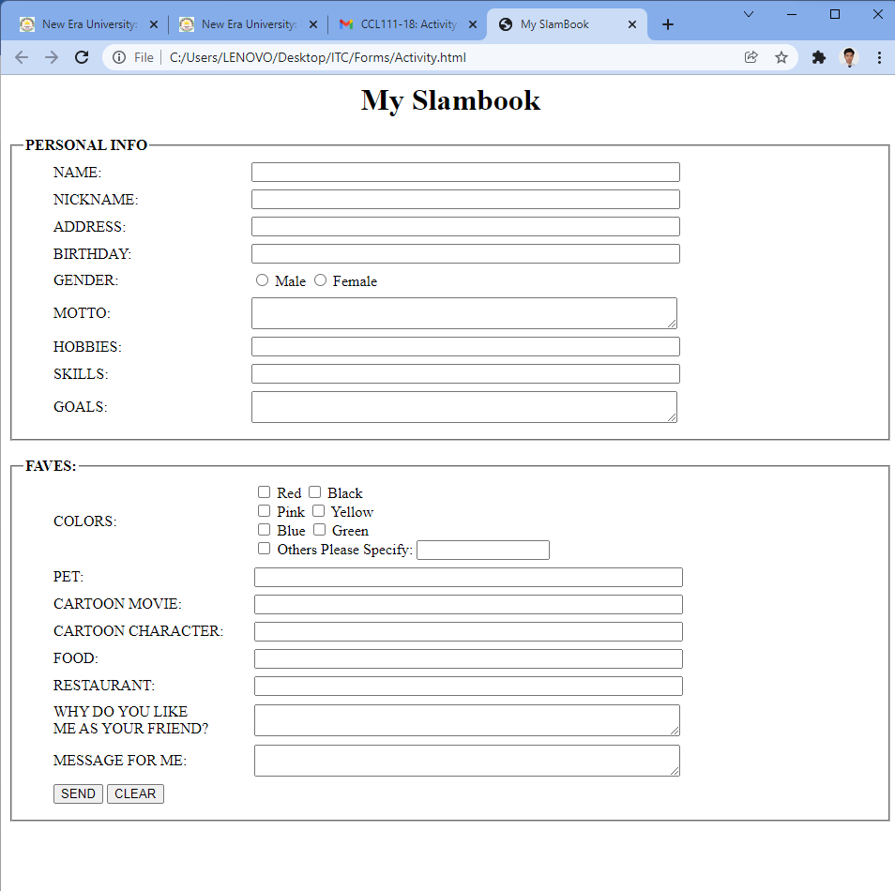

Resource files:  
<https://drive.google.com/drive/folders/1QR9u6NlCZO64EDhix8XNTLPg_kfTAcQG?usp=sharing>