SIMATS ENGINEERING
Practical Laboratory Exercise_Questions
CSA6303- Threat Intelligence and Network Security CO3-AT3-
Assessment Questions

Subject | Threat Intelligence | Total Marks | 30
Questions | 3 (all compulsory) | Marks per  Question | 10
Reg.No | 192311265 | Name | Vikas Reddy
Faculty | Dr.V.Parthipan | Slot | A
Instructions: Answer all questions. Each question carries 5 marks. Support answers with examples and diagrams where appropriate.
CO3: Perform threat analysis using intelligence models and utilize industry tools for monitoring and detection.
Code of Conduct
I Vikas Reddy/192311265 (Name / Reg No) certify that this submission is my original work and that I have adhered to the guidelines specified for this assessment. I understand that any violation of academic integrity rules will result in disciplinary action.
Signature of Student :Vikas

Questions :
Exercise 1: Threat Intelligence Platform Investigation
Objective: To investigate suspicious IP addresses, domains, and file hashes using a threat intelligence platform.
Practical Tasks:
- Examine sample IoCs using VirusTotal or another authorized threat intelligence platform.
- Review available reputation scores and threat classifications.
- Record the findings and recommend appropriate security actions.
Expected Output: A threat intelligence investigation report.
CODE:
import webbrowser import json while True:
print("\n1.IP Address 2.Domain 3.File Hash 4.Exit") choice = input("Enter choice: ") if choice == "4":
break if choice == "1":
typ, path = "IP", "ip-address" elif choice == "2":
typ, path = "Domain", "domain" elif choice == "3":
typ, path = "Hash", "file"
else:
print("Invalid choice!") continue
ioc = input("Enter IoC: ") webbrowser.open(f"https://www.virustotal.com/gui/{path}/{ioc}") malicious = int(input("Malicious detections: ")) suspicious = int(input("Suspicious detections: ")) status = "Malicious" if malicious > 0 else (
"Suspicious" if suspicious > 0 else "No detections"
)
report = {
"Type": typ,
"IoC": ioc,
"Classification": status
} with open("report.json", "a") as f:
f.write(json.dumps(report) + "\n") print("\nInvestigation Report:", report) print("Report saved successfully!")
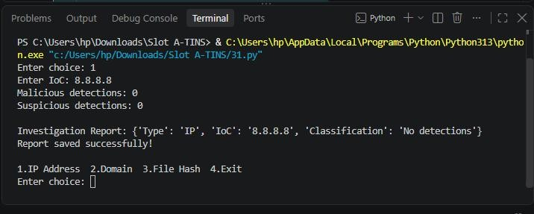
Exercise 2: Security Log Collection and Correlation
Objective: To collect and correlate security events from different sources.
Practical Tasks:
- Collect sample authentication, firewall, and web server logs.
- Identify common IP addresses, timestamps, and user activities.
- Correlate events to identify suspicious patterns.
Expected Output: A correlated security event summary.
CODE:
auth_logs = [
"10:00 192.168.1.10 Login Failed user1",
"10:02 192.168.1.10 Login Failed user1",
"10:05 192.168.1.20 Login Success user2"
]
firewall_logs = [
"10:03 192.168.1.10 Blocked Port 22",
"10:06 192.168.1.20 Allowed Port 80"
]
web_logs = [
"10:04 192.168.1.10 Access /admin",
"10:07 192.168.1.20 Access /home"
]
print("AUTHENTICATION LOGS") for log in auth_logs:
print(log)
print("\nFIREWALL LOGS") for log in firewall_logs:
print(log)
print("\nWEB SERVER LOGS") for log in web_logs: print(log)
all_logs = auth_logs + firewall_logs + web_logs print("\nCORRELATED SECURITY EVENTS") for log in all_logs: ip = log.split()[1]
count = sum(ip in item.split() for item in all_logs) if count >= 3:
print("Suspicious IP:", ip) print("Related Events:", count) print("Action: Investigate and monitor immediately") break
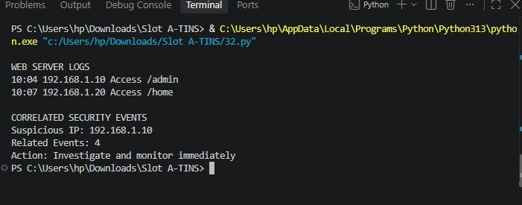
Exercise 3: Threat Hunting Using Network Logs
Objective: To identify suspicious network activities through proactive threat hunting.
Practical Tasks:
- Examine sample network traffic logs.
- Identify unusual outbound connections and repeated connection attempts.
- Investigate suspicious communication patterns and document relevant IoCs.
Expected Output: A threat-hunting report with findings and recommendations.
CODE:
logs = [
"192.168.1.10 10.0.0.5 443",
"192.168.1.10 10.0.0.5 443",
"192.168.1.10 10.0.0.5 443",
"192.168.1.20 8.8.8.8 53",
"192.168.1.30 45.10.20.5 8080",
"192.168.1.30 45.10.20.5 8080"
]
print("NETWORK TRAFFIC LOGS")
for log in logs:
print(log)
print("\nTHREAT HUNTING RESULTS") connections = {} for log in logs: ip = log.split()[1] connections[ip] = connections.get(ip, 0) + 1 for ip, count in connections.items(): if count >= 3:
print("Suspicious IP:", ip) print("Connection Attempts:", count) print("Status: Repeated Connections") if ip == "45.10.20.5":
print("Possible Unusual Outbound Connection:", ip) print("\nRECOMMENDATIONS")
print("1. Investigate suspicious IP addresses.") print("2. Monitor repeated connection attempts.") print("3. Block confirmed malicious connections.") print("4. Maintain network traffic monitoring.")
